Appendix
Table A1: Average Nosema ceranae gene copies for all 80 hives as produced from results of qPCRs.
Hive Number | Gene Copy Number | Hive Number | Gene Copy Number
24_1 | 0 | 24_43 | 0
24_2 | 0 | 24_44 | 76
24_3 | 28 | 24_45 | 987
24_4 | 542 | 24_46 | 403
24_5 | 435129 | 24_47 | 4947802
24_6 | 1399762 | 24_48 | 486670
24_7 | 7098688 | 24_49 | 342
24_8 | 325 | 24_50 | 24
24_9 | 1558 | 24_51 | 0
24_10 | 284398 | 24_52 | 0
24_11 | 1062 | 24_53 | 0
24_12 | 166 | 24_54 | 0
24_13 | 22 | 24_55 | 0
24_14 | 42721 | 24_56 | 0
24_15 | 22 | 24_57 | 0
24_16 | 242281 | 24_58 | 0
24_17 | 0 | 24_59 | 0
24_18 | 0 | 24_60 | 0
24_19 | 23 | 24_61 | 653
24_20 | 0 | 24_62 | 1134
24_21 | 0 | 24_63 | 29
24_22 | 0 | 24_64 | 0
24_23 | 0 | 24_65 | 0
24_24 | 0 | 24_66 | 0
24_25 | 0 | 24_67 | 0
24_26 | 0 | 24_68 | 51
24_27 | 0 | 24_69 | 25
24_28 | 0 | 24_70 | 0
24_29 | 0 | 24_71 | 0
24_30 | 0 | 24_72 | 0
24_31 | 0 | 24_73 | 203
24_32 | 0 | 24_74 | 298690
24_33 | 0 | 24_75 | 62
24_34 | 0 | 24_76 | 0
24_35 | 0 | 24_77 | 0
24_36 | 0 | 24_78 | 0
24_37 | 0 | 24_79 | 0
24_38 | 0 | 24_J1 | 0
24_41 | 0 | 24_M1 | 0
24_42 | 167791

Table A2: Percentages of land designated arable within a 2 km radius of hives.
Hive Number | Arable Percentage | Hive Number | Arable Percentage
24_1 | 0.648495399 | 24_43 | 0.278388461
24_2 | 0.712609387 | 24_44 | 0.763392191
24_3 | 0.232364939 | 24_45 | 0.609549863
24_4 | 0.630639144 | 24_46 | 0.364472964
24_5 | 0.372382232 | 24_47 | 0.117892852
24_6 | 0.210434696 | 24_48 | 0.113365155
24_7 | 0.196350438 | 24_49 | 0.350559562
24_8 | 0.396816712 | 24_50 | 0.487590152
24_9 | 0.216165133 | 24_51 | 0.201840338
24_10 | 0.3374285 | 24_52 | 0.128867005
24_11 | 0.145600159 | 24_53 | 0.495448893
24_12 | 0.108590758 | 24_54 | 0.35412625
24_13 | 0.526585427 | 24_55 | 0.210167637
24_14 | 0.395702775 | 24_56 | 0.613628451
24_15 | 0.247016706 | 24_57 | 0.291867695
24_16 | 0.142601343 | 24_58 | 0.399602089
24_17 | 0.790499876 | 24_59 | 0.108331261
24_18 | 0.417893376 | 24_60 | 0.695414304
24_19 | 0.263566277 | 24_61 | 0.610445163
24_20 | 0.125901607 | 24_62 | 0.300323303
24_21 | 0.417893376 | 24_63 | 0.519870679
24_22 | 0.783586173 | 24_64 | 0.778015419
24_23 | 0.822581447 | 24_65 | 0.390828608
24_24 | 0.25686294 | 24_66 | 0.162390613
24_25 | 0.558965431 | 24_67 | 0.290630595
24_26 | 0.608704302 | 24_68 | 0.150708779
24_27 | 0.630738622 | 24_69 | 0.458569581
24_28 | 0.342651082 | 24_70 | 0.341656304
24_29 | 0.455635134 | 24_71 | 0.617974734
24_30 | 0.75345668 | 24_72 | 0.339268839
24_31 | 0.196766973 | 24_73 | 0.51628948
24_32 | 0.169004277 | 24_74 | 0.147475752
24_33 | 0.561452375 | 24_75 | 0.155881621
24_34 | 0.22511813 | 24_76 | 0.502113902
24_35 | 0.35875979 | 24_77 | 0.187465805
24_36 | 0.510470032 | 24_78 | 0.47449284
24_37 | 0.438292792 | 24_79 | 0.227128083
24_38 | 0.334294952 | 24_J1 | 0.676444268
24_41 | 0.63428344 | 24_M1 | 0.1171823
24_42 | 0.100815677

Table A3: Numerical donation of day in the year from when specimens were collected.
Hive Number | Day of Sampling | Hive Number | Day of Sampling
24_1 | 146 | 24_43 | 233
24_2 | 155 | 24_44 | 235
24_3 | 161 | 24_45 | 230
24_4 | 159 | 24_46 | 237
24_5 | 158 | 24_47 | 234
24_6 | 164 | 24_48 | 231
24_7 | 163 | 24_49 | 242
24_8 | 166 | 24_50 | 232
24_9 | 164 | 24_51 | 233
24_10 | 173 | 24_52 | 238
24_11 | 177 | 24_53 | 242
24_12 | 183 | 24_54 | 245
24_13 | 187 | 24_55 | 245
24_14 | 190 | 24_56 | 246
24_15 | 194 | 24_57 | 246
24_16 | 194 | 24_58 | 245
24_17 | 198 | 24_59 | 237
24_18 | 199 | 24_60 | 253
24_19 | 200 | 24_61 | 253
24_20 | 203 | 24_62 | 254
24_21 | 203 | 24_63 | 256
24_22 | 210 | 24_64 | 252
24_23 | 205 | 24_65 | 260
24_24 | 204 | 24_66 | 261
24_25 | 213 | 24_67 | 261
24_26 | 215 | 24_68 | 267
24_27 | 213 | 24_69 | 278
24_28 | 198 | 24_70 | 281
24_29 | 216 | 24_71 | 279
24_30 | 233 | 24_72 | 282
24_31 | 251 | 24_73 | 279
24_32 | 246 | 24_74 | 284
24_33 | 233 | 24_75 | 281
24_34 | 258 | 24_76 | 284
24_35 | 259 | 24_77 | 293
24_36 | 265 | 24_78 | 301
24_37 | 267 | 24_79 | 303
24_38 | 273 | 24_J1 | 284
24_41 | 233 | 24_M1 | 285
24_42 | 231

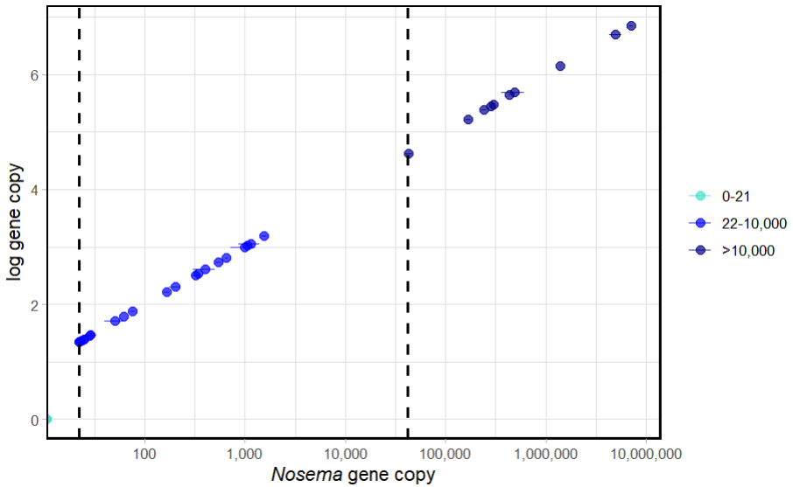
Figure A1: Distribution of Nosema gene copy number within individual hives. This plot displays the differences between different copy levels. The dashed lines demonstrate the lowest data point at a specific copy level; the first being the low-mid copy level, 22-10,000 and the second being the high copy level, >10,000. Horizontal lines in data points show standard error, as this is an average gene copy obtained from two replicates.
Table A4. Results of the generalised additive model used to assess the factors effect on log N. ceranae gene copy number. This displays the non-significant variables and the conditions that these factors were analysed under.
Factor | Result | Conditions
Seasonality | (edf = 0.70, F = 0.10, p > 0.1) | Smooth term
Latitude | (edf = 1.00, F = 1.38, p > 0.2) | Smooth term

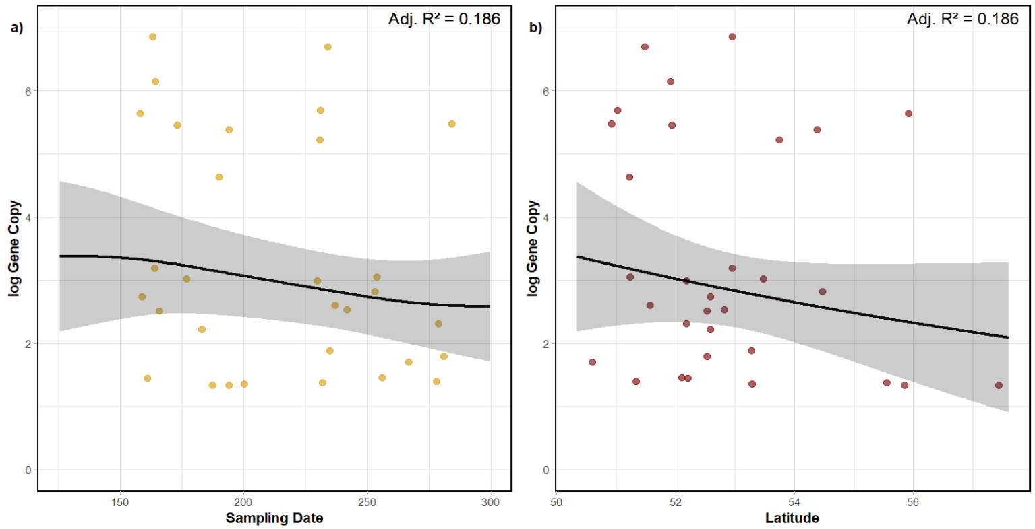
Figure A2. Scatter plots displaying the influence seasonality and latitude has on log₁₀ Nosema ceranae gene copy.
Table A5. Results of the generalised additive model used to assess the factors effect on the bacterial Shannon diversity index within the gut microbiome. This displays non-significant variables and the conditions that these factors were analysed.
Factors | Result | Conditions
Arable | (β = 0.01 ± 0.001, t = -2.19, p > 0.1). | None
Seasonality | (edf = 1.63, F = 0.20, p > 0.1) | Smooth term
Latitude | (edf = 1.00, F = 0.70, p > 0.4) | Smooth term

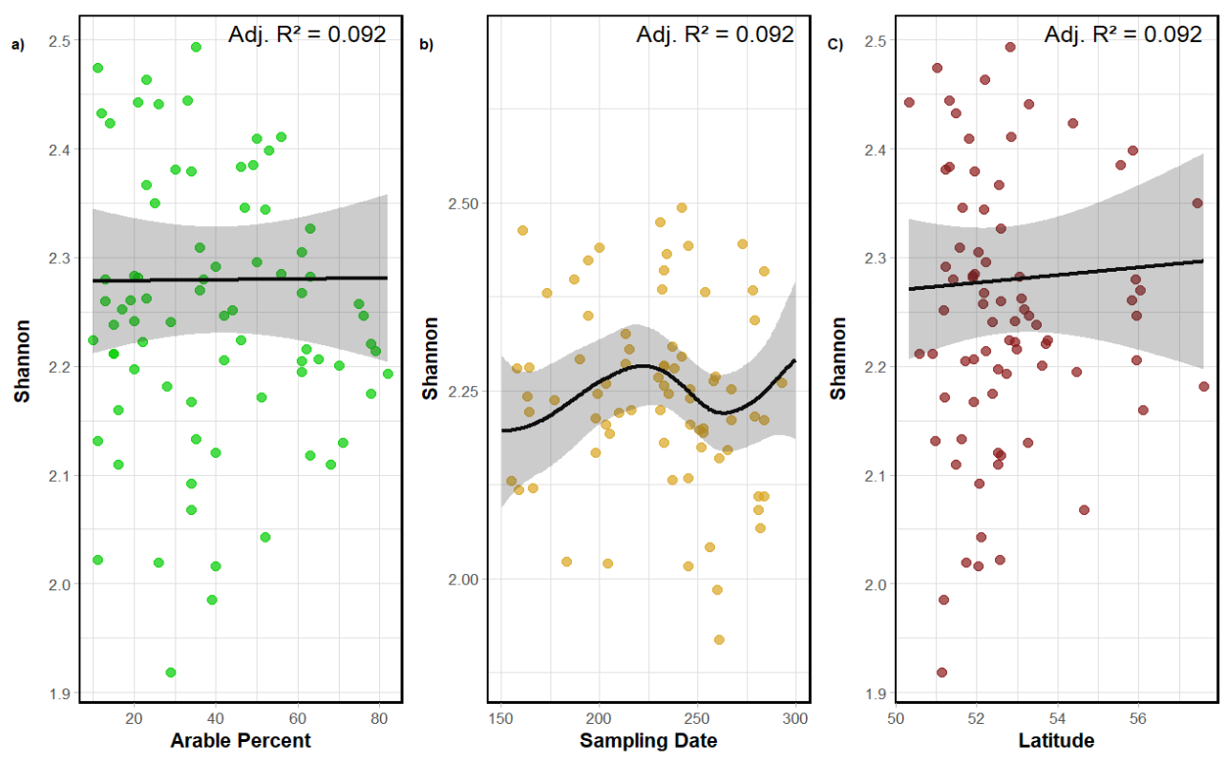

Figure A3. Scatter plots revealing the effects of abiotic factors on the Shannon diversity index within the gut microbiome of honeybees. Every plot displays the influence of each non-significant factor; a) Arable land cover. b) Seasonality. c) Latitude.
Table A6. Results of pairwise PERMANOVA that assessed the beta diversity between different copy levels of N. ceranae and months of sampling.

Level and Categories Tested | Results
0-21 vs 22-10,000 | F = 1.27, R² < 0.005, p > 0.05
0-21 vs >10,000 | F = 1.99, R² = 0.008, p < 0.05
22-10,000 vs >10,000 | F = 1.73, R² = 0.01, p < 0.05
July vs August | F = 4.01, R² = 0.03, p < 0.05
July vs September | F = 2.12, R² = 0.01, p = 0.06
July vs June | F = 2.35, R² = 0.02, p < 0.05
July vs October | F = 2.92, R² = 0.02, p < 0.05
August vs September | F = 1.92, R² = 0.01, p = 0.06
August vs June | F = 2.27, R² = 0.02, p < 0.05
August vs October | F = 1.54, R² = 0.01, p > 0.05
September vs June | F = 1.86, R² = 0.01, p = 0.06
September vs October | F = 1.26, R² = 0.01, p > 0.05
June vs October | F = 1.80, R² = 0.02, p = 0.06

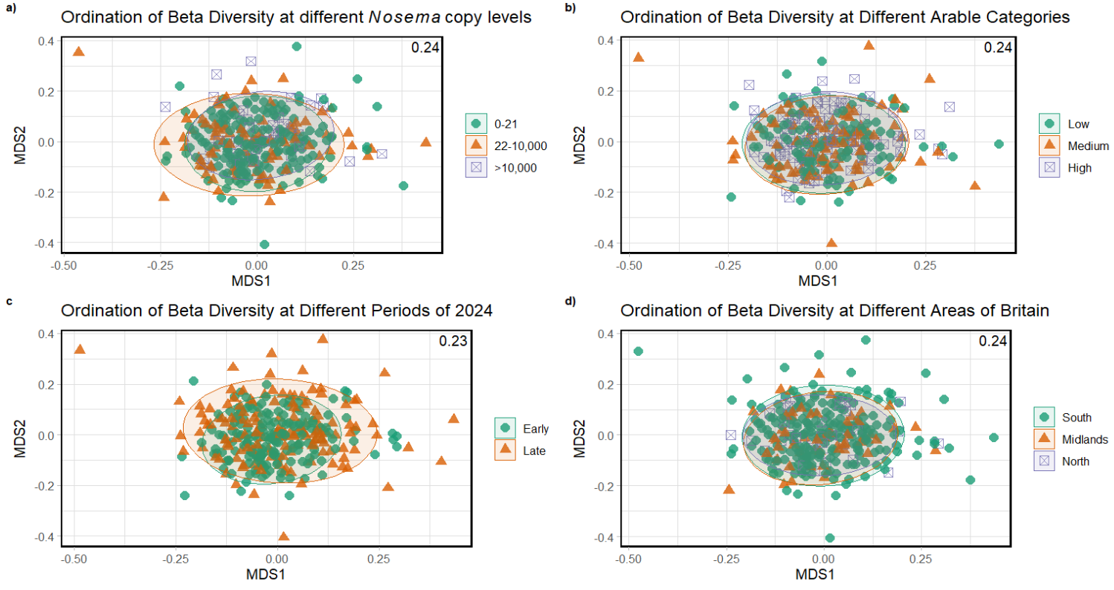
Figure A4. Ordination plots displaying patterns of beta diversity across environmental gradients and sampling factors. The ordination was derived from Non-Metric Multidimensional Scaling (NMDS) based on Bray–Curtis dissimilarity and displays the variation in community composition among samples. Points represent individual samples and are coloured and shaped according to grouping variables. Ellipses indicate 95% confidence intervals around group centroids. Panels show the ordinations based on a) Nosema copy number categories (0-21, 22–10,000, >10,000), b) arable land-use intensity c) season of sampling (Early = May-July and Late = August-October) d) geographic regions based on latitude.
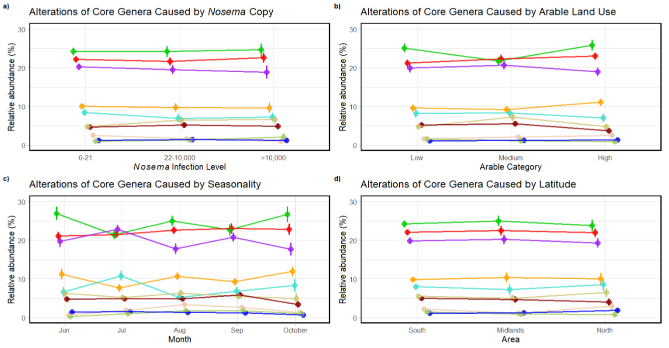

Figure A5. Line visualisation showing changes in relative abundance (%) of core microbiome genera, including Apibacter, and opportunistic taxa across copy levels and different environmental categories. Apibacter was included due to its comparable relative abundance to the lowest-abundance core genus, Bifidobacterium. Standard error is demonstrated by vertical lines at each data point. Each plot displays the influences of each variable. a) N. ceranae. b) Arable land cover. c) Seasonal variation (March and May removed for visualisation purposes as only one hive came from these months). d) Latitude.

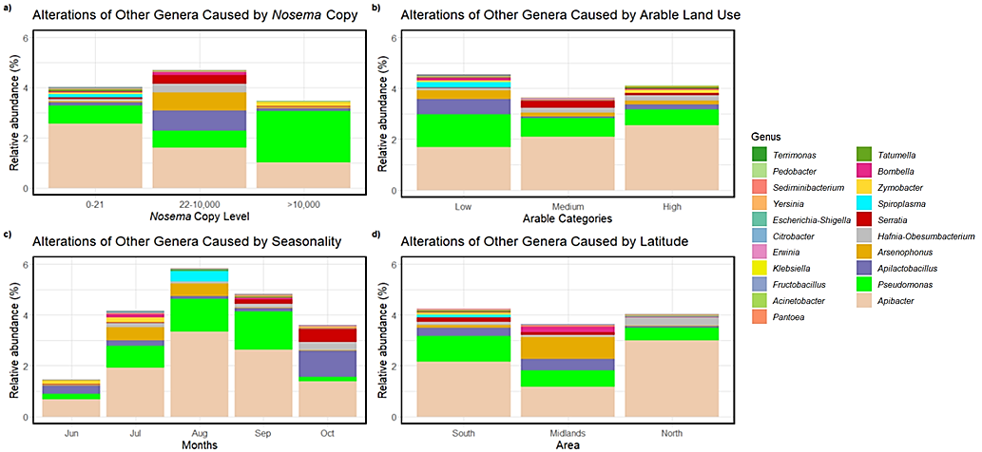

Figure A6. Bar plots demonstrating variations of relative abundances of gut microbiome genera, excluding core taxa, as impacted by different environmental factors. Dark grey bars within stacks represents bacterial groups that are not in the top 19 most detected genera in the gut microbiome, excluding core microbiome genera. The individual graphs represent the influence of each environmental variable; a) N. ceranae. b) Arable land cover. c) Seasonal variation (May was removed for visualisation purposes as only one hive came from these months). d) Latitude.

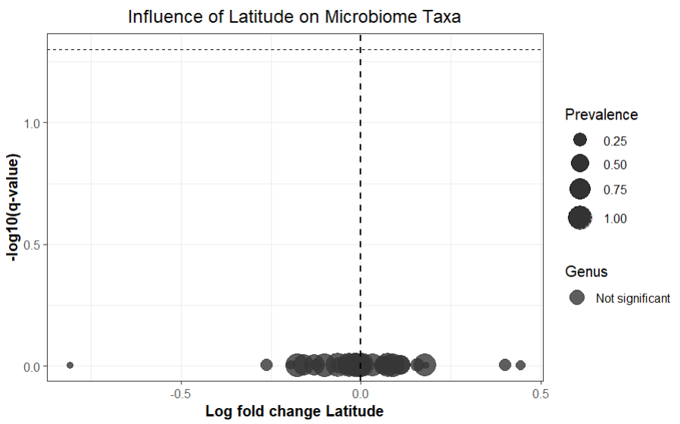
Figure A7. Volcano plot displaying differentially abundant bacterial ASVs and the influence of latitude on these variants through ANCOM-BC analysis. Each point represents an individual ASV, with point size being proportional to the prevalence of each ASV across hives.
Table A8. Results of the ANCOMBC analysis showing the association between bacterial ASV abundance and log₁₀ Nosema ceranae gene copy number. Taxa were assigned to the lowest available taxonomic rank, with a maximal classification at the genus level. Log fold change (lfc) values indicate the direction and magnitude of the relationship between ASV abundance and log₁₀ Nosema gene copy number. q-values represent Benjamini-Hochberg adjusted p-values, with lower values indicating stronger statistical support for differential abundance.

ASV | Taxa | lfc Log₁₀_Nosema_number | q value Log₁₀_Nosema_number
ASV1 | Gilliamella sp. | 0.00063 | 0.987992
ASV10 | Bombilactobacillus sp. | 0.007303 | 0.987992
ASV11 | Commensalibacter sp. | 0.045298 | 0.874165
ASV12 | Apibacter sp. | -0.17359 | 0.171556
ASV13 | Snodgrassella sp. | -0.00332 | 0.987992
ASV14 | Commensalibacter sp. | 0.097322 | 0.567257
ASV15 | Frischella perrara | 0.074376 | 0.731544
ASV16 | Bombilactobacillus sp. | -0.07672 | 0.731544
ASV17 | Bombilactobacillus sp. | -0.03652 | 0.874165
ASV18 | Bifidobacterium asteroids | 0.021296 | 0.987992
ASV19 | Snodgrassella alvi | -0.01126 | 0.987992
ASV2 | Snodgrassella alvi | -0.0359 | 0.874165
ASV20 | Bartonella sp. | -0.04419 | 0.874165
ASV21 | Pseudomonas sp. | -0.07031 | 0.863154
ASV22 | Lactobacillus sp. | 0.06943 | 0.731544
ASV23 | Bombilactobacillus sp. | 0.063238 | 0.731544
ASV24 | Lactobacillus apis | -0.0202 | 0.987992
ASV25 | Apilactobacillus sp. | -0.00622 | 0.987992
ASV26 | Gilliamella sp. | -0.22501 | 0.063717
ASV28 | Arsenophonus sp. | 0.003195 | 0.987992
ASV29 | Commensalibacter sp. | -0.03153 | 0.874165
ASV3 | Lactobacillus kullabergensis | 0.057807 | 0.731544
ASV30 | Bombilactobacillus sp. | -0.00994 | 0.987992
ASV32 | Hafnia-Obesumbacterium alvei | -0.06584 | 0.731544
ASV33 | Serratia fonticola | 0.179015 | 0.063804
ASV34 | Bombilactobacillus sp. | 0.020776 | 0.987992
ASV4 | Bartonella apis | 0.003495 | 0.987992
ASV47 | Bombella sp. | 1.015925 | 0.001659
ASV5 | Lactobacillus apis | -0.03109 | 0.874165
ASV53 | Gilliamella apicola | 0.198086 | 0.092667
ASV57 | Bombilactobacillus sp. | 0.067415 | 0.731544
ASV6 | Lactobacillus melliventris | 0.03442 | 0.874165
ASV67 | Pantoea sp. | -0.69091 | 0.003486
ASV7 | Bombilactobacillus sp. | 0.016977 | 0.987992
ASV8 | Lactobacillus helsingborgensis | -0.00414 | 0.987992
ASV9 | Frischella perrara | 0.060154 | 0.863154

Table A9. Results of the ANCOM-BC analysis showing the association between bacterial ASV abundance and season (early and late). Taxa were assigned to the lowest available taxonomic rank, with a maximal classification at the genus level. Log fold change (lfc) values indicate the direction and magnitude of the relationship between ASV abundance and season. q-values represent Benjamini-Hochberg adjusted p-values, with lower values indicating stronger statistical support for differential abundance.

ASV | Taxa | Lfc Season | q value Season
ASV1 | Gilliamella sp. | 0.06526 | 0.86864
ASV10 | Bombilactobacillus sp. | -0.22633 | 0.659089
ASV11 | Commensalibacter sp. | -0.19068 | 0.7659
ASV12 | Apibacter sp. | -0.09243 | 0.926669
ASV13 | Snodgrassella sp. | -0.18996 | 0.659089
ASV14 | Commensalibacter sp. | -0.56387 | 0.311954
ASV15 | Frischella perrara | 0.254535 | 0.659089
ASV16 | Bombilactobacillus sp. | 0.150388 | 0.780732
ASV17 | Bombilactobacillus sp. | 0.25086 | 0.612552
ASV18 | Bifidobacterium asteroides | -0.16381 | 0.659089
ASV19 | Snodgrassella alvi | 0.311341 | 0.640146
ASV2 | Snodgrassella alvi | -0.2949 | 0.434234
ASV20 | Bartonella sp. | 0.437326 | 0.460218
ASV21 | Pseudomonas sp. | -0.80093 | 0.206905
ASV22 | Lactobacillus sp. | -0.03044 | 0.949816
ASV23 | Bombilactobacillus sp. | 0.308769 | 0.640146
ASV24 | Lactobacillus apis | 0.380333 | 0.514123
ASV25 | Apilactobacillus sp. | -0.67098 | 0.311954
ASV26 | Gilliamella sp. | 2.032298 | 0.042248
ASV28 | Arsenophonus sp. | 1.394579 | 0.045551
ASV29 | Commensalibacter sp. | -0.86023 | 0.169761
ASV3 | Lactobacillus kullabergensis | 0.02021 | 0.949816
ASV30 | Bombilactobacillus sp. | -0.04576 | 0.949816
ASV32 | Hafnia-Obesumbacterium alvei | -0.44506 | 0.51754
ASV33 | Serratia fonticola | 1.226831 | 0.045551
ASV34 | Bombilactobacillus sp. | -0.06905 | 0.939396
ASV4 | Bartonella apis | -0.61468 | 0.311954
ASV47 | Bombella sp. | -0.79336 | 0.311954
ASV5 | Lactobacillus apis | 0.012417 | 0.952138
ASV53 | Gilliamella apicola | -0.55035 | 0.460218
ASV57 | Bombilactobacillus sp. | 1.047702 | 0.184719
ASV6 | Lactobacillus melliventris | -0.12217 | 0.768245
ASV67 | Pantoea sp. | -2.03945 | 0.045551
ASV7 | Bombilactobacillus sp. | 0.255214 | 0.640146
ASV8 | Lactobacillus helsingborgensis | -0.26477 | 0.640146
ASV9 | Frischella perrara | -0.16946 | 0.767864

Table A10. Results of the ANCOM-BC analysis showing the association between bacterial ASV abundance and arable land use percentage. Taxa were assigned to the lowest available taxonomic rank, with a maximal classification at the genus level. Log fold change (lfc) values indicate the direction and magnitude of the relationship between ASV abundance and arable land use percentage. q-values represent Benjamini-Hochberg adjusted p-values, with lower values indicating stronger statistical support for differential abundance.
ASV | Taxa | lfc Arable percent | q value Arable percent
ASV1 | Gilliamella sp. | -0.0011 | 0.943806
ASV10 | Bombilactobacillus sp. | -0.00224 | 0.943806
ASV11 | Commensalibacter sp. | 0.001692 | 0.943806
ASV12 | Apibacter sp. | -0.02494 | 0.019941
ASV13 | Snodgrassella sp. | 0.003963 | 0.876155
ASV14 | Commensalibacter sp. | -0.01816 | 0.040228
ASV15 | Frischella perrara | -0.00138 | 0.943806
ASV16 | Bombilactobacillus sp. | -0.01204 | 0.097431
ASV17 | Bombilactobacillus sp. | -0.00172 | 0.943806
ASV18 | Bifidobacterium asteroids | 0.005936 | 0.522977
ASV19 | Snodgrassella alvi | -0.00262 | 0.943806
ASV2 | Snodgrassella alvi | -0.00367 | 0.839573
ASV20 | Bartonella sp. | -0.01598 | 0.071527
ASV21 | Pseudomonas sp. | -0.03502 | 0.000793
ASV22 | Lactobacillus sp. | 0.000625 | 0.962661
ASV23 | Bombilactobacillus sp. | 0.015044 | 0.078031
ASV24 | Lactobacillus apis | 0.002952 | 0.932217
ASV25 | Apilactobacillus sp. | -0.03137 | 0.001256
ASV26 | Gilliamella sp. | 0.029048 | 0.008862
ASV28 | Arsenophonus sp. | -0.01032 | 0.250262
ASV29 | Commensalibacter sp. | -0.01009 | 0.151342
ASV3 | Lactobacillus kullabergensis | -0.00084 | 0.962661
ASV30 | Bombilactobacillus sp. | -0.00018 | 0.971077
ASV32 | Hafnia-Obesumbacterium alvei | 0.002133 | 0.943806
ASV33 | Serratia fonticola | 0.004141 | 0.839573
ASV34 | Bombilactobacillus sp. | -0.00861 | 0.299174
ASV4 | Bartonella apis | -0.00322 | 0.943806
ASV47 | Bombella sp. | -0.03482 | 0.019941
ASV5 | Lactobacillus apis | -0.00459 | 0.817945
ASV53 | Gilliamella apicola | 0.002785 | 0.932217
ASV57 | Bombilactobacillus sp. | 0.013061 | 0.111944
ASV6 | Lactobacillus melliventris | -0.00034 | 0.971077
ASV67 | Pantoea sp. | 0.015943 | 0.097431
ASV7 | Bombilactobacillus sp. | 0.004482 | 0.876155
ASV8 | Lactobacillus helsingborgensis | -0.00084 | 0.962661
ASV9 | Frischella perrara | 0.002061 | 0.943806

Table A11. Results of the ANCOM-BC analysis showing the association between bacterial ASV abundance and latitude. Taxa were assigned to the lowest available taxonomic rank, with a maximal classification at the genus level. Log fold change (lfc) values indicate the direction and magnitude of the relationship between ASV abundance and latitude. q-values represent Benjamini-Hochberg adjusted p-values, with lower values indicating stronger statistical support for differential abundance.
ASV | Taxa | lfc Latitude | q value Latitude
ASV1 | Gilliamella sp. | -0.01082 | 0.992989275
ASV10 | Bombilactobacillus sp. | -0.03348 | 0.992989275
ASV11 | Commensalibacter sp. | -0.17824 | 0.992989275
ASV12 | Apibacter sp. | -0.00422 | 0.992989275
ASV13 | Snodgrassella sp. | -0.00211 | 0.992989275
ASV14 | Commensalibacter sp. | -0.15741 | 0.992989275
ASV15 | Frischella perrara | 0.111422 | 0.992989275
ASV16 | Bombilactobacillus sp. | 0.08276 | 0.992989275
ASV17 | Bombilactobacillus sp. | -0.00215 | 0.992989275
ASV18 | Bifidobacterium asteroides | 0.08692 | 0.992989275
ASV19 | Snodgrassella alvi | 0.059792 | 0.992989275
ASV2 | Snodgrassella alvi | -0.06315 | 0.992989275
ASV20 | Bartonella sp. | -0.12975 | 0.992989275
ASV21 | Pseudomonas sp. | -0.02013 | 0.992989275
ASV22 | Lactobacillus sp. | 0.113397 | 0.992989275
ASV23 | Bombilactobacillus sp. | -0.06134 | 0.992989275
ASV24 | Lactobacillus apis | 0.061658 | 0.992989275
ASV25 | Apilactobacillus sp. | -0.04459 | 0.992989275
ASV26 | Gilliamella sp. | 0.443567 | 0.992989275
ASV28 | Arsenophonus sp. | 0.40202 | 0.992989275
ASV29 | Commensalibacter sp. | 0.15793 | 0.992989275
ASV3 | Lactobacillus kullabergensis | 0.003809 | 0.992989275
ASV30 | Bombilactobacillus sp. | -0.03447 | 0.992989275
ASV32 | Hafnia-Obesumbacterium alvei | -0.26056 | 0.992989275
ASV33 | Serratia fonticola | -0.12357 | 0.992989275
ASV34 | Bombilactobacillus sp. | -0.02829 | 0.992989275
ASV4 | Bartonella apis | 0.032802 | 0.992989275
ASV47 | Bombella sp. | 0.181546 | 0.992989275
ASV5 | Lactobacillus apis | -0.0172 | 0.992989275
ASV53 | Gilliamella apicola | -0.19375 | 0.992989275
ASV57 | Bombilactobacillus sp. | 0.086939 | 0.992989275
ASV6 | Lactobacillus melliventris | 0.074301 | 0.992989275
ASV67 | Pantoea sp. | -0.80947 | 0.992989275
ASV7 | Bombilactobacillus sp. | -0.10089 | 0.992989275
ASV8 | Lactobacillus helsingborgensis | -0.03183 | 0.992989275
ASV9 | Frischella perrara | 0.178736 | 0.992989275

