Supplementary Information
- Survey data
Figure S1 below shows the sample sizes of different LISS PreFer datasets and subgroups, and which data was available to PreFer participants. Note that 64 people in the target group (LISS members aged 18-45 in 2020 who participated in at least one Core survey in 2007-2020) were not included in any dataset. These are people from the households assigned to the holdout set but for whom the outcome was not available.
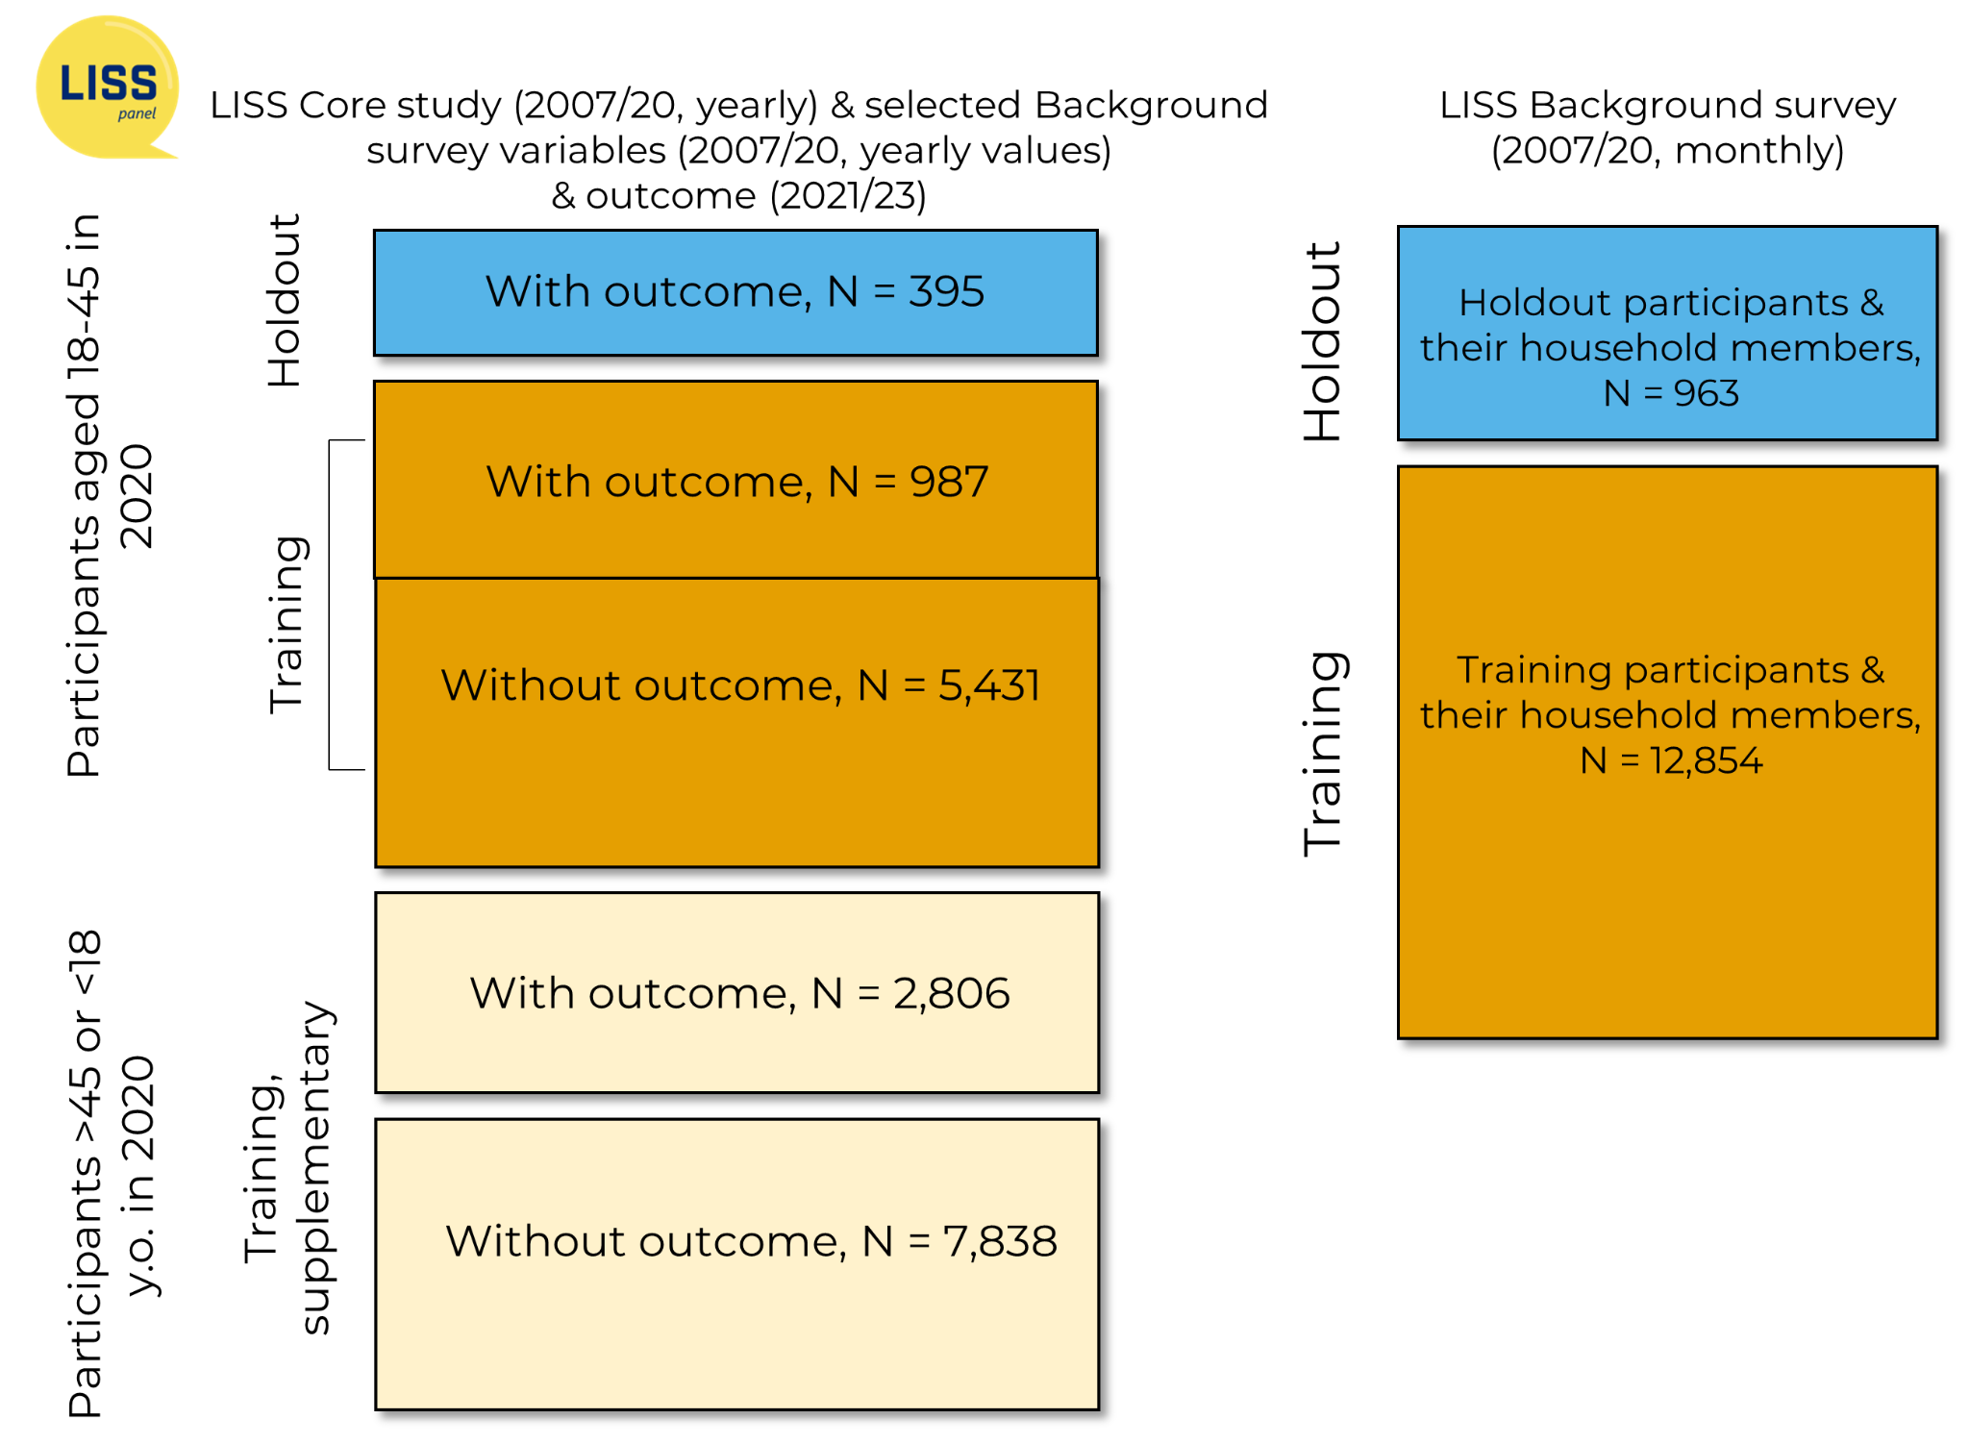
Figure S1. LISS data used in PreFer. Training and supplementary training datasets (brown and yellow) with the outcome were available for the data challenge participants. Holdout sets (blue) were available only for the organisers for the evaluation.
Table S1 LISS panel studies that are included in the merged dataset.
Name | Description | DOI
Background variables | Socio-demographic variables at the household level and individual level. Filled in by a contact person about all the household members when the household joins the panel and updated monthly. Includes age, gender, position within household, civil status, type of housing, urbanity, occupation, income. | https://doi.org/10.57990/qn3k-as78
Core Study modules:
Health | Physical and mental health self-assessments and medication use, lifestyle habits. | https://doi.org/10.17026/dans-ze3-5uk9
Religion and Ethnicity | Religious upbringing, religious affiliation, religiosity, religious orthodoxy. Nationality, origin, ethnic identification, language proficiency and use. | https://doi.org/10.17026/dans-xkw-t8dm
Social Integration and Leisure | Social contacts, core discussion network, loneliness. Leisure activities, voluntary work and informal care, social media usage. | https://doi.org/10.17026/dans-zaf-casa
Family and Household | Family structure, social support from family, parenting and children, domestic responsibilities, child education and childcare. | https://doi.org/10.17026/dans-xkd-5hp5
Work and Schooling | Employment status and history, job satisfaction and conditions. Education, qualifications, and training. | https://doi.org/10.17026/dans-x26-tttv
Personality | Subjective well-being, personality traits. | https://doi.org/10.17026/dans-x5h-4cxd
Politics and Values | Political engagement, affiliation, and attitudes. Values and social attitudes. | https://doi.org/10.17026/dans-zms-r5rz
Economic Situation: Assets | Different kinds of assets, loans and debts. | https://doi.org/10.17026/dans-z2r-n69z
Economic Situation: Income | Different sources of income, subjective standard of living. | https://doi.org/10.17026/dans-24y-dkqk
Economic Situation: Housing | Housing characteristics, expenditures, satisfaction with housing. | https://doi.org/10.17026/dans-zgv-9qky

- Register data
CBS datasets
Figure S2 below shows the sample sizes of different CBS PreFer datasets and subgroups, and which data was available to PreFer participants. Brief descriptions of the datasets used in PreFer are provided in Table S2.
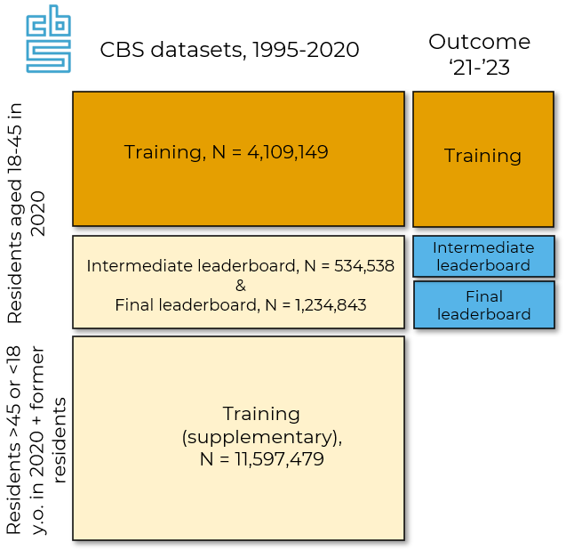
Figure S2. Register data used in PreFer. The data challenge participants could use data up to 2020 about people in the training set (brown), and in the holdout sets and supplementary training set (yellow). The outcome for people in the holdout (blue) and supplementary groups was not available for the challenge participants.
Table S2 The list of datasets based on the Dutch registers available to the participants of the data challenge.
Name of the dataset | Description | DOI
Gbapersoontab [CBS] | Personal characteristics of people in the population register [48]: age, gender, migration status of individuals and their parents. Coverage: from 1994 | https://doi.org/10.57934/0b01e4108071ba40
Gbaburgerlijkestaatbus [CBS] | Past and current civil status of persons included in the population register (single, married, registered partnership, divorced, etc.), with start date and end date of each status. Coverage: from 1995 | https://doi.org/10.57934/0b01e410803b37e0
Gbaverbintenispartnerbus [CBS] | Partner's IDs to link partner's characteristics | https://doi.org/10.57934/0b01e410801f93bf
Gbamigratiegebeurtenisbus [CBS] | Migration dates. Coverage: from 1995 | https://doi.org/10.57934/0b01e4108021261a
Gbahuishoudensbus [CBS] | Household identifiers, composition, and start/end dates (due to member additions/removals, address changes). Coverage: from 1995 | https://doi.org/10.57934/0b01e410802125bb
Hoogsteopltab [CBS] | Highest achieved (meaning: with a diploma) and followed (meaning: without a diploma) level of education. Coverage: from 1999 | https://doi.org/10.57934/0b01e410801fd716
Inpatab [CBS] | Personal income. Coverage: from 2011 | https://doi.org/10.57934/0b01e41080372fbd
Inhatab [CBS] | Household income. Coverage: from 2011 | https://doi.org/10.57934/0b01e41080371196
Vehtab [CBS] | Household wealth. Coverage: from 2006 | https://doi.org/10.57934/0b01e4108037363f
Spolisbus [CBS] | Employment (excluding self-employed) and characteristics of jobs. Coverage: from 2010 | https://doi.org/10.57934/0b01e410804cb681
Secmbus [CBS] | Personal socio-economic category (employed, self-employed, studying, etc.). Coverage: from 1999 | https://doi.org/10.57934/0b01e410803432a6
Nabijheidkindopvtab [CBS] | Proximity to childcare (from objects, e.g. living places). Coverage: from 2012 | https://doi.org/10.57934/0b01e41080238887
Gbaadresobjectbus [CBS] | Past and current addresses of people registered in the Netherlands: address ID, date of registration at this address, and end date of address (when a person moved out or died). Coverage: from 1994 | https://doi.org/10.57934/0b01e410802154d6
Vbowoningtypetab [CBS] | Type of housing. Coverage: from 2020 | https://doi.org/10.57934/0b01e4108053c864
Vslgwbtab [CBS] | Municipality and neighbourhood codes of residence objects to link external data about municipalities and neighbourhoods. Coverage: from 1995 | https://doi.org/10.57934/0b01e41080236a82
Networks:
Burennetwerktab [CBS] | Neighbours network. Coverage: from  2009 | https://doi.org/10.57934/0b01e410807607b7
Colleganetwerktab [CBS] | Colleagues network. Coverage: from 2009 | https://doi.org/10.57934/0b01e410807607b1
Familienetwerktab [CBS] | Family network. Coverage: from 2009 | https://doi.org/10.57934/0b01e41080760802
Huisgenotennetwerktab [CBS] | Household network. Coverage: from 2009 | https://doi.org/10.57934/0b01e4108076077c
Klasgenotennetwerktab [CBS] | Classmates network. Coverage: from 2009 | https://doi.org/10.57934/0b01e4108075f996
External data: results of the Dutch elections | Results of the Dutch general elections (2017), provincial elections (2019), and municipal elections (2020) by municipality – public data imported into CBS secure access environment. | DOI not available
External data: StatLine data on municipalities | The database of Statistics Netherlands that contains public statistical data on the Dutch economy and society. | DOI not available

Deriving the target population for the register data
The target population was defined by selecting all individuals aged 18-45 at the end of 2020 (born between January 1, 1975, and December 31, 2002) who were registered at a residential address in the Netherlands on December 31, 2020 (initially, N = 6,092,379). We then excluded 213,849 individuals (3.5%) who were no longer residents at the end of 2023, as their fertility outcomes for the 2021–2023 period could not be reliably determined. Temporary moves abroad did not lead to exclusion if individuals were again registered at the end of 2023, since births abroad are added to the register upon re-entry.

PreFer Base dataset
PreFer Base dataset includes variables mostly from 2020 about individuals, their parents, and their married or registered partners. Most variables were selected from the CBS datasets, based on research on fertility determinants, and covered topics such as demographics, partnerships, education and employment, personal and household income, assets, household characteristics, and neighbourhood characteristics. We also constructed several variables, including total number of children, age of the youngest child, total number of marriages and partnerships, and characteristics of jobs (all at the end of 2020). For individuals with a partner, we also included an anonymised identification number to enable linking with additional partner-related data. We prepared this Base dataset for people in the target population and for 2020 Dutch residents outside of the target population.
- Submission
In the first phase (survey data), submissions took the form of a GitHub repository containing the model, preprocessing and prediction code, and a Dockerfile. Participants used a template GitHub repository to prepare these scripts; https://github.com/eyra/fertility-prediction-challenge, a copy of which is archived in the replication package at Dataverse. We also prepared guides to make this process easier https://preferdatachallenge.nl/posts/. Submissions were made via the Next platform http://next.eyra.co/.
- Details on reproducibility
Survey submissions
Because of the larger number of submissions, we included the details about the survey submissions in Additional file 1. It contains the details about the model and data preprocessing, reproducibility results, description of fixes we made to make models run, and the likely causes of a discrepancy in scores (original and reproduced).
Register submissions
Analysed submissions were mostly reproducible. The winning submission reproduced without any changes and produced scores (both from the saved model and from the retrained model) that matched the original scores. Another one required no code changes and reproduced with a practically identical score (the 0.01 difference in F1 may stem from the different train–test split). Four submissions used the netcbs package to construct network features and required minor code changes because the package has been updated since the challenge and the earlier version used at the time cannot be installed through the standard CBS procedure for the remote-access environment. Their scores stayed identical or close to the original (differences from 0.01 to 0.03), despite the different split. One of these submissions also required reconstructing a file of municipality characteristics downloaded from StatLine (the database of Statistics Netherlands that contains public statistical data on the Dutch economy and society).
Another submission contained an error in producing colleagues' network features that we fixed before the reproducibility study; that caused the score to change slightly (0.01), but reproducing this submission did not require any additional fixes (except updating paths to the raw CBS datasets because CBS changed dataset versions in the file names). The remaining submission required no changes but reproduced with a very different score (higher than the original). Since the environment was the same, the likely cause is that the original model was produced with different code. This submission is among those affected by the split change, but the corrected split keeps partners together and removes a potential source of leakage, which would lower rather than raise the score, so the split does not explain the gap.

Table S3. Description, scores, and reproducibility results for each register-based submission. F1 (O) means the original F1 score (submitted predictions evaluated); F1 (R) is the reproduced F1 score.
Team | Model | Feature selection | Details | F1 (O) | F1 (R) | Fixes made
Stork Oracle | CatBoost | theory-driven | Features: selection from the PreFer Base file, supplemented by family network data and data about cohabiting partners, including partners who are not married or registered. Decision threshold tuned to maximise F1 [49]. | 0.59 | 0.59 | No fixes made
Cruijff | Fine-tuned LLM | NA | An open-weight LLM fine-tuned on "books of life"(natural-language life histories constructed from the tabular register data) and the predicted probability from a gradient-boosted decision tree trained on the PreFer Base dataset. Decision threshold tuned to maximise F1 [25, 26]. | 0.57 | NA | Not assessed (requires ODISSEI supercomputer)
SBU EUI | foundation model | NA | A transformer-based foundation model pre-trained from scratch on a large number of life sequences and fine-tuned for fertility prediction [24]. | 0.57 | NA | Not assessed (requires ODISSEI supercomputer)
teamSGBD | LightGBM | data-driven | Features: the PreFer Base file plus income trends, educational changes, municipality-level election data, and network variables. Several hundred additional variables were constructed that captured the same information as in the PreFer Base file, but for 3 personal networks (neighbour, family, colleagues). Decision threshold tuned to maximise F1 [29]. | 0.56 | 0.57 | Error fixed in creating colleagues networks files; CBS datasets paths updated
ConceptionCoders | Voting ensemble | theory-driven | Variables: selection from from the PreFer Base file and several additional variables, such as longitudinal income, municipality-level election data, and family network features (number of siblings, parents, and children of siblings). Oversampling of the minority class (those who had a child in 2021-2023) to match the majority class size. | 0.55 | 0.55 | Code adjusted for the newer netcbs package
DEPLearning | XGBoost | theory-driven | Variables: selection from the PreFer Base file plus municipality-level election data, municipality-level statistics, network features – number of siblings, siblings’ children under 3 years old, and their total number of children, colleagues’ children under 3 years old. Oversampling of the minority class (those who had a child in 2021-2023) to match the majority class size. | 0.54 | 0.52 | Code adjusted for the newer netcbs package. File with municipality-level statistics from StatLine reconstructed
JustThe2OfUs | Random forest | theory-driven | Variables: selection from the PreFer Base file plus municipality-level election data; network features – number of children of siblings under 4/12/18 years, sibling count, parental age at first birth. Class imbalance is handled via ‘class_weight’ parameter in the random forest. | 0.54 | 0.52 | Code adjusted for the newer netcbs package
Cruijff & Stork Oracle | Fine-tuned LLM | NA | Predicted probabilities generated by the Stork Oracle’s model are added to the textual "books of life" (see the Cruijff model above). | 0.50 | NA | Not assessed (requires ODISSEI supercomputer)
data storks | Random forest | theory-driven | Selection from the PreFer Base file plus municipal-level elections data. Oversampling the positive class to handle class imbalance. | 0.19 | 0.47 | No fixes made
PhDecline | Gradient boosting classifier | theory-driven | Variables: selection from the PreFer Base file | 0.43 | 0.44 | No fixes made
Code babies | Penalised logistic regression | theory-driven | Variables: selection from the PreFer Base file and network features – N of children under 3 years old and under 12 years old present among persons' siblings, colleagues, colleagues of siblings, siblings of colleagues. | 0.35 | 0.38 | Code adjusted for the newer netcbs package

