Supporting information
Design and synthesis of novel pyrazolopyrimidine-based derivatives as reversible BTK inhibitors with potent antiproliferative activity in mantle cell lymphoma
Fansheng Ran^{a,b}, Yang Liu^{b}, Guisen Zhao^{b,*}
ª School of Pharmacy and Jiangsu Province Key Laboratory for Inflammation and Molecular Drug Target, Nantong University, Nantong 226001, China.
^{b} Department of Medicinal Chemistry, Key Laboratory of Chemical Biology (Ministry of Education), School of Pharmaceutical Sciences, Shandong University, Jinan, Shandong 250012, PR China

¹H NMR, ¹³C NMR and HRMS spectra for target compounds
Compound 13a
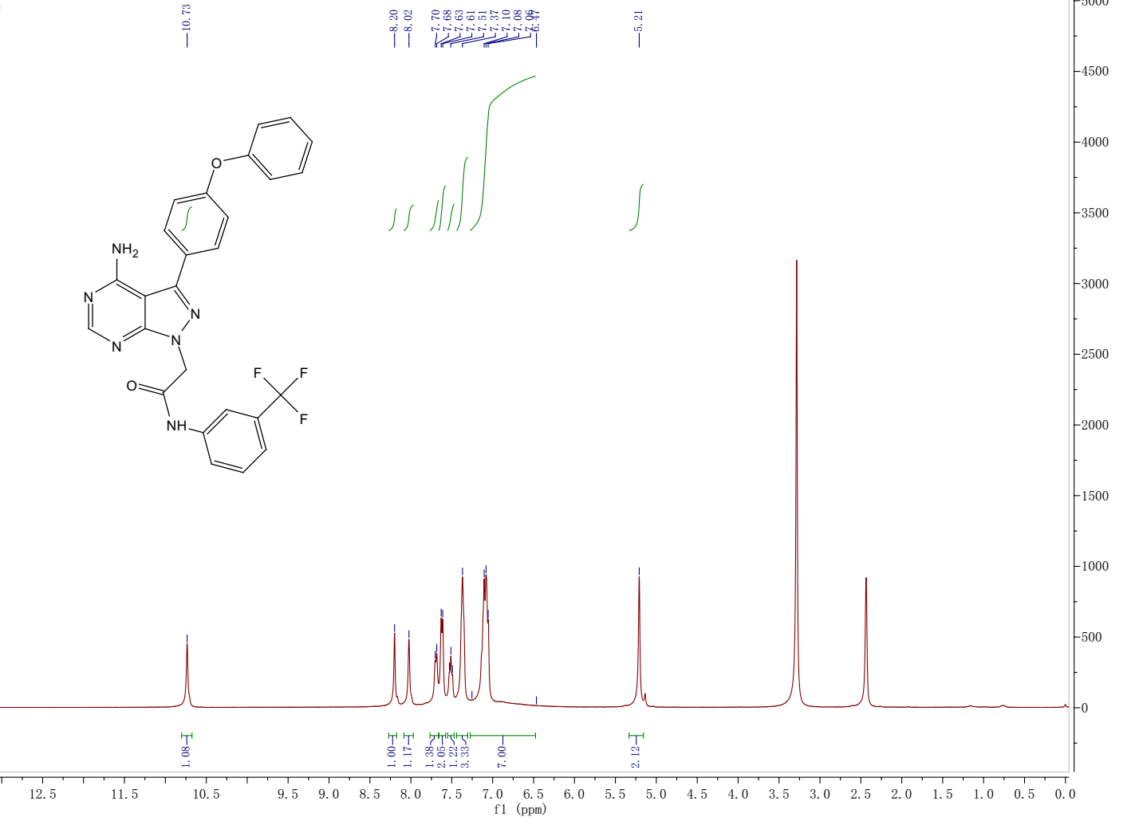
¹H NMR spectrum of the target compound 13a
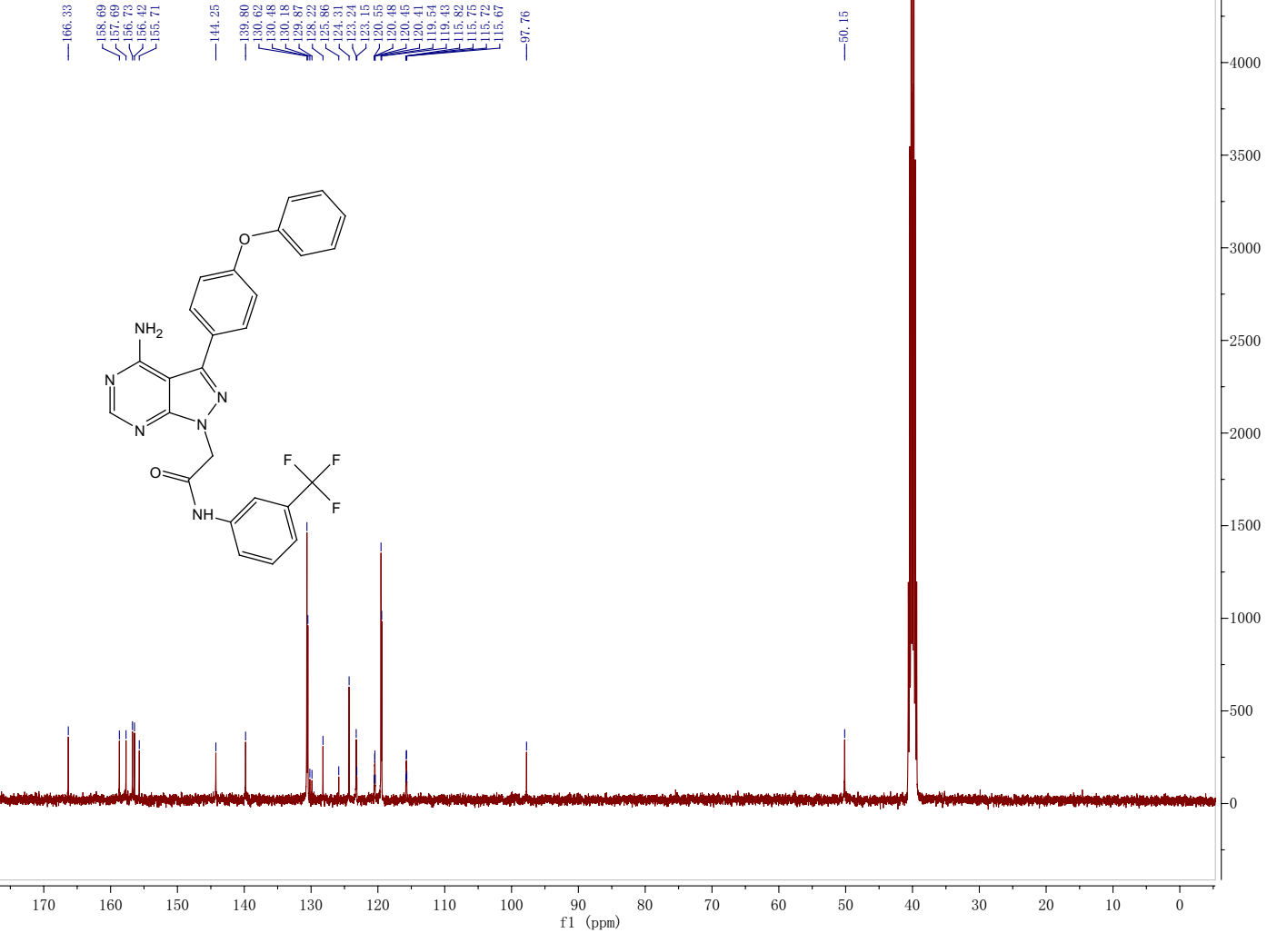
¹³C NMR spectrum of the target compound 13a
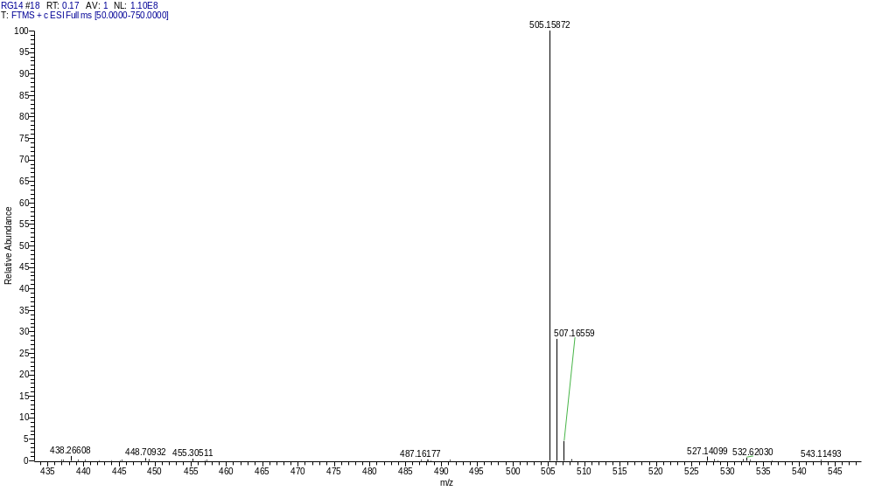
HRMS of the target compound 13a

Compound 13b
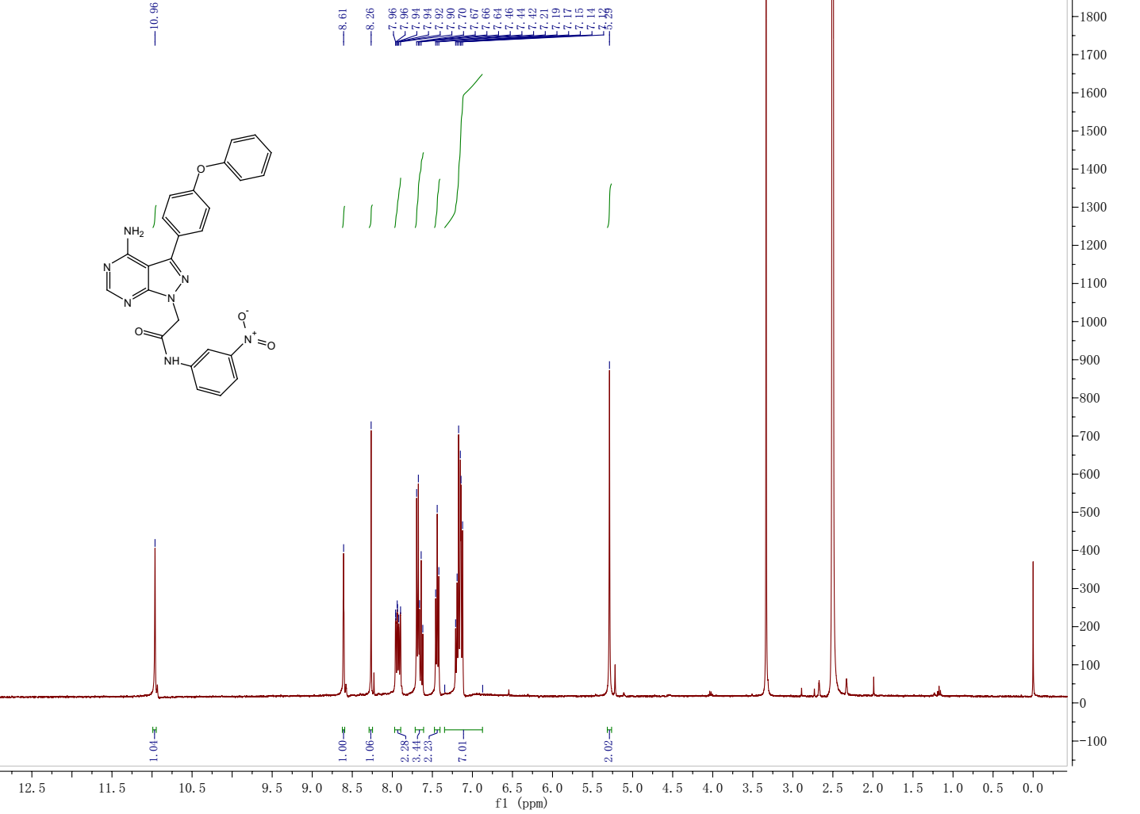
¹H NMR spectrum of the target compound 13b
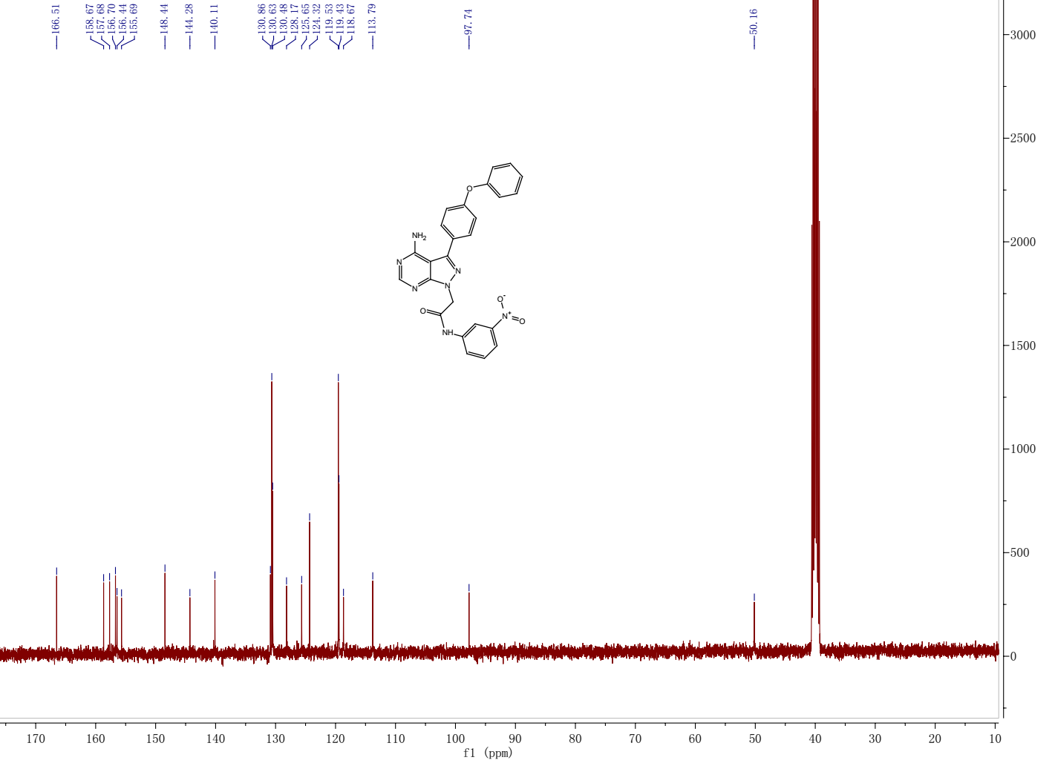
¹³C NMR spectrum of the target compound 13b

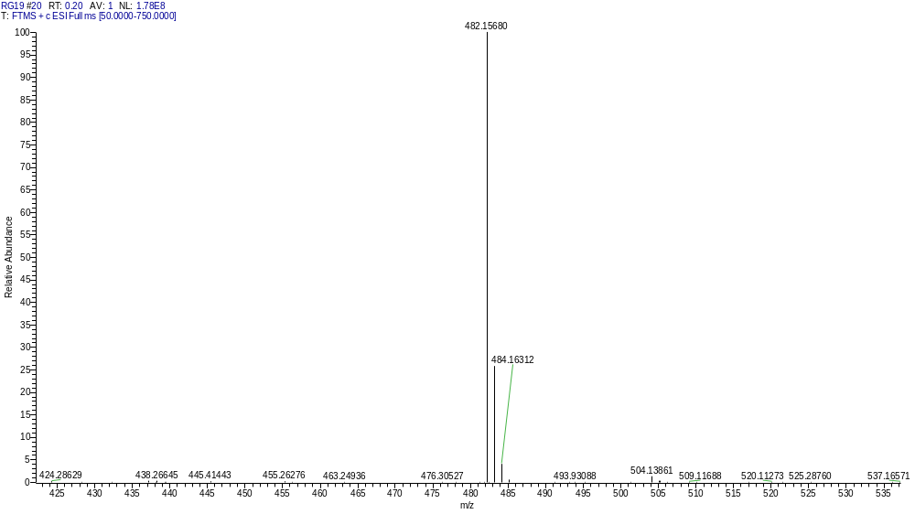
HRMS of the target compound 13b

Compound 13c
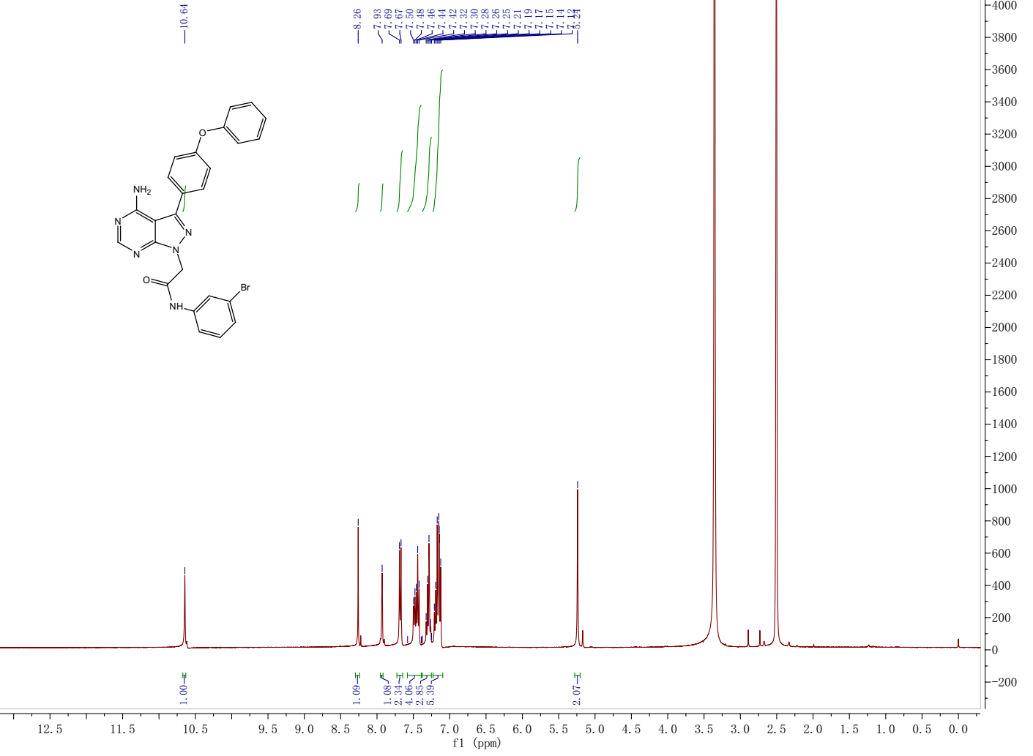
¹H NMR spectrum of the target compound 13c
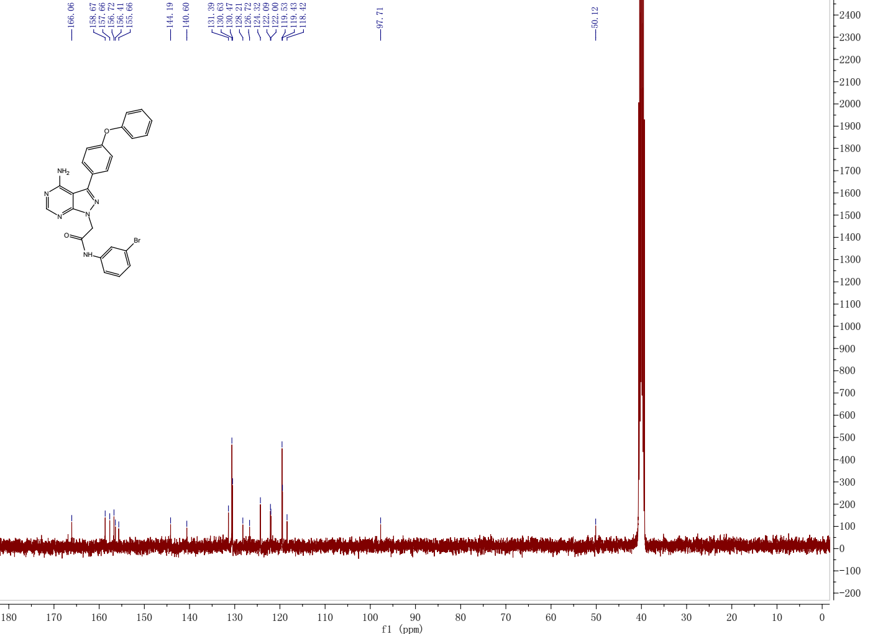
¹³C NMR spectrum of the target compound 13c

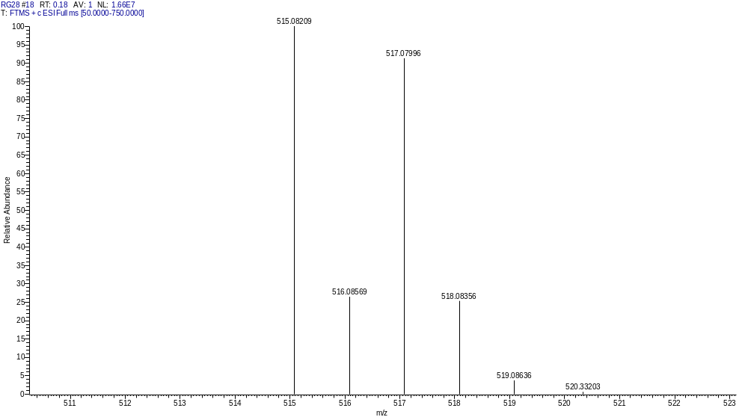
HRMS of the target compound 13c

Compound 13d
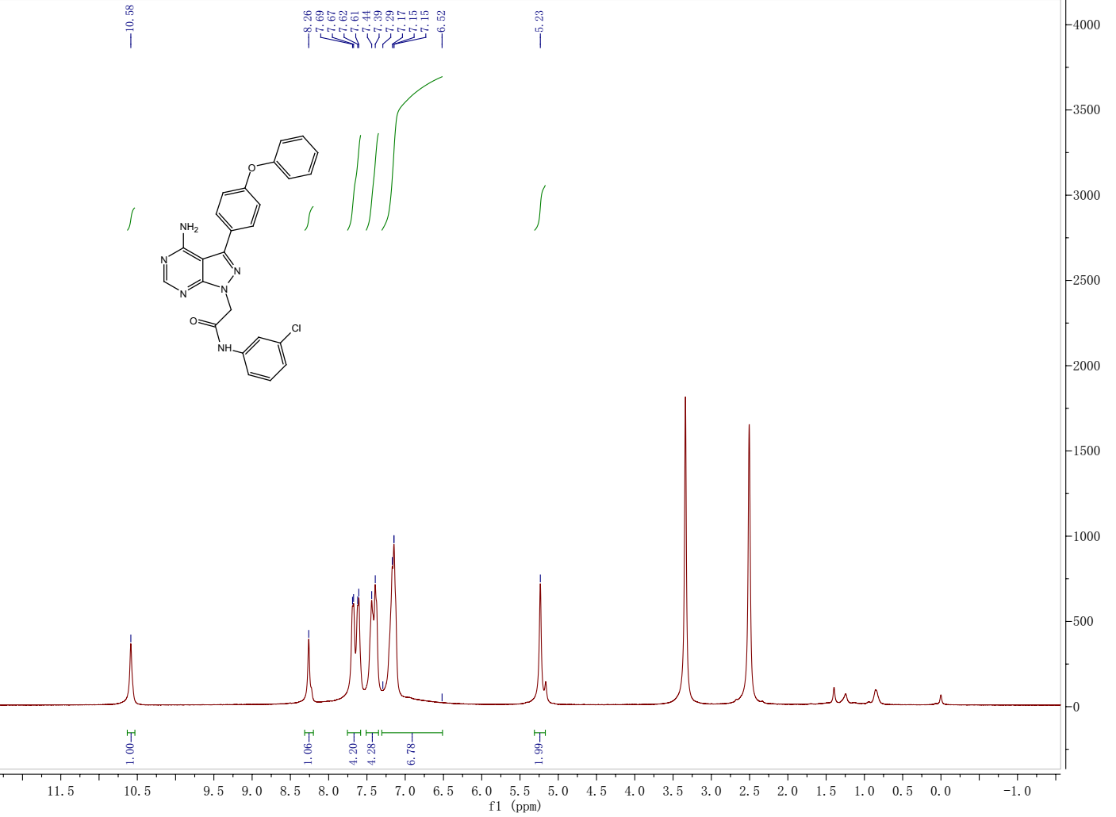
¹H NMR spectrum of the target compound 13d
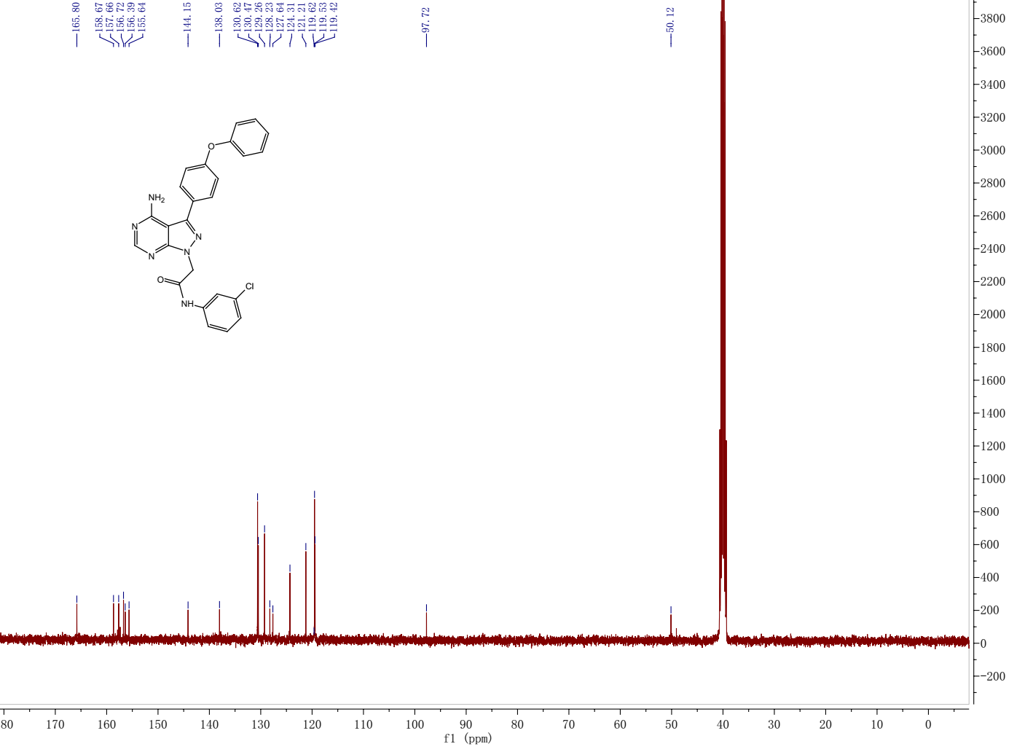
¹³C NMR spectrum of the target compound 13d

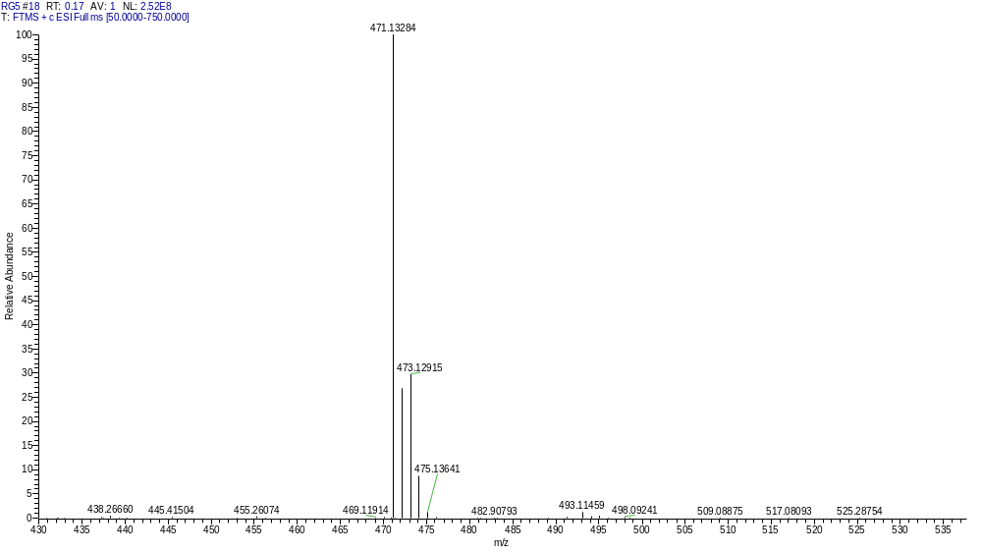
HRMS of the target compound 13d

Compound 13e
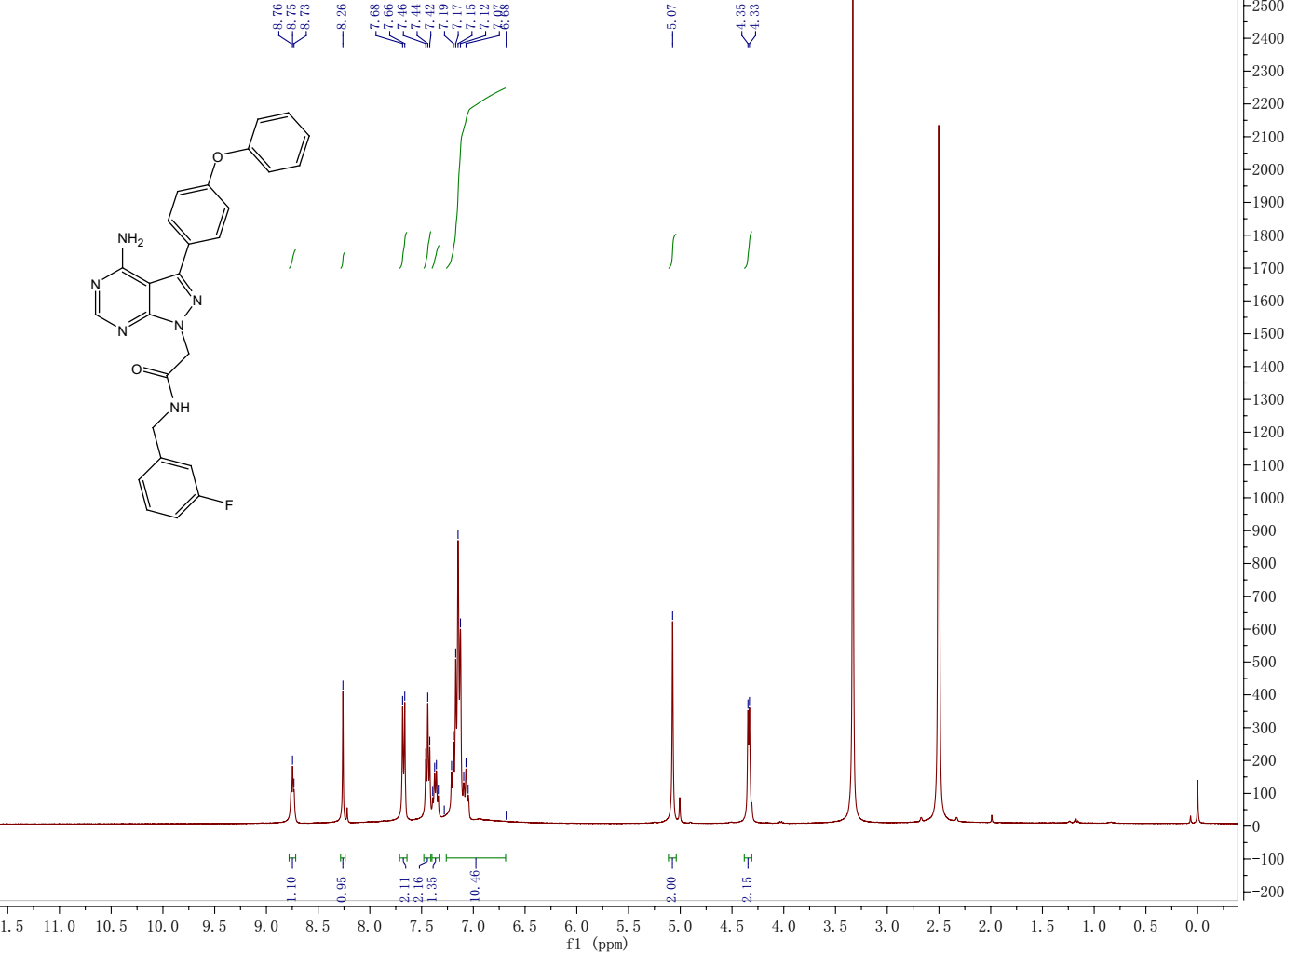
¹H NMR spectrum of the target compound 13e
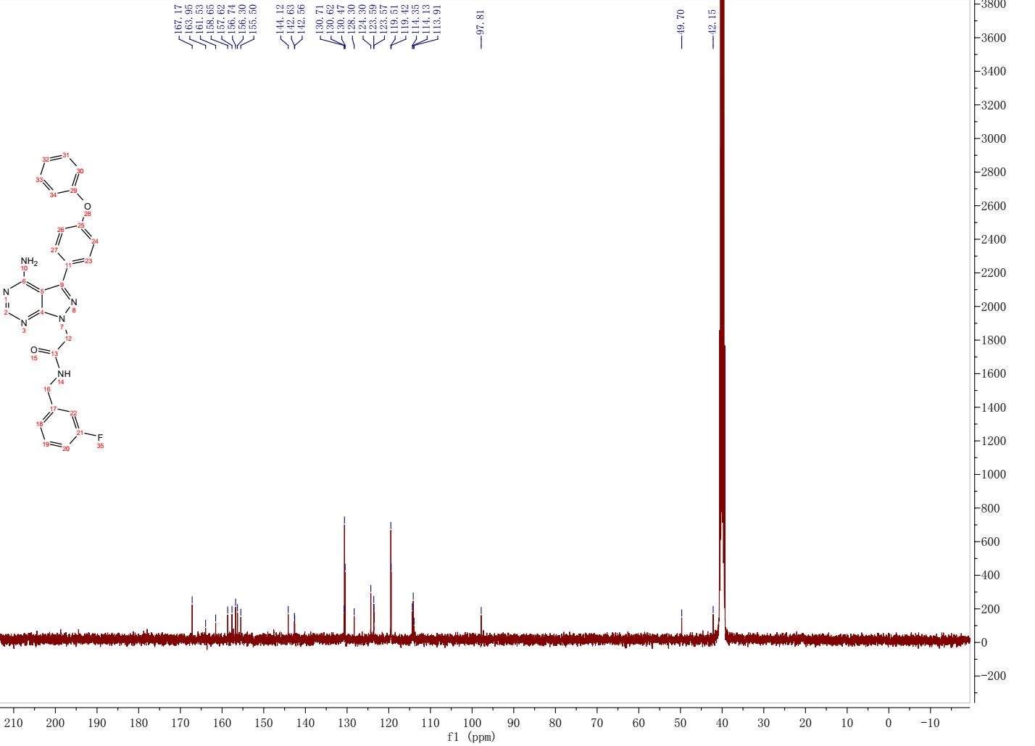
¹³C NMR spectrum of the target compound 13e

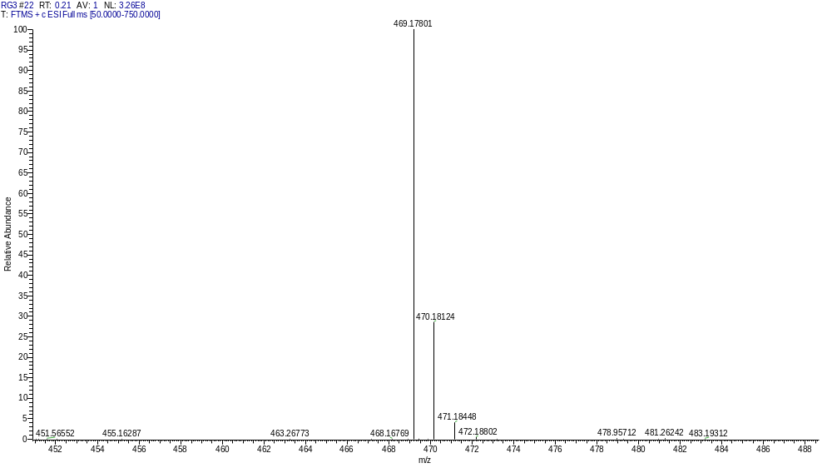
HRMS of the target compound 13e

Compound 13f
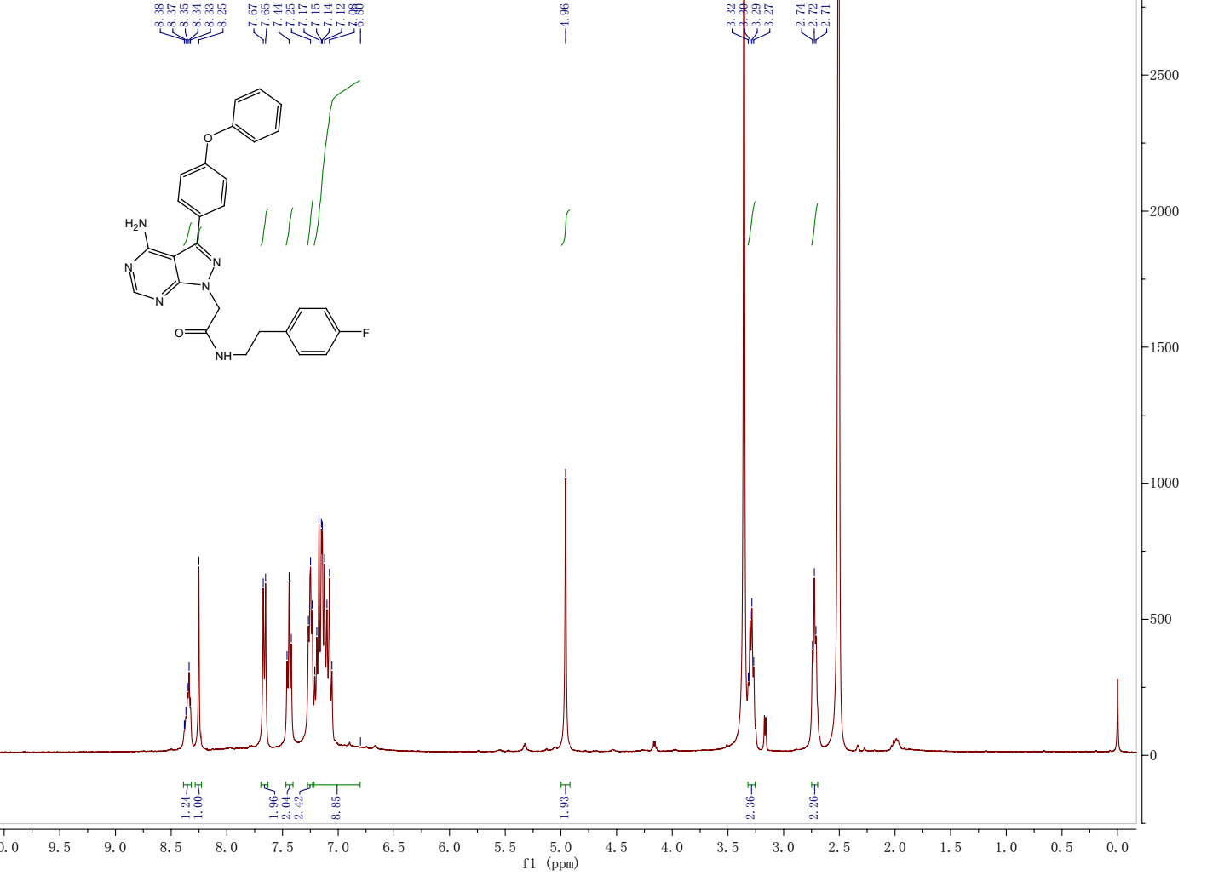
¹H NMR spectrum of the target compound 13f
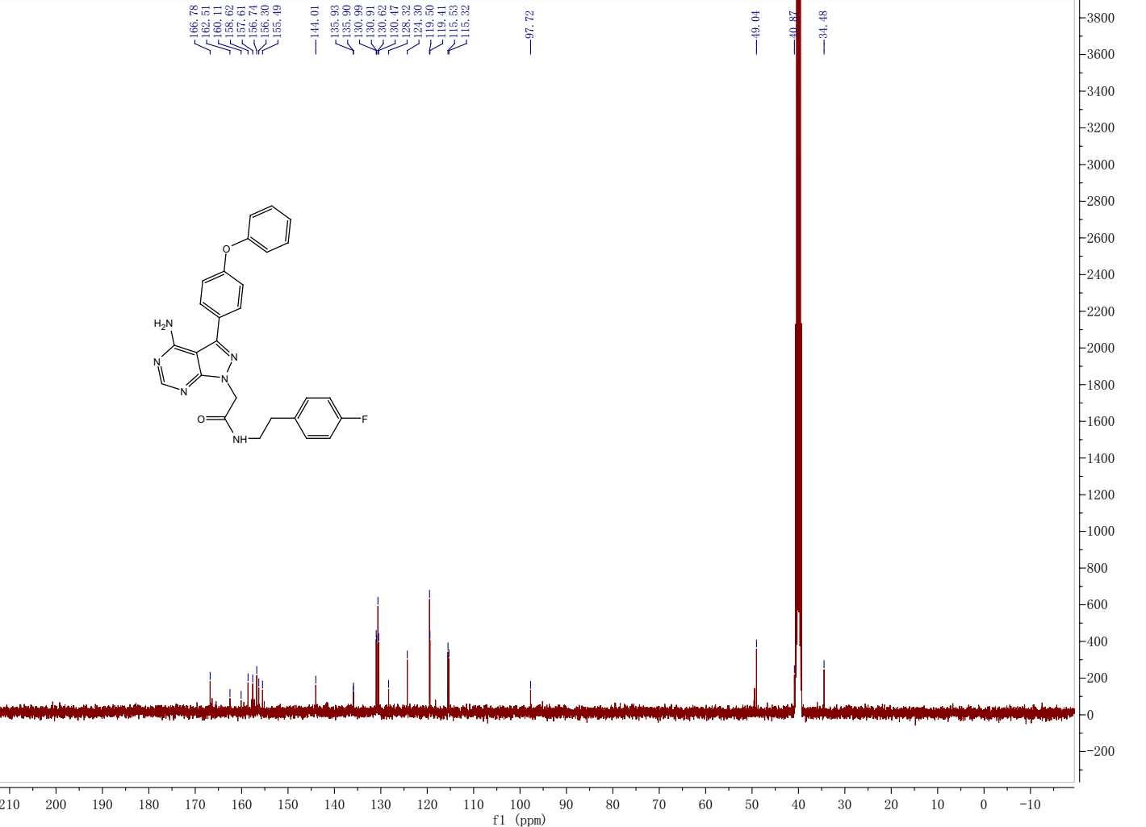
¹³C NMR spectrum of the target compound 13f

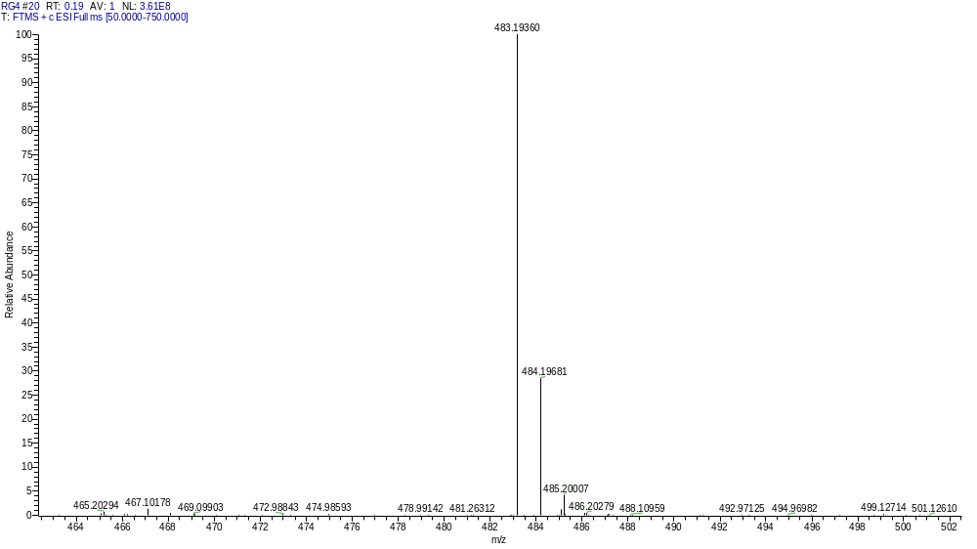
HRMS of the target compound 13f

Compound 13g
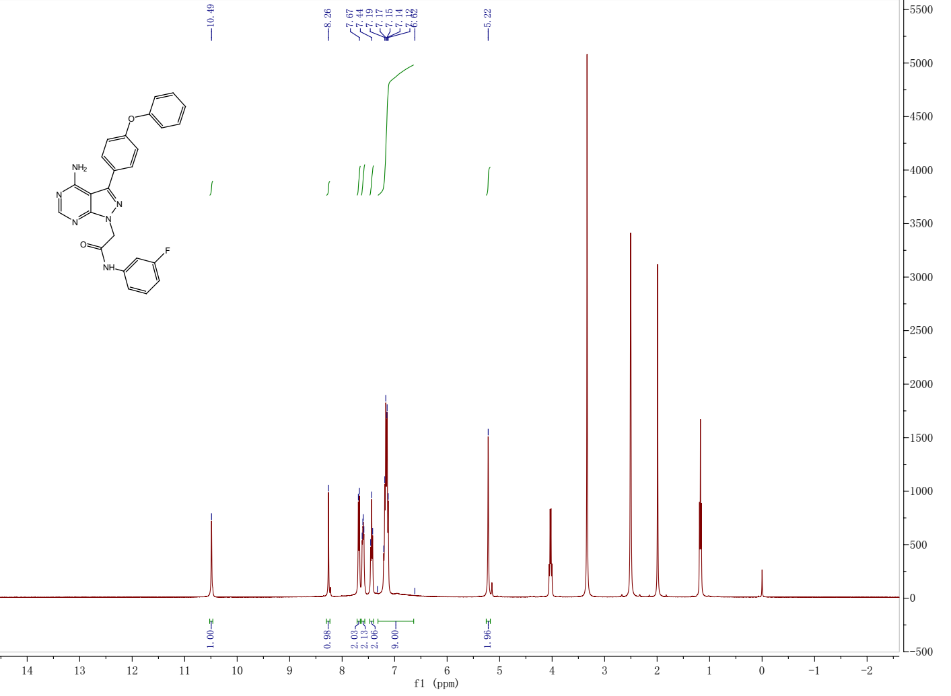
¹H NMR spectrum of the target compound 13g
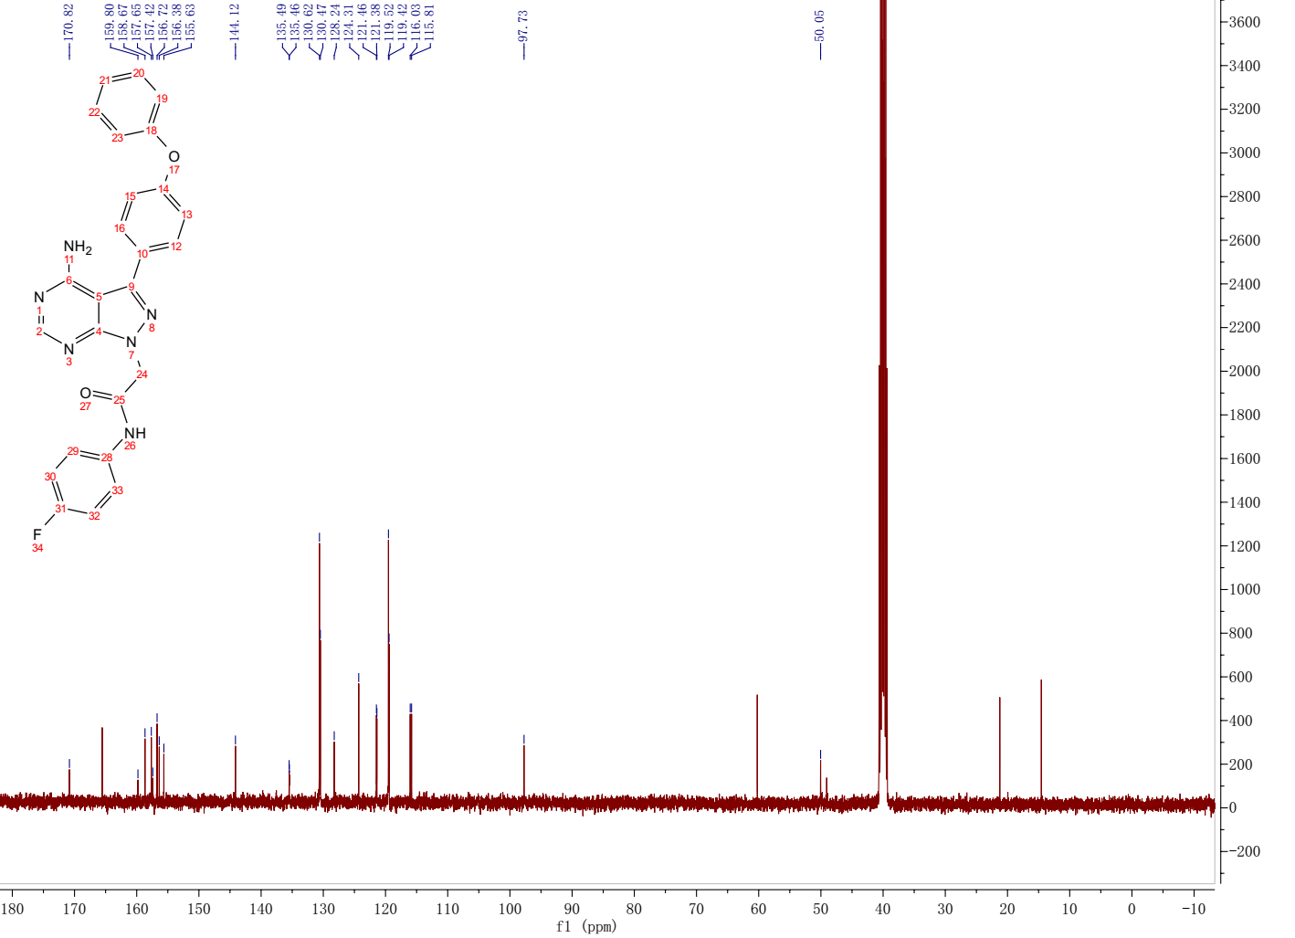
¹³C NMR spectrum of the target compound 13g

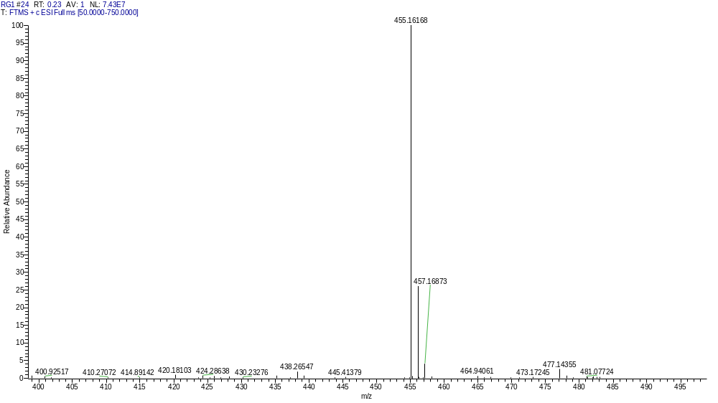
HRMS of the target compound 13g

Compound 13h
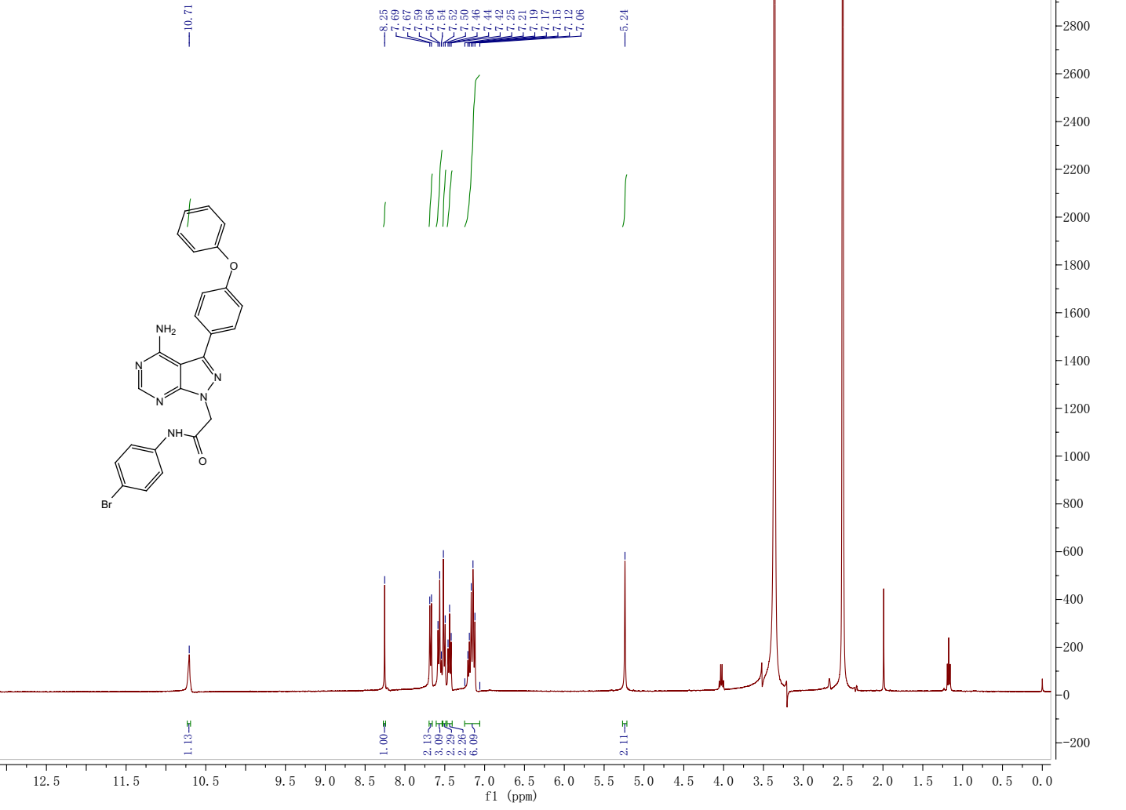
¹H NMR spectrum of the target compound 13h
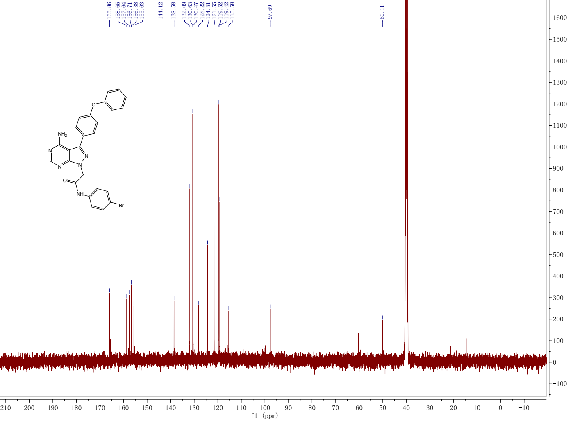
¹³C NMR spectrum of the target compound 13h

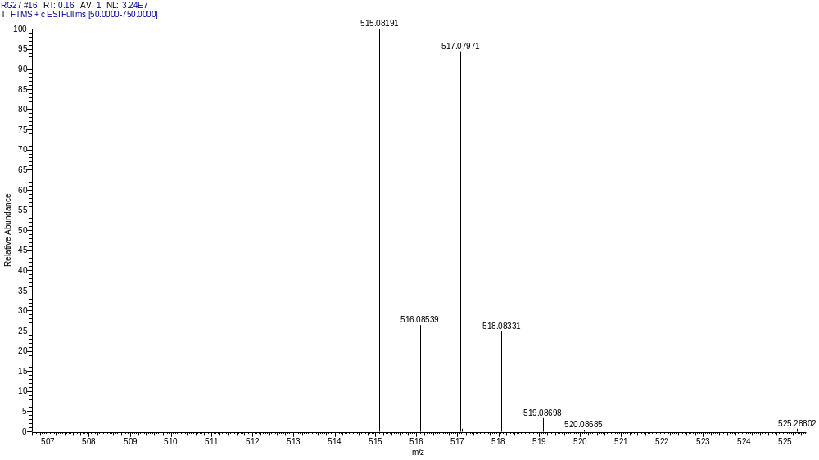
HRMS of the target compound 13h

Compound 13i
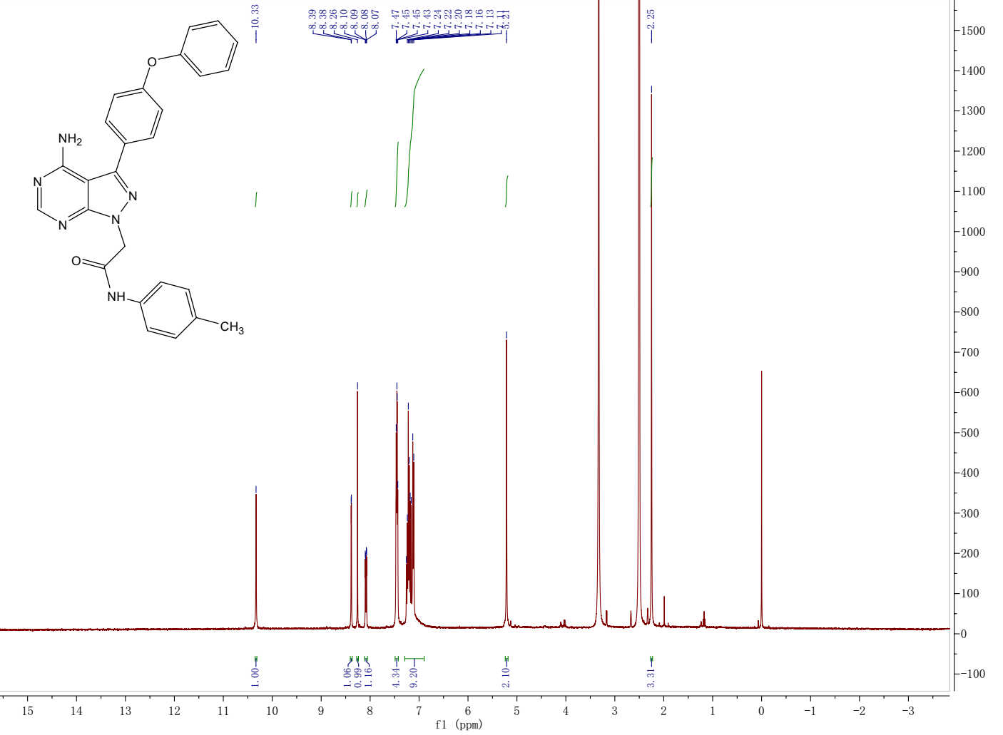
¹H NMR spectrum of the target compound 13i
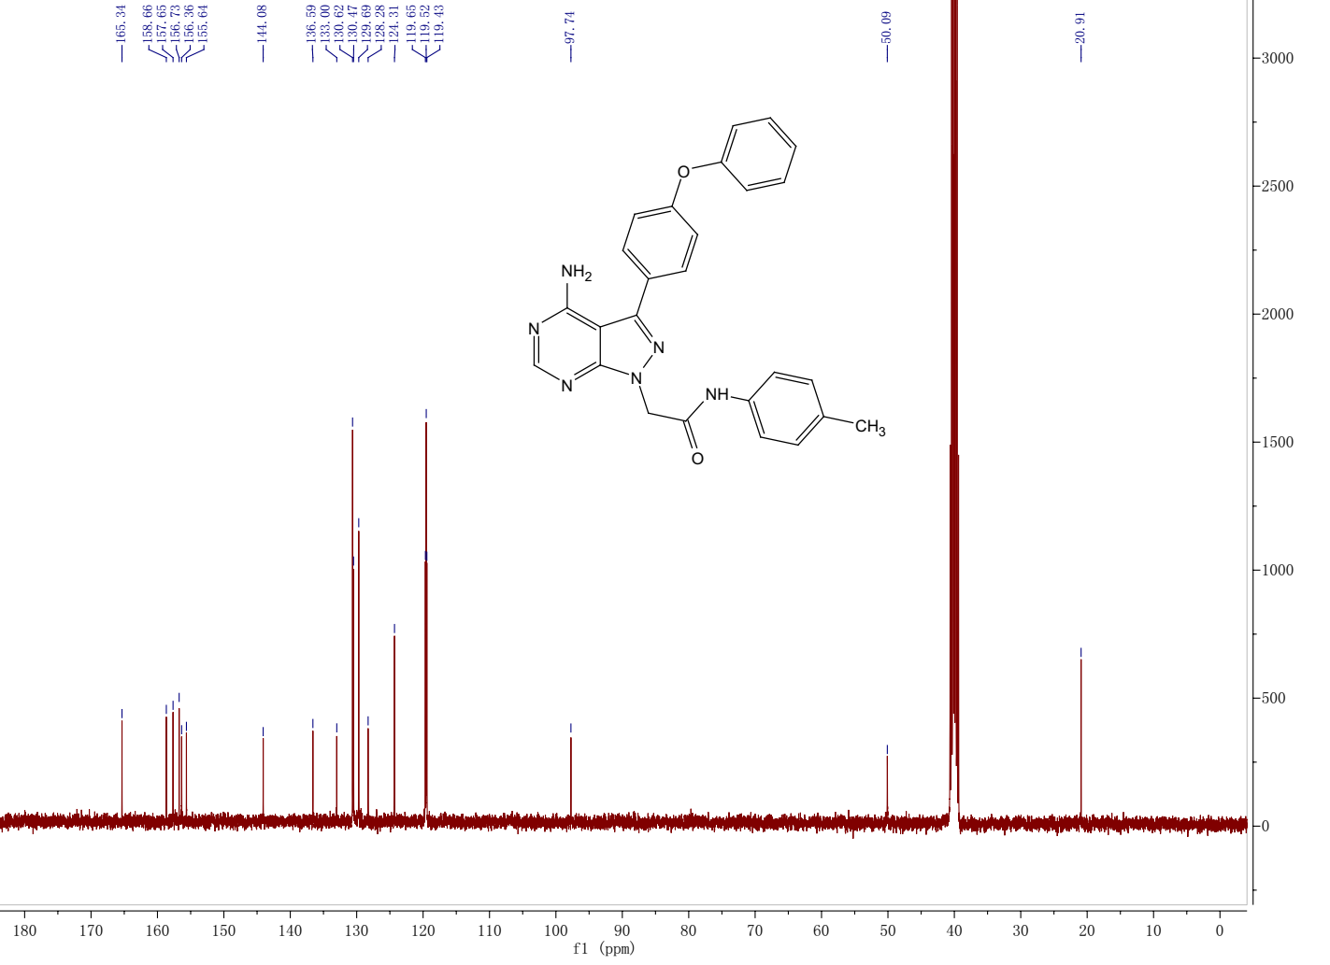
¹³C NMR spectrum of the target compound 13i

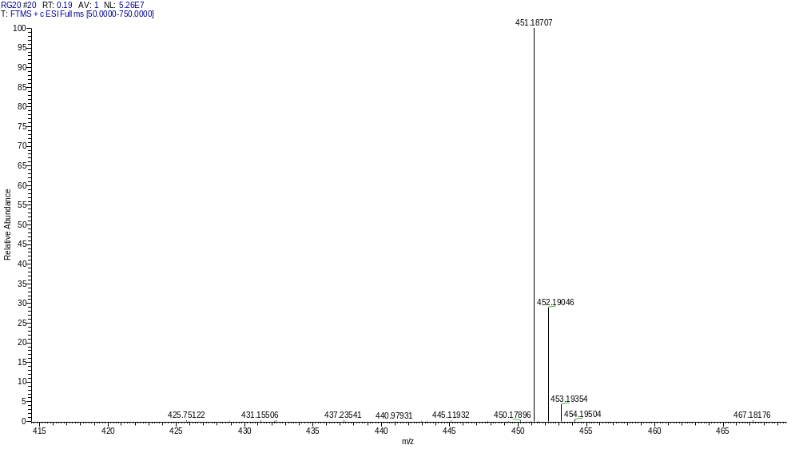
HRMS of the target compound 13i

Compound 13j
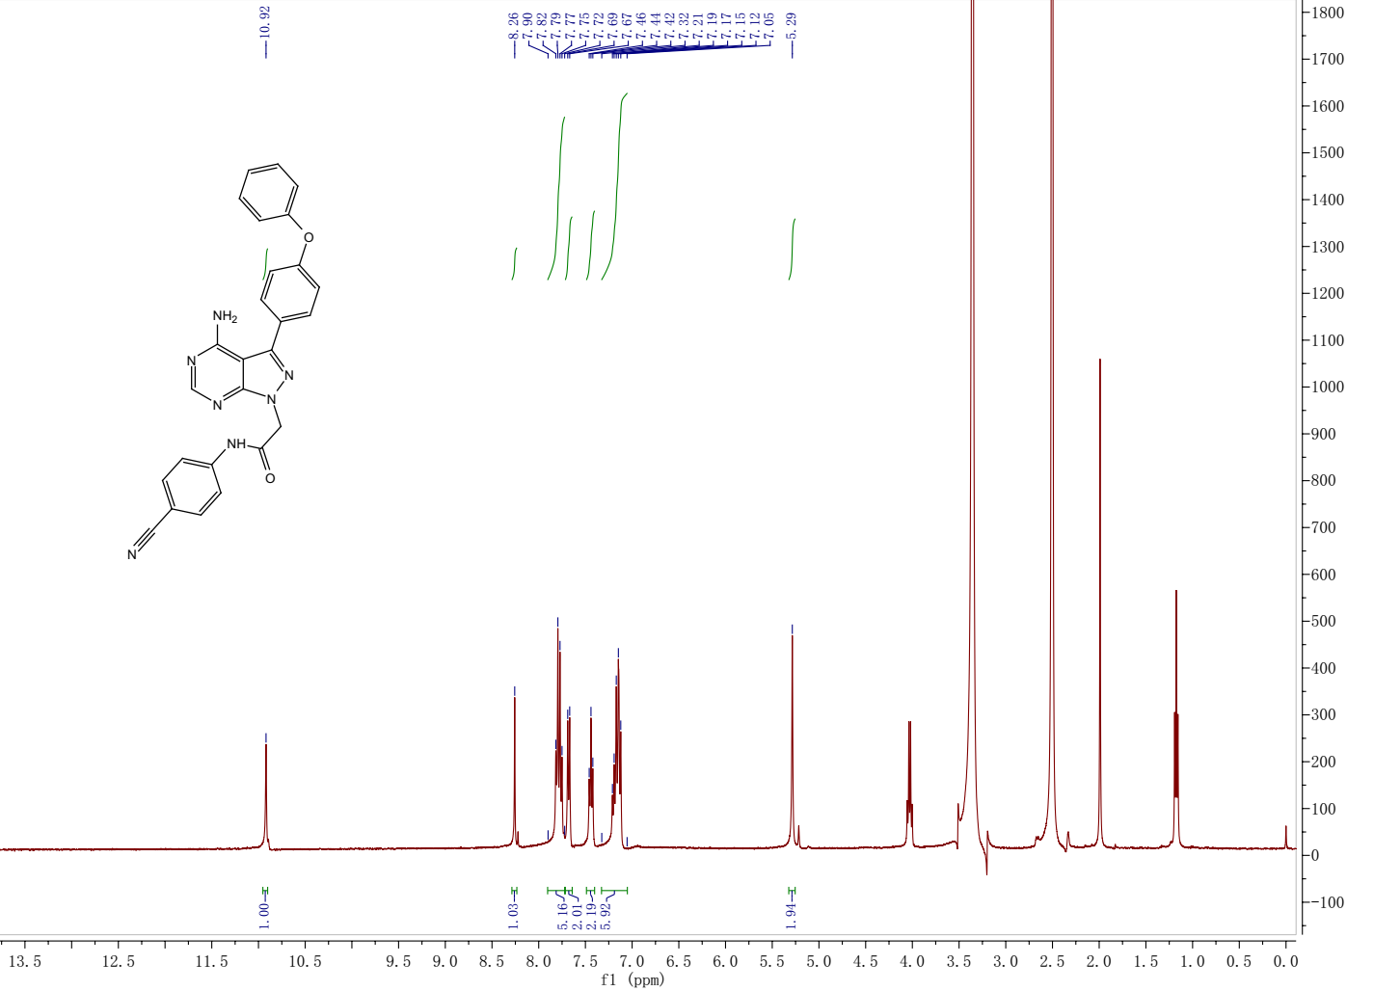
¹H NMR spectrum of the target compound 13j
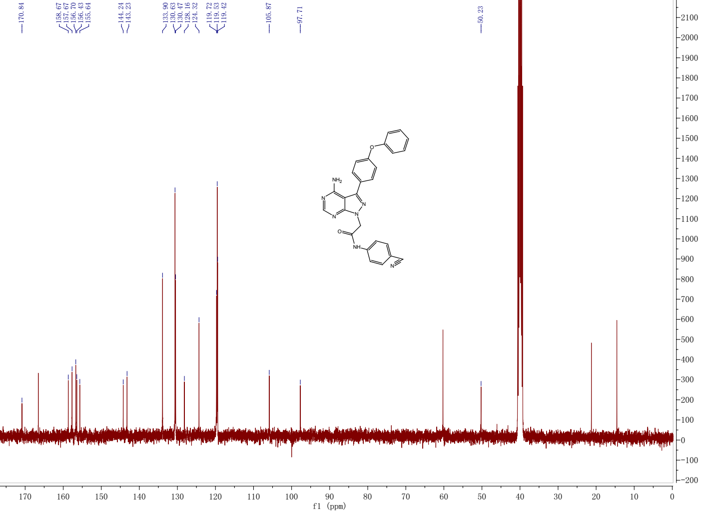
¹³C NMR spectrum of the target compound 13j

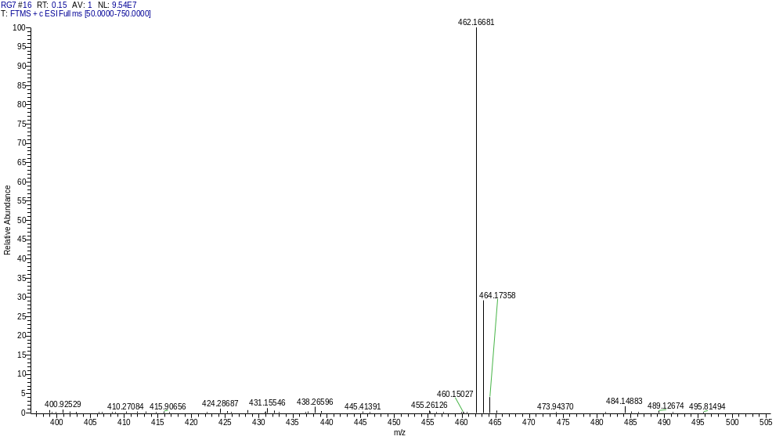
HRMS of the target compound 13j

Compound 13k
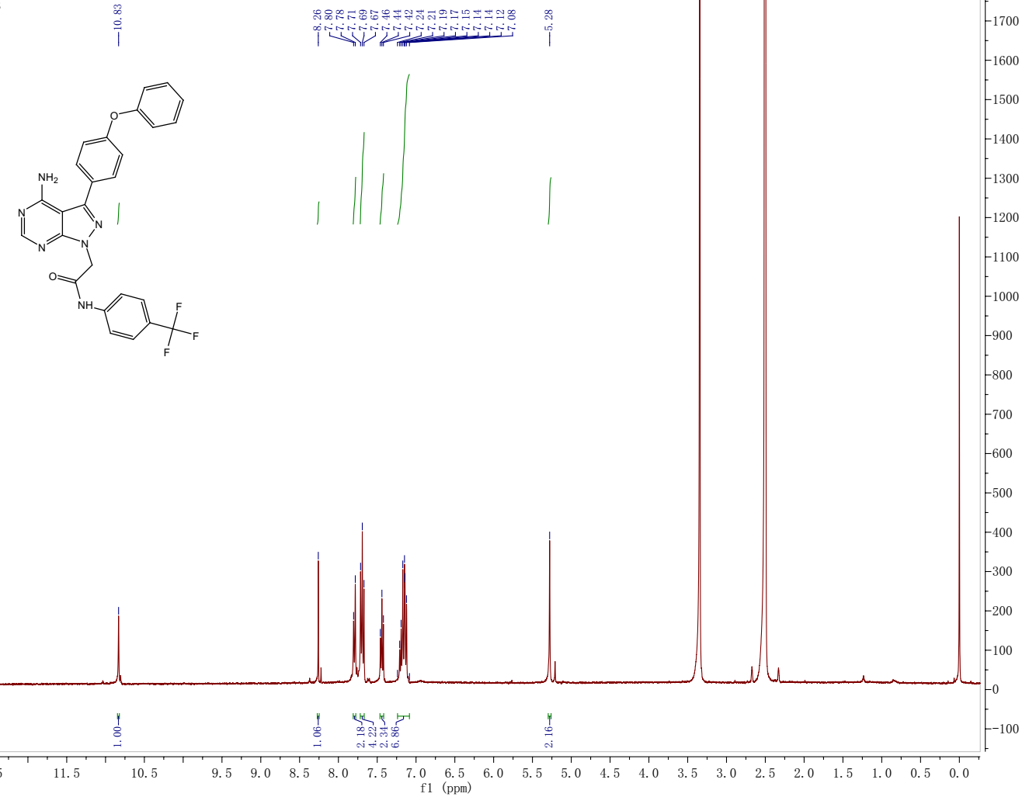
¹H NMR spectrum of the target compound 13k
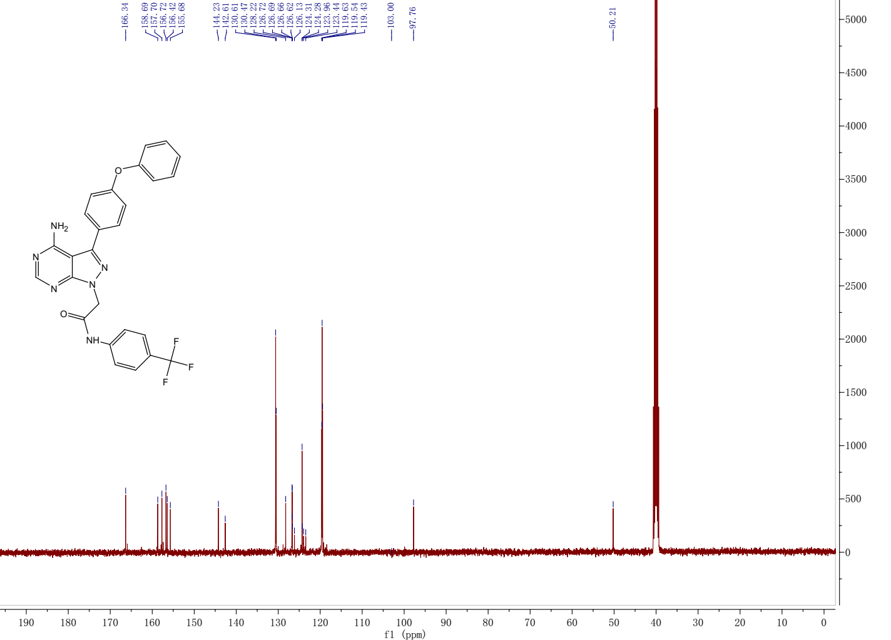
¹³C NMR spectrum of the target compound 13k
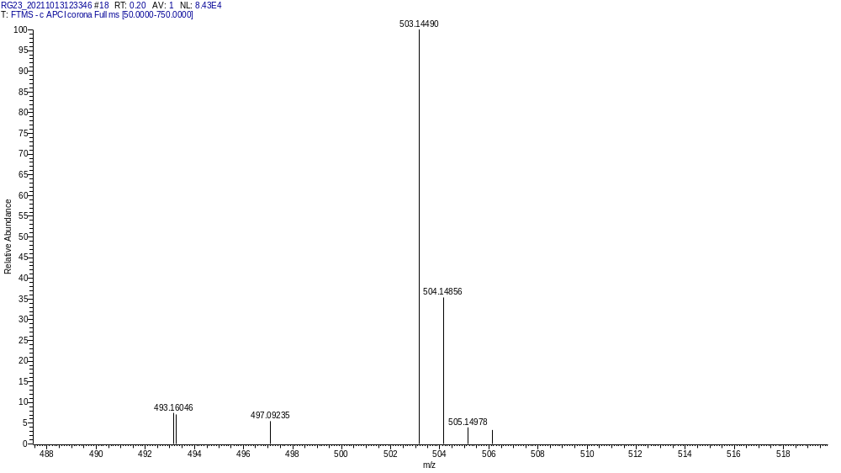
HRMS of the target compound 13k

Compound 13l
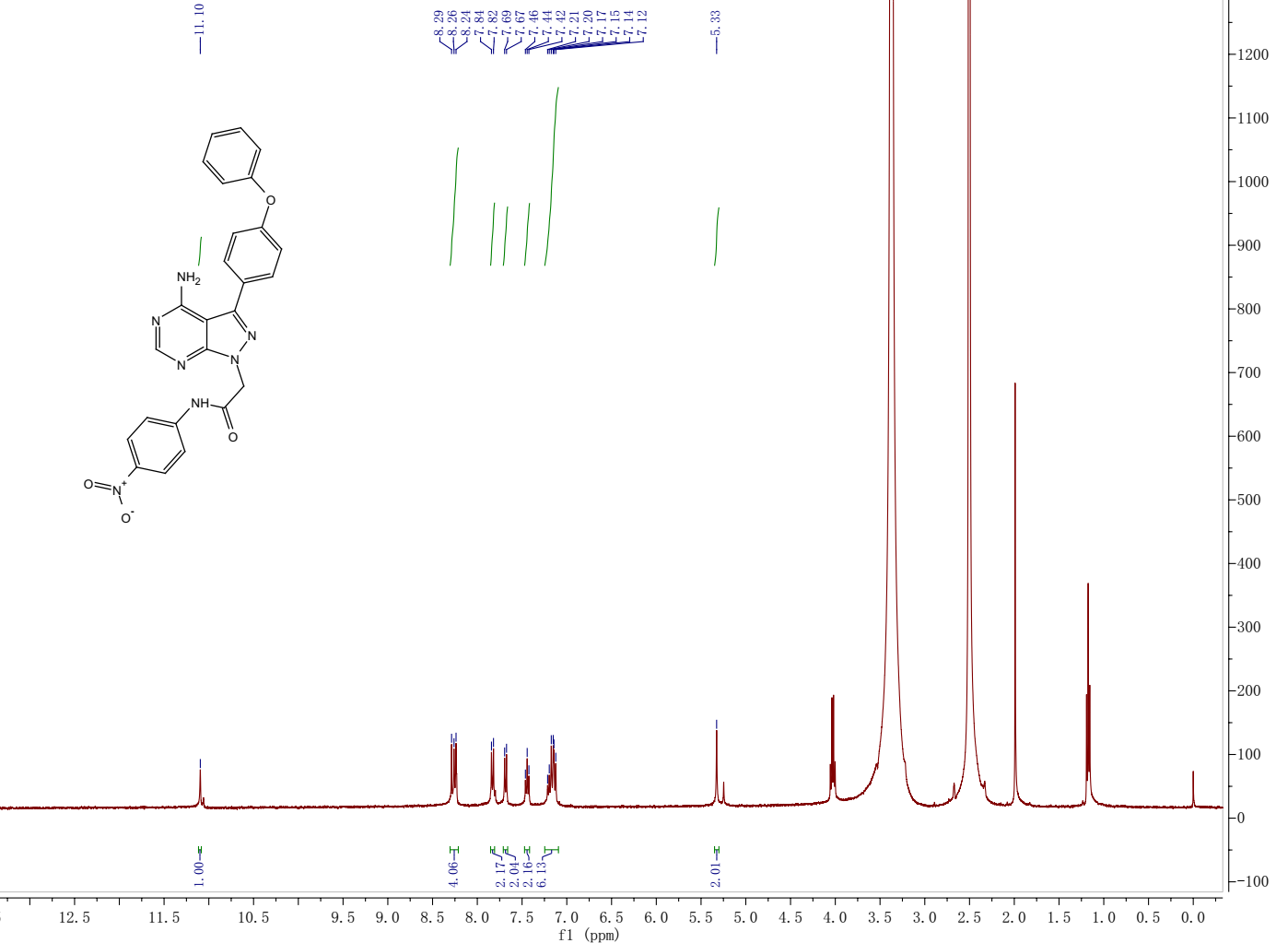
¹H NMR spectrum of the target compound 13l
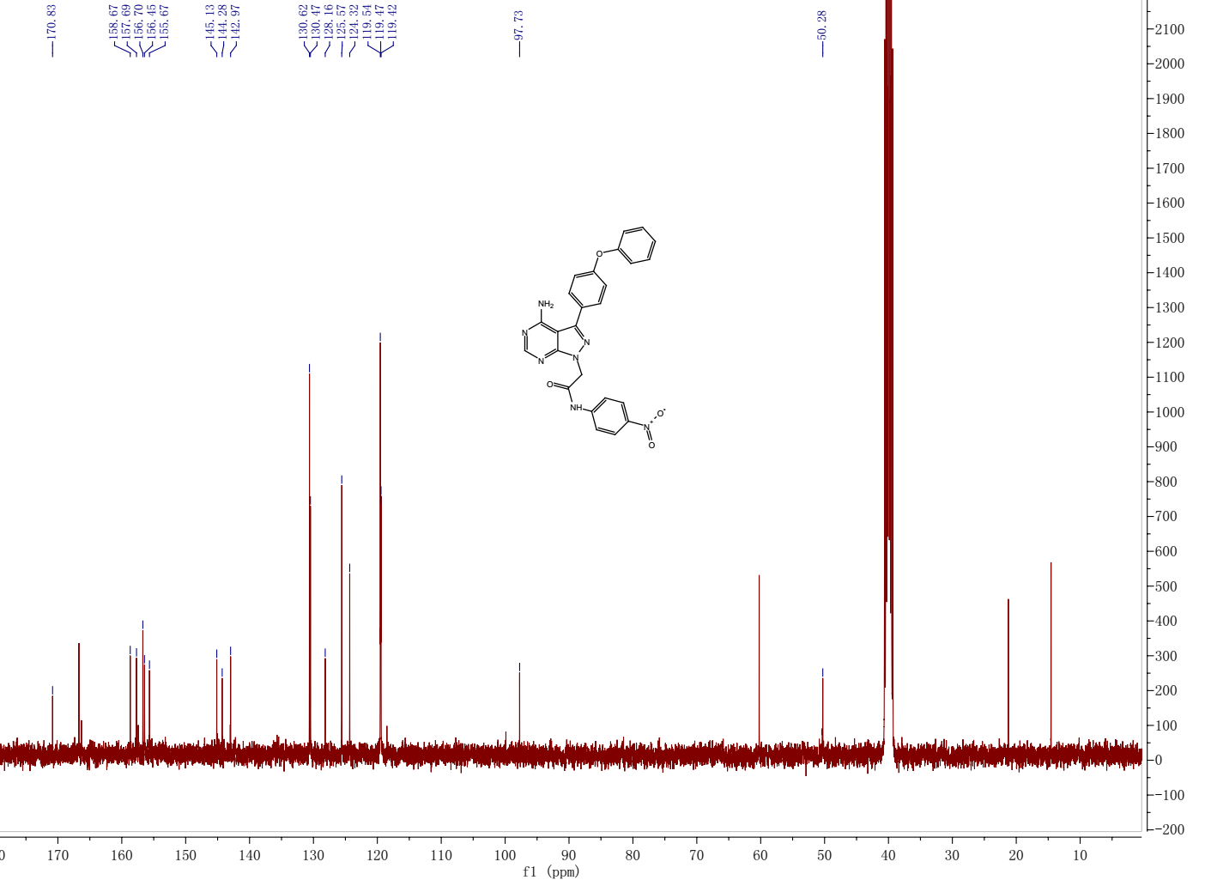
¹³C NMR spectrum of the target compound 13l

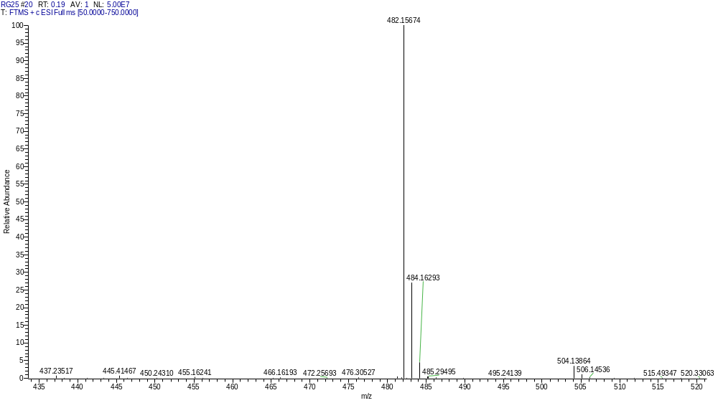
HRMS of the target compound 13l

Compound 13m
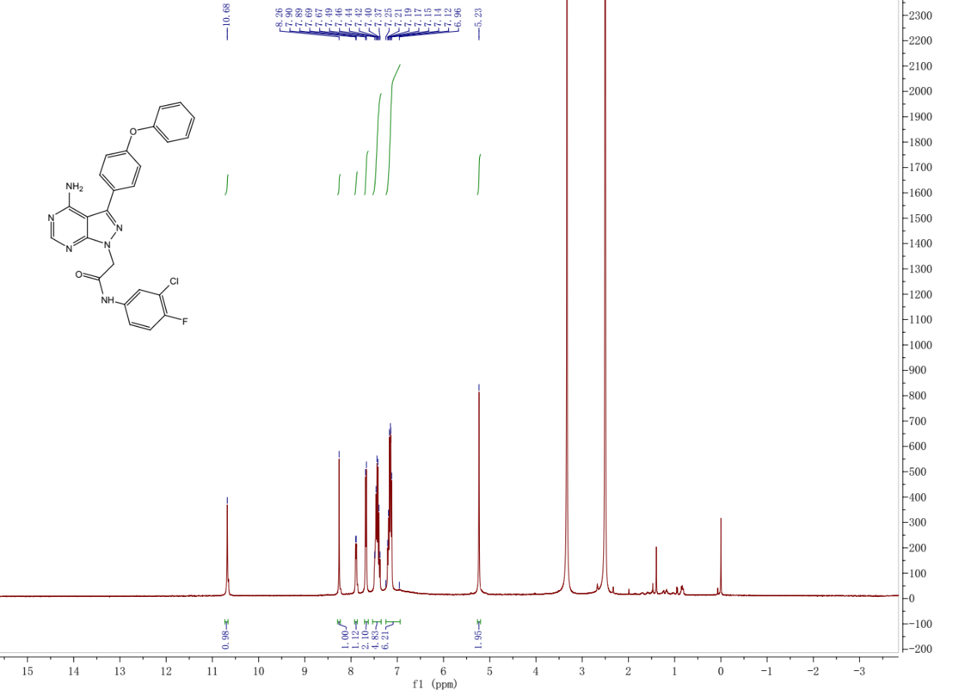
¹H NMR spectrum of the target compound 13m
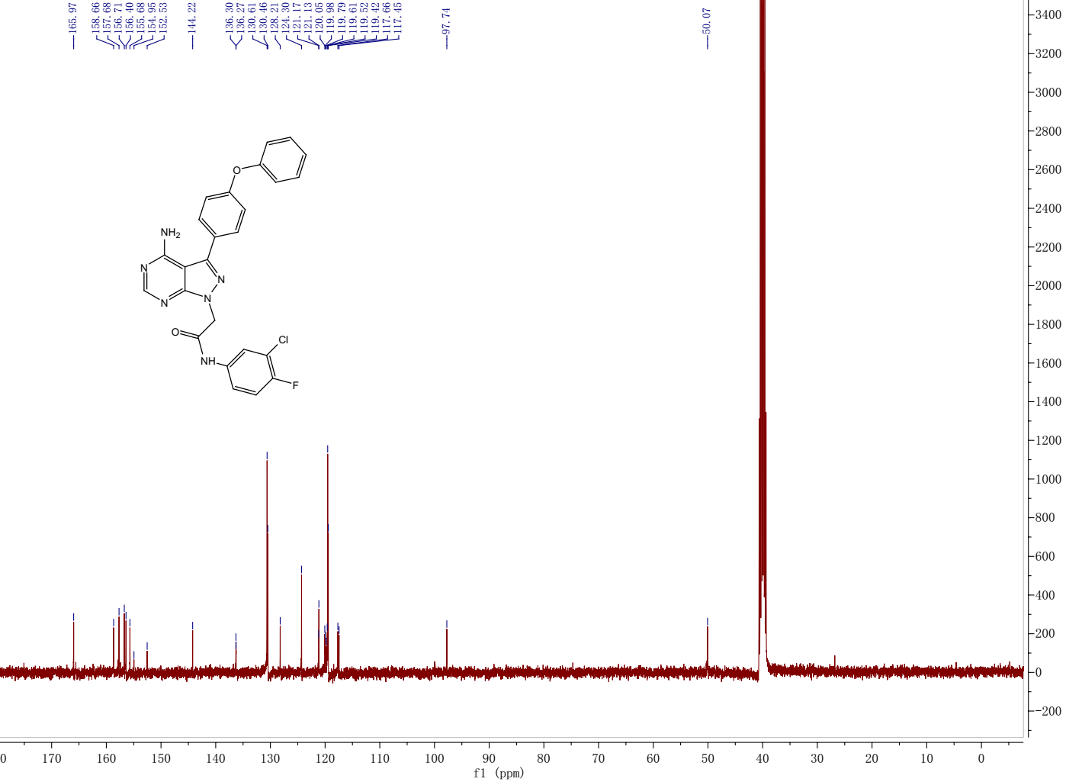
¹³C NMR spectrum of the target compound 13m

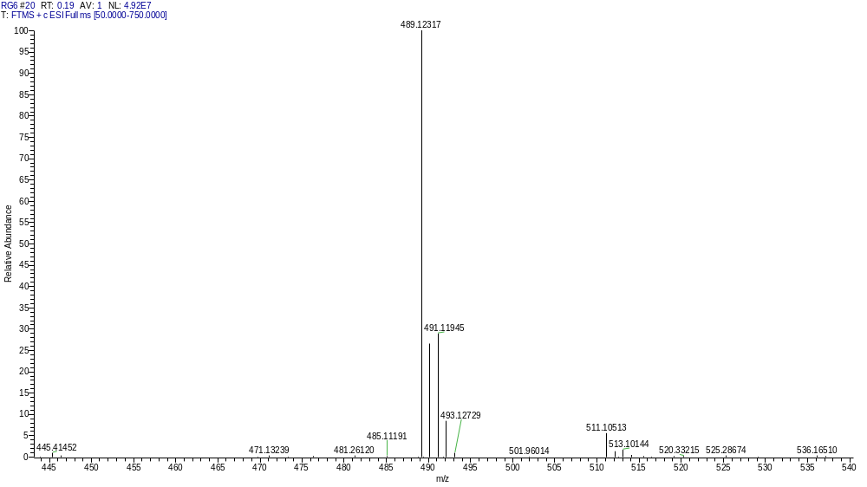
HRMS of the target compound 13m

Compound 13n
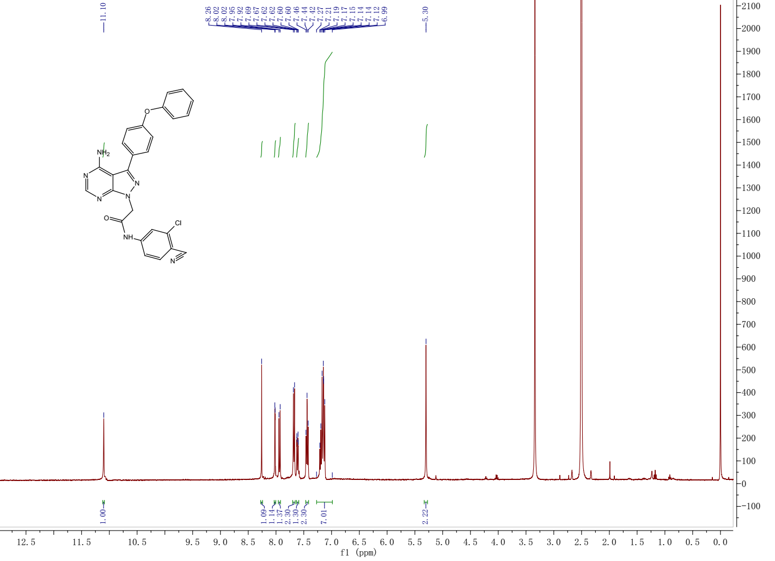
¹H NMR spectrum of the target compound 13n
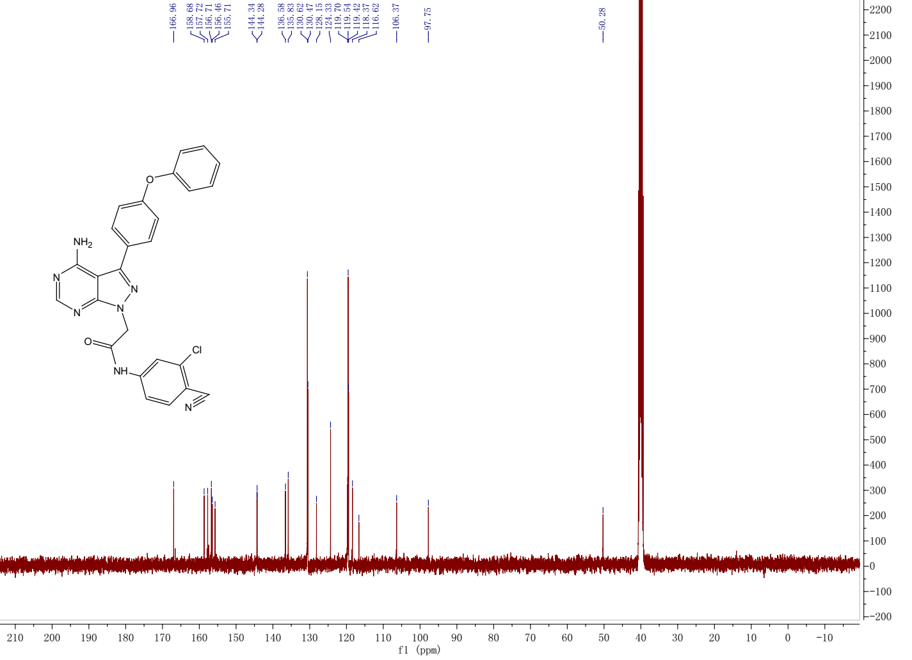
¹³C NMR spectrum of the target compound 13n

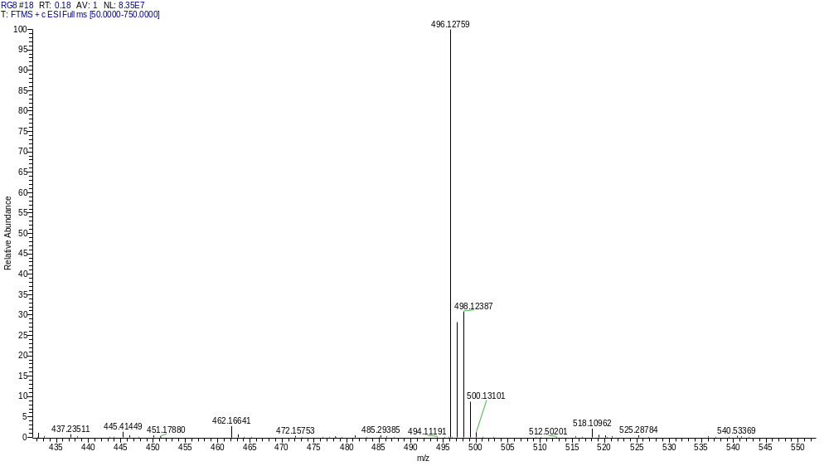
HRMS of the target compound 13n

Compound 13o
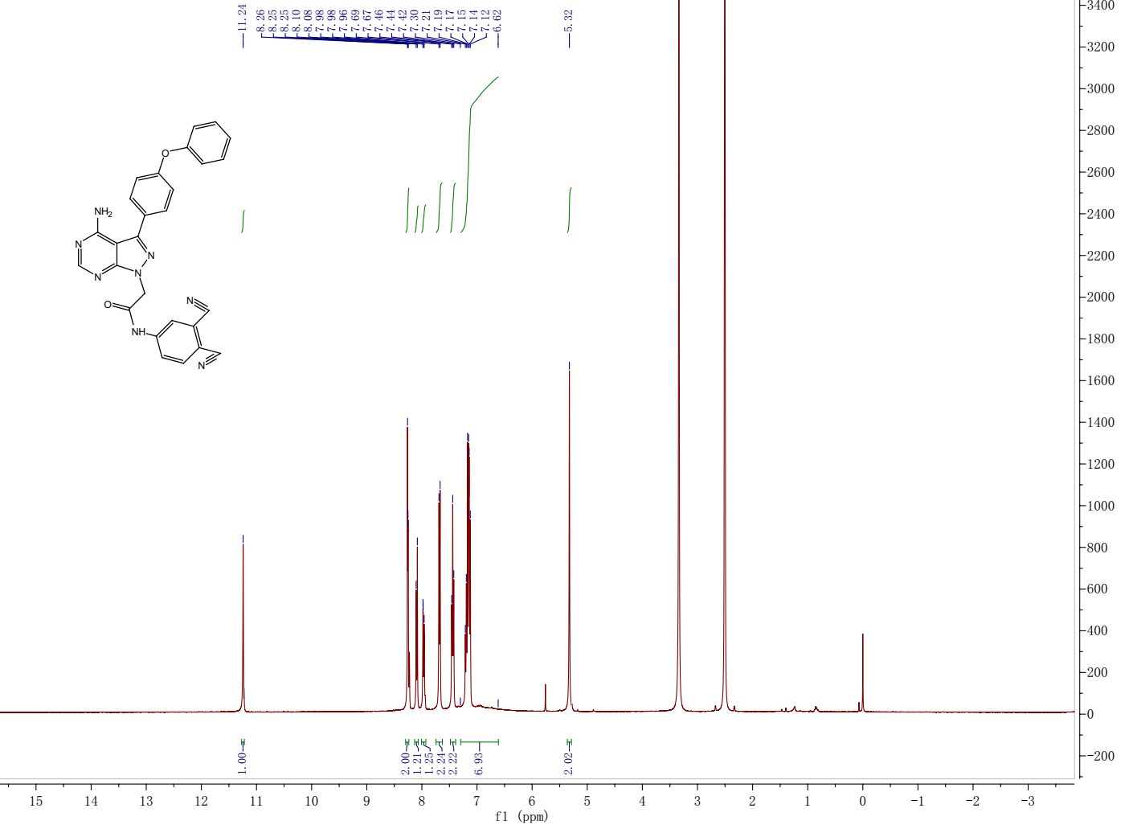
¹H NMR spectrum of the target compound 13o
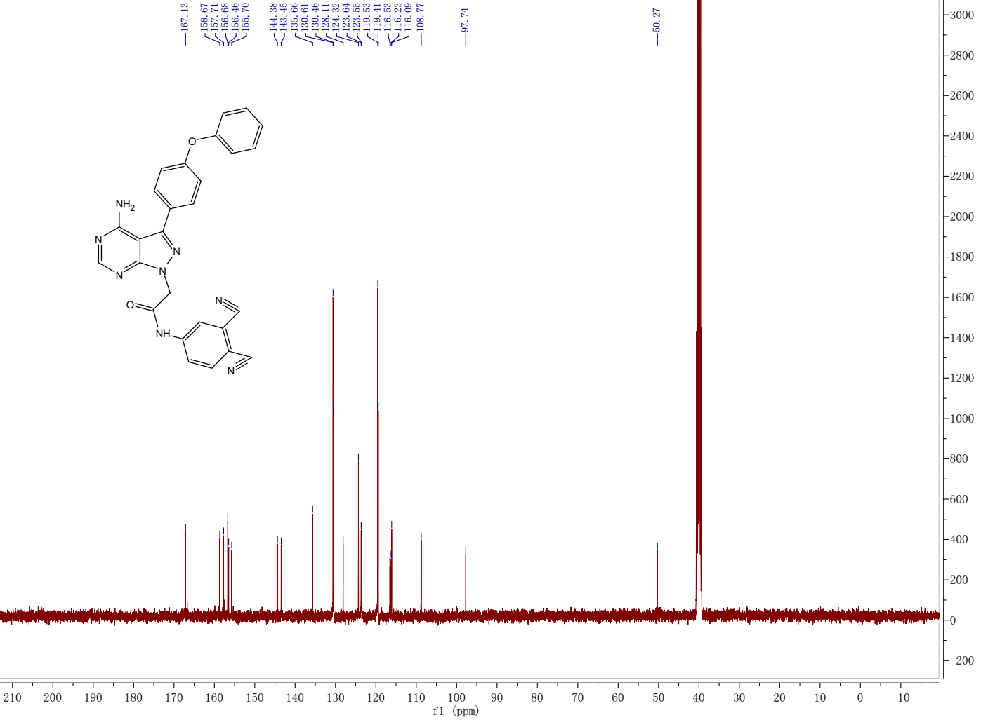
¹³C NMR spectrum of the target compound 13o

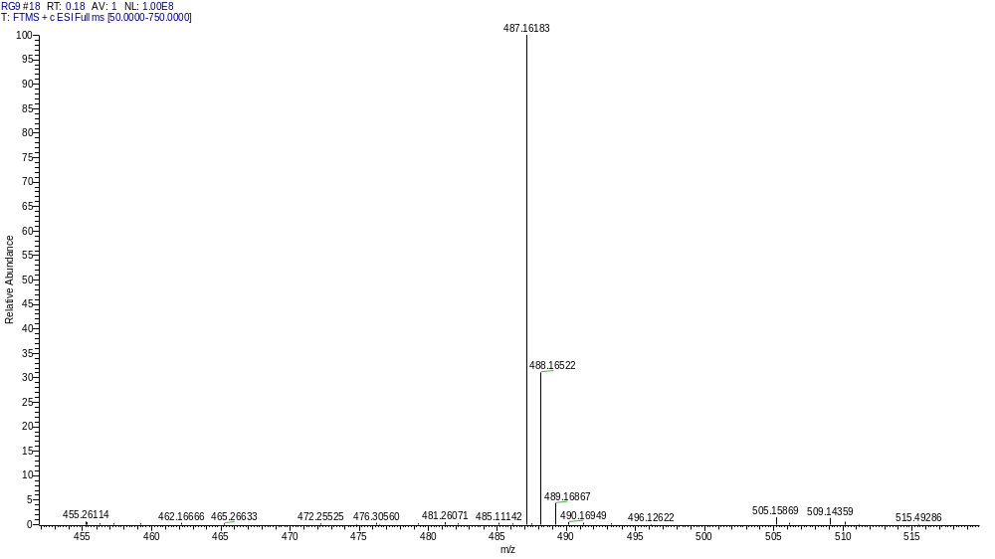
HRMS of the target compound 13o

Compound 13p
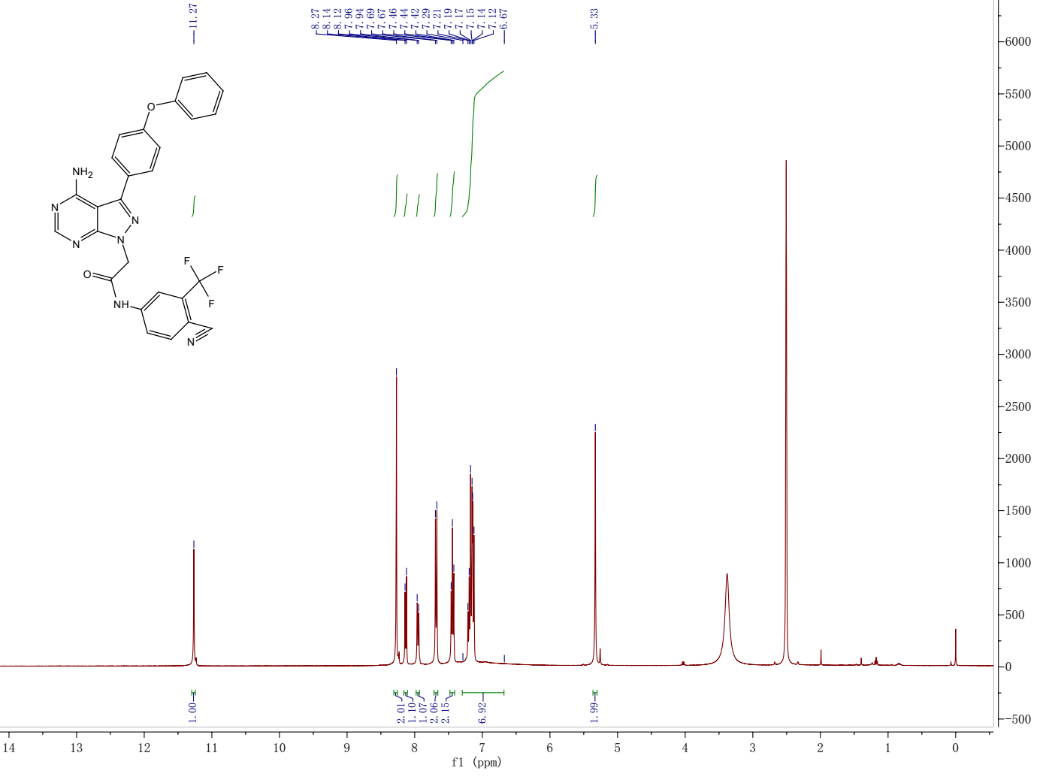
¹H NMR spectrum of the target compound 13p
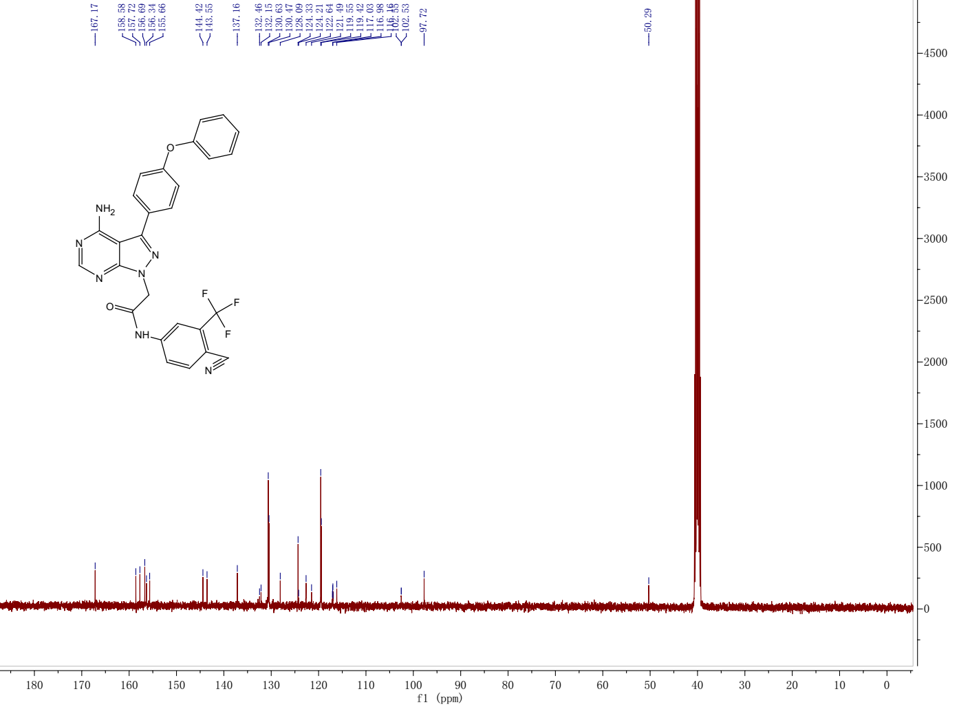
¹³C NMR spectrum of the target compound 13p

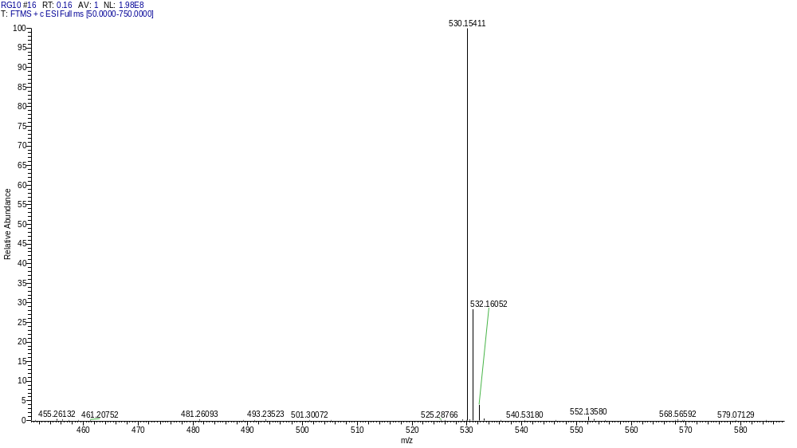
HRMS of the target compound 13p

Compound 13q
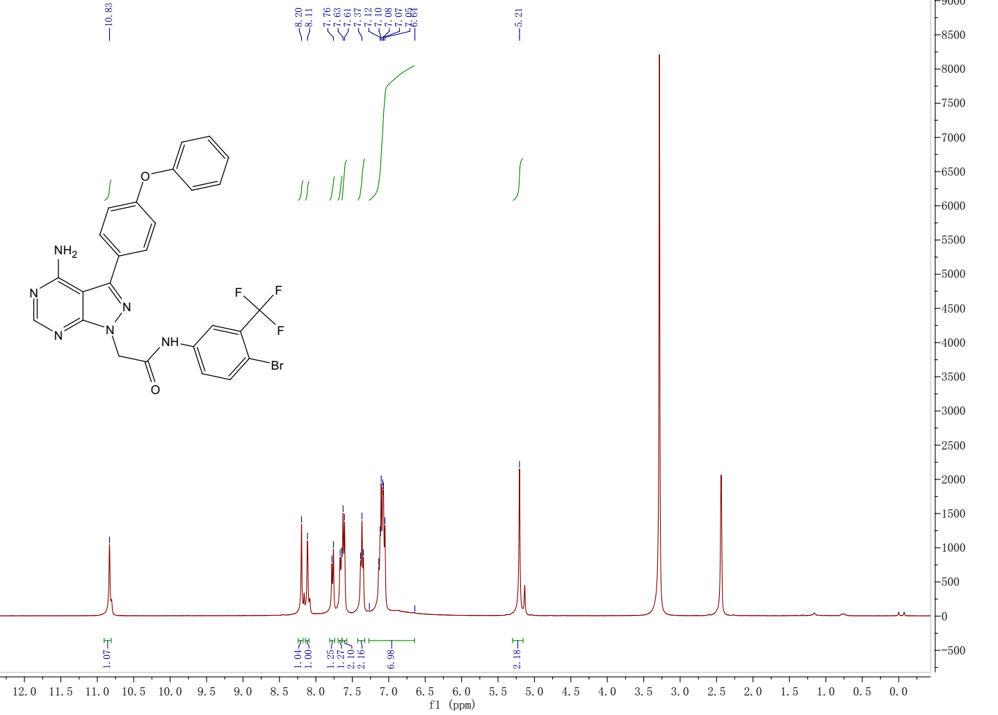
¹H NMR spectrum of the target compound 13q
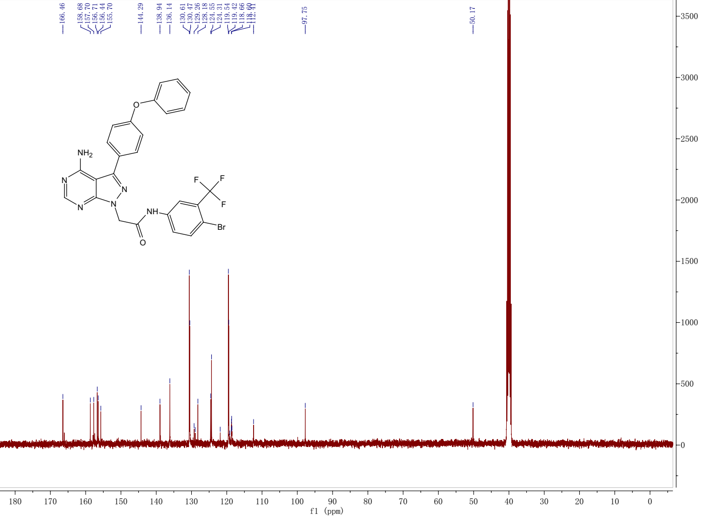
¹³C NMR spectrum of the target compound 13q

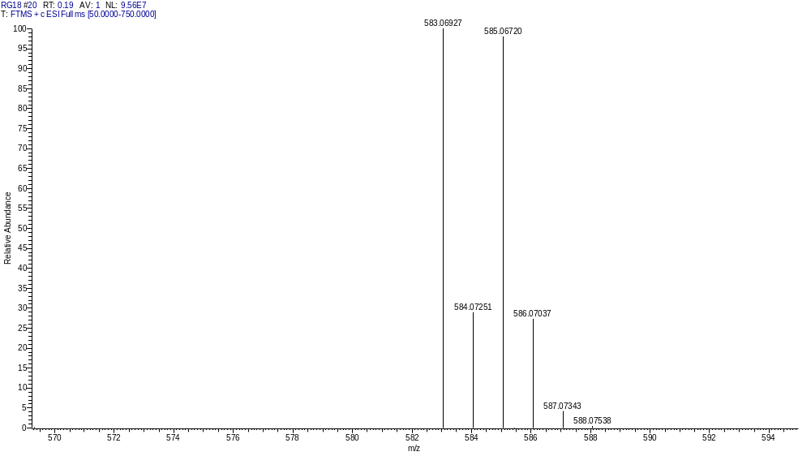
HRMS of the target compound 13q

Compound 13r
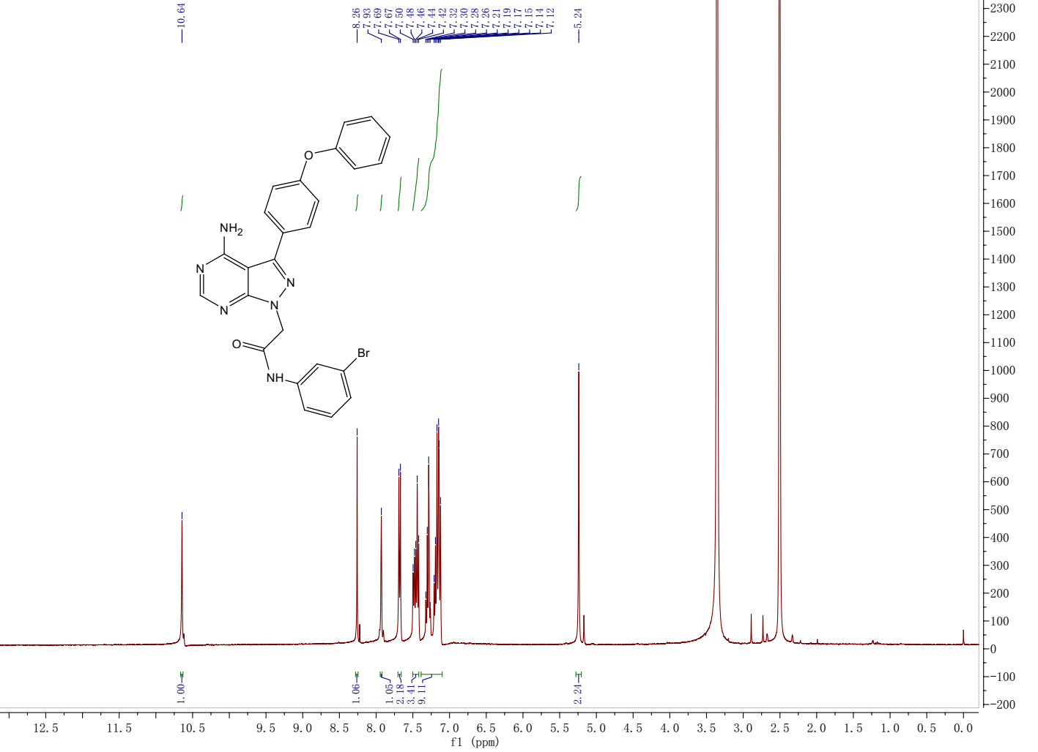
¹H NMR spectrum of the target compound 13r
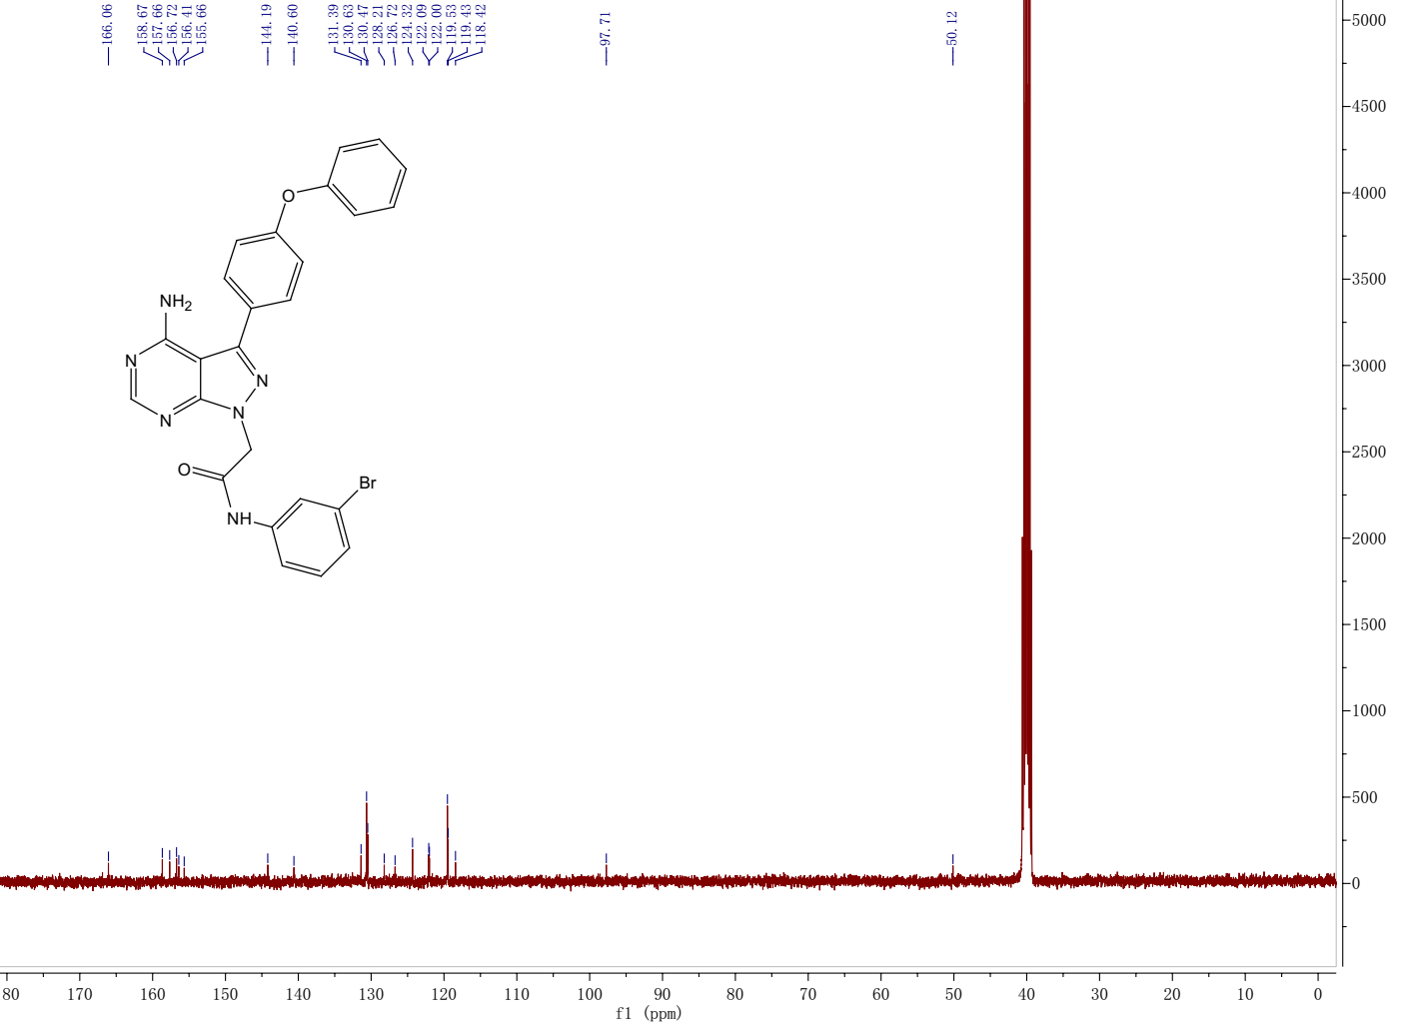
¹³C NMR spectrum of the target compound 13r

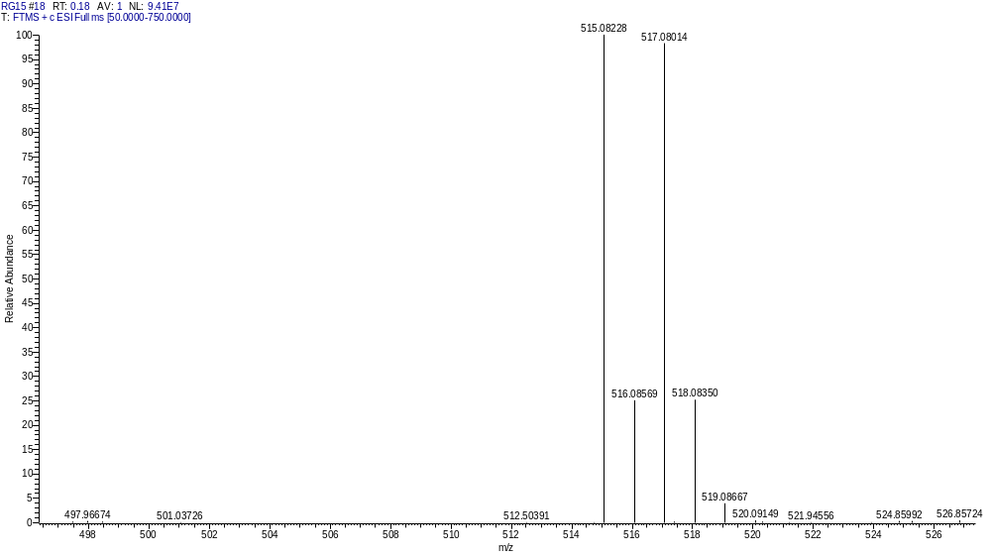
HRMS of the target compound 13r

Compound 13s
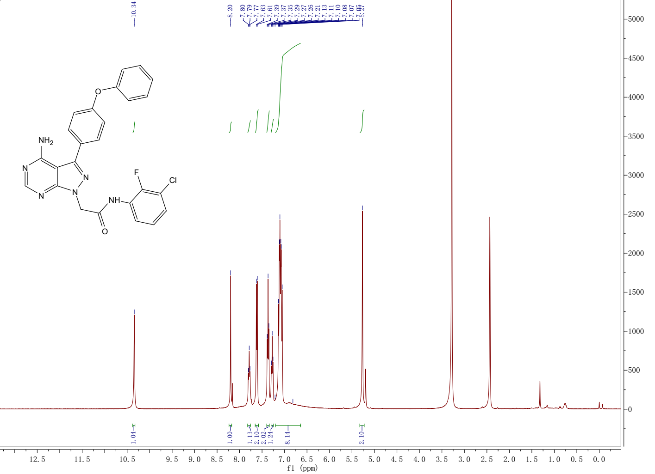
¹H NMR spectrum of the target compound 13s
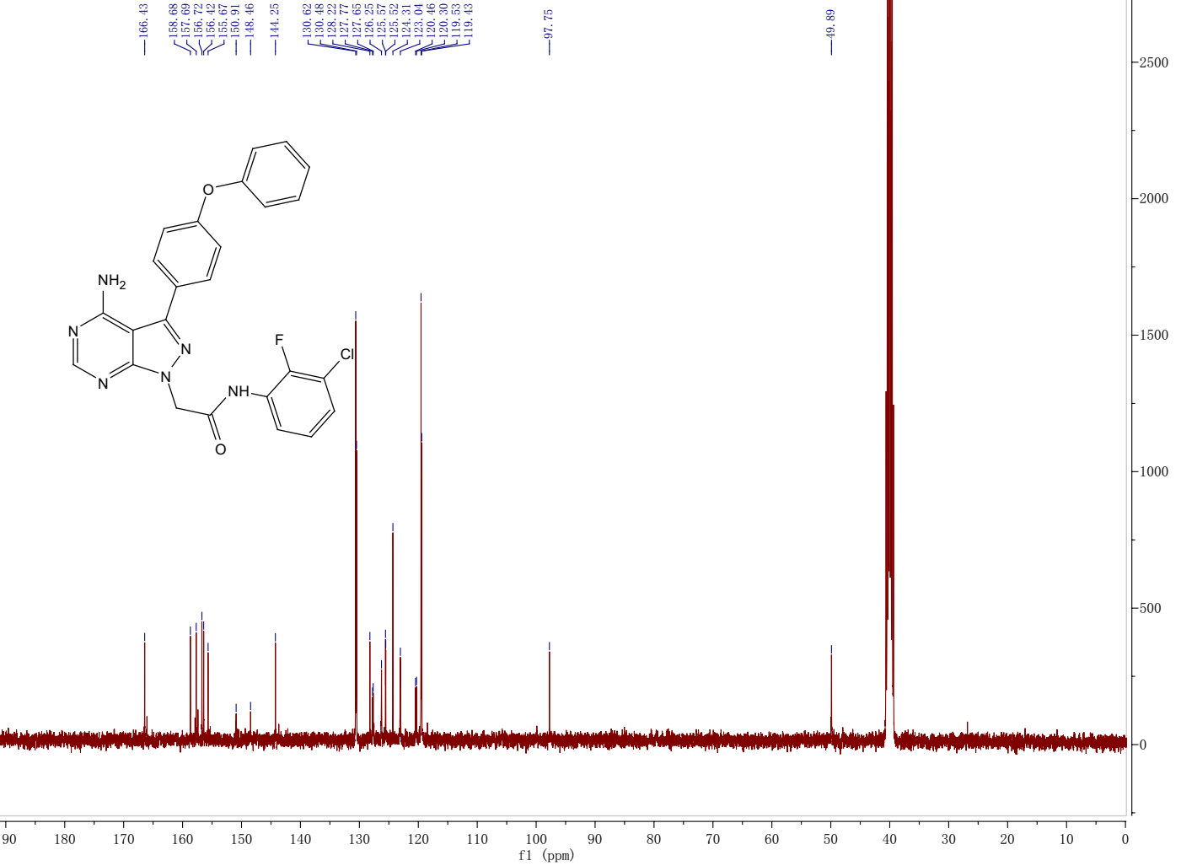
¹³C NMR spectrum of the target compound 13s

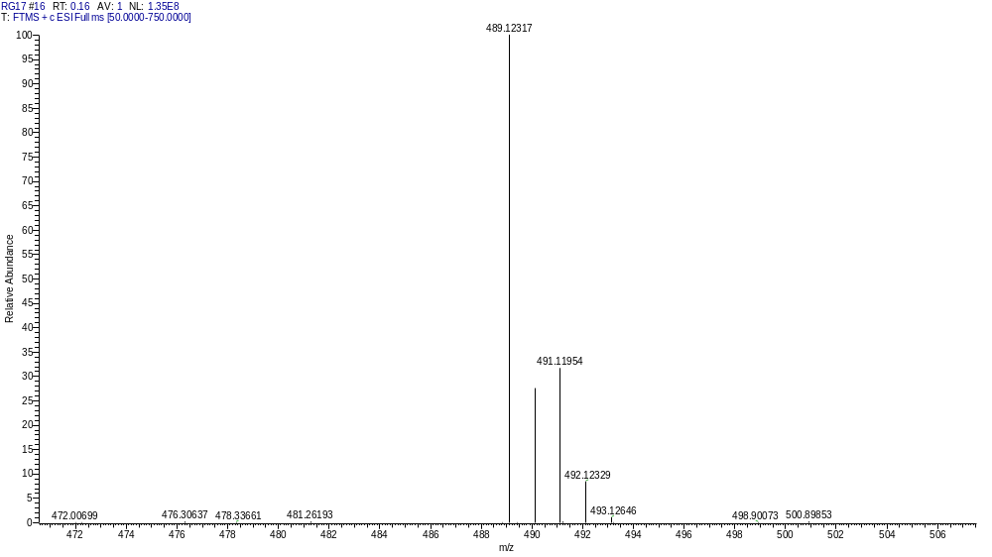
HRMS of the target compound 13s

Compound 13t
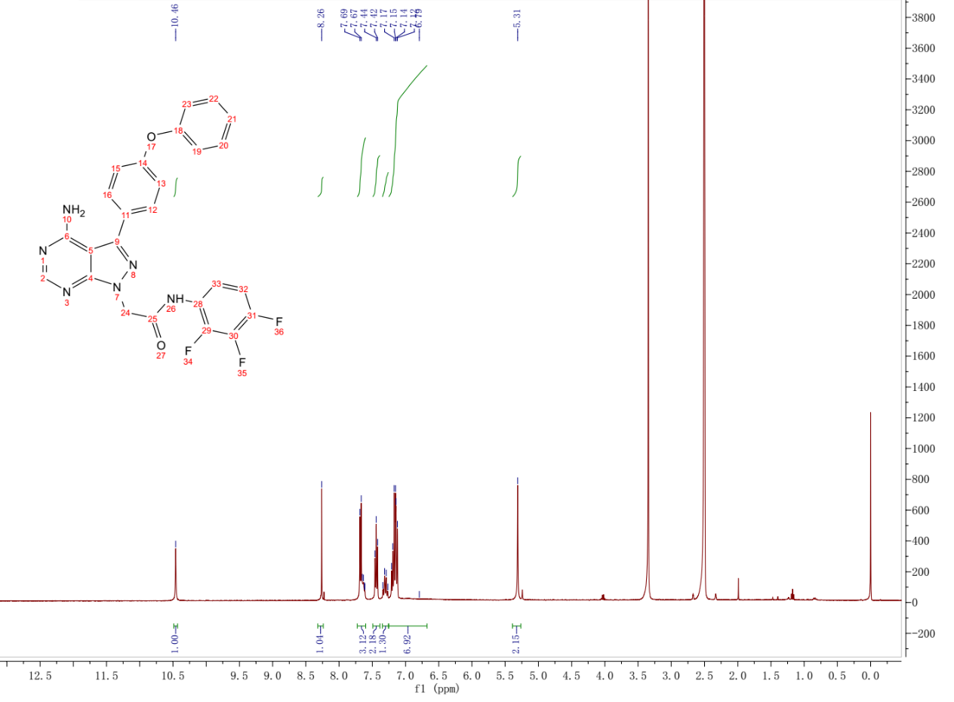
¹H NMR spectrum of the target compound 13t
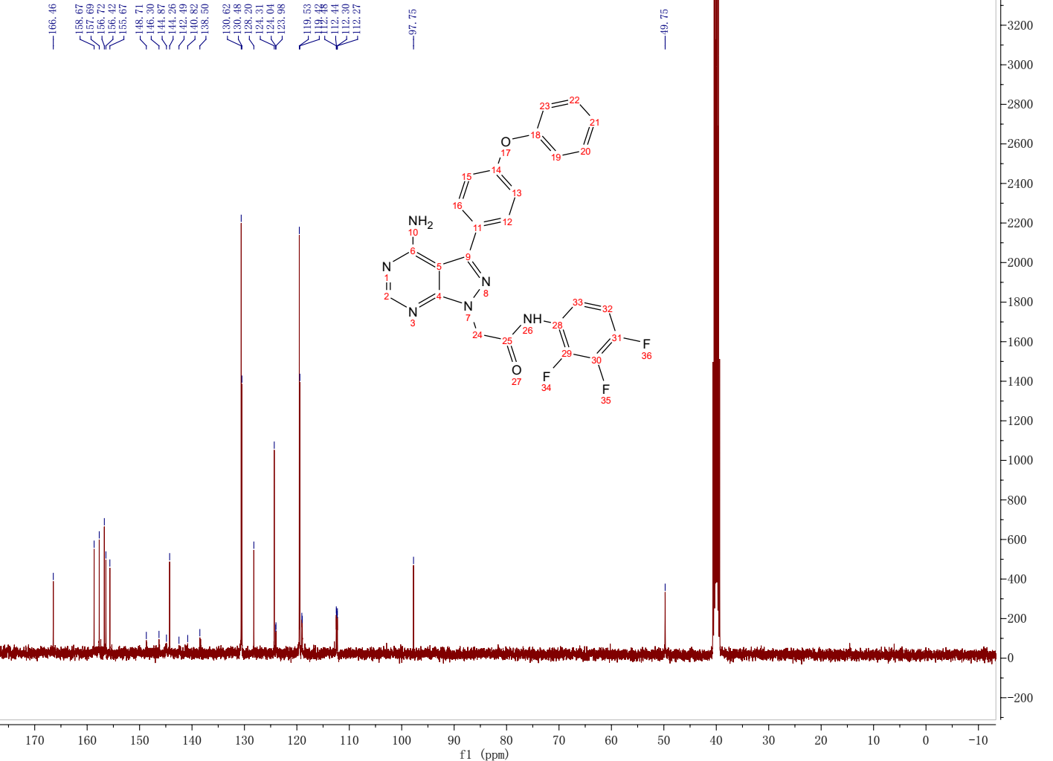
¹³C NMR spectrum of the target compound 13t

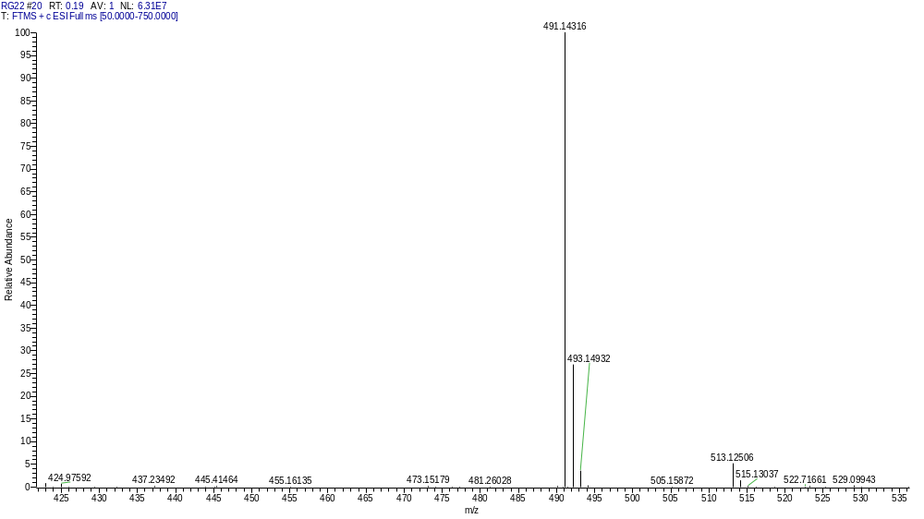
HRMS of the target compound 13t

Compound 13u
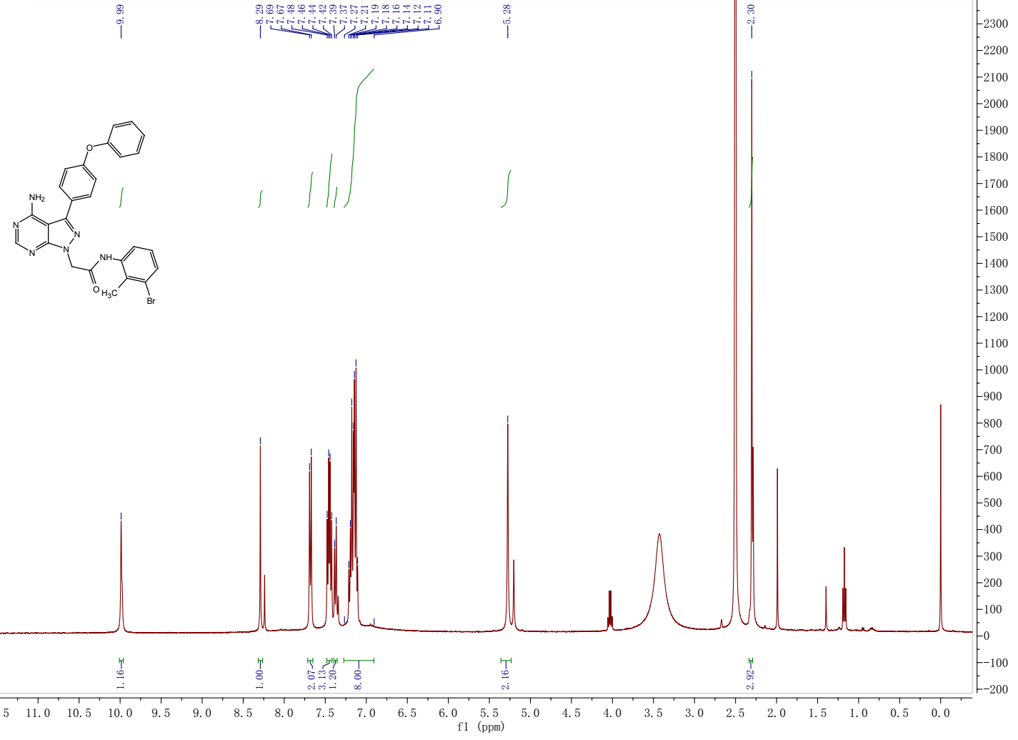
¹H NMR spectrum of the target compound 13u
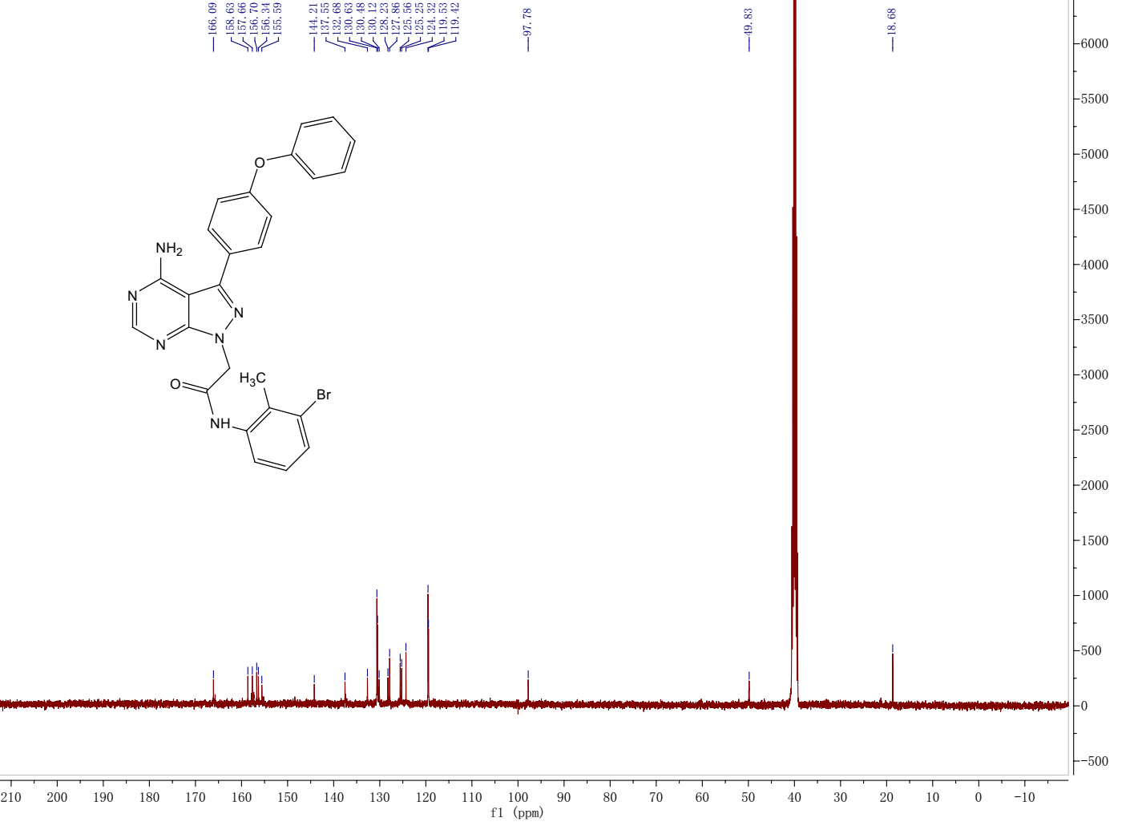
¹³C NMR spectrum of the target compound 13u

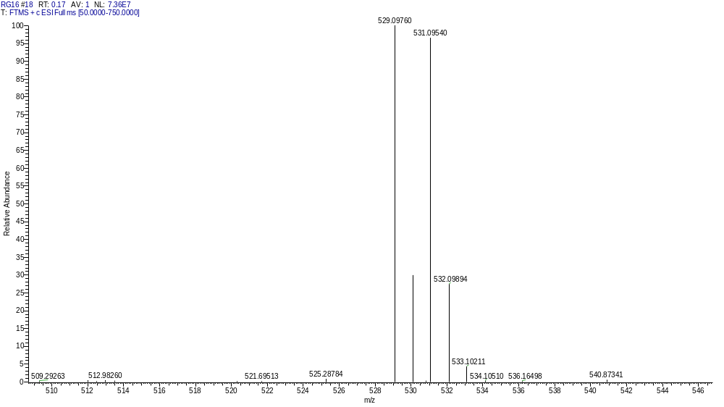
HRMS of the target compound 13u

Compound 13v
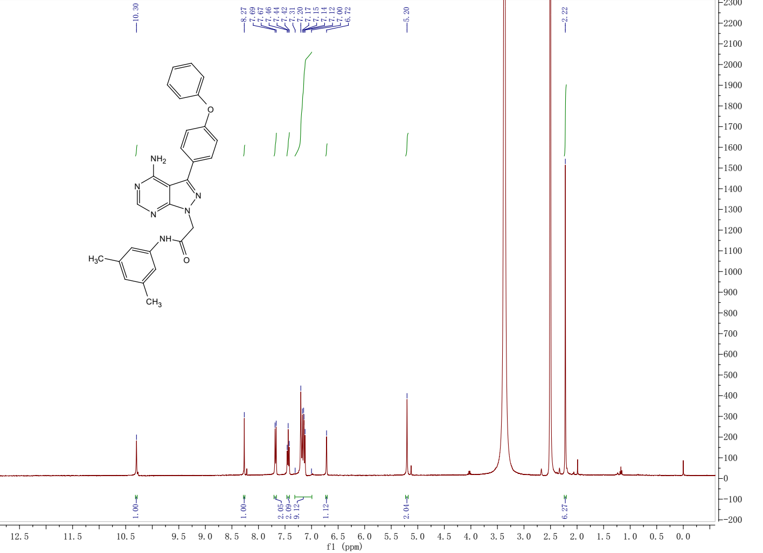
¹H NMR spectrum of the target compound 13v
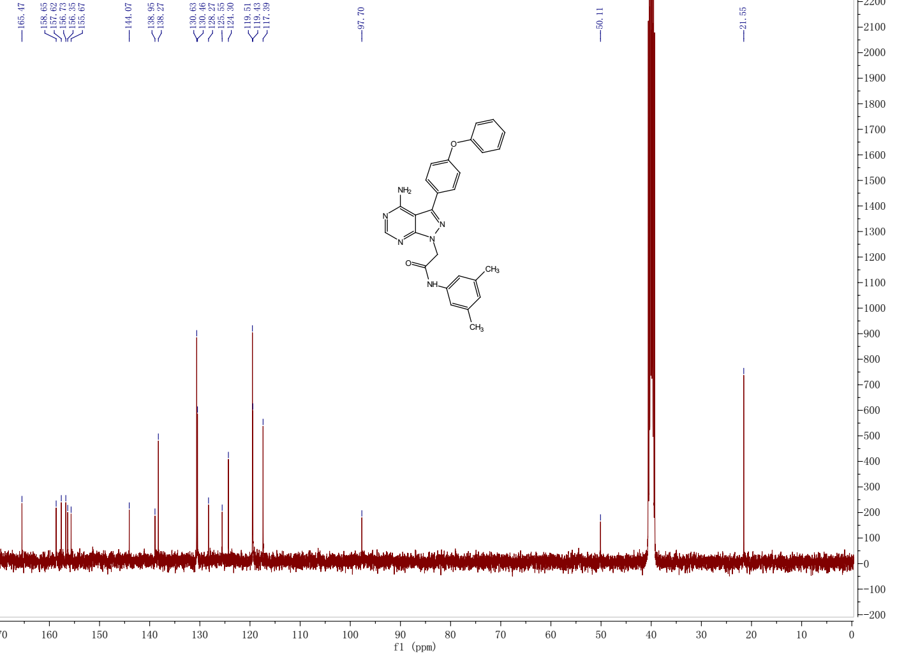
¹³C NMR spectrum of the target compound 13v

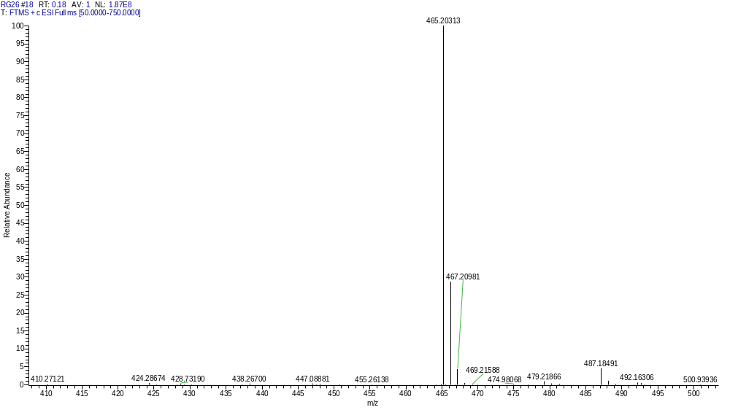
HRMS of the target compound 13v

