Supplementary analysis of microbiota maturation across additional Ross and Hubbard cohorts
In the primary cohort, we identified four stages of early-life caecal microbiota maturation, characterised by distinct microbial community configurations. To assess the robustness of these caecal microbiota fluctuations, two additional broiler cohorts were analysed.
Materials and methods
In brief, the primary cohort described in the main paper consisted of male Ross 308 broilers obtained from a local hatchery, and housed at the faculty of Veterinary Medicine of Ghent University (Belgium) in 2019. The two additional cohorts (Ross 308 and Hubbard Redbro, which is a slower-growing broiler genotype) were housed at Flanders Research Institute for Agriculture, Fisheries and Food (ILVO, Merelbeke-Melle, Belgium) in 2025. Chicks in the additional cohorts, consisting of 288 chicks each, were hatched on-farm within the trial stables and deprived of feed and water for 48h post-hatch, mimicking the conditions of commercial hatchery practice, as was used in the primary cohort.
Additionally, because chicks in the primary cohort were obtained from the hatchery within a 24h-48h post-hatch window (referred to as day-old chicks), hatching was closely monitored in the validation cohorts to exclude differences in biological age as a potential explanation for the inter-individual variability in pace of microbiota maturation observed in the primary cohort. As a result, chicks within each pen were matched for biological age, resulting in nine pens of 17 chicks per cohort in which all birds were identical in biological age.
Both breeds were housed in separate compartments of the same stable and received separate feeds tailored to their nutritional requirements, formulated by poultry nutritionists and produced at ILVO facilities. In contrast, broilers from cohort 1 received commercially available feed formulations (Versele-Laga, Deinze, Belgium).
Sampling schedules were largely similar between both the 2019 and 2025 cohorts, with sampling in the additional cohorts taking place between days 2 – 8 and on days 10, 14 and 21, compared with day 2 – 11, 22 and 29 in the primary cohort. Sample collection, DNA extraction, sequencing and statistical analysis were all performed as described in the main manuscript. Note that on day 2 and 3 in the additional cohorts, a pooled sample of four chicks per pen was considered as one biological replicate to obtain sufficient caecal content for analysis.
To increase the number of observations available for defining microbial community states and thereby improving the resolution of the maturation-stage classification, Dirichlet multinomial mixture (DMM) modelling was performed on a combined dataset including all three cohorts. Subsequent analyses were performed independently for each cohort, allowing assessment of the reproducibility of the identified maturation stages and the consistency of maturation-associated microbial features across cohorts.
Results & Discussion
DMM-clustering revealed the same maturation stage clusters in both validation cohorts as observed for the original cohort. The recovery of similar maturation stages within a combined dataset containing three independent cohorts, despite marked differences in genotype, housing environment and year of sampling, supports the existence of discrete and reproducible microbiota maturation stages during the first weeks post-hatch. Moreover, birds of identical biological age frequently occupied different GM maturation stages, even in the validation cohorts where hatch timing was tightly controlled. These observations indicate that biological age alone cannot explain the inter-individual variation in GM maturation stage progression observed among broilers reared under the same experimental conditions.
The two validation cohorts reproduced the main features of caecal microbiota maturation observed in the primary analysis, including four discrete developmental community states, progressive increases in alpha diversity, strong compositional restructuring across maturation stages, and a transition from early colonising communities towards complex anaerobic communities characteristic of later development (Figure 1, Figure 2).
As in the primary cohort, indicator species analysis revealed Clostridium as indicative of maturation stage I and Faecalibacterium as indicative for maturation stage IV in both validation cohorts. No conserved indicator genus was identified for maturation stage II, while indicator taxa associated with maturation stage III differed between cohorts, further supporting the transitional nature of these intermediate maturation stages (Table S6).
The taxonomic composition of corresponding maturation stages was not identical between cohorts. This cohort-specific variation was most pronounced in the intermediate maturation stages, whereas the early and late maturation stages were characterised by more consistent taxonomic signatures. These findings indicate that microbiota maturation represents a reproducible developmental process despite variation in the specific taxa contributing to individual maturation states.

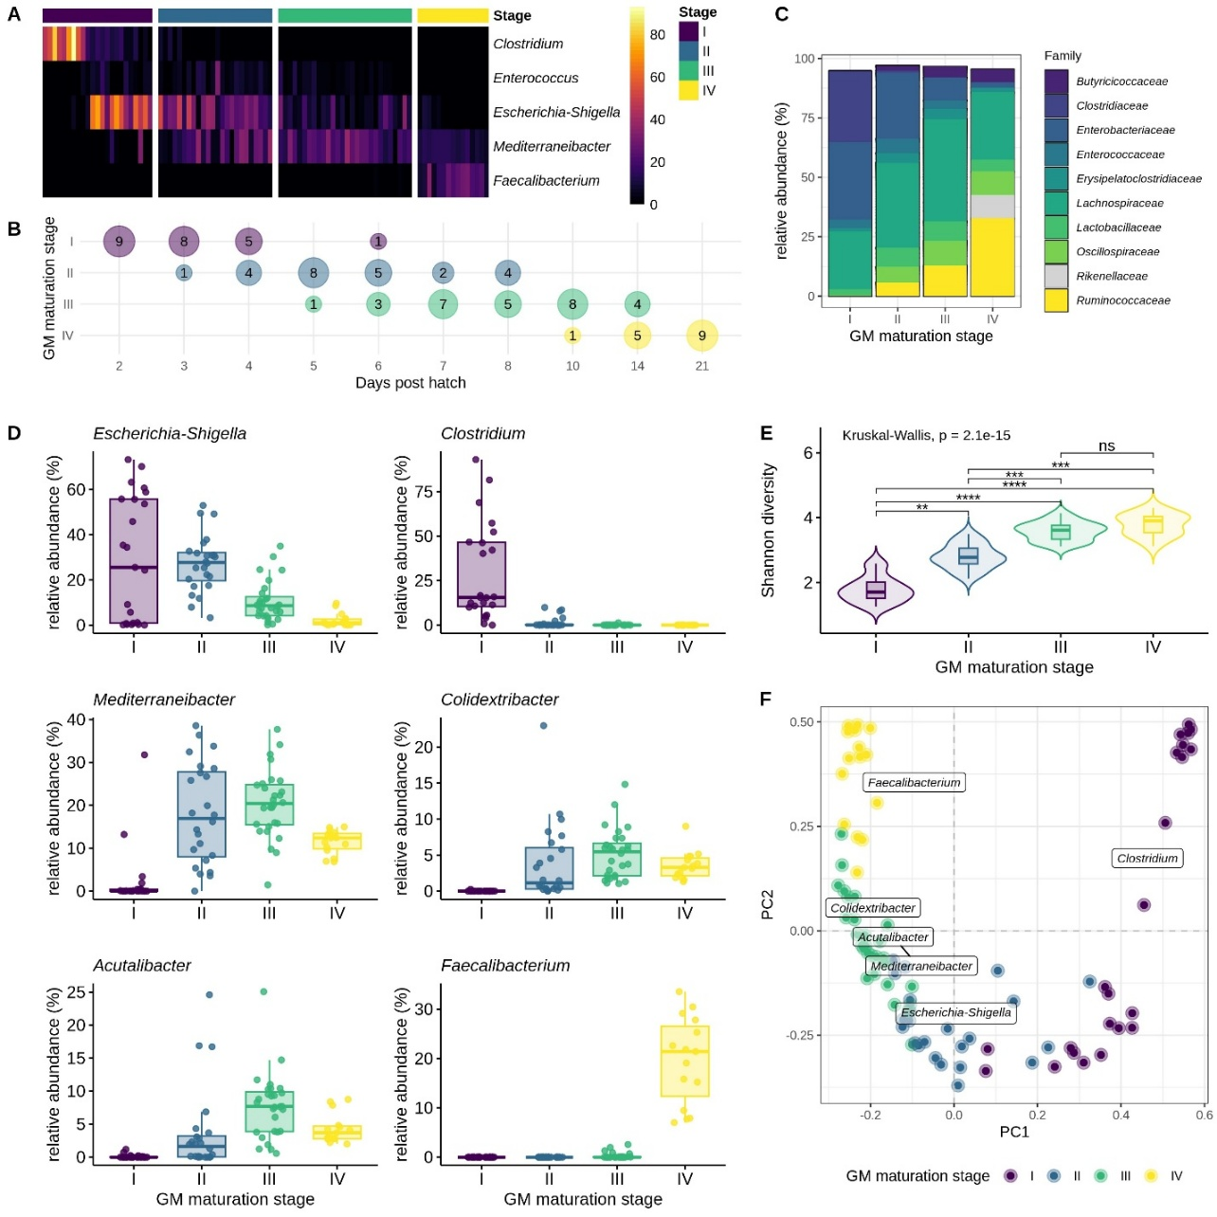
Figure 1. Caecal microbiota maturation stages in Ross308, cohort 2. Samples were grouped based on genus-level microbial community composition using Dirichlet multinomial mixtures (DMM) clustering, identifying four distinct maturation stages. (A) Heatmap showing the relative abundance of genera most strongly associated with the identified maturation stages. Each cell corresponds to the microbiota of an individual bird. Within each gut microbiota (GM) maturation stage, samples are ordered by bird age. (B) Graphic representation of the microbiota progression in the caecum. Nodes are ordered based on age of the birds and labelled to include the number of samples per timepoint allocated to each GM maturation stage. (C) The relative microbial abundance of the most abundant families per GM maturation stage. (D) The relative microbial abundance of a selection of representative genera of each GM maturation stage is visualised in comparison with the relative abundance in the other GM maturation stages, with each dot representing an individual chicken microbiota. (E) The alpha diversity (Shannon index) plotted for each GM maturation stage. (F) Principal component analysis (PCA) plots of Hellinger transformed genus-level microbiota variation. Each dot represents an individual chicken microbiota and is colored based on the GM maturation stage. The weighted average scores of the drivers for the different GM maturation stages were a posteriori projected.
ns p > 0.05, * p ≤ 0.05, ** p ≤ 0.01, *** p ≤ 0.001, ****p ≤ 0.0001

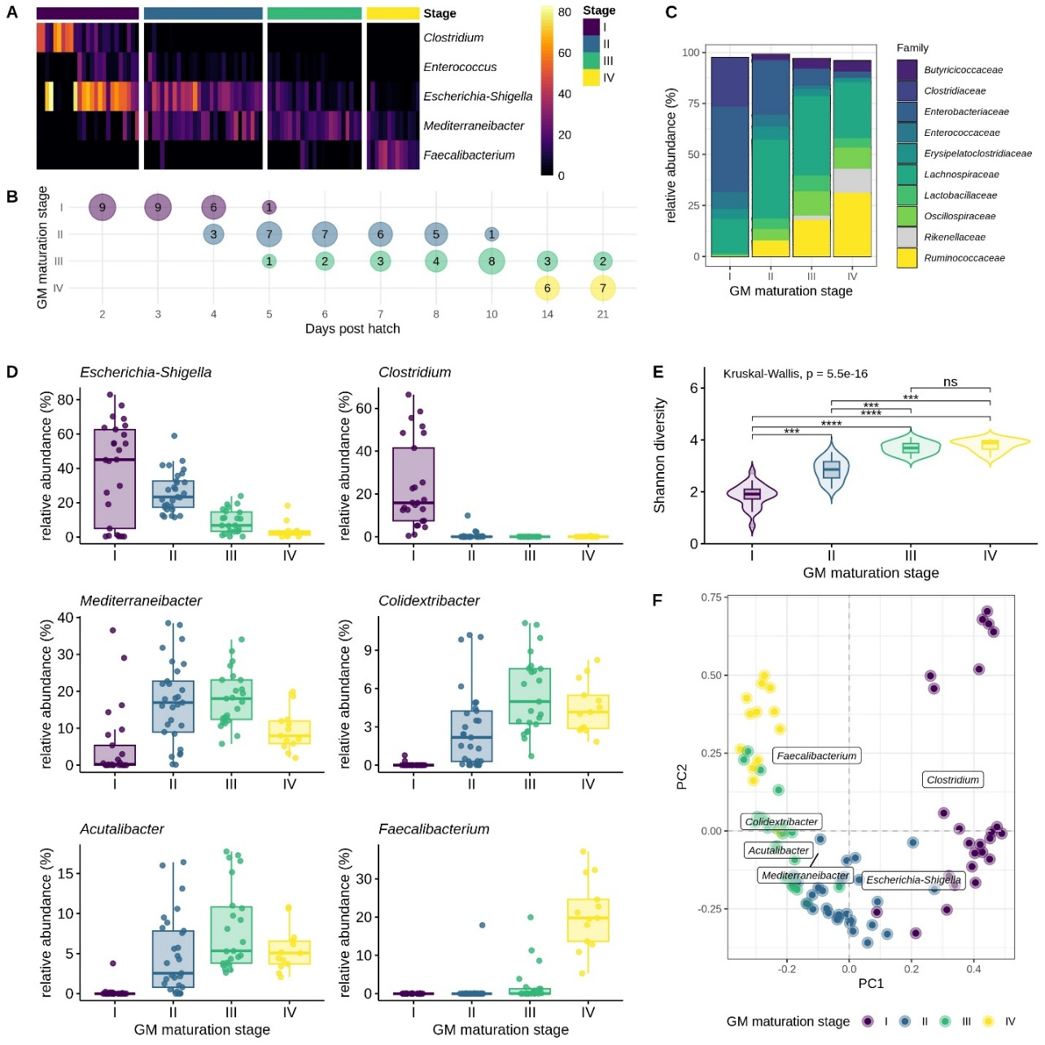
Figure 2. Caecal microbiota maturation stages in Hubbard Redbro cohort. Samples were grouped based on genus-level microbial community composition using Dirichlet multinomial mixtures (DMM) clustering, identifying four distinct maturation stages. (A) Heatmap showing the relative abundance of genera most strongly associated with the identified maturation stages. Each cell corresponds to the microbiota of an individual bird. Within each gut microbiota (GM) maturation stage, samples are ordered by bird age. (B) Graphic representation of the microbiota progression in the caecum. Nodes are ordered based on age of the birds and labelled to include the number of samples per timepoint allocated to each GM maturation stage. (C) The relative microbial abundance of the most abundant families per GM maturation stage. (D) The relative microbial abundance of a selection of representative genera of each GM maturation stage is visualised in comparison with the relative abundance in the other GM maturation stages, with each dot representing an individual chicken microbiota. (E) The alpha diversity (Shannon index) plotted for each GM maturation stage. (F) Principal component analysis (PCA) plots of Hellinger transformed genus-level microbiota variation. Each dot represents an individual chicken microbiota and is colored based on the GM maturation stage. The weighted average scores of the drivers for the different GM maturation stages were a posteriori projected.
ns p > 0.05, * p ≤ 0.05, ** p ≤ 0.01, *** p ≤ 0.001, ****p ≤ 0.0001

