Supplementary figures
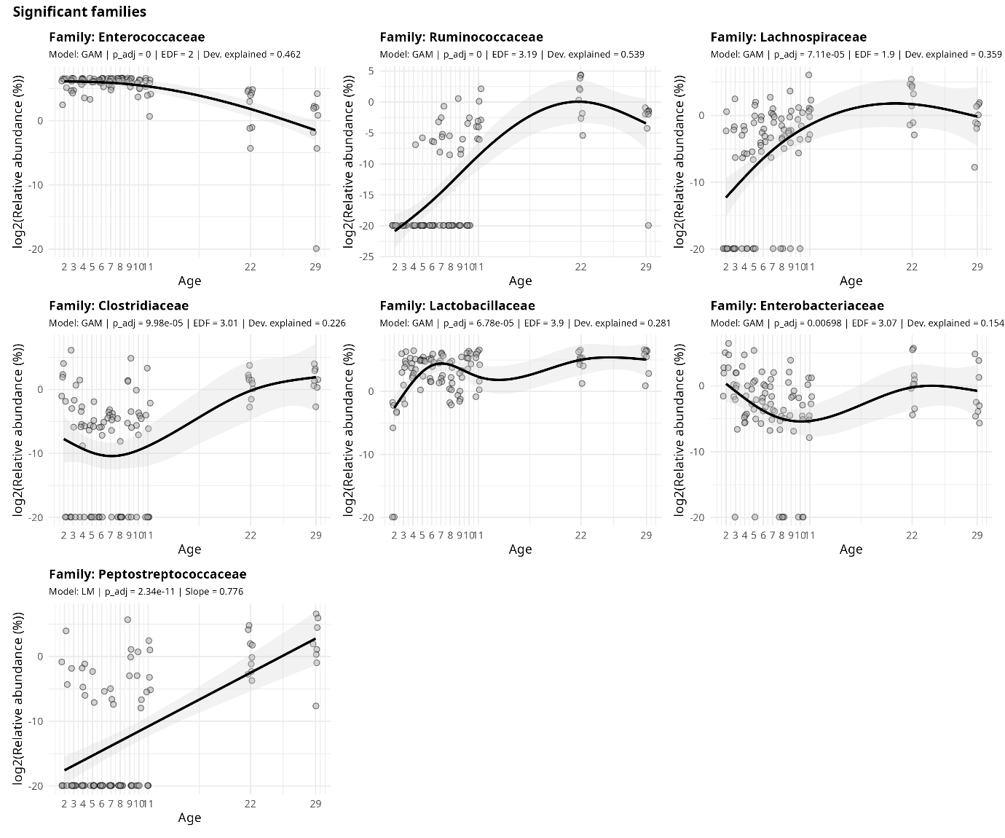
Figure S1. Family relative abundance as a function of age (days post hatch) in the ileum. For each family, both a generalised additive model (GAM) and a linear model (LM) was fitted, after which the best model was selected by comparing the model AICs. GAMs were considered superior when their AIC was at least two units lower than that of the corresponding LM. For GAMs, each plot displays the fitted smooth term for age (solid line) with 95% confidence intervals (shaded area). For LMs, each plot displays the fitted estimate for age (solid line) with 95% confidence intervals (shaded area). The log2 transformed relative abundance values (%) are shown as dots. Read depth was included in the model as a covariate but is not visualised.
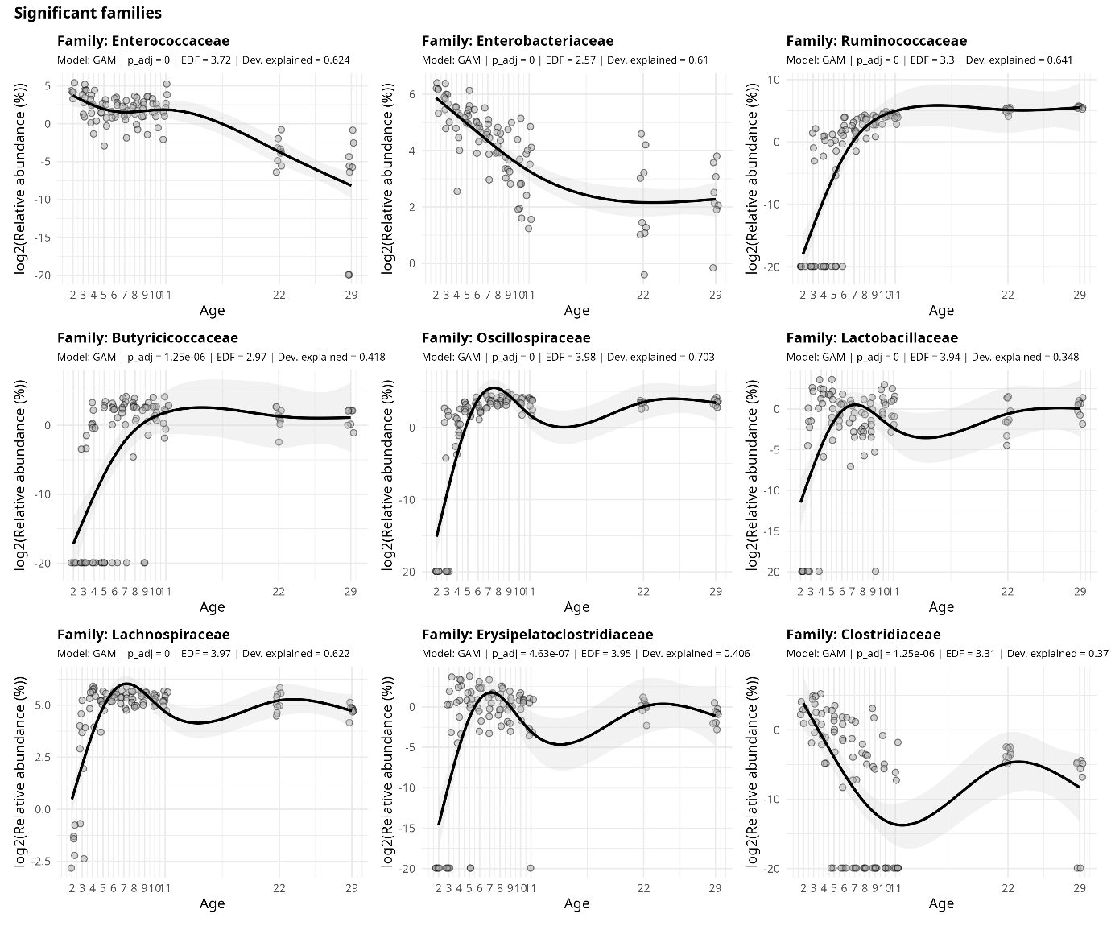
Figure S2. Family relative abundance as a function of age (days post hatch) in the caecum. Each plot displays the fitted smooth term for age (solid line) with 95% confidence intervals (shaded area). The log2 transformed relative abundance values (%) are shown as dots. Read depth was included in the model as a covariate but is not visualised.
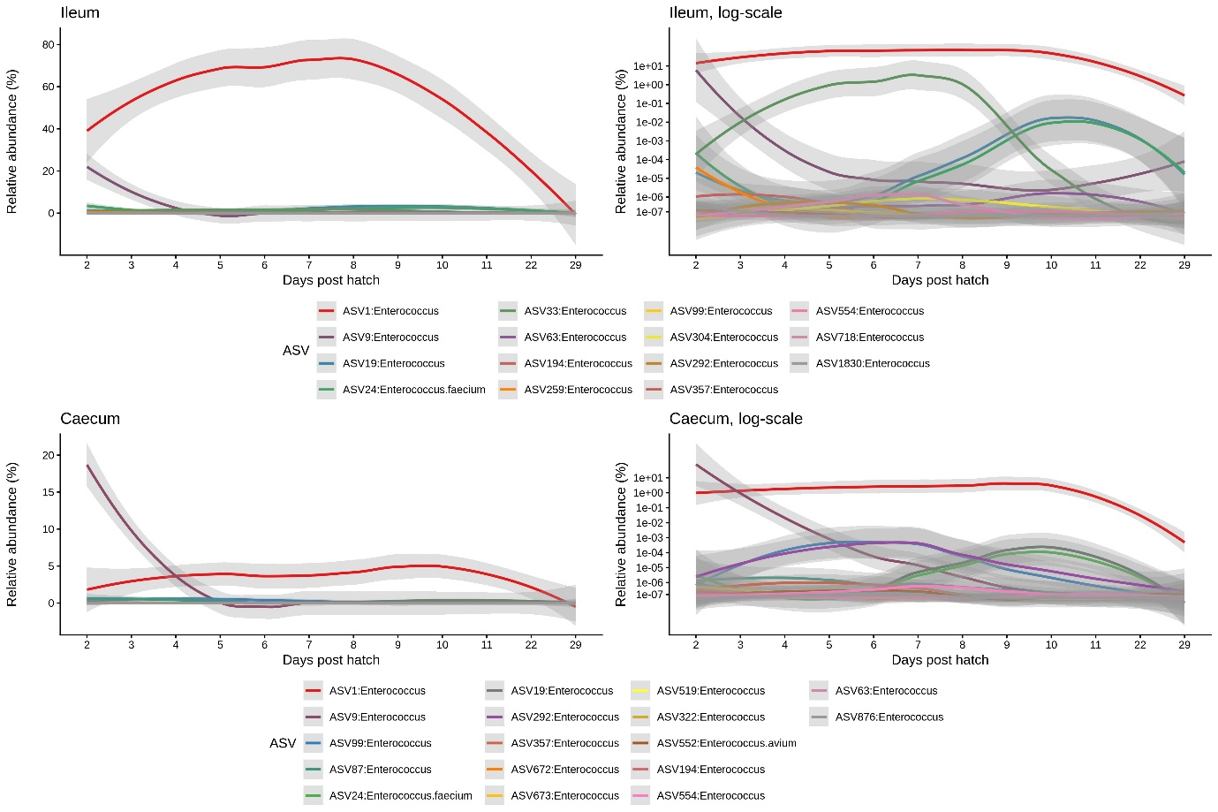
Figure S3. Colonisation patterns of ASVs belonging to the genus Enterococcus. The mean relative abundance of the ASVs belonging to the genus Enterococcus in the ileal (top row) or caecal (bottom row) microbiota are shown. The ASVs are ordered based on the total abundance in the ileum or caecal microbiota. Curves show LOESS fit for the data per category, and shaded areas show 95% confidence intervals for the fit. To support visual interpretation of the data, all graphs are plotted on a linear y-scale (left) and a log-transformed y-scale (right).

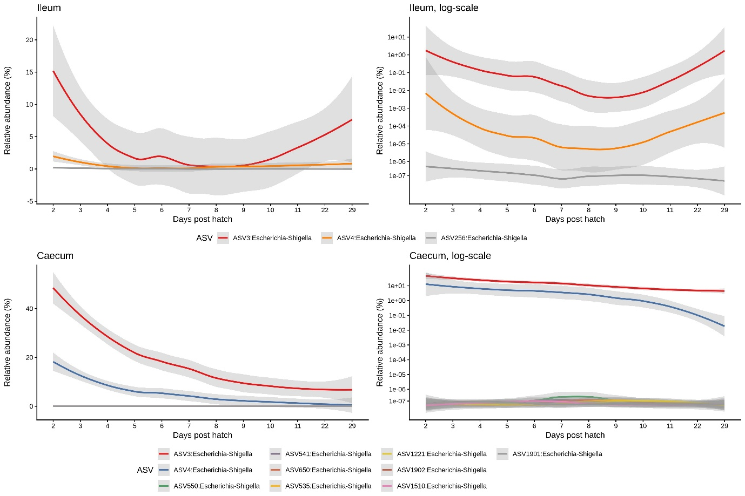
Figure S4. Colonisation patterns of ASVs belonging to the genus Escherichia-Shigella. The mean relative abundance of the ASVs belonging to the genus Escherichia-Shigella in the ileal (top row) or caecal (bottom row) microbiota are shown. The ASVs are ordered based on the total abundance in the ileum or caecal microbiota. Curves show LOESS fit for the data per category, and shaded areas show 95% confidence intervals for the fit. To support visual interpretation of the data, all graphs are plotted on a linear y-scale (left) and a log-transformed y-scale (right).

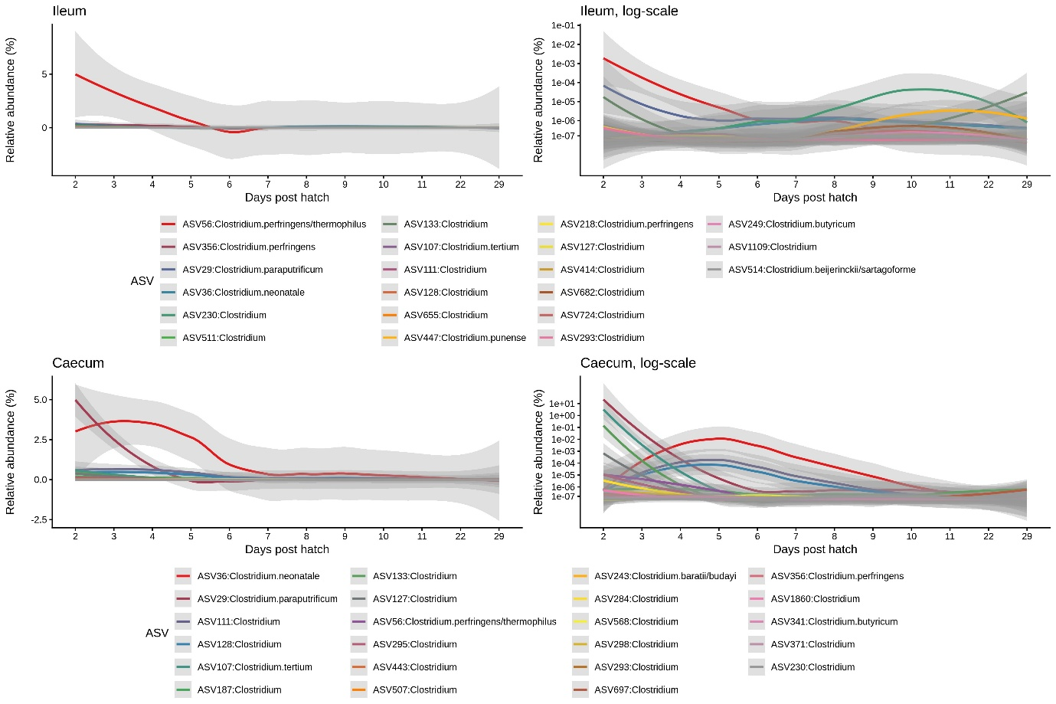
Figure S5. Colonisation patterns of ASVs belonging to the genus Clostridium. The mean relative abundance of the ASVs belonging to the genus Clostridium in the ileal (top row) or caecal (bottom row) microbiota are shown. The ASVs are ordered based on the total abundance in the ileum or caecal microbiota. Curves show LOESS fit for the data per category, and shaded areas show 95% confidence intervals for the fit. To support visual interpretation of the data, all graphs are plotted on a linear y-scale (left) and a log-transformed y-scale (right).

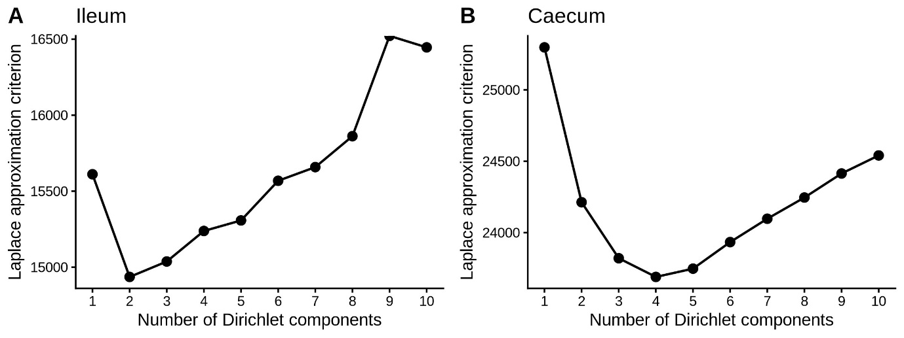
Figure S6. Selection of the number of Dirichlet multinomial mixture (DMM) components for ileal and caecal microbiota. The Laplace approximation criterion is shown for models containing increasing numbers of Dirichlet components. The models with lowest criterion values were selected as the optimal model, resulting in two components in the ileum (A) and four components in the caecum (B).
Figure S7. Contribution of the taxonomic groups to the DMM determined maturation stages. The top microbial drivers for each DMM cluster in the caecum (A: DMM cluster I, B: DMM cluster II, C: DMM cluster III and D: DMM cluster IV) and ileum (E: ileal DMM cluster I, F: DMM cluster II) are shown. The microbial genera shown are limited to the top 10% drivers for each DMM cluster.

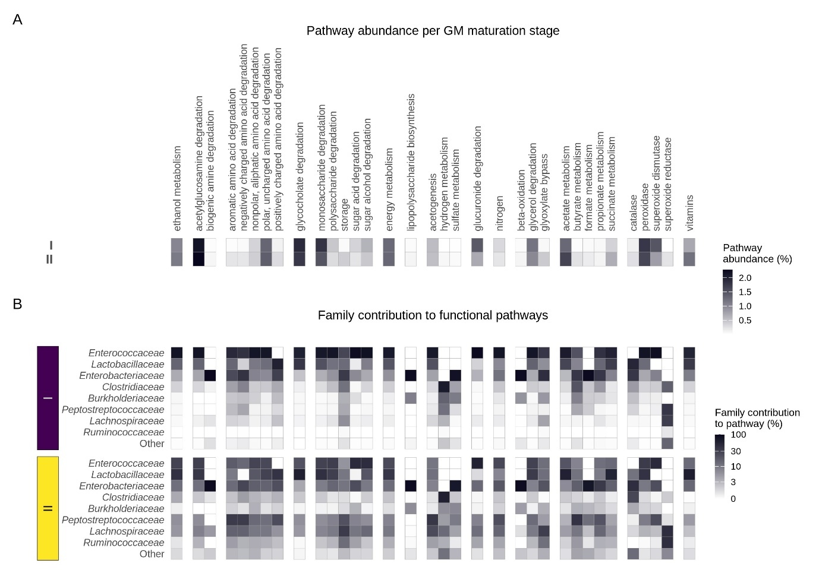

Figure S8. Functional prediction of the successional ileal gut maturation stages. PICRUSt2-predicted KEGG Orthologues (KOs) were mapped to Gut Metabolic Modules (GMMs) representing predicted microbial metabolic pathways. Predicted functions are shown across the two identified ileal maturation stages. (A) Relative abundance of predicted functional pathways (GMMs) across successional GM maturation stages. (B) Heatmap showing the relative contribution of the top 8 ileal bacterial families to predicted functional pathways within each ileal GM maturation stage. Colours indicate the proportion of a given functional pathway that is attributed to each bacterial family, independent of the overall abundance of that pathway. Families not among the dominant taxa were grouped as “Other”.

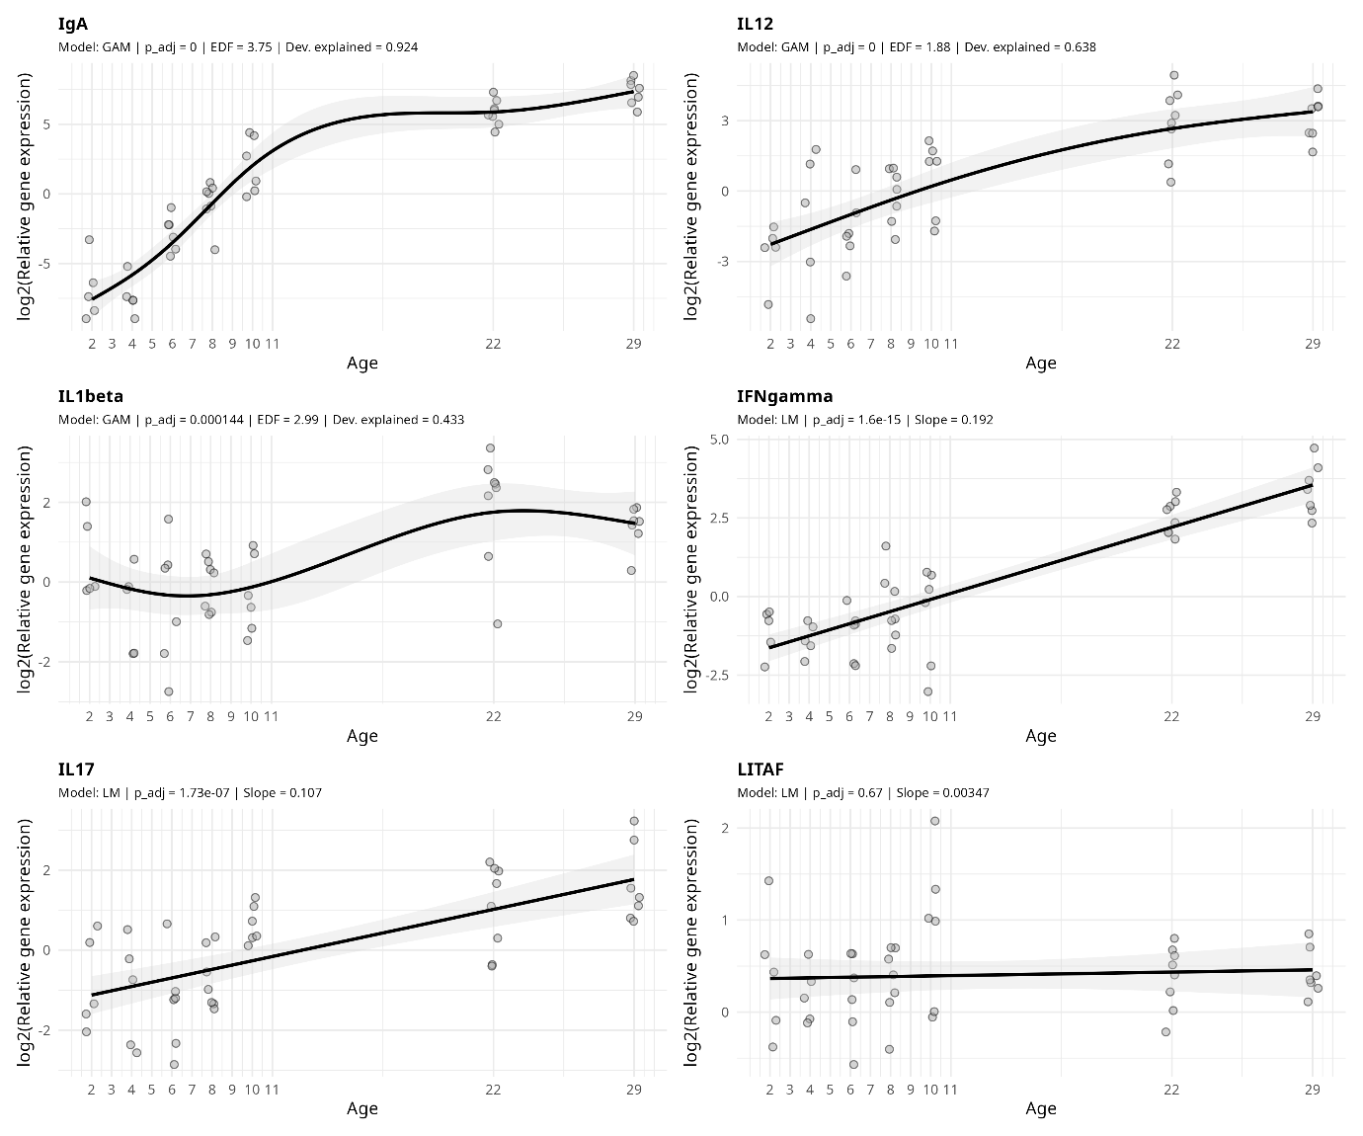

Figure S9. Relative gene expression as a function of age (days post hatch) in the ileum. For each gene, both a generalised additive model (GAM) and a linear model (LM) was fitted, after which the best model was selected by comparing the model AICs. GAMs were considered superior when their AIC was at least two units lower than that of the corresponding LM. For GAMs, each plot displays the fitted smooth term for age (solid line) with 95% confidence intervals (shaded area). For LMs, each plot displays the fitted estimate for age (solid line) with 95% confidence intervals (shaded area). The log2 transformed relative gene expression values are shown as dots.
Note: LITAF is included in the plot for completeness, but did not change with age.

