SUPPORT INFORMATION
A polarized charge model for RNA: enhanced stability of G-quadruplexes and improved folding free energy landscapes

Shuaizhen Tian¹, Nana Wang², Xinxin Du¹, Mengxi Qiu¹, John Z.H. Zhang^{3*}
¹ School of Life Science and Engineering, Jining University, Jining 273199, China.
²Department of Criminal Science and Technology, Shandong Police College, Jina 250200, China
³ Faculty of Synthetic Biology, Shenzhen University of Advanced Technology, Shenzhen 518000, China

Contents
- Supplementary Fig. S1,S2
Schematic diagram illustrating the calculation procedure of the PNC model.
- Supplementary Fig. S3,S4
PLUMED input file
- Supplementary Fig. S5
Schematic diagram of the convergence for PNC calculations.
- Supplementary Fig. S6,S7
RMSD variations of the overall 8UTG system and G-tetrad over simulation time.
- Supplementary Fig. S8
Schematic diagram showing the outward escape of ammonium ions and counterions within the 8UTG channel.
- Supplementary Fig. S9-S17
Stability of ions under different force fields combined with distinct ion models.
- Supplementary Fig. S18
Schematic diagram of electrostatic potential calculations at different positions of mobile ions.
- Supplementary Fig. S19-S22
Variations in hydrogen bond distances between G-G pairs over simulation time under different force fields.
- Supplementary Fig. S23-S36
Convergence of metadynamics simulations with different simulation durations under various force fields.
- Supplementary Fig. S37,S38
Free Free energy profiles obtained from MetaD simulations using different force fields.
- Supplementary Fig. S39-S41
Hydrogen bonds in the experimental structure of 1F7Y.
- Supplementary Table S1
Lennard-Jones parameters of different K⁺ and Na⁺ models.
- Supplementary Table S2
The charges of the important atoms in 24 residues from the 8UTG system under different force fields.
- Supplementary Table S3
The number of state transition of folding during the metadynamics simulations.
- Supplementary Table S4
The charges of the important atoms in the 6 residues from 1F7Y system forming the hydrogen bonds under different force fields.

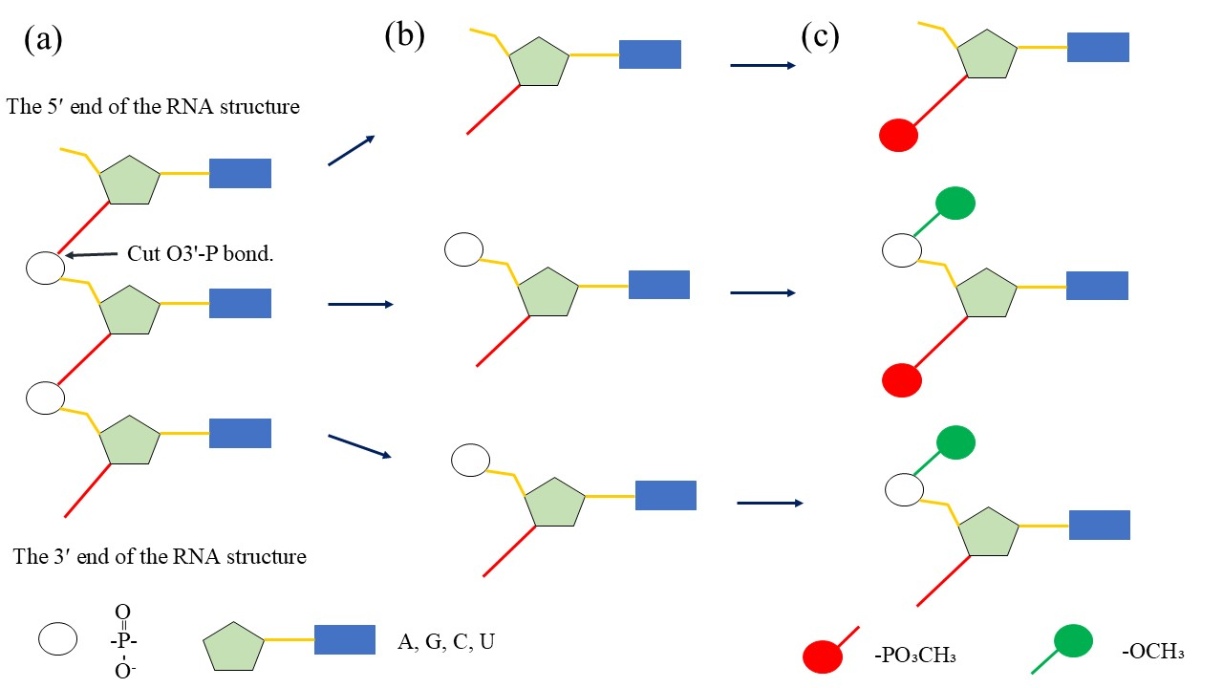
Fig. S1 The process of dividing the RNA structure into several fragments within the PNC method. (a) the RNA structure, (b) the fragment immediately after cleavage, (c) the fragment following capping

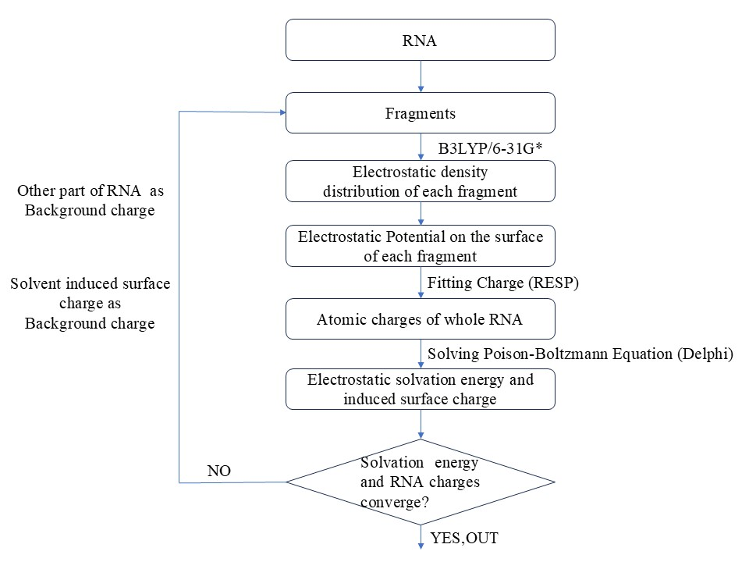
Fig. S2 The flow chart for PNC generation
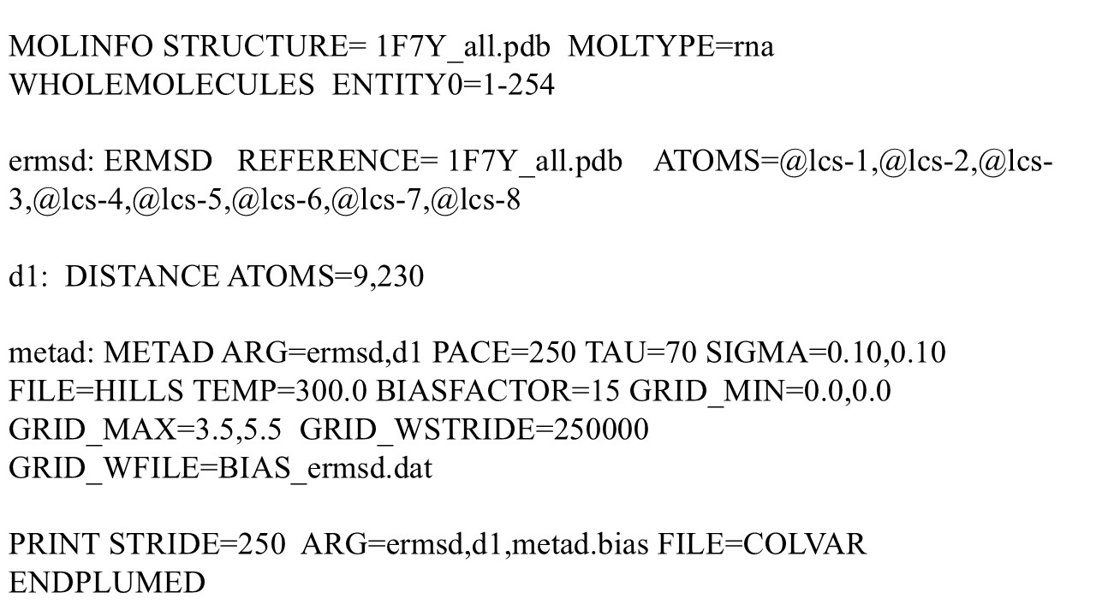
Fig. S3 The input parameters of PLUMED during eRMSD and Distance as CVs
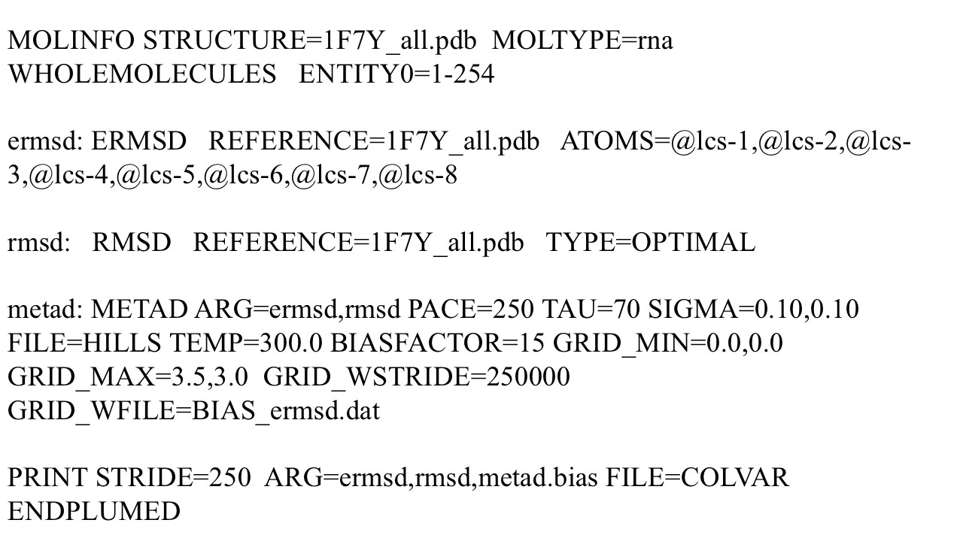
Fig. S4 The input parameters of PLUMED during eRMSD and RMSD as CVs
Table S1 Lennard-Jones parameters of different K⁺ and Na⁺ models
Ion model | K⁺ ion model |  | Na⁺ ion model
Ion model | ɛ (Kcal/mol) | r_{m}/2(Å) | ɛ (Kcal/mol) | r_{m}/2(Å)
JC | 0.4297 | 1.593 | 0.3526 | 1.212
DK | 0.1000 | 1.870 | - | -
IOD | 0.1702 | 1.745 | 0.0291 | 1.465
HFE | 0.1513 | 1.683 | 0.0264 | 1.454
AMBER | 0.1937 | 1.705 | 0.0028 | 1.868

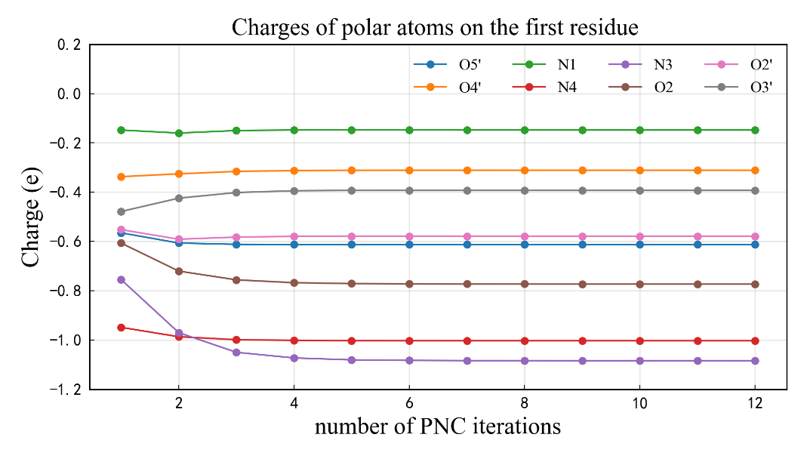
Fig. S5 Charge evolution of polar atoms on residue C1 in the 8UTG structure during PNC parameter calculation

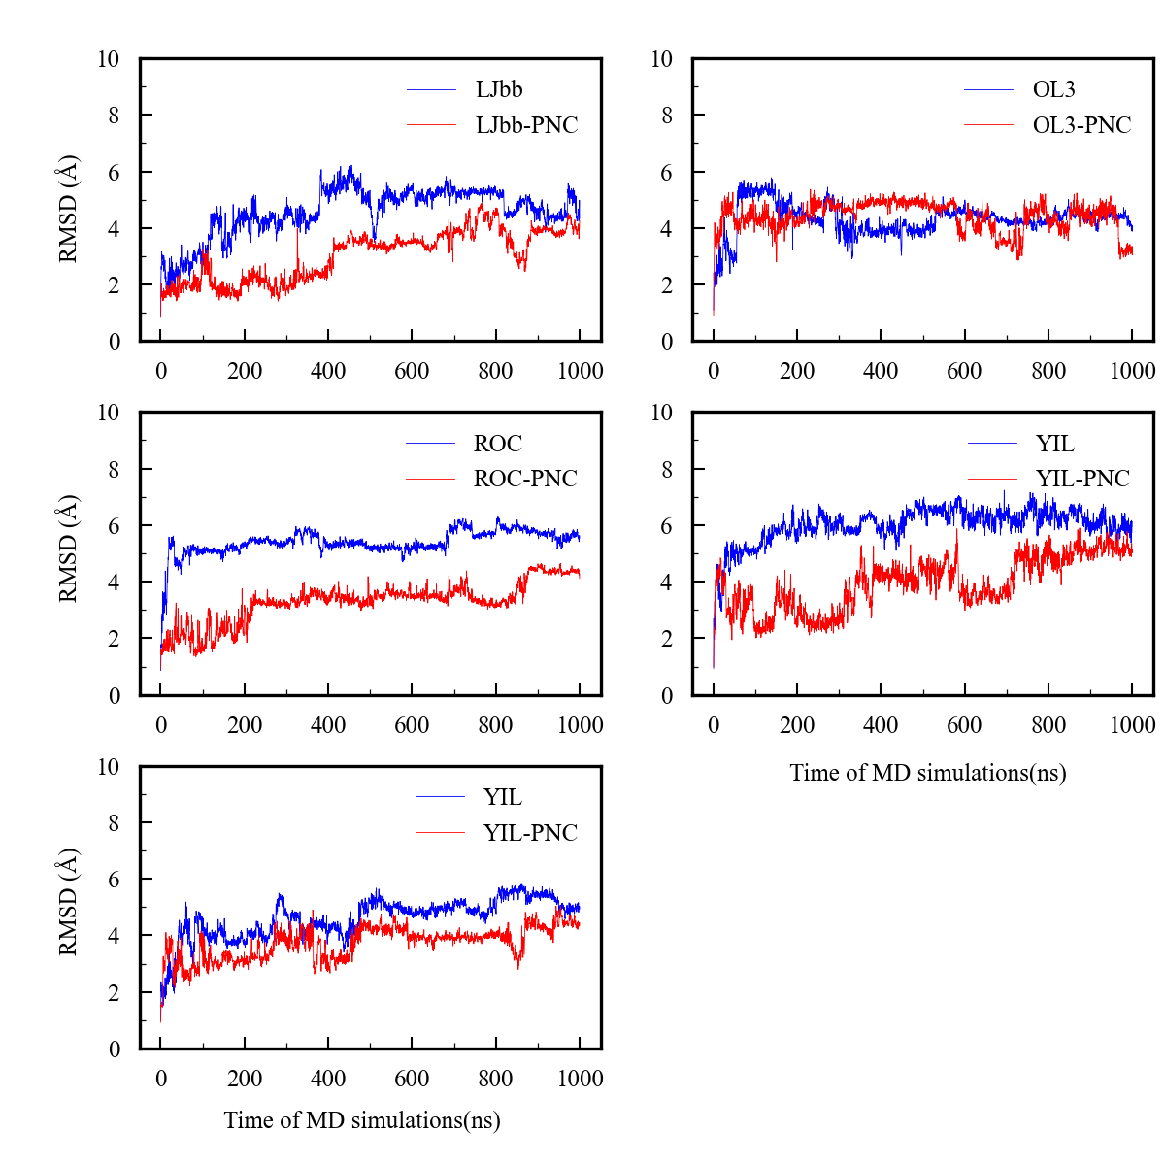
Fig. S6 RMSD for 8UTG systems in the 1000ns MD simulations using different force filed
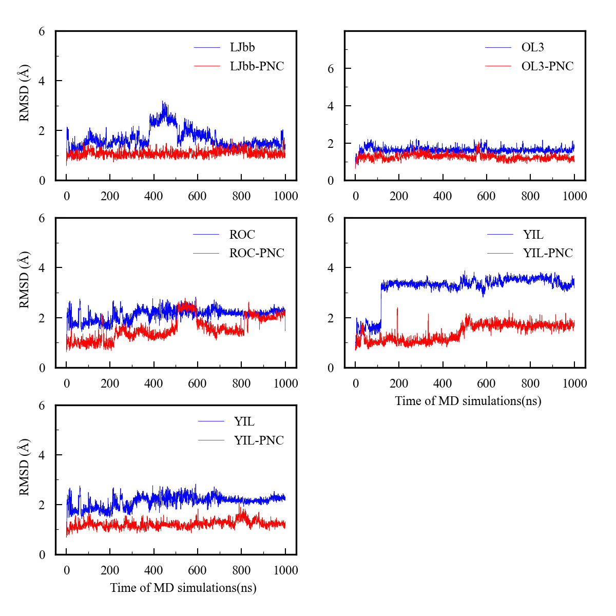
Fig. S7 RMSD of G-tetrads for 8UTG systems in the 1000ns MD simulations using different force filed
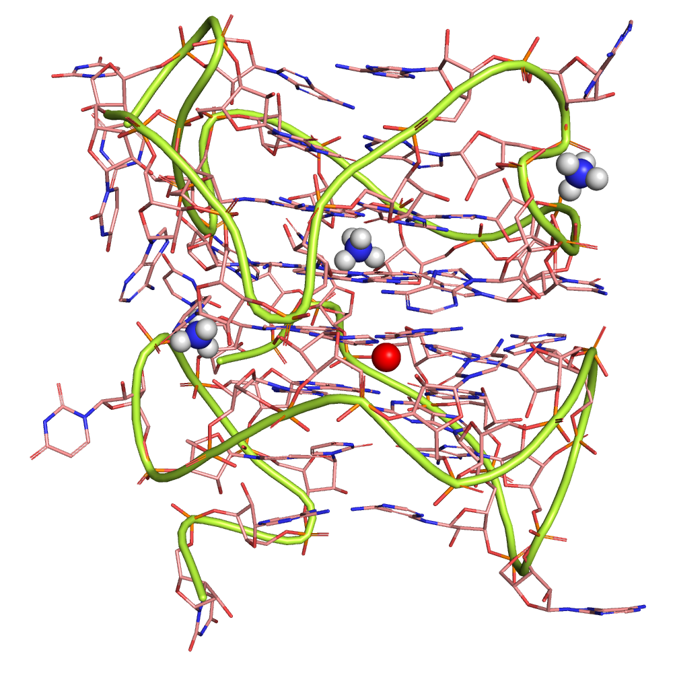
Fig. S8 In OL3 force field, the terminal NH₄⁺ ions detach from their original coordination sites and migrate into the outer grooves of the GQ, where they form stable interactions with phosphate groups. This structure was extracted from the final frame of the simulation. Similar behaviors were also observed under the ROC and Shaw force fields
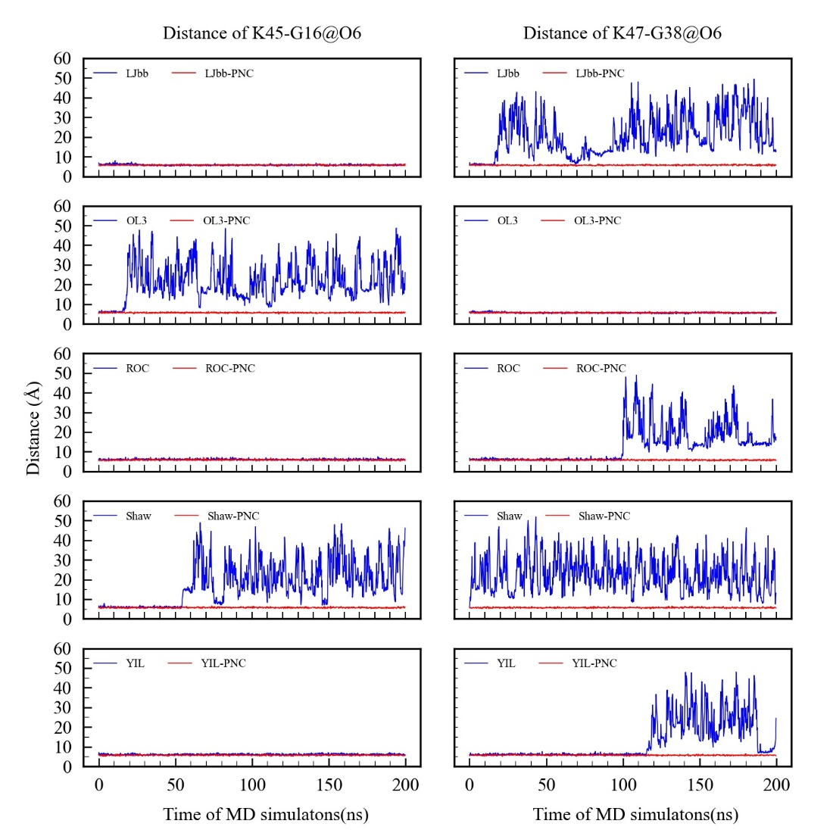
Fig. S9 Using JC K⁺ parameters, the distance of K45-G16@O6 and K47-G38@O6 as a function of simulation time under different force field simulations
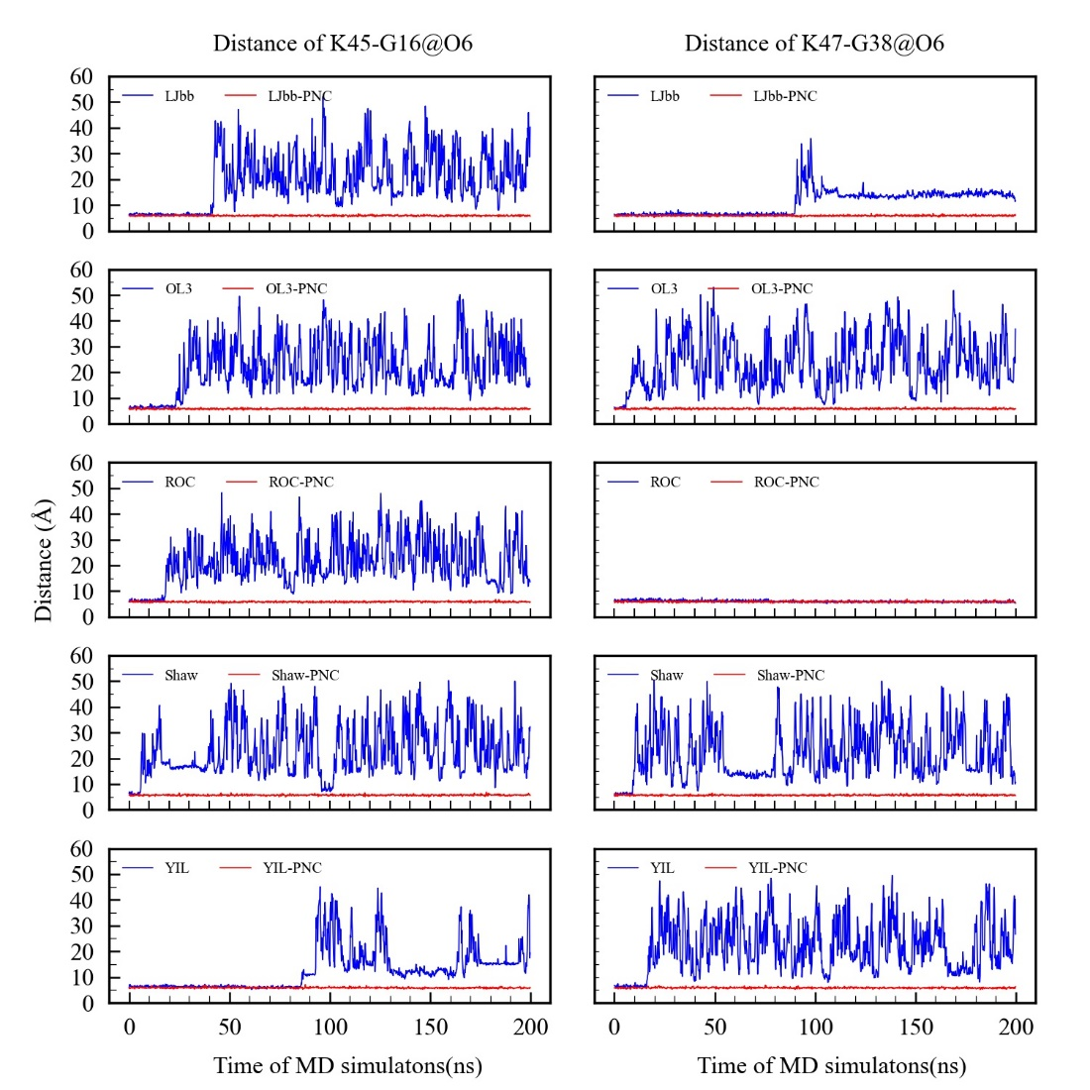
Fig. S10 Using DK K⁺ parameters, the distance of K45-G16@O6 and K47-G38@O6 as a function of simulation time under different force field simulations

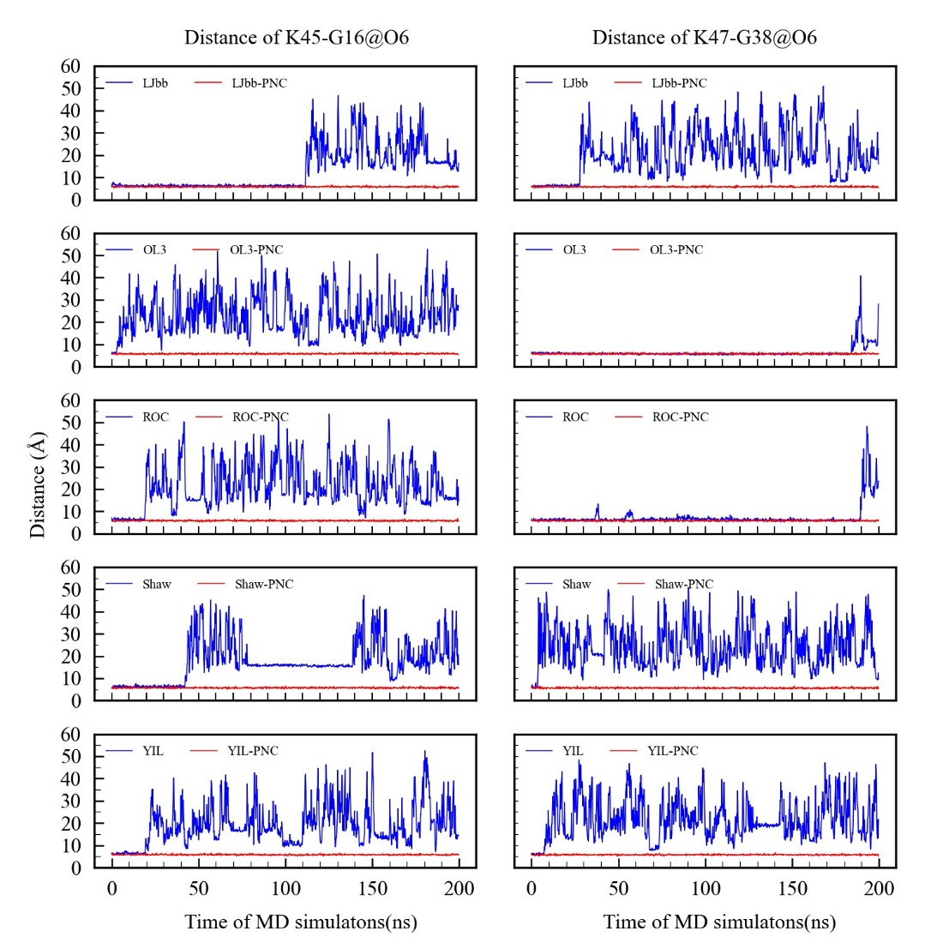
Fig. S11 Using IOD K⁺ parameters, the distance of K45-G16@O6 and K47-G38@O6 as a function of simulation time under different force field simulations
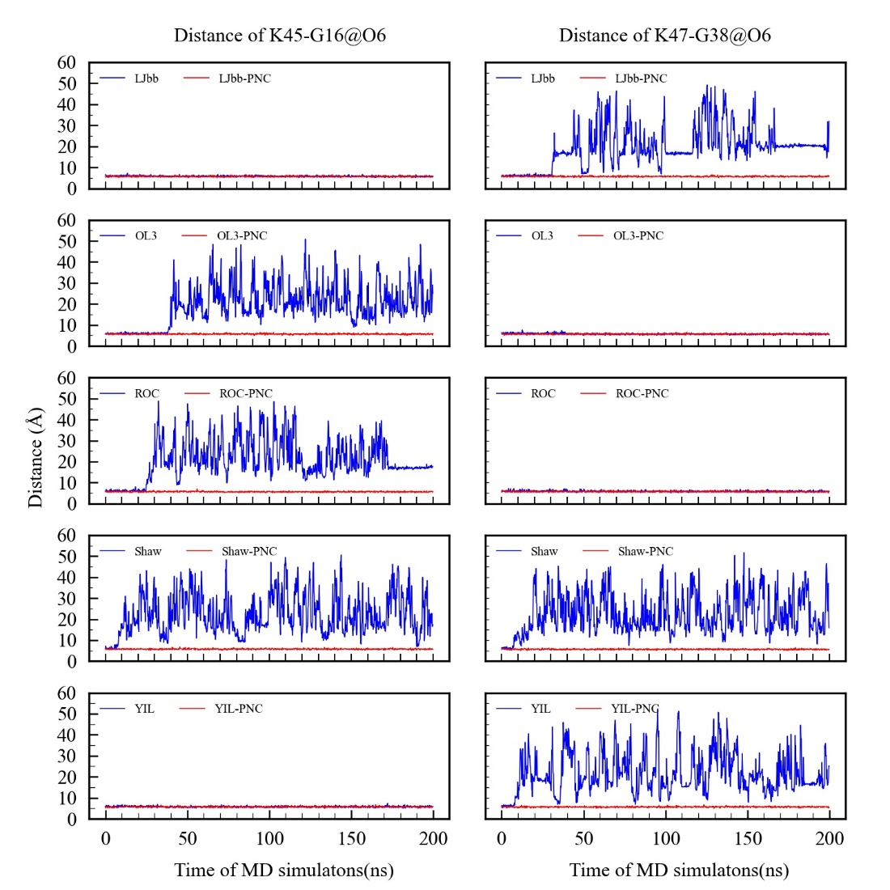
Fig. S12 Using HFE K⁺ parameters, the distance of K45-G16@O6 and K47-G38@O6 as a function of simulation time under different force field simulations

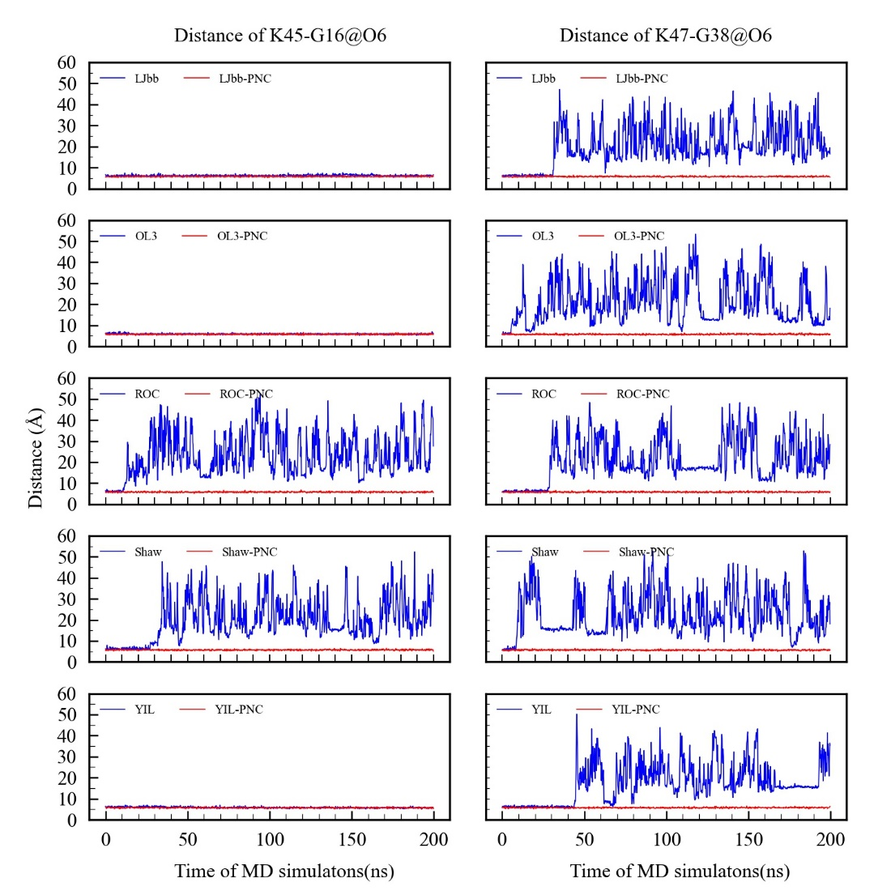
Fig. S13 Using Amber K⁺ parameters, the distance of K45-G16@O6 and K47-G38@O6 as a function of simulation time under different force field simulations

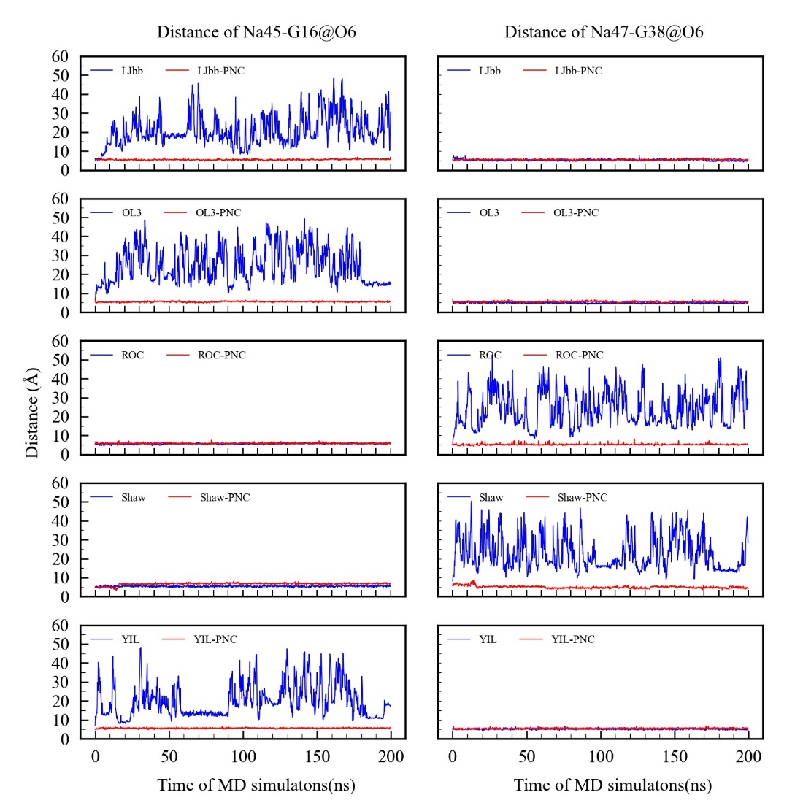
Fig. S14 Using JC Na⁺ parameters, the distance of Na45-G16@O6 and Na47-G38@O6 as a function of simulation time under different force field simulations

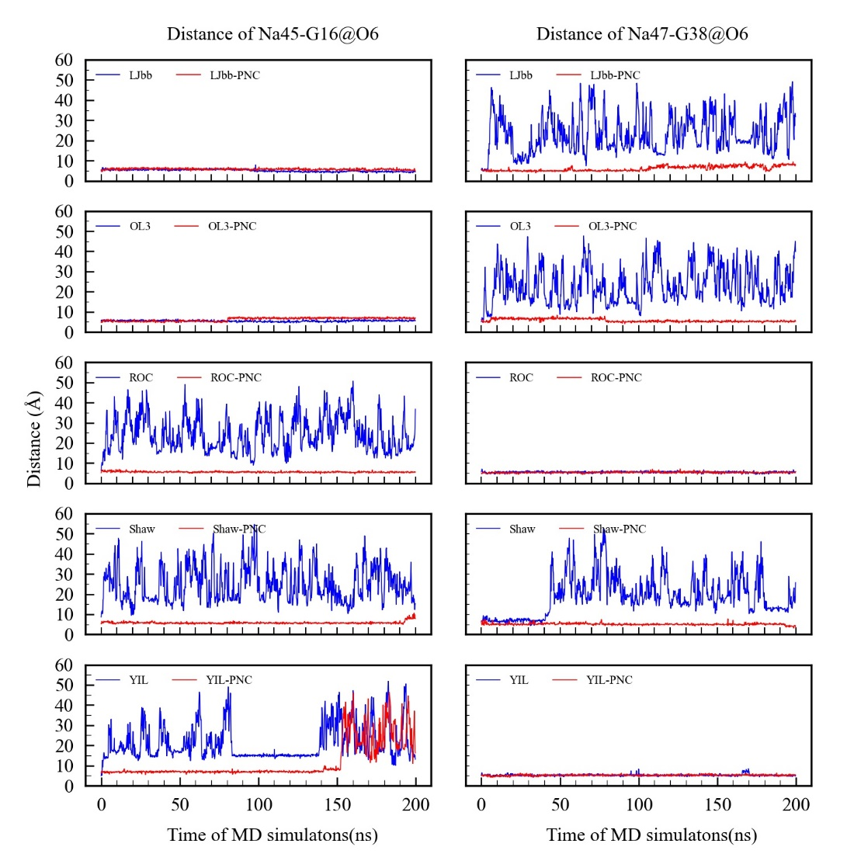
Fig. S15 Using IOD Na⁺ parameters, the distance of Na45-G16@O6 and Na47-G38@O6 as a function of simulation time under different force field simulations

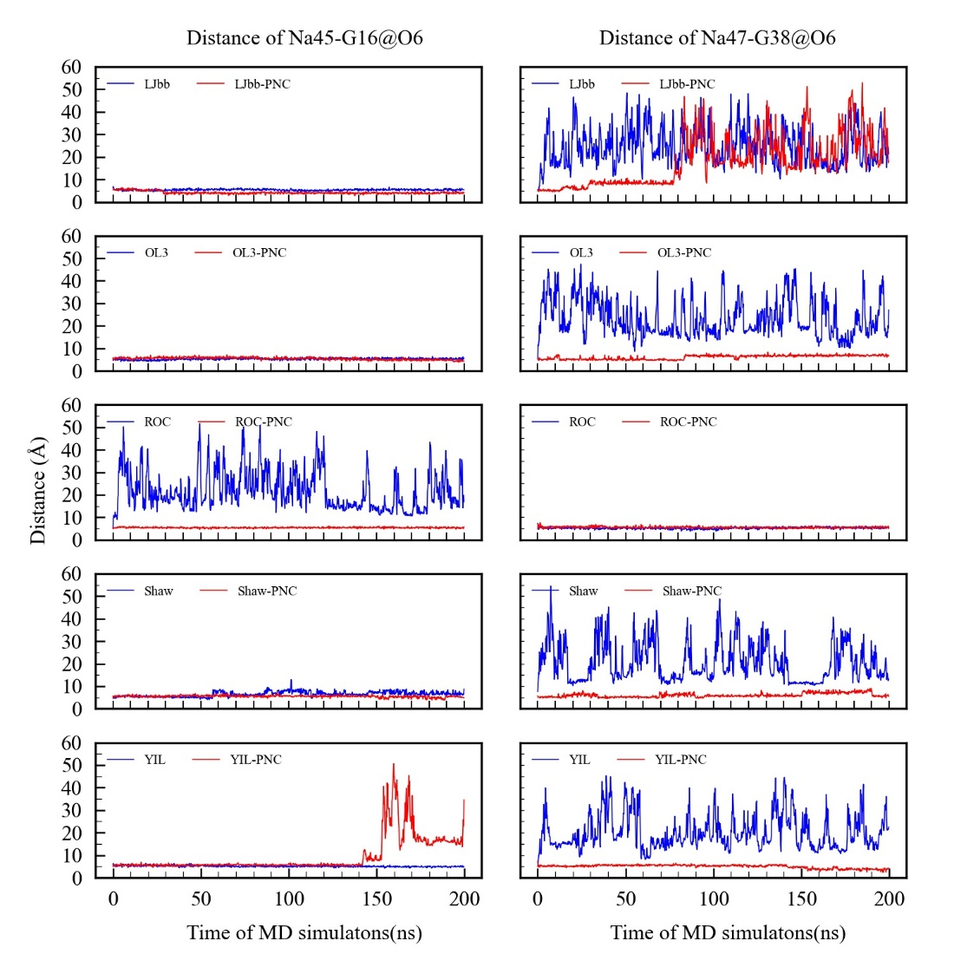
Fig. S16 Using HFE Na⁺ parameters, the distance of Na45-G16@O6 and Na47-G38@O6 as a function of simulation time under different force field simulations

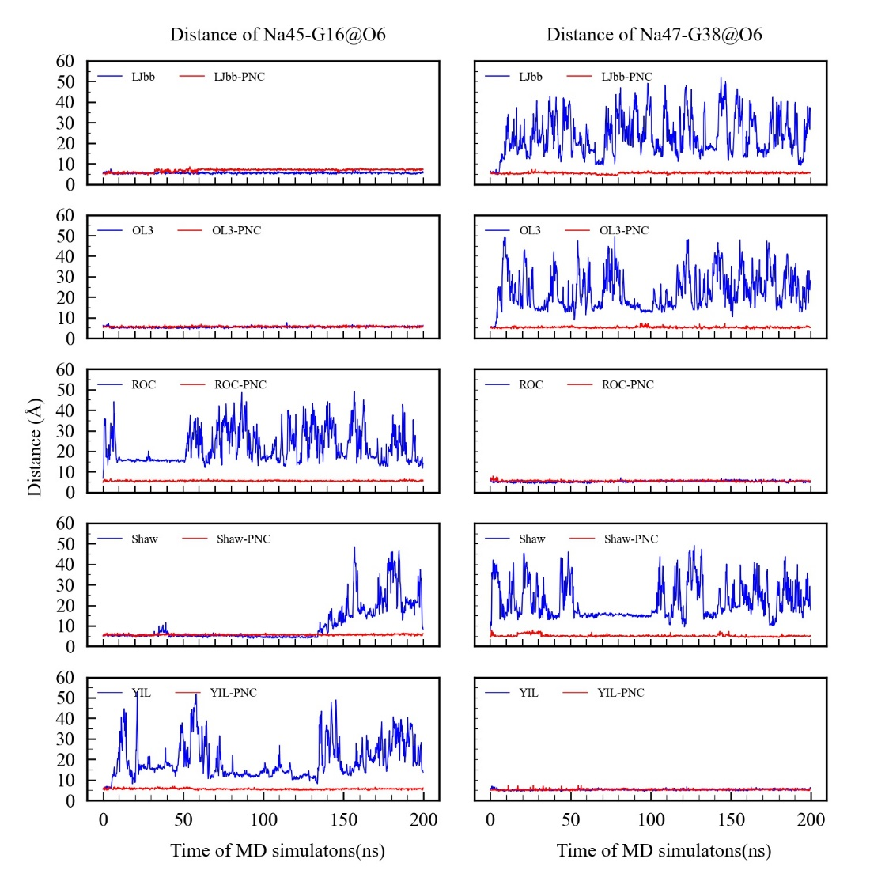
Fig. S17 Using Amber Na⁺ parameters, the distance of Na45-G16@O6 and Na47-G38@O6 as a function of simulation time under different force field simulations
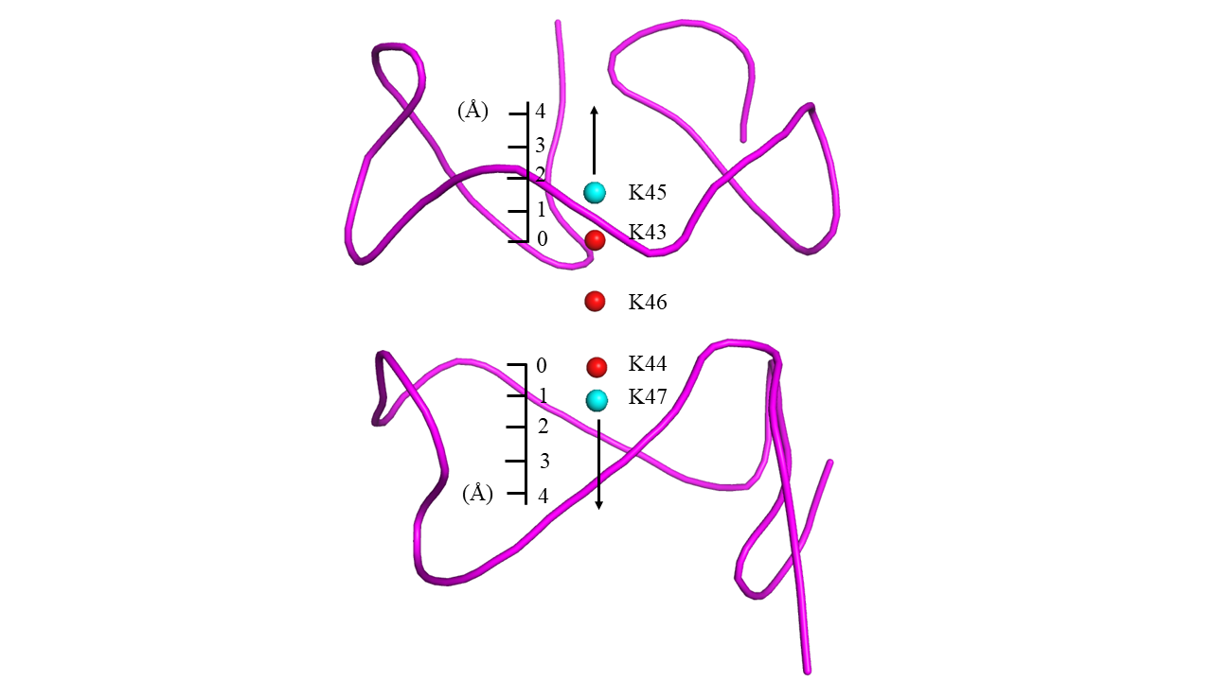
Fig. S18 Schematic illustration of K45 or K47 ion moving along the central channel

Table S2 The charges of the important atoms from the 8UTG system under different force fields
Atom | PNC-NH₄^{+a} | PNC-K^{b} | LJbb | OL3 | ROC | Shaw | YIL
G-tetrad
G5@O6 | -0.70 | -0.71 | -0.56 | -0.56 | -0.56 | -0.56 | -0.56
G11@O6 | -0.69 | -0.70 | -0.56 | -0.56 | -0.56 | -0.56 | -0.56
G14@O6 | -0.68 | -0.71 | -0.56 | -0.56 | -0.56 | -0.56 | -0.56
G18@O6 | -0.74 | -0.75 | -0.56 | -0.56 | -0.56 | -0.56 | -0.56
G-tetrad
G4@O6 | -0.76 | -0.78 | -0.56 | -0.56 | -0.56 | -0.56 | -0.56
G10@O6 | -0.72 | -0.73 | -0.56 | -0.56 | -0.56 | -0.56 | -0.56
G13@O6 | -0.74 | -0.74 | -0.56 | -0.56 | -0.56 | -0.56 | -0.56
G17@O6 | -0.77 | -0.76 | -0.56 | -0.56 | -0.56 | -0.56 | -0.56
triad
G8@O6 | -0.68 | -0.69 | -0.56 | -0.56 | -0.56 | -0.56 | -0.56
U15@O4 | -0.68 | -0.67 | -0.58 | -0.58 | -0.58 | -0.58 | -0.58
U19@O4 | -0.67 | -0.68 | -0.58 | -0.58 | -0.58 | -0.58 | -0.58
G-tetrad
G26@O6 | -0.69 | -0.69 | -0.56 | -0.56 | -0.56 | -0.56 | -0.56
G32@O6 | -0.69 | -0.70 | -0.56 | -0.56 | -0.56 | -0.56 | -0.56
G35@O6 | -0.72 | -0.74 | -0.56 | -0.56 | -0.56 | -0.56 | -0.56
G39@O6 | -0.74 | -0.74 | -0.56 | -0.56 | -0.56 | -0.56 | -0.56
G-tetrad
G25@O6 | -0.73 | -0.75 | -0.56 | -0.56 | -0.56 | -0.56 | -0.56
G31@O6 | -0.73 | -0.75 | -0.56 | -0.56 | -0.56 | -0.56 | -0.56
G34@O6 | -0.71 | -0.73 | -0.56 | -0.56 | -0.56 | -0.56 | -0.56
G38@O6 | -0.71 | -0.71 | -0.56 | -0.56 | -0.56 | -0.56 | -0.56
triad
G29@O6 | -0.70 | -0.72 | -0.56 | -0.56 | -0.56 | -0.56 | -0.56
U36@O4 | -0.66 | -0.67 | -0.58 | -0.58 | -0.58 | -0.58 | -0.58
U40@O4 | -0.68 | -0.69 | -0.58 | -0.58 | -0.58 | -0.58 | -0.58
45NH₄⁺
N | -0.71 | - | -0.91 | -0.91 | -0.91 | -0.91 | -0.91
NH1 | 0.44 | - | 0.48 | 0.48 | 0.48 | 0.48 | 0.48
NH2 | 0.43 | - | 0.48 | 0.48 | 0.48 | 0.48 | 0.48
NH3 | 0.42 | - | 0.48 | 0.48 | 0.48 | 0.48 | 0.48
NH4 | 0.41 | - | 0.48 | 0.48 | 0.48 | 0.48 | 0.48
46NH₄⁺
N | -0.71 | - | -0.91 | -0.91 | -0.91 | -0.91 | -0.91
NH1 | 0.42 | - | 0.48 | 0.48 | 0.48 | 0.48 | 0.48
NH2 | 0.43 | - | 0.48 | 0.48 | 0.48 | 0.48 | 0.48
NH3 | 0.42 | - | 0.48 | 0.48 | 0.48 | 0.48 | 0.48
NH4 | 0.43 | - | 0.48 | 0.48 | 0.48 | 0.48 | 0.48
47NH₄⁺
N | -0.70 | - | -0.91 | -0.91 | -0.91 | -0.91 | -0.91
NH1 | 0.44 | - | 0.48 | 0.48 | 0.48 | 0.48 | 0.48
NH2 | 0.41 | - | 0.48 | 0.48 | 0.48 | 0.48 | 0.48
NH3 | 0.43 | - | 0.48 | 0.48 | 0.48 | 0.48 | 0.48
NH4 | 0.42 | - | 0.48 | 0.48 | 0.48 | 0.48 | 0.48
ªPNC for native RNA system containing the NH₄⁺
^{b}PNC for native RNA system with the NH₄⁺ was substituted with K⁺
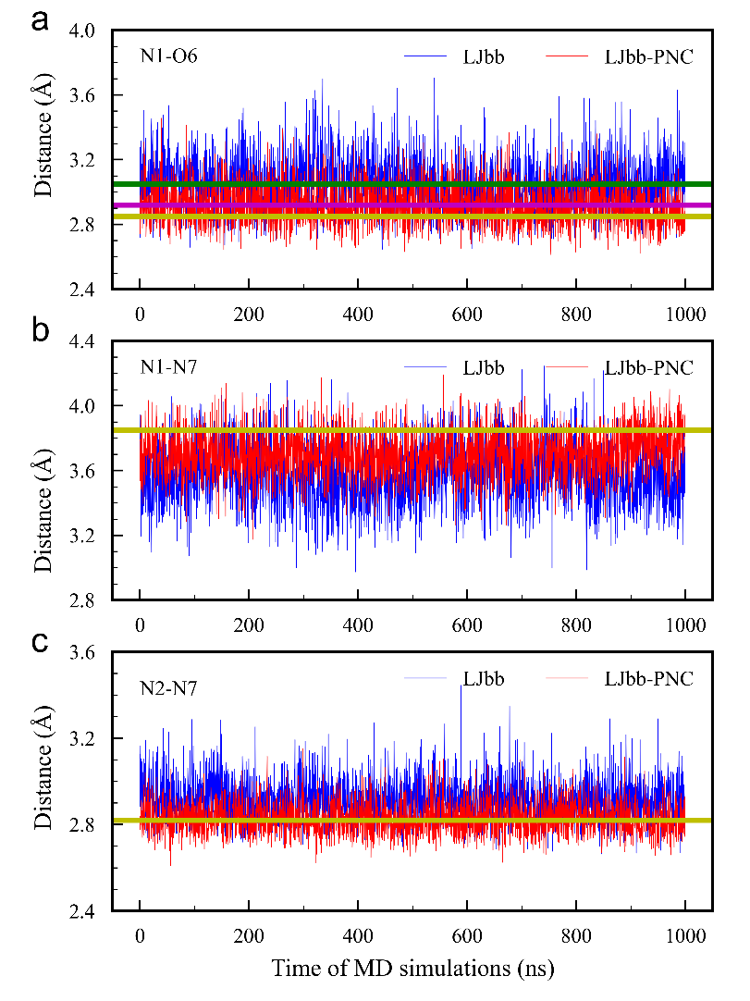
Fig. S19 The heavy atoms distance from G35, G39 on 1000ns MD simulation under LJbb force field. (a) the hydrogen bond distance formed by N1 and O6. (b) N1 and N7 distance. (c) the hydrogen bond distance formed by N2 and N7. The averaged distance under LJbb-PNC is given by the purple line while that of LJbb by the green line. The yellow line is the distance from the experimental structure
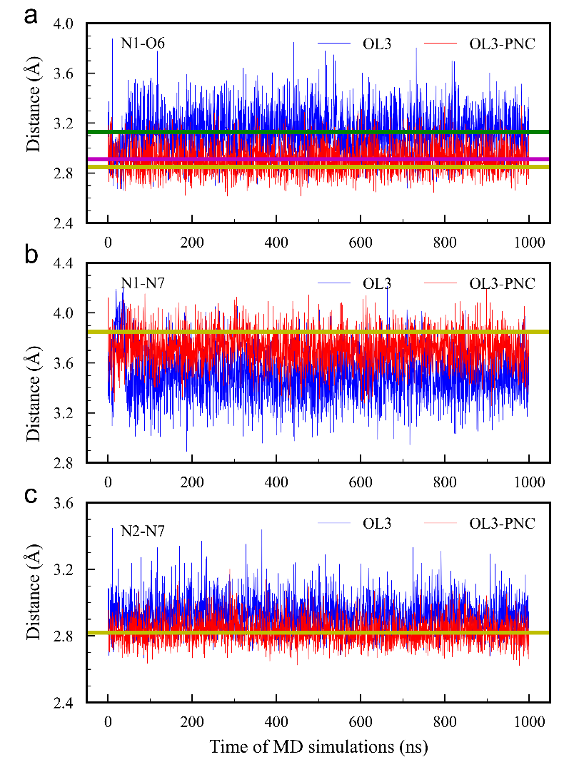
Fig. S20 The heavy atoms distance from G35, G39 on 1000ns MD simulation under OL3 force field. (a) the hydrogen bond distance formed by N1 and O6. (b) N1 and N7 distance. (c) the hydrogen bond distance formed by N2 and N7. The averaged distance under OL3-PNC is given by the purple line while that of OL3 by the green line. The yellow line is the distance from the experimental structure
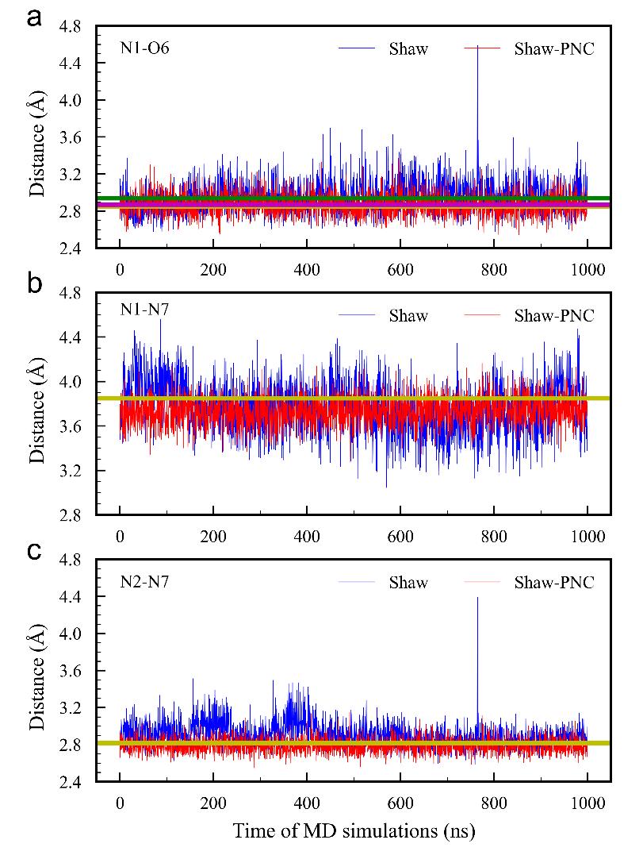
Fig. S21 The heavy atoms distance from G35, G39 on 1000ns MD simulation under Shaw force field. (a) the hydrogen bond distance formed by N1 and O6. (b) N1 and N7 distance. (c) the hydrogen bond distance formed by N2 and N7. The averaged distance under Shaw-PNC is given by the purple line while that of Shaw by the green line. The yellow line is the distance from the experimental structure
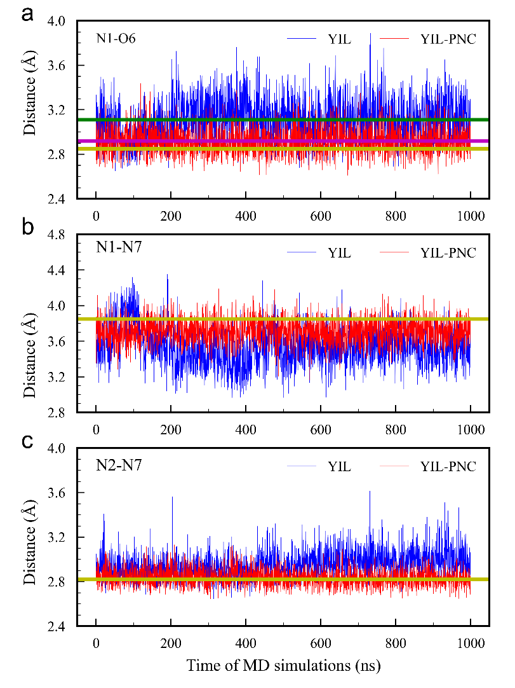
Fig. S22 The heavy atoms distance from G35, G39 on 1000ns MD simulation under YIL force field. (a) the hydrogen bond distance formed by N1 and O6. (b) N1 and N7 distance. (c) the hydrogen bond distance formed by N2 and N7. The averaged distance under YIL-PNC is given by the purple line while that of YIL by the green line. The yellow line is the distance from the experimental structure

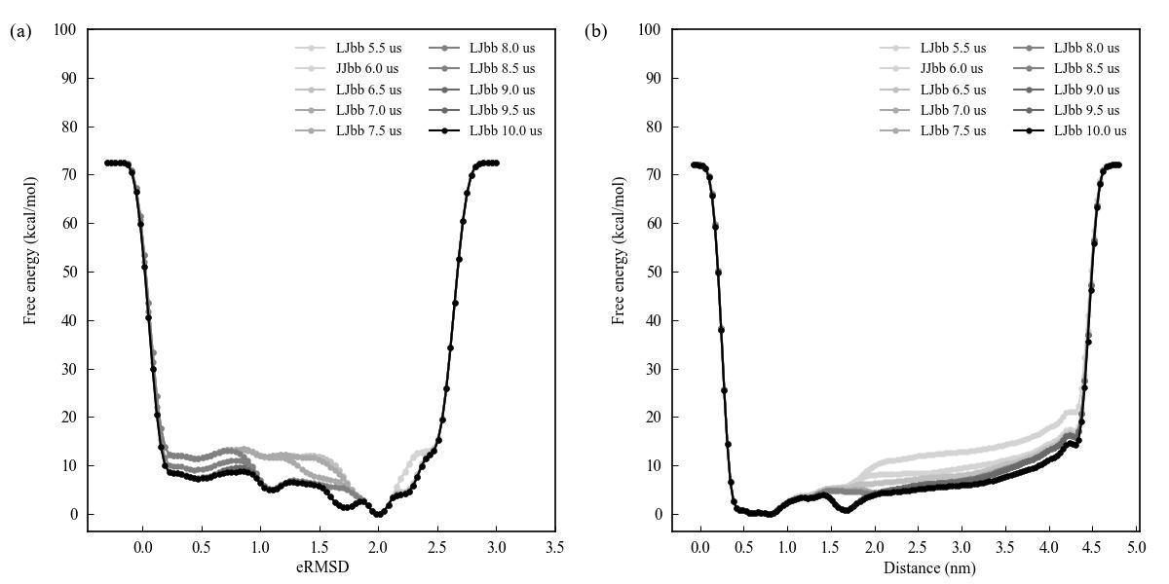
Fig. S23 Estimates of the free energy as a function of the (a) eRMSD or (b) Distance calculated every 400000 Gaussian kernels deposited from a 10us-long well-tempered metadynamics simulation base on LJbb force field

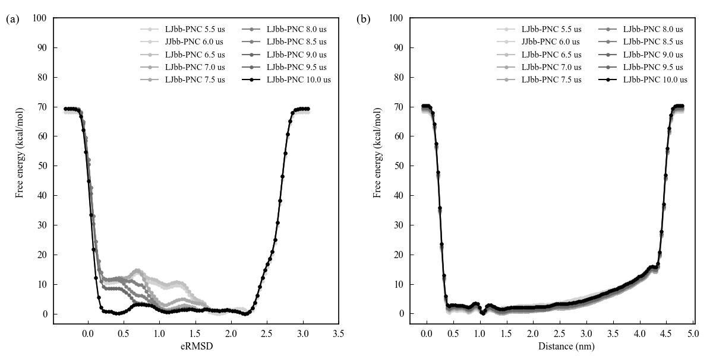
Fig. S24 Estimates of the free energy as a function of the (a) eRMSD or (b) Distance calculated every 400000 Gaussian kernels deposited from a 10us-long well-tempered metadynamics simulation base on LJbb-PNC force field
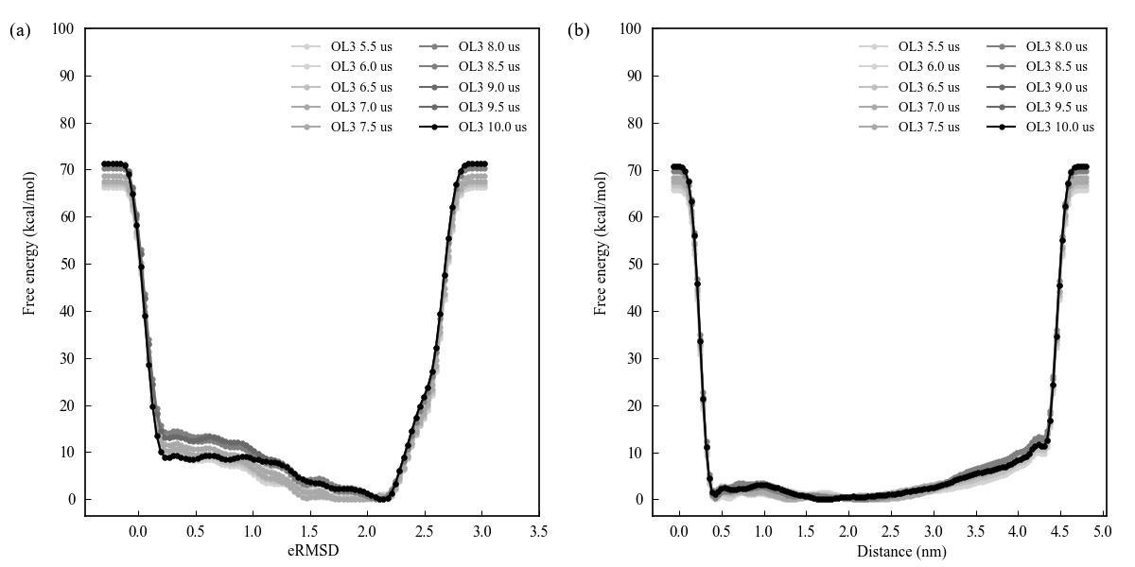
Fig. S25 Estimates of the free energy as a function of the (a) eRMSD or (b) Distance calculated every 400000 Gaussian kernels deposited from a 10us-long well-tempered metadynamics simulation base on OL3 force field
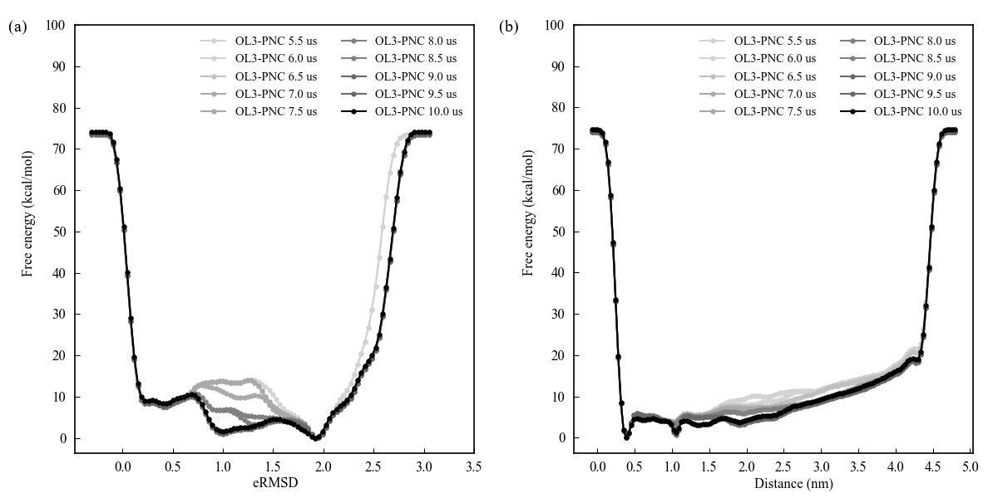
Fig. S26 Estimates of the free energy as a function of the (a) eRMSD or (b) Distance calculated every 400000 Gaussian kernels deposited from a 10us-long well-tempered metadynamics simulation base on OL3-PNC force field
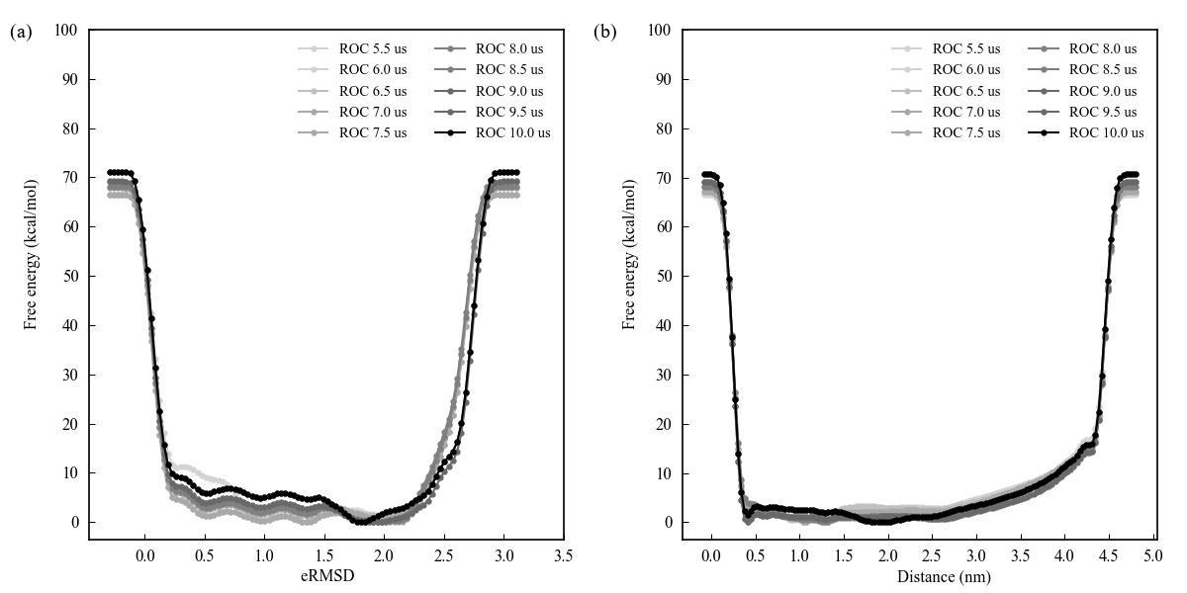
Fig. S27 Estimates of the free energy as a function of the (a) eRMSD or (b) Distance calculated every 400000 Gaussian kernels deposited from a 10us-long well-tempered metadynamics simulation base on ROC force field
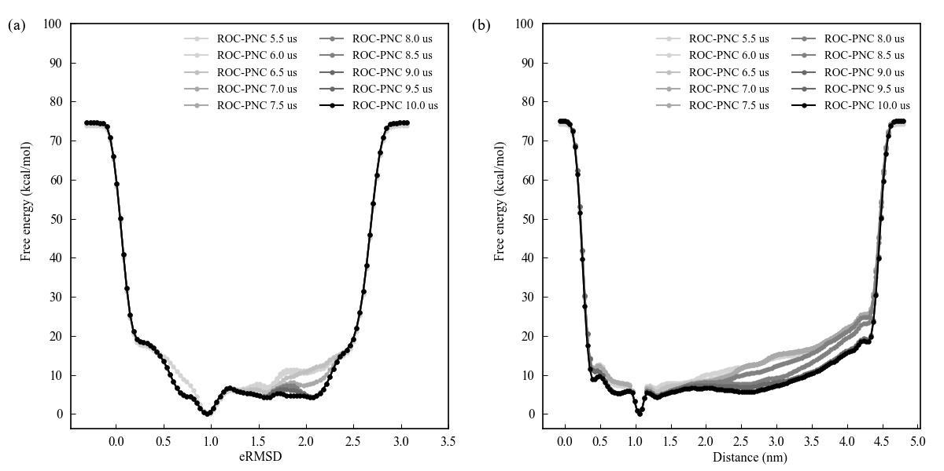
Fig. S28 Estimates of the free energy as a function of the (a) eRMSD or (b) Distance calculated every 400000 Gaussian kernels deposited from a 10us-long well-tempered metadynamics simulation base on ROC-PNC force field
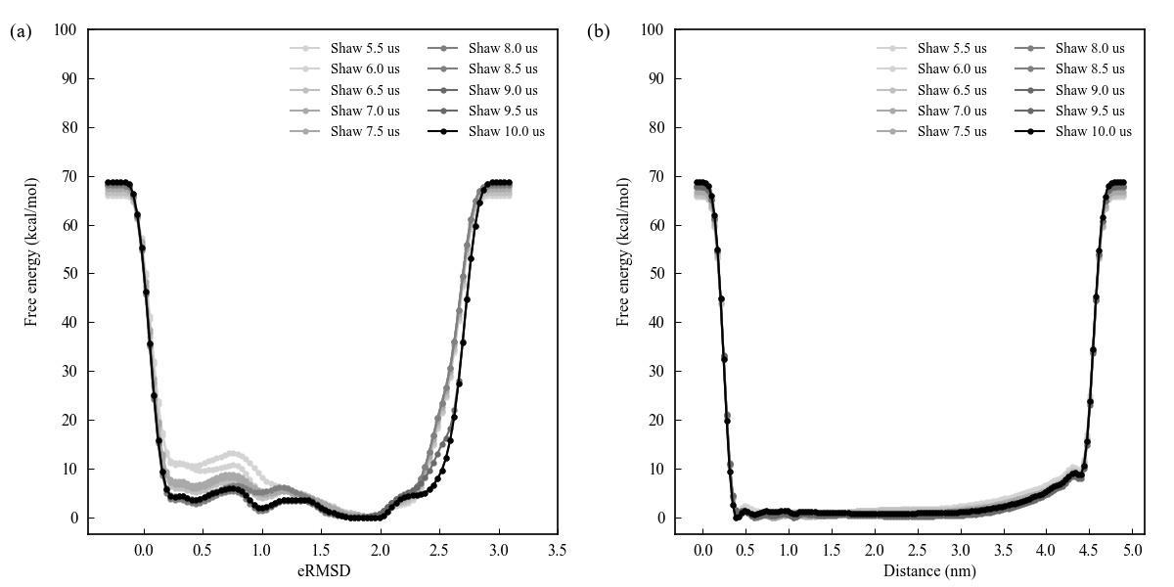
Fig. S29 Estimates of the free energy as a function of the (a) eRMSD or (b) Distance calculated every 400000 Gaussian kernels deposited from a 10us-long well-tempered metadynamics simulation base on Shaw force field
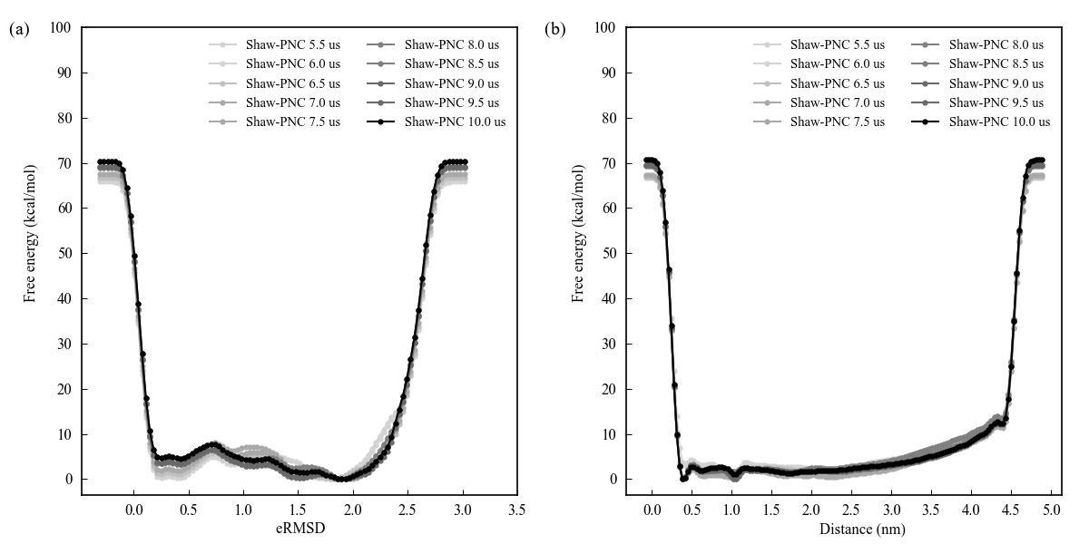
Fig. S30 Estimates of the free energy as a function of the (a) eRMSD or (b) Distance calculated every 400000 Gaussian kernels deposited from a 10us-long well-tempered metadynamics simulation base on Shaw-PNC force field
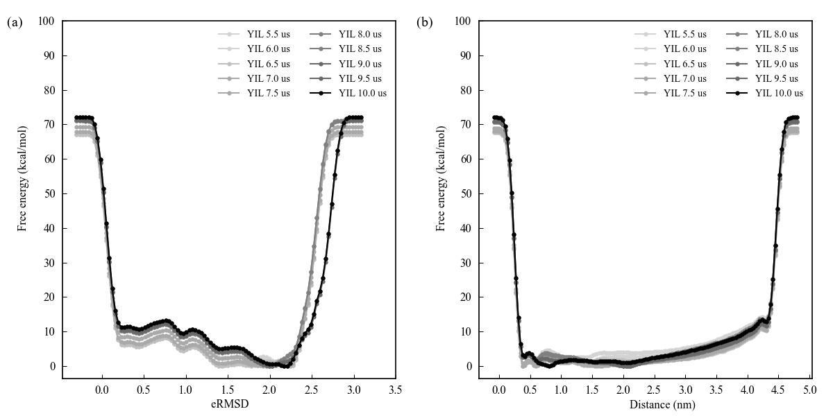
Fig. S31 Estimates of the free energy as a function of the (a) eRMSD or (b) Distance calculated every 400000 Gaussian kernels deposited from a 10us-long well-tempered metadynamics simulation base on YIL force field
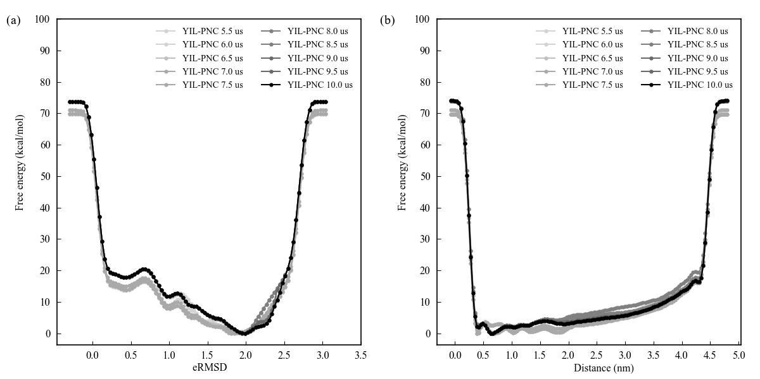
Fig. S32 Estimates of the free energy as a function of the (a) eRMSD or (b) Distance calculated every 400000 Gaussian kernels deposited from a 10us-long well-tempered metadynamics simulation base on YIL-PNC force field

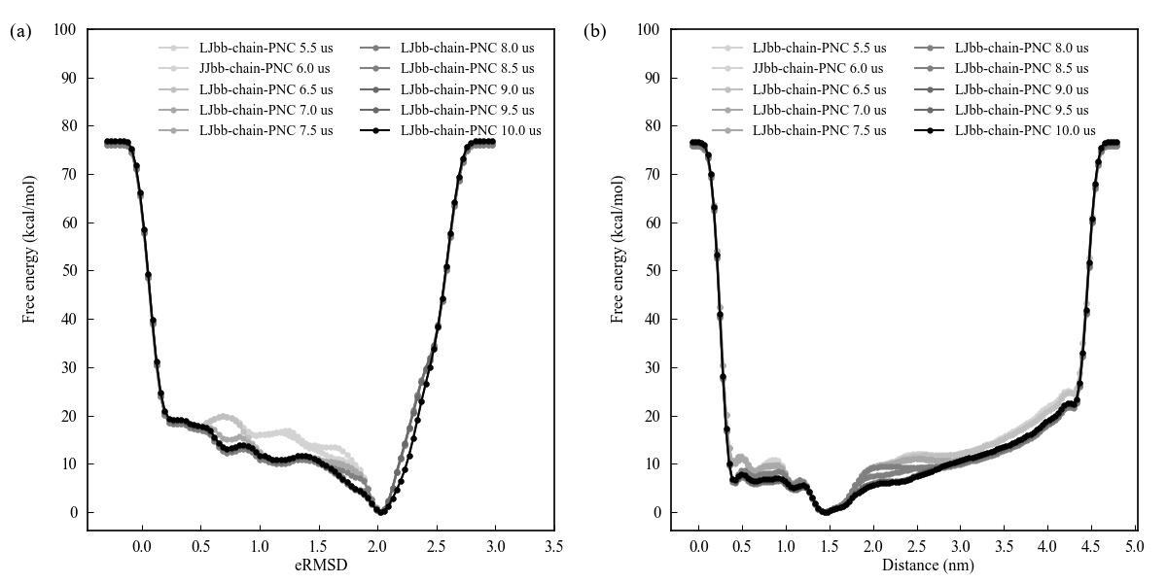
Fig. S33 Estimates of the free energy as a function of the (a) eRMSD or (b) Distance calculated every 400000 Gaussian kernels deposited from a 10us-long well-tempered metadynamics simulation base on LJbb-chain-PNC force field
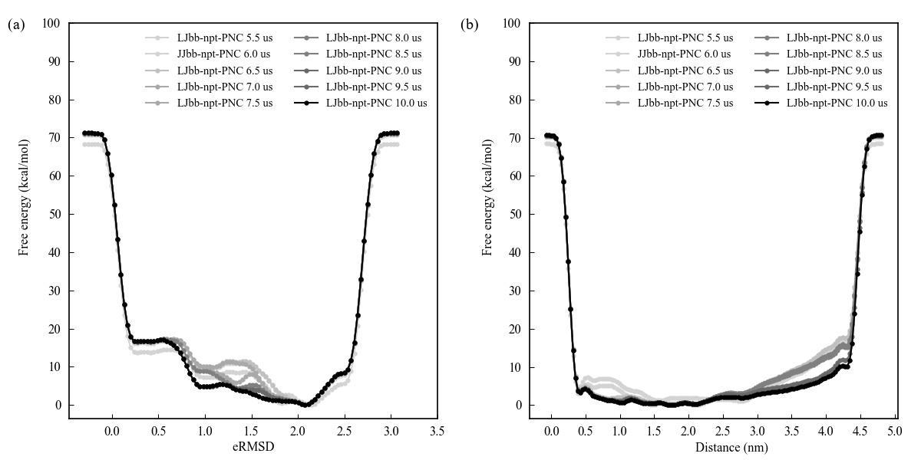
Fig. S34 Estimates of the free energy as a function of the (a) eRMSD or (b) Distance calculated every 400000 Gaussian kernels deposited from a 10us-long well-tempered metadynamics simulation base on LJbb-npt-PNC force field
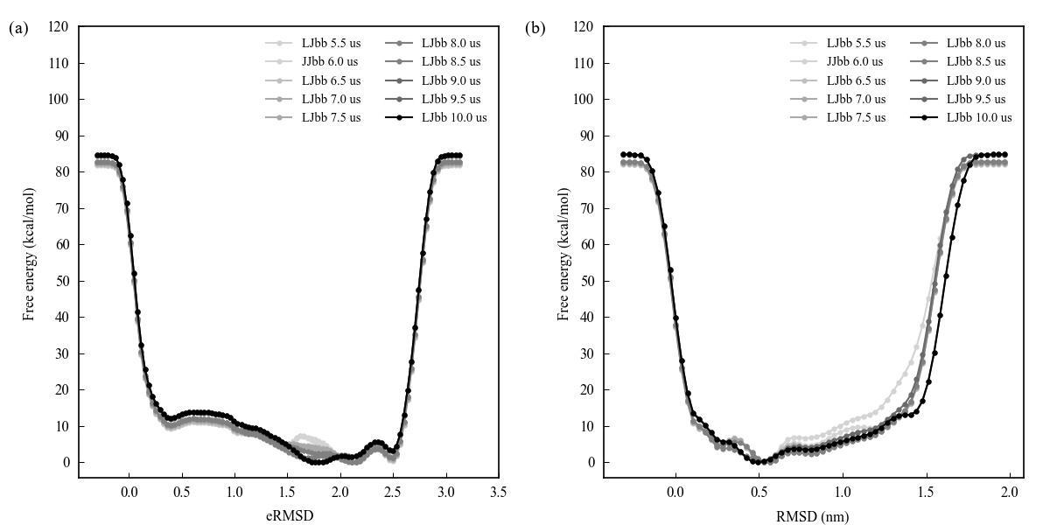
Fig. S35 Estimates of the free energy as a function of the (a) eRMSD or (b) RMSD calculated every 400000 Gaussian kernels deposited from a 10us-long well-tempered metadynamics simulation base on LJbb force field
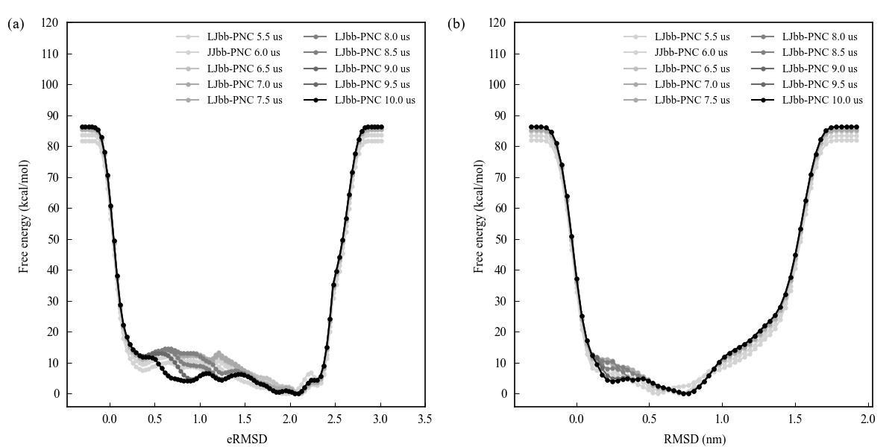
Fig. S36 Estimates of the free energy as a function of the (a) eRMSD or (b) RMSD calculated every 400000 Gaussian kernels deposited from a 10us-long well-tempered metadynamics simulation base on LJbb-PNC force field
Table S3 The number of state transition of folding during the metadynamics simulations
Parameters | the number of folding/unfolding events^{a,b}
Force fields with CVs (eRMSD, Distance)
LJbb | 34
LJbb-PNC | 21
OL3 | 43
OL3-PNC | 18
ROC | 30
ROC-PNC | 16
Shaw | 42
Shaw-PNC | 24
YIL | 28
YIL-PNC | 16
LJbb-chain-PNC | 24
LJbb-npt-PNC | 18
Force fields with CVs
(eRMSD, RMSD)
LJbb | 68
LJbb-PNC | 11
ª A conformation with an eRMSD < 1.20 is defined as the folded state
^{b} A conformation with an eRMSD > 1.80 is defined as the unfolded state

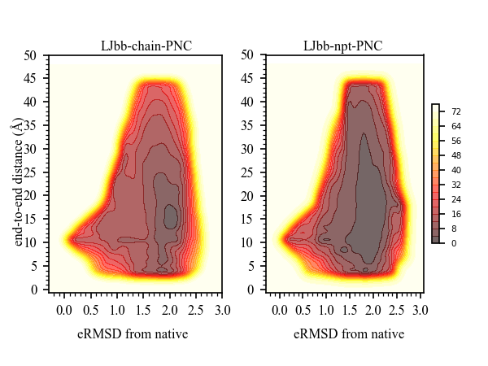
Fig. 37 Free energy profiles obtained from MetaD simulations at 300 K using different force fields

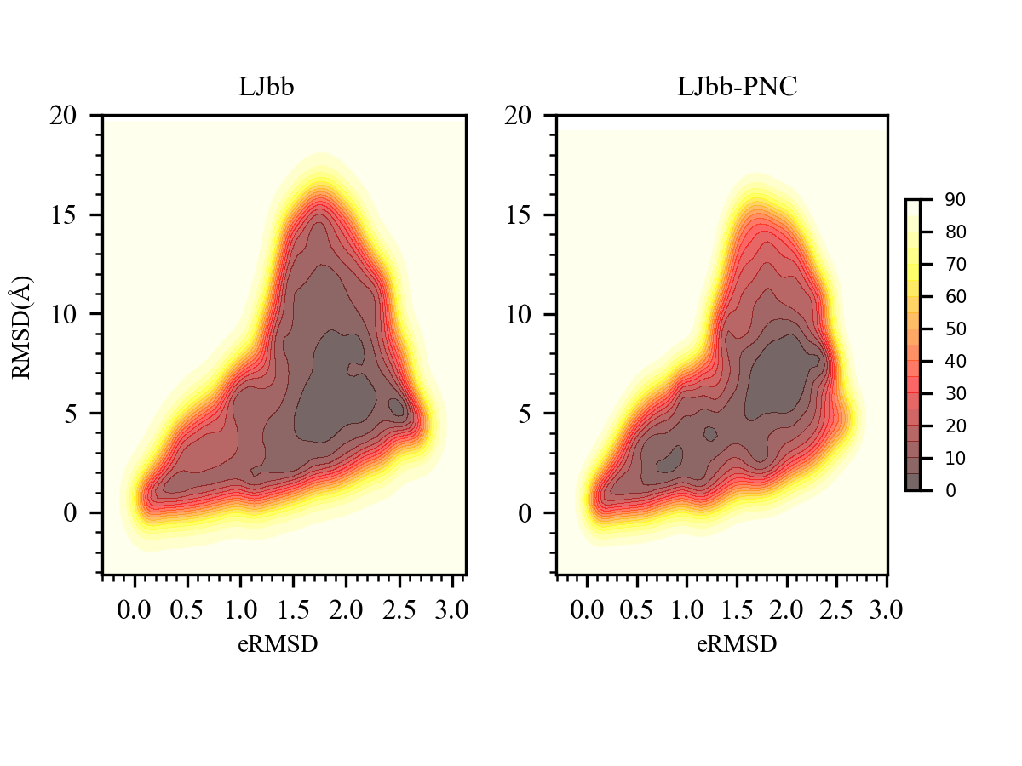
Fig. 38 Free energy profiles obtained from MetaD simulations at 300 K using different force fields

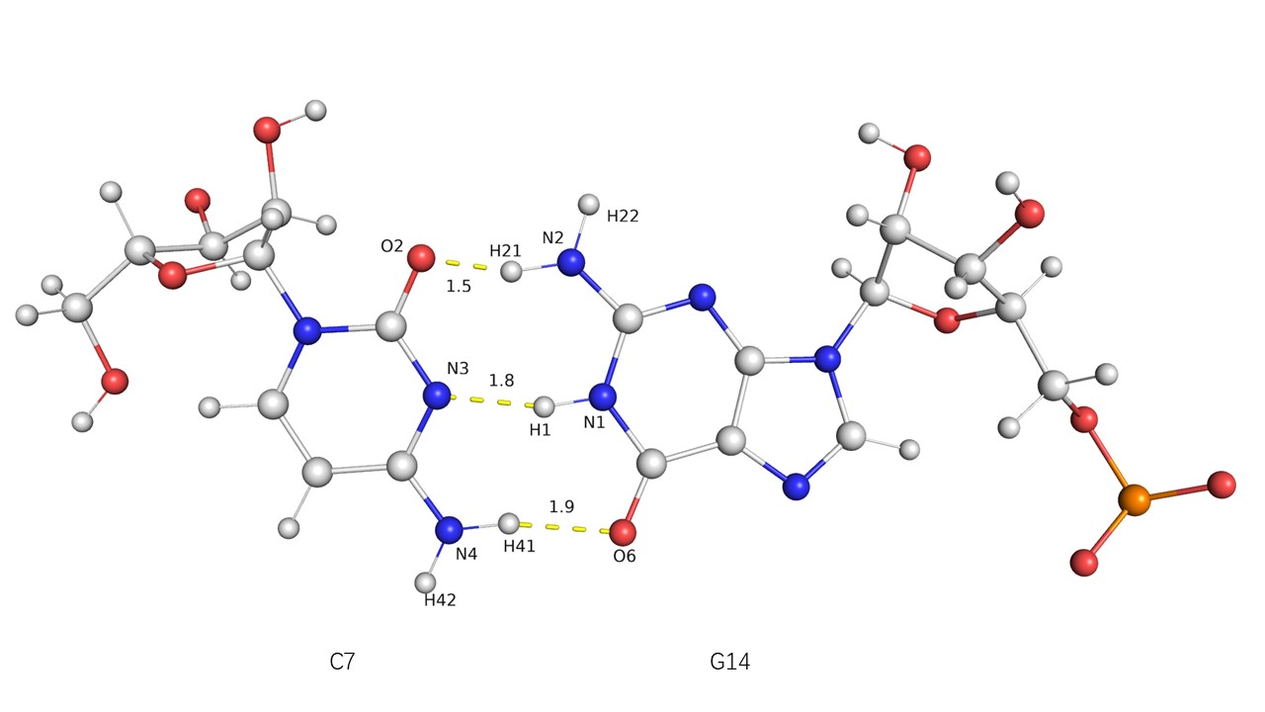
Fig. S39 The hydrogen bonds formed by residues C7 and G14 in 1F7Y system. The structure from experiment, and the hydrogen bond is given by yellow line with unit Å
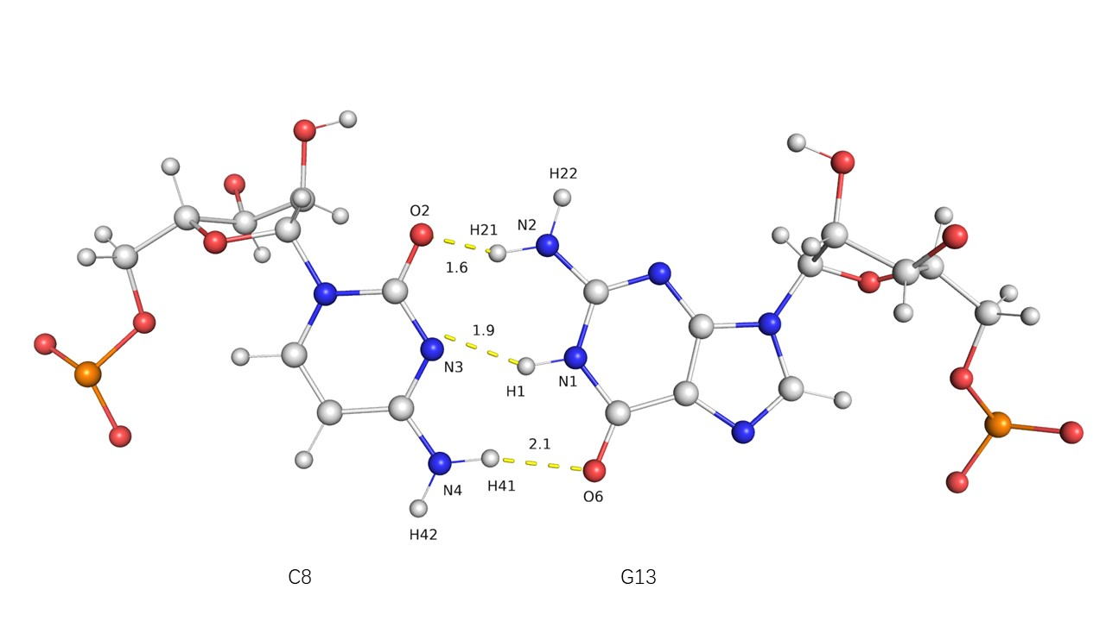
Fig. S40 The hydrogen bonds formed by residues C8 and G13 in 1F7Y system. The structure from experiment, and the hydrogen bond is given by yellow line with unit Å
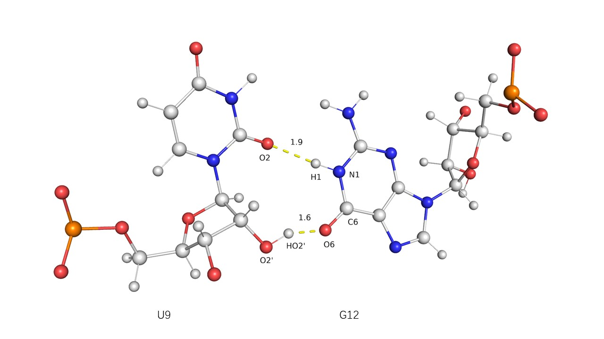
Fig. S41 The hydrogen bonds formed by residues U9 and G12 in 1F7Y system. The structure from experiment, and the hydrogen bond is given by yellow line with unit Å
Table S4 The charges of the important atoms in the 6 residues from 1F7Y system forming the hydrogen bonds under different force fields
 | Atom | PNC | LJbb | OL3 | ROC | Shaw | YIL
 | C7@O2 | -0.77 | -0.63 | -0.63 | -0.63 | -0.63 | -0.63
 | C7@N3 | -1.08 | -0.76 | -0.76 | -0.76 | -0.76 | -0.76
 | C7@N4 | -1.00 | -0.95 | -0.95 | -0.95 | -0.95 | -0.95
 | C7@H41 | 0.48 | 0.42 | 0.42 | 0.42 | 0.42 | 0.42
 | C7@H42 | 0.47 | 0.42 | 0.42 | 0.42 | 0.42 | 0.42
 | G14@N2 | -1.04 | -0.97 | -0.97 | -0.97 | -0.97 | -0.97
 | G14@H22 | 0.44 | 0.44 | 0.44 | 0.44 | 0.44 | 0.44
 | G14@H21 | 0.55 | 0.44 | 0.44 | 0.44 | 0.44 | 0.44
 | G14@N1 | -0.70 | -0.48 | -0.48 | -0.48 | -0.48 | -0.48
 | G14@H1 | 0.46 | 0.34 | 0.34 | 0.34 | 0.34 | 0.34
 | G14@O6 | -0.66 | -0.56 | -0.56 | -0.56 | -0.56 | -0.56
 | C8@O2 | -0.72 | -0.63 | -0.63 | -0.63 | -0.63 | -0.63
 | C8@N3 | -1.04 | -0.76 | -0.76 | -0.76 | -0.76 | -0.76
 | C8@N4 | -0.98 | -0.95 | -0.95 | -0.95 | -0.95 | -0.95
 | C8@H41 | 0.46 | 0.42 | 0.42 | 0.42 | 0.42 | 0.42
 | C8@H42 | 0.46 | 0.42 | 0.42 | 0.42 | 0.42 | 0.42
G13@N2 |  | -1.00 | -0.97 | -0.97 | -0.97 | -0.97 | -0.97
G13@H22 |  | 0.43 | 0.44 | 0.44 | 0.44 | 0.44 | 0.44
G13@H21 |  | 0.52 | 0.44 | 0.44 | 0.44 | 0.44 | 0.44
G13@N1 |  | -0.69 | -0.48 | -0.48 | -0.48 | -0.48 | -0.48
G13@H1 |  | 0.44 | 0.34 | 0.34 | 0.34 | 0.34 | 0.34
G13@O6 |  | -0.66 | -0.56 | -0.56 | -0.56 | -0.56 | -0.56
 | U9@O2 | -0.63 | -0.55 | -0.55 | -0.55 | -0.55 | -0.55
 | U9@O2’ | -0.63 | -0.61 | -0.61 | -0.61 | -0.61 | -0.61
 | U9@HO2’ | 0.51 | 0.42 | 0.42 | 0.42 | 0.42 | 0.42
 | G12@N1 | -0.66 | -0.48 | -0.48 | -0.48 | -0.48 | -0.48
 | G12@H1 | 0.42 | 0.34 | 0.34 | 0.34 | 0.34 | 0.34
 | G12@O6 | -0.71 | -0.56 | -0.56 | -0.56 | -0.56 | -0.56

