Supplementary Material
The supplementary material presents candidate inflammatory indices, pCR rates stratified by clinical factors, and patterns of missingness in the analysis variables.
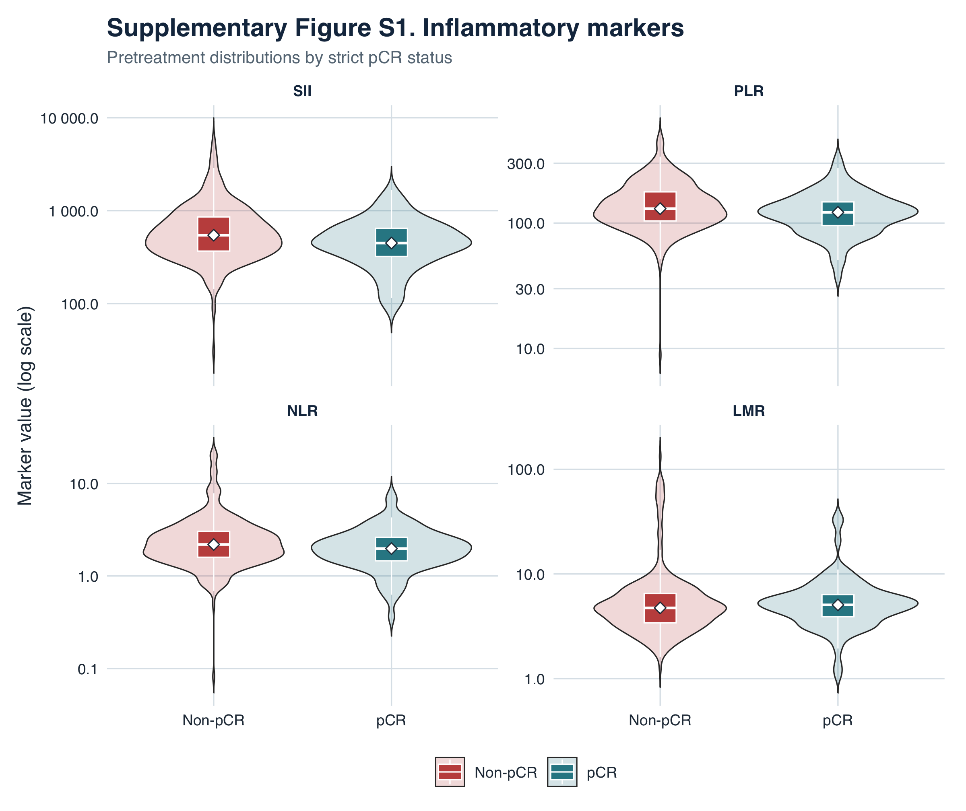
Supplementary Figure S1. Distributions of preoperative SII, PLR, NLR, and LMR according to strictly defined pCR status. Violin plots depict the distributions, box plots show the interquartile ranges, and white diamonds indicate medians.
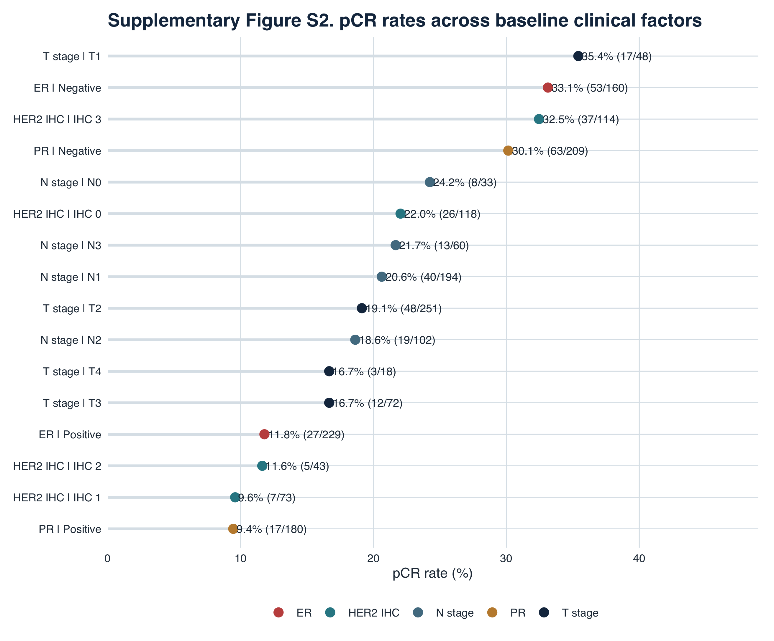
Supplementary Figure S2. pCR rates across levels of baseline clinical factors. Labels adjacent to each point indicate the number of pCR events divided by the total number of evaluable patients at that level.
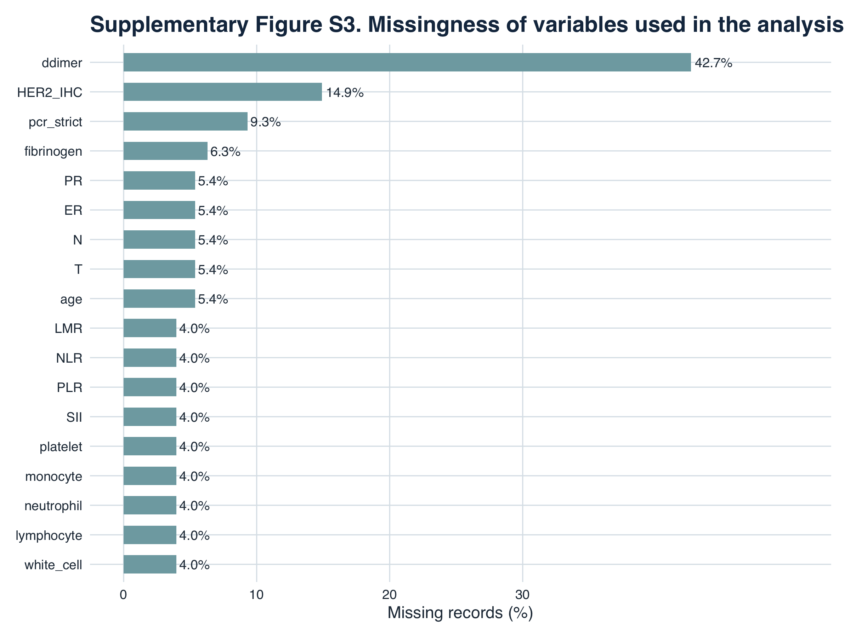
Supplementary Figure S3. Proportions of missing data for analysis variables. Missingness was calculated using all 429 registry records.

