Supplemental information
Table S1. Demographic and phenotypic characteristics of the 1,620 patients
Figure S1. Comparison of diagnostic yields of genome sequencing between first-tier and previously tested cohorts
Table S2. Category of inconclusive case
Table S3. Multivariable logistic regression analysis of diagnostic outcome by disease category and number of clinical features
Figure S2. Integrative Genomics Viewer (IGV) screenshot and Sanger sequencing chromatograms of the SLC12A3 variants
Table S4. Result from family testing
Table S5. Reanalysis results of database/pipeline updates
Table S6. Reanalysis results of clinical requests
Table S7. Satisfaction survey summary of clinicians
Table S8. Satisfaction survey summary of patients

Table S1. Demographic and phenotypic characteristics of the 1,620 patients
Characteristic |  | n | Percentage (%)
Gender | Male | 935 | 57.72
 | Female | 685 | 42.28
Age of onset | Neonatal & infancy (<2) | 639 | 39.44
 | Childhood (2-11) | 381 | 23.52
 | Adolescent (12-18) | 115 | 7.10
 | Adult (>18) | 99 | 6.11
 | unknown | 386 | 23.83
Category | Neurodevelopmental disorder | 785 | 48.46
 | Neurology disorder | 254 | 15.68
 | Dysmorphic and congenital abnormality syndromes | 154 | 9.51
 | Endocrine disorders | 61 | 3.77
 | Haematological and immunological disorders | 57 | 3.52
 | Metabolic disorders | 53 | 3.27
 | Tumor syndrome | 68 | 4.20
 | Renal and urinary tract disorders | 40 | 2.47
 | Skeletal disorders | 41 | 2.53
 | Ophthalmological disorders | 30 | 1.85
 | Dermatological disorders | 15 | 0.93
 | Cardiovascular disorders | 19 | 1.17
 | Gastroenterology and Hepatology | 15 | 0.93
 | Hearing and ear disorders | 10 | 0.62
 | Growth disorders | 8 | 0.49
 | Respiratory disorders | 7 | 0.43
 | Autoimmune or Rheumatological disorders | 3 | 0.19
Previous genetic testing (N=1620) | No | 778 | 48.02
Previous genetic testing (N=1620) | Yes | 842 | 51.98
Previous genetic testing (N=1620) | 1 | 593 | 36.60
 | 2 | 179 | 11.05
 | 3 | 56 | 3.46
 | 4 | 12 | 0.74
 | 5 | 2 | 0.12

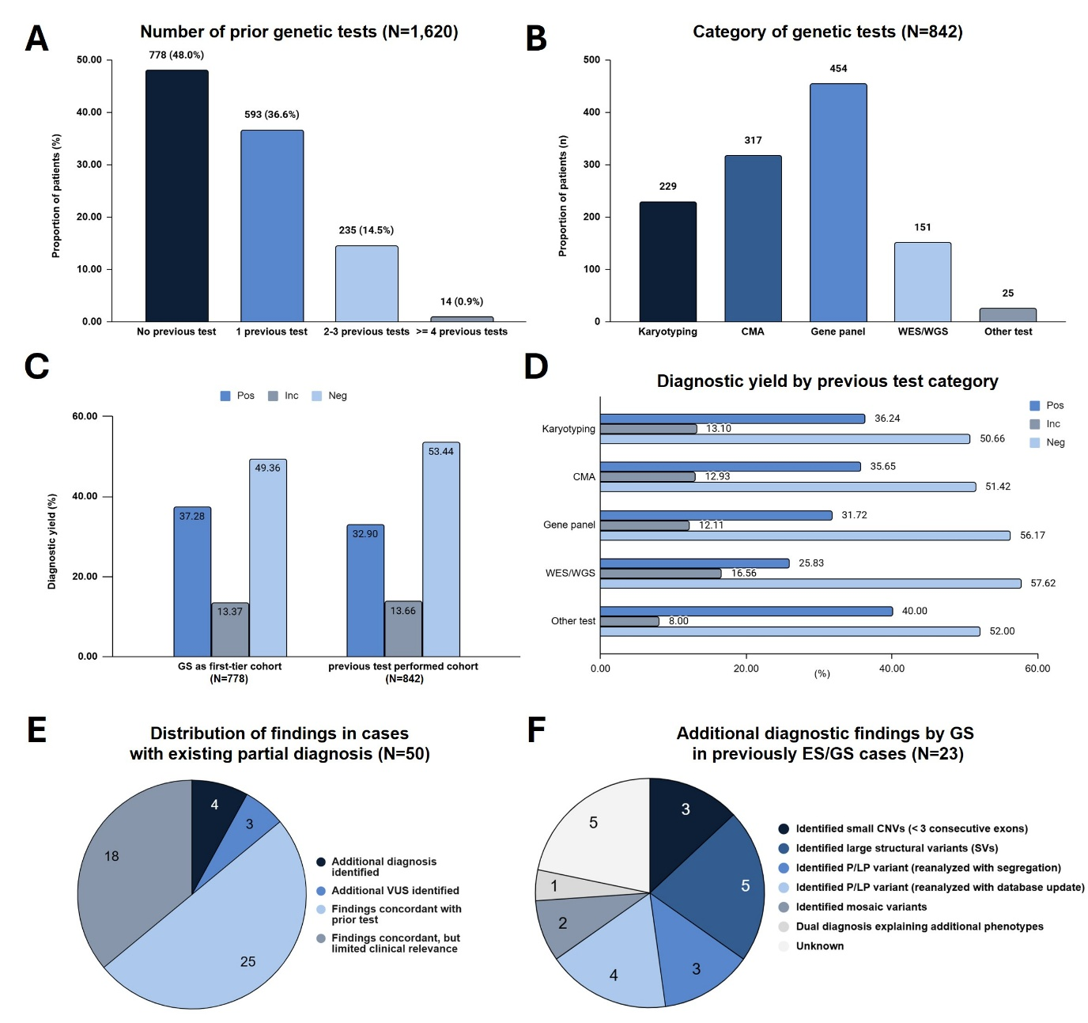
Figure S1. Comparison of diagnostic yields of genome sequencing between first tier and previously tested cohorts. A. Proportion of patients by the number of prior genetic tests (N=1,620). B. Proportion of patients undergoing prior genetic tests by test category (N=842). C. Diagnostic yield of GS in the first-tier cohort (N=778) versus the previously tested cohort (N=842). D. Diagnostic yield based on the specific categories of prior genetic tests. E. Distribution of findings among cases with a previously existing partial diagnosis (N=50). F. Detailed classification of additional diagnostic findings by GS in previously ES/GS tested cases (N=23).
Table S2. Category of inconclusive case
 | No. of patients
P/LP variant(s) identified, but only partially explaining the phenotype | 5
Mosaic P/LP variant identified | 2
Single heterozygous P/LP variant identified in an AR disorder | 35
Disease-gene association reported as GUS | 17
Identified VUS requiring RNA-seq validation | 36
Identified VUS requiring confirmation of assumed de novo variants | 36
Identified VUS requiring further functional studies | 88
Total | 219
P/LP, Pathogenic/Likely pathogenic; GUS, gene of uncertain significance; VUS, variant of uncertain significance

Table S3. Multivariable logistic regression analysis of diagnostic outcome by disease category and number of clinical features
Category | Avg_symptom count | Coefficient (β) | SE | OR | 95% CI | p-value
Clinical Features
Number of HPO terms | 2.89 | 0.031 | 0.029 | 1.03 | 0.97 – 1.09 | 0.293
Disease Category
Cardiovascular disorders (Reference) | 2.63 | - | - | 1.00 (Ref) | - | -
Dermatological disorders | 2.00 | 0.038 | 0.783 | 1.04 | 0.22 – 4.82 | 0.962
Dysmorphic and congenital abnormality syndromes | 3.59 | 0.440 | 0.548 | 1.55 | 0.53 – 4.55 | 0.422
Endocrine disorders | 2.49 | 0.390 | 0.587 | 1.48 | 0.47 – 4.66 | 0.507
Gastroenterology and Hepatology | 2.73 | 0.015 | 0.783 | 1.01 | 0.22 – 4.71 | 0.985
Growth disorders | 1.75 | -0.889 | 1.190 | 0.41 | 0.04 – 4.23 | 0.455
Haematological and immunological disorders | 2.56 | -0.291 | 0.614 | 0.75 | 0.22 – 2.49 | 0.636
Metabolic disorders | 2.42 | -0.423 | 0.628 | 0.66 | 0.19 – 2.25 | 0.501
Neurodevelopmental disorder | 3.02 | 0.570 | 0.526 | 1.77 | 0.63 – 4.96 | 0.279
Neurology disorder | 2.64 | 0.121 | 0.539 | 1.13 | 0.39 – 3.25 | 0.822
Ophthalmological disorders | 2.70 | 0.760 | 0.638 | 2.14 | 0.61 – 7.47 | 0.234
Renal and urinary tract disorders | 2.30 | 0.421 | 0.618 | 1.52 | 0.45 – 5.11 | 0.496
Skeletal disorders | 2.83 | 0.141 | 0.624 | 1.15 | 0.34 – 3.91 | 0.821
Tumor syndrome | 2.72 | 1.027 | 0.575 | 2.79 | 0.91 – 8.62 | 0.074
Hearing and ear disorders, Respiratory disorders, and Autoimmune or Rheumatological disorders (all with 0% diagnostic yield) were excluded from this analysis to avoid complete separation. Cardiovascular disorders was used as the reference category (first alphabetically among the remaining 14 categories). β, regression coefficient (log-odds); SE, standard error; OR, odds ratio; CI, confidence interval.

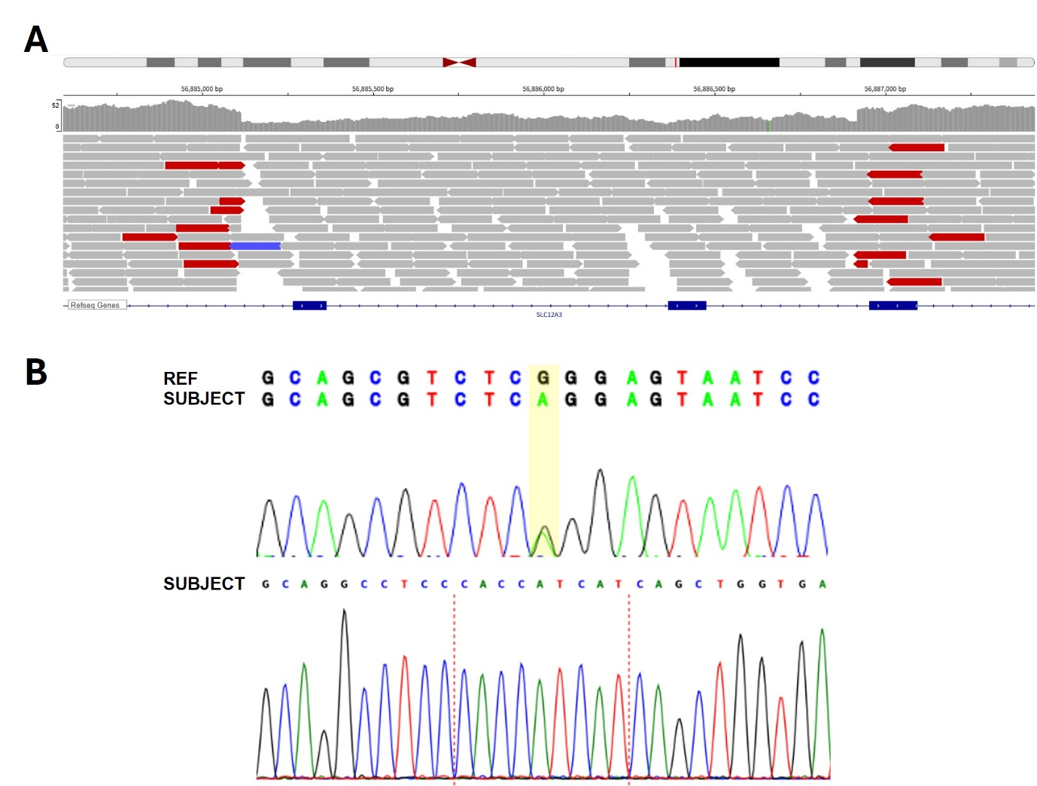
Figure S2. Integrative Genomics Viewer (IGV) screenshot and Sanger sequencing chromatograms of the SLC12A3 variants. A. IGV screenshot showing whole-genome sequencing reads at the SLC12A3 locus (chr16:56,884,593–56,887,437, GRCh38). A heterozygous deletion (NC_000016.10:g.56885114_56886917delinsCACCATCAT) spanning exons 14–15 of SLC12A3 (NM_001126108.2) was identified. The SLC12A3 gene annotation (RefSeq Genes) is displayed at the bottom. B. Sanger sequencing chromatograms confirming the two heterozygous SLC12A3 variants. Variant 1 (NM_001126108.2:c.2902C>T [p.Arg968Ter]); The yellow highlight indicates the nucleotide substitution site (REF: reference sequence). Variant 2 (NC_000016.10:g.56885114_56886917delinsCACCATCAT); The red dotted line indicates the deletion breakpoint.

Table S4. Result from family testing
Number of families (subjects) tested |  | 353 (711)
Cases with changes in test results by family testing |  | No. patients
 | Inconclusive -> Positive | 32
 | Inconclusive -> Negative | 29
 | Positive -> Inconclusive | 6
 | Positive -> Negative | 4
 | Total | 71
Distribution of inheritance |  | No. variants
 | Assumed de novo | 96
 | de novo (with STR) | 6
 | Confirmed in trans | 33
 | Confirmed in cis | 7
 | inherited from a (mildly) affected parent | 35
 | inherited from an unaffected parent | 38
 | Inherited from a parent with an uncertain phenotype or incomplete penetrance | 78
 | Shared with similarly affected family member(s) | 18
 | Tested in only one parent | 35
 | SF variant | 20
 | Total | 366
Variants reclassified by family testing |  | No. variants
 | LP -> P | 28
 | VUS -> LP | 34
 | VUS -> LB | 33
 | LP -> VUS | 6
 | LP -> LB | 3
 | Total | 104
STR, Short Tandem Repeat; LP, Likely pathogenic; P, pathogenic; VUS, variant of uncertain significance; LB, likely benign

Table S5. Reanalysis results of database/pipeline updates
Drivers for Reanalysis | INC/NEG  >POS (n) | NEG  >INC (n) | INC  >INC (n) | Time to Reanalysis (Months)
Disease-gene association reported as GUS | - | 2 | 2 | 13.25
Disease curated on OMIM/ORPHA | 3 | - | 2 | 9.60
Variant reclassified by database/pipeline update | 6 | 4 | 1 | 12.27
Total | 9 | 6 | 5 | 11.80

Table S6. Reanalysis results of clinical requests
Reason for Request | Requested  Cases (n) | Reanalysis  Cases (n)
Additional symptoms provided | 3 | 1
Request for reanalysis | 3 | 1
Total | 6 | 2ª
ª Both cases were reclassified as positive following reanalysis: one after re-evaluation prompted by newly provided clinical symptoms, and the other after identifying an additional variant during a clinician-requested reanalysis.

Table S7. Satisfaction survey summary of clinicians
 | 2023 | 2024 | 2025
Satisfaction with diagnostic test results | 89 | 95.6 | 96.4
Satisfaction with genetic and Sanger test results | 90 | 95.7 | 89.3
Helpfulness of results for clinical management | 100 | 100 | 96.4
Convenience of program process | 78 | 91.3 | 89.3
Necessity of program continuation | 100 | 100 | 100
Average | 91.4 | 96.52 | 94.28

Table S8. Satisfaction survey summary of patients
 | 2024 | 2025
Convenience of program process | 99.1 | 96.9
Convenience of location | 94.8 | 88.5
Program promotion and information guidance | 98.3 | 94.6
Reliability of the testing process | 100 | 95
Satisfaction with waiting time for test results | 92.2 | 92.7
Satisfaction with diagnostic test results | 97.4 | 95.8
Satisfaction with counseling on additional test (e.g., family testing) | 96.5 | 93.5
Alleviation of financial burden | 100 | 96.2
Overall satisfaction with the program | 100 | 97.3
Necessity of program continuation | 99.1 | 97.7
Average | 97.74 | 94.82

