Supplementary materials for Quantification of sidewall defects and surface passivation strategies in blue InGaN/GaN micro light emitting diodes
Lee-Woon Jang^{a†}, Sang-Ik Lee^{b†}, Andrej Kuznetsov^{c}, A. L. Zakgeim^{d}, E. B. Yakimov^{e,f}, Pil-Kyu Jang^{g}, Anton E. Chernyakov^{d}, Luiza A. Alexanyan^{e}, M. L Skorikov^{h}, Ivan V. Shchemerov^{e}, Anton A. Vasilev^{e}, Alexander Y. Polyakov^{e}*, and In-Hwan Lee^{b}*
† Contributed equally.
ª The Institute for High Technology Materials and Devices, Korea University, Seoul 02841, Republic of Korea
^{b} Department of Materials Science and Engineering, Korea University, Seoul 02841, Republic of Korea
^{c} Department of Physics, Centre for Materials Science and Nanotechnology, University of Oslo, P.O. Box 1048 Blindern, N-0316 Oslo, Norway
^{d} Research & Engineering Center for Submicron Heterostructures for Microelectronics, Russian Academy of Sciences; 26, Politekhnicheskaya 194021, St.-Petersburg, Russia
^{e} National University of Science and Technology MISIS, 4 Leninsky Ave, Moscow, 119049, Russia
^{f} Institute of Microelectronics Technology and High Purity Materials, Russian Academy of Sciences, Chernogolovka, Moscow Region 142432, Russia
^{g} Department of Semiconductor Systems Engineering, Korea University, Seoul 02841, Republic of Korea
^{h} P.N. Lebedev Physical Institute, Russian Academy of Science, 53 Leninsky Ave, Moscow 119991, Russia

*E-mails: ihlee@korea.ac.kr, aypolyakov@gmail.com

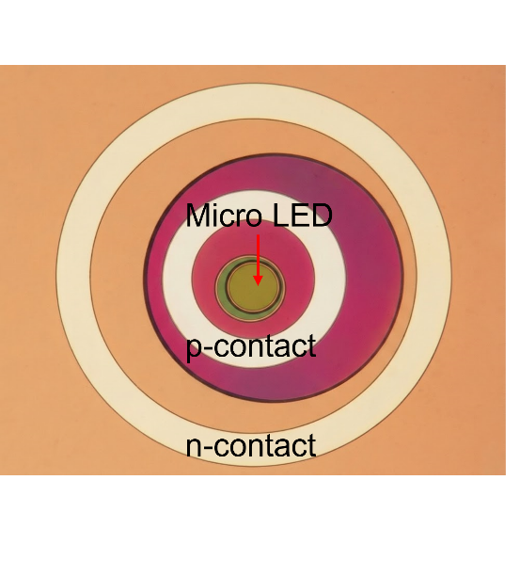
Fig. S1. Schematic representation of the μLED chip with passivations and Ohmic contact rings

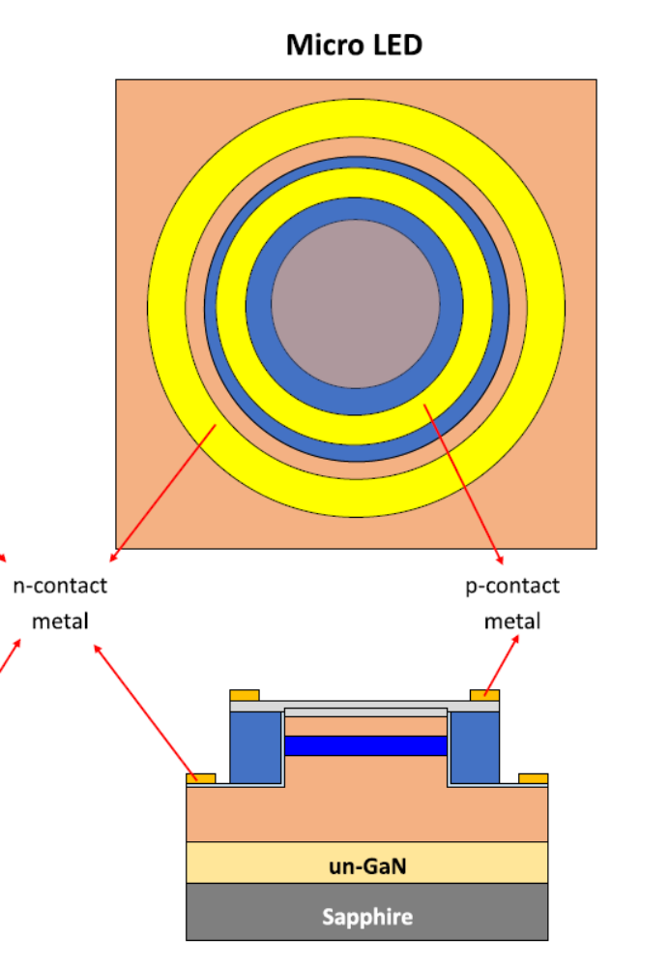

Fig. S2. (Color online) Schematics of the μLED structure, the Ohmic contacts rings widths are 15 μm

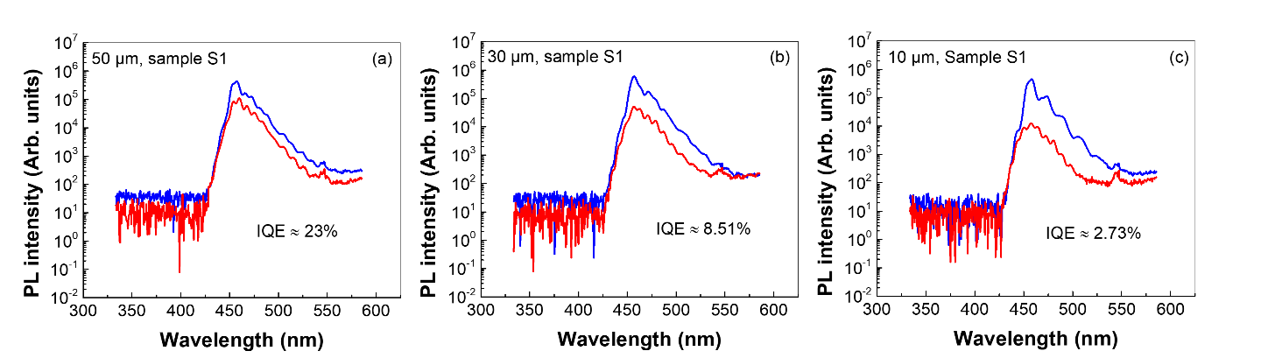
Fig. S3. (Color online). Actual PL spectra measured at 10K (blue lines) and 300K (red lines) for the as-etched samples (type S1) with diameters 50 μm (a), 30 μm (b), and 10 μm (c).

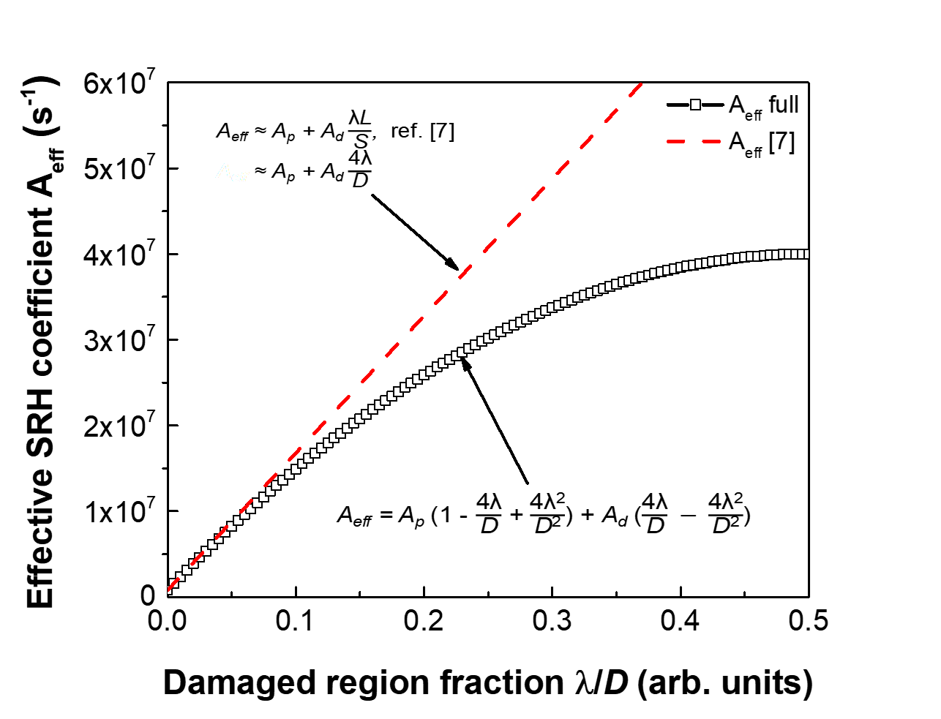
Fig. S4. The difference with the A_{eff} as a function of λ/D for Eq(4) and Eq(6) of the paper

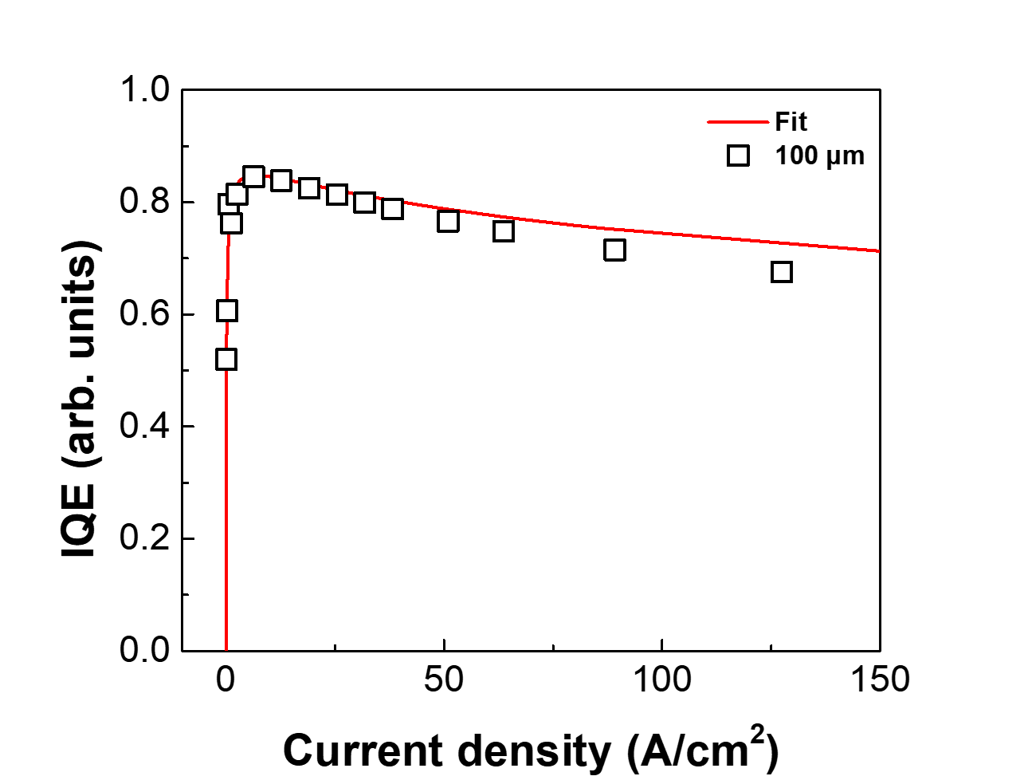
Fig. S5. Fitting results for the 100 μm LED for A_{eff}=8×10⁵ s⁻¹, B=10⁻¹¹ cm³s⁻¹, C=10⁻³⁰ cm⁶s⁻¹.

