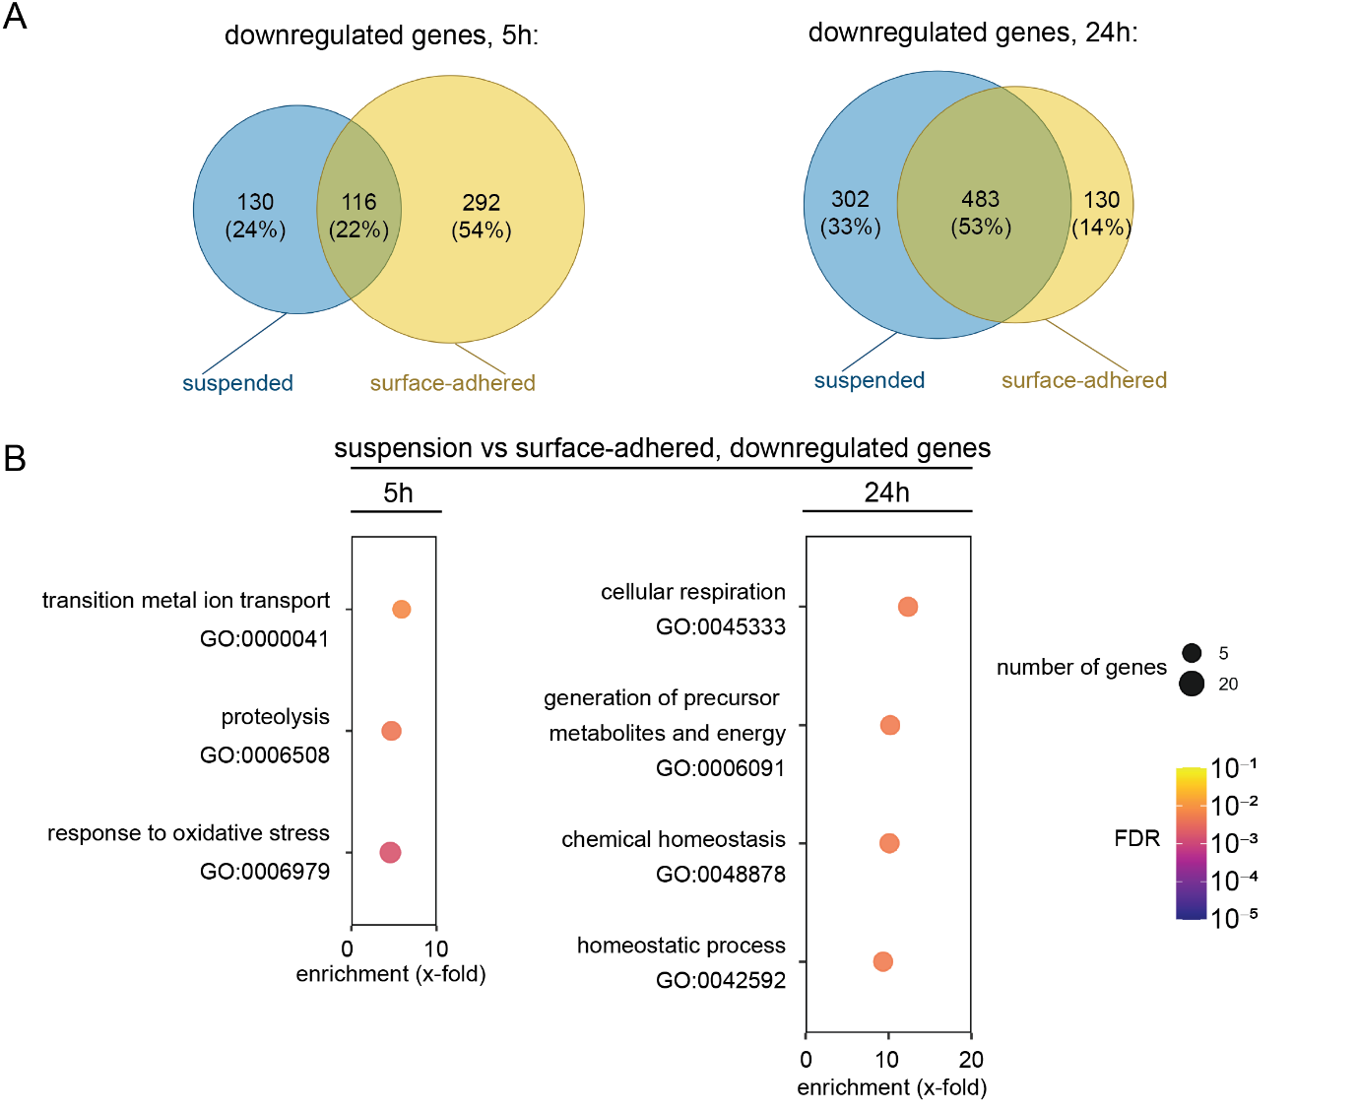
Figure S1. Comparison of downregulated genes in liquid-suspension and surface-adhered biofilms
- Venn diagrams showing the overlap in genes downregulated in liquid-suspension and surface-adhered biofilms at 5 and 24 h.
- Gene Ontology Analysis of genes downregulated in liquid-suspension biofilms relative to surface-adhered biofilms. The size of datapoints indicates number of genes assigned to a GO term, colour shows p-value.

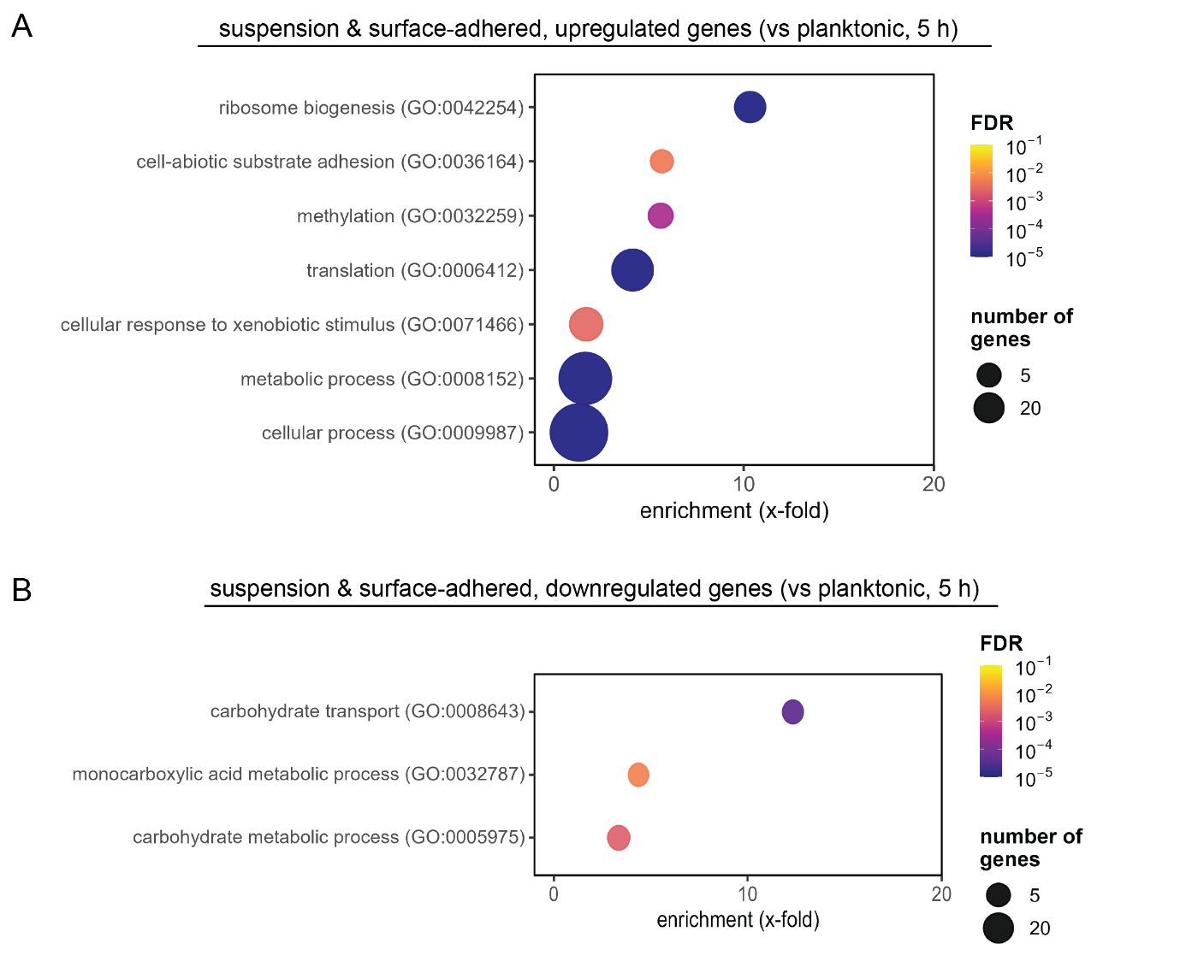
Figure S2. Gene Ontology Analysis of gene expression compared to planktonic controls (genes-in-common for both biofilm morphologies) at 5 hours
- GO analysis for liquid-suspension and surface-adhered C. albicans biofilm upregulated genes-in-common as compared to planktonic controls
- As described in A, but for downregulated genes-in-common.

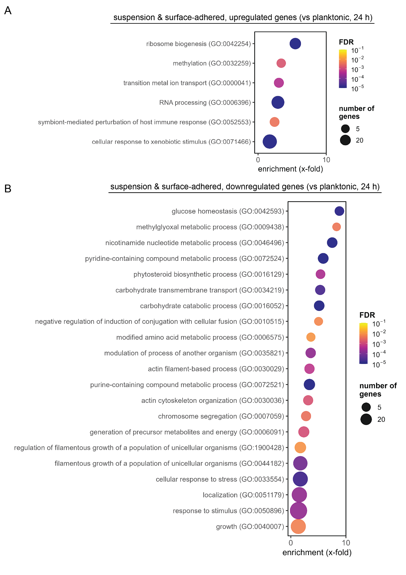
Figure S3. Gene Ontology Analysis of gene expression compared to planktonic controls (genes-in-common for both biofilm morphologies) at 24 hours
- GO analysis for liquid-suspension and surface-adhered C. albicans biofilm upregulated genes-in-common as compared to planktonic controls
- As described in A, but for downregulated genes-in-common.
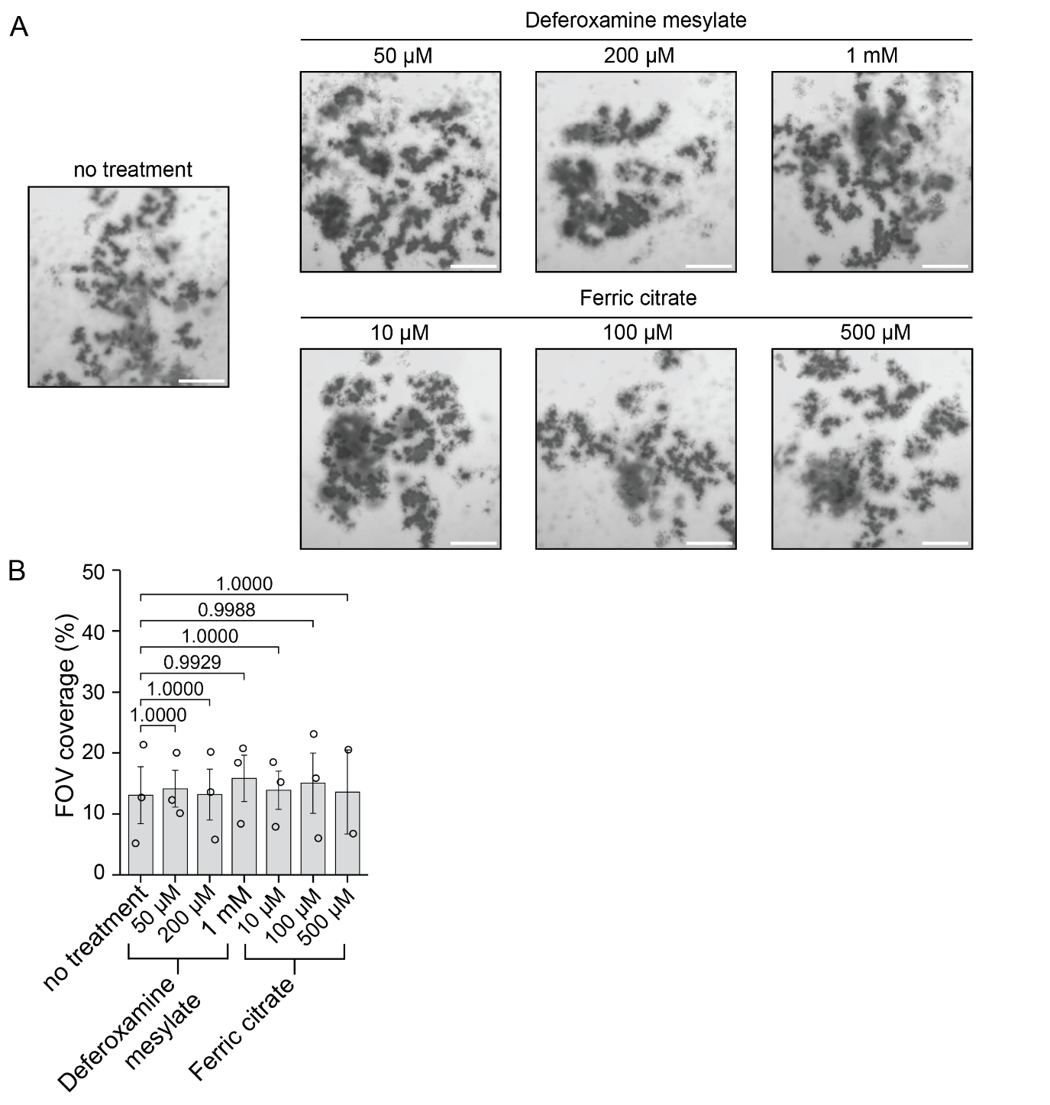
Figure S4. Iron chelation and supplementation do not impact on C. albicans liquid-suspension biofilm morphology
- Microscopy images of suspended aggregates formed in liquid suspension with agarose surfaces, treated with deferoxamine mesylate and ferric citrate. Scale bar = 1.5 mm.
- Image-based quantification of suspension growth for conditions in panel A. Shown are averages and the SEM of 3 independent repeats (one-way ANOVA with Dunnett's post hoc test, p values shown, two repeats for ferric citrate 500 µM only). FOV (field of view) coverage: the total 2D area within the image field of view occupied by suspension growth.

Table S1. Strains used in this study
Identifier | Genotype | Background | Source
SC5314 | wildtype strain | SC5314 (Clade I) | Ted White
SN250 | ura3Δ:: λimm434:: URA3-IRO1/ura3Δ:: λimm434 arg4::hisG/arg4::hisG his1::hisG/his1::hisG leu2::hisG::CdHIS1/leu2::hisG::CmLEU2 | SC5314 | Suzanne Nobile
SN425 | ura3Δ::λimm434::URA3-IRO1/ura3Δ::λimm434 arg4::hisG::CdARG4/arg4::hisG his1::hisG/his1::hisG leu2::hisG::CdHIS1/leu2::hisG::CmLEU2 | SC5314 | Suzanne Nobile
rob1Δ/Δ | rob1Δ::LEU2/rob1Δ::HIS1 | SN152 | Homann collection
efg1Δ/Δ | efg1Δ::LEU2/efg1Δ::HIS1 | SN152 | Homann collection
ndt80Δ/Δ | ndt80Δ::LEU2/ndt80Δ::HIS1 | SN152 | Homann collection
brg1Δ/Δ | brg1Δ::LEU2/brg1Δ::HIS1 | SN152 | Homann collection
tec1Δ/Δ | tec1Δ::LEU2/tec1Δ::HIS1 | SN152 | Homann collection
bcr1Δ/Δ | bcr1Δ::LEU2/bcr1Δ::HIS1 | SN152 | Homann collection

Dataset S1. RNAseq data analyses. Compiled transcriptomics results for biofilm morphology comparisons at 5 and 24 hours of growth, FDR < 0.05, Log2FC >= 1, as lists of unique and shared genes that were upregulated and downregulated at 5 hours and 24 hours of growth (data for Venn diagrams in Figure 4 and Figure S1).
Dataset S2. Gene ontology analyses of the RNAseq data. Candida Genome Database GO Term Finder output (gene ontology enrichment analysis) for biofilm morphology comparisons: overlapping genes, upregulated and downregulated genes at 5 and 24 hours of growth. Plots for this data are presented in Figure 4, Figure S1, Figure S2 and Figure S3.
Dataset S3. Source data for figures. Numerical values for biological repeats in plots for image-based quantification of suspension growth and XTT metabolic assays: Figure 1D, Figure 2A & B, Figure 5B, Figure 6B, Figure 6D and Figure S4B.
Video S1. C. albicans liquid-suspension growths. Gentle perturbation applied to 24-well microplate with C. albicans suspension biofilm, causing movement of the biofilms in suspension due to lack of surface adherence. Scale bar = 1.5 mm.

