Towards guideline-grounded clinical decision-making: a multi-scale study of retrieval augmented generation based large language model agents

Supplementary Material

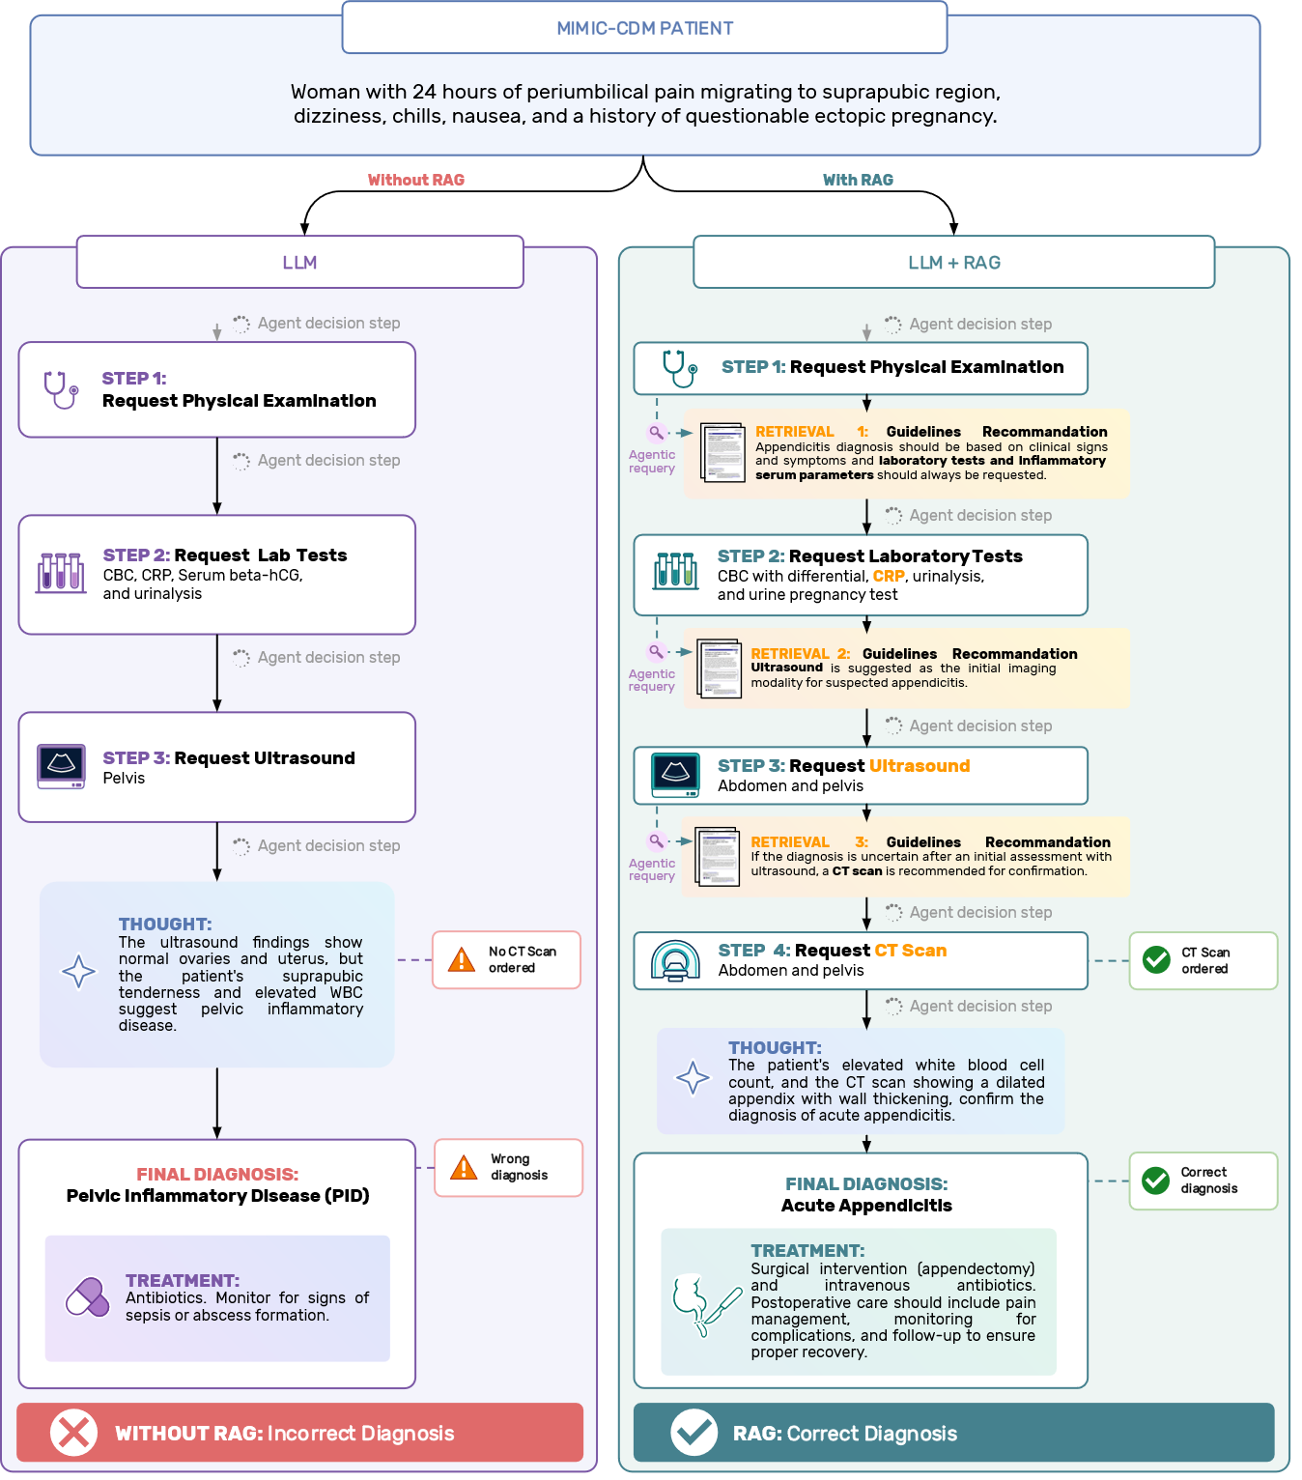
Supplementary Fig. 1 | Second case-level comparison of the same backbone model with and without RAG. This illustrative pathway shows how retrieval can alter both the diagnostic work-up and the final diagnosis. In the non-RAG setting, the model skips key tests and converges on an incorrect diagnosis. Whereas the same backbone model for the same seed and same patient, but equipped with RAG, retrieves guideline passages at each decision step, grounding its tests ordering into a more informed reasoning, and reaches the correct final diagnosis and care plan. This figure represents an actual case from an acute appendicitis patient taken from the dataset, that we have then manually anonymized. In this comparison, the backbone model is Qwen3-30B-A3B quantized in 4 bits-per-weight and ran with seed 4896.

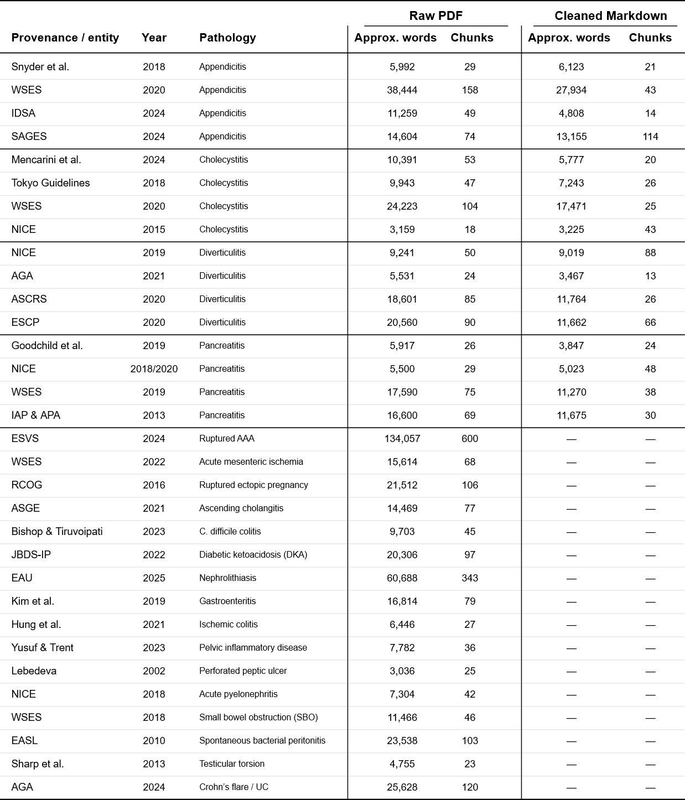
Supplementary Table 1 | Detailed corpus composition. The approximate word count is computed as the total number of words contained within each chunks, including word overlap. Only the four target pathologies documents have been manually cleaned into markdown.

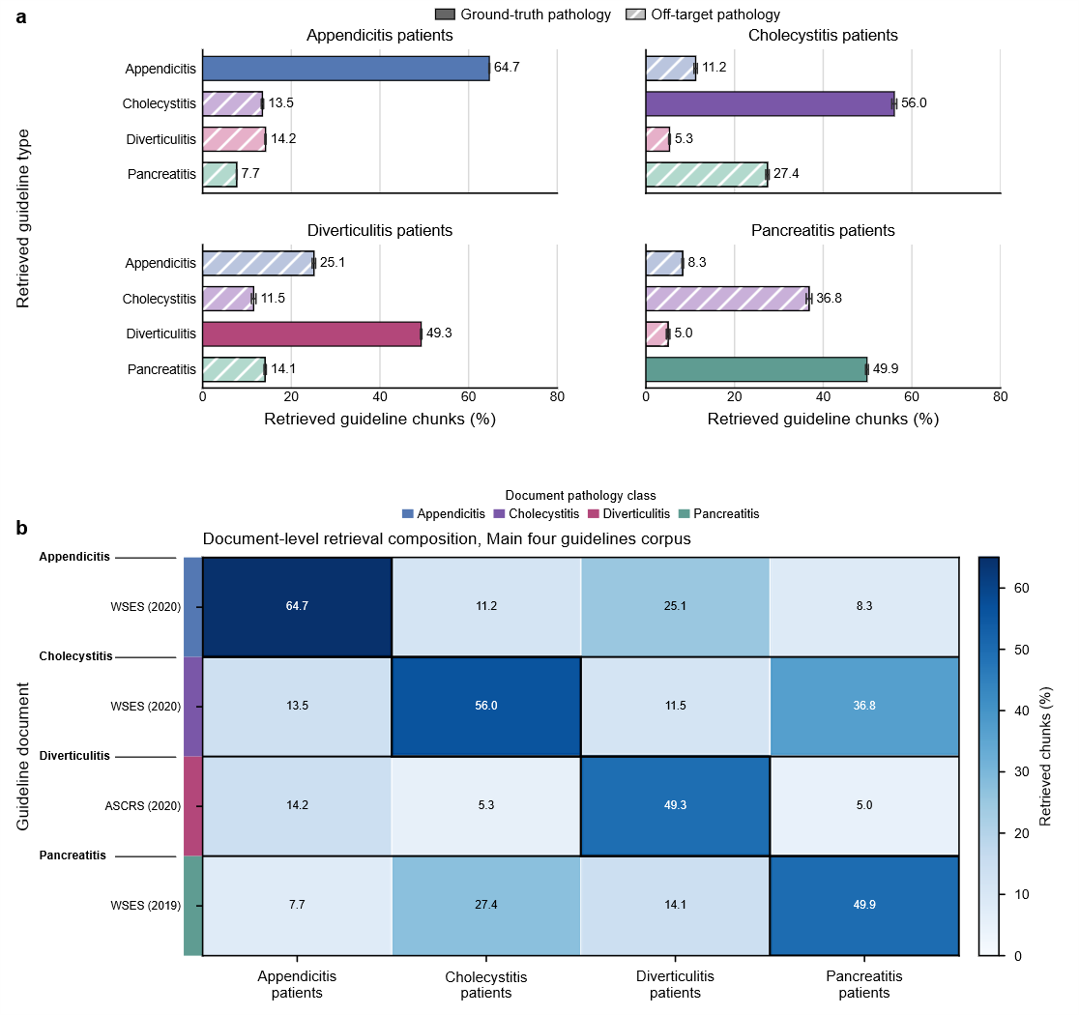
Supplementary Fig. 2 | Composition of guideline retrieval across patient pathologies and source documents, main four guidelines corpus. Main four guidelines corpus corresponds to the four guidelines used in the original MIMIC-CDM study to evaluate whether the LLMs fail to order the exams required by diagnostic guidelines. a, Guideline-level composition of retrieved chunks, stratified by the ground-truth pathology of the patient case. For each pathology, bars show the mean percentage of retrieved chunks originating from each of the four pathology-specific guideline groups. Within each seed, retrieval proportions were averaged across the eight evaluated LLM backbones; bars show the mean across the three resulting seed-level means (n = 3 seeds), and error bars denote ±1 s.d. across these seed-level means. Solid bars denote the guideline group corresponding to the ground-truth patient pathology, whereas hatched bars denote off-target guideline groups. b, Document-level composition of retrieved chunks. Rows represent individual guideline or reference documents and columns represent the ground-truth patient pathology. Cell values show the mean percentage of retrieved chunks originating from each document, calculated across the same three seed-level means after averaging across the eight backbones within each seed (n = 3 seeds). The colored strip adjacent to each row denotes the pathology associated with the source document. Black outlines indicate document blocks whose pathology matches the ground-truth patient pathology. Guideline sources are identified by the issuing organization or guideline series for organizational guidelines and by first author for article-based sources; years indicate the corresponding publication or guideline version.

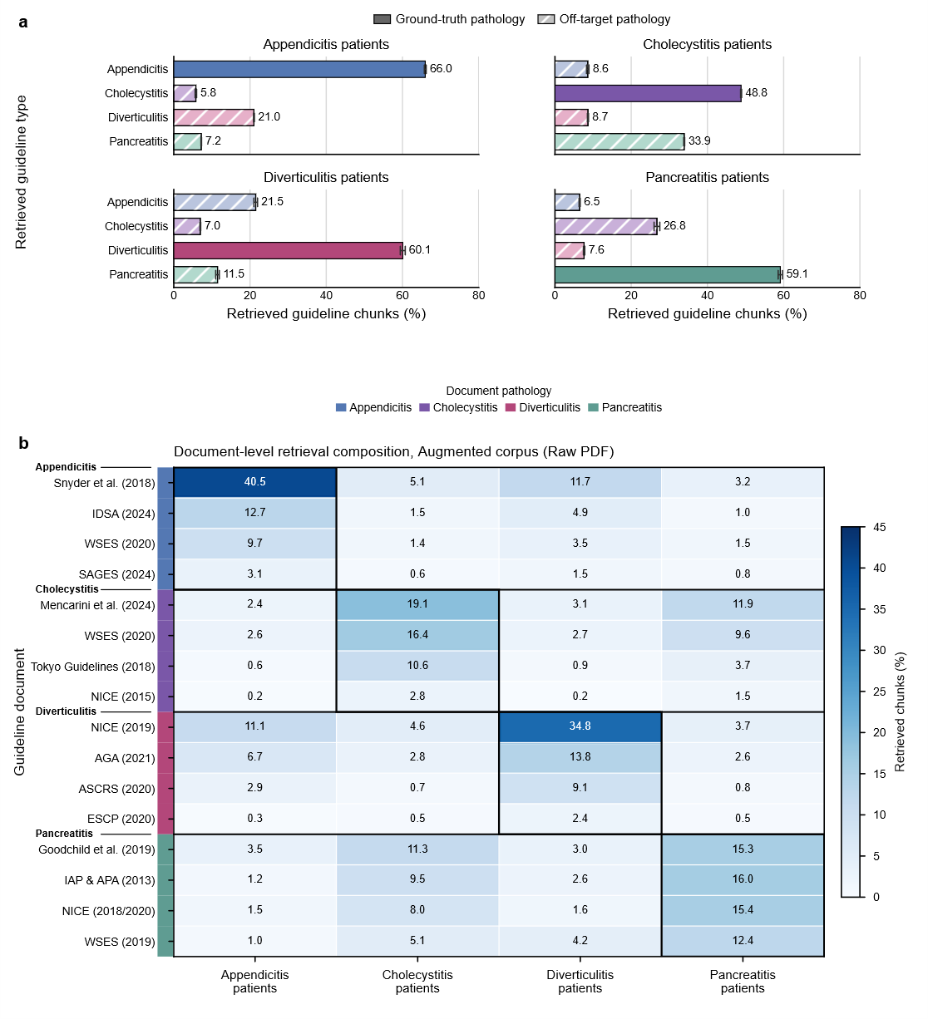
Supplementary Fig. 3 | Composition of guideline retrieval across patient pathologies and source documents, augmented corpus, raw PDF. a, Guideline-level composition of retrieved chunks, stratified by the ground-truth pathology of the patient case. For each pathology, bars show the mean percentage of retrieved chunks originating from each of the four pathology-specific guideline groups. Within each seed, retrieval proportions were averaged across the eight evaluated LLM backbones; bars show the mean across the three resulting seed-level means (n = 3 seeds), and error bars denote ±1 s.d. across these seed-level means. Solid bars denote the guideline group corresponding to the ground-truth patient pathology, whereas hatched bars denote off-target guideline groups. b, Document-level composition of retrieved chunks. Rows represent individual guideline or reference documents and columns represent the ground-truth patient pathology. Cell values show the mean percentage of retrieved chunks originating from each document, calculated across the same three seed-level means after averaging across the eight backbones within each seed (n = 3 seeds). The colored strip adjacent to each row denotes the pathology associated with the source document. Black outlines indicate document blocks whose pathology matches the ground-truth patient pathology. Guideline sources are identified by the issuing organization or guideline series for organizational guidelines and by first author for article-based sources; years indicate the corresponding publication or guideline version.
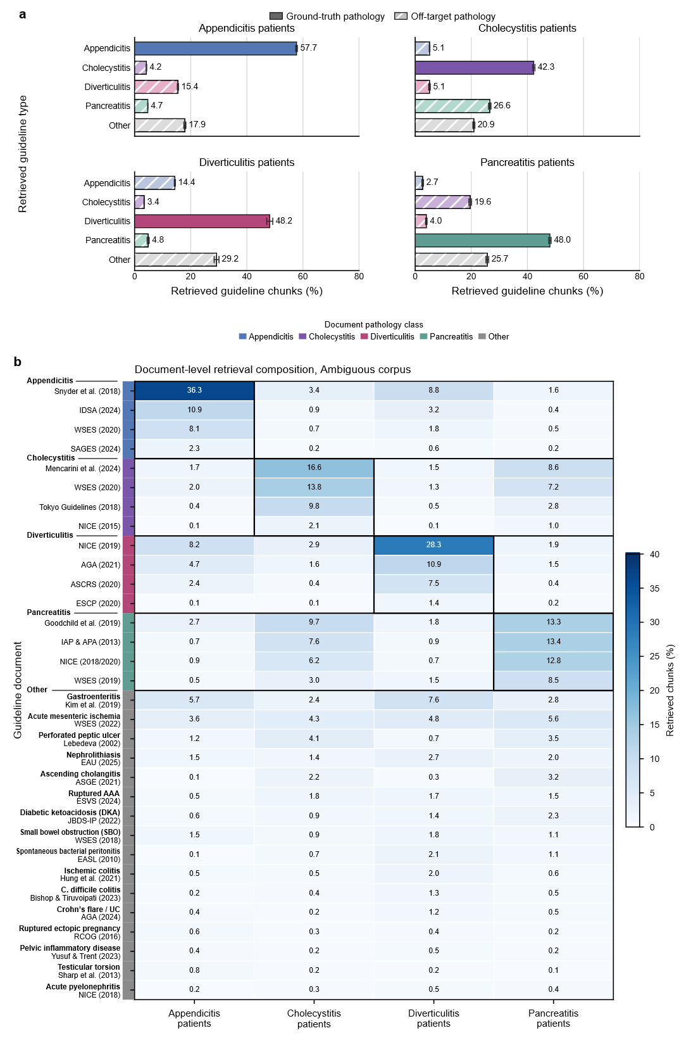
Supplementary Fig. 4 | Composition of guideline retrieval across patient pathologies and source documents from the ambiguous corpus. Figure also available the paper’s extended data section, but added here again to allow for easy comparison. a, Retrieved chunks by guideline type and patient pathology; solid and hatched bars indicate ground-truth and off-target pathologies, respectively (mean ± s.d., n = 3 seeds). b, Document-level composition; values show mean retrieved-chunk percentages, with row colors denoting source pathology and black outlines indicating pathology-matched document blocks.
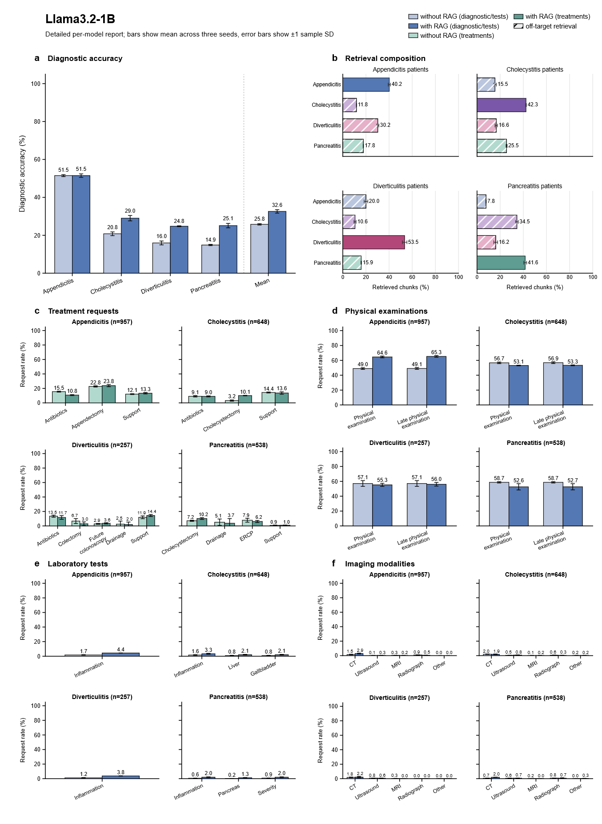
Supplementary Fig. 5 | Detailed per-model report, Llama3.2-1B. Quantized to 4.0 bpw, run over n=3 seeds. Error bars indicate sample standard deviations across the three decoding seeds. Each backbone–condition was evaluated on all 2,400 MIMIC-CDM cases.

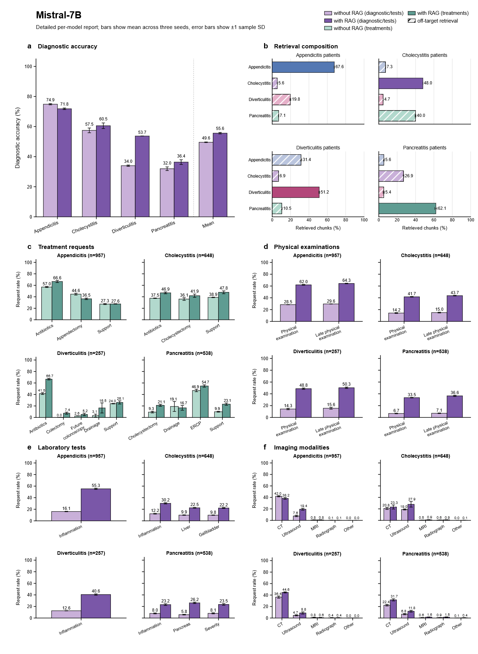
Supplementary Fig. 6 | Detailed per-model report, Mistral-7B. Quantized to 4.0 bpw, run over n=3 seeds. Error bars indicate sample standard deviations across the three decoding seeds. Each backbone–condition was evaluated on all 2,400 MIMIC-CDM cases.

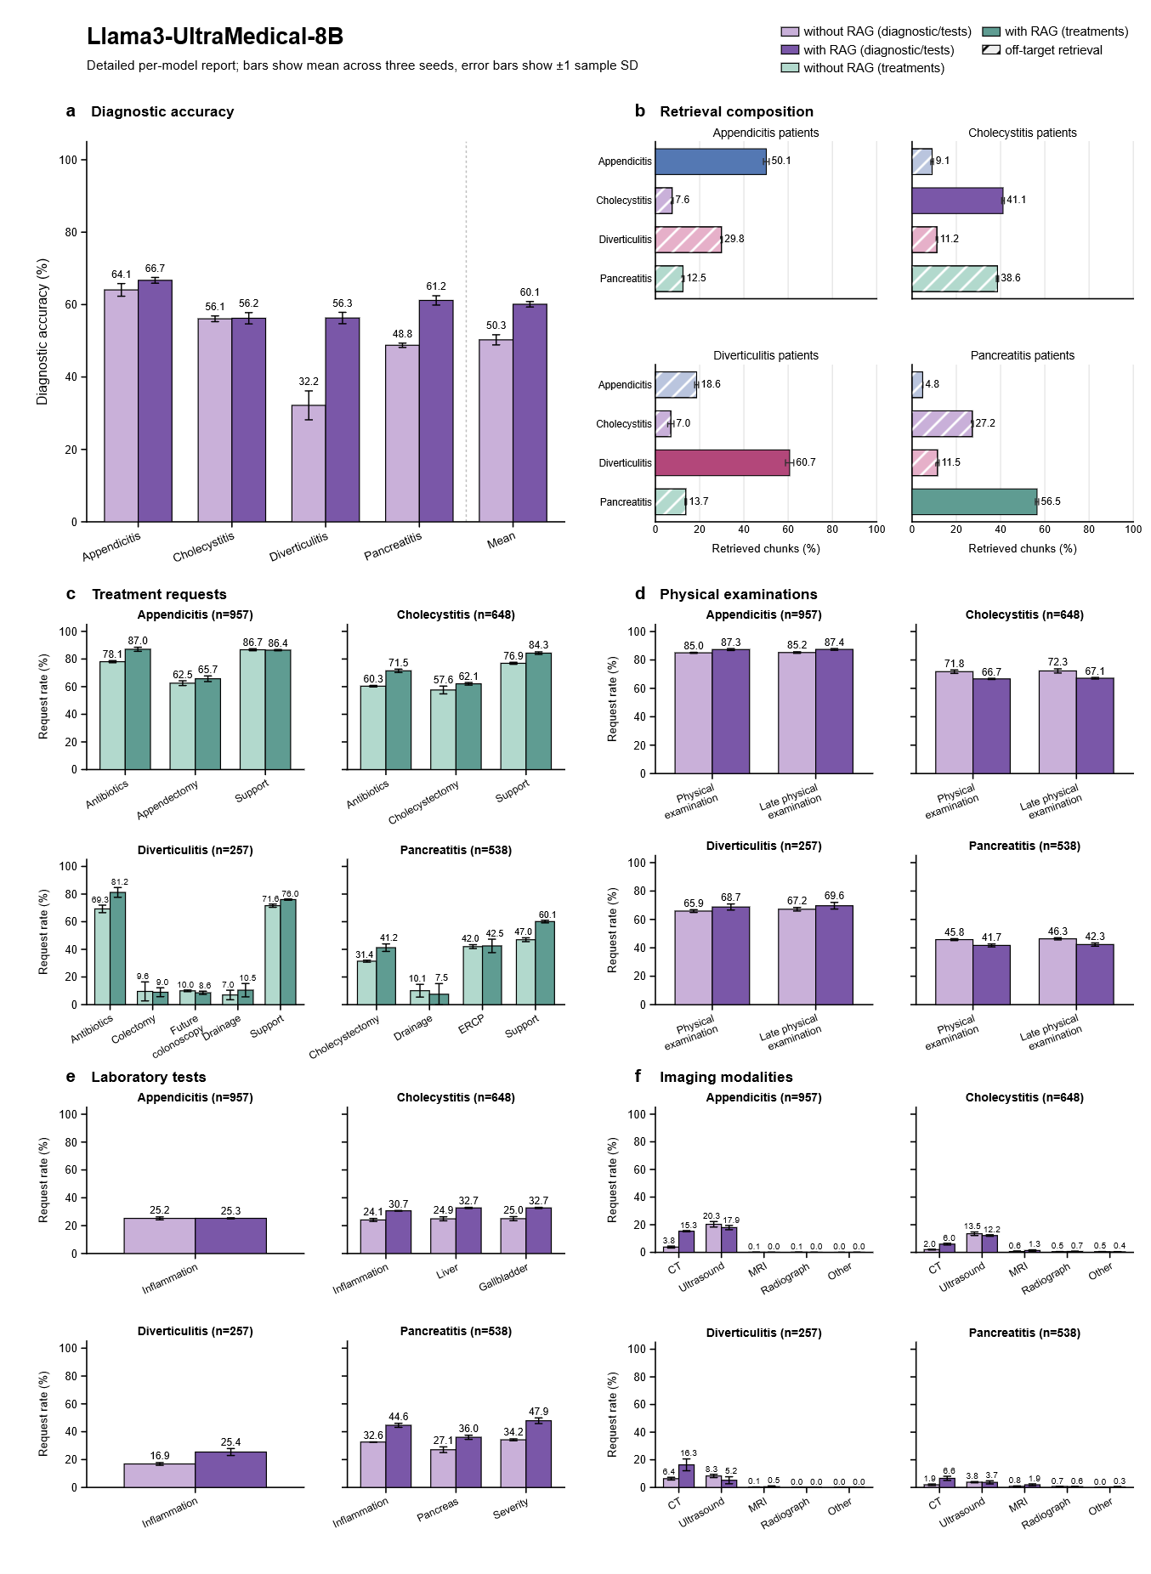
Supplementary Fig. 7 | Detailed per-model report, Llama3-UltraMedical-8B. Quantized to 4.0 bpw, run over n=3 seeds. Error bars indicate sample standard deviations across the three decoding seeds. Each backbone–condition was evaluated on all 2,400 MIMIC-CDM cases.

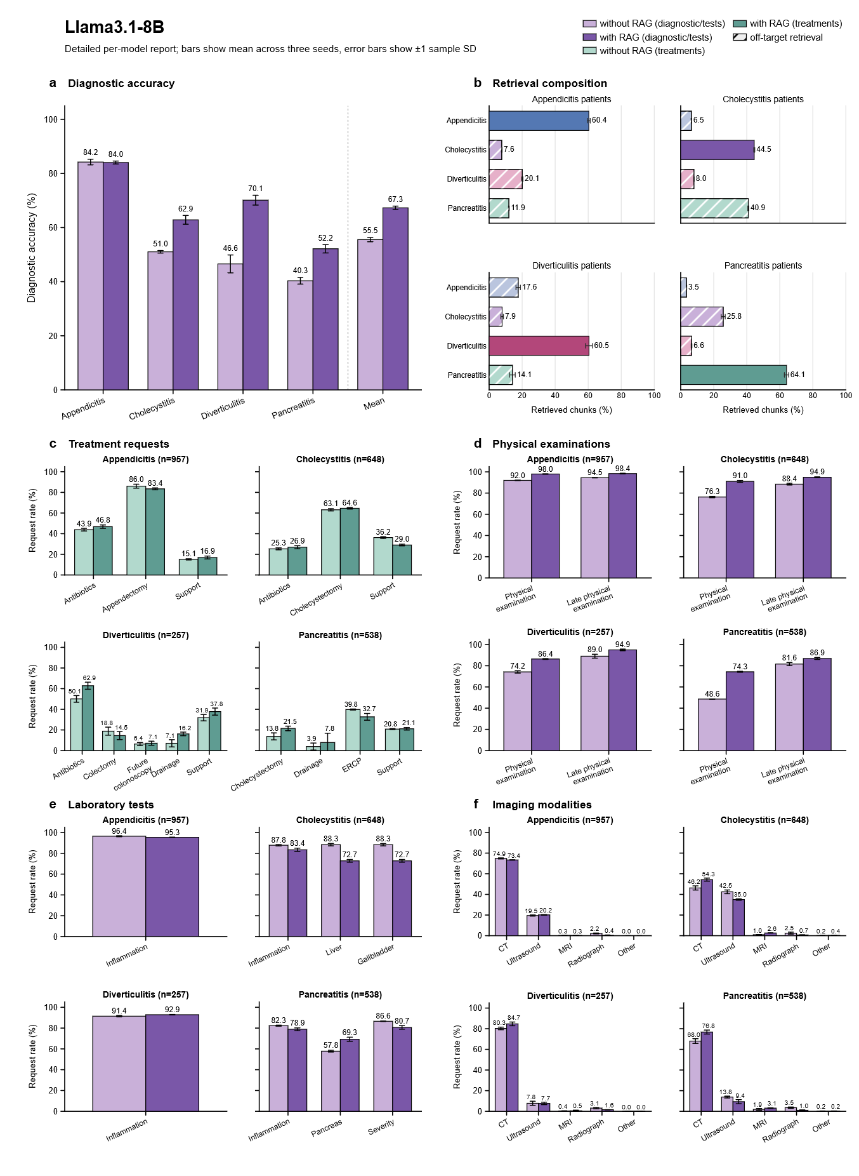
Supplementary Fig. 8 | Detailed per-model report, Llama3.1-8B. Quantized to 4.0 bpw, run over n=3 seeds. Error bars indicate sample standard deviations across the three decoding seeds. Each backbone–condition was evaluated on all 2,400 MIMIC-CDM cases.

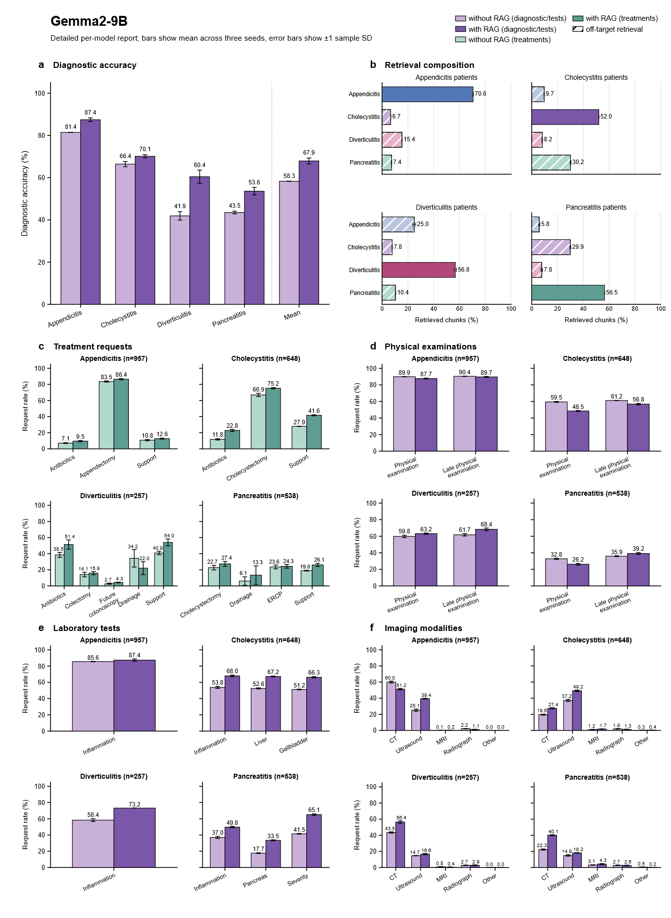
Supplementary Fig. 9 | Detailed per-model report, Gemma2-9B. Quantized to 4.0 bpw, run over n=3 seeds. Error bars indicate sample standard deviations across the three decoding seeds. Each backbone–condition was evaluated on all 2,400 MIMIC-CDM cases.

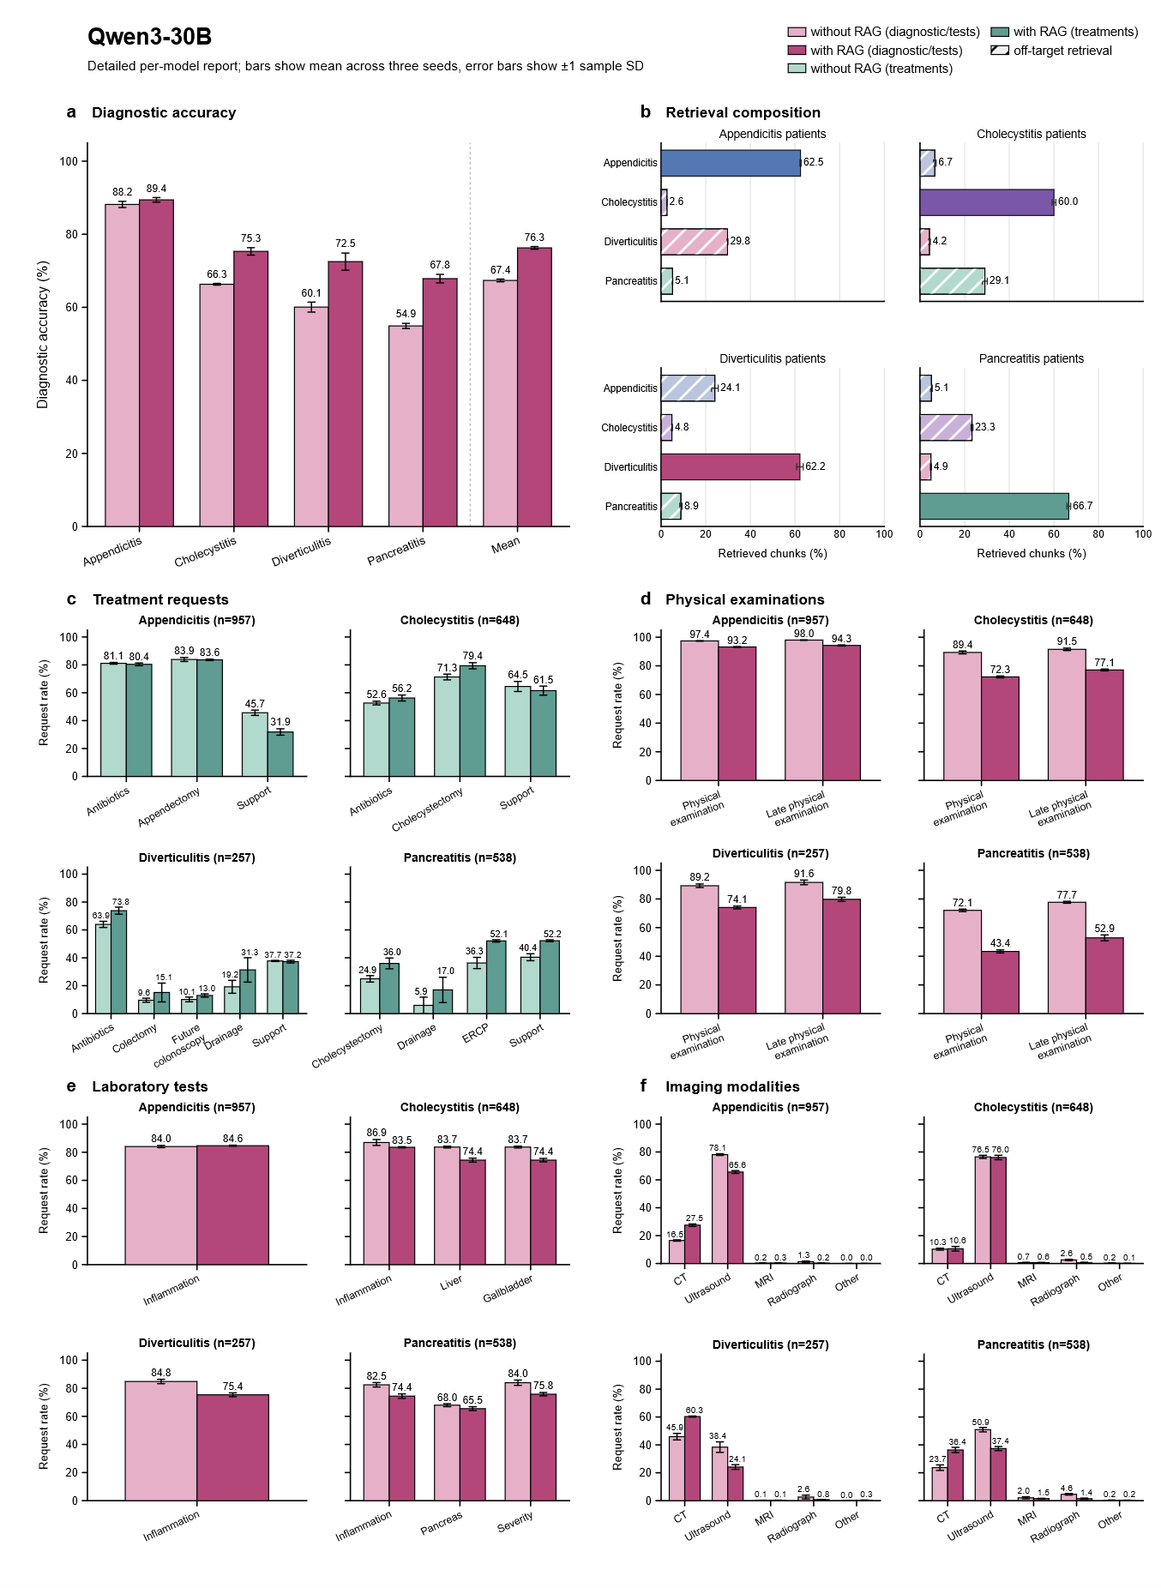
Supplementary Fig. 10 | Detailed per-model report, Qwen3-30B. Quantized to 4.0 bpw, run over n=3 seeds. Error bars indicate sample standard deviations across the three decoding seeds. Each backbone–condition was evaluated on all 2,400 MIMIC-CDM cases.

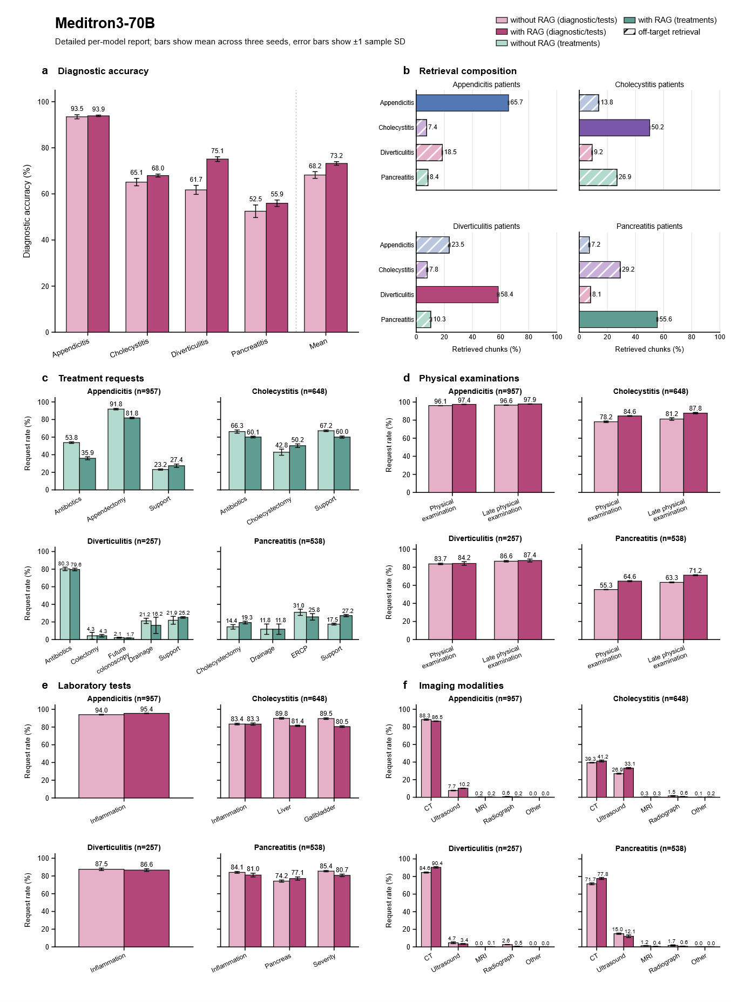
Supplementary Fig. 11 | Detailed per-model report, Meditron3-70B. Quantized to 4.0 bpw, run over n=3 seeds. Error bars indicate sample standard deviations across the three decoding seeds. Each backbone–condition was evaluated on all 2,400 MIMIC-CDM cases.

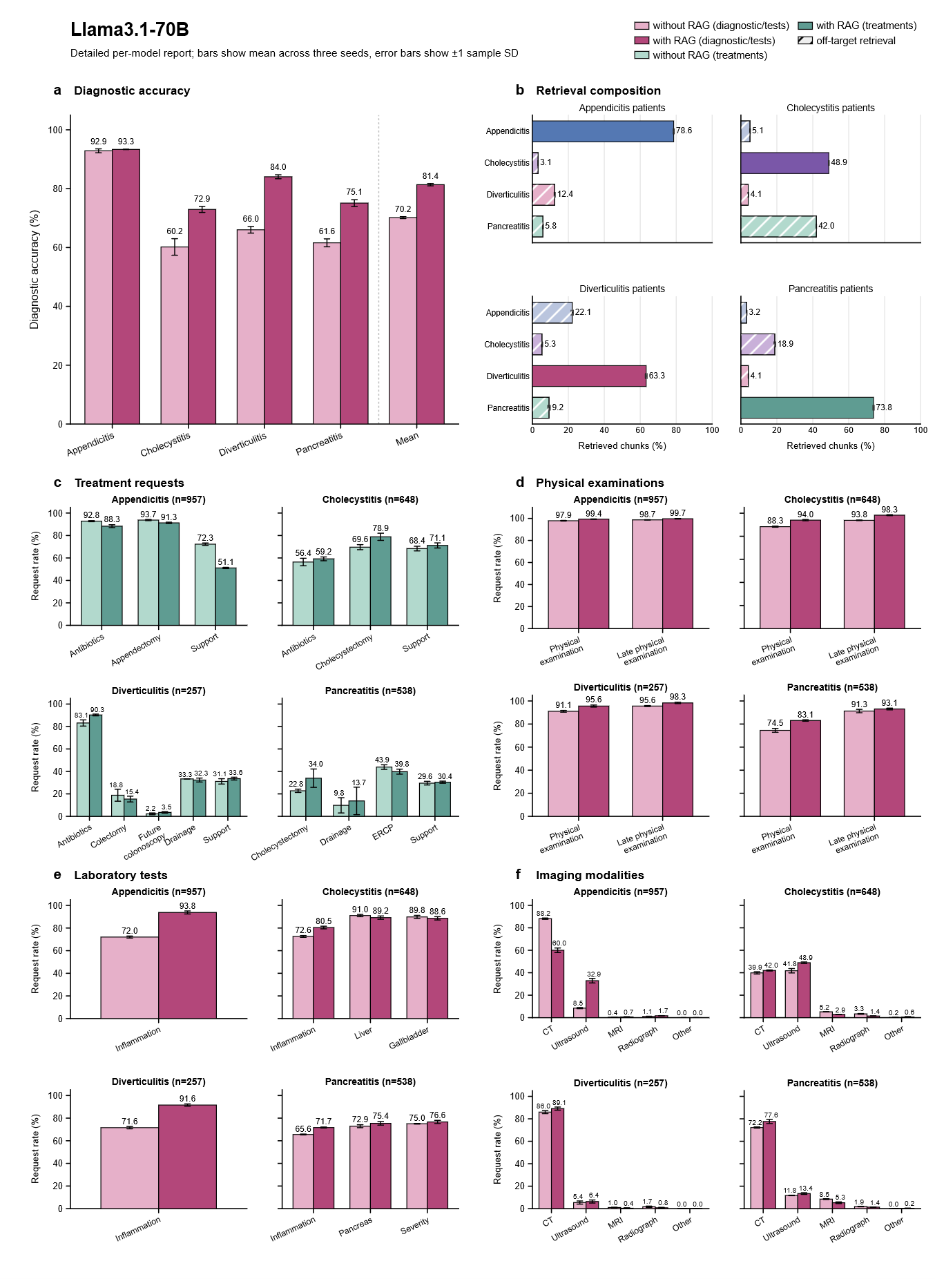
Supplementary Fig. 12 | Detailed per-model report, Llama3.1-70B. Quantized to 4.0 bpw, run over n=3 seeds. Error bars indicate sample standard deviations across the three decoding seeds. Each backbone–condition was evaluated on all 2,400 MIMIC-CDM cases.

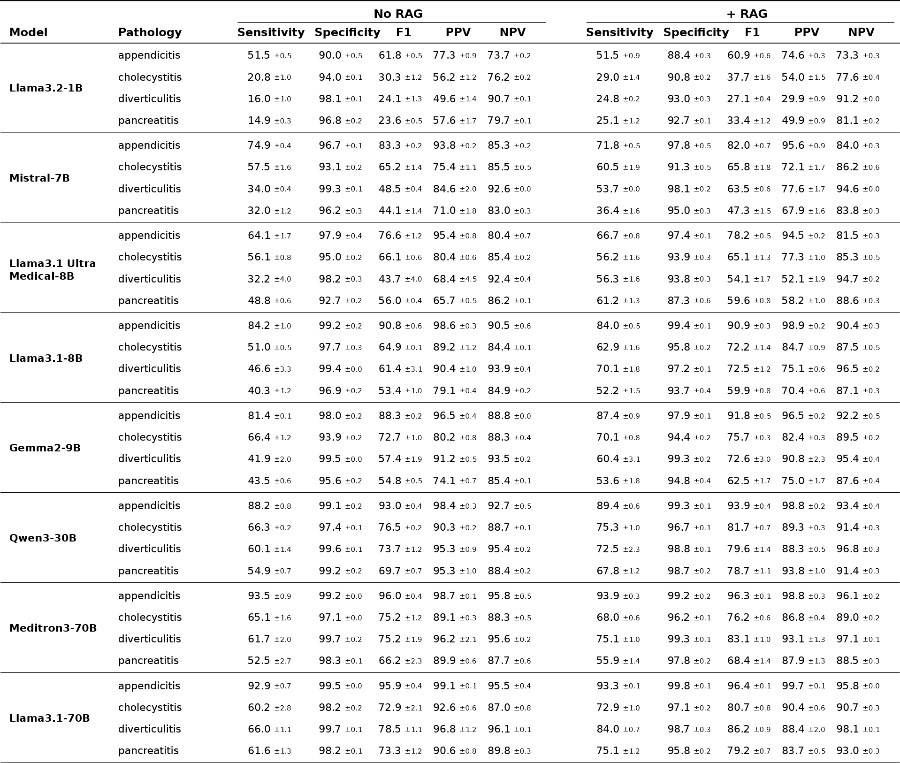
Supplementary Table 2 | Additional metrics. The sensitivity equates per-class diagnosis accuracy used throughout this study. To calculate these additional metrics, false positives and true negatives were counted over the diseases included in this dataset and therefore not representative of a general population and so these metrics are to be interpreted with caution.

