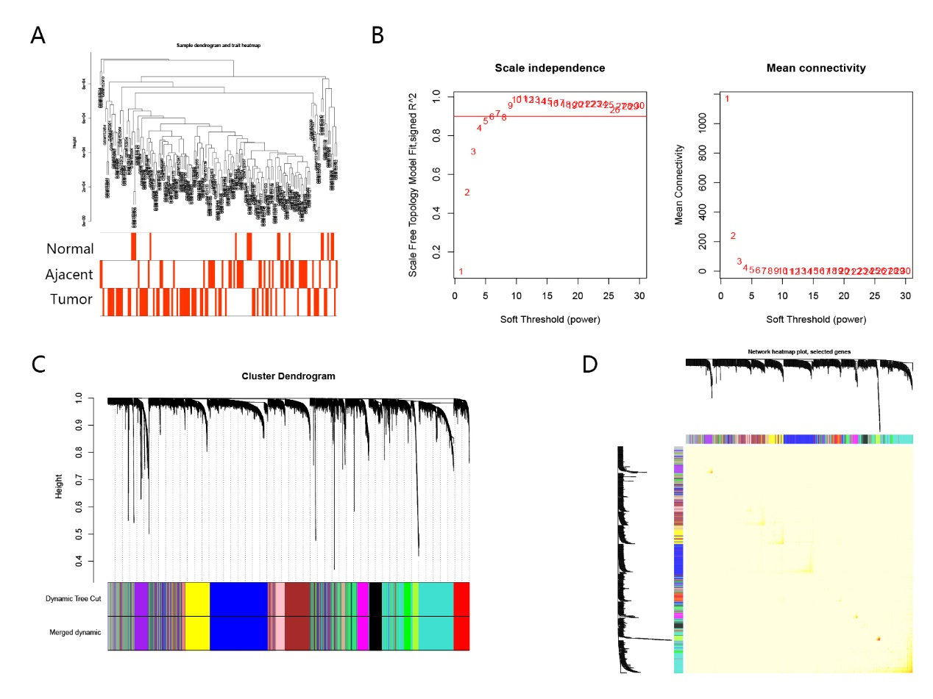
Supplementary Figure 1. WGCNA of genes between prostate normal, adjacent and tumor tissues in GSE6919. A. Cluster dendrogram displays the relationship between prostate normal, adjacent and tumor samples. B. Analysis of the scale-free fit index for various soft thresholding powers (β), the β value was set 5. C. Hierarchical cluster tree showing co-expression modules identified by WGCNA. D. Heatmap plot show the TOM among all genes. Light color shows low overlap and red color indicates higher overlap. The left side and the top side show the gene dendrogram and module assignment.

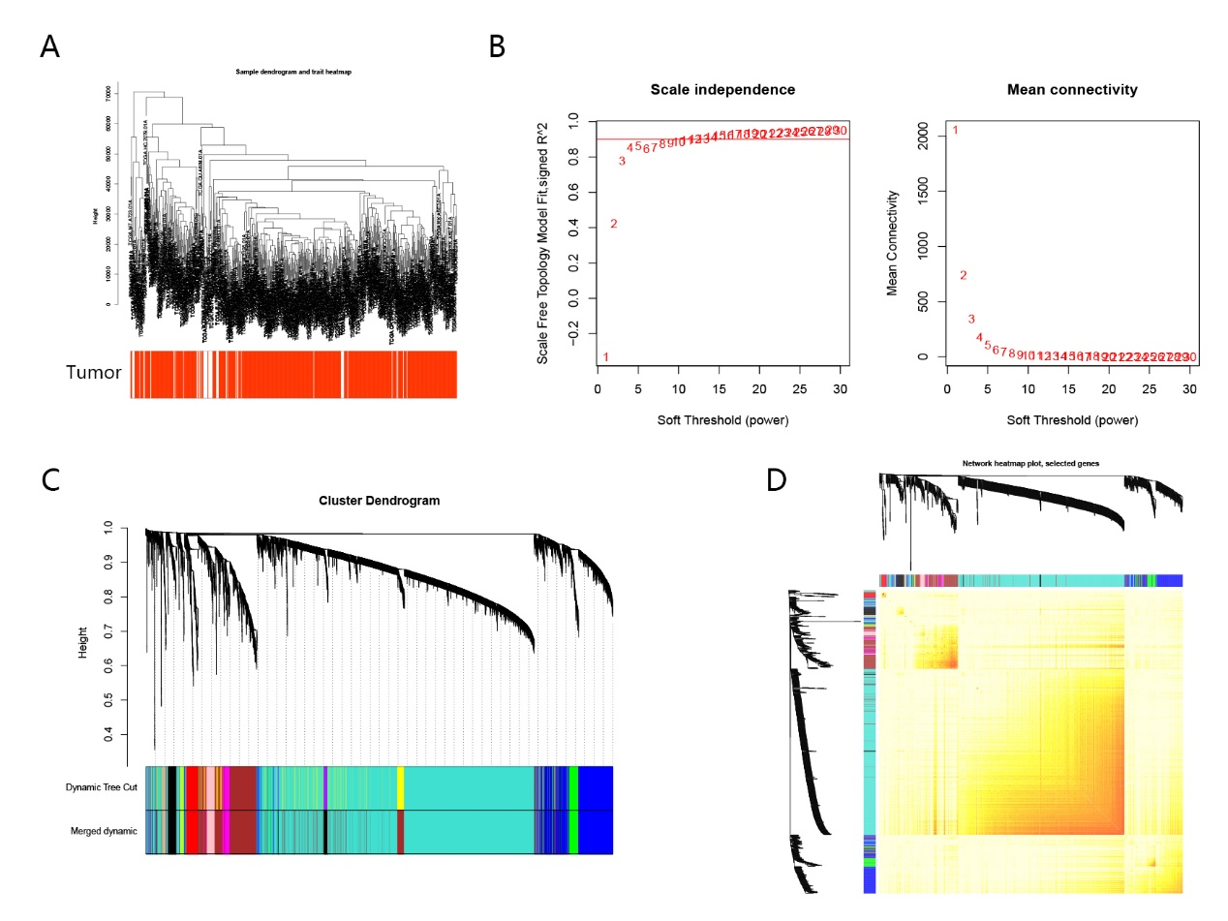
Supplementary Figure 2. WGCNA of genes between prostate normal and tumor tissues in TCGA. A. Cluster dendrogram displays the relationship between prostate normal and tumor samples. B. Analysis of the scale-free fit index for various soft thresholding powers (β), the β value was set 4. C. Hierarchical cluster tree showing co-expression modules identified by WGCNA. D. Heatmap plot show the TOM among all genes. Light color shows low overlap and red color indicates higher overlap. The left side and the top side show the gene dendrogram and module assignment.

