Huge spread in CMIP6 diffuse radiation impairs carbon budget estimates – Supplementary Information

TC Chakraborty^{1,*}
¹Pacific Northwest National Laboratory, Richland, WA, USA
*Corresponding author: TC Chakraborty, Email: tc.chakraborty@pnnl.gov
Supplementary Information
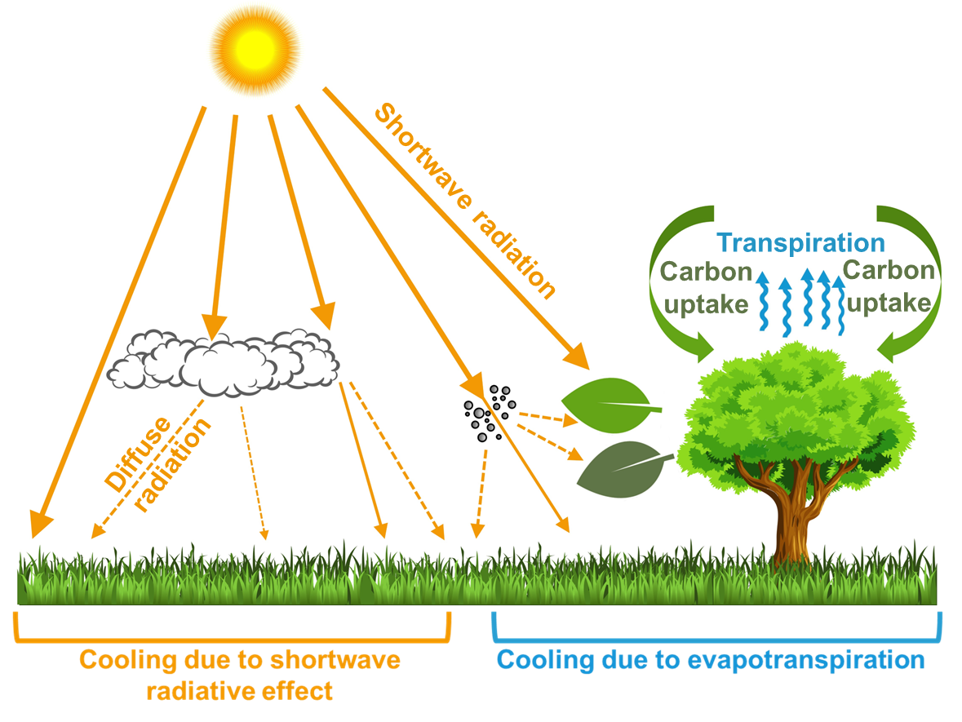
Figure S1 | Conceptual framework of diffuse solar radiation impacts on terrestrial ecosystems | Schematic illustration of atmospheric scattering processes and canopy-level biophysical interactions. Direct solar beam radiation is scattered forward by clouds, aerosols, and atmospheric gases into multidirectional diffuse solar radiation. Canopy penetration by diffuse radiation enhances light availability across shaded sub-canopy foliage. This diffuse radiation fertilization effect stimulates canopy gross primary productivity and modulates surface water fluxes (transpiration) and temperature via both shortwave radiative and evaporative cooling pathways.

Table S1 | 16 primary CMIP6 models considered | Characteristics of the 16 Coupled Model Intercomparison Project Phase 6 (CMIP6) climate models evaluated against each other and against surface observations from the Global Energy Balance Archive (GEBA). Columns detail the standard model acronym, the comprehensive model name, the native atmospheric dynamical grid discretization and coordinate dimensions, and the archived temporal resolution of downwelling surface diffuse shortwave radiation ($K_{↓,d}$).
Model | Full Model Name | Native Resolution | Raw Frequency
ACCESS-CM2 | Australian Community Climate and Earth System Simulator Climate Model Version 2 | 1.25° × 1.88° (144 × 192) | 3-hourly
BCC-CSM2-MR | Beijing Climate Center Climate System Model 2 Moderate Resolution | 1.12° × 1.12° (160 × 320) | 3-hourly
CanESM5-1 | Canadian Earth System Model version 5.1 | 2.79° × 2.81° (64 × 128) | Monthly
CESM2 | Community Earth System Model version 2 | 0.94° × 1.25° (192 × 288) | Monthly
CNRM-CM6-1 | Centre National de Recherches Météorologiques Climate Model 6.1 | 1.40° × 1.41° (128 × 256) | Monthly
FGOALS-g3 | Flexible Global Ocean-Atmosphere-Land System Model Grid-point Version 3 | 2.28° × 2.00° (80 × 180) | 3-hourly
GFDL-CM4 | Geophysical Fluid Dynamics Laboratory Climate Model 4 | 2.00° × 2.50° (regridded 90 × 144) | 3-hourly
GISS-E2-1-G | Goddard Institute for Space Studies Model E2.1-G | 2.00° × 2.50° (90 × 144) | 3-hourly
HadGEM3-GC31-LL | Hadley Centre Global Environment Model 3 - GC3.1 Low Resolution | 1.25° × 1.88° (144 × 192) | Monthly
IITM-ESM | Indian Institute of Tropical Meteorology Earth System Model | 1.90° × 1.88° (94 × 192) | 3-hourly
KACE-1-0-G | Korea Meteorological Administration Advanced Community Earth System 1.0 | 1.25° × 1.88° (144 × 192) | 3-hourly
MRI-ESM2-0 | Meteorological Research Institute Earth System Model version 2.0 | 1.12° × 1.12° (160 × 320) | 3-hourly
NorCPM1 | Norwegian Climate Prediction Model version 1 | 1.89° × 2.50° (96 × 144) | Monthly
NorESM2-MM | Norwegian Earth System Model 2 - Medium Resolution | 0.94° × 1.25° (192 × 288) | Monthly
TaiESM1 | Taiwan Earth System Model version 1 | 0.94° × 1.25° (192 × 288) | Monthly
UKESM1-0-LL | United Kingdom Earth System Model version 1.0 Low Resolution | 1.25° × 1.88° (144 × 192) | Monthly
Table S2 | Additional CMIP6 models processed | Characteristics of the 5 alternative model configurations processed in the study, showing model acronym, full name, native grid resolution, and archived temporal frequency of surface diffuse shortwave radiation ($K_{↓,d}$) as in Table S1.
Model | Full Model Name | Native Resolution | Raw Frequency
CESM2-WACCM | CESM2 - Whole Atmosphere Community Climate Model | 0.94° × 1.25° (192 × 288) | Monthly
CESM2-FV2 | Community Earth System Model version 2 - Finite Volume 2° | 1.89° × 2.50° (96 × 144) | Monthly
CESM2-WACCM-FV2 | CESM2-WACCM - Finite Volume 2° | 1.89° × 2.50° (96 × 144) | Monthly
CanESM5 | Canadian Earth System Model version 5 | 2.79° × 2.81° (64 × 128) | Monthly
NorESM2-LM | Norwegian Earth System Model 2 - Low Resolution | 1.89° × 2.50° (96 × 144) | Monthly

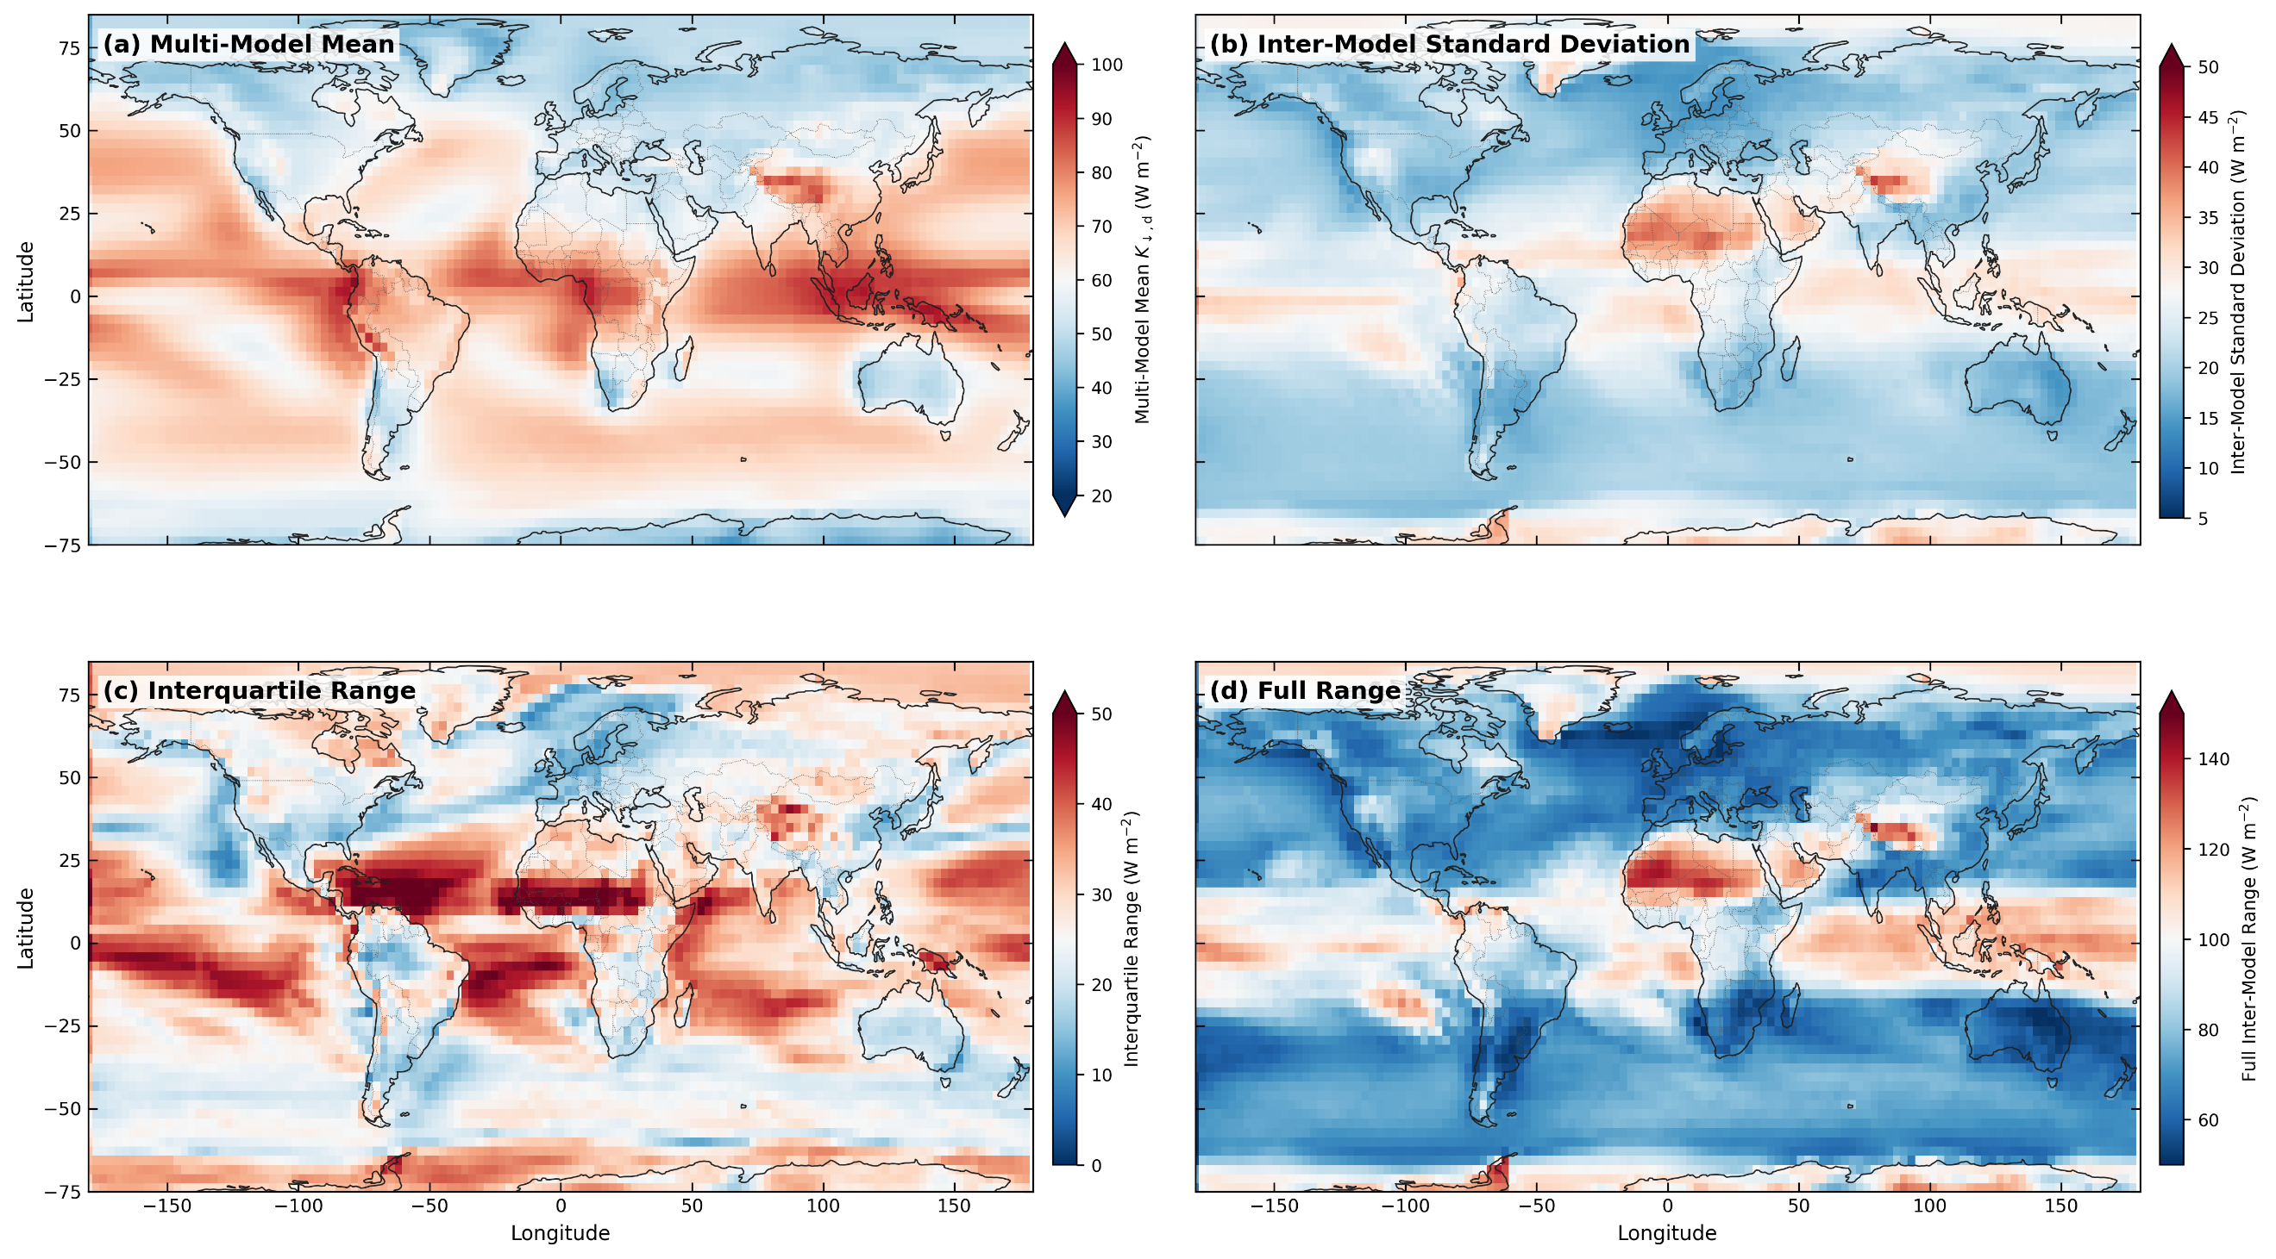
Figure S2 | Spatial patterns of diffuse solar radiation at surface across 16 primary CMIP6 models | Global gridded distributions of climatological (2000–2014) downwelling surface diffuse solar radiation ($K_{↓,d}$) from historical simulations of 16 CMIP6 Earth system models, regridded to a common 2.79° × 2.81° grid. a, Multi-model ensemble mean of $K_{↓,d}$, exhibiting elevated irradiance over equatorial tropical rainforests and major aerosol transport pathways. b, Inter-model standard deviation. c, Inter-model interquartile range. d, Inter-model full range.

Table S3 | Aggregate diffuse radiation estimates from all CMIP6 models processed | Multi-year mean surface diffuse shortwave radiation ($K_{↓,d}$) simulated across all 21 CMIP6 climate model configurations processed in the study for the 2000–2014 period. The area-weighted global and terrestrial means (± standard error; both in W m⁻²) are shown.

Model | Global | Global Land
ACCESS-CM2 | 63.95 ± 0.05 | 60.95 ± 0.06
BCC-CSM2-MR | 49.98 ± 0.05 | 49.81 ± 0.08
CESM2 | 67.45 ± 0.05 | 62.10 ± 0.10
CESM2-FV2 | 67.26 ± 0.11 | 61.84 ± 0.09
CESM2-WACCM | 68.15 ± 0.06 | 62.76 ± 0.10
CESM2-WACCM-FV2 | 69.33 ± 0.12 | 65.99 ± 0.11
CNRM-CM6-1 | 96.38 ± 0.18 | 89.36 ± 0.22
CanESM5 | 88.56 ± 0.22 | 78.91 ± 0.13
CanESM5-1 | 89.37 ± 0.22 | 80.11 ± 0.13
FGOALS-g3 | 41.20 ± 0.06 | 40.49 ± 0.05
GFDL-CM4 | 58.24 ± 0.08 | 56.51 ± 0.07
GISS-E2-1-G | 66.61 ± 0.22 | 60.91 ± 0.17
HadGEM3-GC31-LL | 63.72 ± 0.05 | 61.20 ± 0.06
IITM-ESM | 88.69 ± 0.13 | 88.71 ± 0.14
KACE-1-0-G | 103.05 ± 0.08 | 100.88 ± 0.09
MRI-ESM2-0 | 36.85 ± 0.03 | 33.91 ± 0.05
NorCPM1 | 53.79 ± 0.23 | 40.89 ± 0.19
NorESM2-LM | 50.31 ± 0.20 | 39.04 ± 0.16
NorESM2-MM | 48.78 ± 0.11 | 36.39 ± 0.16
TaiESM1 | 47.50 ± 0.11 | 40.57 ± 0.19
UKESM1-0-LL | 63.13 ± 0.05 | 59.87 ± 0.06

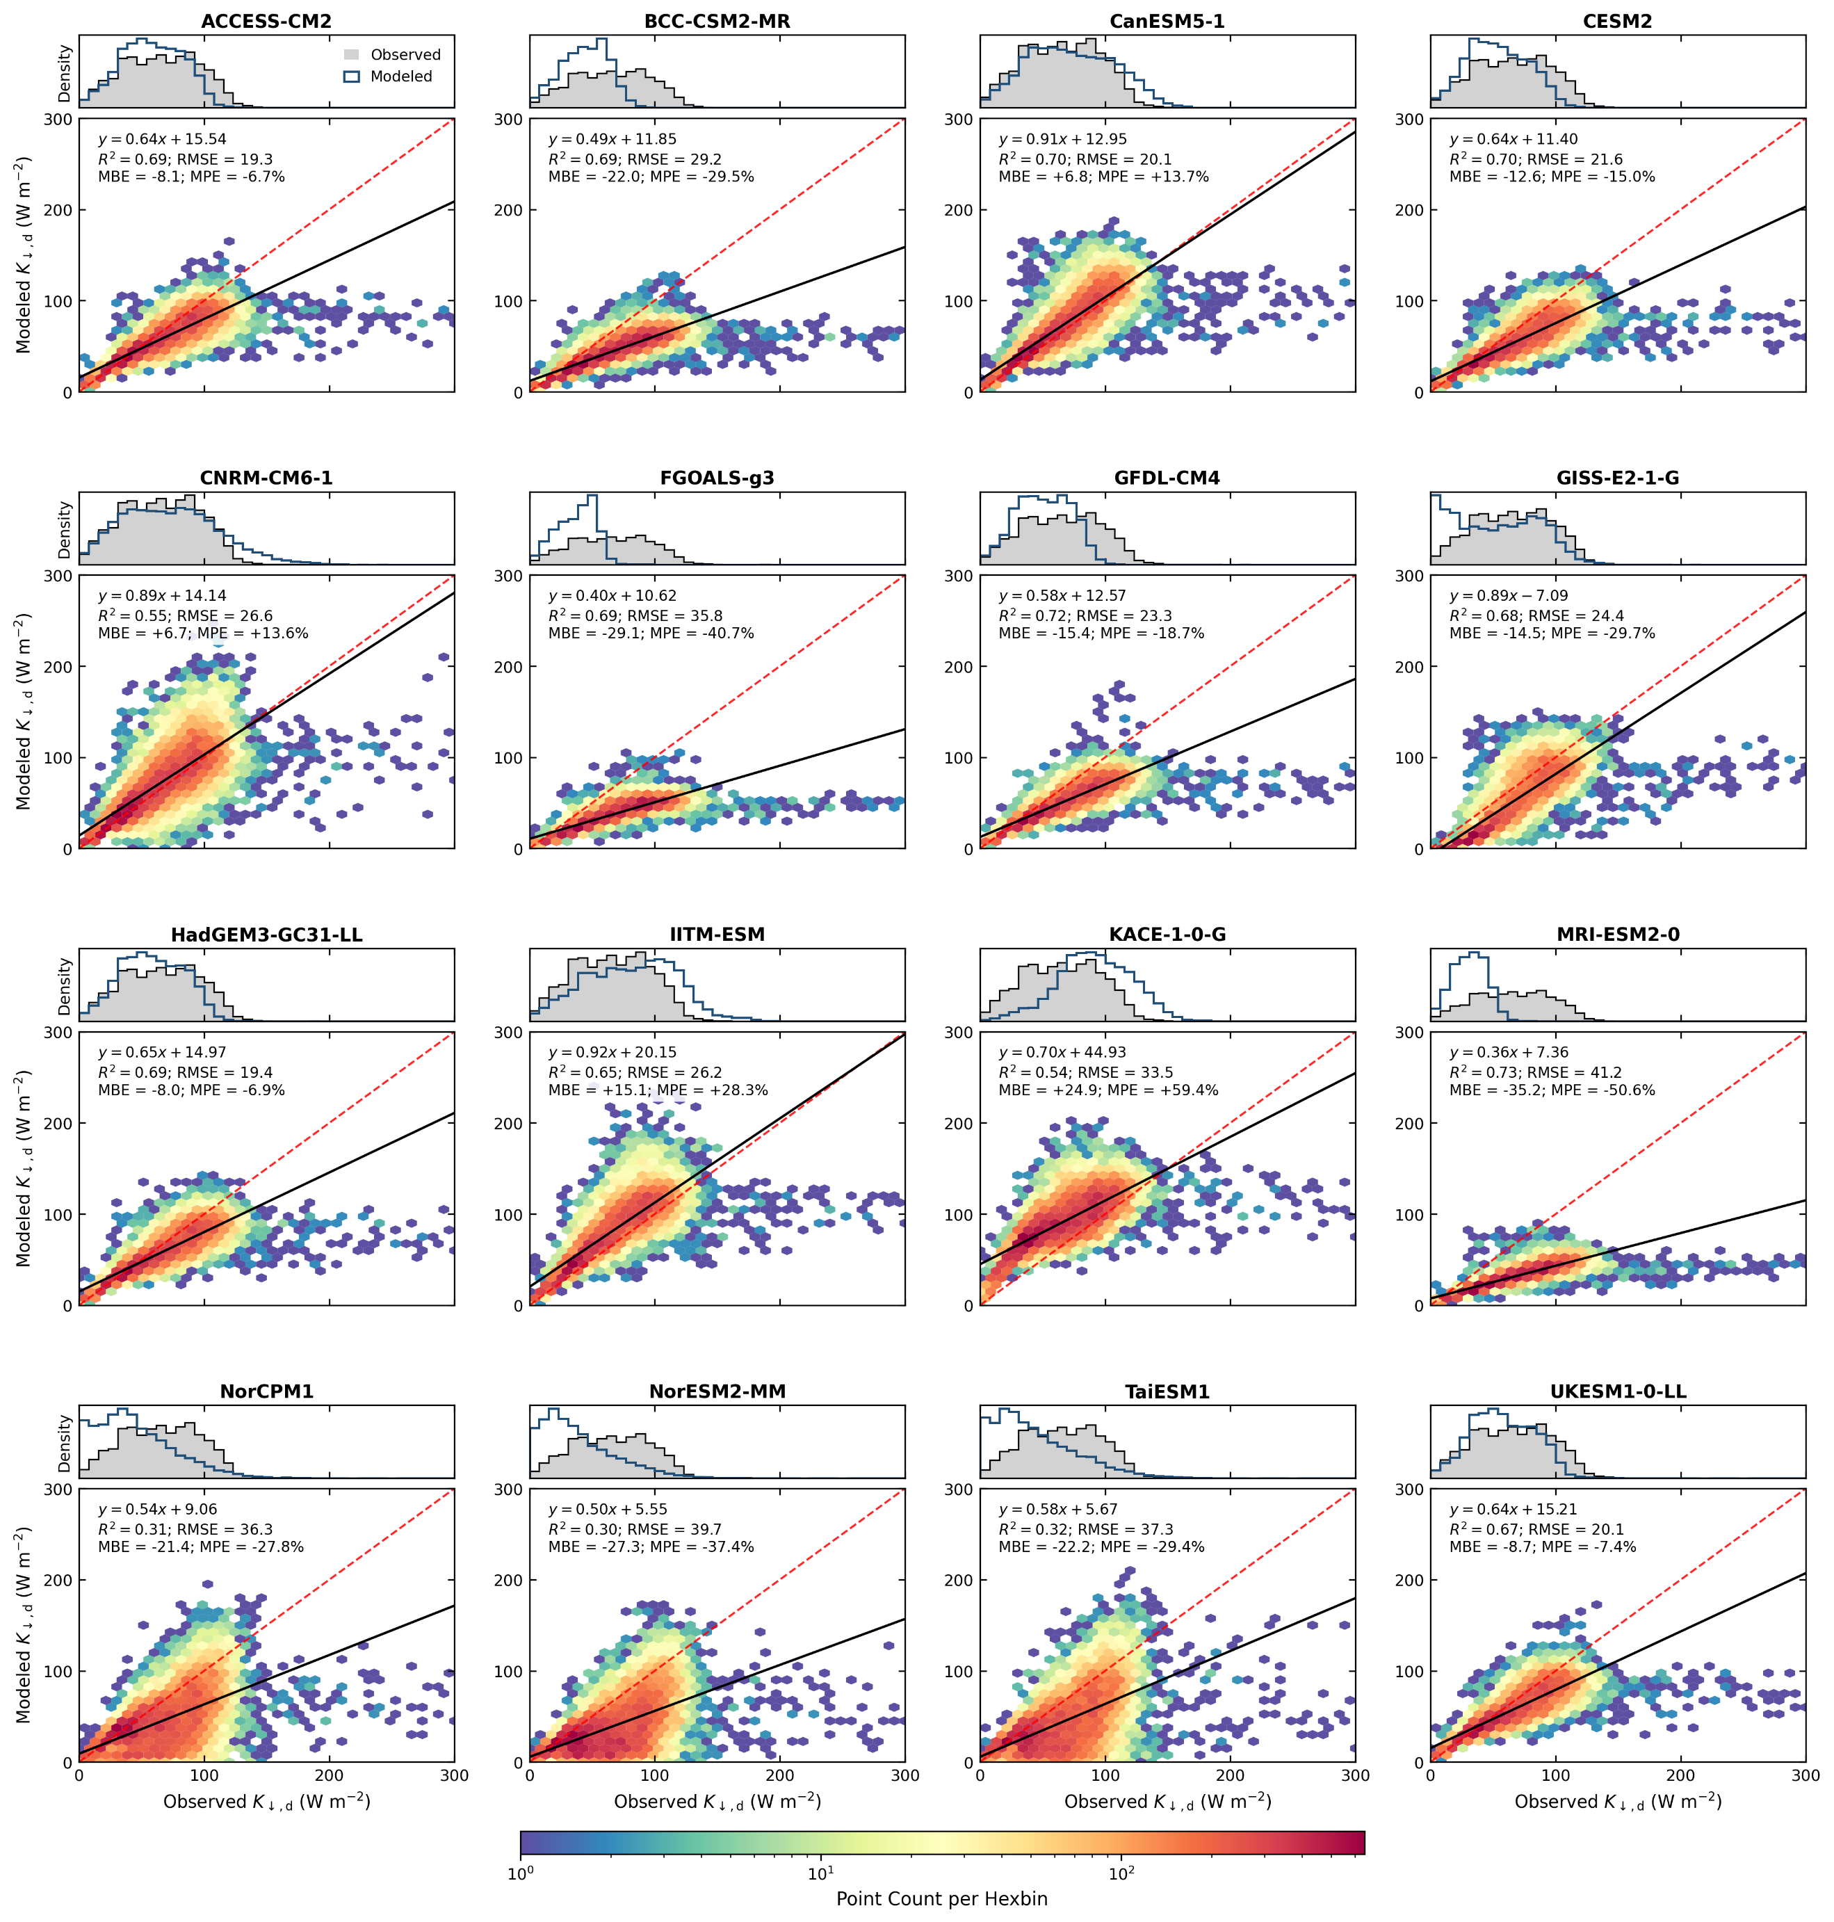
Figure S3 | Evaluation of monthly simulated diffuse solar radiation against collocated observations across 16 primary CMIP6 models | Monthly modeled diffuse solar radiation ($K_{↓,d}$) at surface against 16,590 quality-controlled ground-level observations from the Global Energy Balance Archive (GEBA) over the 2000–2014 period. Color scale indicates observation–model pair counts per hexagonal bin on a logarithmic scale. Solid black lines denote ordinary least-squares linear fits and dashed red lines denote the 1:1 identity line. Model performance statistics are annotated within each panel, including coefficient of determination ($R^{2}$), root-mean-square error (RMSE, W m⁻²), mean bias error (MBE, W m⁻²), and mean percentage error (MPE, %). The histograms display normalized probability density distributions (5 W m⁻² bin widths) for collocated GEBA station observations (gray fill) and simulated model values (blue outline).

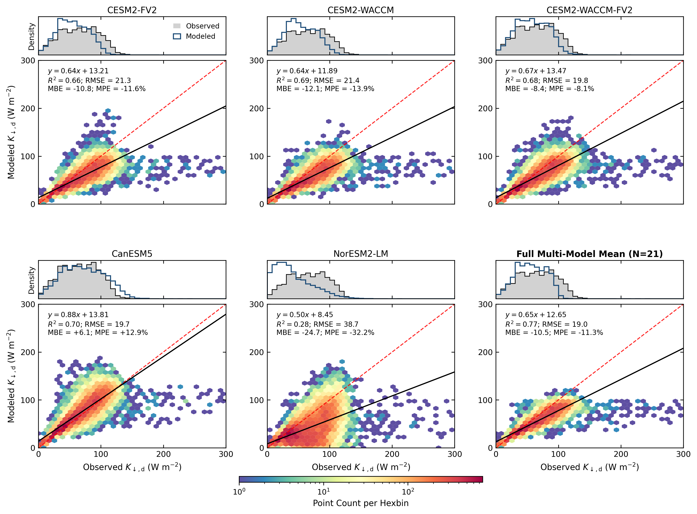
Figure S4 | Evaluation of monthly simulated diffuse solar radiation against collocated observations across remaining CMIP6 models | Benchmark comparisons for the 5 additional CMIP6 model configurations processed and the full multi-model ensemble mean against collocated monthly GEBA surface measurements. As in Fig. S3, data density is represented by logarithmic hexbins, with ordinary least-squares regression lines (black), 1:1 identity lines (dashed red), annotated performance metrics ($R^{2}$, RMSE, MBE, MPE), and top marginal probability density histograms of observed (gray fill) versus simulated (blue/red outline) diffuse solar radiation ($K_{↓,d}$).

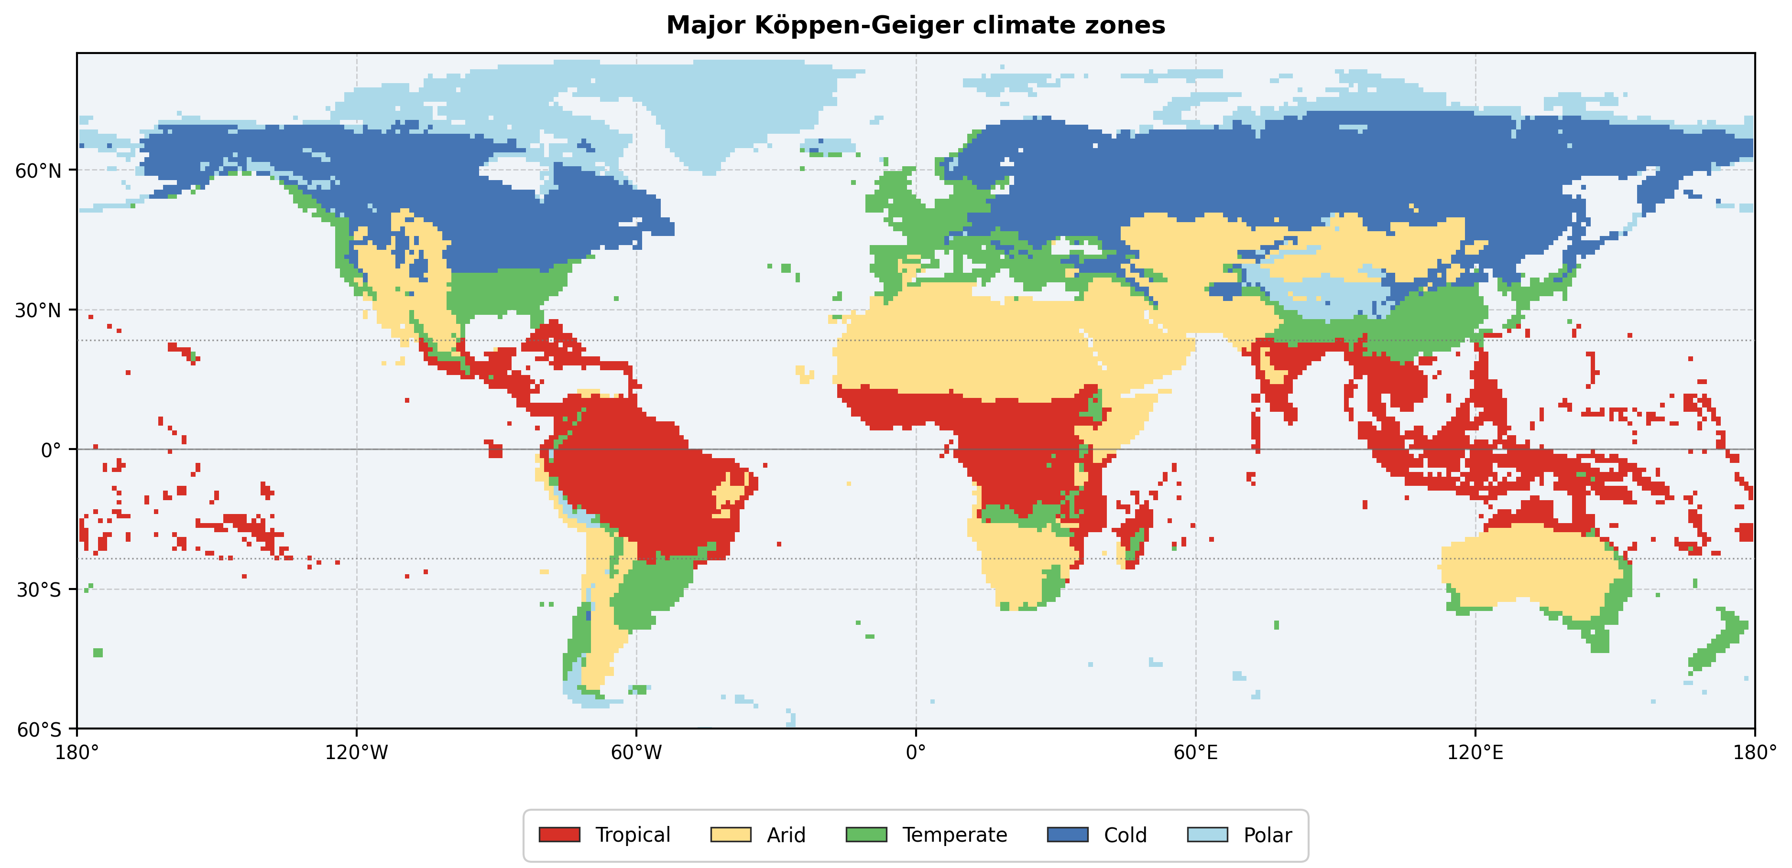
Figure S5 | Spatial distribution of major Köppen–Geiger climate zones | Global distribution of the five primary terrestrial climate zones classified according to the updated Köppen–Geiger climate classification system²⁵, aggregated to a 1° spatial resolution for climate regime stratification (see Fig. 1d).

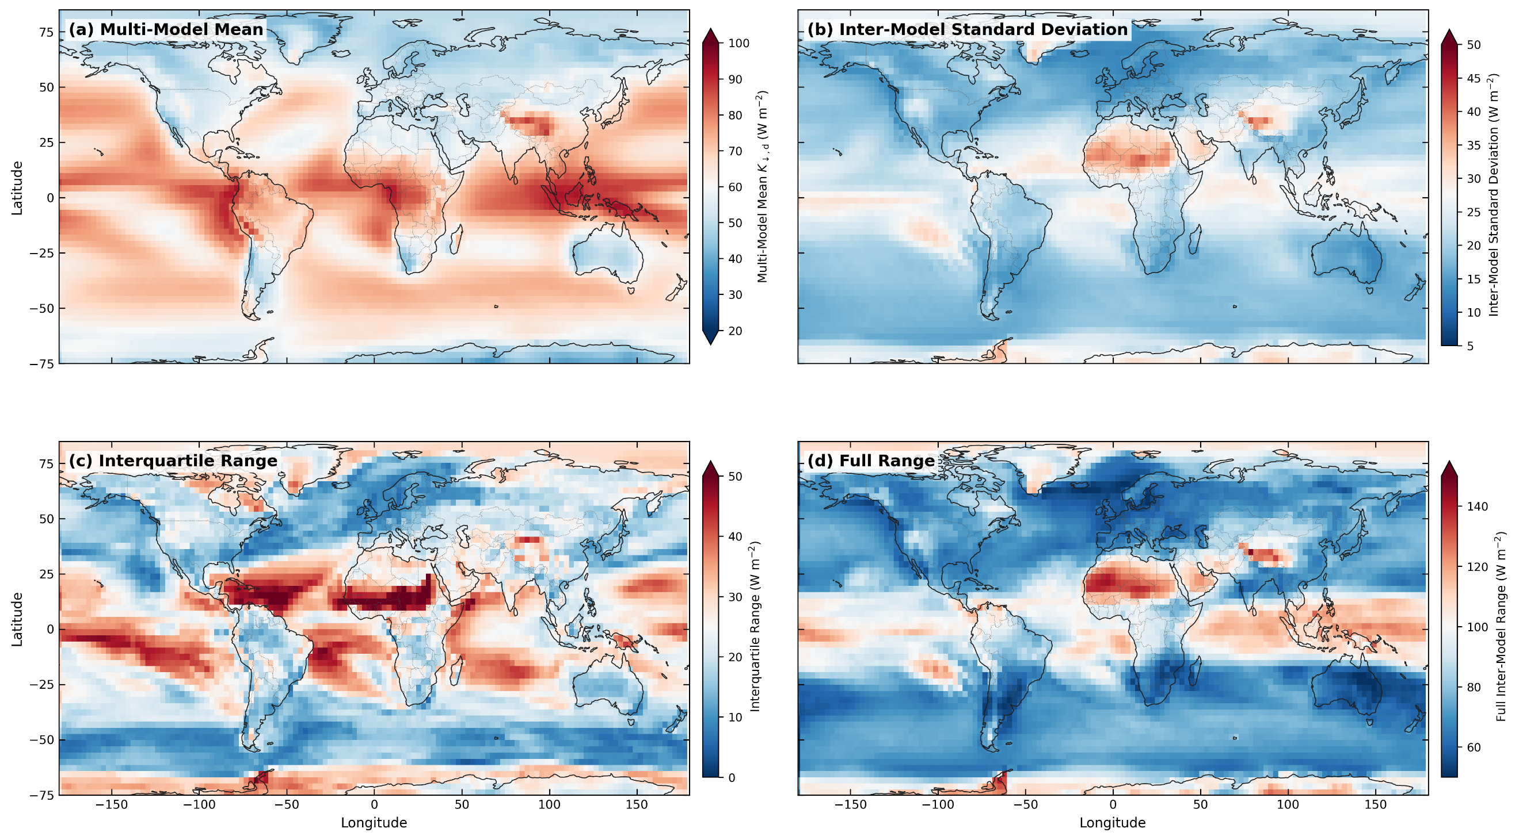
Figure S6 | Spatial patterns of diffuse solar radiation at surface across all CMIP6 configurations | Same as Fig. S2, but for all CMIP6 configurations (16 primary models + 5 additional configurations considered).

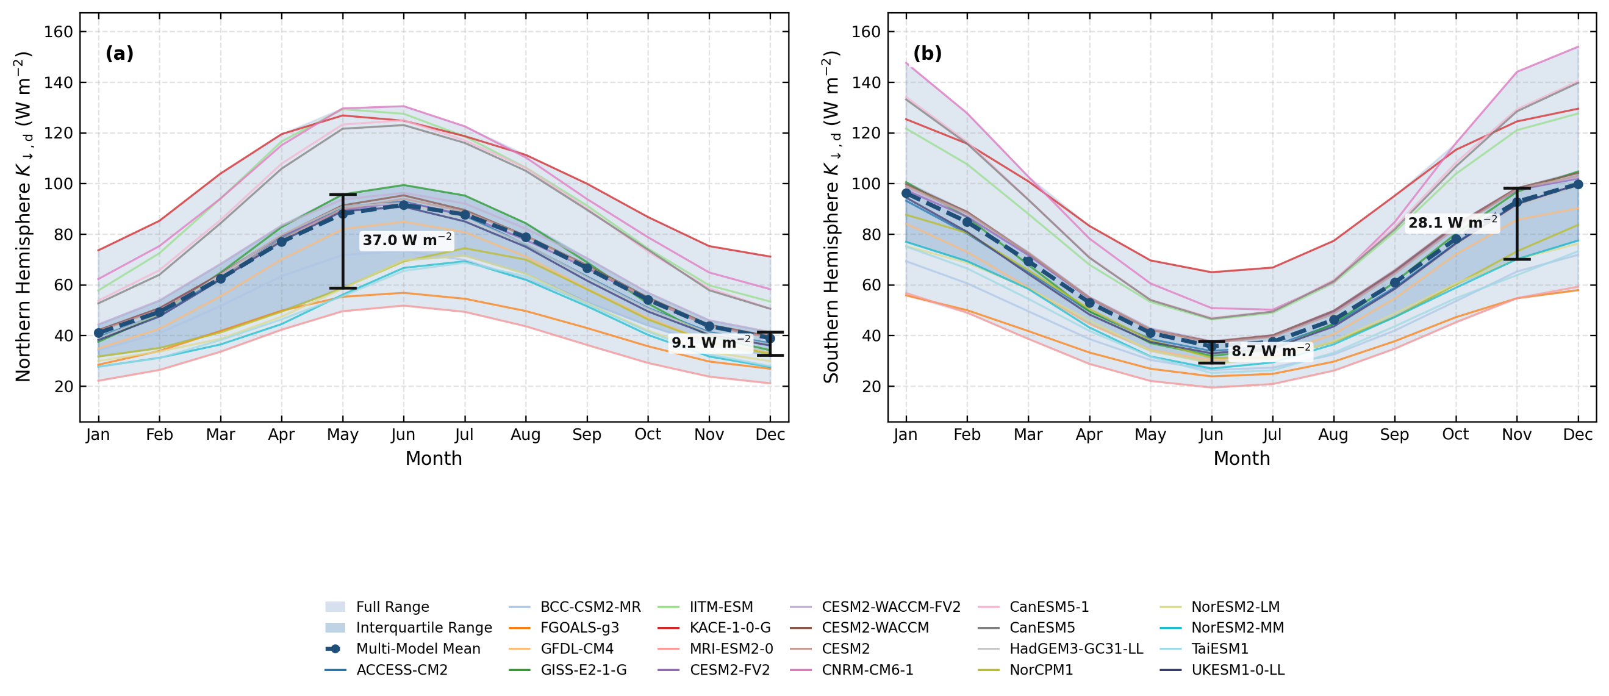
Figure S7 | Seasonal cycles of hemispheric diffuse solar radiation across all 21 CMIP6 model configurations | Climatological monthly spatial mean diffuse shortwave radiation ($K_{↓,d}$) for the a, Northern Hemisphere and b, Southern Hemisphere for 21 processed CMIP6 model configurations. Colored curves represent individual model simulations, the bold dashed dark blue curve with markers denotes the multi-model ensemble mean, dark blue shading indicates the interquartile range, and light blue shading denotes the full model spread. Maximum and minimum hemispheric inter-model interquartile spreads are highlighted with error bars and annotated values.

