Supplementary Information for

Mechanical energy-induced CO₂ conversion using liquid metals

Junma Tang¹, Jianbo Tang^{1*}, Mohannad Mayyas¹, Mohammad B. Ghasemian¹, Jing Sun¹, Md Arifur Rahim¹, Jiong Yang¹, Jialuo Han¹, Douglas J. Lawes², Rouhollah Jalili¹, Torben Daeneke³, Maricruz G. Saborio¹, Zhenbang Cao¹, Francois-Marie Allioux¹, Anthony P. O’Mullane⁴, Richard B. Kaner^{5,6}, Dorna Esrafilzadeh^{7*}, Michael D. Dickey⁸, Kourosh Kalantar-Zadeh^{1*}

¹School of Chemical Engineering, University of New South Wales (UNSW), Sydney 2052, Australia
²Mark Wainwright Analytical Centre, University of New South Wales (UNSW), Sydney 2052, Australia
³School of Engineering, Royal Melbourne Institute of Technology (RMIT), Melbourne 3001, Australia
⁴School of Chemistry, Physics and Mechanical Engineering, Queensland University of Technology (QUT), Brisbane, QLD 4001, Australia
⁵Department of Chemistry and Biochemistry and California NanoSystems Institute, University of California, Los Angeles, Los Angeles, California 90095, United States
⁶Department of Material Science and Engineering, University of California, Los Angeles, Los Angeles, California 90095, United States
⁷Graduate School of Biomedical Engineering, University of New South Wales (UNSW), Sydney 2052, Australia
⁸Department of Chemical and Biomolecular Engineering, North Carolina State University, Raleigh, North Carolina 27695, United States

*Correspondence to: jianbo.tang@unsw.edu.au (J.T.), d.esrafilzadeh@unsw.edu.au (D.E.) k.kalantar-zadeh@unsw.edu.au (K.K.-Z.)

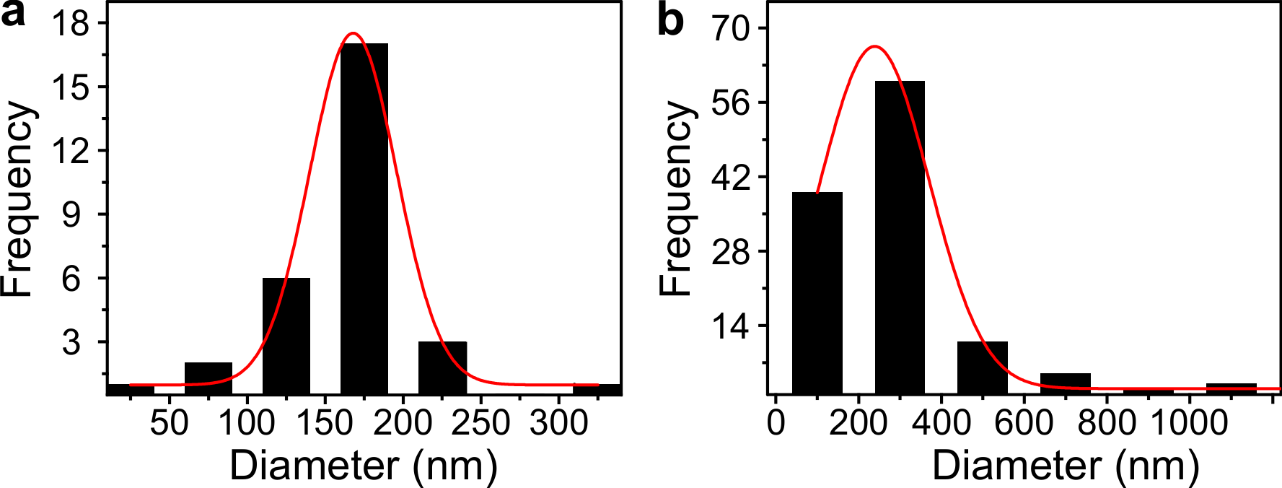
Supplementary Fig. 1 | Size distribution characterization. a, The size distribution of the Ag_{0.72}Ga_{0.28} rods. b, The size distribution of the Ga particles after probe sonication.

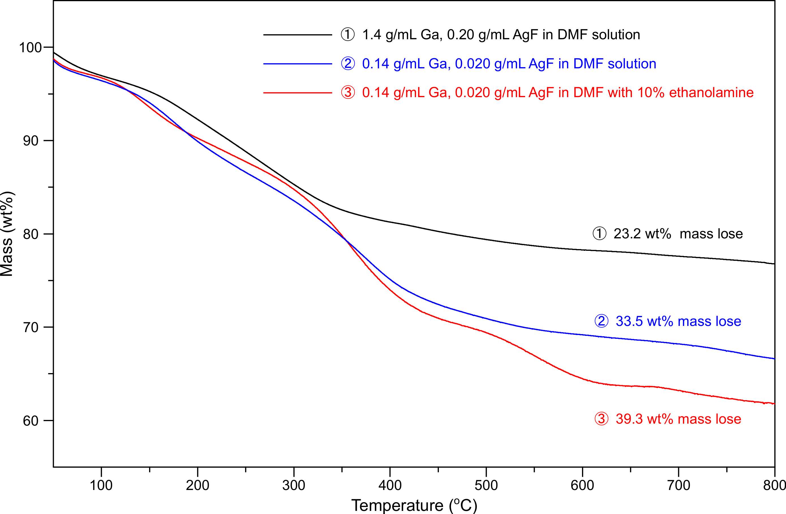
Supplementary Fig. 2 | TGA results of the produced carbonaceous materials in different conditions in the 20 mL reactor. The mass of samples acquired from 2.0 ml homogenous reaction solution is 13.59 mg (1.4 g/mL Ga, 0.20 g/mL AgF in DMF solution), 8.33 mg (0.14 g/mL Ga, 0.020 g/mL AgF in DMF solution) and 11.6 mg (0.14 g/mL Ga, 0.020 g/mL AgF in 90% DMF with 10% ETA solution). Based on mass lose from TGA, we calculated the produced carbon in the 20 mL reactor per hour.

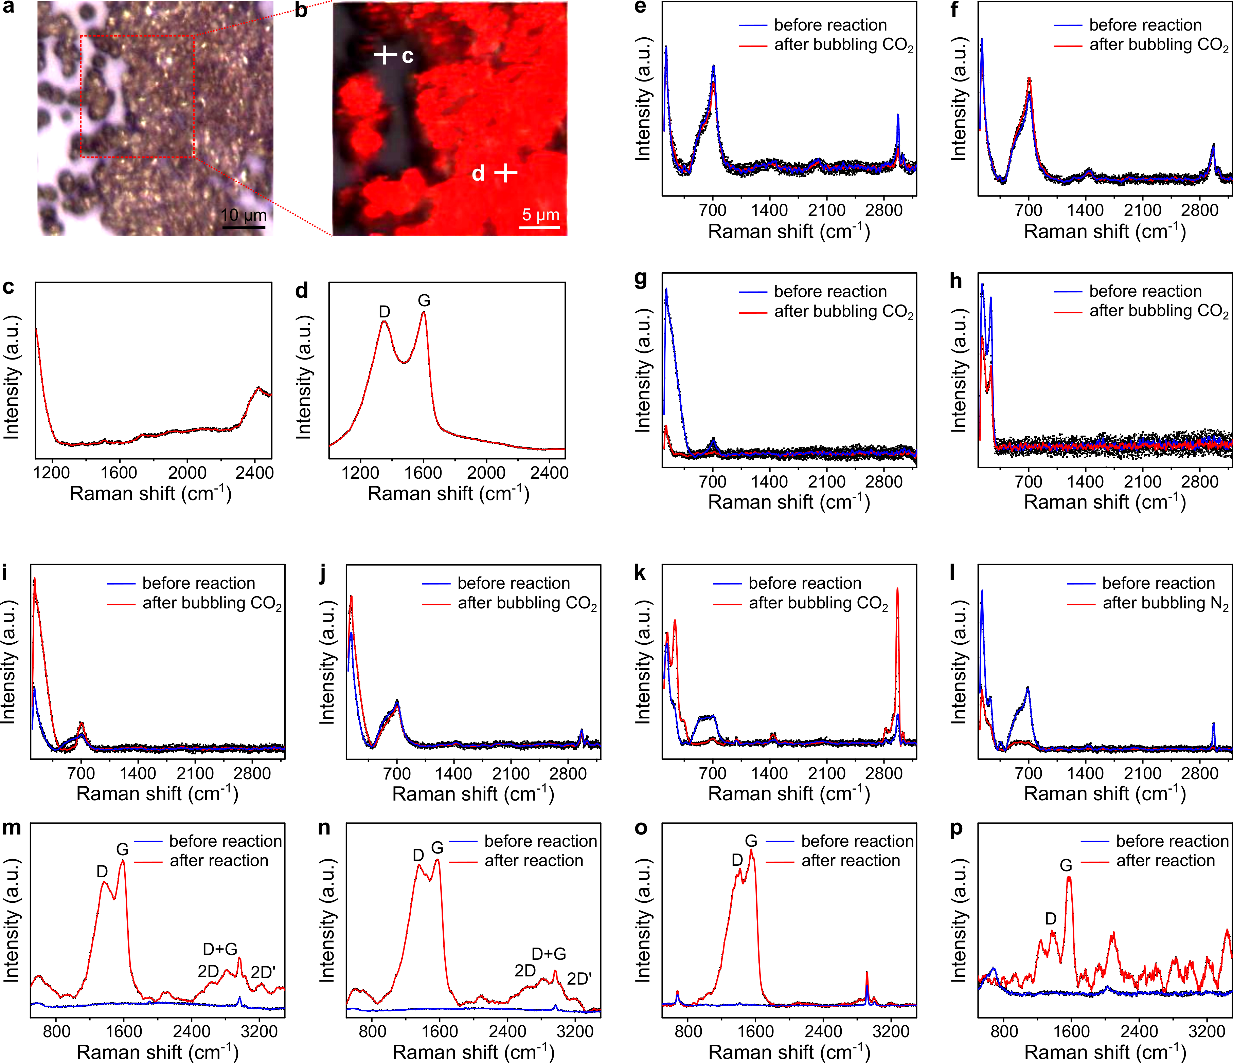
Supplementary Fig. 3 | Raman characterisation. a,b, Raman mapping on the surface of the mixture after 5 hours reaction from the system by employing 1.4 g/mL Ga and 0.20 g/mL AgF as precursors in DMF (centring at 1600 cm⁻¹). c,d, Raman spectra pointed on the glass substrate and the surface of mixture separately (marked in b). e,f, Raman spectra on the surface of 7.0 g Ga-Ag bimetallic catalysts containing 2.0 wt% (e) and 5.0 wt% (f) Ag, respectively, before and after 5 hours reaction in DMF solution. g,h, Raman spectra on the surface of catalysts containing Ga (1.4 g/mL, g) or AgF (0.20 g/mL, h), respectively, as the catalysts. i,j, Raman spectra on the surface of catalysts before and after 5 hours reaction by employing KCl (0.20 g/mL, i) and NaCl (0.20 g/mL, j) as the precursor with Ga (1.4 g/mL) in the DMF system. k, Raman spectra of the mixture before and after pumping CO₂ into the reaction unit for 5 hours with a magnetic stirrer as the energy source (using 1.4 g/mL Ga and 0.20 g/mL AgF as precursors). l, Raman spectra of the mixture before and after bubbling N₂ into the reaction system for 5 hours (employing 1.4 g/mL Ga and 0.20 g/mL AgF). m,n, Raman spectrum of the carbonaceous materials on the surface of catalysts by utilizing 50- or 100-time diluted reaction unit (containing 0.028 g/mL gallium with 0.0040 g/mL AgF or 0.014 g/mL gallium with 0.0020 g/mL AgF, respectively). o,p, Raman spectrum of the carbonaceous product on the surface of mixture with DMSO (o) and water (p), respectively, as the reaction solution (using 0.14 g/mL Ga and 0.020 g/mL AgF as precursors).

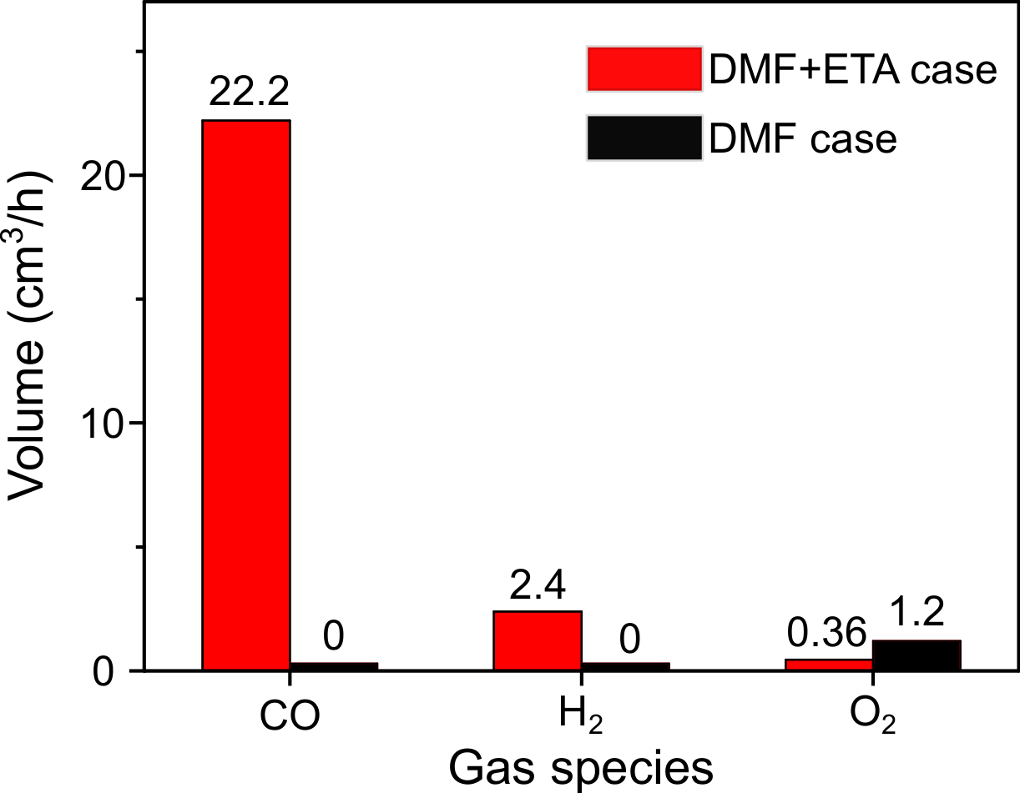
Supplementary Fig. 4 | GC analysis of the gas products in the 20 mL reactor. Output gas measurements during the reaction using DMF or DMF+ETA as reaction solution for 5 hours. The amount of H₂ decreased sharply and was almost undetectable after 30 hours reaction (in the scaled-up experiments). Thus, the generation of H₂ in DMF+ETA case is associated to the contamination in ETA (purity: ~ 98%).

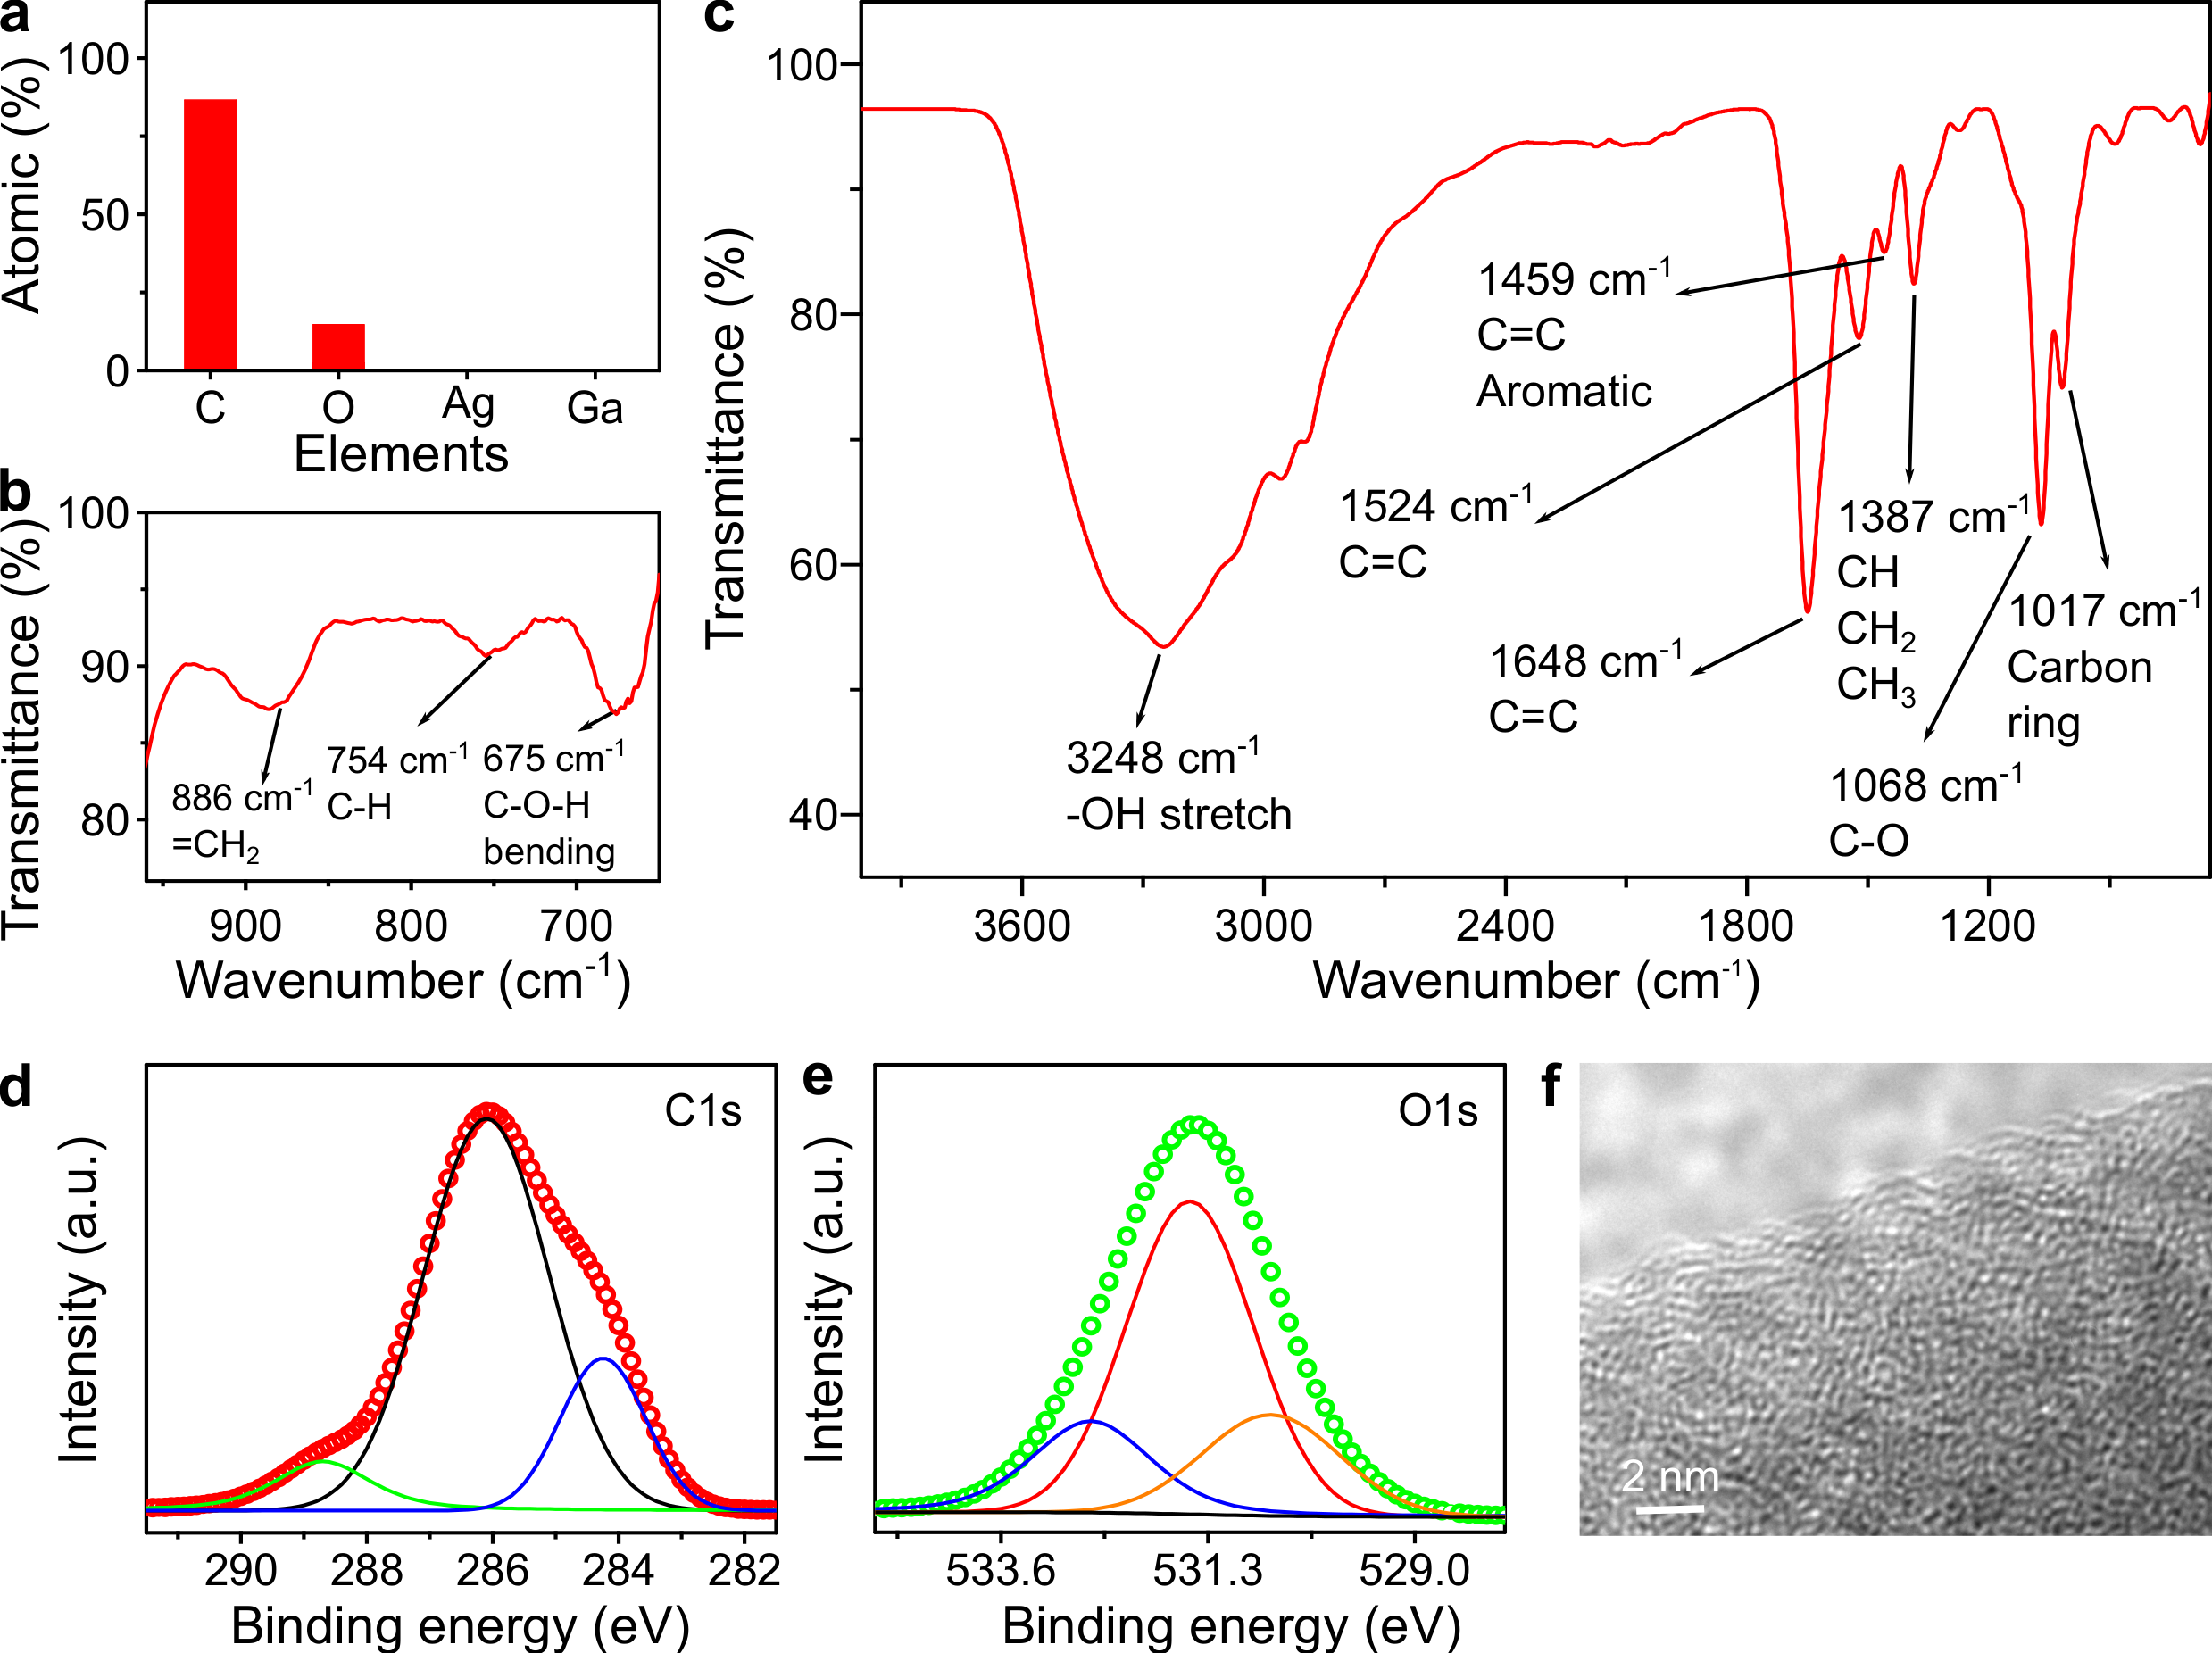

Supplementary Fig. 5 | Characterisation of the carbonaceous materials. a, Elemental ratio of the carbonaceous products from EDS mappings. b,c, FTIR spectrum of the produced solid carbon. d,e, C1s and O1s XPS spectra of the carbonaceous materials. g, HRTEM image of the carbonaceous materials in amorphous state.

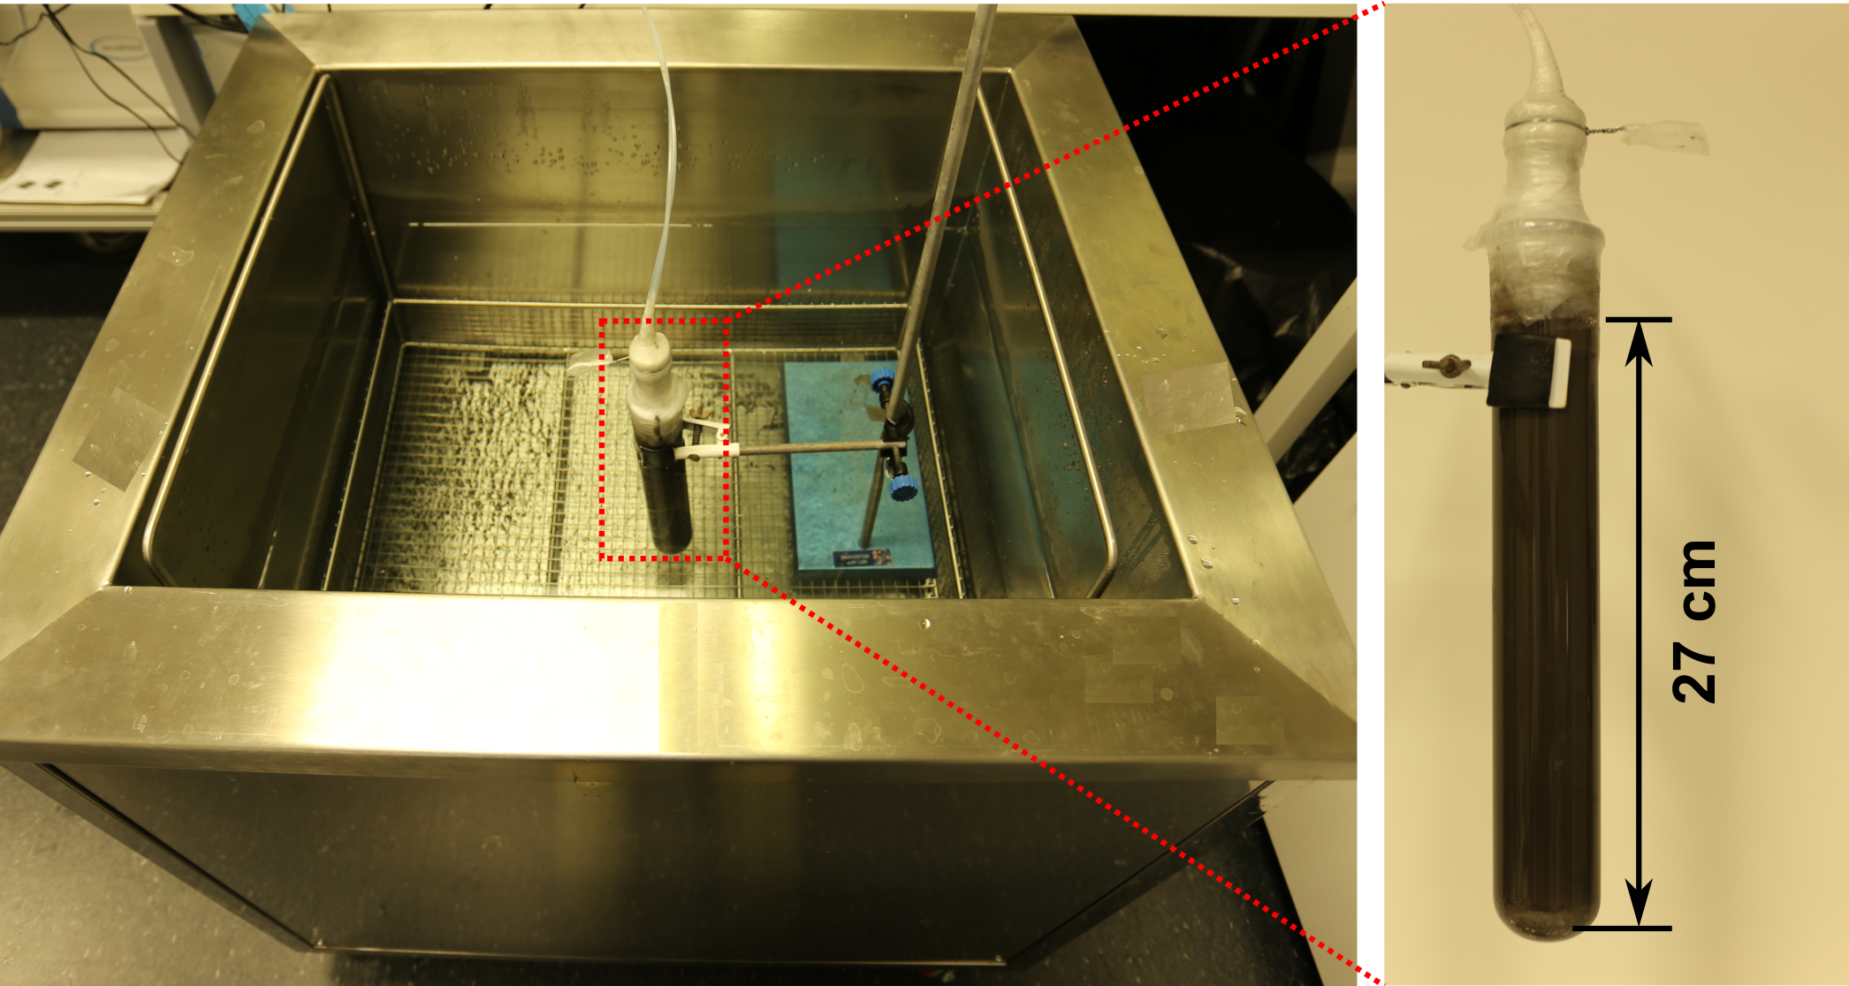
Supplementary Fig. 6 | Photos of the set-up for CO₂ capture and conversion. In DMF+ETA case, the height of the reactor is 27 cm for 92% efficiency at the CO₂ flow rate of ~8 sccm.
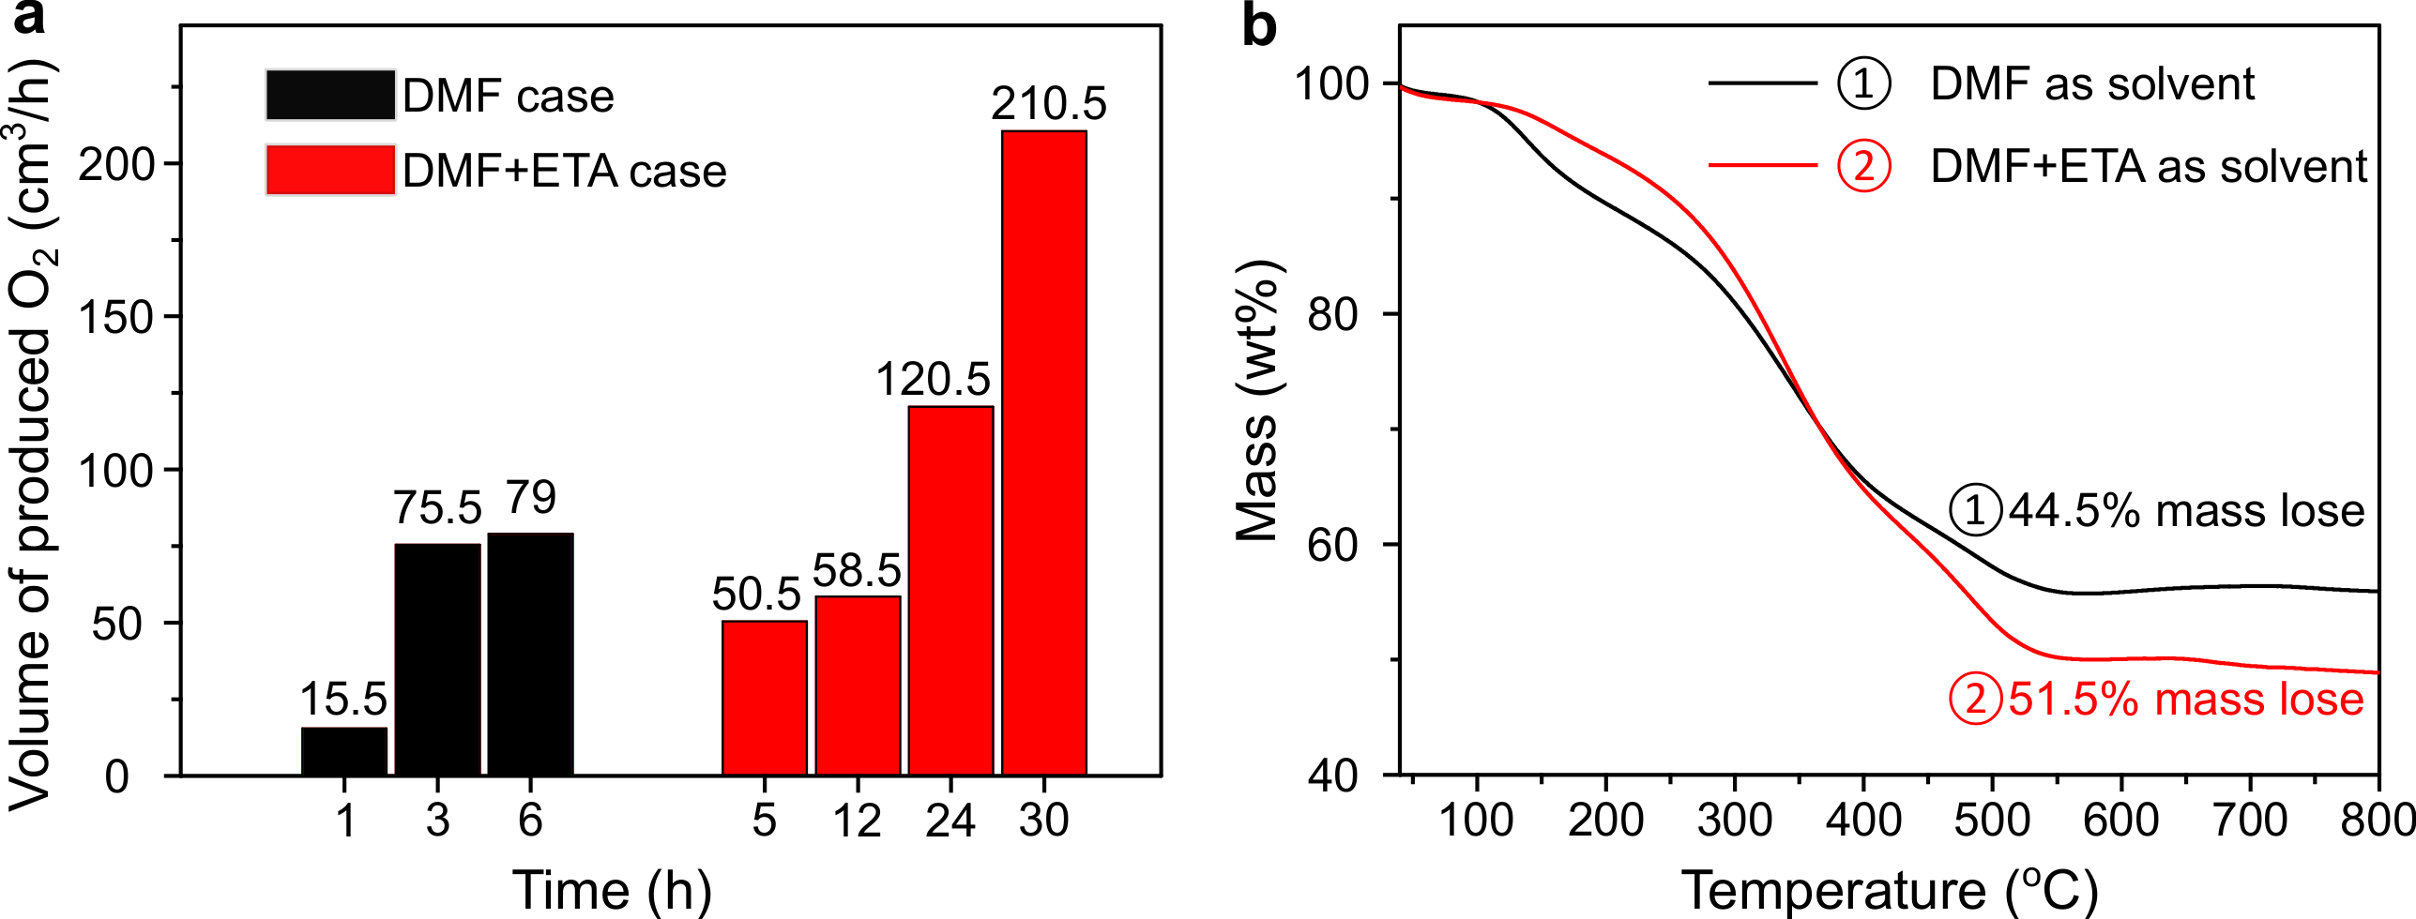

Supplementary Fig. 7 | GC analysis and TGA curves of the produced carbon in the scaled-up experiments. a, O₂ measurements in the output gas at different time during the reaction using DMF and DMF+ETA as reaction solution. b, TGA curves of the produced carbon. ① The curve of the carbonaceous materials produced in the 40 cm high reactor using DMF as the solvent for 6 h. The mass of the sample from 2.0 mL reaction solution was found to be 8.35 mg. ② The TGA of produced carbon in the 27 cm high reactor using DMF+ETA as the solvent for 30 h. The mass of the sample from 2.0 mL reaction solution was found to be 8.80 mg.

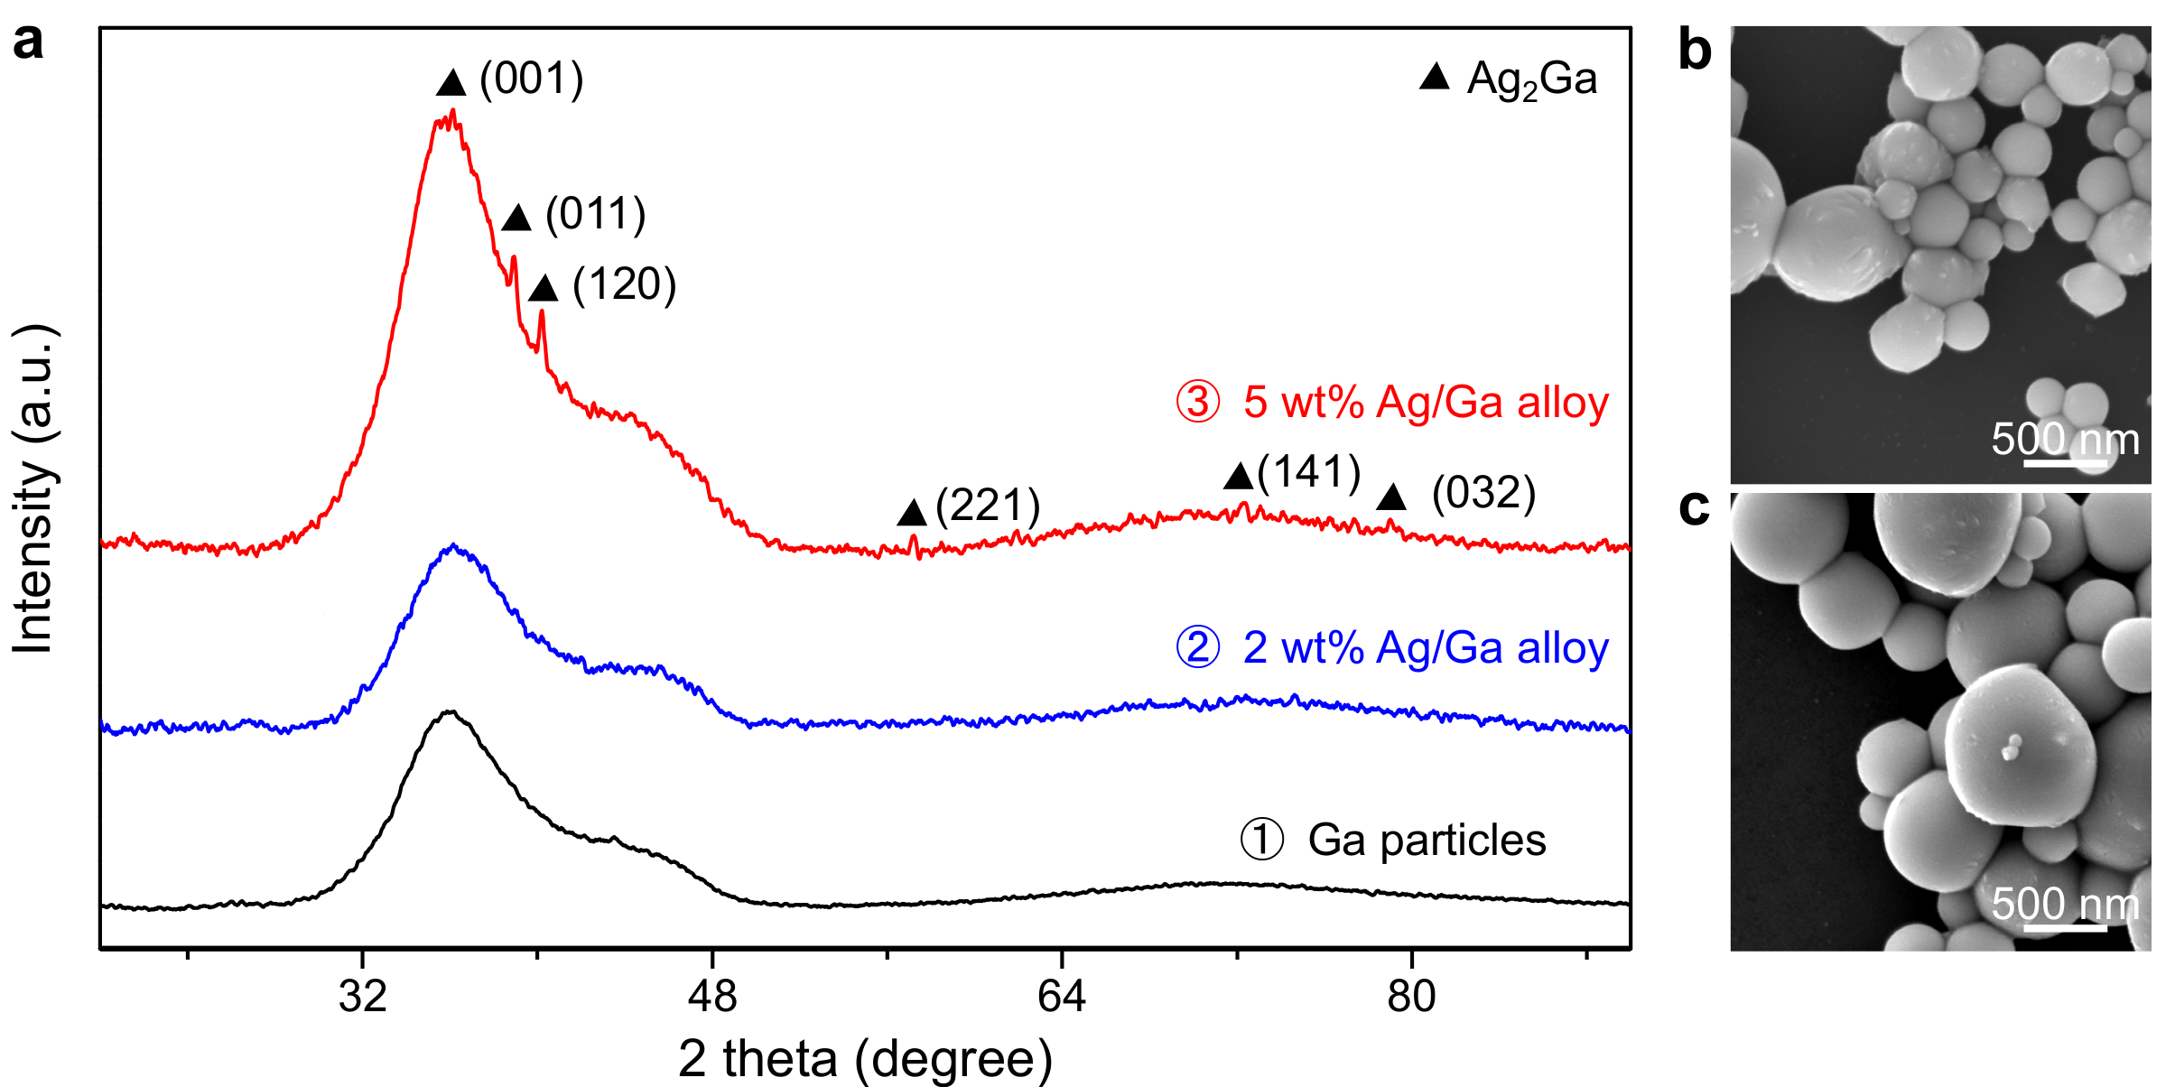
Supplementary Fig. 8 | Characterisation of the Ga-Ag alloy samples. a, XRD patterns of ① the gallium particles, bimetallic Ga-Ag alloys containing ② 2.0 wt% and ③ 5.0 wt% Ag after probe sonication. The sample with 2.0 wt% Ag has no detectable XRD signal. b, c, SEM images of the Ga-Ag alloys containing ② 2.0 wt% and ③ 5.0 wt% Ag, respectively, after probe sonication. No Ag_{0.72}Ga_{0.28} rods were observed in these two samples.

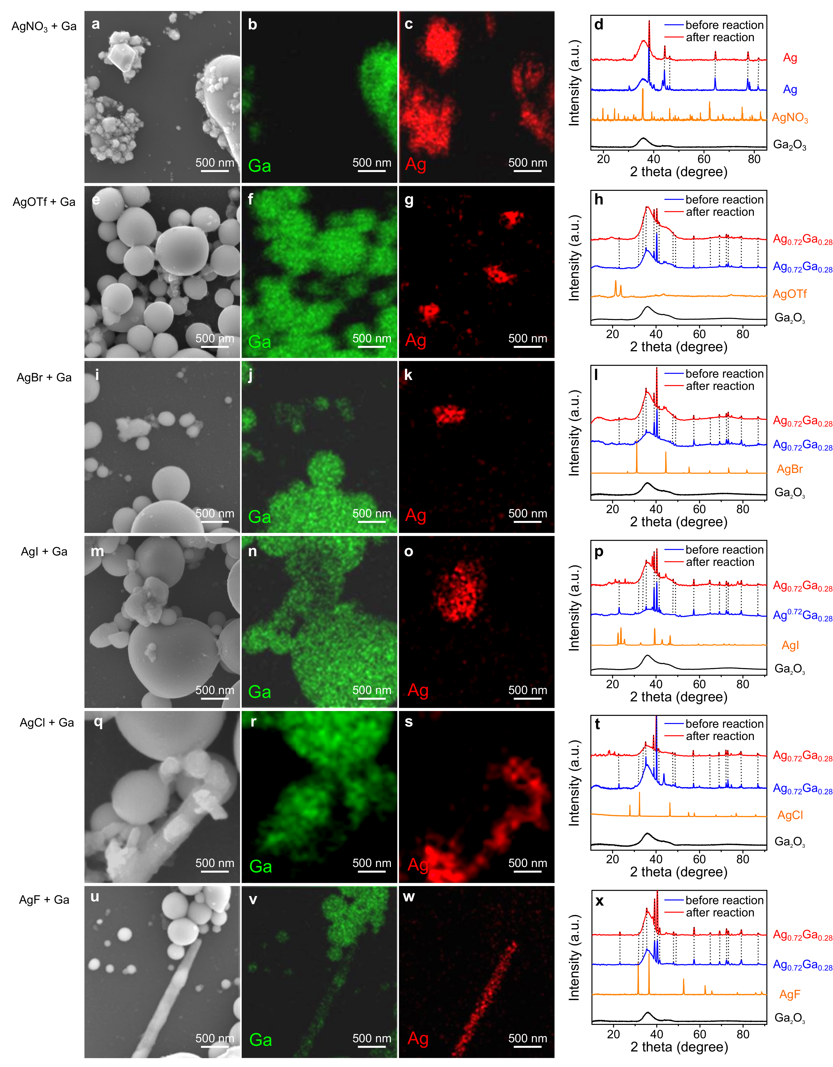
Supplementary Fig. 9 | SEM, EDS and XRD of the materials. SEM (the left panel), EDS (the middle two panels), and XRD (the right panel) characterisations of the functional materials by using different silver salts as precursors after probe sonication.
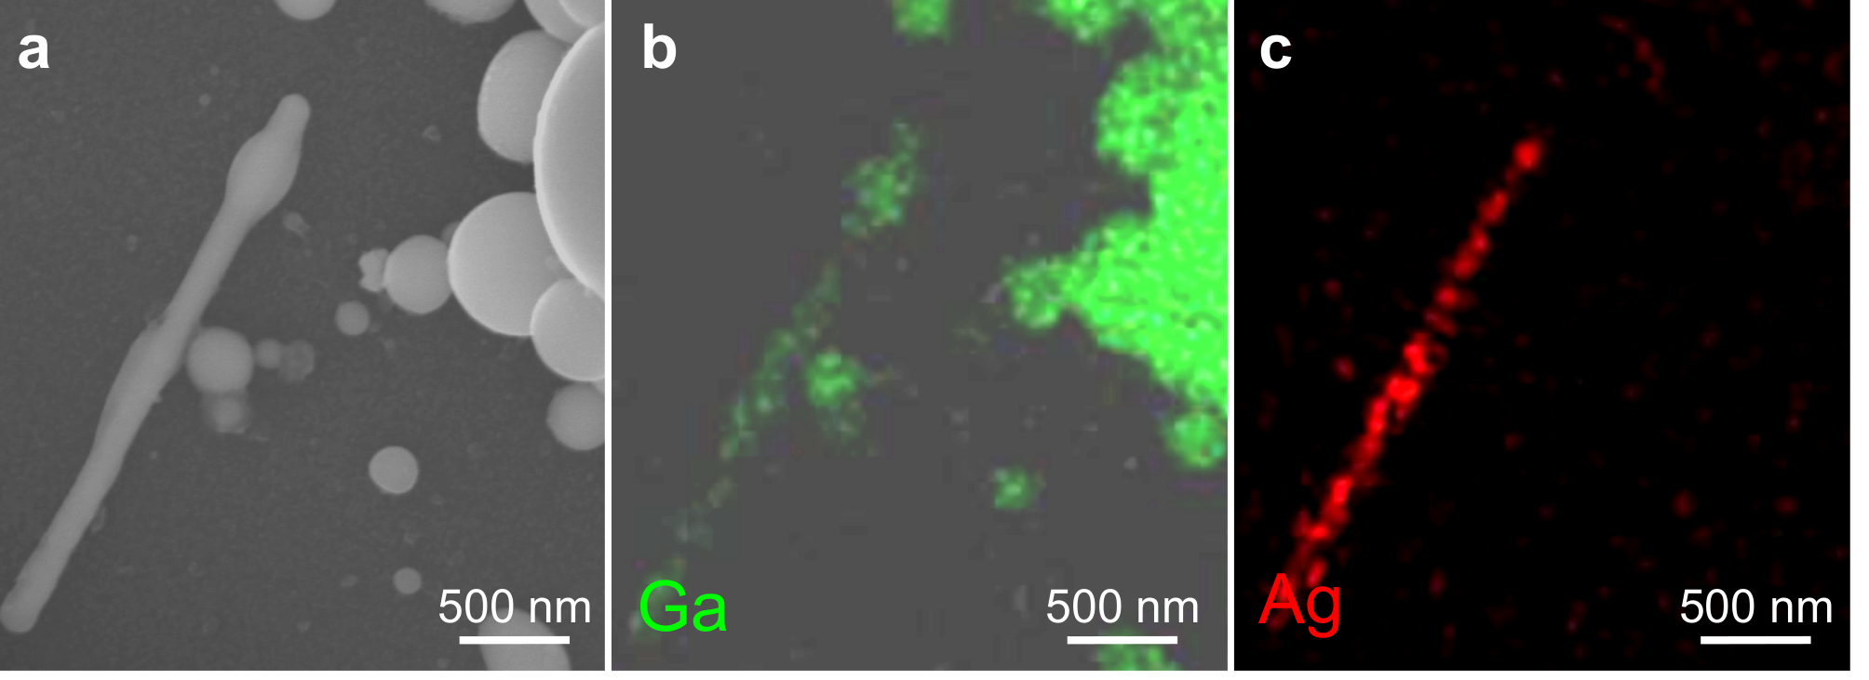
Supplementary Fig. 10 | SEM and EDS images of Ga/Ag_{0.72}Ga_{0.28} after reaction for 5 hours. a, SEM. b, Mapping of Ga. c, Mapping of Ag. The structure of the Ag_{0.72}Ga_{0.28} rods remains the same after long-term reaction.

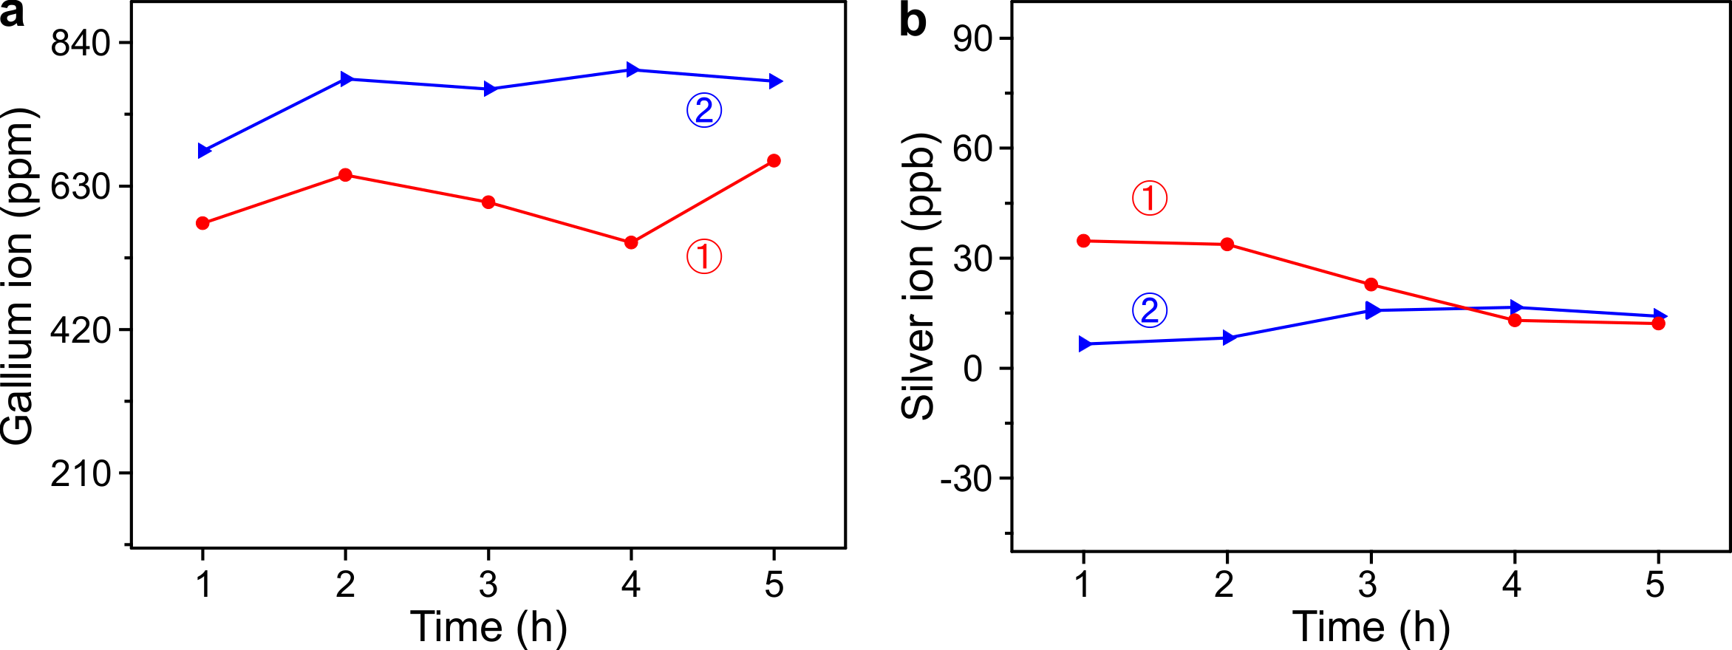
Supplementary Fig. 11 | Concentration of the Ga ions and Ag ions in the reaction solution. a,b, ICP-MS results about the concentration of Ga ions (a) and Ag ions (b) in the reaction system during CO₂ conversion for 5 hours. The samples were taken every hour (0.14 g/mL Ga and 0.020 g/mL AgF as precursors in DMF solution). The experiments were repeated twice.

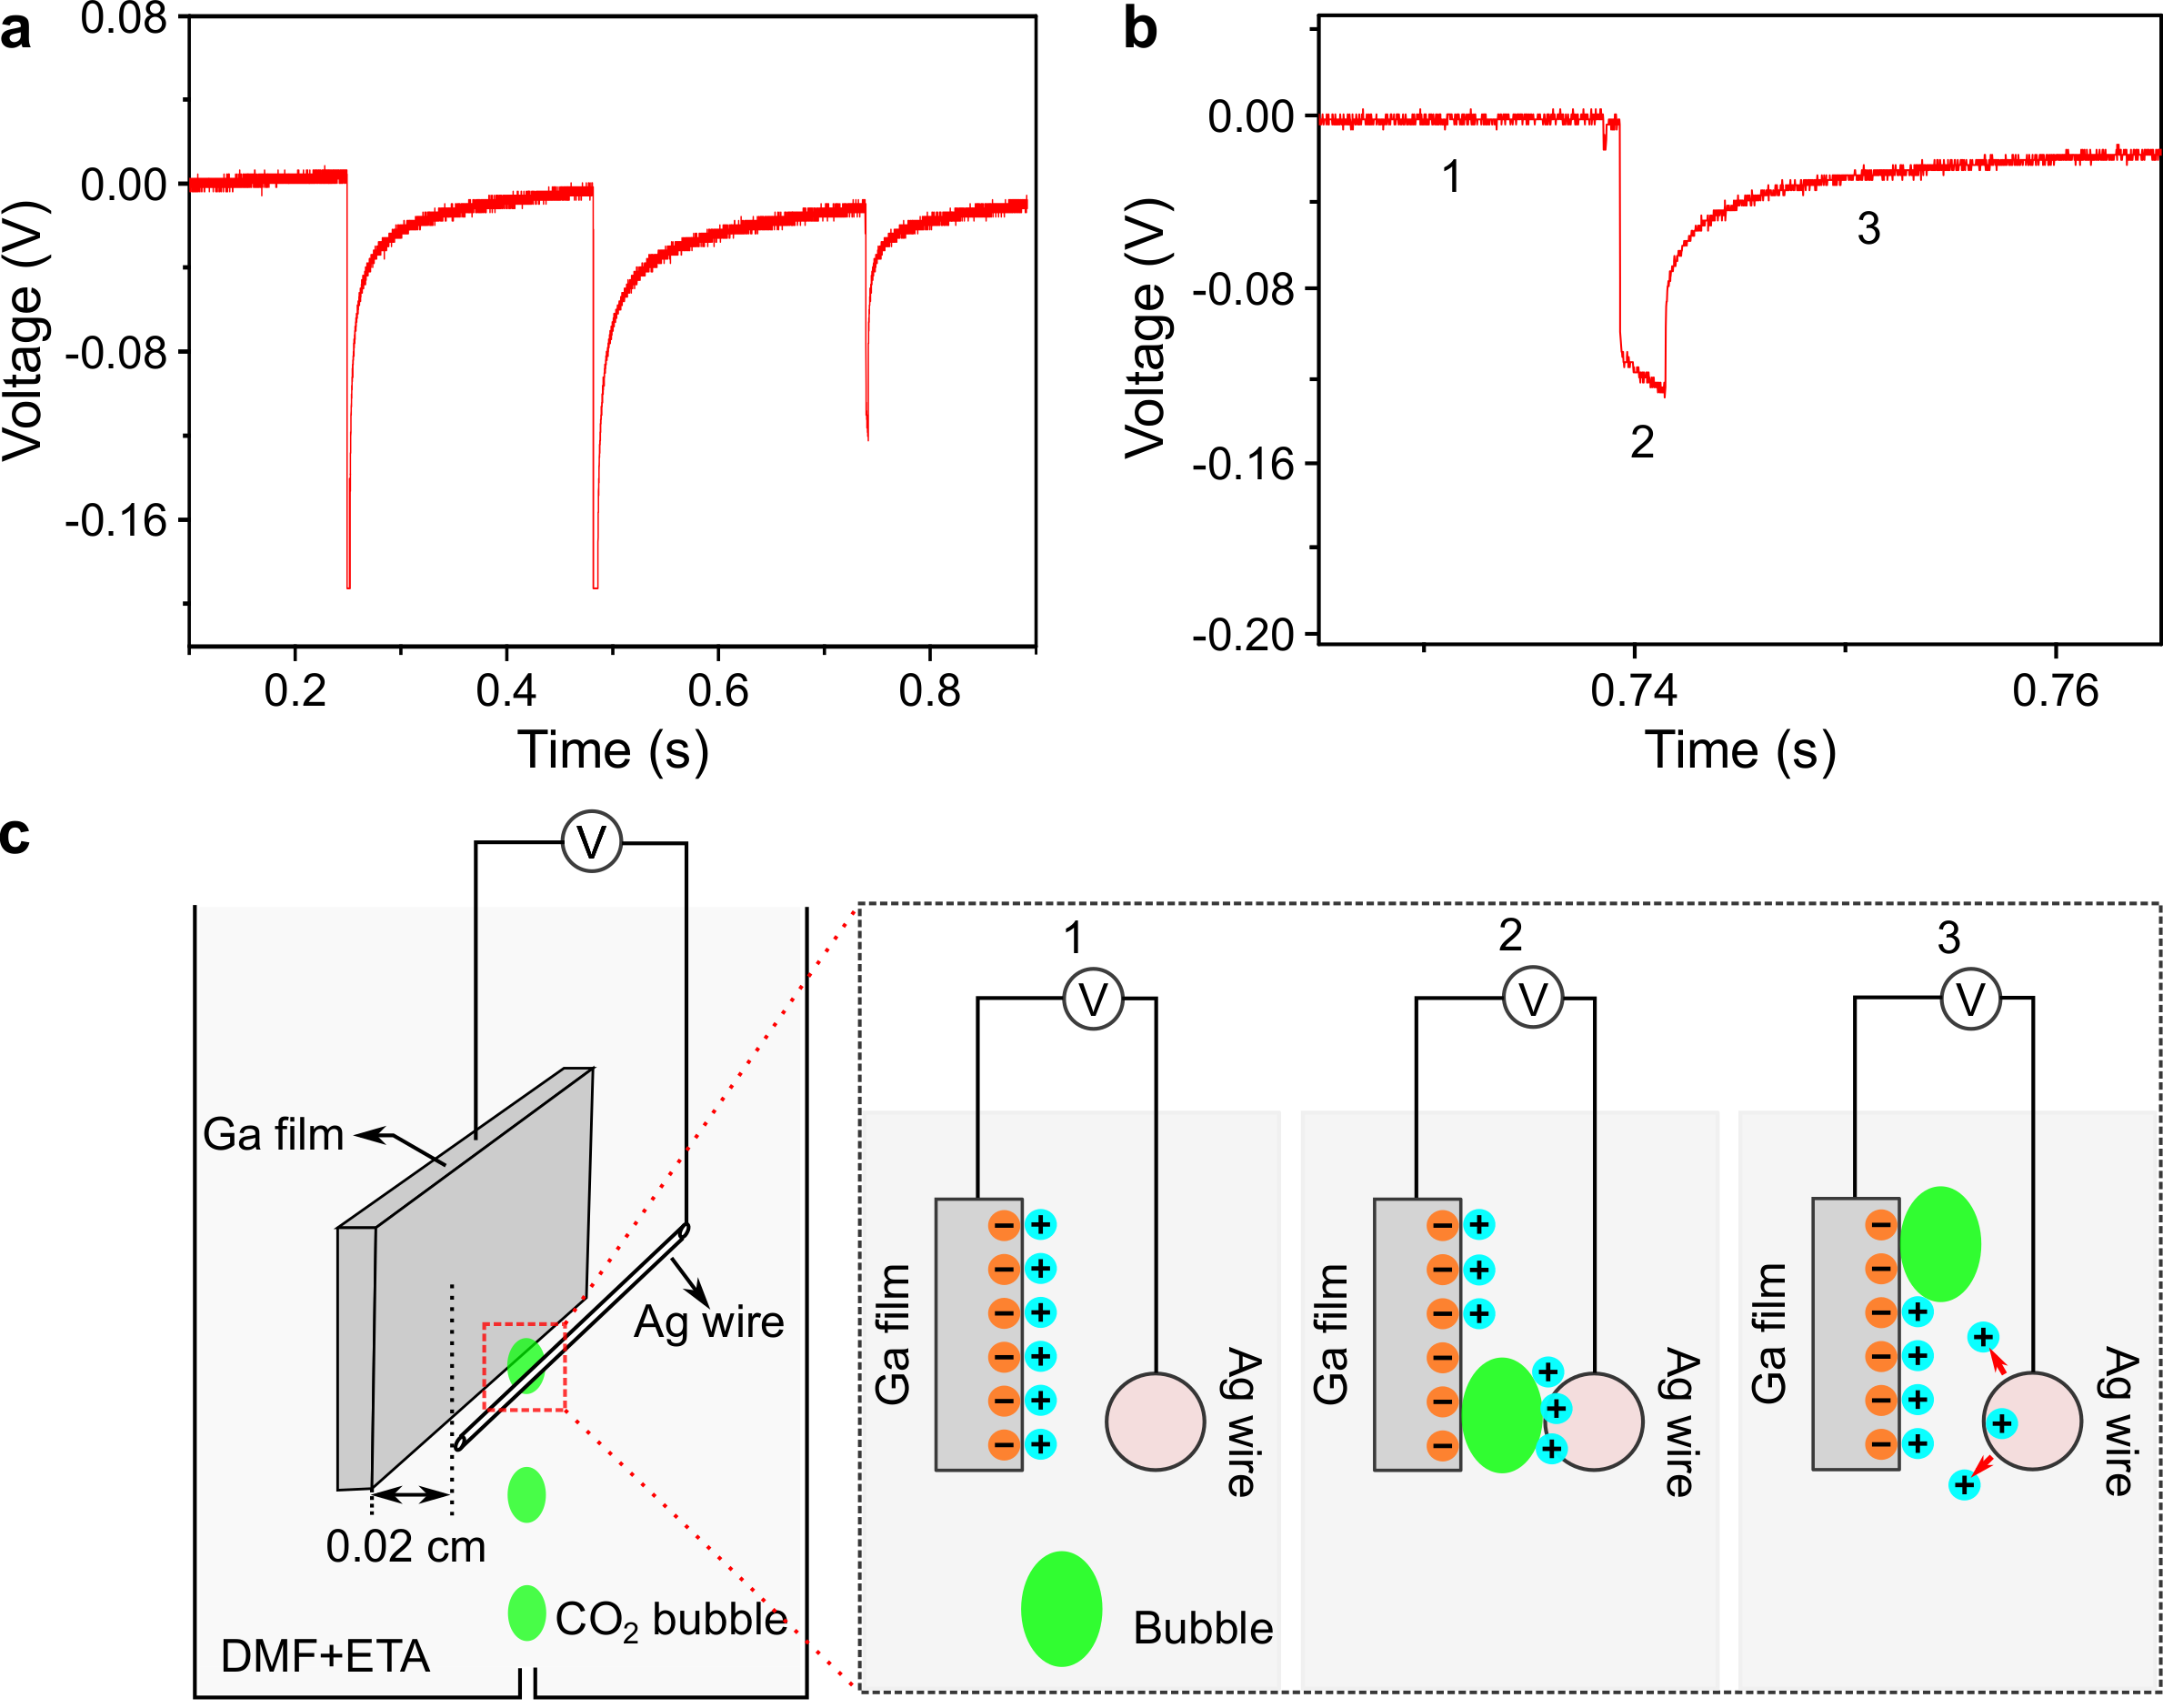
Supplementary Fig. 12 | Measurement of the triboelectric voltage induced by bubbles passing through liquid Ga film/Ag wire electrodes. a, The measurement of voltage generated from the triboelectric effect. The open circuit voltage between Ga film and Ag wire was monitored during the CO₂ bubble contact and detachment processes. The Ga film was prepared by coating liquid Ga on a copper foil, and an Ag wire was used as the Ag_{0.72}Ga_{0.28} rod in our CO₂ conversion experiment. The experiment was conducted in the same solution as that used in our CO₂ conversion experiment (DMF+ETA solution with 0.1 M HCl). b, An example of the time-dependant open-circuit voltage curve with different tribo-electric processes indicated. c, The schematics of the set-up and the proposed tribo-electric processes in corresponds to b. (1-before CO₂ bubble inserting between the Ga film and the Ag wire; 2-the inserting CO₂ bubble inducing an open circuit voltage; 3-the system gradually returning to its initial state during the bubble detachment.)
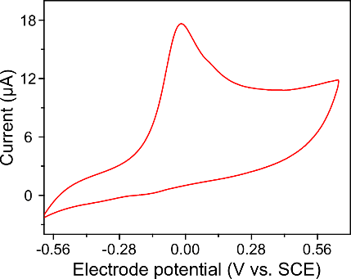
Supplementary Fig. 13 | Cyclic voltammetry characterisation. Cyclic voltammetry curve when using Ga particles and Ag_{0.72}Ga_{0.28} (non-rod morphology - mix of AgI with Ga) as the working electrode.

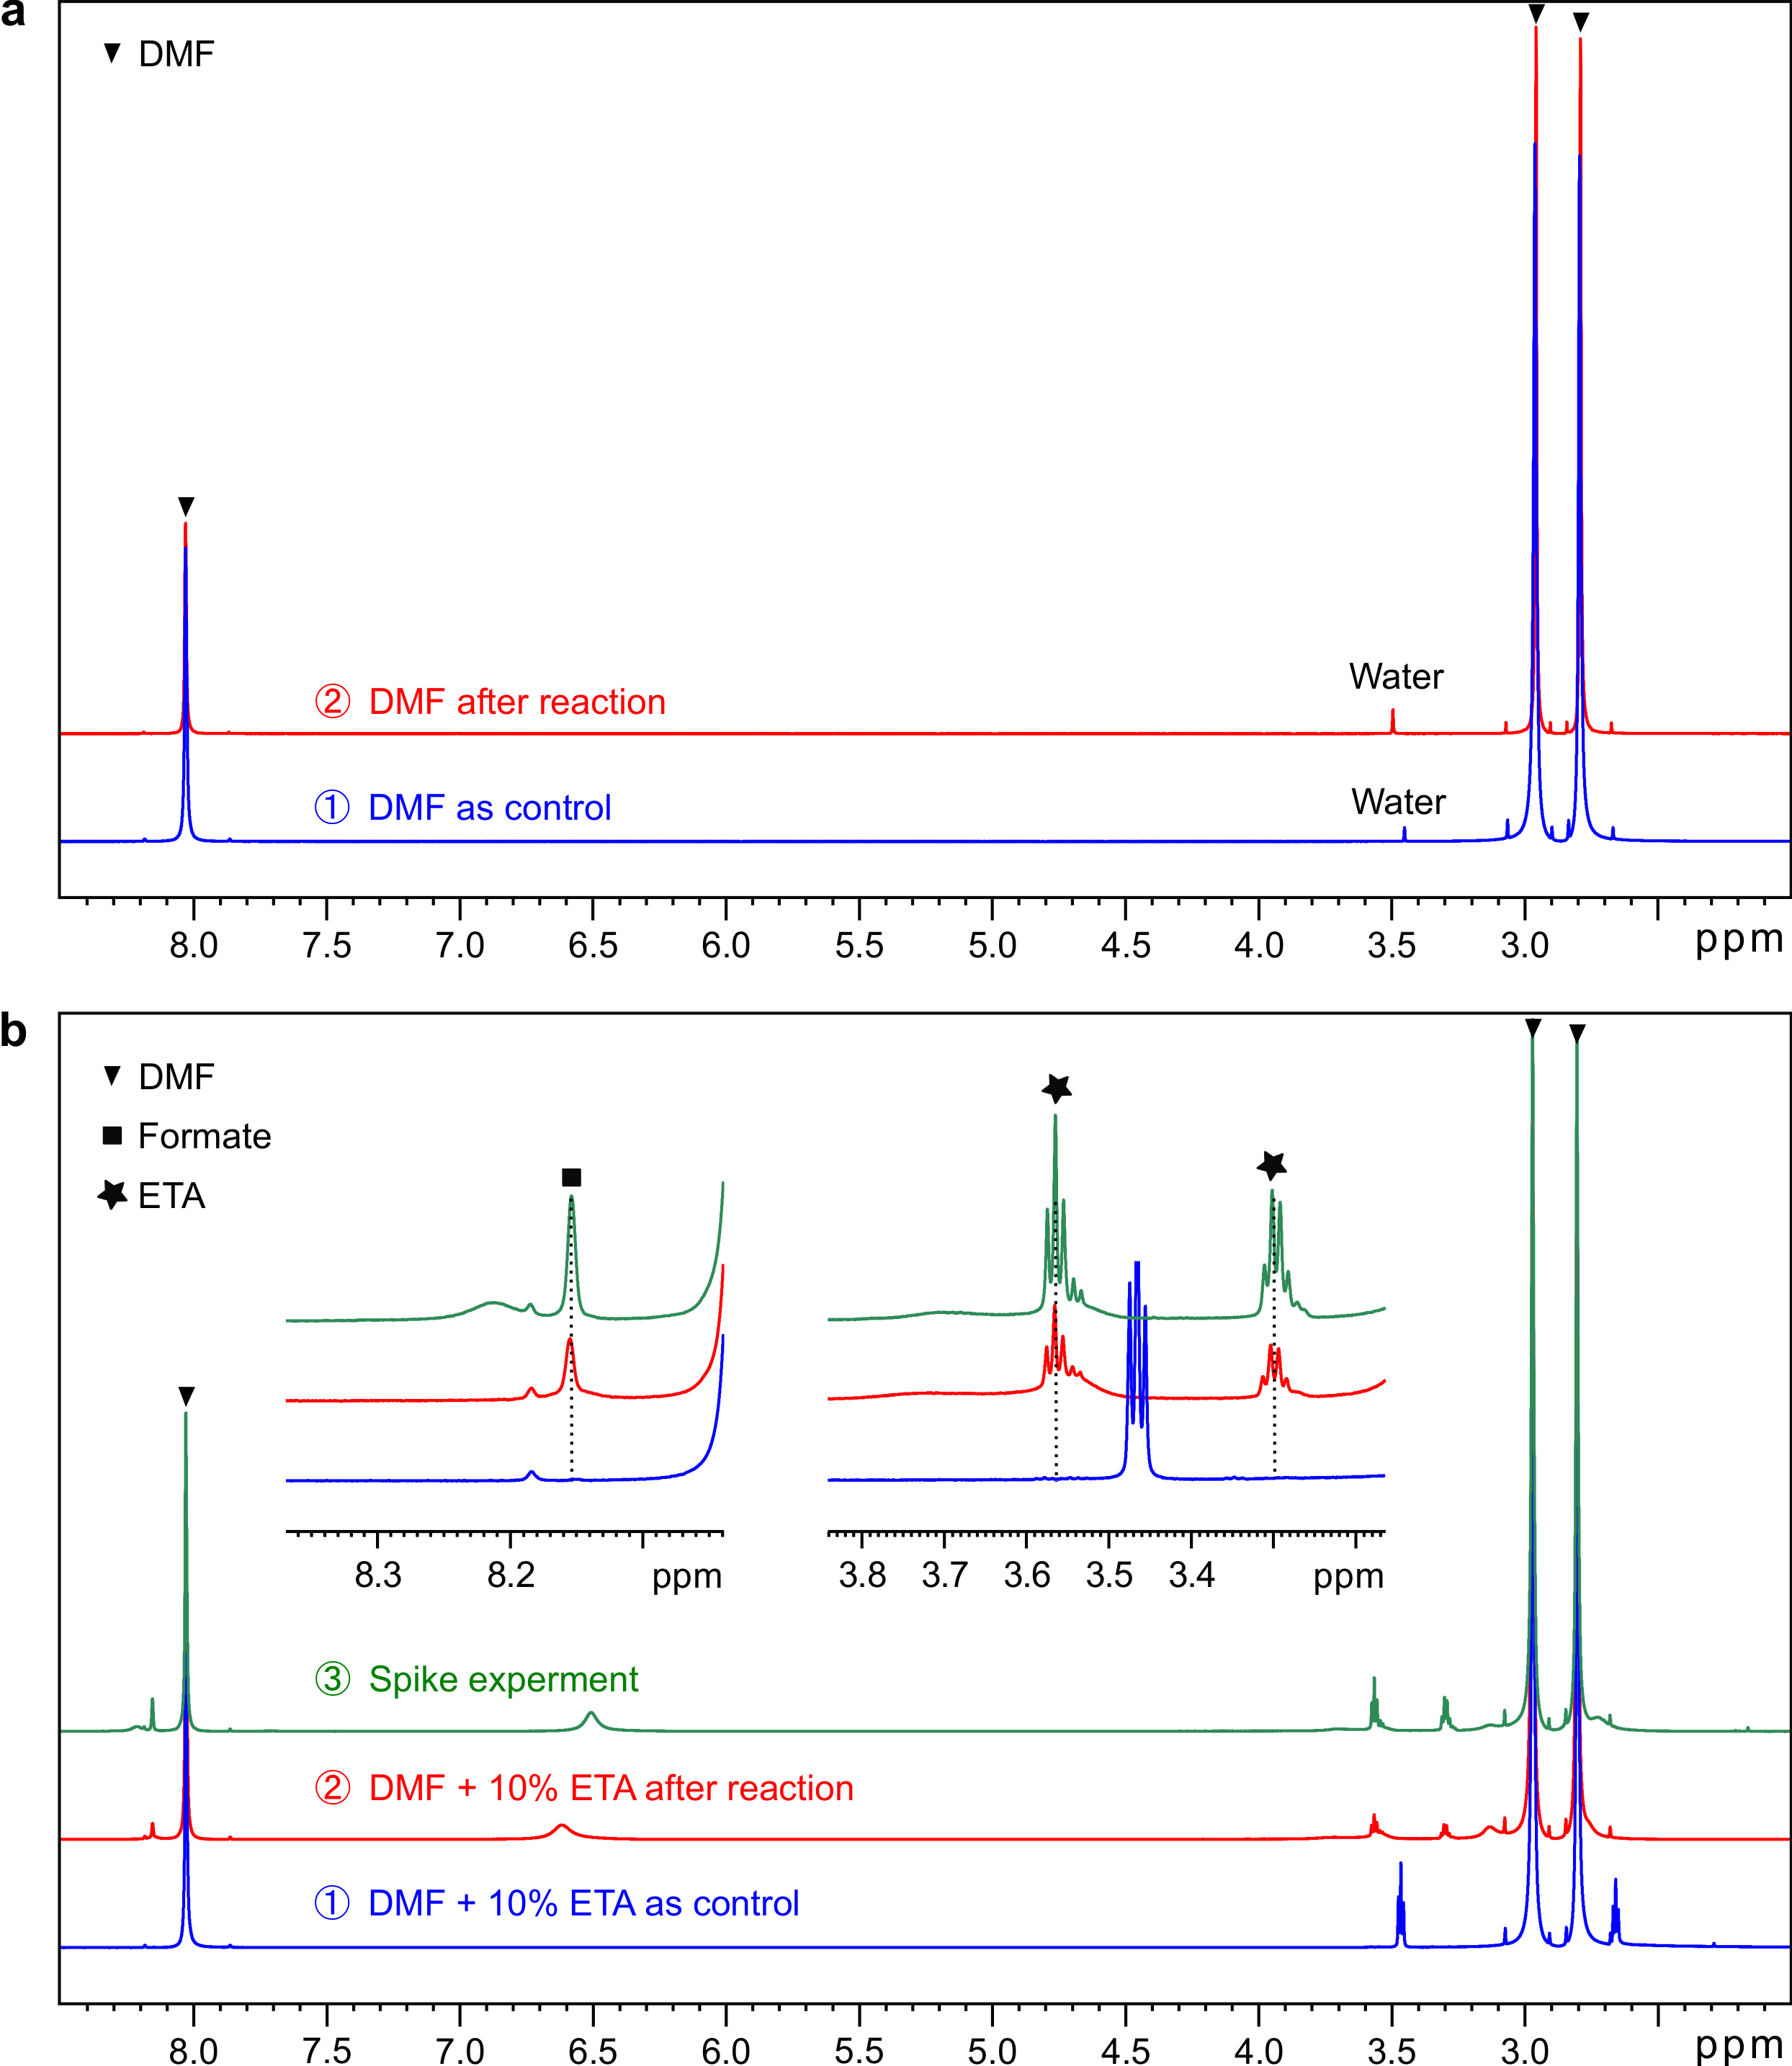
Supplementary Fig. 14 | NMR results. a, NMR spectra of DMF before ① and after ② 5 hours of CO₂ reaction. b, NMR spectra of 90% DMF with 10% ETA as the reaction solution before ① and after ② CO₂ reduction for 5 hours, and the spectrum of spike experiment ③ was acquired with the addition of 0.10 μL formic acid into ②.

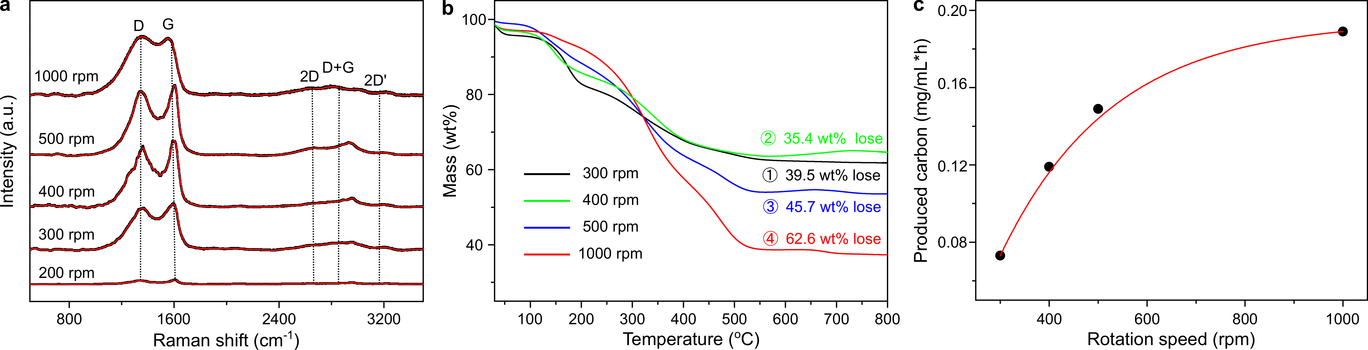
Supplementary Fig. 15 | The CO₂ conversion results using overhead stirring as the mechanical energy input. a, Raman spectra of produced carbon on the surface of the catalysts using overhead stirring as the input energy at different rotation speed for 24 hours (utilizing a 50 mL reactor containing 0.14 g/mL Ga and 0.020 g/mL AgF in 90% DMF with 10% ETA solution). b, TGA results of the carbon produced at different rotation for 24 hours CO₂ conversion. The mass of the sample from 2.0 mL reaction solution was found to be 10.2 mg (300 rpm), 18.8 mg (400 rpm), 17.6 mg (500 rpm) and 15.75 mg (1000 rpm), respectively. c, The trend of produced carbonaceous materials (per hour in per millilitre reaction solution) as the rotation speed increases.

Supplementary Table 1 | Capture and conversion of CO₂ under different configurations and scenarios.

CO₂ conversion setups | Solvent ⁽¹⁾ | Volume of the reactor  (mL) | Height of the reactor  (cm) | Reaction time (h) | CO (cm³/h) | O₂ (cm³/h) | Volume of CO₂ in the input (cm³/h) ⁽²⁾ | Volume of CO₂ in the output (cm³/h) | Produced solid carbon (mg/h) | Conversion efficiency (%)
Bath sonication | DMF | 20 | 4.5 | 5 | 0 | 1.2 | 600 | 591 | 4.75 | 1.5%
Bath sonication | DMF | 500 | 40 | 1 | 0 | 15.5 | 516 | 377.5 |  | 26.8%
Bath sonication | DMF | 500 | 40 | 3 | 0 | 75.5 | 516 | 375.5 |  | 27.2%
Bath sonication | DMF | 500 | 40 | 6 | 0 | 79 | 516 | 371.5 | 160 | 28%
Bath sonication | 90%DMF+10%ETA | 20 | 4.5 | 5 | 22.2 | 0.36 | 600 | 563 | 7.95 | 6.2%
Bath sonication | 90%DMF+10%ETA | 330 | 27 | 5 | 13 | 50.5 | 480 | 0 |  | 100%
Bath sonication | 90%DMF+10%ETA | 330 | 27 | 12 | 15 | 58.5 | 480 | 0 |  | 100%
Bath sonication | 90%DMF+10%ETA | 330 | 27 | 24 | 0 | 120.5 | 480 | 40.5 |  | 91.5%
Bath sonication | 90%DMF+10%ETA | 330 | 27 | 30 | 0 | 210.5 | 480 | 38.7 | 360 | 92%
Stirring at 300 rpm | 90%DMF+10%ETA | 50 | 3.0 | 24 |  |  | 600 |  | 3.65
Stirring at 400 rpm | 90%DMF+10%ETA | 50 | 3.0 | 24 |  |  | 600 |  | 5.95
Stirring at 500 rpm | 90%DMF+10%ETA | 50 | 3.0 | 24 |  |  | 600 |  | 7.45
Stirring at 1000 rpm | 90%DMF+10%ETA | 50 | 3.0 | 24 |  |  | 600 |  | 9.45
Notes:
(1) The concentrations of reaction co-contributors were 0.14 g/mL and 0.020 g/mL, for gallium and AgF, respectively.
(2) The flow rate of CO₂ bubbling was set at 10 sccm. However, the actual flow rates of the input gas in the scale-up reactors were reduced due to the pressure and the viscosity influences of the solvents.

Calculation of produced carbon and conversion rate: Based on our TGA results, the mass of the produced carbon materials is $m_{TGA}×(δ-φ)$, where m_{TGA} and δ (%) are the mass of the collected sample before the TGA experiment and the mass loss ratio after the TGA test, respectively. The 𝜑 was the mass loss below 100 °C introduced to account for the loosely bound or adsorbed water and gas molecules in the sample¹. The total mass of the carbon materials produced (m_{c}) in the reactor (V₀, mL) per hour is:
$m_{C}=\frac{{V_{0}×m}_{TGA}×\left(δ-φ\right)}{V_{TGA}×T}$ $\left(S1\right)$
Where V₀ is the volume of the reactor, V_{TGA} (2 mL) is the volume of the sample collected for TGA and T (h) is the reaction time.
The CO₂ conversion rate (R) is defined as the volume ratio of the amount of captures and reduced CO₂ (V_{r}) to that of the CO₂ bubbled (V_{b}) into the reactor per hour:
$R=\frac{V_{r}}{V_{b}}×100\%$ $\left(S2\right)$
where V_{b} is the flow rate of CO₂ bubbled into the reaction system (controlled at 10 sccm), which corresponds to 600 cm³ CO₂ gas input to the 20 mL reactor per hour. However, due to the pressure and the viscosity of the solvent in the scaled-up experiments, the flow rate of CO₂ was ~8.6 and ~8.0 sccm in DMF and DMF+ETA cases. V_{r} is calculated based on the GC results of the collected gas or the products.
Two approaches were used to measure the volume of the captured and reduced CO₂ gas, which correspond to two V_{r} calculation methods:
(1) For the experiments conducted in the 20 mL small reactor, the amount of the reduced CO₂ was obtained from the products based on TGA and GC experiments:
$V_{r}={(\frac{M_{{CO}_{2}}}{M_{C}}m}_{C})/d_{{CO}_{2}}+V_{CO}$ $\left(S3\right)$
where $M_{{CO}_{2}}$ and $M_{C}$ are the molecular weight of CO₂ and C, respectively, and $d_{{CO}_{2}}$ is the density of CO₂, which is taken as 0.00198 g/cm³.
(2) For the experiments conducted in the scaled-up reactors, V_{r} was obtained directly from the amount of the output CO₂ gas ($V_{{out-CO}_{2}}$) from GC experiments.
$V_{r}=V_{b}-V_{{out-CO}_{2}}$ $\left(S4\right)$

Estimation of the energy consumption: When the experiment was conducted in the 20 mL reactor, the energy consumption during our CO₂ conversion process was roughly calculated by considering the power input from the bath sonicator (P₀, 20 W)², the size of the reactor (V₀, 20 cm³) and the liquid volume in the bath sonicator (V_{B}, 2000 cm³) when the bath sonicator was employed as the energy source. Thus, the energy used for CO₂ conversion (P₁, W) is:
$P_{1}=P_{0}×\frac{V_{0}}{V_{B}}$ $(S5)$
Further considering the size of the reactor being increased to 40 cm and 27 cm, respectively, the 27% or 92% of the bubbled CO₂ was fully converted when DMF or DMF with 10% ETA were employed as the reaction solution. So, the energy consumption in both cases (Q_{DMF} and Q_{DMF+ETA}, kW∙h) for capturing and converting 1.0 tonne (1×10⁶ g) of CO₂ was determined by equations (S4, S5):
$Q_{DMF}=P_{1}×\left(\frac{1×{10}^{6}}{d_{{CO}_{2}}×V_{r(DMF)}}\right)$ $(S6)$
$Q_{DMF+ETA}=P_{1}×(\frac{1×{10}^{6}}{d_{{CO}_{2}}×V_{r\left(DMF+ETA\right)}})$ $(S7)$

The triboelectrochemical process: Under the assumption that the Ag_{0.72}Ga_{0.28} rods act as long nano conductors that close the electrical loop, the open-circuit voltage $V_{o}\left(t\right)$ between the liquid metal and the DMF at a distance of $z\left(t\right)$ can be described by the following equation³:
$V_{o}\left(t\right)=-\frac{σ\left(t\right)z\left(t\right)}{ε}$ $\left(S8\right)$
where $σ\left(t\right)$ is the time-dependent charge density between Ga/DMF, $ε=1.09ε_{0}$ is the permittivity of CO₂ gas and $ε_{0}=8.8×{10}^{-12}$ F/m is the permittivity of vacuum. Initially, $σ\left(0\right)$ can be taken as the charge density of the Ga/DMF EDL and $z\left(0\right)$ as the EDL thickness.
As the CO₂ bubbles displace the Ga/DMF interface from $z\left(0\right)$ to $z\left(t\right)$, the charge density $σ\left(t\right)$ decreases with time. This discharge process of the capacitive EDL is essentially determined by the mobility of the charges (ions) in the electrolyte. Therefore, if the bubble/liquid metal interaction is comparable or faster than the discharge process (which is reasonable in our experiment under high frequency mechanical agitation), equilibrium will not be reached. As a result, $σ\left(0\right)$ discharges exponentially:
$σ\left(t\right)=σ\left(0\right)e^{-t/t_{R}}$ $\left(S9\right)$
and equation (S8) then becomes:
$V_{o}\left(t\right)=-σ\left(0\right)z\left(t\right)e^{-t/t_{R}}/ε$ $\left(S10\right)$
To calculate $V_{o}\left(t\right)$, we assume that $σ\left(0\right)$ is on the order of 1 μC/cm^{4, 5}, which corresponds to the EDL thickness $z\left(0\right)$; $z\left(t\right)$ is equivalent to the size of the CO₂ bubbles which is comparable to that of the Ga nanoparticles ~100 nm (for such small bubbles, we can); t is the same time scale as that of the mechanical agitation (sonication or stirring) and we assume t_{R} is on the order of 10 μs. Equation (S10) then gives a rough estimation V₀(1/f) = -8 V at f = 40 kHz sonication. Therefore, this transient potential rise is due to the insufficient discharge of the EDL capacitor as a result of the separation of the Ga/DMF interface, which shares similar working principles with triboelectric nanogenerators.
Despite its apparent high magnitude, this voltage $V_{o}\left(t\right)$alone cannot cause CO₂ conversion since the electric field intensity $V_{o}\left(t\right)/z\left(t\right)$ drops during the process, in comparison to the EDL capacitor electric field intensity $V_{o}\left(0\right)/z\left(0\right)$. The CO₂ conversion process takes place when the very long Ag_{0.72}Ga_{0.28} rods close the electrochemical loop with the Ga droplets and the CO₂ bubbles. This nanoscale triboelectrochemical process can also explain why the sample with long Ag_{0.72}Ga_{0.28} rods shows better performance than the other Ag_{0.72}Ga_{0.28} structures.

NMR result discussion: NMR tests were performed to confirm that DMF and ETA only acted as a solvent and was not directly involved in the CO₂ conversion process. The NMR results showed that there were no significant changes in the ¹H spectra of DMF and ETA before and after reaction (Supplementary Fig. 10a). When ETA is introduced into the reaction system, the hydrogen from HCl, water and amine group of ETA exchange with each other, resulting in a new chemical shift at 6.5 ppm⁶. Furthermore, the protonated ethanolamine CH₂ peaks are shifted to 3.3 and 3.6 ppm, respectively (Supplementary Fig. 10b). Based on previous studies, the amine group of ETA can impact CO₂ reduction process by generating format as a by-product^{7, 8}. A new peak was observed at 8.16 ppm, which was confirmed to be formate by the addition of a small amount of formic acid. However, compared with the production of solid carbonaceous materials, the quantity of produced formate is insignificant and negligible.

References

1. Ganguly, A., Sharma, S., Papakonstantinou, P., Hamilton, J. Probing the Thermal Deoxygenation of Graphene Oxide Using High-Resolution In Situ X-ray-Based Spectroscopies. J. Phys. Chem. C 115, 17009-17019 (2011).
2. Asadi, A. et al. Effect of sonication characteristics on stability, thermophysical properties, and heat transfer of nanofluids: A comprehensive review. Ultrason. Sonochem. 58, 104701 (2019).
3. Wang, Z. L. On Maxwell's displacement current for energy and sensors: the origin of nanogenerators. ‎Mater. Today 20, 74-82 (2017).
4. Emets, V. V., Damaskin, B. B. Chemisorption interaction of liquid electrodes of gallium and In–Ga, Cd–Ga and Tl–Ga alloys with solvents in a wide range of their donor numbers. J. Electroanal. Chem 600, 191-204 (2007).
5. García de Arquer, F. P. et al. CO₂ electrolysis to multicarbon products at activities greater than 1 A cm⁻². Science 367, 661-666 (2020).
6. Yoon, Y.-G., Pfrommer, B. G., Louie, S. G., Canning, A. NMR chemical shifts in amino acids: effects of environments in the condensed phase. Solid State Commun. 131, 15-19 (2004).
7. Zhang, S. et al. Polyethylenimine-enhanced electrocatalytic reduction of CO₂ to formate at nitrogen-doped carbon nanomaterials. J. Am. Chem. Soc. 136, 7845-7848 (2014).
8. Sen, R., Goeppert, A., Kar, S., Prakash, G. K. S. Hydroxide Based Integrated CO₂ Capture from Air and Conversion to Methanol. J. Am. Chem. Soc. 142, 4544-4549 (2020).

