Supplemental Statistical Analyses

Supplemental Methods
For each reader pair, association was summarized with Pearson correlation, and agreement was summarized with the mean absolute difference, Bland-Altman mean bias, and 95% limits of agreement. Proportional bias was explored by linear regression of reader difference on pair mean. Spearman correlation between absolute pairwise difference and pair mean assessed whether dispersion increased with longer ETT. Each pair-specific analysis included one independent difference per examination; pooled limits across correlated reader pairs were not used for inference.
Frame-rate robustness was evaluated using Spearman correlation between acquisition frame rate and the examination-level mean absolute pairwise difference. Mean disagreement was also summarized for examinations acquired below 10 frames per second versus 10 frames per second or higher. A sensitivity analysis repeated the ICC calculation after excluding the four examinations acquired at 3 frames per second.

Supplemental Results
Pairwise Pearson correlations ranged from 0.753 to 0.815, and mean absolute differences ranged from 0.48 to 0.50 seconds. Mean biases were small (−0.19 to +0.07 seconds). Proportional bias was detected for Readers 1 and 2 but not for the other reader pairs. Absolute disagreement increased with mean ETT for Readers 1 and 2 and more weakly for Readers 1 and 3; the Readers 2 and 3 association did not reach statistical significance. These exploratory findings suggest that fixed limits of agreement should be interpreted cautiously at longer ETT values.
Reader pair | Pearson r | Mean absolute difference (s) | Mean bias (s) | 95% limits of agreement (s) | Difference-vs-mean slope (P) | Absolute difference vs mean, ρ (P)
Reader 1 - Reader 2 | 0.815 | 0.48 | -0.19 | -1.57 to 1.19 | -0.210 (.010) | 0.465 (<.001)
Reader 1 - Reader 3 | 0.802 | 0.49 | -0.12 | -1.39 to 1.14 | -0.042 (.613) | 0.253 (.040)
Reader 2 - Reader 3 | 0.753 | 0.50 | +0.07 | -1.52 to 1.65 | +0.174 (.066) | 0.235 (.058)
Table S1. Detailed pair-specific association, agreement, proportional-bias, and magnitude-dependent dispersion analyses. Difference is first-listed reader minus second-listed reader. Analyses were exploratory and were not adjusted for multiple testing.

Supplemental Figure
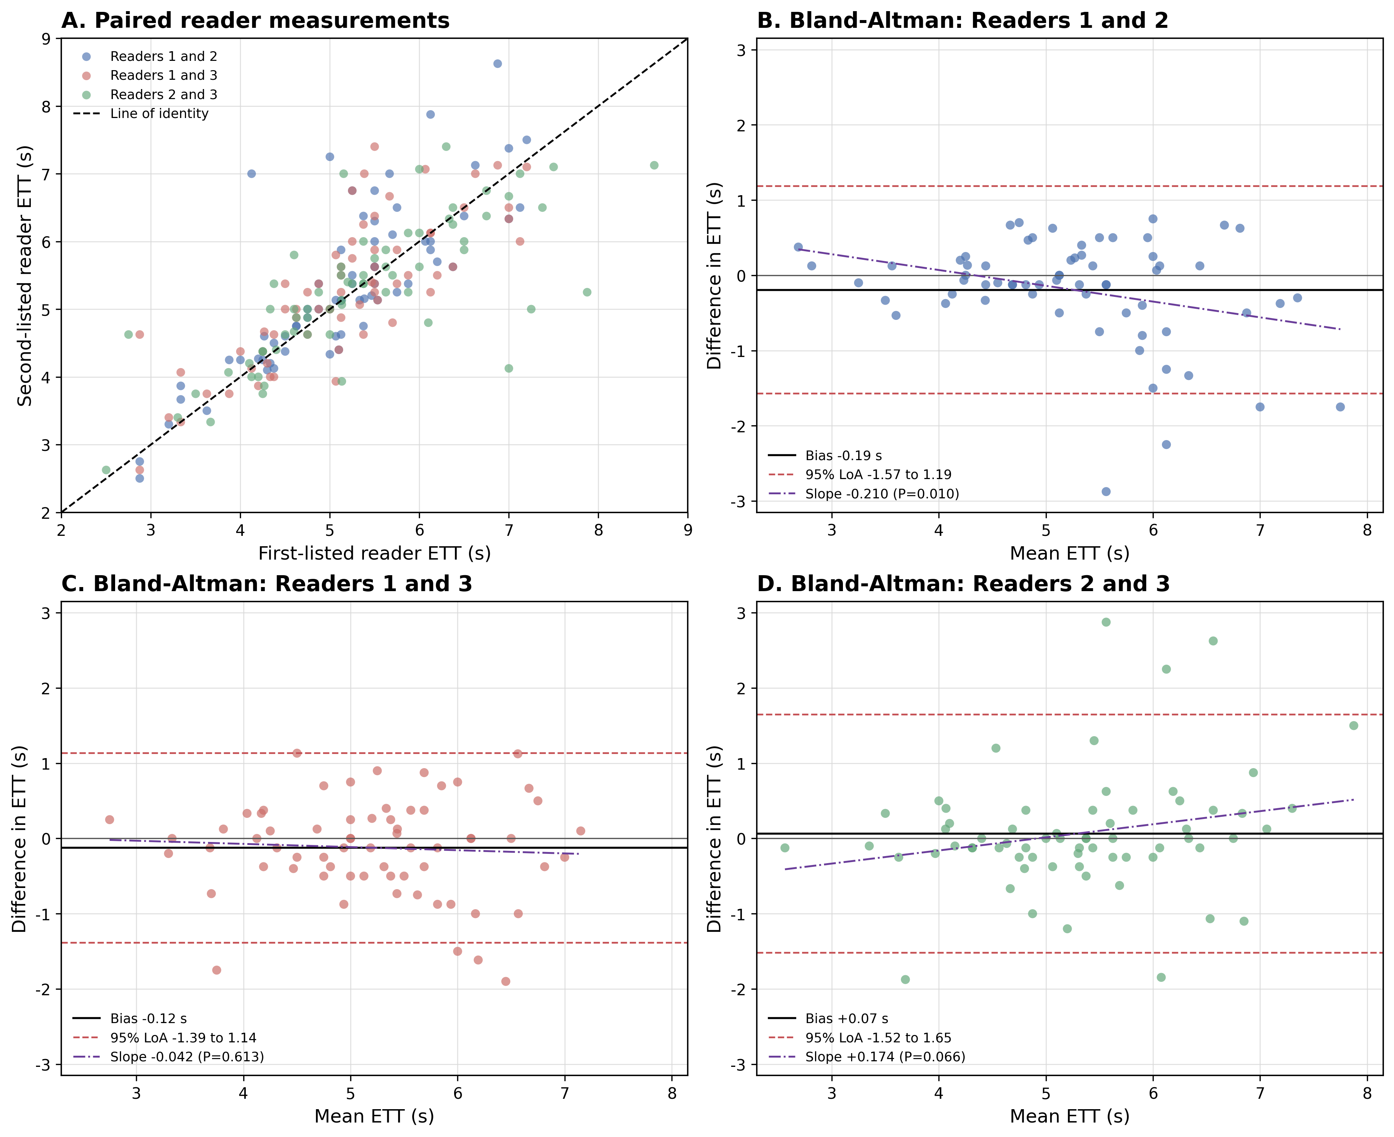
Figure S1. Detailed inter-reader analysis of quantitative, frame-based ETT. Panel A shows paired reader measurements and the line of identity. Panels B-D show pair-specific Bland-Altman plots with mean bias (black), 95% limits of agreement (red dashed), and fitted difference-vs-mean regression (purple dash-dot).

Frame-Rate Robustness
Acquisition frame rate was not associated with examination-level mean absolute pairwise disagreement (ρ = 0.002; P = .988). Mean disagreement was 0.489 seconds below 10 frames per second and 0.492 seconds at 10 frames per second or higher. Subgroup summaries are descriptive because several frame-rate groups were small.
Acquisition frame rate (frames/s) | Examinations, n | Mean case-level pairwise absolute difference (s) | Median case-level pairwise absolute difference (s)
3 | 4 | 0.500 | 0.444
8 | 43 | 0.488 | 0.333
10 | 8 | 0.492 | 0.400
13 | 1 | 1.231 | 1.231
15 | 10 | 0.418 | 0.267
Table S2. Descriptive reader disagreement by acquisition frame rate. Case-level disagreement is the mean absolute difference across the three reader pairs for each examination.

Sensitivity Analysis Excluding 3-Frames-per-Second Examinations
Analysis set | ICC(A,1) | ICC(A,3)
Full cohort (n = 66) | 0.777 | 0.913
Excluding 3-frames-per-second examinations (n = 62) | 0.766 | 0.908
Table S3. Sensitivity analysis of continuous quantitative ETT reliability. Excluding the four 3-frames-per-second examinations left the ICC estimates essentially unchanged.

