Supplementary Materials
Supplementary Figure 1. Pedigree of the families of FAD cases with P117L mutation (A), and with I213F mutation (B).
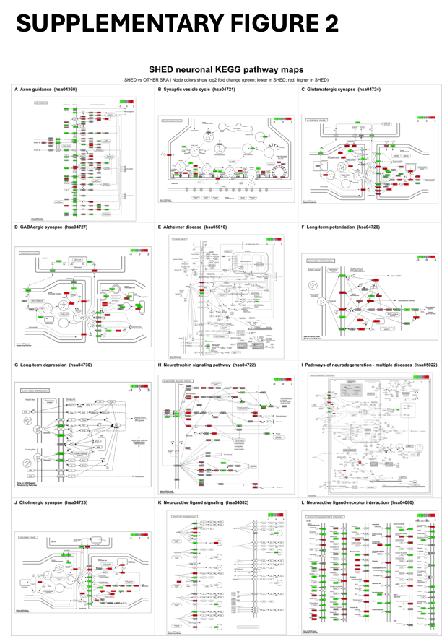
Supplementary Figure 2. KEGG pathway enrichment analysis of predicted miRNA targets. Enrichment of selected pathways associated with neuronal function and neurodegeneration, including axon guidance (hsa04360), synaptic vesicle cycle (hsa04721), glutamatergic synapse (hsa04724), GABAergic synapse (hsa04727), Alzheimer disease (hsa05010), long-term potentiation (hsa04720), long-term depression (hsa04730), neurotrophin signaling pathway (hsa04722), pathways of neurodegeneration—multiple diseases (hsa05022), cholinergic synapse (hsa04725), neuroactive ligand–receptor interaction (hsa04080), and neuroactive ligand signaling (hsa04082). These pathways highlight the potential involvement of exosomal miRNA targets in neuronal function, synaptic transmission and plasticity, and molecular processes relevant to learning, memory, and neurodegenerative disease.

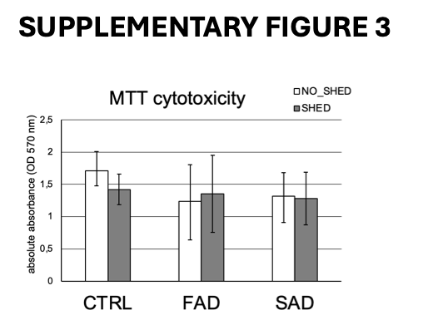
Supplementary Figure 3. Potential toxicity evaluations via colorimetric MTT assays. Bar charts illustrate absolute absorbance measurements at 570 nm mapping CTRL, FAD, and SAD cohorts, evaluating environments with SHED (grey) versus NO_SHED (white) backdrops. Metabolic activity measurements remain stable within the standard 1.0 to 1.7 thresholds across groups.

