Electro-oxidation of Polystyrene Nanoplastics Using a Titanium-based Anode Modified with Ag–Sn/Pb–PbO₂: ANN-PSO Modeling

S. Mohammad Esmaeil Zakeri¹, Mehrzad Feilizadeh^{1∗}
1. Department of Chemical Engineering, School of Chemical and Petroleum Engineering, Shiraz University,
Shiraz, Iran

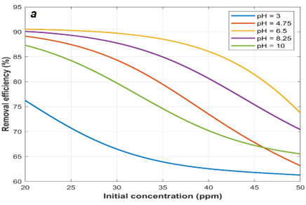
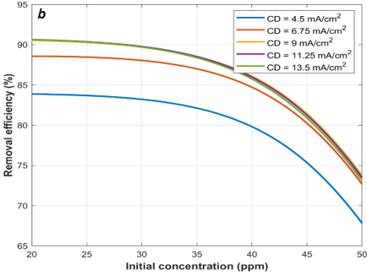

Figure S1. Effect of initial concentration on the removal efficiency of the PS NPs in different (a) pH and (b) Current densities.

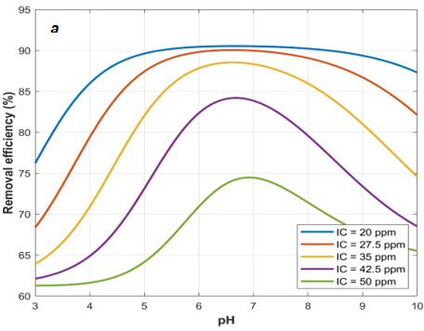

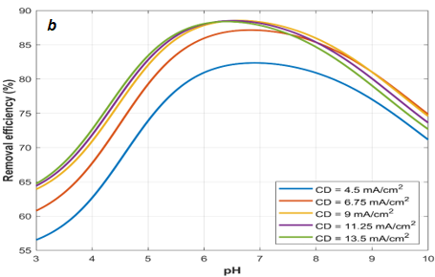
Figure S2. Effect of pH on the removal efficiency of the PS NPs in different (a) Initial concentrations and (b) Current densities.

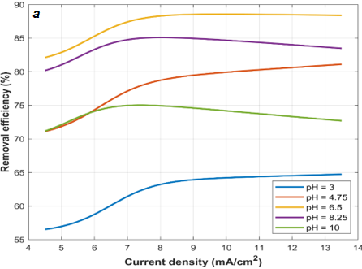
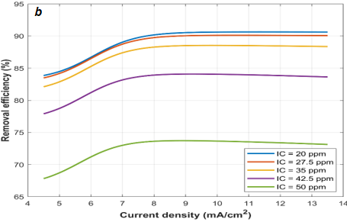

Figure S3. Effect of current density on the removal efficiency of the PS NPs in different (a) pH and (b) Initial concentrations.

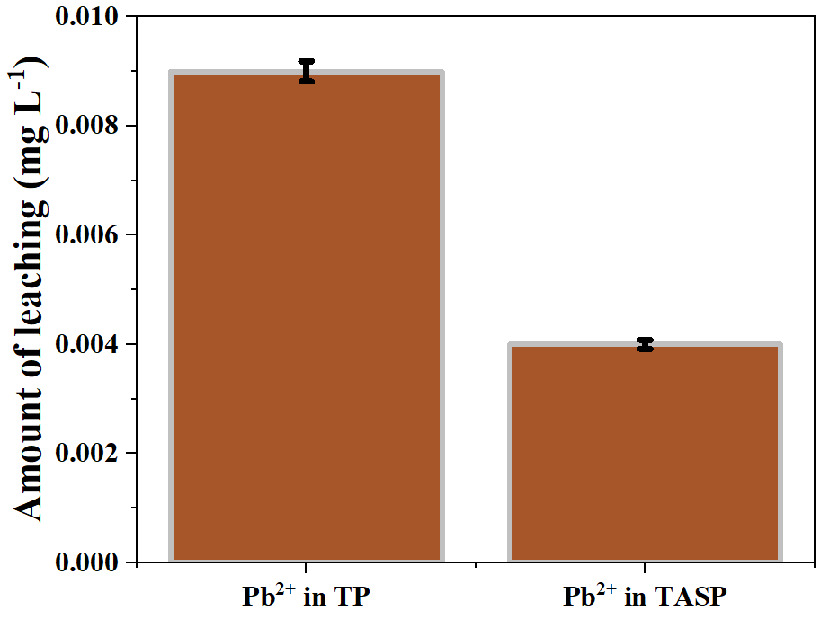
Figure S4. Pb²⁺ leaching from TP and TASP electrodes under the optimized EO conditions.

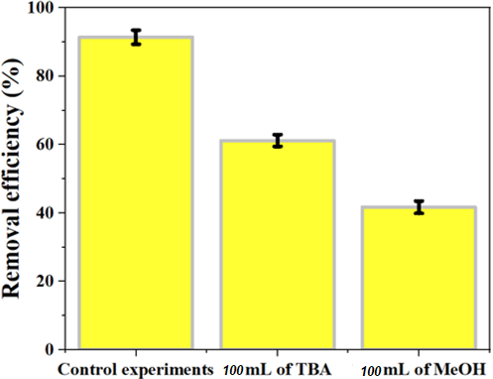
Figure S5. PS-NP removal efficiency in the absence of scavenger and in the presence of tert-butanol (TBA) and methanol (MeOH) under optimized operating conditions.

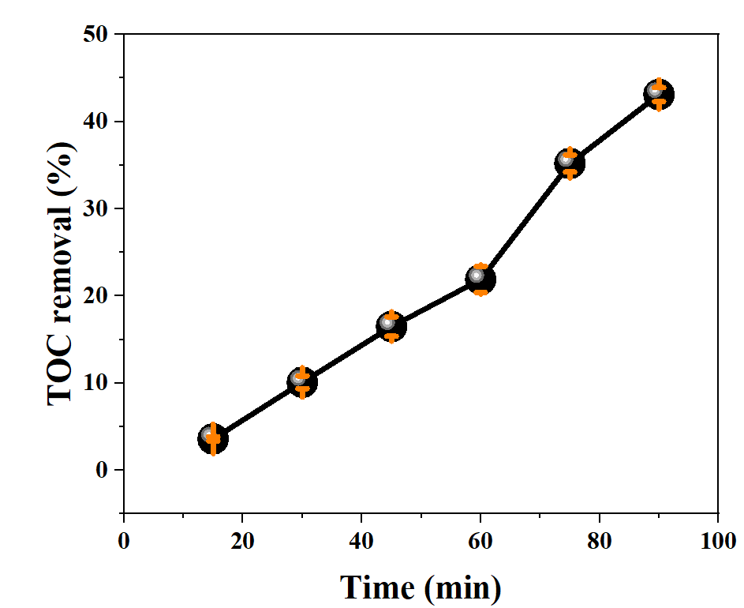
Figure S6. Time-dependent TOC removal during EO of PS NPs under the optimized operating conditions.

Table S1. ANOVA summary for the quadratic RSM model developed for PS-NP electro-oxidation.
Source | Sum of Squares | df | Mean Square | F-value | p-value
Model | 4937 | 7 | 705 | 78.33 | < 0.0001 | significant
A-pH | 477 | 1 | 477 | 52.96 | < 0.0001
B-Initial concentration | 1984 | 1 | 1984 | 220.41 | < 0.0001
C-Current density | 174 | 1 | 174 | 19.33 | < 0.0001
AC | 46.0 | 1 | 46.0 | 5.11 | 0.0284
A² | 782 | 1 | 782 | 86.89 | < 0.0001
B² | 18.4 | 1 | 18.4 | 2.05 | 0.1591
C² | 11.2 | 1 | 11.2 | 1.24 | 0.2711
Residual | 432 | 48 | 9.00
Lack of Fit | 429 | 45 | 9.54 | 9.87 | 0.0412 | significant
Pure Error | 2.90 | 3 | 0.9667
Cor Total | 5368 | 55

Table S2. Weights and biases of the ANN model.
Neuron | Hidden layer |  |  |  |  | Output layer
Neuron | Weight matrix (W^{ih}) |  |  | Bias vector |  | Weight vector (W^{ho}) | Bias
Neuron | pH | Initial concentration | Current density
1 | 1.710 | 1.157 | 0.157 | -1.500 |  | -0.653 | -0.540
2 | -0.447 | -0.150 | -3.162 | -2.209 |  | -0.183 | -0.540
3 | 2.846 | -1.191 | 0.119 | 1.674 |  | 0.710 | -0.540

∗ Corresponding author, E-mail: m.feilizadeh@utwente.nl, m.feilizadeh@shirazu.ac.ir.

