Supporting information
“Machine-learned potentials link vacancy-dependent copper transport to post-implantation profiles in silicon”

Mingzhu Liu,^{1,2} Yiwen Su,³ Xinzhong Wang,³ Jiashu Chen^{1*}
¹ School of Physics, Central South University, Changsha, China
² Department of Biomedical Sciences, College of Biology, Hunan University, Changsha, China
³ Department of Mechanical Engineering, Hong Kong Polytechnic University, Hung Hom, Kowloon, Hong Kong, China
* Corresponding author: Jiashu Chen (jiashu.chen@csu.edu.cn)

- Density Functional Theory Calculations
In this study, all Density Functional Theory (DFT) calculations were conducted using CP2K (version 8.1) software ¹. Double-zeta plus polarization (DZVP) basis sets were employed, combined with Goedecker-type pseudopotentials and the Perdew-Burke-Ernzerhof (PBE) exchange-correlation functional ². The energy cutoff was defined as 300 Ry, with the energy convergence threshold defined as 1.0×10⁻⁶ Hartree. Monkhorst-Pack k-point gird with a 2×2×2 grid was used for the Brillouin zone. Lattice relaxation was performed with a force convergence criterion of 2.0×10⁻⁴ Hartree/Bohr (about 10 meV/Å). For NEB calculations, we employed a force convergence criterion of 2.0 × 10⁻⁴ Hartree/Bohr (about 10 meV/Å) to relax the intermediate images.
- Construction of Dataset
The construction of the deep potential dataset followed the steps outlined in Fig. 1 in the main text.
  - Initial Dataset
As shown in Fig. S1, we designated two adjacent tetrahedral interstitial sites as the starting and ending structures of the diffusion path for Cu_{i}^{T} in Si (Cu_{i}→Cu_{i}). Then, we set those shown in Fig. S2(a) and Fig. S2(b) as the starting and ending structures of the diffusion path (Cu_{i}+V_{Si}→Cu_{s}), respectively.
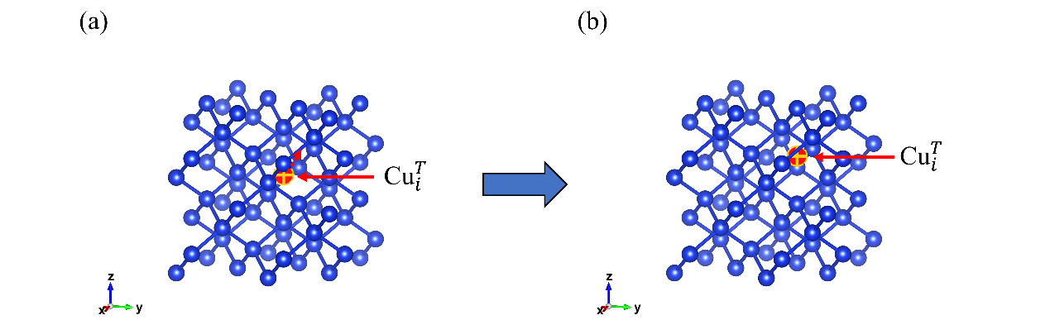
Fig. S1. The diffusion path of Cu_{i}^{T} from a tetragonal site and an equivalent site (Cu_{i}^{T}→Cu_{i}). Si atoms are represented in blue, while Cu atoms are depicted in red.
At last, we designated the structures shown in Fig. S3 as the starting and ending structures of the diffusion path (Cu_{s}-Cu_{i} + V_{Si} → Cu_{s}-Cu_{s}) and those shown in Fig. S4 as the starting and ending structures of the diffusion path (Cu_{s}-Cu_{i} + V_{Si} → Cu_{s}-Si-Cu_{s}). We utilized 9 intermediate states for the nudged elastic band (NEB) calculations of the Cu_{i}→Cu_{i} diffusion path and 7 intermediate states for other three diffusion paths.
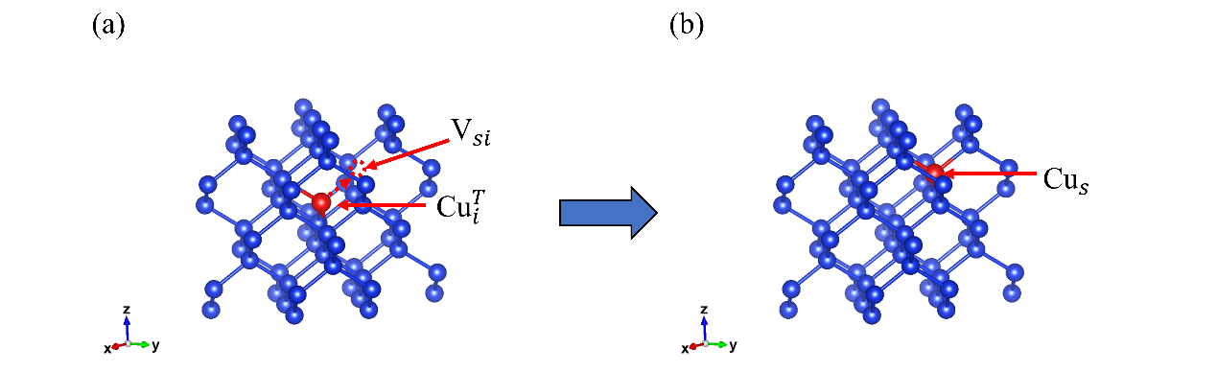
Fig. S2. The diffusion path of interstitial copper Cu_{i} with a pre-existing vacancy V_{Si} (Cu_{i} + V_{Si} → Cu_{s}). Si atoms are represented in blue, while Cu atoms are depicted in red
Linear interpolation between the initial and final structures (see Fig. S1) from the NEB calculation was employed to create intermediate structures for diffusion path (Cu_{i}+V_{Si}→Cu_{s}). Compression and stretching were applied to these intermediate structures (the lattice variation spanned from 98% to 102%), and random perturbations were introduced to the atomic positions and vectors of a supercell. Energies and forces of these modified structures were computed using DFT to form dataset D₁ (the folder “Initial Dataset/Si64Cu” provided detailed method in obtaining coordinate files).
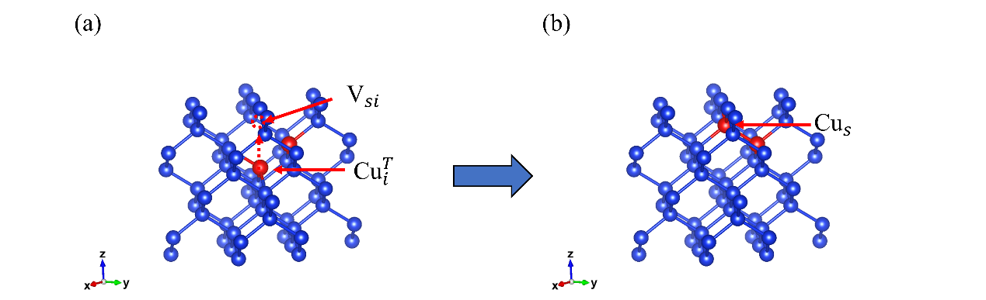
Fig. S3. The diffusion path of Cu_{s}-Cu_{i} pairs with a pre-existing vacancy V_{Si} (Cu_{s}-Cu_{i} + V_{Si} → Cu_{s}-Cu_{s}). Si atoms are represented in blue, while Cu atoms are depicted in red.
Similarly, linear interpolation between the initial and final structures (see Fig. S2) from the NEB calculation was employed to create intermediate structures for diffusion path (Cu_{s}-Cu_{i} + V_{Si} → Cu_{s}-Cu_{s}). Compression and stretching were applied to these intermediate structures (the lattice variation spanned from 98% to 102%), and random perturbations were introduced to the atomic positions and vectors of a supercell. Energies and forces of these modified structures were computed using DFT to form dataset D₂ (the folder “Initial Dataset/Si63Cu” provided detailed method to obtain coordinate files).
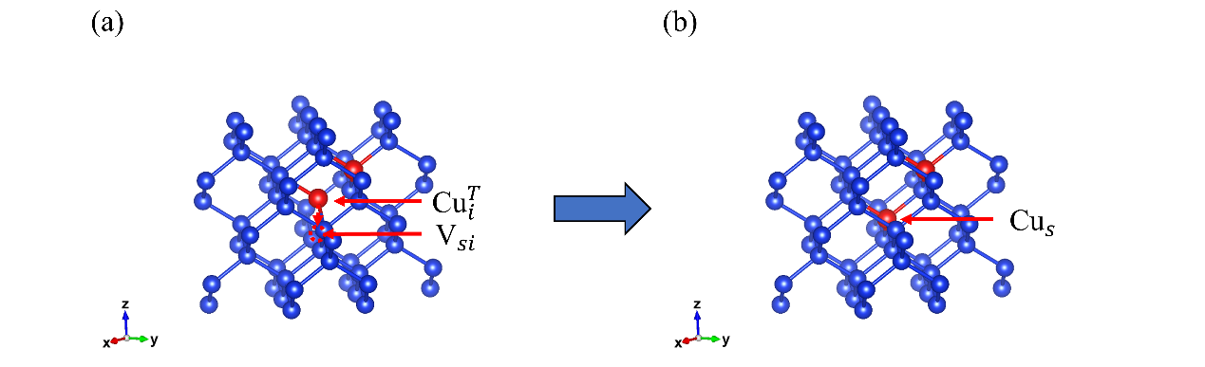
Fig. S4. The diffusion path of Cu_{s}-Cu_{i} pairs with a pre-existing vacancy V_{Si} (Cu_{s}-Cu_{i} + V_{Si} → Cu_{s}-Si-Cu_{s}). Si atoms are represented in blue, while Cu atoms are depicted in red.
Then, linear interpolation between the initial and final structures (see Fig. S2) from the NEB calculation was employed to create intermediate structures for diffusion path (Cu_{s}-Cu_{i} + V_{Si} → Cu_{s}-Cu_{s} and Cu_{s}-Cu_{i} + V_{Si} → Cu_{s}-Si-Cu_{s}). Compression and stretching were applied to these intermediate structures (the lattice variation spanned from 98% to 102%), and random perturbations were introduced to the atomic positions and vectors of supercell. Energies and forces of these modified structures were computed using DFT to form dataset D₃ (the folder “Initial Dataset/Si62Cu2” provided detailed method to obtain coordinate files).
Finally, the initial dataset was constructed by merging the D₁, D₂, and D₃ datasets, as shown in Fig. 1(a). Similarly, the method used to generate the initial dataset could also be applied to create the test dataset. Detailed methods to obtain coordinate files for the three systems were provided in three folders “Test Dataset/Si64Cu”, “Test Dataset/Si63Cu”, and “Test Dataset/Si62Cu2”, respectively.
  - DP-GEN Iterations
DP-GEN is a software platform utilized for generating reliable datasets and facilitating active learning ³. Its workflow includes iterative steps of training, exploration and labeling. During the training process, four models with different random seeds were developed using the deepmd-kit ⁴ software. The deep potentials underwent training for 4×10⁶ steps. The embedding network consisted of three layers with 25, 50, and 100 nodes, respectively. Similarly, the fitting network was composed of three layers, each containing 240 nodes. The Adam method was employed to minimize the loss functions and the learning rate decayed exponentially from 1.00×10⁻³ to 3.51×10⁻⁸.
Subsequently, the model bias was quantified and characterized by evaluating the consistency of the forces predicted across the four models. As suggested in Reference ⁵, when the deviation for a configuration fell within the range of [0.15, 0.25] eV/Å, this structure was subsequently labeled and incorporated into the dataset for the next iteration. During the exploration stage, all deviations for snapshots in the 10 ps DeePMD NVT trajectory (with temperatures ranging from 50 K to 2800 K, amorphous samples could be collected because the melting point of Si is 1683 K) were below 0.10 eV/Å, indicating convergence of the DP-GEN iteration. Ultimately, approximately 25779 configurations were collected.
- Deep Potential Molecular Dynamics Simulations
The initial system was consisted of 4104 atoms (4096 Si atoms and 8 Cu atoms), with dimensions of 43.5×43.5×43.5 Å³, as shown in Fig. 1(b). For the diffusion calculations, DeePMD simulations were performed using the deepmd-kit ⁴ within the LAMMPS package ⁶. We enforced periodic boundary conditions along the x, y and z directions. Throughout the simulations, the canonical (NVT) ensemble was utilized with a Nose-Hoover thermostat ^{5,7}. The time step is set to 1 fs and 500 ps of DeePMD simulations were conducted at high temperatures (>600 K).
- DFT-MD method
In the application of the DP-MD approach, the present study utilizes an all-electron density-functional theory, via the DMOL software, to calculate pair potentials for various projectile-target combinations.⁸ Comprehensive DFT computational methodologies are documented in earlier publications⁹ and the resultant potential from DMOL is utilized to precisely characterize the interactions between the substrate atoms and the implanted ions.¹⁰ Employing the Tersoff potential,¹¹ the study delineates the interactions among substrate atoms. This potential is adept at not only mirroring the accurate equilibrium characteristics but also at modeling the interatomic forces of Si-Si substrates¹² accurately.
The current investigation conducted ion implantation simulations via the Large-scale Atomic/Molecular Massively Parallel Simulator (LAMMPS).¹³ Interatomic interactions within the substrate were modeled using a Tersoff-type potential, whereas the interactions between the substrate atoms and the implanted ions were characterized by a tabulated potential derived from DMOL calculations. The computational domain for the MD simulation was set to have dimensions of 11 nm × 11 nm × Z nm, where the parameter Z was determined by the maximum penetration depth of the implanted ions. Structurally, the model was divided into three distinct layers: a boundary layer that immobilized the entire assembly, a thermostat layer responsible for temperature regulation, and a Newtonian layer that adhered to Newton’s second law.
In our methodology, periodic boundary conditions were implemented in the x and y axes, and fixed boundary conditions were established along the z axis. The implantation of ions was executed within a central region measuring 10 nm × 10 nm on the substrate’s surface. The methodology accounted for the variability in potential impact sites on the substrate by randomly allocating initial ion positions within a 10 nm square region, positioned at 1 nm above the substrate. The number of ions implanted per simulation (N) was determined from the ion dose (D_{n}) and the specific area of ion implantation S (S=1×10⁻¹² cm²), thus N=D_{n}/S. To obtain the dopant distribution profile, around 20,000 ion trajectories were computationally modeled.
Ion implantation was conducted sequentially, with next ions introduced after thermal relaxation of the substrate to 293 K.¹⁴ The simulation timestep was augmented to 1 fs from 0.001 fs, guaranteeing that the system’s particles displaced no more than 0.02 Å per timestep. The velocity (V) of implantation correlated with the energy of the ions. The electronic stopping model was integrated to refine the accuracy of our computational results.
Supercells are segmented into slabs aligned with the implantation axis, and the mean attributes of these slabs serve to define the stratification. Subsequently, the dopant concentration within each stratum is quantified by the dopant count in the respective slab. The concentration of dopant for each slab N is obtained by N=n/h, where n is the number of dopants for each slab and h is the height of the slab. More detailed computational settings can be found in reference.^{9,15-17}
- Data availability statements
The data supporting this article have been included as part of the Supporting Information.
Data for this article, including all testing data and training data are available at Figshare at https://doi.org/10.6084/m9.figshare.27676536.v1.
6. Other results
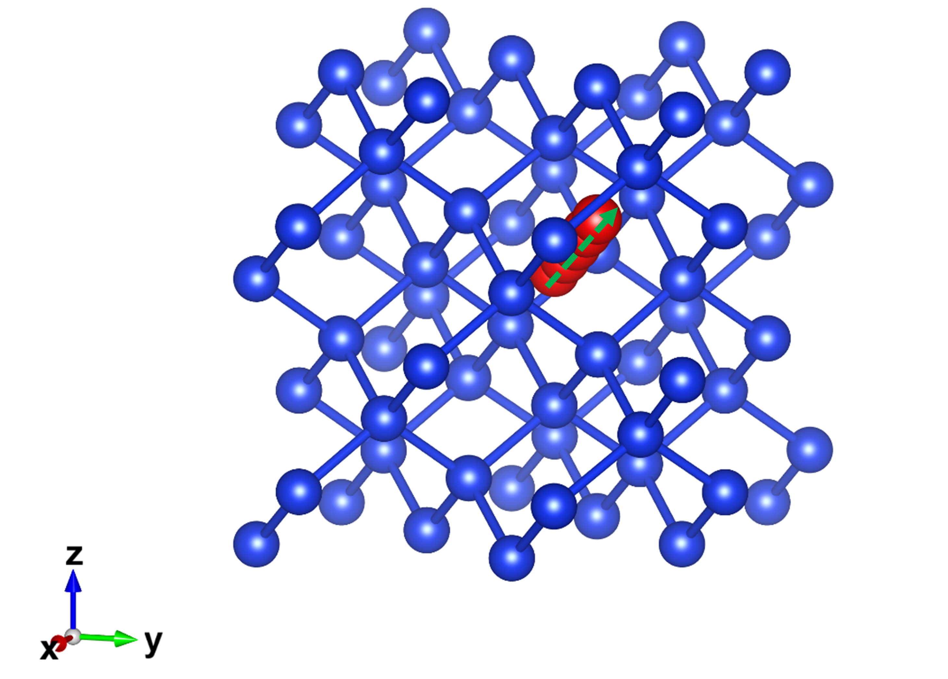
Fig. S5. The diffusion path of Cu_{i} from a tetragonal interstitial site and an equivalent site (denoted by the green arrow). Si atoms are represented in blue, while Cu atoms are depicted in red.
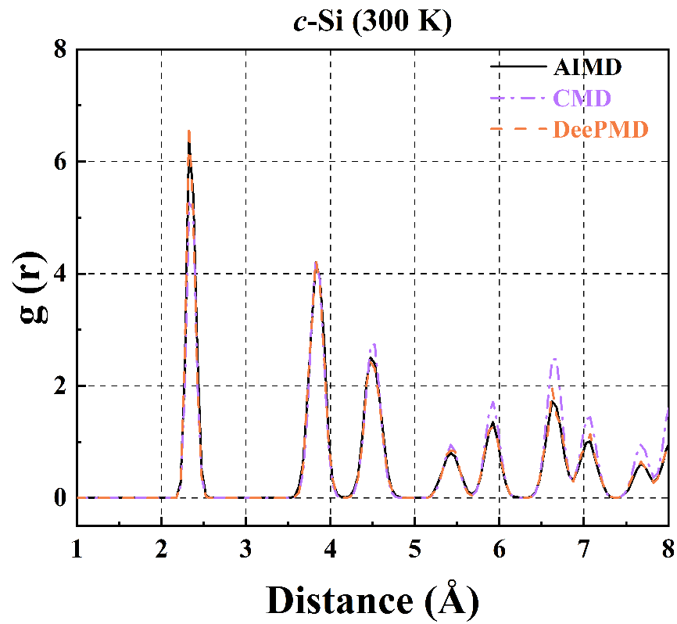
Fig. S6. Structural and migration properties relevant to copper diffusion in silicon. Radial distribution functions (RDFs) for crystalline silicon (c-Si).
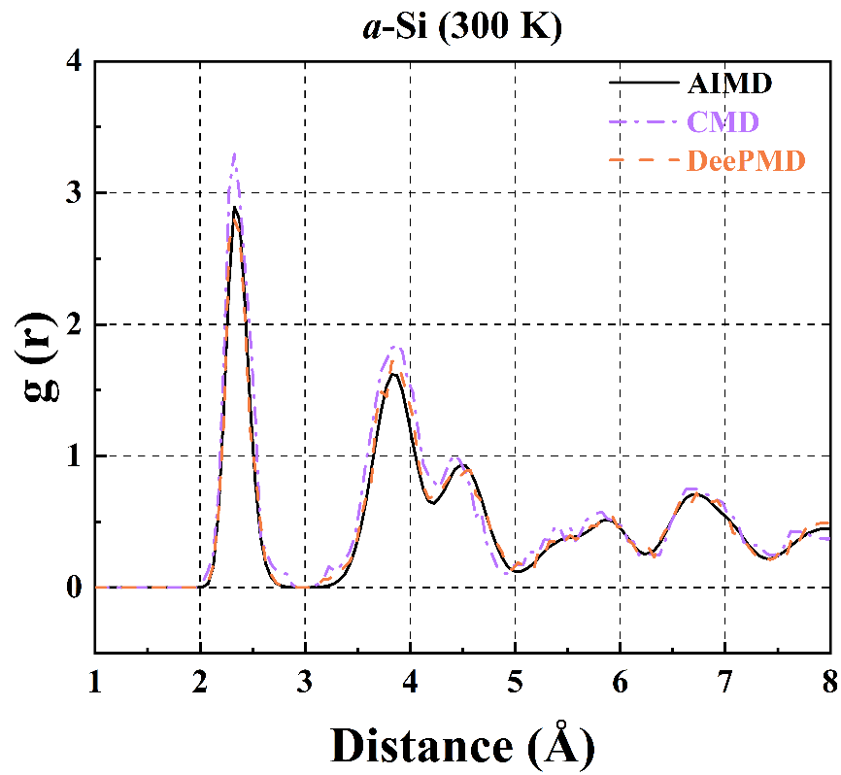
Fig. S7. Structural and migration properties relevant to copper diffusion in silicon. Radial distribution functions (RDFs) for amorphous silicon (a-Si).

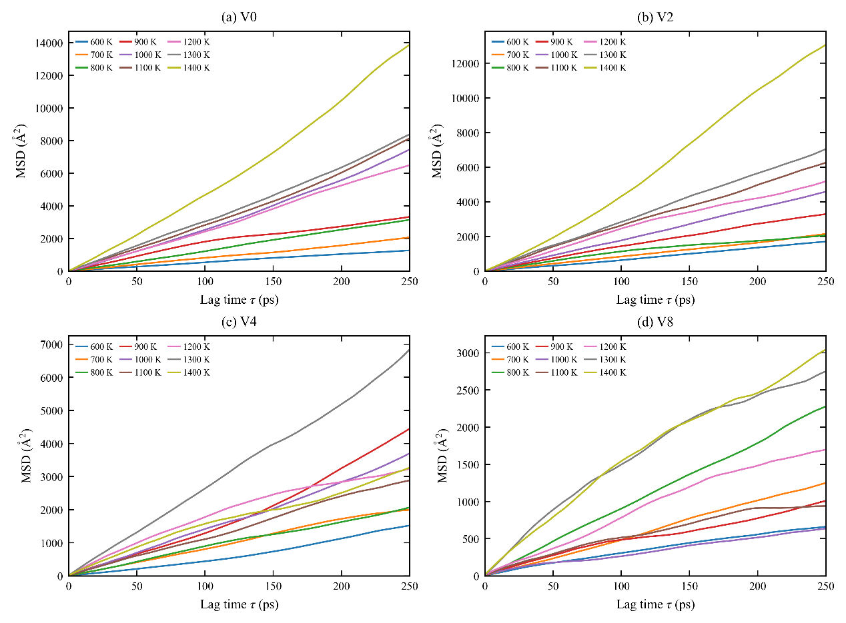
Fig. S8. Vacancy-dependent Cu diffusion in crystalline Si from DPMD simulations. a–d, Cu mean-squared displacements for V0, V2, V4 and V8 at 600–1400 K.
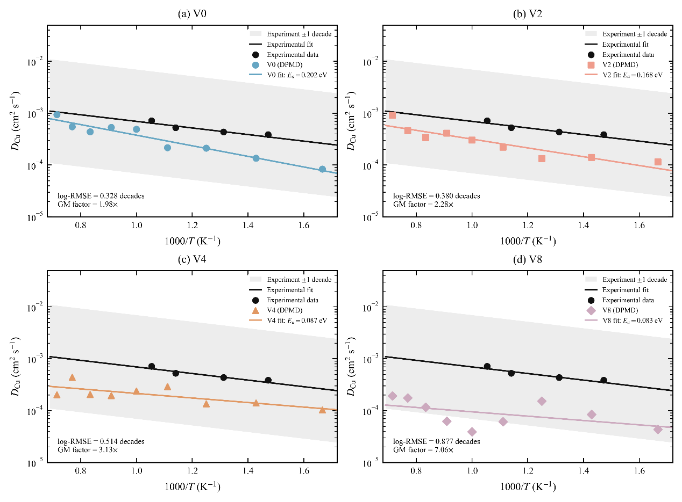
Fig. S9. Vacancy-dependent Cu diffusion in crystalline Si from DPMD simulations. a–d, Corresponding diffusion coefficients compared with the vacancy-free experimental reference; shading denotes a factor-of-ten interval.
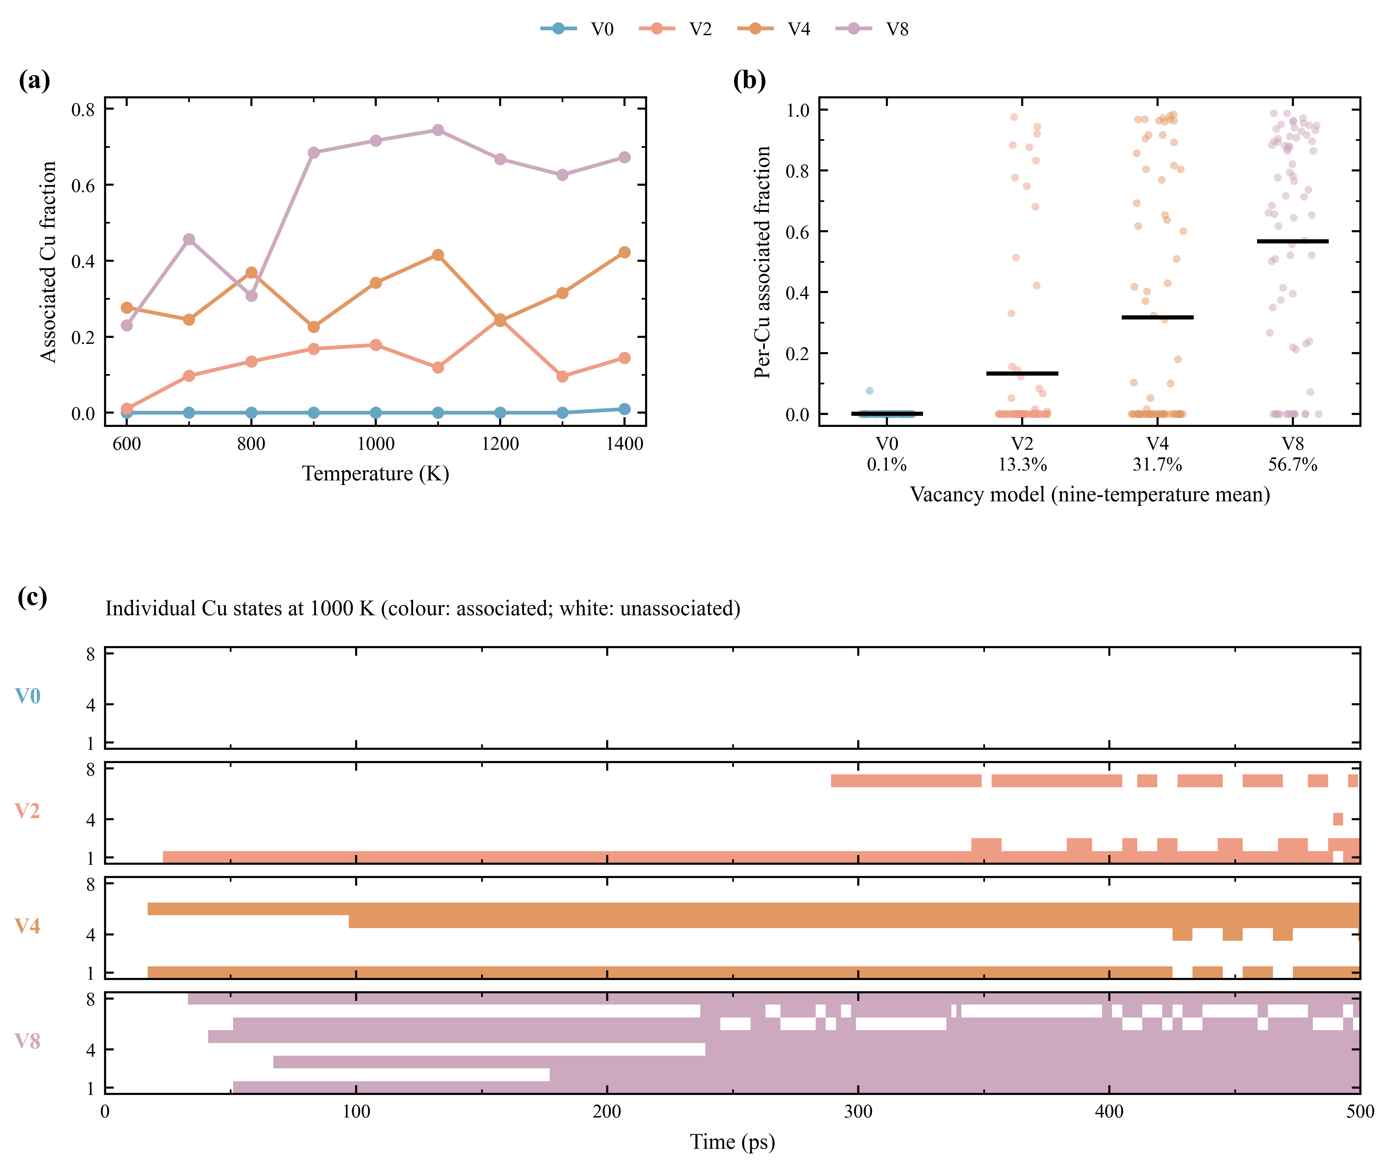
Fig. S10. Structural-state heterogeneity of Cu in vacancy-containing Si. a, Temperature-dependent fraction of Cu observations classified as substitutional-like or vacancy-neighbouring. b, Individual-Cu associated-state fractions for all nine temperatures (72 Cu–temperature observations per model). Black horizontal lines denote model means; percentages beneath the model labels give the corresponding nine-temperature averages. c, Representative state histories of eight Cu atoms at 1000 K. Coloured intervals indicate structurally associated states; white intervals were not classified as associated. Assignment used distance cutoffs of 1.47 Å for substitutional-like sites and 2.82 Å for vacancy-neighbouring sites, followed by a three-frame median filter. The classification does not by itself establish irreversible trapping.
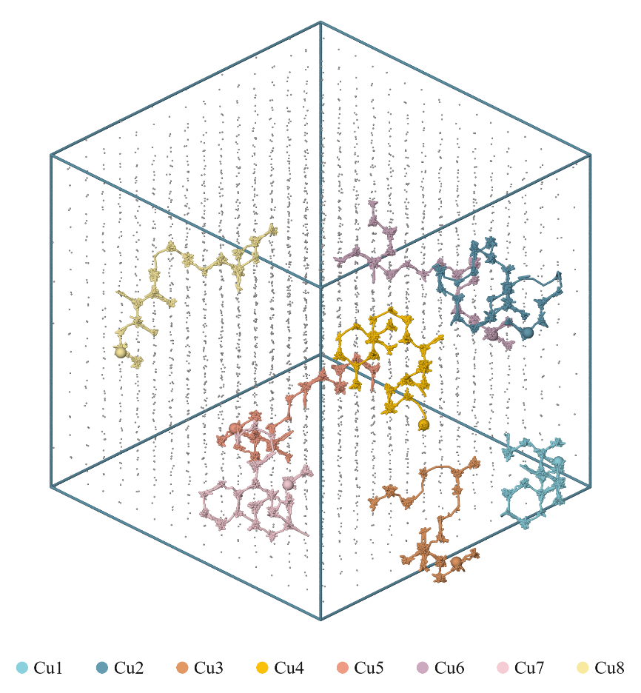
Fig. S10. Temperature- and vacancy-dependent Cu migration trajectories in crystalline Si. (V0 model at 700 K)
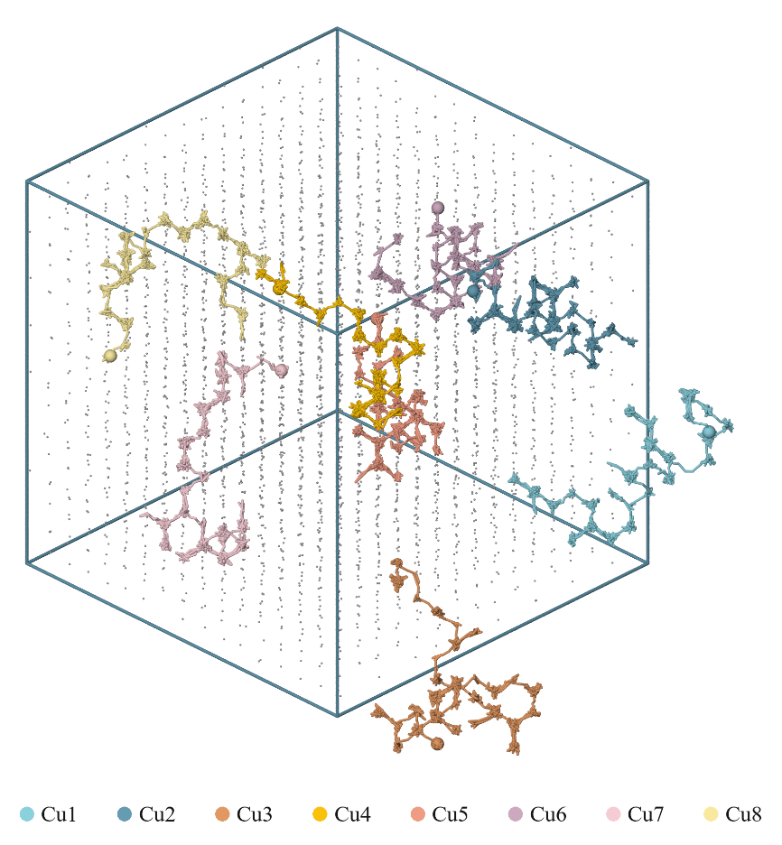
Fig. S11. Temperature- and vacancy-dependent Cu migration trajectories in crystalline Si. (V0 model at 800 K)
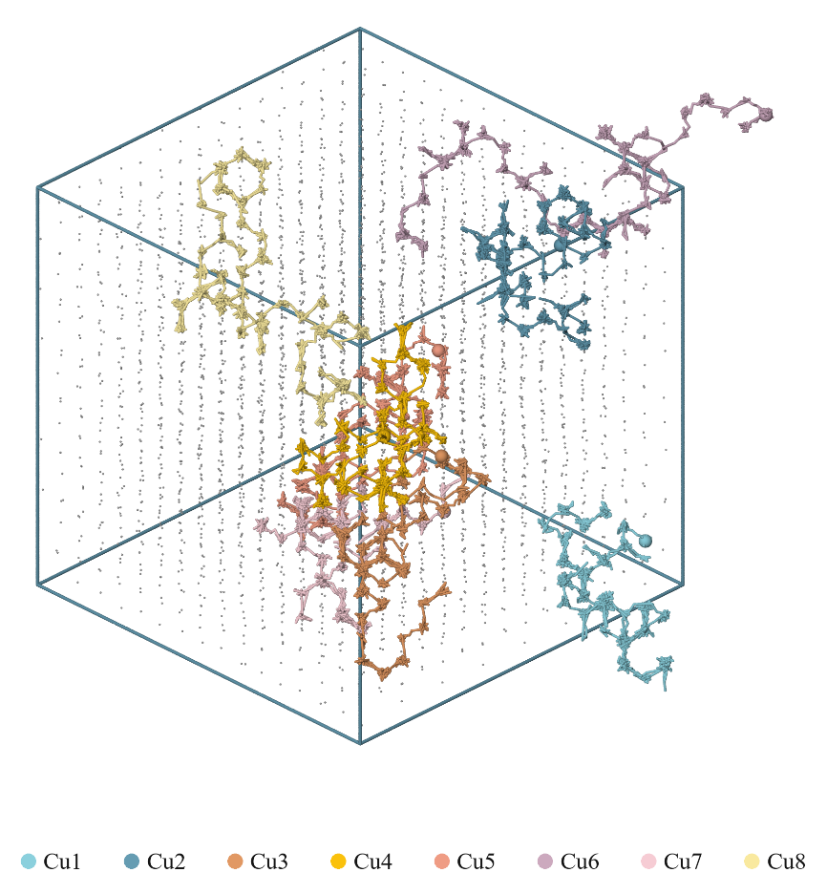
Fig. S12. Temperature- and vacancy-dependent Cu migration trajectories in crystalline Si. (V0 model at 900 K)
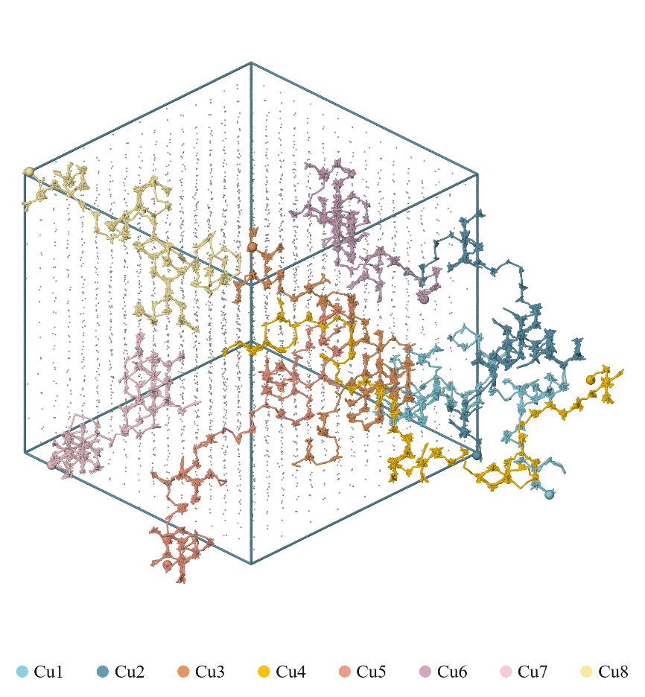
Fig. S13. Temperature- and vacancy-dependent Cu migration trajectories in crystalline Si. (V0 model at 1100 K)
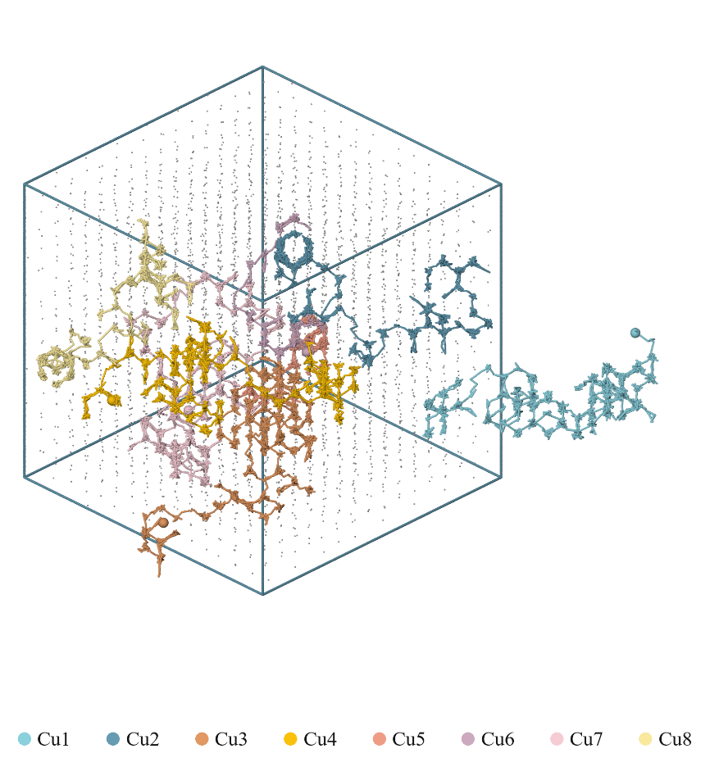
Fig. S14. Temperature- and vacancy-dependent Cu migration trajectories in crystalline Si. (V0 model at 1200 K)
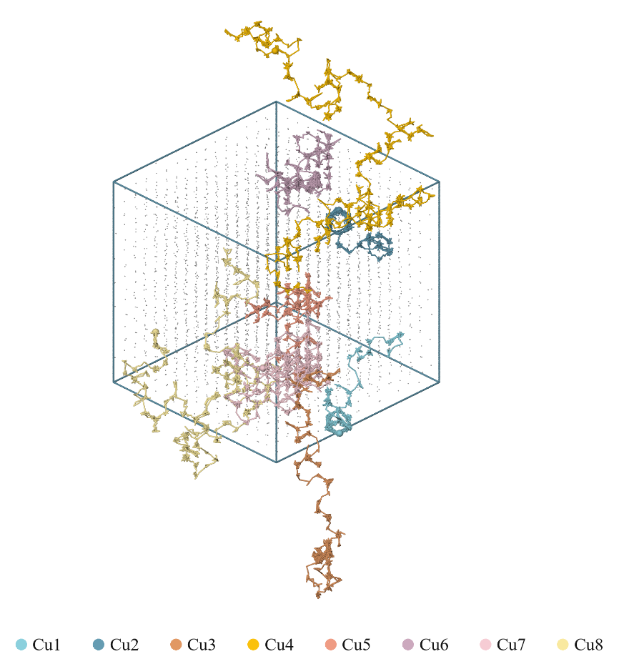
Fig. S15. Temperature- and vacancy-dependent Cu migration trajectories in crystalline Si. (V0 model at 1300 K)
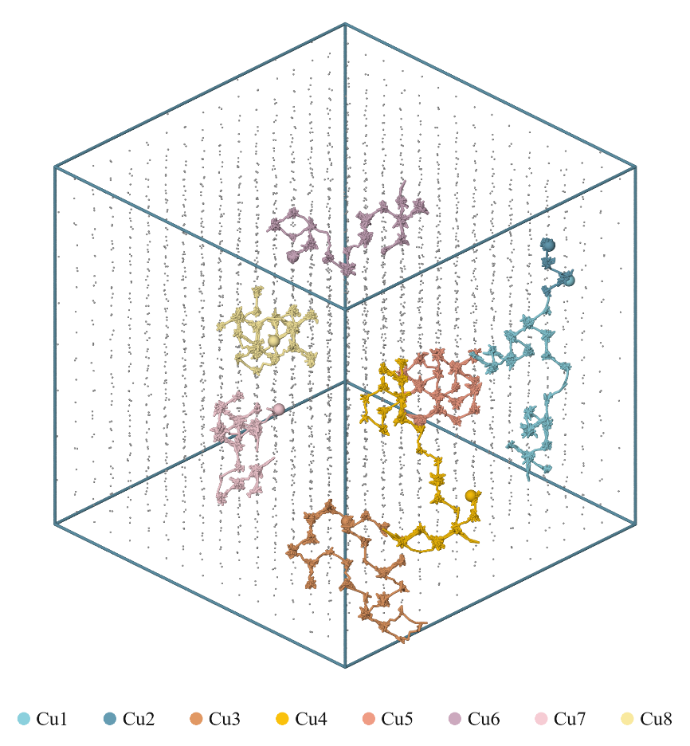
Fig. S16. Temperature- and vacancy-dependent Cu migration trajectories in crystalline Si. (V2 model at 700 K)
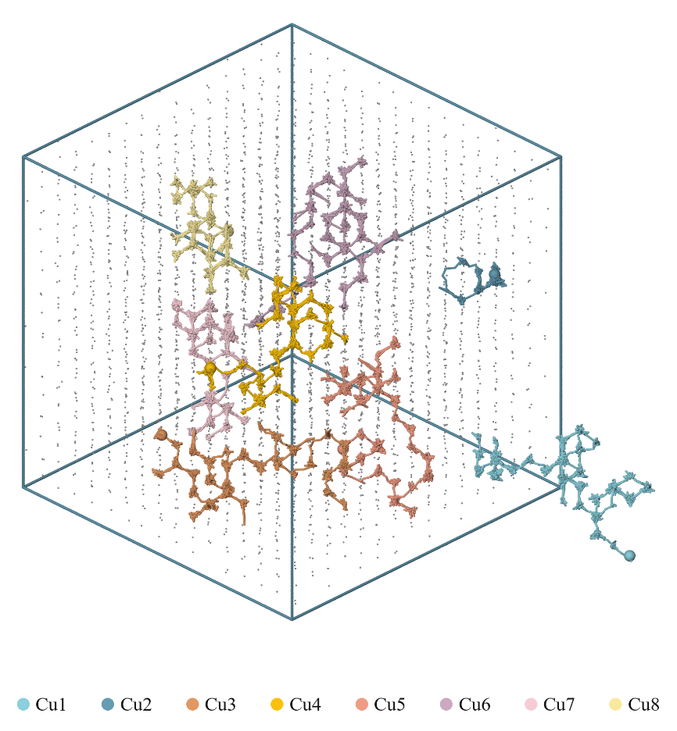
Fig. S17. Temperature- and vacancy-dependent Cu migration trajectories in crystalline Si. (V2 model at 800 K)
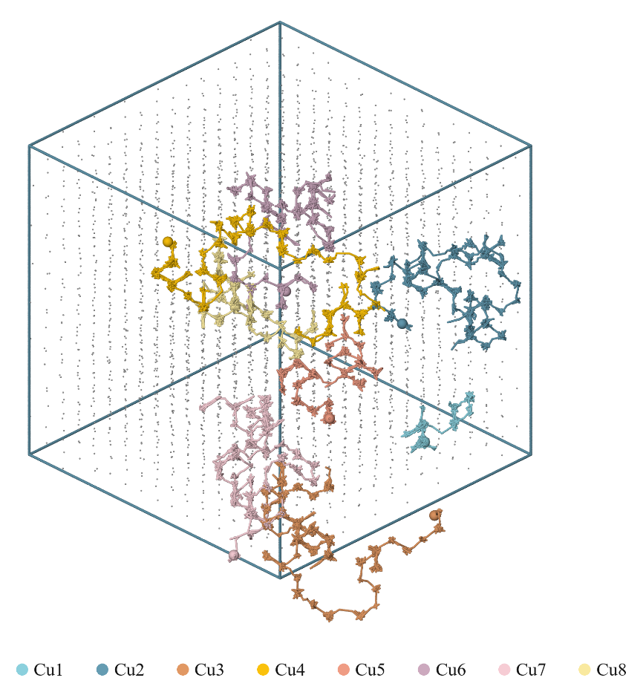
Fig. S18. Temperature- and vacancy-dependent Cu migration trajectories in crystalline Si. (V2 model at 900 K)
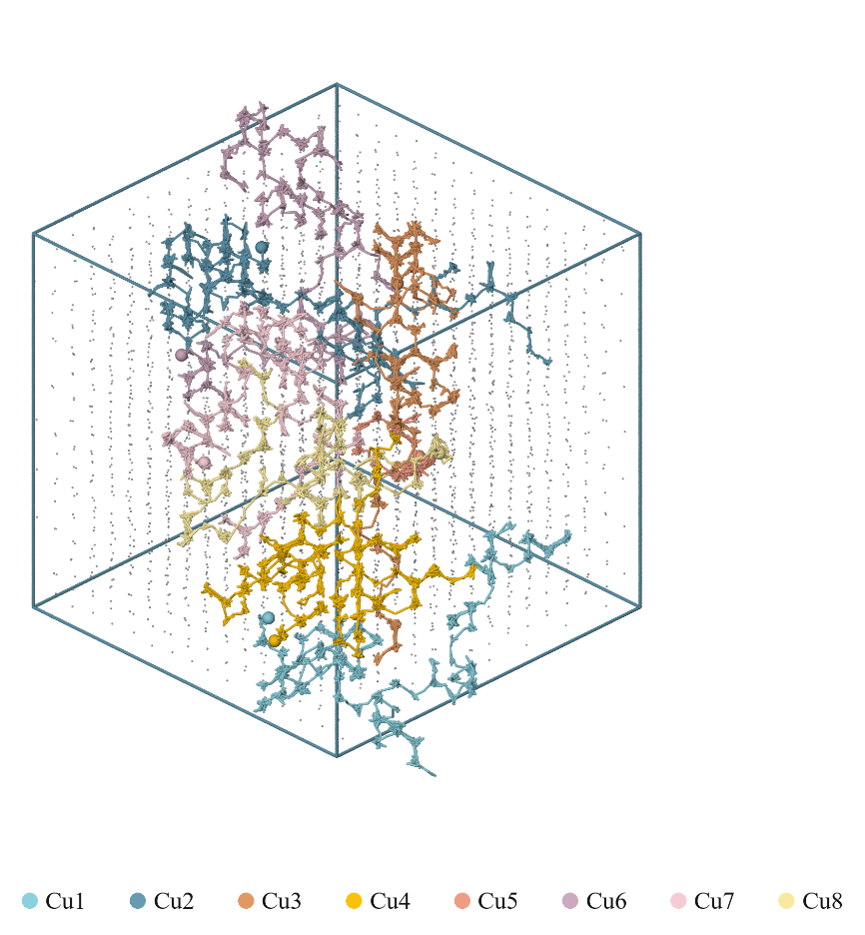
Fig. S19. Temperature- and vacancy-dependent Cu migration trajectories in crystalline Si. (V2 model at 1100 K)
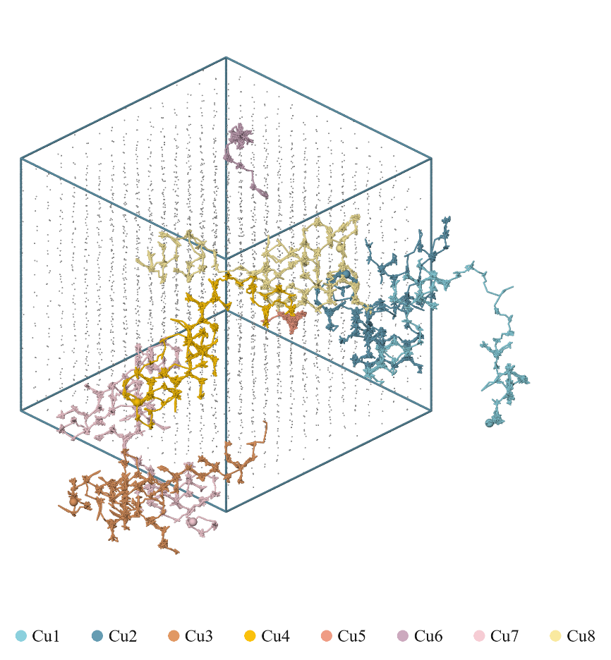
Fig. S20. Temperature- and vacancy-dependent Cu migration trajectories in crystalline Si. (V2 model at 1200 K)
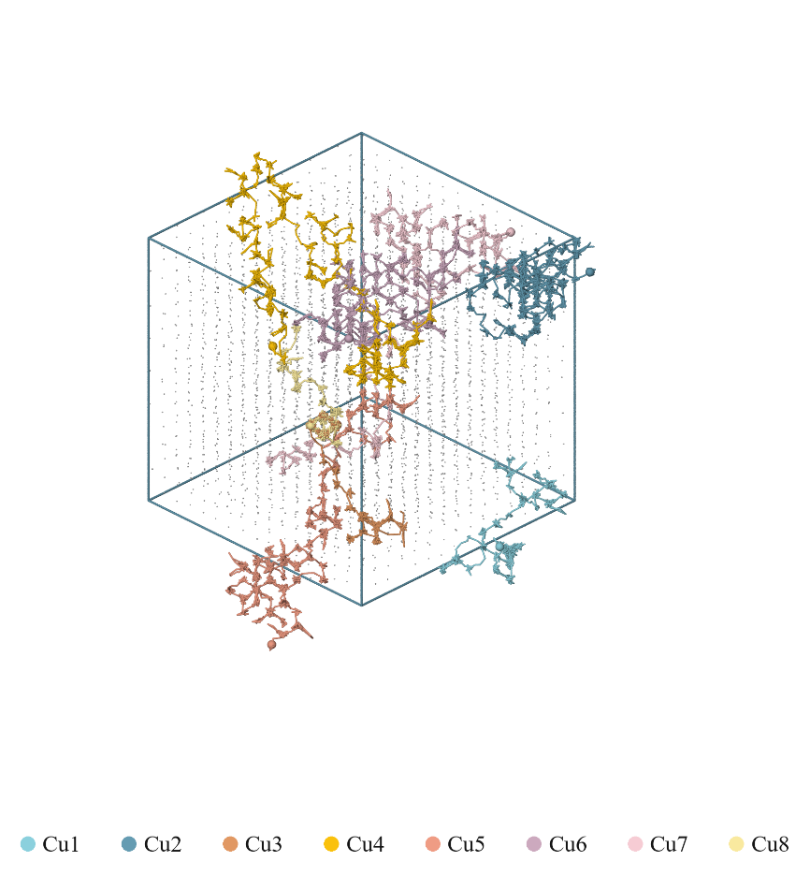
Fig. S21. Temperature- and vacancy-dependent Cu migration trajectories in crystalline Si. (V2 model at 1300 K)
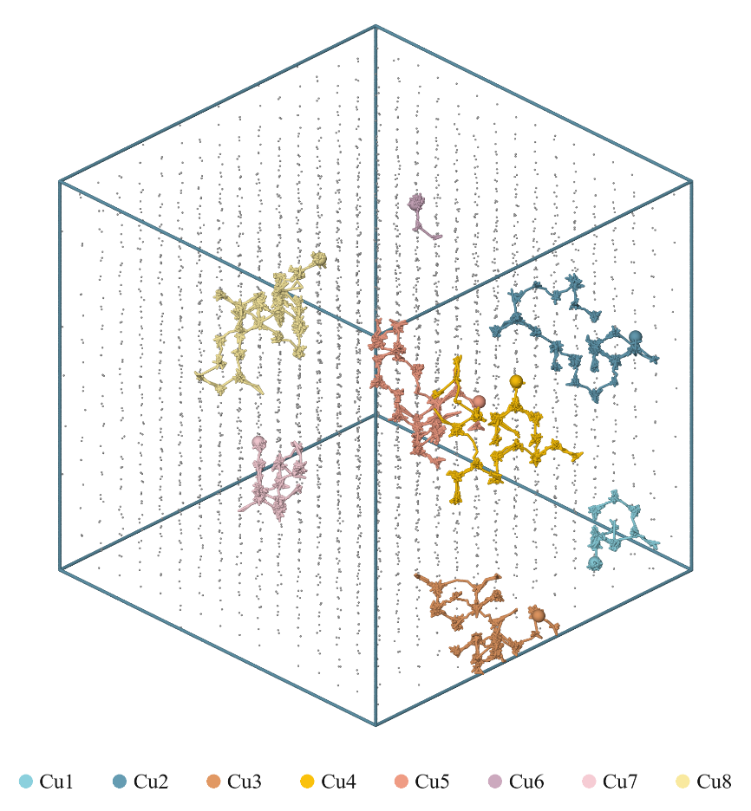
Fig. S22. Temperature- and vacancy-dependent Cu migration trajectories in crystalline Si. (V4 model at 700 K)
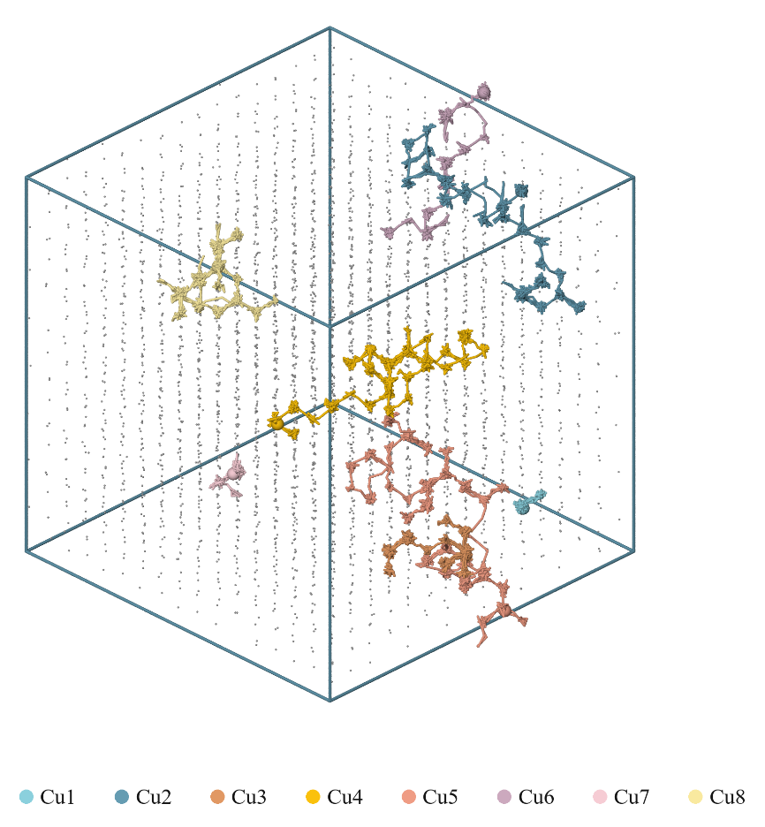
Fig. S23. Temperature- and vacancy-dependent Cu migration trajectories in crystalline Si. (V4 model at 800 K)
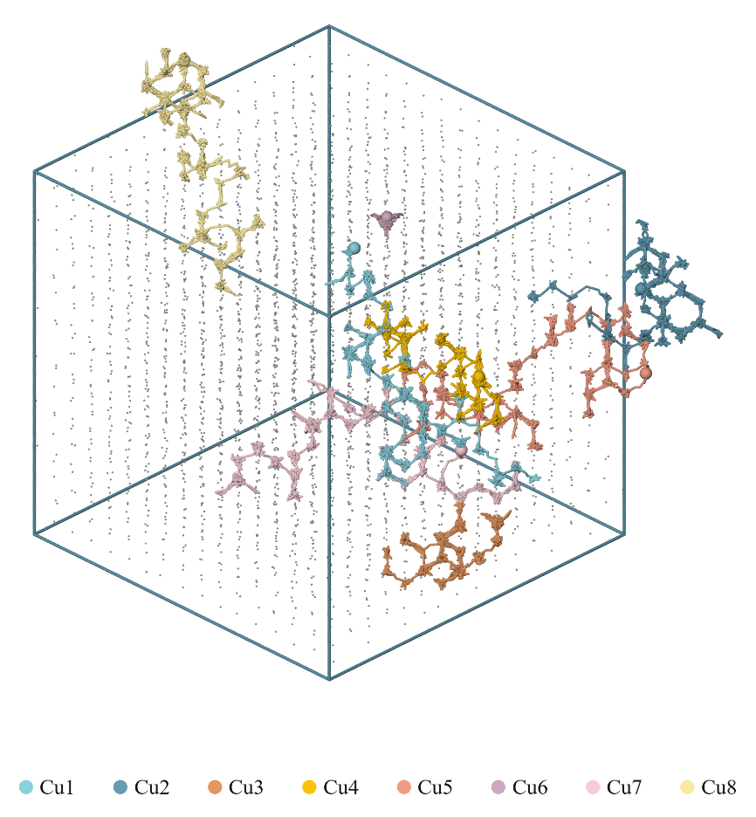
Fig. S24. Temperature- and vacancy-dependent Cu migration trajectories in crystalline Si. (V4 model at 900 K)
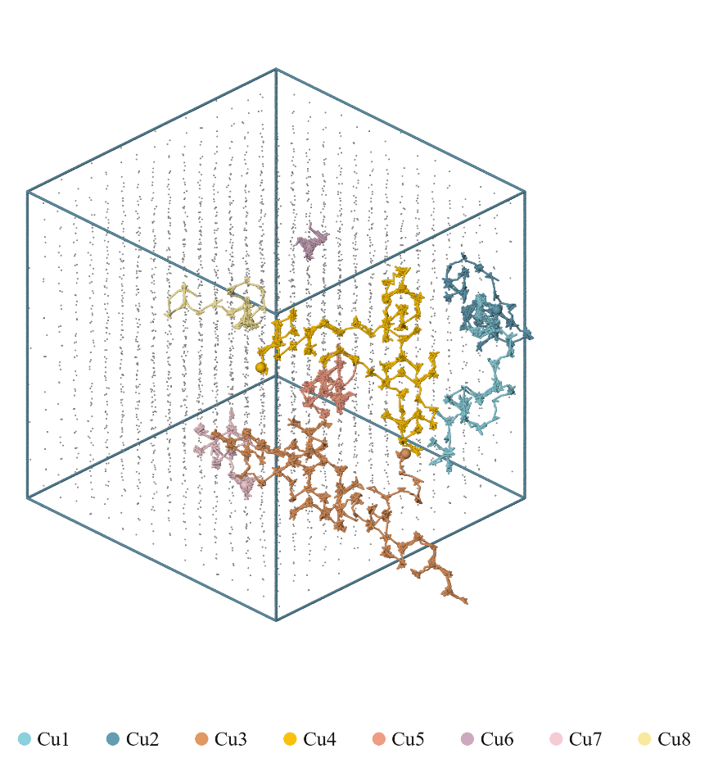
Fig. S25. Temperature- and vacancy-dependent Cu migration trajectories in crystalline Si. (V4 model at 1100 K)
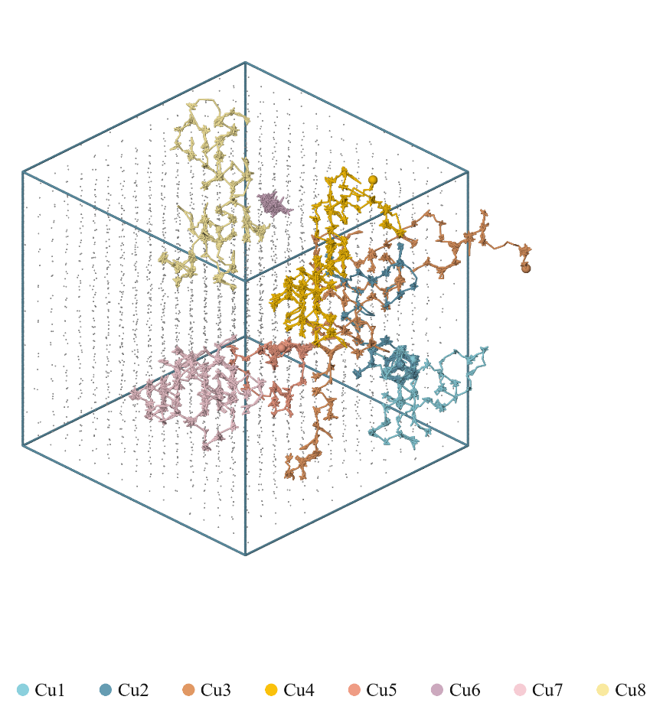
Fig. S26. Temperature- and vacancy-dependent Cu migration trajectories in crystalline Si. (V4 model at 1200 K)
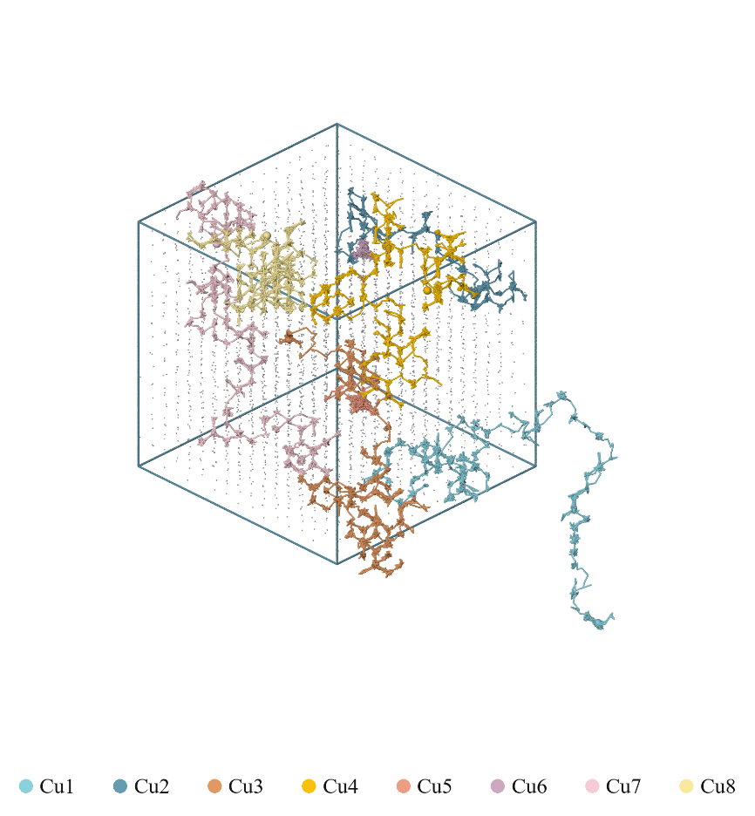
Fig. S27. Temperature- and vacancy-dependent Cu migration trajectories in crystalline Si. (V4 model at 1300 K)
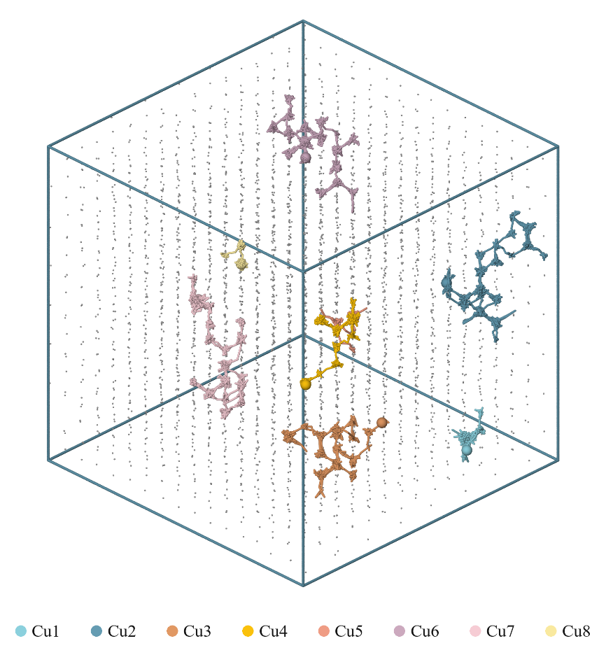
Fig. S28. Temperature- and vacancy-dependent Cu migration trajectories in crystalline Si. (V8 model at 700 K)
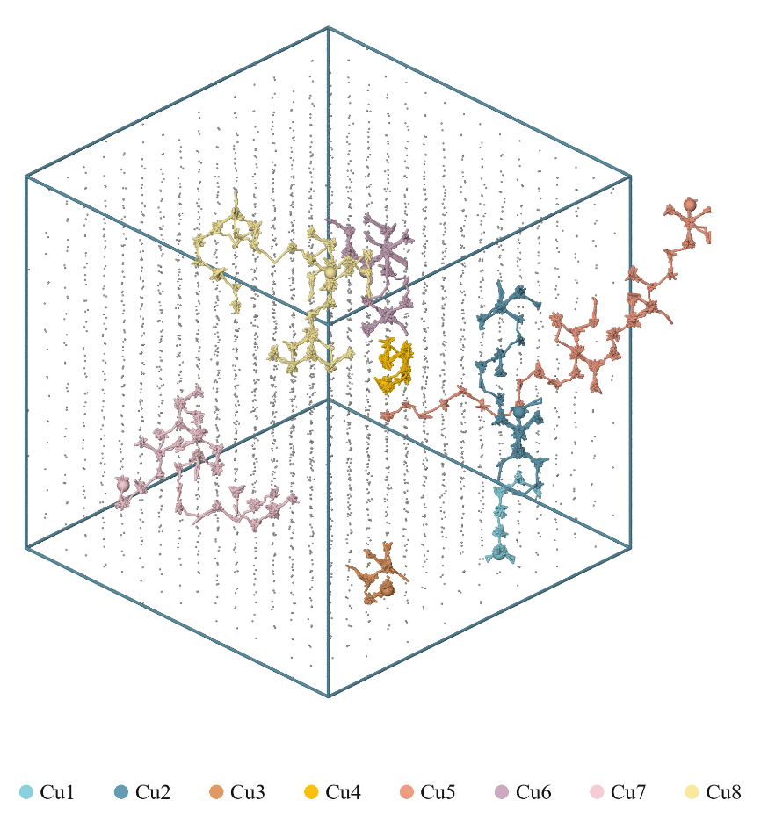
Fig. S29. Temperature- and vacancy-dependent Cu migration trajectories in crystalline Si. (V8 model at 800 K)
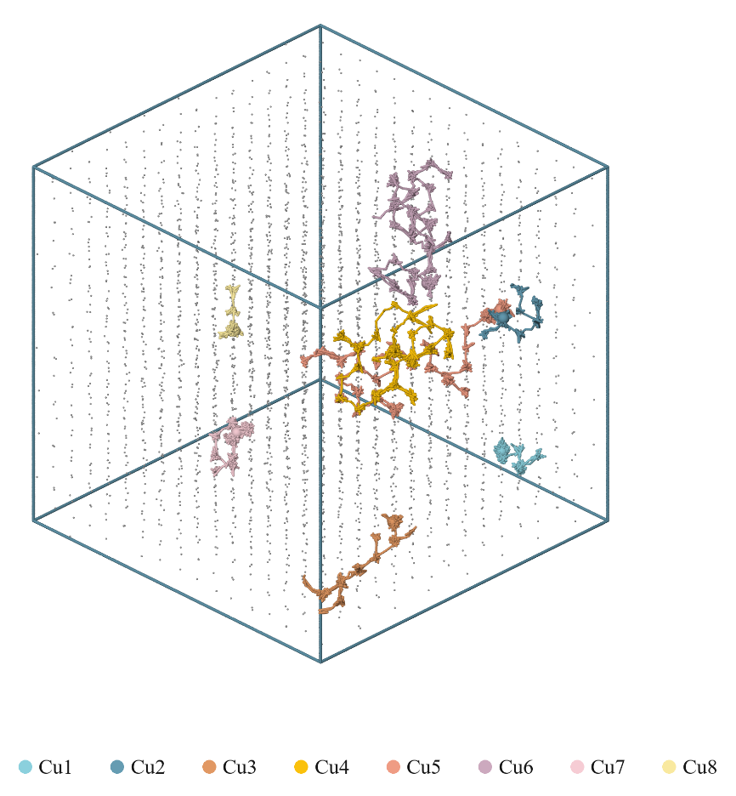
Fig. S30. Temperature- and vacancy-dependent Cu migration trajectories in crystalline Si. (V8 model at 900 K)
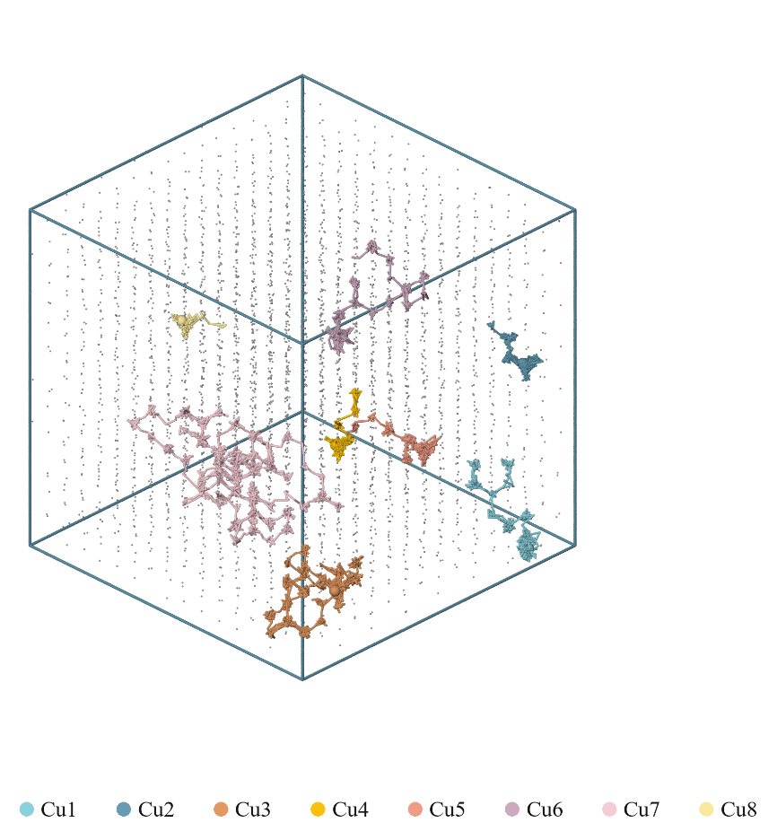
Fig. S31. Temperature- and vacancy-dependent Cu migration trajectories in crystalline Si. (V8 model at 1100 K)
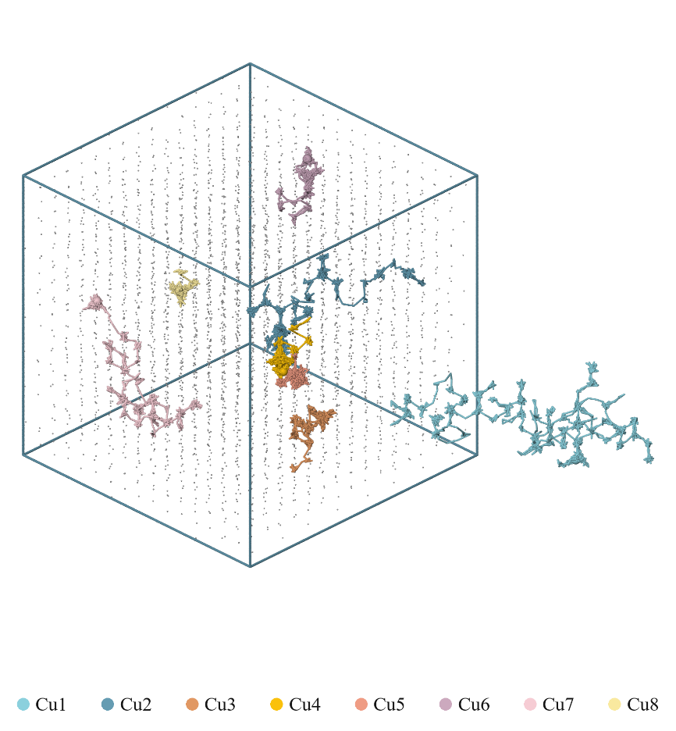
Fig. S32. Temperature- and vacancy-dependent Cu migration trajectories in crystalline Si. (V8 model at 1200 K)
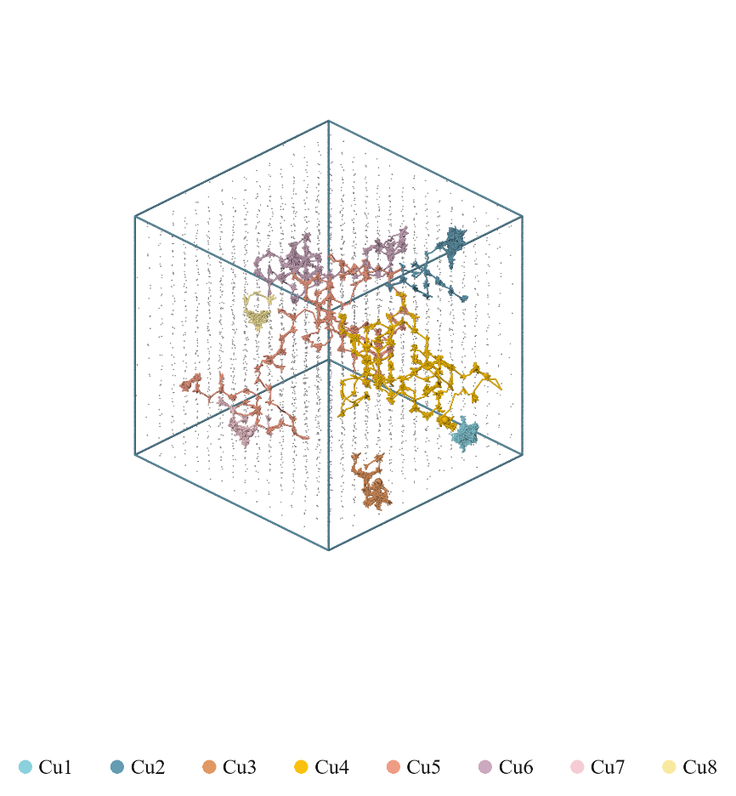
Fig. S33. Temperature- and vacancy-dependent Cu migration trajectories in crystalline Si. (V8 model at 1300 K)

References
1 VandeVondele, J. et al. Quickstep: Fast and accurate density functional calculations using a mixed Gaussian and plane waves approach. Computer Physics Communications 167, 103–128 (2005). https://doi.org/10.1016/j.cpc.2004.12.014
2 Perdew, J. P. B., Kieron; Ernzerhof, Matthias Generalized Gradient Approximation Made Simple. Phys. Rev. Lett 77, 3865–3868 (1996).
3 Zhang, Y. et al. DP-GEN: A concurrent learning platform for the generation of reliable deep learning based potential energy models. Computer Physics Communications 253 (2020). https://doi.org/10.1016/j.cpc.2020.107206
4 Wang, H., Zhang, L., Han, J. & E, W. DeePMD-kit: A deep learning package for many-body potential energy representation and molecular dynamics. Computer Physics Communications 228, 178–184 (2018). https://doi.org/10.1016/j.cpc.2018.03.016
5 Hoover, W. G. J. P. r. A. Canonical dynamics: Equilibrium phase-space distributions. 31, 1695 (1985).
6 Plimpton, S. Fast parallel algorithms for short-range molecular dynamics. 117, 1–19 (1995).
7 Nosé, S. J. T. J. o. c. p. A unified formulation of the constant temperature molecular dynamics methods. 81, 511–519 (1984).
8 DMol is a trademark of Bio Sym. Inc., San Diego, California. USA.
9 Chen, J. et al. Improving the accuracy of ion implantation simulations through the use of DFT-MD methodology. Physica B: Condensed Matter 675, 415616 (2024).
10 Zinoviev, A. N. & Nordlund, K. Comparison of repulsive interatomic potentials calculated with an all-electron DFT approach with experimental data. Nuclear Instruments and Methods in Physics Research Section B: Beam Interactions with Materials and Atoms 406, 511–517 (2017). https://doi.org/10.1016/j.nimb.2017.03.047
11 Tersoff, J. New empirical approach for the structure and energy of covalent systems. Phys Rev B Condens Matter 37, 6991–7000 (1988). https://doi.org/10.1103/physrevb.37.6991
12 Fan, Y. et al. Molecular dynamics simulation of color centers in silicon carbide by helium and dual ion implantation and subsequent annealing. Ceramics International 47, 24534–24544 (2021). https://doi.org/10.1016/j.ceramint.2021.05.172
13 Plimpton, S. Fast parallel algorithms for short-range molecular dynamics. Journal of computational physics 117, 1–19 (1995).
14 Lehtinen, O. et al. Molecular dynamics simulations of shallow nitrogen and silicon implantation into diamond. Physical Review B 93 (2016). https://doi.org/10.1103/PhysRevB.93.035202
15 Chen, J. et al. Application of DP-MD methodology in ion implantation for wide bandgap power semiconductor materials. Surfaces and Interfaces, 106140 (2025).
16 Chen, J. et al. Atomistic simulation of boron implantation and defect-mediated diffusion in silicon via DFT-MD and deep potential molecular dynamics. Physical Chemistry Chemical Physics (2026).
17 Yan, X. et al. Deep learning modeling of oxygen redistribution and thermal transport in silicon on insulator and buried oxide layers. Communications Materials 7, 80 (2026). https://doi.org/10.1038/s43246-026-01130-z

