Supplementary Information

Bioprospecting the Cultivable Bacteria Associated with Trididemnum maragogi from the Saint Peter and Saint Paul’s Archipelago (Brazil) for Bioactive Metabolites

Julia Stutz Fiascaª, Bianca Perez Martins^{e}, Renan Silva Oliveira^{b}, Luís Guilherme Pereira Feitosa^{c}, Gabriel Padilla Maldonado^{e}, Norberto Peporine Lopes^{c}, Tito Monteiro da Cruz Lotufo^{d}, Paula Christine Jimenez^{b}, Letícia Veras Costa-Lotufoª, Bianca Del Bianco Sahm^{a,c,*}

ªInstitute of Biomedical Sciences, Department of Pharmacology, University of São Paulo, São Paulo, SP, 05508-000, Brazil.
^{b}Institute of Marine Sciences, Department of Marine Sciences, Federal University of São Paulo, Santos, SP, 11.070-100, Brazil.
^{c}Faculty of Pharmaceutical Sciences of Ribeirão Preto, Department of Biomolecular Sciences, University of São Paulo, Ribeirão Preto, SP 14040-903, Brazil.
^{d}Oceanographic Institute, Department of Biological Oceanography, University of São Paulo, São Paulo, SP, 05508-120, Brazil.
^{e}Institute of Biomedical Sciences, Department of Microbiology, University of São Paulo, São Paulo, SP, 05508-000, Brazil.

Table S1. Cultured bacteria isolated from the ascidian Trididemnum maragogi, collected in the São Pedro and São Paulo Archipelago, Brazil. The table includes the isolation culture medium, molecular identification based on 16S rRNA gene sequencing, the closest reference type strain, percentage sequence similarity with the type strain (GenBank, NCBI database), length of the obtained sequence, and the GenBank (NCBI) accession number (#).
Strain | Original media isolation | Most similar species | Type strain | Similarity | Sequence length | Accession #
BRB-738 | A1 | Sporosarcina gallistercoris | JQ794609.1 | 89.45% | 1363 | PZ448937
BRB-743 | A1 | Bacillus pumilus | PP488496.1 | 99.12% | 1383 | PZ448938
BRB-755 | A1 | Bacillus cereus | KY312751.1 | 99.64% | 1398 | PZ448939
BRB-756 | TMA | Paenibacillus taichungensis | MG452781.1 | 99.28% | 1394 | PZ448940
BRB-757 | TMA | Bacillus pumilus | MK358921.1 | 98.76% | 1380 | PZ448941
BRB-765 | A1 | not identified | - | - | - | -
BRB-777 | SWA | Ochrobactrum sp. | MW409884.1 | 96.84% | 1366 | PZ448942
BRB-783 | SCA | not identified | - | - | - | -
BRB-784 | A1 | Paenibacillus campinasensis | MK737372.1 | 96.56% | 1284 | PZ448943
BRB-785 | SCA | Micromonospora sp. | FN658637.1 | 98.81% | 677 | PZ448944
BRB-786 | TMA | Bacillus subtilis | KT986093.1 | 96.61% | 1410 | PZ448945
BRB-787 | SCA | Tsukamurella sputi | OR262597.1 | 96.66% | 1365 | PZ448946
BRB-788 | SCA | Bacillus sp. | KJ394449.1 | 99.60% | 744 | PZ448947
BRB-789 | A1 | Bacillus subtilis | KM983016.1 | 95.46% | 1140 | -*
BRB-790 | TMA | Brucella anthropi | MF356870.1 | 94.15% | 1139 | -*
BRB-797 | SWA | Rhodococcus sp. | DQ227674.1 | 99.31% | 721 | PZ448948
BRB-803 | SWA | Salinispora arenicola | JX007950.1 | 96.36% | 1365 | PZ448949
BRB-804 | SCA | Microbacterium sp. | KR906309.1 | 92.61% | 1279 | PZ448950
BRB-805 | SCA | Micromonospora sp. | GU397370.1 | 97.23% | 1334 | PZ448951
BRB-808 | SCA | Salinispora sp. | OP028107.1 | 97.98% | 1330 | PZ448952
BRB-809 | TMA | Streptomyces sp. | EU214921.1 | 99.85% | 668 | PZ448953
BRB-810 | SWA | Micromonospora aurantiaca | MH588238.1 | 98.16% | 768 | PZ448954
BRB-811 | A1 | not identified | - | - | - | -
BRB-812 | SCA | not identified | - | - | - | -
BRB-813 | SCA | Micromonospora sp. | MG917693.1 | 99.68% | 1241 | PZ448955
BRB-814 | SWA | Micromonospora aurantiaca | AJ245712.1 | 98.60% | 710 | PZ448956
BRB-815 | SCA | Serratia marcescens | PP577657.1 | 97.27% | 1379 | PZ448957
BRB-816 | A1 | Bacillus altitudinis | KP742971.1 | 97.10% | 1399 | PZ448958
BRB-817 | SCA | Bacillus sp. | KJ733940.1 | 94.93% | 1411 | PZ448959
BRB-818 | A1 | Bacillus sp. | KM521213.1 | 89.08% | 1358 | PZ448960
BRB-819 | A1 | Bacillus altitudinis | KY819009.1 | 98.64% | 1397 | PZ448961
BRB-820 | A1 | Bacillus pumilus | KF591118.1 | 95.77% | 1373 | PZ448962
BRB-821 | A1 | Bacillus sp. | JF900600.1 | 88.83% | 1413 | -*
BRB-822 | A1 | Ochrobactrum sp. | MF347451.1 | 89.28% | 1287 | PZ448963
BRB-823 | A1 | Serratia marcescens | KX343948.1 | 98.02% | 1304 | PZ448964
BRB-824 | SCA | Ochrobactrum sp. | MF347451.1 | 98.83% | 1282 | PZ448965
BRB-825 | A1 | Serratia marcescens | EF102860.1 | 94.72% | 1041 | -*
BRB-826 | A1 | Microbacterium sp. | KR906309.1 | 94.59% | 1203 | PZ448966
BRB-827 | A1 | Streptomyces sp. | OQ421909.1 | 95.49% | 1311 | PZ448967
BRB-828 | A1 | Microbacterium resistens | KJ575058.1 | 94.59% | 1365 | PZ448968
BRB-829 | A1 | Micromonospora humi | OK047717.1 | 98.93% | 745 | PZ448969
BRB-830 | TMA | not identified | - | - | - | -
BRB-831 | SCA | Micromonospora sp. | MF188121.1 | 96.10% | 953 | PZ448970
BRB-832 | SWA | Micromonospora sp. | MG917693.1 | 98.48% | 1312 | PZ448971
BRB-833 | SCA | Bacillus safensis | KT380676.1 | 97.25% | 1404 | PZ448972
BRB-834 | SWA | Ochrobactrum intermedium | AB840683.1 | 99.30% | 710 | PZ448973
BRB-835 | SWA | Micromonospora aurantiaca | OL414803.1 | 97.57% | 1307 | PZ448974
BRB-836 | SWA | Micromonospora aurantiaca | MG917693.1 | 98.24% | 1359 | PZ448975
BRB-837 | SCA | Micromonospora aurantiaca | MG917693.1 | 96.94% | 1262 | PZ448976
BRB-838 | SWA | Micromonospora aurantiaca | MG917693.1 | 97.88% | 1310 | PZ448977
* - Sequences not accepted at GenBank (NCBI) due low quality/similarity
Table S2. Cell growth inhibition (%) of bacterial extracts tested at 50 and 5 µg/mL against the 501mel and HCT-116 cell lines, determined by the MTT assay after 72 h of incubation. Values represent the mean ± standard deviation (SD) of three independent experiments (n = 3) performed in duplicate. Statistical analyses were conducted using GraphPad Prism v.10.0.
Strain | 501mel |  |  |  | HCT-116
 | 5µg/mL | SD | 50µg/mL | SD | 5µg/mL | SD | 50µg/mL | SD
BRB-738 | 20.44 | 11.31 | 48.58 | 13.71 | 40.17 | 6.43 | 76.61 | 11.93
BRB-743 | 16.71 | 4.99 | 24.39 | 3.30 | 21.37 | 8.93 | 37.35 | 5.94
BRB-755 | 18.57 | 10.01 | 26.19 | 6.75 | 23.08 | 8.37 | 36.76 | 12.76
BRB-756 | 18.50 | 7.65 | 21.79 | 9.24 | 16.87 | 9.38 | 31.54 | 10.44
BRB-757 | 17.42 | 8.97 | 20.05 | 6.68 | 16.20 | 8.71 | 23.42 | 8.76
BRB-765 | 32.47 | 8.97 | 42.00 | 7.78 | 19.39 | 8.36 | 34.72 | 14.64
BRB-777 | 17.84 | 10.75 | 14.48 | 28.77 | 2.08 | 15.99 | 21.49 | 18.12
BRB-783 | 9.97 | 16.71 | 21.04 | 15.49 | 28.79 | 6.00 | 25.58 | 21.92
BRB-784 | 9.00 | 17.40 | 33.91 | 12.75 | 41.64 | 5.95 | 48.74 | 7.24
BRB-785 | 3.97 | 17.97 | 9.30 | 11.51 | 19.66 | 7.32 | 25.47 | 7.90
BRB-786 | -0.38 | 27.71 | 0.94 | 19.56 | 20.99 | 12.81 | 26.76 | 6.20
BRB-787 | -7.34 | 17.71 | -3.84 | 14.08 | 20.58 | 7.08 | 25.30 | 8.19
BRB-788 | 19.57 | 6.93 | 22.45 | 7.45 | 19.54 | 11.26 | 23.48 | 12.01
BRB-789 | 34.85 | 2.81 | 80.63 | 8.75 | 21.65 | 13.06 | 65.72 | 12.42
BRB-790 | 17.18 | 14.46 | 21.22 | 15.34 | 9.73 | 18.22 | 12.34 | 18.30
BRB-797 | 11.87 | 11.99 | 31.74 | 18.90 | 17.71 | 30.44 | 59.91 | 30.29
BRB-803 | 16.70 | 20.71 | 60.58 | 6.15 | 46.75 | 9.54 | 86.13 | 8.91
BRB-803(SWB) | 22.81 | 12.09 | 69.05 | 13.17 | 57.86 | 8.37 | 86.80 | 9.63
BRB-804 | 32.87 | 5.50 | 37.46 | 7.86 | 35.33 | 16.00 | 39.86 | 14.18
BRB-805 | 16.77 | 16.02 | 43.10 | 5.87 | 19.65 | 7.76 | 28.15 | 12.77
BRB-808 | 29.98 | 22.13 | 73.12 | 11.85 | 23.70 | 23.85 | 71.23 | 10.84
BRB-809 | 25.95 | 9.04 | 40.98 | 6.82 | 32.60 | 8.14 | 47.22 | 9.83
BRB-810 | 35.02 | 16.51 | 99.83 | 3.08 | 54.64 | 18.05 | 99.38 | 2.17
BRB-811 | 25.55 | 11.77 | 31.03 | 4.65 | 32.55 | 12.73 | 42.83 | 6.86
BRB-812 | 5.60 | 20.58 | 17.67 | 12.60 | 19.38 | 13.33 | 24.12 | 8.30
BRB-813 | 20.10 | 28.82 | 31.10 | 26.13 | 36.80 | 9.45 | 57.70 | 6.21
BRB-814 | 42.68 | 4.26 | 96.04 | 10.31 | 58.87 | 4.91 | 101.11 | 2.35
BRB-815 | 21.43 | 11.55 | 33.15 | 10.83 | 19.37 | 13.64 | 24.00 | 15.41
BRB-816 | 23.65 | 20.00 | 15.21 | 17.92 | 15.55 | 14.61 | 17.82 | 20.80
BRB-817 | 31.38 | 7.02 | 34.65 | 5.65 | 32.21 | 12.04 | 31.06 | 11.85
BRB-818 | 21.82 | 11.46 | 22.80 | 16.51 | 33.83 | 5.42 | 32.78 | 9.11
BRB-819 | 19.95 | 9.86 | 25.67 | 11.91 | 37.18 | 7.96 | 35.63 | 8.18
BRB-820 | 8.86 | 12.24 | 11.20 | 17.26 | 21.73 | 8.17 | 21.40 | 9.36
BRB-821 | 9.27 | 16.52 | 9.22 | 20.13 | 27.09 | 18.92 | 35.42 | 17.34
BRB-822 | 26.37 | 6.86 | 17.02 | 13.82 | 30.87 | 17.59 | 34.58 | 9.31
BRB-823 | 19.26 | 17.51 | 14.06 | 21.32 | 6.99 | 27.82 | 31.23 | 11.81
BRB-824 | -7.01 | 17.13 | 15.63 | 22.16 | 11.18 | 6.54 | 24.99 | 19.57
BRB-825 | 14.69 | 11.09 | 16.43 | 23.65 | 26.47 | 17.23 | 42.49 | 18.75
BRB-826 | 31.52 | 16.26 | 53.73 | 28.34 | 33.01 | 15.33 | 46.95 | 7.09
BRB-827 | 19.70 | 10.60 | 50.92 | 15.91 | 32.61 | 7.09 | 63.22 | 5.01
BRB-828 | 9.55 | 15.61 | 25.76 | 9.03 | 30.36 | 16.77 | 44.15 | 6.69
BRB-829 | 29.18 | 12.28 | 32.54 | 7.33 | 35.24 | 14.96 | 36.67 | 6.93
BRB-830 | 21.16 | 17.67 | 29.03 | 13.33 | 29.61 | 9.87 | 44.79 | 5.52
BRB-831 | 26.99 | 12.64 | 46.72 | 17.42 | 32.05 | 9.85 | 55.43 | 3.80
BRB-832 | 45.79 | 5.65 | 104.07 | 10.88 | 69.23 | 10.13 | 98.32 | 1.72
BRB-833 | 32.53 | 4.93 | 47.39 | 4.92 | 25.57 | 9.06 | 47.85 | 7.90
BRB-834 | 16.77 | 16.44 | 37.86 | 24.41 | 42.89 | 10.13 | 76.47 | 15.50
BRB-835 | 5.40 | 2.47 | 32.15 | 27.10 | 23.12 | 23.89 | 41.74 | 21.66
BRB-836 | 14.51 | 9.77 | 54.04 | 10.74 | 37.80 | 19.53 | 83.85 | 8.44
BRB-837 | 15.99 | 14.89 | 87.95 | 10.58 | 54.24 | 31.21 | 84.62 | 33.26
BRB-838 | 18.12 | 5.59 | 31.67 | 13.14 | 35.00 | 12.23 | 50.26 | 7.56

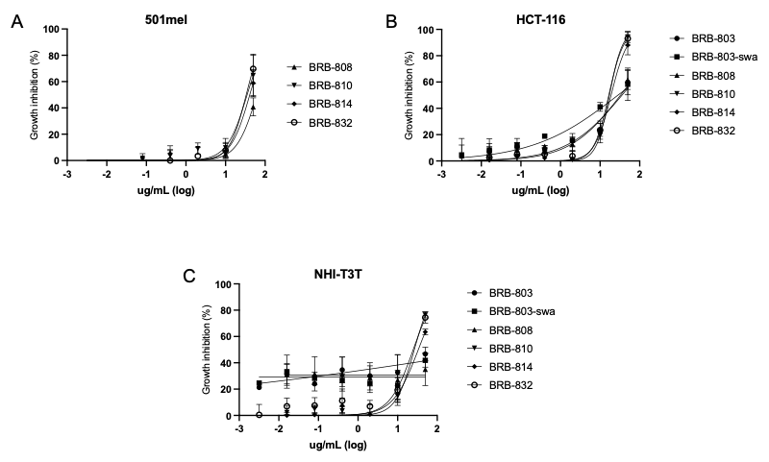
Figure S1. Cytotoxicity profile of bacteria extracts against 501mel (A), HCT-116 (B) and NHI-T3T (C) cell lines after 72 h of incubation assessed by the MTT assay. Data represent the mean and error bars represent ± SD of three independent experiments (n=3), determined by non-linear regression analysis using GraphPad Prism v.10.0.

Table S3. Compounds annotated in the extracts of strains BRB-803, BRB-808, BRB-810, BRB-814, and BRB-832 based on LC-MS/MS data analyzed using the GNPS platform.
ID | RT (min) | m/z  [M+H]⁺ | Compound | Superclass | Class | GNPS Library
1 | 7.07 | 467.2123 | Staurosporine | Tryptophan alkaloids | Carbazole alkaloids | CCMSLIB00000001655
2 | 6.93 | 483.2075 | 7-Hydroxystaurosporine | Tryptophan alkaloids | Carbazole alkaloids | CCMSLIB00000001672
3 | 14.50 | 718.2916 | Rifamycin S | Macrolides | Ansa macrolides | CCMSLIB00000001651
3 | 14.49 | 696.3096* | Rifamycin S | Macrolides | Ansa macrolides | CCMSLIB00000001653
4 | 2.86 | 197.1287 | Cyclo(Val-Pro) | Small peptides | Dipeptides | CCMSLIB00000007148
5 | 4.46 | 245.1293 | Cyclo(Phe-Pro) | Small peptides | Dipeptides | CCMSLIB00000007136
6 | 4.24 | 211.1446 | Cyclo(Pro-Leu) | Small peptides | Dipeptides | CCMSLIB00012440742
7 | 3.94 | 211.1446 | Cyclo(Ile-Pro) | Small peptides | Dipeptides | CCMSLIB00012440376
8 | 5.27 | 164.1070 | N-Phenethylacetamide | Tyrosine alkaloids | Phenylethylamines | CCMSLIB00012440055
9 | 4.04 | 180.1021 | N-Acetyltyramine | Tyrosine alkaloids | Phenylethylamines | CCMSLIB00012352516
10 | 2.02 | 176.0706 | Indole-3-acetic acid | Tryptophan alkaloids | Simple indole alkaloids | CCMSLIB00005883215
11 | 5.74 | 203.1183 | N-Acetyltryptamine | Tryptophan alkaloids | Simple indole alkaloids | CCMSLIB00000851993
12 | 5.47 | 243.0885 | Lumichrome | Pseudoalkaloids | Pteridine alkaloids | CCMSLIB00005883215
*[M+Na]⁺
Phe: phenylalanine; Hyp: hydroxyproline; Val: valine; Pro: proline.

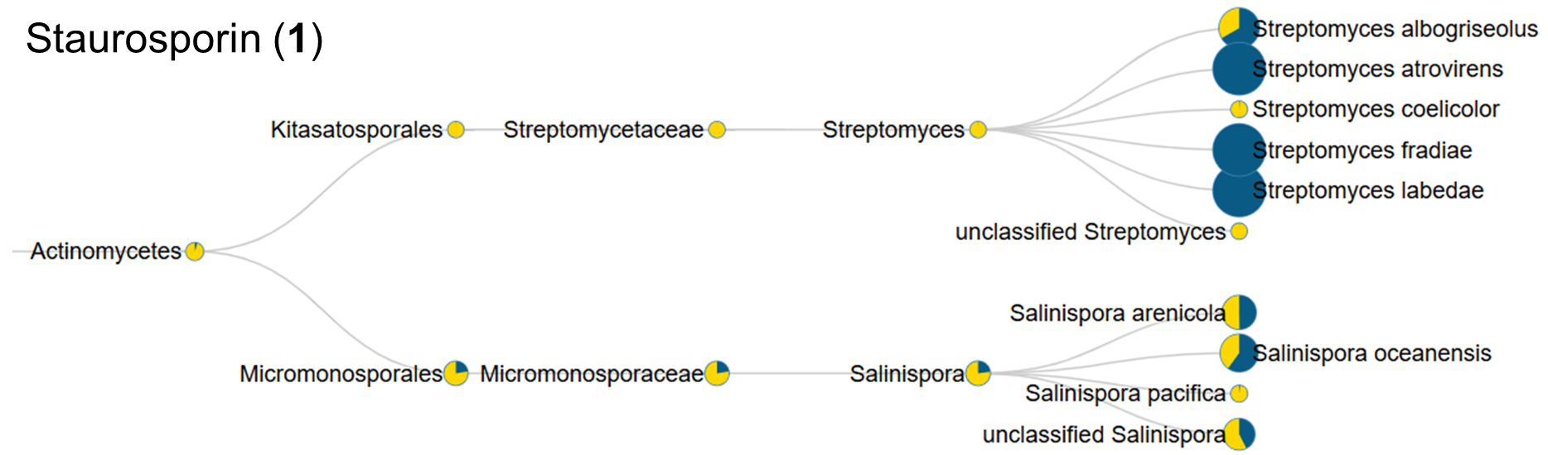
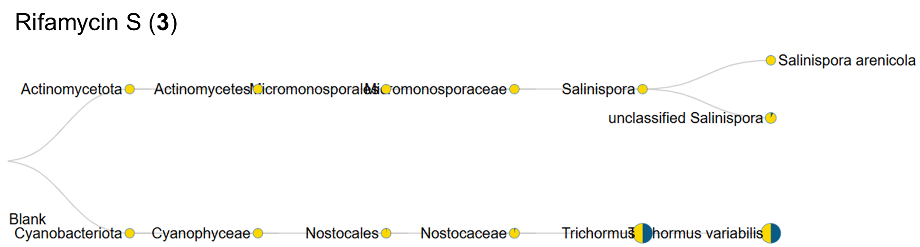

Figure S2. Occurrence of MS/MS spectra of annotated compounds 1, and 3 in taxa of microorganism datasets, using the microbeMASST tool. The yellow color in the taxa nodes corresponds to the available samples in MassIVE repository, while the blue color corresponds to the spectral matching samples. The size of taxa nodes is proportional to the matching rates between samples that presented the researched spectra and samples available in the data repository. Spectrum USI for compounds: (1) mzspec:GNPS2:TASK-d41f9b41b13c45e7881b575a855cda90-nf_output/clustering/spectra_reformatted.mgf:scan:1032 and (3) mzspec:GNPS2:TASK-d41f9b41b13c45e7881b575a855cda90-nf_output/clustering/spectra_reformatted.mgf:scan:1447.

Table S4: Information for strains with dDDH values >70% in relation to BRB 832. Only the values obtained by Formula 2 (recommended) from GGDC are presented.
Query genome | Strain | Genome accession number | dDDH value (%) | Model C.I. | G+C difference (%) | ANI (%)
Micromonospora aurantiaca | NPDC005956 | GCF_040629315.1 | 95,8 | [94,4 - 96,9%] | 0 | 99,4819
Micromonospora aurantiaca | bgisy067 | GCF_057709585.1 | 91,7 | [89,6 - 93,4%] | 0,02 | 98,9773
Micromonospora aurantiaca | NPDC049642 | GCF_040675195.1 | 90,7 | [88,5 - 92,6%] | 0,17 | 98,8203
Micromonospora sp. | L5 | GCF_000177655.2 | 90,6 | [88,4 - 92,5%] | 0,13 | 98,9133
Micromonospora aurantiaca | CA-214725 | GCF_051107635.1 | 90,6 | [88,3 - 92,4%] | 0,18 | 98,8870
Micromonospora aurantiaca | bgisy085 | GCF_057709245.1 | 90,6 | [88,4 - 92,5%] | 0,06 | 98,9066
Micromonospora aurantiaca | bgisy078 | GCF_057709385.1 | 90,6 | [88,4 - 92,5%] | 0,07 | 98,9041
Micromonospora aurantiaca | NPDC007086 | GCF_040634605.1 | 90,6 | [88,3 - 92,4%] | 0,03 | 98,8458
Micromonospora aurantiaca | NBC_00468 | GCF_036013875.1 | 90,4 | [88,1 - 92,3%] | 0,01 | 98,8961
Micromonospora aurantiaca | NPDC005802 | GCF_040630475.1 | 90,4 | [88,1 - 92,3%] | 0,1 | 98,9178
Micromonospora aurantiaca | NPDC093267 | GCF_040683655.1 | 90,4 | [88,1 - 92,3%] | 0,18 | 98,8270
Micromonospora globosa* | NRRL B-2673 | GCF_000717585.1 | 90,4 | [88,1 - 92,3%] | 0,02 | 98,8528
Micromonospora aurantiaca | G9 | GCF_020995455.1 | 90,3 | [88,1 - 92,2%] | 0,17 | 98,8264
Micromonospora aurantiaca | DSM 45487 | GCF_900090255.1 | 90,3 | [88 - 92,2%] | 0,21 | 98,8167
Micromonospora aurantiaca | NPDC003500 | GCF_042878715.1 | 90,3 | [88 - 92,1%] | 0,14 | 98,8624
Micromonospora aurantiaca | NPDC049921 | GCF_044461005.1 | 90,3 | [88 - 92,2%] | 0,27 | 98,8167
Micromonospora aurantiaca | bgisy192 | GCF_057707155.1 | 90,3 | [88 - 92,2%] | 0,2 | 98,7791
Micromonospora aurantiaca | ALFB5 | GCF_008806405.1 | 90,3 | [88 - 92,2%] | 0,39 | 98,6781
Micromonospora aurantiaca | SYSU D00622 | GCF_056150285.1 | 90,2 | [87,9 - 92,1%] | 0,41 | 98,8470
Micromonospora aurantiaca | SYSU B001 | GCF_056150525.1 | 90,2 | [87,9 - 92,1%] | 0,08 | 98,8796
Micromonospora aurantiaca | NPDC004821 | GCF_054083255.1 | 90,2 | [87,9 - 92,1%] | 0,27 | 98,8747
Micromonospora sp. | CNZ286 | GCF_014207755.1 | 90,2 | [87,9 - 92,1%] | 0,19 | 98,8870
Micromonospora sp. | WMMB235 | GCF_001855515.1 | 90,2 | [87,9 - 92,1%] | 0,13 | 98,8427
Micromonospora aurantiaca | bgisy066 | GCF_057709605.1 | 90,2 | [87,9 - 92,1%] | 0,13 | 98,8528
Micromonospora aurantiaca | bgisy064 | GCF_057709645.1 | 90,2 | [87,9 - 92,1%] | 0,16 | 98,9201
Micromonospora aurantiaca | NPDC006960 | GCF_040635415.1 | 90 | [87,6 - 91,8%] | 0,02 | 98,7907
Micromonospora aurantiaca | NPDC060137 | GCF_042729475.1 | 90 | [87,5 - 91,8%] | 0,24 | 98,7814
Micromonospora aurantiaca | bgisy074 | GCF_965344395.1 | 89,9 | [87,3 - 91,6%] | 0,19 | 98,7853
Micromonospora aurantiaca | NPDC049406 | GCF_044466245.1 | 89,9 | [87,5 - 91,7%] | 0,31 | 98,8633
Micromonospora aurantiaca | ATCC 27029 | GCF_000145235.1 | 89,9 | [87,5 - 91,8%] | 0,14 | 98,8427
Micromonospora aurantiaca | SCN-SN1 | GCF_055285015.1 | 89,9 | [87,6 - 91,8%] | 0,44 | 98,8095
Micromonospora aurantiaca | bgisy074 | GCF_057709405.1 | 89,8 | [87,3 - 91,6%] | 0,19 | 98,7853
Micromonospora sp. | CNZ297 | GCF_007827625.1 | 89,7 | [87,1 - 91,5%] | 0,3 | 98,8193
Micromonospora aurantiaca | ATCC 27029 | GCF_003721415.1 | 89,7 | [87,2 - 91,5%] | 0,38 | 98,7961
Micromonospora aurantiaca | NPDC024002 | GCF_040638915.1 | 89,6 | [87,1 - 91,4%] | 0,18 | 98,7337
Micromonospora aurantiaca | NPDC023626 | GCF_040640135.1 | 89,5 | [87 - 91,4%] | 0,1 | 98,8077
Micromonospora aurantiaca | NPDC049894 | GCF_044461085.1 | 89,5 | [87,1 - 91,4%] | 0,3 | 98,7982
Micromonospora aurantiaca | SYSU B003 | GCF_056150475.1 | 89,4 | [86,9 - 91,2%] | 0,05 | 98,7240
Micromonospora aurantiaca | SYSU B002 | GCF_056150505.1 | 89,4 | [86,9 - 91,3%] | 0,05 | 98,7585
Micromonospora aurantiaca | NPDC002243 | GCF_054049115.1 | 89,4 | [87,1 - 91,4%] | 0,04 | 98,8229
Micromonospora sp. | CNZ296 | GCF_007827635.1 | 89,3 | [86,4 - 90,8%] | 0,27 | 98,7157
Micromonospora aurantiaca | NPDC060153 | GCF_042729095.1 | 89,2 | [86,3 - 90,8%] | 0,27 | 98,6229
Micromonospora sp. | WMMD718 | GCF_029626075.1 | 89 | [85,2 - 89,9%] | 0,47 | 98,5639
Micromonospora aurantiaca | S3 | GCF_014472385.1 | 88,8 | [87,7 - 91,9%] | 0,24 | 98,5844
Micromonospora sp. | RV43 | GCF_001029515.1 | 88,8 | [85,5 - 90,1%] | 0,51 | 98,4549
Micromonospora aurantiaca | 110B(2018) | GCF_003351365.1 | 87,8 | [87,7 - 91,9%] | 0,19 | 98,8943
Micromonospora aurantiaca | NPDC051691 | GCF_044759105.1 | 86,84 | [86,6 - 91,1%] | 0,65 | 98,2180
*The strain M. globosa has this epithet in NCBI’s entry, however, in the taxonomy session it is identified as M. aurantiaca.

Table S5. Biosynthetic gene cluster (BGC) regions detected in the genome of strain BRB-832 using antiSMASH with the “relaxed” detection parameter.
Region | BGC type | Most similar known cluster | Similarity confidence
1 | Terpene | Isorenieratene | Low
2 | Terpene | - | -
3 | NAGGN | - | -
4 | NRPS, 2dos, t1PKS, NRPS-like | Quinolidomicin A | Medium
5 | T1PKS | FW0622 | Low
6 | NI-siderophore | - | -
7 | NRPS-like, NRPS, T1PKS, PKS-like | - | -
8 | Terpene-precursor | - | -
9 | NRPS-like,NRPS,T1PKS | - | -
10 | Terpene | - | -
11 | T2PKS | Formicamycin | Low
12 | Oligosaccharide, terpene | - | -
13 | Betalactone | - | -
14 | PKS-like, NRPS-like, transAT-PKS, NRPS | Largimycin A1/Largimycin A2/Largimycin A3 | Medium
15 | Other, oligosaccharide, T2PKS, NI-siderophore | Komodoquinone B | Medium
16 | Terpene, Ripp-like | Lymphostin/neolymphostinol B/lymphostinol/neolymphostin B | Low
17 | Terpene | - | -
18 | Terpene-precursor | - | -
19 | Terpene-precursor | CDA1b/CDA2a/CDA2b/CDA3a/CDA3b/CDA4a/CDA4b | Low
20 | T3PKS | Loseolamycin A1/loseolamycin A2 | High
* Abbreviations: NAAGN - N-acetylglutaminylglutamine amide, NRPS - Non-ribosomal peptide synthetase, 2dos - 2-deoxy-streptamine aminoglycoside, T1PKS - Type 1 polyketide synthase, NI-siderophore - NRPS-independent, IucA/IucC-like siderophores, T2PKS - Type 2 polyketide synthase, transAT-PKS - trans-acyltransferase polyketide synthases, T3PKS - - Type 2 polyketide synthase

