SUPPLEMENTARY ELECTRONIC DATA

Beyond the desert: new paleoenvironmental evidence for Nothrotheriops (Xenarthra, Folivora) from the Late Pleistocene of Argentina

Linear regression analysis of mandibular depth versus molariform toothrow length.

Statistics
Slope 1.011
Intercept -0.4838

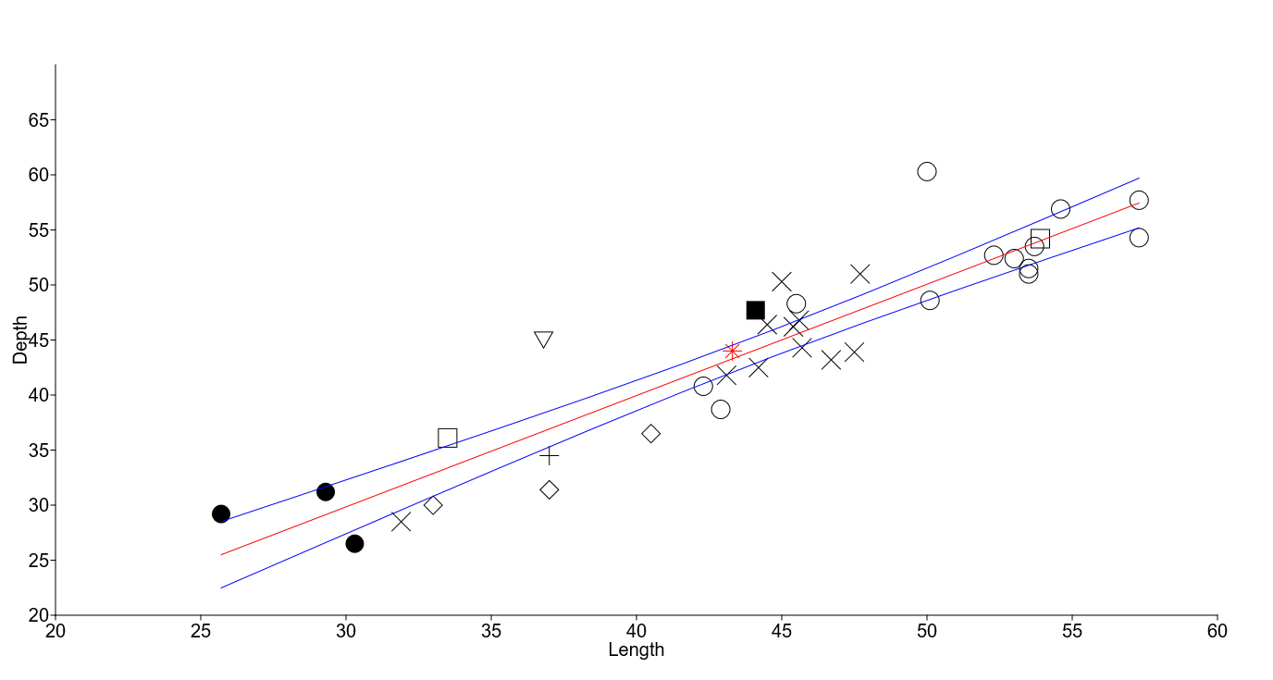

Ordinary Least Squares Regression: Length-Depth

Slope a: 1.011 Std. error a: 0.072781
t: 13.891 p (slope): 1.4118E-15
Intercept b: -0.4838 Std. error b: 3.2839

95% bootstrapped confidence intervals (N=1999):
Slope a: (0.85727, 1.1396)
Intercept b: (-6.5909, 6.6029)

Correlation:
r: 0.92206
r2: 0.8502
t: 13.891
p (uncorr.): 1.4118E-15
Permutation p: 0.0001

Residuals
Length Depth Regress. Residual
33,5 36,1 33,386 2,7144
29,3 31,2 29,139 2,0607
25,7 29,2 25,5 3,7004
37 34,5 36,924 -2,4242
30,3 26,5 30,15 -3,6503
53,9 54,2 54,011 0,18948
44,1 47,7 44,102 3,5975
46,7 43,2 46,731 -3,5311
44,2 42,5 44,204 -1,7036
31,9 28,5 31,768 -3,2679
45,4 46,2 45,417 0,7832
45,7 44,3 45,72 -1,4201
45,6 46,8 45,619 1,181
47,5 43,9 47,54 -3,64
44,5 46,4 44,507 1,8931
43,1 41,8 43,091 -1,2914
47,7 51 47,742 3,2578
45 50,3 45,012 5,2876
54,6 56,9 54,718 2,1818
53,5 51,5 53,606 -2,1061
53,5 51 53,606 -2,6061
45,5 48,3 45,518 2,7821
53,7 53,5 53,808 -0,30832
50 60,3 50,068 10,232
52,3 52,7 52,393 0,30712
57,3 54,3 57,448 -3,148
57,3 57,7 57,448 0,25199
42,9 38,7 42,889 -4,1892
42,3 40,8 42,283 -1,4826
50,1 48,6 50,169 -1,5686
53 52,4 53,101 -0,7006
37 31,4 36,924 -5,5242
33 30 32,88 -2,8801
43,3 44 43,294 0,70636
40,5 36,5 40,463 -3,9628
36,8 45 36,722 8,278

Plot residuals
