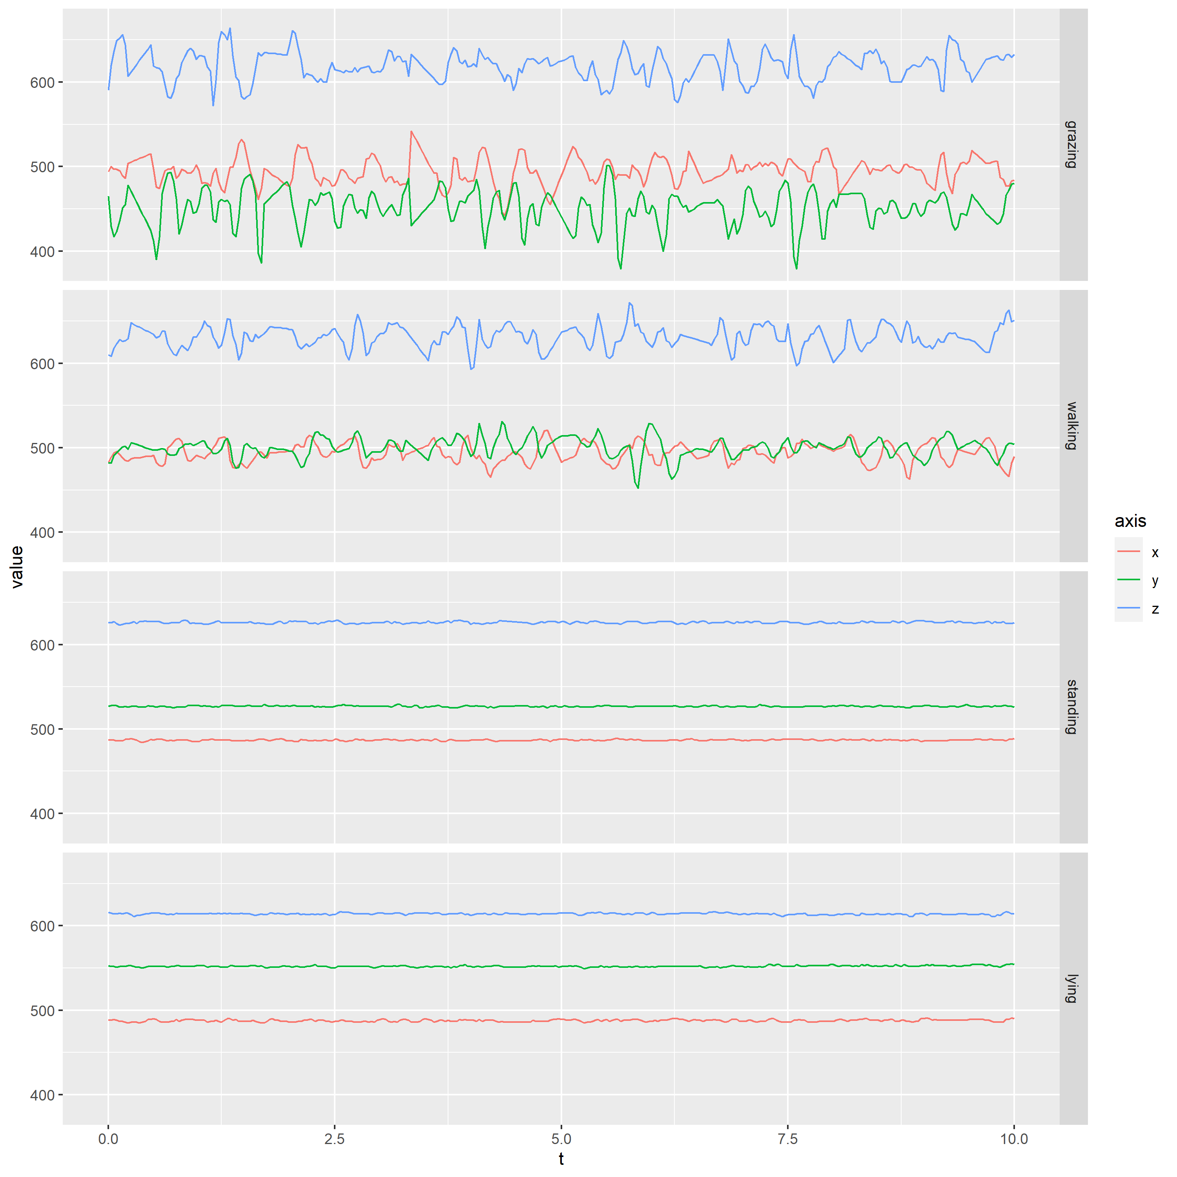
Figure 1: Representative acceleration plots of the three axes vs time in seconds for the different activity types.

