Supplementary Information
Associations of genetic predisposition to Alzheimer’s disease with blood-based biomarkers: a community-based study

Wei Q, et al.

Contents
Table S1. Associations of APOE genotypes with core plasma biomarkers for Alzheimer’s disease in dementia-free participants.
Figure S1. Associations of PRS with blood-based biomarkers for Alzheimer’s disease from the restricted cubic spline models in dementia-free participants.
Figure S2. Associations of polygenic risk scores with neuroinflammatory and peripheral inflammatory biomarkers from the restricted cubic spline models in dementia-free participants.
Table S2. Associations of APOE genotypes with plasma biomarkers for neurodegeneration and inflammation in dementia-free participants.
Figure S3. Associations of genetic predisposition to Alzheimer’s disease with Alzheimer’s disease biomarkers by age and sex in dementia-free participants.
Figure S4. Associations of genetic predisposition to Alzheimer’s disease with neuroinflammatory and peripheral inflammatory biomarkers by sex in dementia-free participants.

Table S1. Associations of APOE genotypes with core plasma biomarkers for Alzheimer’s disease in dementia-free participants.
APOE genotype | P-tau217ª (n=3481) |  | P-tau181ª (n=3518) |  | Aβ42/Aβ40 ratio^{b} (n=1274) |  | P-tau217/Aβ42 ratioª (n=1131)
APOE genotype | n | β (95% CI) | n | β (95% CI) | n | β (95% CI) | n | β (95% CI)
ε2/ε2 or ε2/ε3 | 450 | -0.06 (-0.11- -0.02)* | 449 | 0.00 (-0.03-0.04) | 170 | 0.07 (-0.20-0.33) | 149 | -0.15 (-0.24- -0.05)*
ε3/ε3 | 2495 | 0.00 (reference) | 2527 | 0.00 (reference) | 905 | 0.00 (reference) | 804 | 0.00 (reference)
ε2/ε4 or ε3/ε4 | 520 | 0.12 (0.08-0.17)** | 525 | 0.05 (0.02-0.09)** | 192 | -0.55 (-0.80- -0.30)** | 173 | 0.18 (0.10-0.27)**
ε4/ε4 | 16 | 0.55 (0.32-0.78)** | 17 | 0.28 (0.12-0.45)** | 7 | -1.54 (-2.73- -0.34)* | 5 | 0.78 (0.32-1.24)**
NOTE. ªThe original data were natural log-transformed to reduce skewness. ^{b}Plasma Aβ42/Aβ40 ratio was multiplied by 100. β coefficients (95% confidence intervals) were derived from the models that were adjusted for age, sex, education, body mass index, diabetes, hyperlipidemia, hypertension, coronary heart disease, estimated glomerular filtration rate, and stroke. Abbreviations: CI, confidence interval; APOE, apolipoprotein E gene; Aβ, amyloid-beta; P-tau, phosphorylated tau protein. *p<0.05; **p<0.001.

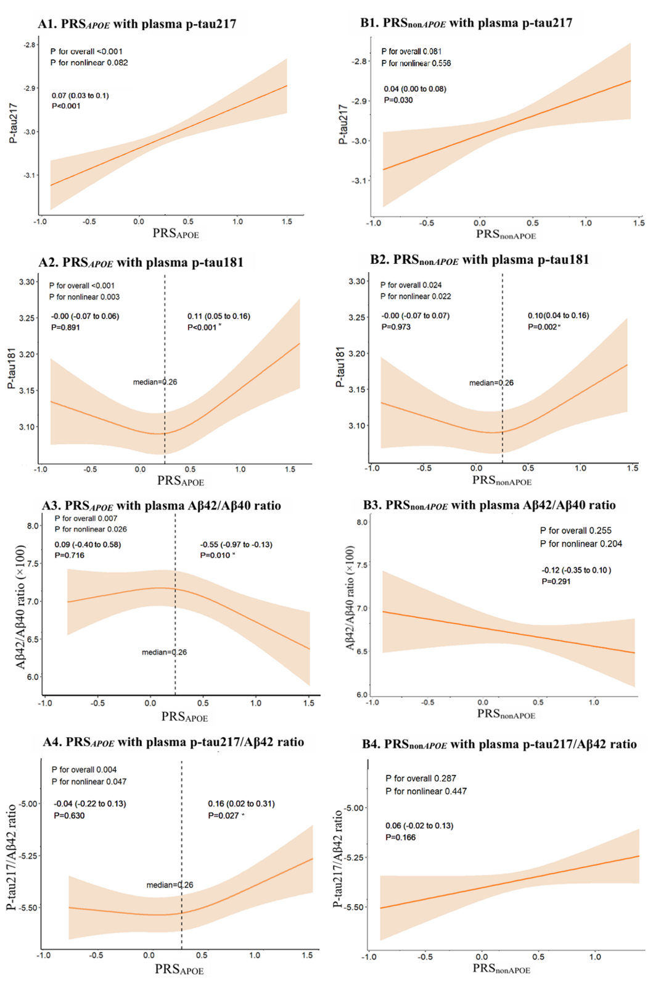Figure S1. Associations of PRS with blood-based biomarkers for Alzheimer’s disease from the restricted cubic spline models in dementia-free participants.
NOTE. A1-A4. Associations of PRS_{APOE} with plasma p-tau217 (A1), PRS_{APOE} with plasma p-tau181 (A2), PRS_{APOE} with plasma Aβ42/Aβ40 ratio (A3), and PRS_{APOE} with plasma p-tau217/Aβ42 ratio (A4). B1-B4. Associations of PRS_{nonAPOE} with plasma p-tau217 (B1), PRS_{nonAPOE} with plasma p-tau181 (B2), PRS_{nonAPOE} with plasma Aβ42/Aβ40 ratio (B3), and PRS_{nonAPOE} with plasma p-tau217/Aβ42 ratio (B4). Solid lines represent Alzheimer’s disease core plasma biomarkers and shaded areas indicate 95% confidence intervals derived from restricted cubic spline regression models with three knots at the 10th, 50th, and 90th percentiles. Data represent β coefficient (95% confidence intervals) of core plasma biomarkers of Alzheimer’s disease associated with PRS_{APOE} and PRS_{nonAPOE} derived from the models that were adjusted for age, sex, education, body mass index, diabetes, hyperlipidemia, hypertension, coronary heart disease, estimated glomerular filtration, and stroke. *The significant associations survived the Bonferroni corrections for multiple comparisons. Abbreviations: Aβ, amyloid-beta; P-tau, phosphorylated tau protein; PRS_{APOE}, polygenic risk score with APOE gene; PRS_{nonAPOE}, polygenic risk score without APOE gene.

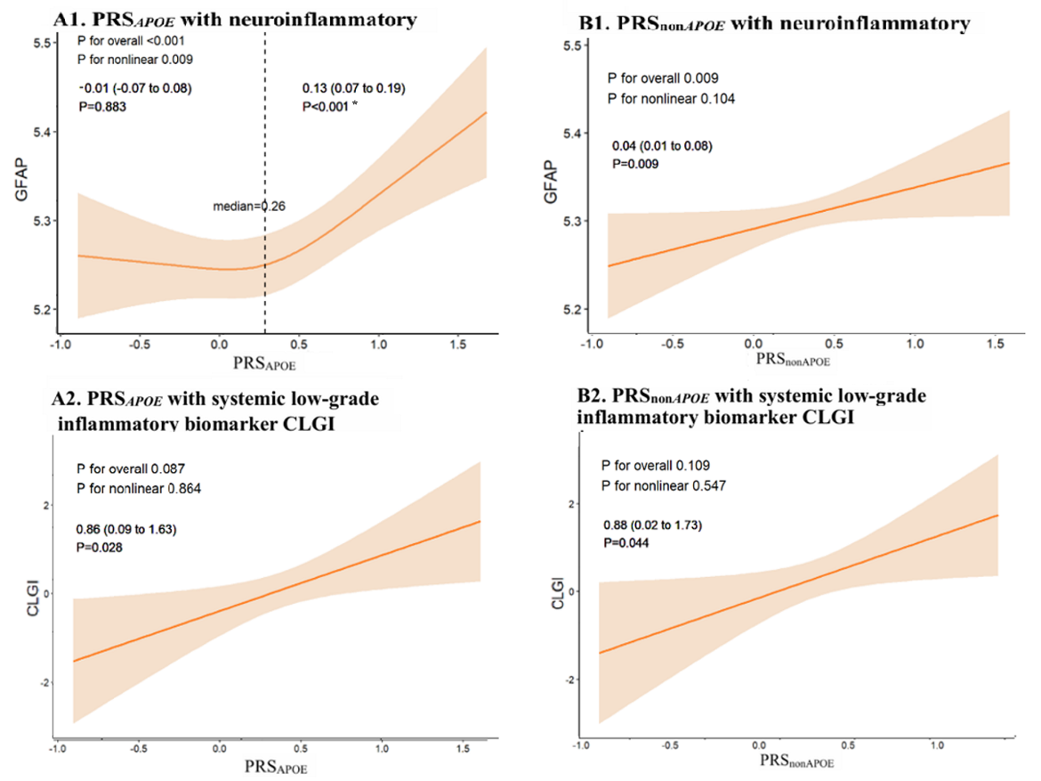

Figure S2. Associations of polygenic risk scores with neuroinflammatory and peripheral inflammatory biomarkers from the restricted cubic spline models in dementia-free participants.
NOTE. A1-A2. Association of PRS_{APOE} with neuroinflammatory biomarker GFAP (A1) and PRS_{APOE} with systemic low-grade inflammatory biomarker CLGI (A2). B1-B2. Associations of PRS_{nonAPOE} with neuroinflammatory biomarker GFAP (B1) and PRS_{nonAPOE} with systemic low-grade inflammatory biomarker CLGI (B2). Solid lines represent central and peripheral inflammation of Alzheimer’s disease and shaded areas indicate 95% confidence intervals derived from restricted cubic spline regression models with three knots at the 10th, 50th, and 90th percentiles. Data represent β coefficient (95% confidence intervals) of central and peripheral inflammation of Alzheimer’s disease associated with PRS_{APOE} and PRS_{nonAPOE} derived from the models that were adjusted for age, sex, education, body mass index, diabetes, hyperlipidemia, hypertension, coronary heart disease, estimated glomerular filtration, and stroke. *The significant associations survived the Bonferroni corrections for multiple comparisons. Abbreviations: GFAP, glial fibrillary acidic protein; CLGI, chronic low-grade inflammation; PRS_{APOE}, polygenic risk score with APOE gene; PRS_{nonAPOE}, polygenic risk score without APOE gene.
Table S2. Associations of APOE genotypes with plasma biomarkers for neurodegeneration and inflammation in dementia-free participants.
APOE genotype | NfLª (n=1273) |  | T-tau (n=1274) |  | BD-tauª (n=1519) |  | GFAPª (n=3559) |  | CLGI^{b} (n=1620)
APOE genotype | n | β (95% CI) | n | β (95% CI) | n | β (95% CI) | n | β (95% CI) | n | β (95% CI)
ε2/ε2 or ε2/ε3 | 170 | -0.06 (-0.14-0.02) | 170 | 0.01 (-0.15-0.16) | 201 | -0.02 (-0.06-0.03) | 455 | -0.07 (-0.10- -0.03)** | 223 | 0.52 (-0.47-1.52)
ε3/ε3 | 904 | 0.00 (reference) | 905 | 0.00 (reference) | 1088 | 0.00 (reference) | 2554 | 0.00 (reference) | 1157 | 0.00 (reference)
ε2/ε4 or ε3/ε4 | 192 | 0.02 (-0.05-0.10) | 192 | -0.03 (-0.18-0.12) | 225 | 0.03 (-0.01-0.08) | 532 | 0.10 (0.06-0.13)** | 232 | 0.35 (-0.62-1.33)
ε4/ε4 | 7 | -0.10 (-0.46-0.26) | 7 | -0.10 (-0.81-0.61) | 5 | 0.30 (0.04-0.56)* | 18 | 0.23 (0.05-0.42)* | 8 | 7.14 (2.33-11.95)*
NOTE. ªThe original data were natural log-transformed to reduce skewness. ^{b}The CLGI score was derived from IL-6, IL-8, TNFα and IFNγ. β coefficients (95% confidence intervals) were derived from the models that were adjusted for age, sex, education, body mass index, diabetes, hyperlipidemia, hypertension, coronary heart disease, estimated glomerular filtration rate, and stroke. Abbreviations: CI, confidence interval; APOE, apolipoprotein E gene; NfL, neurofilament light chain; T-tau, total tau protein; BD-tau, brain-derived tau protein; GFAP, glial fibrillary acidic protein; CLGI, chronic low-grade inflammation; IL-6, interleukin-6; IL-8, interleukin-8; TNFα, tumor necrosis factor-alpha; IFNγ, interferon-gamma. *p<0.05; **p<0.001.

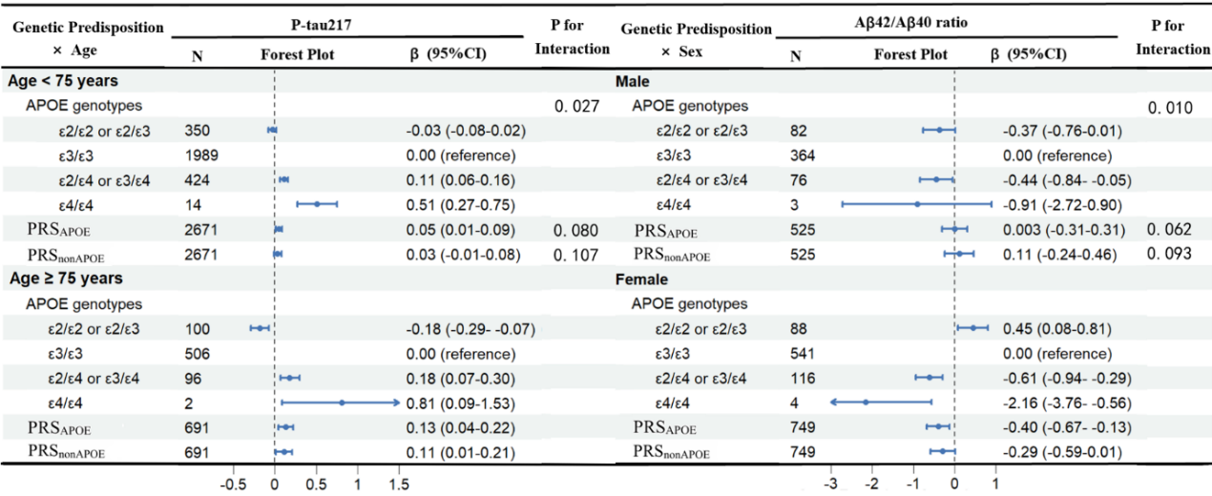

Figure S3. Associations of genetic predisposition to Alzheimer’s disease with Alzheimer’s disease biomarkers by age and sex in dementia-free participants.
NOTE. β-coefficients (95% confidence intervals) were derived from the linear regression models that were adjusted for age, sex, education, body mass index, diabetes, hyperlipidemia, hypertension, coronary heart disease, estimated glomerular filtration, and stroke. Abbreviations: APOE, apolipoprotein E gene; PRS_{APOE,} polygenic risk score with APOE gene; PRS_{nonAPOE}, polygenic risk score without APOE gene; P-tau, phosphorylated tau protein; Aβ, amyloid-beta.

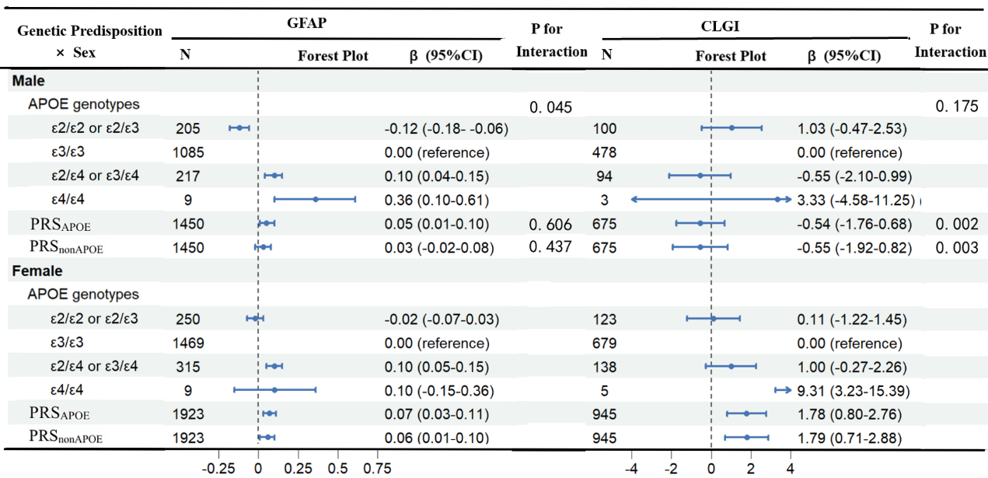

Figure S4. Associations of genetic predisposition to Alzheimer’s disease with neuroinflammatory and peripheral inflammatory biomarkers by sex in dementia-free participants.
NOTE. β-coefficients (95% confidence intervals) were derived from the linear regression models that were adjusted for age, sex, education, body mass index, diabetes, hyperlipidemia, hypertension, coronary heart disease, estimated glomerular filtration, and stroke. Abbreviations: APOE, apolipoprotein E gene; PRS_{APOE}, polygenic risk score with APOE gene; PRS_{nonAPOE}, polygenic risk score without APOE gene; GFAP, glial fibrillary acidic protein; CLGI, chronic low-grade inflammation.

