Supplementary information

Supplementary Table S1. Prognostic value of day-to-day variation indices in parenclitic deviation for 180-day mortality, independent of mean parenclitic deviation (δ), MELD and age
Hazard ratios are from Cox proportional hazards models, one per connection, each containing the day-to-day variation index, the mean parenclitic deviation along the same connection, Model for End-Stage Liver Disease (MELD) and age. All predictors were standardised by subtracting the mean and dividing by the standard deviation of the sample analysed for that connection, so hazard ratios are per standard deviation increase and are comparable between predictors. Follow-up was counted from treatment day 7 and 40 patients who died on or before day 7 were therefore excluded. The corrected P is that index's own P value, Bonferroni-corrected across the three connections.
Mean absolute successive difference (MASD)
Connection | n (deaths) | MASD | Mean δ | MELD | Age | Corrected P (MASD)
Albumin–bilirubin | 518 (163) | 1.11 (0.94 to 1.31), P=0.22 | 0.82 (0.69 to 0.97), P=0.021 | 1.71 (1.50 to 1.94), P=3×10⁻¹⁶ | 1.78 (1.51 to 2.10), P=5×10⁻¹² | 0.66
CRP–WCC | 578 (175) | 1.20 (1.04 to 1.38), P=0.012 | 0.93 (0.78 to 1.11), P=0.42 | 1.69 (1.49 to 1.91), P=3×10⁻¹⁶ | 1.73 (1.47 to 2.03), P=3×10⁻¹¹ | 0.035
WCC–bilirubin | 653 (195) | 1.21 (1.07 to 1.37), P=0.003 | 0.95 (0.81 to 1.11), P=0.52 | 1.65 (1.46 to 1.86), P=6×10⁻¹⁶ | 1.70 (1.46 to 1.98), P=9×10⁻¹² | 0.008
Coefficient of variation (CV)
Connection | n (deaths) | CV | Mean δ | MELD | Age | Corrected P (CV)
Albumin–bilirubin | 518 (163) | 1.15 (0.97 to 1.36), P=0.12 | 0.91 (0.76 to 1.09), P=0.33 | 1.71 (1.50 to 1.94), P=3×10⁻¹⁶ | 1.80 (1.52 to 2.12), P=3×10⁻¹² | 0.36
CRP–WCC | 578 (175) | 1.21 (1.05 to 1.41), P=0.010 | 1.09 (0.94 to 1.25), P=0.25 | 1.67 (1.47 to 1.90), P=3×10⁻¹⁵ | 1.74 (1.48 to 2.05), P=2×10⁻¹¹ | 0.030
WCC–bilirubin | 653 (195) | 1.18 (1.03 to 1.35), P=0.019 | 1.11 (0.97 to 1.26), P=0.14 | 1.64 (1.46 to 1.86), P=1×10⁻¹⁵ | 1.72 (1.48 to 2.01), P=4×10⁻¹² | 0.056

Supplementary Figure S1. Parenclitic deviation over the treatment period by treatment arm, one panel per connection. Points are the mean parenclitic deviation δ on each treatment day in the targeted albumin arm (orange, solid) and the standard care arm (teal, dashed); error bars are ± 1 standard error of that day's mean. Days on which fewer than 10 patients contributed a measurement are omitted.

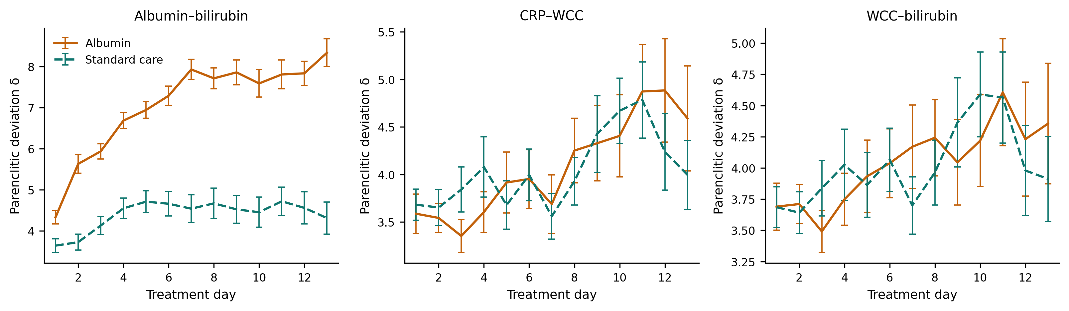

Supplementary Figure S2. Survival to 180 days by day-to-day variation in parenclitic deviation, one panel per connection. Patients are split at the median coefficient of variation (CV) of parenclitic deviation (δ) over treatment days 1–7 for that connection, into those below (navy, solid) and above (red, dashed) the median. Follow-up is counted from treatment day 7, the landmark: patients who died on or before day 7 were excluded, so that the exposure is fixed before follow-up begins. Curves are Kaplan–Meier estimates and P values are from the log-rank test, unadjusted. The adjusted estimates, accounting for the mean parenclitic deviation on the same connection, Model for End-Stage Liver Disease (MELD) and age, are given in Supplementary Table S1.

