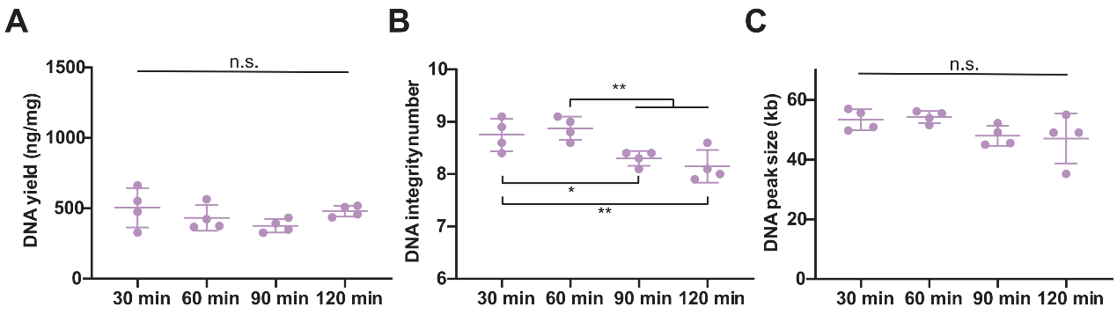
Figure S1. Evaluation of DNA in coarse smashed frozen rabbit liver at different lysis times (55°C water bath).
(A) DNA yields, ng DNA/mg tissue. (B) DNA integrity number values. (C) DNA peak sizes. n.s., non-significant; *, p values < 0.05; **, p values < 0.01. Ordinary one-way ANOVA (A, B, C).

