Supporting Information
Table S1. Brief description of some molecular descriptors used in the models
Table S2. Two different QSAR models and their comparative statistical results
Table S3. Chemical structure of newly designed compounds, their predicted activities and docking binding energy
Table S4. The participating atoms in binding to 4AW5 receptor
Table S5. Target Prediction for the selected compounds and control drug Sunitinib
Table S6. Toxicity prediction for 10 selected compounds compared with Control Drug Sunitinib
Figure S1. Molecular binding interactions between the structures of 8b (A) and 8e (B) in the active site of tyrosine kinase enzyme
Figure S2. Molecular binding interactions between the structure of 9j (A) and 9m (B) in the active site of tyrosine kinase enzyme
Figure S3. Molecular binding interactions between the structure of 11b (A) and 11e (B) in the active site of tyrosine kinase enzyme
Figure S4. Molecular binding interactions between the structure of 11j (A) and 11k (B) in the active site of tyrosine kinase enzyme

Table S1. Brief description of some molecular descriptors used in the models
Descriptors | Brief description | Block
X3A | average connectivity index of order 3 | Connectivity indices
MATS1e | Moran autocorrelation of lag 1 weighted by Sanderson electronegativity | 2D autocorrelations
SPAM | average span R | Geometrical descriptors
G (F..F) | Sum of geometrical distances between F..F | 3D Atom Pairs
nN | number of Nitrogen atoms | Constitutional indices
MATS6m | Moran autocorrelation - lag 6 / weighted by atomic masses | 2D autocorrelations
H-046 | H attached to C0(sp3) no X attached to next C | Atom-centered fragments
X5Av | average valence connectivity index of order 5 | Connectivity indices
ATS1m | Broto-Moreau autocorrelation of lag 1 (log function) weighted by mass | 2D autocorrelations
IC1 | Information Content index (neighborhood symmetry of 1-order) | Information indices
MAXDN | maximal electrotopological negative variation | Topological indices
GATS5v | Geary autocorrelation of lag 5 weighted by van der Waals volume | 2D autocorrelations
softness |  | quantum chemical descriptors

Table S2. Two different QSAR models and their comparative statistical results
Model | Eq.no | Equation | nª | R²_{c} | Q² |  | Rmscv | Cvcv | F | SE | R² _{p}
MLR | 1 | PIC₅₀= 469.13X₃A ($±$74.433)-23.69MATS₁e ($±$4.791)-37.827SPAM ($±$12.547)+0.47G(F..F) ($±$0.098)-1.525 nN ($±$0.313)-96.559MATs6m ($±$20.569)-0.285H-046 ($±$0.119)+240.341X₅A_{V} ($±$103.047)+36.153($±$21.905) | 35 | 0.73 | 0.67 |  | 0.709 | 10.08 | 14.7 | 0.59 | 0.67
GA-PLS | 2 | PIC₅₀= -10.117 ATS1m($±1.741$)+4.526IC1($±0.813$)-0.590MAXDN($±0.112$)-3.604GATS5v($±1.440$)-21.621SPAM($±7.366$)+1.108softness ($±0.422$)+23.451($±5.151$) | 35 | 0.82 | 0.71 |  | 0.566 | 7.93 | 22.5 | 0.48 | 0.79

Table S3. Chemical structure of newly designed compounds, their predicted activities and docking binding energy
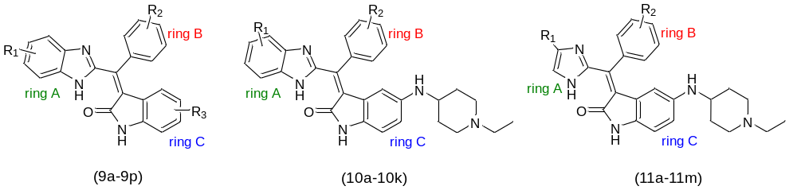
ID | R₁ | R₂ | R₃ | Pred.  pIC₅₀  (MLR) | Leverage  (MLR) | Pred. pIC₅₀  (G-AL) | leverage  (G-AL) | Docking binding energy (Kcal/mol)
9a | H | 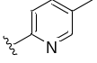 | 5-Cl | 6.89452 | 0.01118 | 8.11217 | 0.14083 | -7.49
9b | H | Py | 5-Cl | 6.80142 | 0.02956 | 7.82904 | 0.09266 | -7.84
9c | H | 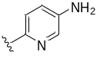 | 5-Cl | 7.60660 | 0.11403 | 8.18066 | 0.25590 | -7.02
9d | 5-o-Me | H | 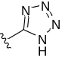 | 5.50315 | 0.2044 | 8.37292 | 0.12141 | -7.88
9e | H | 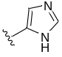 | 5-COOH | 7.84296 | 0.20453 | 8.32016 | 0.32546 | -6.97
9f | 5-OMe | 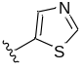 | 5-NH₂ | 7.01783 | 0.14016 | 8.61669 | 0.50260 | -7.85
9g | H | 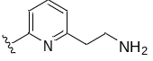 | 5-NH₂ | 8.80828 | 0.32345 | 8.41534 | 0.07376 | -8.85
9h | 5-OMe |  | 5-Br | 7.45791 | 0.05558 | 8.50435 | 0.23727 | -9.88
9i | 5-OMe | 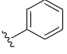 | 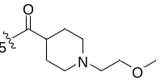 | 9.16829 | 0.31429 | 9.12725 | 0.26363 | -9.51
9j | H |  | 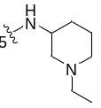 | 7.86382 | 0.07272 | 7.90427 | 0.08085 | -10.09
9k | 5-OMe |  | 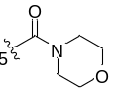 | 8.15836 | 0.10956 | 8.44768 | 0.08238 | -9.08
9l | 5-OMe |  | 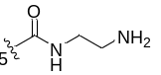 | 8.79949 | 0.15462 | 8.66059 | 0.10192 | -9.68
9m | 5-OH |  | 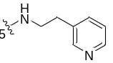 | 9.15898 | 0.15493 | 8.58671 | 0.08734 | -10.12
9n | H |  | 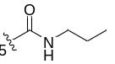 | 7.28927 | 0.05450 | 7.66601 | 0.12349 | -8.95
9o | 5-OMe |  | 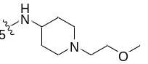 | 7.96974 | 0.03575 | 8.01306 | 0.04117 | -9.03
9p | 5- CF₃ |  | 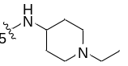 | 7.99679 | 0.08683 | 6.59240 | 0.27641 | -9.20
10a | H | 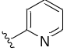 |  | 7.23557 | 0.22651 | 7.04594 | 0.04799 | -9.38
10b | H |  |  | 7.93948 | 0.32631 | 7.36419 | 0.13940 | -8.37
10c | Me | 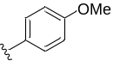 |  | 7.31051 | 0.31820 | 6.96190 | 0.03622 | -9.45
10d | H | 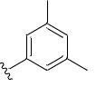 |  | 7.14781 | 0.03840 | 7.19977 | 0.01975 | -9.84
10e | H | 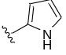 |  | 7.74047 | 0.11640 | 7.46748 | 0.03254 | -8.72
10f | H | 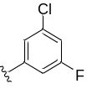 |  | 7.11321 | 0.08720 | 7.77745 | 0.15236 | -9.63
10g | Me |  |  | 7.95514 | 0.09167 | 7.74013 | 0.03974 | -8.73
10h | Me | 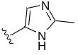 |  | 7.66060 | 0.10431 | 7.57117 | 0.04049 | -9.18
10i | Me | 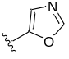 |  | 7.78862 | 0.06307 | 8.04014 | 0.07561 | -9.04
10j | Me |  |  | 7.35144 | 0.12855 | 8.02761 | 0.17602 | -9.5
10k | Me | 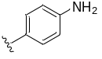 |  | 8.30678 | 0.18930 | 7.70036 | 0.03943 | -9.47
11a | Me | 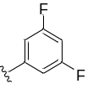 |  | 6.97595 | 0.17319 | 7.14804 | 0.09015 | -9.47
11b | Me | 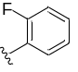 | 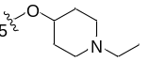 | 8.15129 | 0.06753 | 8.51076 | 0.08698 | -9.43
11c | Me | 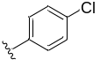 |  | 7.08047 | 0.37100 | 7.08073 | 0.17071 | -9.28
11d | Me | 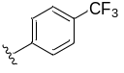 | 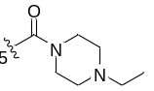 | 7.52653 | 0.05166 | 5.38441 | 0.24585 | -9.43
11e | Me |  | 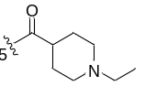 | 7.13319 | 0.03913 | 7.60302 | 0.04734 | -10
11f | Me | 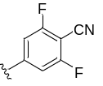 |  | 6.45212 | 0.26774 | 6.82696 | 0.16366 | -9.77
11g | Me | 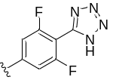 |  | 5.40441 | 0.20074 | 7.55194 | 0.24983 | -10.03
11h | Ph |  |  | 8.01864 | 0.05811 | 8.06233 | 0.05769 | -10.57
11i | 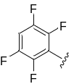 | 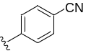 |  | 7.36003 | 0.12140 | 7.35494 | 0.11962 | -10.59
11j | 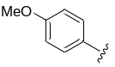 |  |  | 8.04869 | 0.22220 | 7.55738 | 0.00768 | -10.63
11k | Ph | 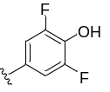 |  | 8.55605 | 0.10797 | 8.78007 | 0.18360 | -10.80
11L | 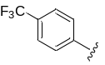 | 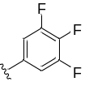 |  | 8.22301 | 0.08508 | 6.36864 | 0.26888 | -10.37
11m | 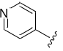 | 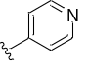 |  | 8.21193 | 0.06276 | 8.17144 | 0.05145 | -10.06

Table S4. The participating atoms in binding to 4AW5 receptor
Name | Amino Acid | The participating ligand atoms in bonding | Type of Interactions
Lig co-crystal | Gly98  Glu140  Phe235  Asp234 | Oxygen of carbonyl  N, C of Piperidine ring  C of side chain  N, C of Piperidine ring | H.B  H-donor, ionic  H-donor  H-donor, ionic
sunitinib | Lys123  Glu 170  Leu223  Asn174  Ala176  Ser179 | Oxygen of carbonyl oxindole  C of oxindole ring  oxindole ring  N of side chain  C of side chain  C of side chain | H-acceptor  H-donor  Arene-H  H-donor  H-donor  H-donor
9f | Val105  Leu223  Glu 170 | Oxindole ring  Oxindole ring  N of NH2 | Arene-H  Arene-H  H-donor
9g | Ala176  Gly175  Asn174  Ser179 | N of the pyridine ring  N of side chain  N of side chain  N of side chain | H-B  H-donor  H-donor  H-donor
9h | Ile97  Ala99  Glu173  Gly175 | N of benzimidazole  C of side chain  N of side chain  N of pyridine ring | H-donor  H-donor  H-donor  H-acceptor
9i | Met172  Glu170  Ser233  Arg220  Asn221 | Oxygen of carbonyl  N of Oxindole ring  C of Piperidine ring  C of Piperidine ring and side chain  C of side chain | H-acceptor  H-donor  H-donor  H-donor  H-donor
9j | Met172  Glu170  Glu140  Asn221 | Oxygen of carbonyl  N of Oxindole ring  C of side chain  C of Piperidine ring | H-acceptor  H-donor  H-donor  H-donor
9k | Met172  Leu223 | N of benzimidazole  imidazole ring | H-donor  Arene-H
9l | Met172  Leu223  Ser233  Arg220 | N of benzimidazole  Benzimidazole ring  C of side chain  C, N of side chain | H-donor  Arene-H  H-donor  H-donor
9m | Met172  Thr169  Ala176  Asn221 | N of benzimidazole  H of OH group  Oxindole ring  N of the pyridine ring | H-donor  H-donor  Arene-H  H-acceptor
10j | Ile97  Met172  Glu170  Leu223  Ser233  Arg220 | S of the thiazole ring  Oxygen of carbonyl  N of Oxindole ring  Oxindole ring  C of Piperidine ring  C of side chain | H-donor  H-acceptor  H-donor  Arene-H  H-donor  H-donor
11b | Met172  Thr169  Glu140  Ser233  Asp234  Asn221 | C of the benzene ring  N of Oxindole ring  C of Piperidine ring  C of Piperidine ring  N of Piperidine ring  C of Piperidine ring and side chain | H-donor  H-donor  H-donor  H-donor  Ionic  H-donor
11e | Asn174  Ala176  Ser179 | N of Piperidine ring  C of Piperidine ring and side chain  C of Piperidine ring | H-donor  H-donor  H-donor
11g | Glu170  Glu173  Met172  Lys123  Arg220  Asn221 | N of Oxindole ring  N of tetrazole ring  Oxygen of carbonyl oxindole  Oxygen of carbonyl side chain  C of side chain  C of side chain | H-donor  H-donor  H-acceptor  H-acceptor  H-donor  H-donor
11h | Met172  Leu223  Ala176  Asn221 | N of benzimidazole and C benzene ring  imidazole ring  benzimidazole ring  C of side chain | H-donor  Arene-H  Arene-H  H-donor
11i | Met172  Glu170  Lys123  Arg220  Asn221 | Oxygen of carbonyl oxindole  N of carbonyl oxindole  Oxygen of carbonyl side chain  C of side chain  C of side chain | H-acceptor  H-donor  H-acceptor  H-donor  H-donor
11j | Ser179  Ala176  Asn174  Lys123  Thr169  Phe171 | C of side chain  C of side chain  N of Piperidine ring  N of CN group  N of CN group  Oxygen of carbonyl oxindole | H-donor  H-donor  H-donor  H-acceptor  H-acceptor  H-acceptor
11k | Ser179  Ala176  Asn174  Thr169  Phe171 | C of side chain  C of side chain  C of Piperidine ring  OH group  Oxygen of carbonyl oxindole | H-donor  H-donor  H-donor  H-donor  H-acceptor
11l | Glu101  Lys123  Ser233  Asn221 | F of CF3 group  F of CF3 group  C of Piperidine ring  C of side chain | H-acceptor  H-acceptor  H-donor  H-donor
11m | Lys123  Ser233  Glu170 | Oxygen of carbonyl side chain  C of Piperidine ring  C of oxindole ring | H-acceptor  H-donor  H-donor

Table S5. Target Prediction for the selected compounds and control drug Sunitinib
Target Classes | sunitinib | 9i | 9j | 9k | 9m | 10j | 11b | 11e | 11h | 11k | 11m
Kinase% | 80% | 46.7% | 93.3% | 66.7% | 80% | 60% | 66.7% | 60% | 33.3% | 20% | 40%
Target1 | KDR | KDR | PDGFRA | FLT1 | KDR | FLT1 | FLT1 | KDR | KDR | PDK1 | KDR
Target2 | EGFR | FGFR1 | KDR | PDGFRA | FGFR1 | KDR | PDGFRA | FLT1 | FGFR1 | SRC | EGFR
Target3 | FLT1 | FLT1 | FGFR1 | KDR | FLT1 | EGFR | KDR | PDGFRA | FLT1 | PDGFRB | FGFR1
KDR: Vascular endothelial growth factor receptor 2, FGFR1: Fibroblast growth factor receptor 1, FLT1: Vascular endothelial growth factor receptor 1, PDGFRA: Platelet-derived growth factor receptor alpha, EGFR: Epidermal growth factor receptor erbB1, SRC: Tyrosine-protein kinase SRC, PDK1: Pyruvate dehydrogenase kinase isoform 1

Table S6. Toxicity prediction for 10 selected compounds compared with the control drug Sunitinib
Compounds | sunitinib | 9i | 9j | 9k | 9m | 10j | 11b | 11e | 11h | 11k | 11m
Carcinogenicity | -0.85 | -0.97 | -0.82 | -0.95 | -0.88 | -0.82 | -0.91 | -0.95 | -0.95 | -0.95 | -0.95
Eye corrosion | -0.98 | -0.98 | -0.98 | -0.98 | -0.98 | -0.98 | -0.98 | -0.98 | -0.98 | -0.98 | -0.99
Eye irritation | -0.96 | -0.95 | -0.95 | -0.95 | -0.93 | -0.98 | -0.97 | -0.97 | -0.94 | -0.94 | -0.96
Ames mutagenesis | -0.52 | -0.54 | -0.5 | -0.51 | +0.51 | -0.56 | -0.54 | -0.58 | -0.57 | -0.66 | -0.62
Hepatotoxicity | +0.95 | +0.57 | +0.57 | +0.72 | +0.75 | +0.7 | +0.7 | +0.65 | +0.72 | +0.7 | +0.75
Acute oral toxicity | III  0.59 | III  0.72 | III  0.53 | III  0.67 | III  0.55 | III  0.57 | III  0.56 | III  0.53 | III  0.44 | III  0.49 | III  0.46
“+” means toxic; “-“means nontoxic.

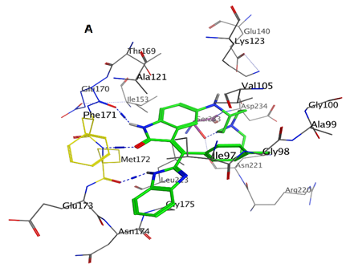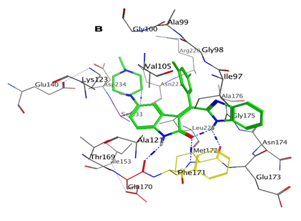
Figure S1. Molecular binding interactions between the structures of 8b (A) and 8e (B) in the active site of tyrosine kinase enzyme
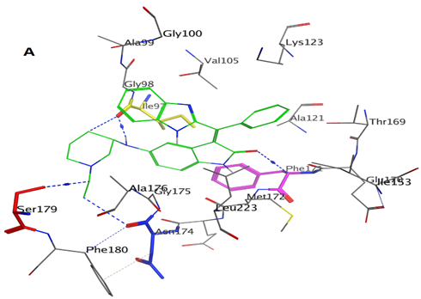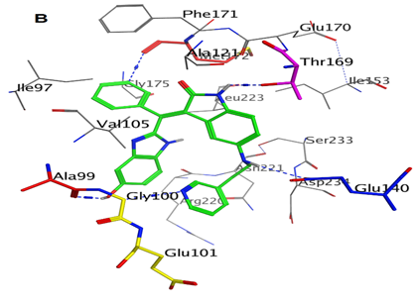
Fig. S2. Molecular binding interaction between the structure of 9j (A) and 9m (B) n the active site of tyrosine kinase enzyme
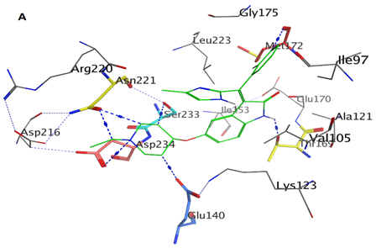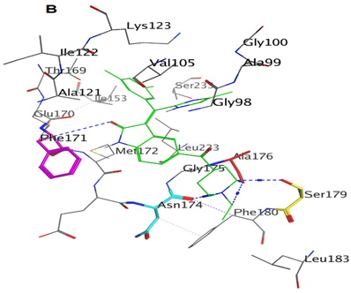
Fig. S3. Molecular binding interaction between the structure of 11b (A) and 11e (B) n the active site of tyrosine kinase enzyme
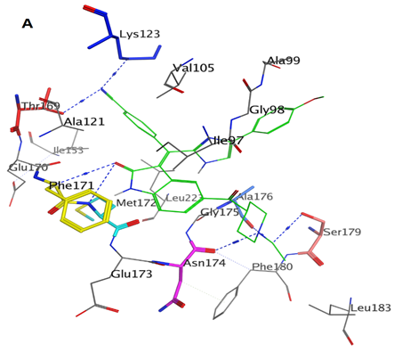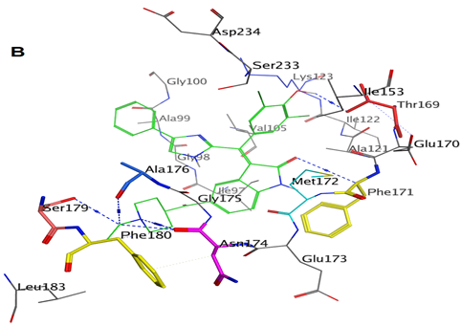
Fig. S4. Molecular binding interaction between the structure of 11j (A) and 11k (B) n the active site of tyrosine kinase enzyme

