Natural Sesquiterpenoids from Laggera pterodonta as bioactive Acetylcholinesterase Inhibitors: Insights from DFT, Molecular Docking, and ADMET Profiling
Hamza Iftikharª, Muhammad Mohsin Ejazª, K.S. Al-Namshah^{b,} Saira Khanª, Sadaf Ashraf^{c} ,Nazia Meer ^{c}, Musarat Riaz ^{d}, Muhammad Saleem^{*a}
ª Department of Chemistry, Faculty of Science, Ghazi University, Dera Ghazi Khan, 32200, Pakistan
^{b} Department of Chemistry, College of Science, Imam Mohammad Ibn Saud Islamic University (IMSIU), Riyadh, 11623, Saudi Arabia.
^{c} Department of Chemistry, University of Balochistan, Quetta, Balochistan, 83700, Pakistan
^{d} Department of Chemistry, Sardar Bahadur Khan Women’s University, Quetta, Balochistan, 83700, Pakistan
*Correspondance: msaleem@gudgk.edu.pk ; hod.chem@gudgk.edu.pk.

Supporting Information file

Cartesian coordinate of all molecules (R, HM-1- HM -5)

REFERENCE
C -4.46723 -1.09178 -0.60126
N -3.0867 -0.82836 -0.21881
C -2.94084 -0.35462 1.16416
C -2.05881 0.89746 1.257
C -0.76295 0.84623 0.40145
C -0.97324 1.49182 -0.96048
C -0.31471 2.56246 -1.40496
C 0.71738 3.3214 -0.60514
C 0.6074 2.99609 0.88901
C 0.43296 1.5108 1.14196
O 1.62345 0.80092 0.68357
C 1.20178 -0.44667 0.31528
C 2.07508 -1.51007 0.08228
C 1.49787 -2.72181 -0.30675
C 0.11595 -2.83374 -0.46203
C -0.75237 -1.75684 -0.25388
C -0.17746 -0.55074 0.15985
C -2.23193 -1.97297 -0.50998
O 3.40454 -1.26892 0.25522
C 4.30908 -2.33706 0.01714
O 2.03946 3.09524 -1.1061
H -4.51328 -1.34319 -1.66416
H -5.07306 -0.19678 -0.44468
H -4.92683 -1.92416 -0.03617
H -3.92698 -0.11822 1.57408
H -2.5283 -1.15131 1.79983
H -2.63938 1.77032 0.94473
H -1.79856 1.05206 2.31094
H -1.7025 0.98896 -1.58645
H -0.48806 2.91579 -2.41748
H 0.55688 4.39448 -0.74528
H 1.50067 3.36006 1.40308
H -0.2566 3.51481 1.31926
H 0.34798 1.30563 2.21583
H 2.11986 -3.5881 -0.48878
H -0.29421 -3.7924 -0.76345
H -2.36776 -2.22817 -1.56712
H -2.55595 -2.8647 0.065
H 5.30211 -1.93185 0.20399
H 4.12746 -3.17743 0.69707
H 4.2512 -2.69006 -1.01886
H 2.26487 2.18503 -0.87317
HM-1
O -4.2379 -3.2926 1.1455
C -5.1673 -2.5209 1.1479
O -6.4218 -2.9847 1.1833
C -4.94 -1.1896 1.1148
C -5.9686 -0.3355 1.1174
C -3.5363 -0.6707 1.0752
C -3.5552 0.8467 1.0431
C -2.1203 1.3571 1.0414
C -1.4024 0.8495 -0.2022
C -2.1204 1.3572 -1.4457
C 0.009 1.3485 -0.2022
C 0.9788 0.695 -0.8502
C 0.699 -0.5664 -1.6061
O 1.6265 -1.5274 -1.1795
C -0.7052 -1.1811 -1.4575
C -1.4024 -0.6735 -0.2022
C -2.8381 -1.1811 -0.1784
C 0.3415 2.6058 0.5391
H -6.9986 -2.2024 1.1783
H -5.7835 0.7484 1.0905
H -7. -0.7168 1.1466
H -2.9923 -1.0225 1.9802
H -4.0877 1.2325 1.9411
H -4.0822 1.1985 0.1281
H -2.1229 2.4701 1.0394
H -1.5941 0.9884 1.9502
H -2.995 1.9756 -1.1433
H -1.4206 1.976 -2.0508
H -2.4701 0.4914 -2.0514
H 2.0042 1.0927 -0.8273
H 0.7741 -0.2799 -2.679
H 1.4433 -2.3169 -1.6597
H -0.6111 -2.2885 -1.3966
H -1.3136 -0.8847 -2.3411
H -0.8627 -1.0445 0.6977
H -3.3769 -0.8113 -1.0793
H -2.8383 -2.2941 -0.1762
H -0.5795 3.0114 1.0146
H 1.0972 2.3835 1.3253
H 0.7537 3.357 -0.1712
HM -2

C -5.2778 4.6889 0.9178
C -5.8322 3.6648 1.8992
O -5.6466 2.3743 1.3836
C -6.1311 1.4676 2.2401
O -6.6343 1.8259 3.2782
C -6.0577 0.1516 1.9438
C -6.5418 -0.7544 2.7996
C -5.4341 -0.2923 0.6573
C -5.4826 -1.8319 0.5772
C -4.7677 -2.3312 -0.6714
C -3.3318 -1.8236 -0.6714
C -2.6138 -2.3313 0.5721
C -2.6139 -2.3312 -1.915
C -1.1568 -1.8898 -1.8758
C -1.0467 -0.3511 -1.8145
C -1.9216 0.1984 -0.7312
C -1.4629 1.097 0.1461
C -3.3318 -0.3006 -0.6714
O -4.0406 0.1667 -1.7871
C -3.9964 0.207 0.6014
C -1.4801 0.2345 -3.152
H -5.4252 5.7134 1.3271
H -4.1911 4.5042 0.764
H -5.8118 4.5977 -0.0545
H -6.919 3.8495 2.053
H -5.2983 3.756 2.8715
H -6.482 -1.8259 2.5583
H -7. -0.4282 3.7449
H -5.9918 0.1279 -0.2094
H -4.9864 -2.2595 1.477
H -6.5472 -2.1536 0.5316
H -4.7673 -3.4442 -0.6782
H -5.2946 -1.9544 -1.5765
H -3.313 -2.9497 1.1783
H -1.7399 -2.9501 0.2686
H -2.2641 -1.4655 1.1778
H -2.6637 -3.4428 -1.9439
H -3.1039 -1.9137 -2.8229
H -0.6414 -2.255 -2.7922
H -0.6812 -2.3161 -0.9643
H 0.0094 -0.0758 -1.5964
H -2.1261 1.4854 0.9331
H -0.4224 1.4478 0.0809
H -4.9184 -0.1668 -1.7133
H -3.4382 -0.1709 1.487
H -3.9896 1.32 0.6051
H -1.7687 -0.5895 -3.8423
H -2.3513 0.9094 -2.996
H -0.6374 0.8112 -3.5948
HM -3

O -7. 1.6213 1.0654
C -6.1776 0.9147 0.5327
O -6.5359 -0.2791 0.046
C -4.8962 1.3297 0.4285
C -3.8771 0.4541 -0.2316
C -2.5457 1.1383 -0.2188
C -1.4045 0.4417 -0.2188
C -0.0731 1.126 -0.206
C 0.6179 0.8659 1.126
C 0.7879 0.5824 -1.3386
C 0.867 -0.9417 -1.2252
C -0.5181 -1.5629 -1.3485
C -1.4045 -1.0553 -0.2188
C -0.8695 -1.563 1.1137
C -2.826 -1.5629 -0.4217
C -3.7751 -0.7909 0.4854
C -4.5383 2.5226 0.9149
H -5.7296 -0.6693 -0.3314
H -4.1871 0.2571 -1.2822
H -2.5054 2.2375 -0.2092
H -0.2173 2.2212 -0.3422
H 1.608 1.3743 1.1364
H -0.0113 1.2633 1.9536
H 0.7621 -0.2294 1.2614
H 0.3339 0.8593 -2.3164
H 1.8109 1.0157 -1.2713
H 1.5171 -1.3351 -2.0384
H 1.2904 -1.2053 -0.2302
H -0.9659 -1.2789 -2.3271
H -0.4349 -2.671 -1.2856
H 0.0391 -2.1814 0.9379
H -0.6083 -0.697 1.7622
H -1.6477 -2.1813 1.6144
H -3.1248 -1.4137 -1.4834
H -2.8725 -2.6464 -0.1714
H -4.7628 -1.2969 0.5702
H -3.4282 -0.6905 1.5382
H -3.4949 2.8605 0.83
H -5.2871 3.166 1.3999
HM -4
C -5.679 2.3268 1.715
C -5.6783 0.8038 1.7138
C -4.9583 0.2963 2.9562
O -7. 0.3361 1.7144
C -4.9612 0.2967 0.4696
C -4.9612 -1.2263 0.4696
C -4.2433 -1.7339 -0.774
C -2.8074 -1.2263 -0.774
C -2.0894 -1.734 0.4695
C -2.0895 -1.7339 -2.0176
C -0.6536 -1.2263 -2.0175
O 0.0066 -1.6932 -3.1629
C -0.6536 0.2967 -2.0175
C -1.3715 0.8044 -0.774
C -1.372 2.3274 -0.775
O -0.7105 0.3373 0.3708
C -2.8074 0.2967 -0.774
C -3.5253 0.8044 0.4696
H -6.205 2.6988 0.8073
H -6.2033 2.6964 2.6245
H -4.6298 2.6981 1.7138
H -4.9573 -0.8167 2.9563
H -5.4828 0.6663 3.8654
H -3.9093 0.6681 2.9547
H -6.9575 -0.6049 1.7137
H -5.486 0.6678 -0.439
H -6.0106 -1.5969 0.4689
H -4.4367 -1.5975 1.3784
H -4.2429 -2.8469 -0.7733
H -4.768 -1.3631 -1.6828
H -2.7885 -2.3524 1.0757
H -1.2155 -2.3528 0.166
H -1.7396 -0.8682 1.0752
H -2.0891 -2.8469 -2.0169
H -2.6142 -1.3631 -2.9264
H -0.1287 -1.5975 -1.1089
H 0.8869 -1.3598 -3.1266
H 0.3959 0.6673 -2.0169
H -1.178 0.6678 -2.9264
H -1.8965 2.6993 0.1335
H -0.3226 2.6982 -0.7748
H -1.8971 2.6974 -1.6839
H -1.1823 0.671 1.1147
H -3.3321 0.6677 -1.6827
H -3.0007 0.4325 1.3781
H -3.5251 1.9174 0.4699

HM -5
C -2.1694 -1.6187 1.2766
C -1.4515 -1.111 0.0331
C -1.4515 0.412 0.0331
C -0.8845 0.9196 1.3524
O -0.2404 2.147 1.1422
C 0.1157 -0.0913 1.8975
C 0.8803 -0.6078 0.7368
C -0.0155 -1.6187 0.0331
C -2.0168 1.1047 2.354
H -0.8237 0.783 -0.8077
C -2.8774 0.9196 -0.1355
C -3.4598 0.3757 -1.4334
C -4.7988 0.989 -1.7014
C -5.4915 0.6418 -2.8082
O -6.6883 1.19 -3.0477
O -5.0303 -0.1634 -3.5815
C -5.3093 1.8802 -0.8454
C -3.5917 -1.0747 -1.2331
C -2.1693 -1.6187 -1.2105
H -2.5195 -0.7534 1.8828
H -3.0441 -2.2364 0.9731
H -1.4697 -2.237 1.8823
H 0.095 2.4267 1.9768
H -0.4203 -0.9248 2.4041
H 0.7934 0.3806 2.6437
H 1.8153 -1.1017 1.0839
H 1.1672 0.2184 0.0484
H 0.3301 -1.7528 -1.0163
H 0.0335 -2.5936 0.5679
H -2.9831 0.824 1.8784
H -1.8375 0.4553 3.24
H -2.0572 2.1695 2.6755
H -3.4974 0.5747 0.7221
H -2.874 2.0321 -0.1678
H -2.8109 0.6127 -2.306
H -7. 0.8025 -3.8828
H -6.2933 2.3308 -1.0424
H -4.7454 2.1628 0.0557
H -4.1679 -1.5307 -2.0691
H -4.1373 -1.3117 -0.2924
H -2.1982 -2.7312 -1.1935
H -1.626 -1.2749 -2.119
1.
HM1 (Laggeranine A)
½a20 D−159:13(c0.16,MeOH);UV(MeOH)Lmax (loge): 195 (4.17)nm; IR(KBr):3429,2930,2874,1695,1623,1461,1434,1384, 1264,1189,1151,1081cm-1; 1Hand13CNMRdata,.HR ESI-MS:m/z249.1495[M-H]-(calcdforC15H22O3,249.1496). 2.3.
2.
HM2 (Laggeranine B)
½a20 D−4.76(c0.14,MeOH);UV(MeOH)Lmax(loge):195(3.64) nm; IR(KBr):3434,2927,2855,1714,1627,1448,1383,1263,1171, 1123,1047cm-1;1Hand13CNMRdata,.HR-ESI-MS:m/z 301.1773[M+Na]+(calcdforC17H26O3,301.1774).

3.
HM3(Pterodontic Acid)
Compound CID:
91895390
MF:
C₁₅H₂₂O₂
MW:
234.33 g/mol
IUPAC Name:
2-[(2R,4aR,8S)-4a,8-dimethyl-3,4,5,6,7,8-hexahydro-2H-naphthalen-2-yl]prop-2-enoic acid
SMILES:
C[C@H]1CCC[C@]2(C1=C[C@@H](CC2)C(=C)C(=O)O)C
InChIKey:
PHYJIMYAZBSQFJ-JVLSTEMRSA-N
InChI:
InChI=1S/C15H22O2/c1-10-5-4-7-15(3)8-6-12(9-13(10)15)11(2)14(16)17/h9-10,12H,2,4-8H2,1,3H3,(H,16,17)/t10-,12+,15+/m0/s1

4. THREE NEW SESPUITERPENOLS FROM LAGGERA PTERODONTA
LI Shun-Lin, DING Jing-Kai

HM4 (Pterodontriol A)
Pterodontriol A (2): Colorless needle-like crystals obtained from acetone, C₁₅H₂₈O₃, mp 186-187.5 °C, [α]D²² 22.7 (MeOH, c 0.22); IR ν_max (KBr) cm⁻¹: 3550 (br, s), 2928, 1460, 1380, 1359, 1215, 1164, 1070, 961, 938, 941, 840; ¹H NMR δ: 4.19 (1H, m, J = 6.0 Hz, 2β-H), 2.60 (1H, m, 6β-H), 2.18 (1H, dd, J = 3.2, 13.6 Hz, 5β-H), 2.12 (2H, m, 3-H₂), 2.08 (1H, m, 8β-H), 1.91 (2H, m, 1-H₂), 1.89 (1H, m, 7β-H), 1.79 (1H, m, 8α-H), 1.60 (1H, m, 6α-H), 1.50 (3H, s, 12-CH₃), 1.47 (3H, s, 13-CH₃), 1.38 (3H, s, 15-CH₃), 1.32 (2H, m, 9-H₂), 1.07 (3H, s, 14-CH₃); ¹³C NMR data are given in Table 1. MS m/z: 238 (M⁺ − H₂O), 220 (M⁺ − 2H₂O), 205, 180, 162, 147, 122, 106, 93, 81, 67, 59, 55, 43.
5.
HM5 (Ilicic Acid)
Compound CID:
11876195
MF:
C₁₅H₂₄O₃
MW:
252.35 g/mol
IUPAC Name:
2-[(2R,4aR,8R,8aR)-8-hydroxy-4a,8-dimethyl-1,2,3,4,5,6,7,8a-octahydronaphthalen-2-yl]prop-2-enoic acid
SMILES:
C[C@]12CCC[C@@]([C@@H]1C[C@@H](CC2)C(=C)C(=O)O)(C)O
InChIKey:
FXKCXGBBUBCRPU-QHSBEEBCSA-N
InChI:
InChI=1S/C15H24O3/c1-10(13(16)17)11-5-8-14(2)6-4-7-15(3,18)12(14)9-11/h11-12,18H,1,4-9H2,2-3H3,(H,16,17)/t11-,12-,14-,15-/m1/s1

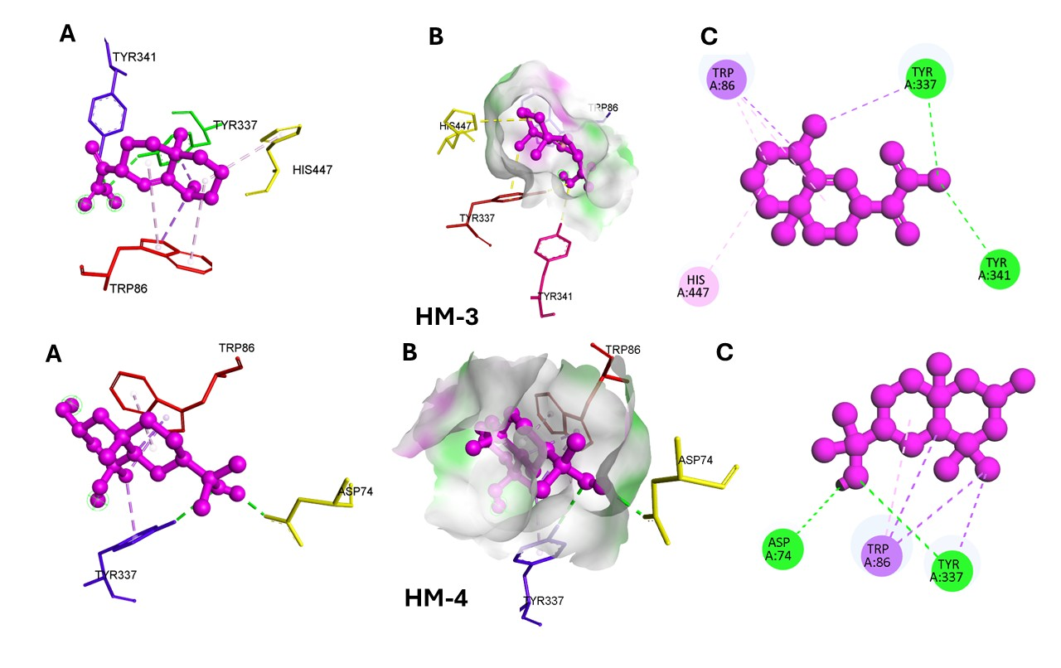
S1 (A) 3D view of amino acid interaction (B) Hydrogen Bond interaction view (C) 2D amino acid interaction view of 4EY6 with HM-3 and HM-4.

*****************************************************************************

Acknowledgements
This work was supported and funded by the Deanship of Scientific Research at Imam Mohammad Ibn Saud Islamic University (IMSIU) (grant number IMSIU-DDRSP2601).
Author contributions
Conceptualization Hamza Iftikhar, Muhammad Mohsin Ejaz, ; original draft writing and editing: Hamza Iftikhar, Muhammad Mohsin Ejaz and Sadaf Ashraf, Reviewing Saira Khan, Nazia Meer, and Musarat Riaz Formal analysis, Funding acquisition K.S. Al-Namshah, Muhammad Saleem, Resources: Saira Khan Data validation, data curation: Muhammad Saleem.
Funding
Authors are thankful to the Higher Education Commission (HEC) for the NRPU Research Grant No. 15788.
Conflict of interest
The authors declare no competing interests.
Data availability
The data presented in the current study will be available on demand.
Ethical approval
Not applicable.
Statement of human and animal rights
Not applicable.
Statement of informed consent
Not applicable.

