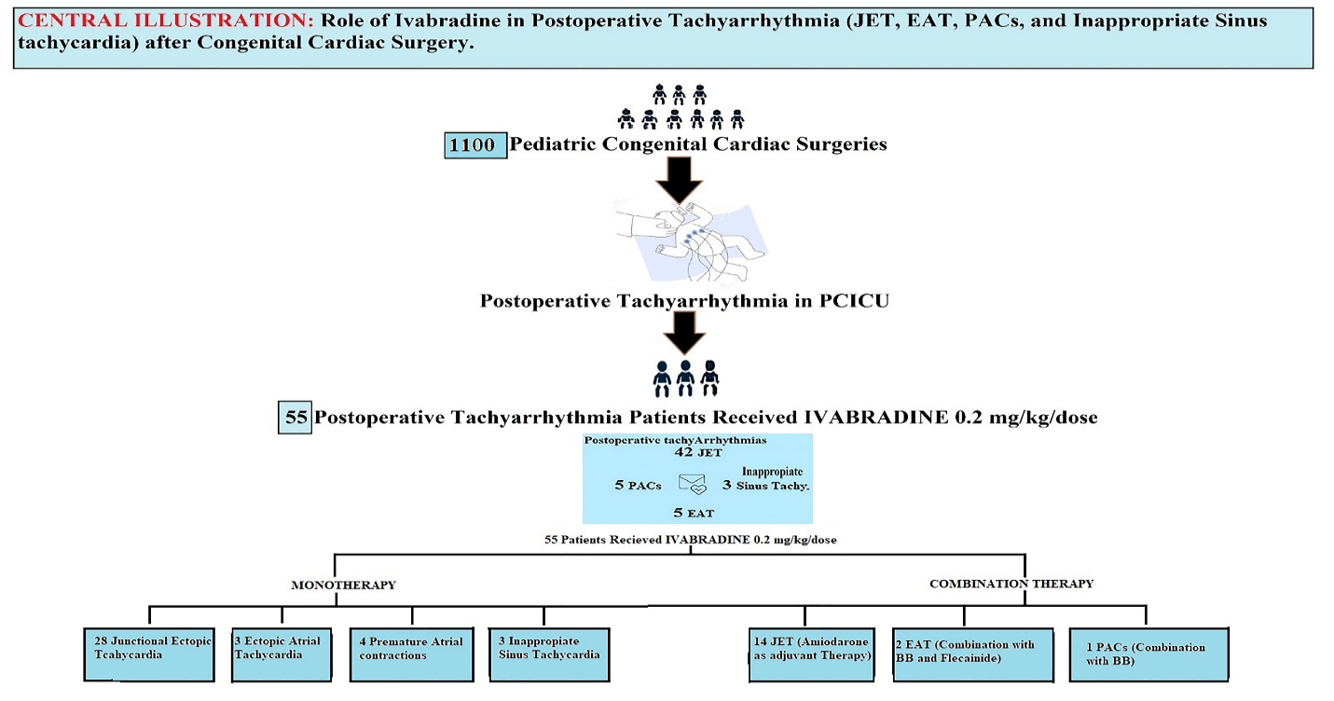
Central illustration: Use of Ivabradine in Post-operative tachyarrhythmias in Congenital Cardiac Surgeries: A Single Center Experience. Representing the use of ivabradine alone or in combination with other antiarrhythmic medications in postoperative tachyarrhythmias (Junctional ectopic tachycardia, inappropriate sinus tachycardia, ectopic atrial tachycardia, and premature atrial contractions).

