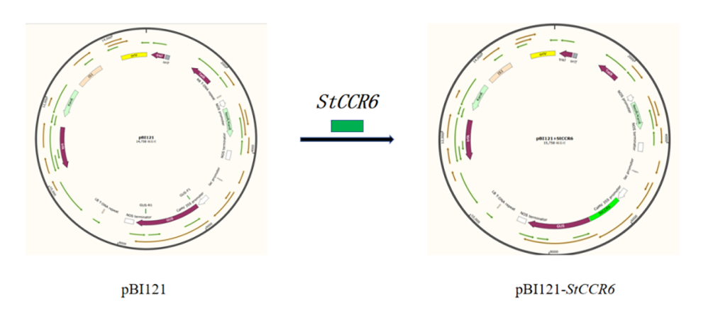
Fig. S1 - Construction of the overexpression vector pBI121-StCCR6.
The StCCR6 coding sequence was amplified from the T3-StCCR6 plasmid using primers with added BamHI and SmaI restriction sites (Table S2), and ligated into the BamHI/SmaI-digested pBI121 binary vector. The recombinant plasmid pBI121-StCCR6 was verified by colony PCR, Sanger sequencing, and double-enzyme digestion, and subsequently introduced into Agrobacterium tumefaciens strain GV3101.

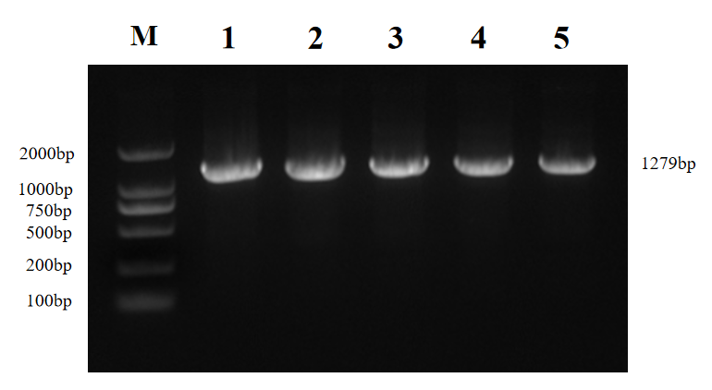
Fig. S2 - PCR products of the dsDNA fragments to be digested.
M, DL2000 DNA marker; lanes 1–5, PCR products of the dsDNA fragments.
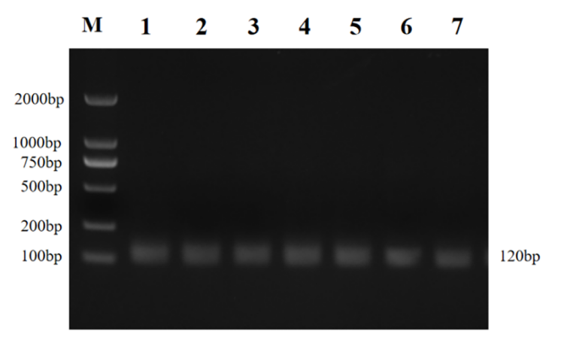
Fig. S3 - PCR verification of the target-site gRNAs.
M, DL2000 DNA marker; lanes 1–5, PCR products of the five target-site gRNAs; lanes 6–7, PCR products of the standard gRNAs.
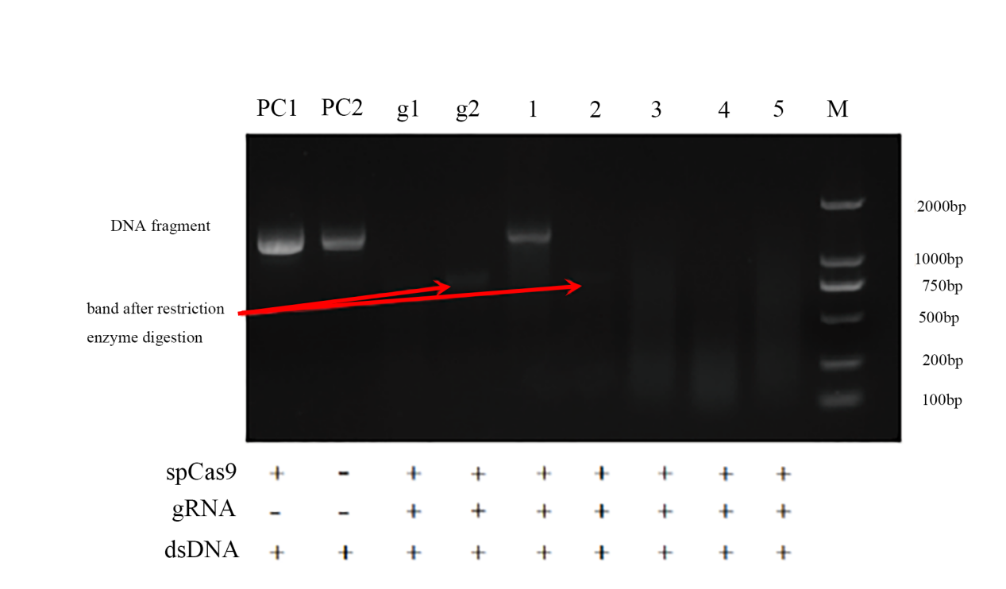
Fig. S4 - In vitro digestion of the target sites.
M, DL2000 DNA marker; lanes 1–4, restriction digestion of the four target sites; g1 and g2, restriction digestion of the standard gRNAs; PC1 and PC2, restriction digestion of the positive controls.

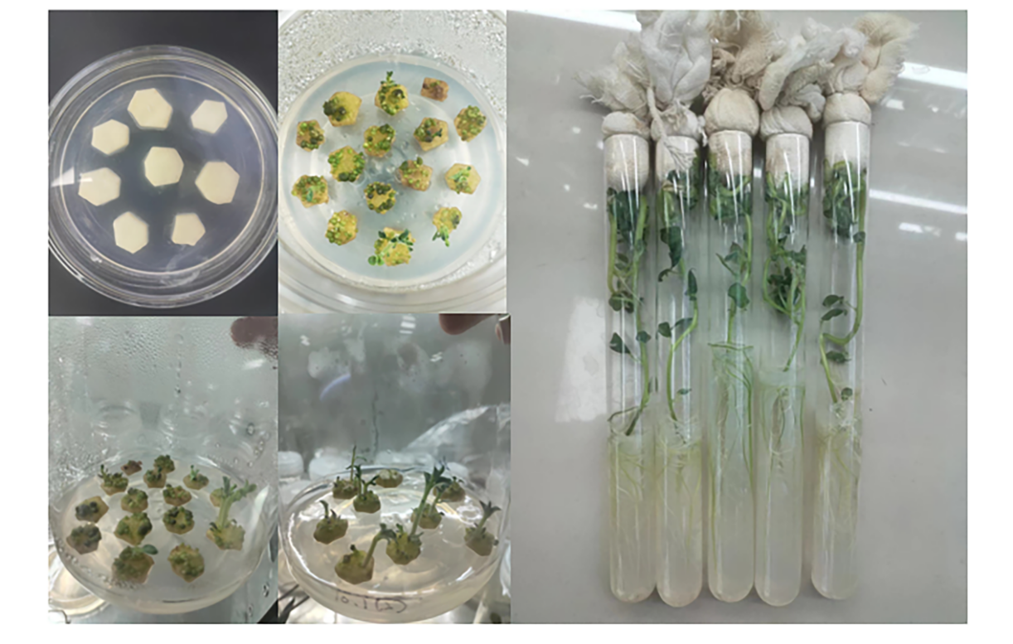
Fig. S5 - Genetic transformation and regeneration of potato chips in vitro.
Sterile plantlet-derived minitubers were sliced into 1–2 mm thick chips, pre-cultured on 1/4 MS medium for 2 d, and infected with Agrobacterium tumefaciens GV3101 carrying the pBI121-StCCR6 vector. Infected chips were transferred to shoot-induction medium containing kanamycin (50 mg/L); regenerated shoots (1–2 cm) were elongated and rooted on MS medium supplemented with CCC (50 mg/L) and kanamycin (75 mg/L).
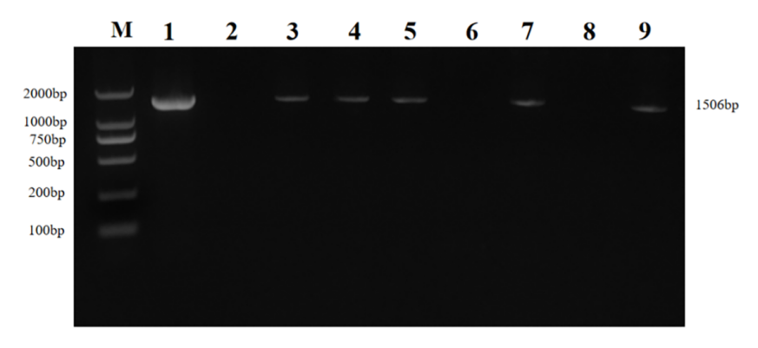
Fig. S6 - PCR identification of vector-specific fragments of StCCR6-overexpressing plants.
M, DNA molecular weight marker (DL2000); lane 1, wild-type; lane 2, positive control; lanes 3–10, StCCR6-overexpressing plants.

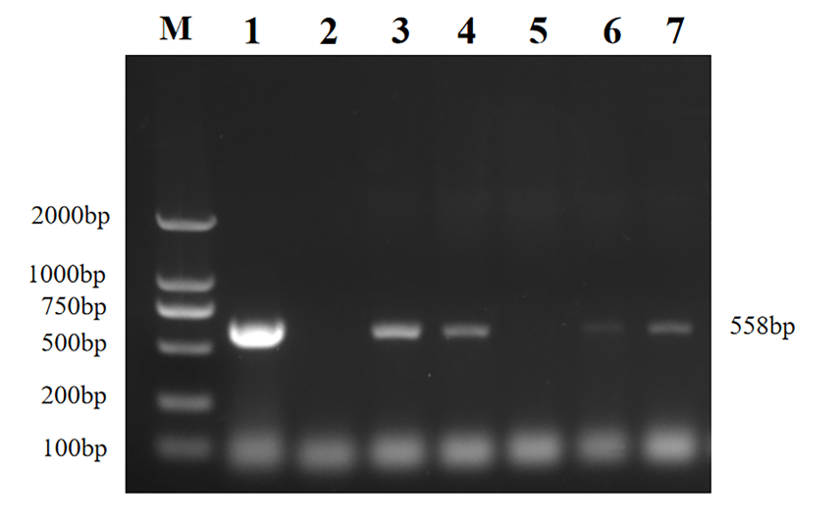
Fig. S7 - PCR identification of the hygromycin resistance gene in transgenic plants.
Transgenic plants were identified by PCR amplification of the hygromycin resistance gene using primers Hygjc2-F and Hygjc2-R.

