Supporting information
Table S1. Prevention service coverage among key populations, 2021-2025.
Key population | Year | Number of individuals reached | Population Size Estimation (PSE)* and year | Coverage against PSE (%)
MSM | 2021 | 34877 | 87817 (2019) | 39.7%
MSM | 2022 | 45920 | 87817 (2019) | 52.3%
MSM | 2023 | 56448 | 93985 (2023) | 60.1%
MSM | 2024 | 73144 | 93985 (2023) | 77.8%
MSM | 2025 | 74964 | 93985 (2023) | 79.8%
TG | 2021 | 6978 | 21019 (2021) | 33.2%
TG | 2022 | 8654 | 21340 (2022) | 40.6%
TG | 2023 | 9622 | 21659 (2023) | 44.4%
TG | 2024 | 16909 | 21981 (2024) | 76.9%
TG | 2025 | 20072 | 21981 (2024) | 91.3%
FEW | 2021 | 28757 | 51215 (2016) | 56.1%
FEW | 2022 | 37517 | 52338 (2022) | 71.7%
FEW | 2023 | 43631 | 52338 (2022) | 83.4%
FEW | 2024 | 47846 | 52338 (2022) | 91.4%
FEW | 2025 | 52444 | 52338 (2022) | 100.2%
PWID | 2021 | 816 | 3202 (2017) | 25.5%
PWID | 2022 | 842 | 3202 (2017) | 26.3%
PWID | 2023 | 833 | 3202 (2017) | 26.0%
PWID | 2024 | 951 | 1313 (2024) | 72.4%
PWID | 2025 | 902 | 1313 (2024) | 68.7%

FEW: Female Entertainment Workers, MSM: men who have sex with men, PWID: people who inject drugs, TG: transgender people
*PSE is the latest available data for each key population

Table S2. Treatment and diagnostic indicators for adults aged 15 years or older by province in Cambodia, 2024 data.
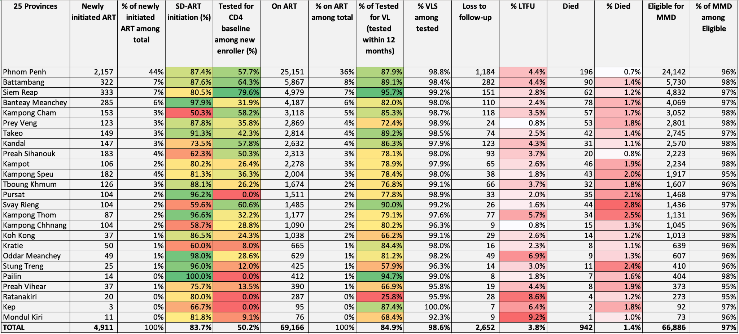
ART: Antiretroviral therapy, LTFU: Lost to follow-up, MMD: multi‑month dispensing, SD-ART: Same-day antiretroviral therapy initiation, VL: Viral load, VLS: Viral load suppression,

Table S3. Treatment and diagnostic indicators for children aged between 0 and 14 years by province in Cambodia, 2024 data.
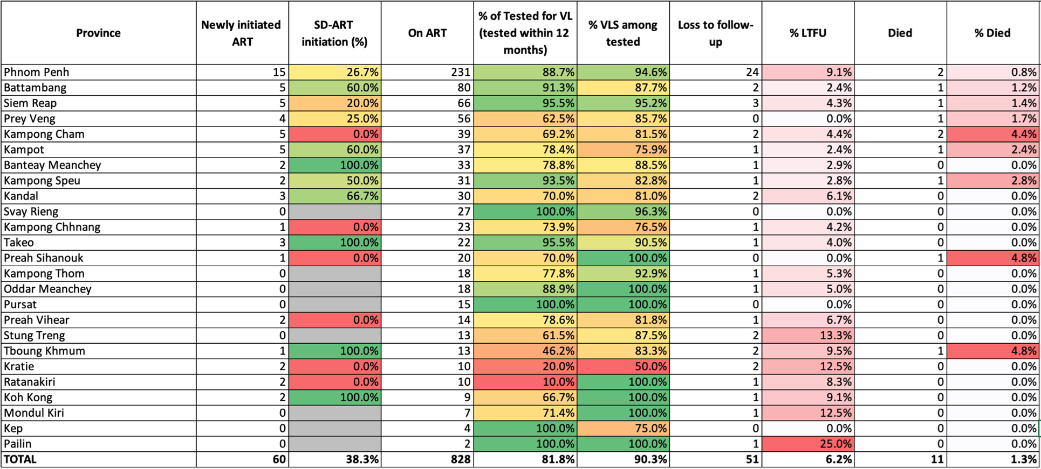
ART: Antiretroviral therapy, LTFU: Lost to follow-up, SD-ART: Same-day antiretroviral therapy initiation, VL: Viral load, VLS: Viral load suppression.

