SUPPLEMENTARY INFORMATION
Multimodal Detection for Underwater Cultural Heritage: A Physics-Guided Color-Bias-Aware Network and Dataset
Zigeng Song^{1,†}, Ruifeng Wei^{1,†}, Wang Man^{1*}, Qin Nie¹, Zongmei Li¹, Xiaofeng Du¹, Xinchang Zhang^{1,2}
¹ Institute of Spatiotemporal Intelligence Application and Innovation, College of Computer Science and Technology, Xiamen University of Technology, Xiamen 361021, China
² School of Geographical Sciences, Guangzhou University, Guangzhou 510006, China
Corresponding author: Wang Man (manwang@xmut.edu.cn)
† These authors contributed equally to this work.

Supplementary

Supplementary Note 1. Color-Bias-Aware Fusion Module (CBFM)
Spatially nonuniform color shifts in underwater images weaken the discriminative features of the RGB modality. To address this issue, this paper proposes a Color-Bias-Aware Fusion Module (CBFM). The module extracts prior features related to spatial distance and geometric structure to enhance the distance awareness of the model and performs adaptive color-bias compensation on RGB features at different spatial locations.
The architecture of CBFM is shown in Fig.S1. Its inputs include the current-layer RGB feature $X∈ℝ^{C×H×W}$, the depth feature $Y∈ℝ^{C×H×W}$ at the same level, and the RGB reference feature $\text{Ref}∈ℝ^{C_{r}×H×W}$ from the preceding stage. Here, H and W denote the spatial dimensions of the target feature, and C denotes the number of channels. The module first applies 1×1 convolutions to the current RGB and depth features for channel projection, such that all three inputs have a unified channel dimension of dim. In this study, dim is set to the channel dimension C of the current RGB feature X. When X and the corresponding depth feature Y already have the same number of channels, the channel projection is implemented as an identity mapping.
- The first stage is physical prior extraction. The preceding RGB reference feature Ref is fed into the Physical Prior Extractor (PPE). PPE first maps the input channels to dim through a 1×1 convolution to obtain the embedded feature E:
$$E={Conv}_{1×1}\left(Resize\left(\text{Ref};H,W\right)\right)$$ | (1)
As illustrated in Fig.S2, PPE contains four parallel branches to jointly characterize local color bias, regional illumination variation, global imaging conditions, and spatial position. The local spatial branch applies 3×3 and 5×5 depthwise convolutions to extract local response features ${\text{E}}_{\text{1}}$ under different receptive fields. The smaller 3×3 kernel captures local color and texture variations, whereas the larger 5×5 kernel aggregates degradation information over a broader neighborhood. The regional pooling branch adaptively average-pools E to $\text{s}\text{×}\text{s}$ resolutions, where $s∈\{2,3,4\}$, and then restores the pooled features to $\text{H}\text{×}\text{W}$ through bilinear interpolation to obtain ${\text{E}}_{\text{2}}$:
$$E_{2}={Conv}_{1×1}\left(Upsampling\left({MsAP}_{s}\left(E\right)\right)\right), s∈\{2,3,4\}$$ | (2)
${MsAP}_{s}\left(·\right)$ denotes Multi-Scale Adaptive Pooling with an output resolution of $\text{s}\text{×}\text{s}$, and $Upsampling\left(·\right)$ denotes bilinear interpolation that restores the feature map to the spatial resolution $\text{H}\text{×}\text{W}$.
The global statistics branch applies Global Average Pooling (GAP) and Global Max Pooling (GMP) to E, producing two feature tensors of size $\text{dim}×1×1$. These features are concatenated along the channel dimension, projected to dim channels through a 1×1 convolution, and activated using SiLU to obtain ${\text{E}}_{\text{3}}$. GAP characterizes the overall response level, while GMP preserves salient responses. Together, they provide statistical information associated with global illumination and color-bias conditions. The positional encoding branch constructs normalized coordinate maps within the range [-1,1], using two channels to encode the horizontal and vertical coordinates, respectively. The coordinate maps are then processed sequentially by Batch Normalization, 1×1 convolution, and SiLU activation to obtain the positional feature ${\text{E}}_{\text{4}}$.
The embedded feature E and the outputs of the four branches are concatenated along the channel dimension and sequentially processed by a 1×1 convolution, Batch Normalization, and SiLU activation to obtain the RGB physical prior representation PriorContext. The channel dimension of PriorContext is then expanded to 2×dim and split along the channel dimension into a scale parameter Scale and a bias parameter Bias:
$$\text{PriorContext}=SiLU\left(BN\left({Conv}_{1×1}\left(\left[E,E_{1},E_{2},E_{3},E_{4}\right]\right)\right)\right)$$ | (3)
- The second stage is physical prior constraint. The scale parameter Scale and bias parameter Bias produced by PPE are used to construct the corrected RGB feature ${\text{X}}_{\text{c}\text{orrected}}$ as follows:
$$S=1+αtanh\left(\text{Scale}\right), B=βtanh\left(\text{Bias}\right)$$ | (4)
$$X_{\text{corrected}}=X⊙S+B$$ | (5)
α and β control the adjustment ranges of the multiplicative gain and additive bias, respectively, and $\text{⊙}$ denotes element-wise multiplication. Because the output of $tanh\left(⋅\right)$ lies within (-1,1), the corresponding parameters are bounded by $\text{S}\text{∈(1-}\text{α}\text{,1+}\text{α}\text{)}$ and $\text{B}\text{∈(-}\text{β}\text{,}\text{β}\text{)}$. This bounded parameterization constrains the correction magnitude and reduces the risk that the physical-prior branch introduces excessive numerical perturbations into the RGB features. In the experiments, the two hyperparameters are set to α=0.5 and β=0.1.
- The third stage is spatial-channel attention guidance. The corrected RGB feature ${\text{X}}_{\text{c}\text{orrected}}$ is added to the depth feature Y to obtain an initial cross-modal representation. Fusion guidance is then constructed from spatial, channel, and physical-prior information.
The Spatial Attention module (SA) computes average pooling and max pooling along the channel dimension, concatenates the resulting maps, and applies a 7×7 convolution with reflection padding to generate the spatial guidance feature ${\text{A}}_{\text{s}}\text{∈}{\text{R}}^{\text{B}\text{×1×}\text{H}\text{×}\text{W}}$, which characterizes the importance of different spatial locations. The Channel Attention module (CA) first applies global average pooling to obtain a channel descriptor and then uses two 1×1 convolutions for channel reduction and restoration, producing the channel guidance feature ${\text{A}}_{\text{c}}\text{∈}{\text{R}}^{\text{B}\text{×}\text{dim}\text{×1×1}}$. The channel reduction ratio is set to r=8 in the experiments. This branch models the relative contribution of different feature channels. Finally, the spatial guidance, channel guidance, and PriorContext are combined to obtain the comprehensive guidance feature A.
- The fourth stage is pixel-attention gated fusion. The Pixel Attention module (PA) takes the initial cross-modal feature and the comprehensive guidance feature A as inputs. Their corresponding channels are stacked pairwise and rearranged into a $\text{2}\text{dim}\text{×}\text{H}\text{×}\text{W}$ grouped representation. A 7×7 grouped convolution with dim groups is then applied, followed by a Sigmoid function, to generate the channel-aware pixel-level gating matrix M. This operation preserves the channel correspondence between modalities while using local neighborhood information to estimate the fusion weight of each channel at different spatial locations. Finally, complementary gating is used to perform weighted bimodal fusion:
$$F=X_{\text{corrected}}⊙M+Y⊙\left(1−M\right)$$ | (6)
For a given channel and spatial location, a gating value close to 1 causes the fused feature to retain more texture information from the corrected RGB feature, whereas a value close to 0 assigns greater importance to the geometric structure provided by the depth feature. In this way, the module adaptively allocates the contributions of the two modalities within a unified feature space.
As shown in Fig.2, UCH-Net places two CBFM modules at the end of the dual-stream backbone and after the third C3k2 module, corresponding to high-level and intermediate-level features, respectively. Both CBFM modules fuse RGB and depth features at the same spatial scale and use early features from the RGB branch as the shared reference for color-bias prior estimation.
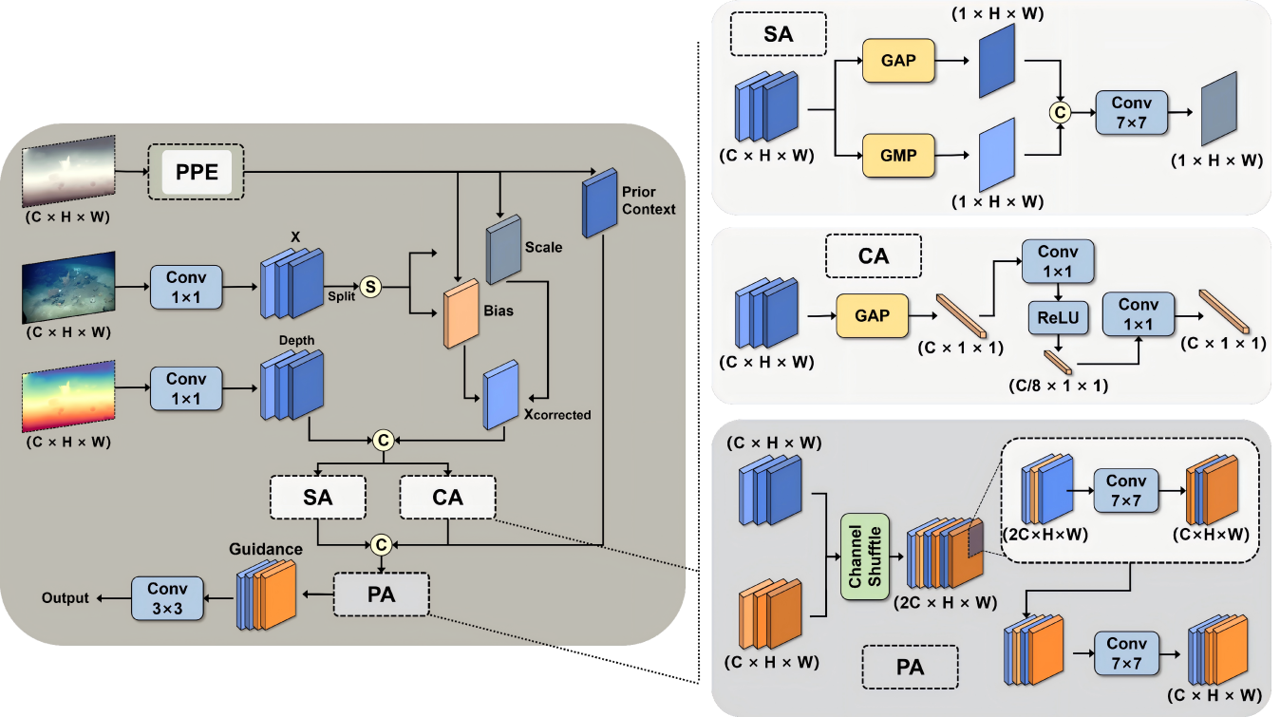
Supplementary Fig. S1 | CBFM(Color-Bias-Aware Fusion Module)
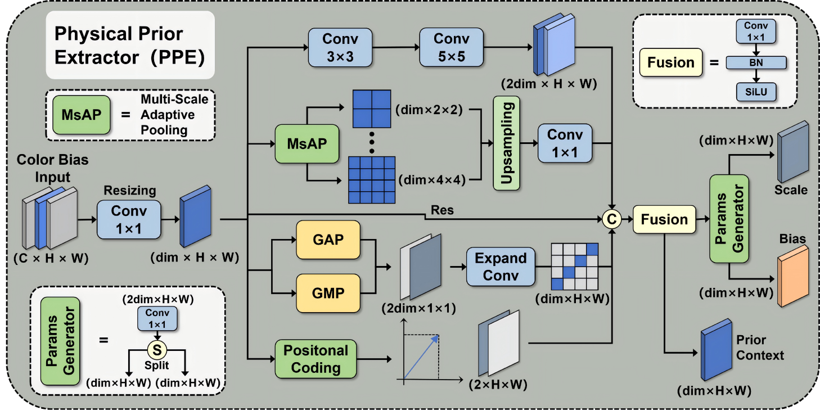
Supplementary Fig. S2 | PPE(Physical Prior Extractor).

Supplementary Note 2. Training hyperparameters and loss formulation
The main hyperparameters of UCH-Net are configured as follows: the physical-prior gain strength scale_strength is set to 0.5, the physical-prior bias strength bias_strength is set to 0.1, and the channel reduction ratio in the attention module is set to 8. The total loss is defined as a weighted sum of the classification loss ${\text{L}}_{\text{cls}}$, bounding-box regression loss ${\text{L}}_{\text{box}}$, and Distribution Focal Loss ${\text{L}}_{\text{dfl}}$:
$${\text{L}}_{\text{total}}\text{=}{\text{λ}}_{\text{cls}}{\text{L}}_{\text{cls}}\text{+}{\text{λ}}_{\text{box}}{\text{L}}_{\text{box}}\text{+}{\text{λ}}_{\text{dfl}}{\text{L}}_{\text{dfl}}$$ | (7)
where ${\text{λ}}_{\text{cls}}$, ${\text{λ}}_{\text{box}}$, and ${\text{λ}}_{\text{dfl}}$ denote the weights of the three loss terms and are set to 0.5, 8.5, and 1.5, respectively. The classification loss ${\text{L}}_{\text{cls}}$ adopts Binary Cross-Entropy (BCE) Loss, where each category is treated as an independent binary classification task. The bounding-box regression loss ${\text{L}}_{\text{box}}$ adopts Complete Intersection over Union (CIoU) Loss, which jointly considers the overlap between the predicted and ground-truth boxes, the distance between their center points, and the consistency of their aspect ratios.
$${\text{L}}_{\text{dfl}}\text{=-}\left[\left({\text{y}}_{\text{i}\text{+1}}\text{-}\text{y}\right)\text{log}{\hat{\text{P}}}_{\text{i}}\text{+}\left(\text{y}\text{-}{\text{y}}_{\text{i}}\right)\text{log}{\hat{\text{P}}}_{\text{i}\text{+1}}\right]$$ | (8)
The Distribution Focal Loss ${\text{L}}_{\text{dfl}}$ is computed by optimizing the probabilities associated with the two discrete grid values ${\text{y}}_{\text{i}}$ and ${\text{y}}_{\text{i}\text{+1}}$ that are closest to the continuous target y, where ${\hat{\text{P}}}_{\text{i}}$ and ${\hat{\text{P}}}_{\text{i}\text{+1}}$ denote the Softmax probabilities predicted by the network at these two discrete positions, respectively. This loss represents continuous bounding-box coordinates as discrete probability distributions, allowing the model to characterize the probability density around the target coordinates.

