Table 1: The analytic geometry classroom scenario
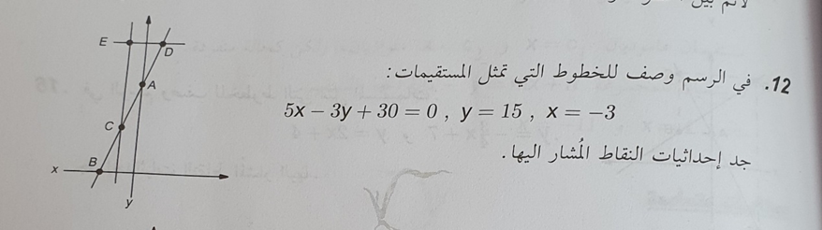
The following situation took place in a 12th-grade mathematics classroom in a 3-unit level class, with 20 students. The topic was “analytic geometry”. In the first part of the lesson, the student Vered asked the teacher to solve homework question 12, because she had struggled to match the equations to the given lines.
Question 12 Pictured are 3 equations:
x=-3, y= 15, 5x - 3y + 30 = 0
Find the x and y values of the points marked in the picture.
After discussing the solution to the question as a class, the teacher turned to the class and asked: What about the equation x=-3, does it represent a linear function?
1 | Teacher | Very nice. I see that you’ve reached an agreement that the equation $y=15$ represents a line parallel to the x-axis, and that the equation $x=-3$ represents a line parallel to the y-axis.  Yuval, you explained very nicely that $y=15$ is a constant linear function and that its slope is zero. What about the equation $x=-3$, does it represent a linear function?
2 | Adam | I think that it’s a constant linear function; we can clearly see that it’s a straight line, but the difference between it and $y=15$ is that it’s parallel to the y-axis.
3 | Students | Yes, it’s a linear function.
4 | Zuhair | No, Adam, it’s not a function at all.
5 | Teacher | Zuhair, I’m really glad you’re joining the discussion. Can you please explain your claim?
6 | Zuhair | According to the definition of a function: “for each x there is a single unique y,” and on the line $x=-3$ that’s not true. I drew it in my notebook.
7 | Teacher | Can you please draw it on the board?
8 | Zuhair | I’d rather not.
9 | Teacher | Come on, don’t be shy, come up here so that we can all understand what you’re saying.
10 | Zuhair | [Zuhair draws on the board and explains:]  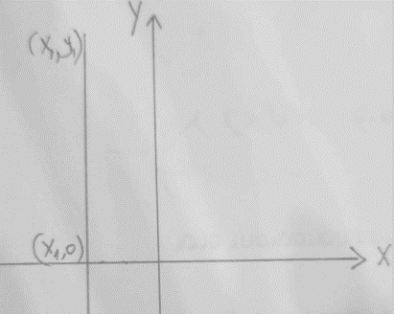  According to the definition of a function, each x has a single unique y. If we take a random point on the given line [he marks (x₁,0)] and another point on the line (x₁,y₁) [marks this as well], they will have the same x value. So, on this line each x has more than one y, and therefore it isn’t a function.
11 | Yana | I don’t agree with you.
12 | Zuhair | Come on, Yana, this time there’s nothing to argue; this is a definition we learned in 8th grade.
13 | Hala | I agree with Zuhair, can I explain why?
14 | Teacher | Just a minute, Hala, let’s go with Yana first.  Yana, can you explain why you don’t agree with Zuhair.  [2 minutes of silence]  I see that it’s quiet. OK, what do you all think?
15 | Yana | Wait, teacher, give us another few minutes to think?
16 | Teacher | OK, take another few minutes to think. Students, you can try to figure it out together.
17 | The teacher walks around among the students  [after 5 minutes]
18 | Teacher | Yana and Ali, I see that you’re trying to reach a conclusion! Did you succeed?
19 | Yana and Ali | Yes, we’re trying.
20 | Teacher | What do you think about sharing what you’ve done so far with the class?
21 | Ali | Yes, gladly! Yana thought that if we find the slope of two points, that would help her to decide if it’s a function, so I suggested that we use the formula for finding the slope of a line. If we take the two points that Zuhair marked on the line parallel to the y-axis, and try to calculate the slope of the line, we get  $$m=\frac{(y1-0)}{(x1-x1) }=\frac{y1}{0}$$  That’s where we stopped. It’s not clear what we got, maybe you can help us guys!
22 | Teacher | Good for you, you did nice work!  You got an expression that is not defined. Who can explain the result in terms of the slope?
23 | Maya | Right, teacher, we learned that dividing by zero is not defined, so the slope that they got, $\frac{y1}{0}$, is not defined. That means it is not a function, and definitely not a linear function.
24 | Yana | You’re right, Zuhair, it is not a function. I was wrong!
25 | Khaled | Cool, teacher, my idea was right! I want to share what I did; can I?
26 | Teacher | Yes, of course! Please share with us, Khaled.
27 | Khaled | I also used the graph, I wanted to find the rate of change of the line by drawing a “step” that’s the slope, but I didn’t manage to do that. Now I understand from Yana and Ali’s use of the formula for finding the slope that this line doesn’t have a slope because the expression wasn’t defined, so it’s not a linear function.
28 | Teacher | Can we conclude that the equation $x=-3$ isn’t a function?
29 | Students | Yes.
30 | Teacher | Good for you, students, you did excellent work!
The teacher moves on to the next exercise.

