Supplementary information for
Wind Damping of Internal Tides in the Global Ocean
Yuxun Liu¹, Zhiyu Liu^{1*}, Dong Wang¹ & Chuanyin Wang²
¹State Key Laboratory of Marine Environmental Science, and Department of Physical Oceanography and Meteorology, College of Ocean and Earth Sciences, Xiamen University, Xiamen, China
²Southern Marine Science and Engineering Guangdong Laboratory (Zhuhai), Zhuhai, China

*Correspondence to: Zhiyu Liu, zyliu@xmu.edu.cn

Supplementary Methods
Two-way coupled ocean-atmosphere simulation
We additionally used the global coupled ocean-atmosphere simulation (COAS) described by Torres et al.²⁴ COAS couples the Goddard Earth Observing System (GEOS) atmospheric model with the Massachusetts Institute of Technology General Circulation Model (MITgcm). The atmospheric component uses the C1440 cubed-sphere configuration with a nominal horizontal grid spacing of 6.9 km and 72 vertical levels, whereas the ocean component uses the LLC2160 configuration with a nominal horizontal resolution of 1/24° and 90 vertical levels. The ocean model includes tidal forcing, allowing the generation and propagation of ITs.
The atmosphere and ocean are coupled every 45 s, with momentum, heat and freshwater exchanged across the air-sea interface. The coupled formulation accounts for the influence of ocean surface currents on air-sea momentum fluxes, thereby allowing atmospheric adjustment to ocean currents. The simulation spans 14 months, with the first two months excluded as spin-up, and provides hourly three-dimensional oceanic and atmospheric fields over the remaining 12 months. ITs wind work was diagnosed from the coupled simulation following the same procedure as that applied to LLC4320 in the main analysis.

Supplementary Figures

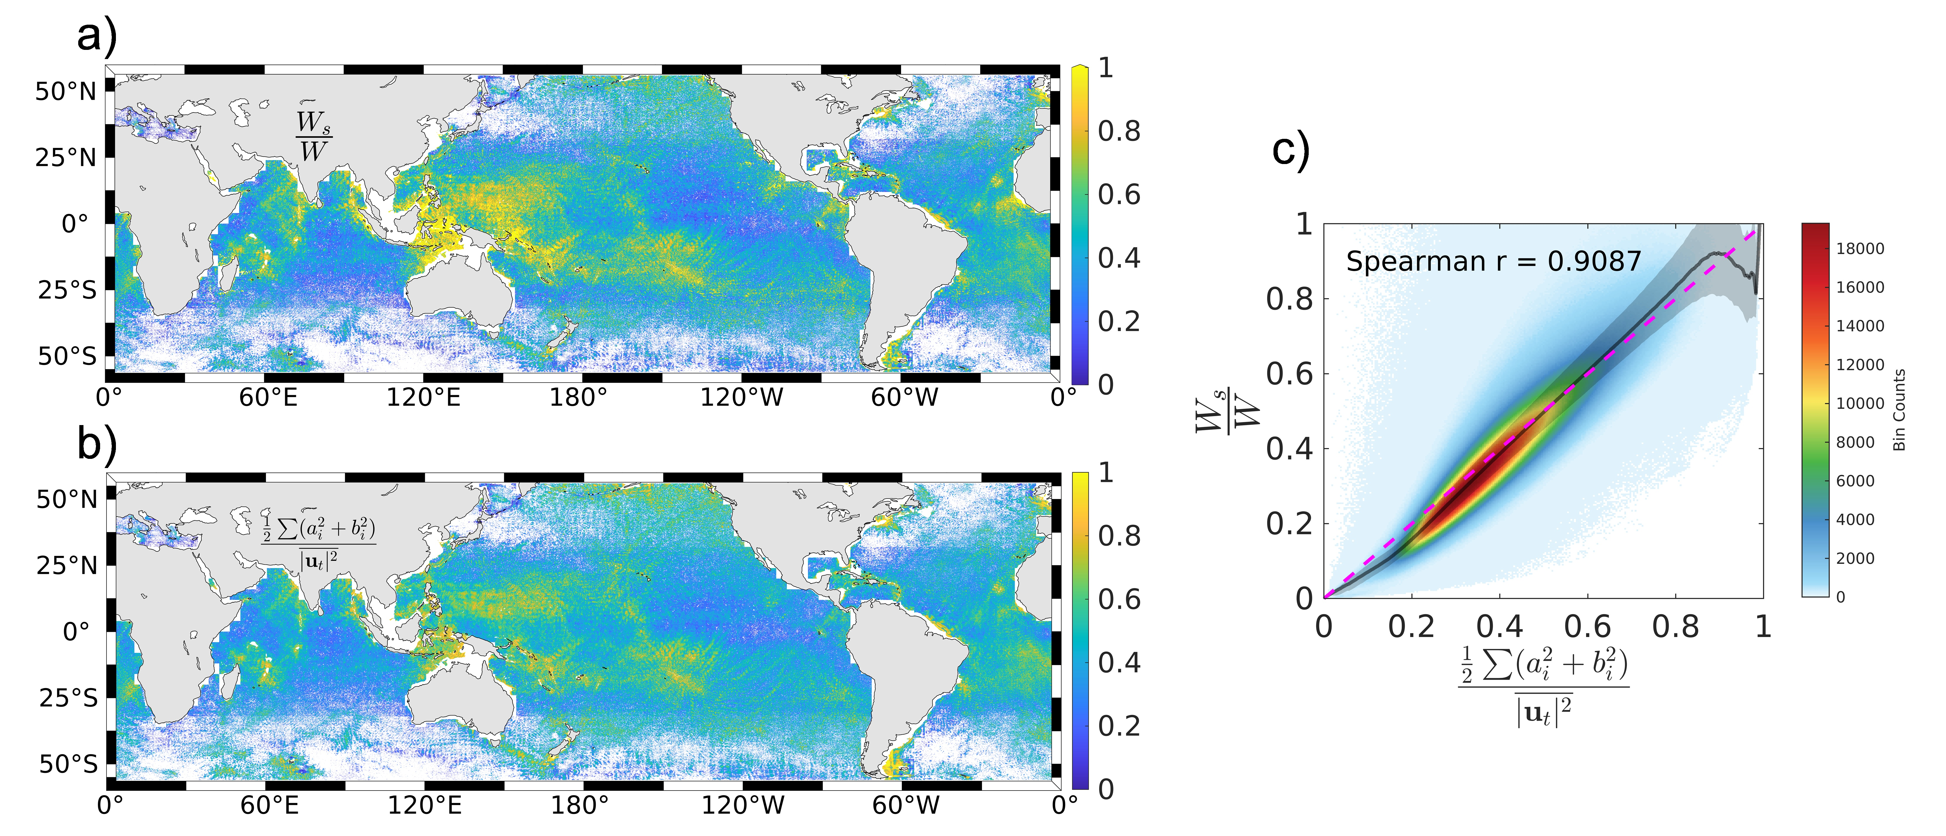
Fig. S1 | Comparison of the wind work and the tidal kinetic energy ratios, highlighting that the discrepancy arises from the incoherent ITs neglected by harmonic analysis. (a) The ratio of the tidally averaged wind work on ITs ${(W}_{s})$ to the directly diagnosed simulation-based wind work $(W)$. (b)The ratio of the summed kinetic energies of individual tidal constituents (derived from harmonic analysis) to the total ITs kinetic energy (calculated from the full ITs velocity). (c) Scatter plot of the two ratios, with the black line and shaded area representing the moving median and the 25th-75th percentile range, respectively. The purple dashed line indicates the 1:1 line.
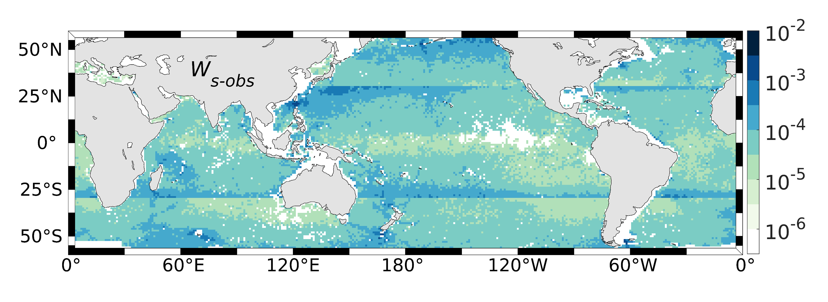
Fig. S2 | Global distribution of observation-based wind damping of ITs estimated using the full semidiurnal and diurnal tidal bands. Unlike the conservative estimate in Fig. 4, which uses only coherent diurnal constituents, this estimate includes the full diurnal-band kinetic energy and yields a globally integrated wind damping of 21.7 GW. The diurnal band also include contributions from non-tidal motions. To reduce the potential contamination from non-tidal diurnal signals, the diurnal-band contribution poleward of the K₁ critical latitude (~30°) is excluded.

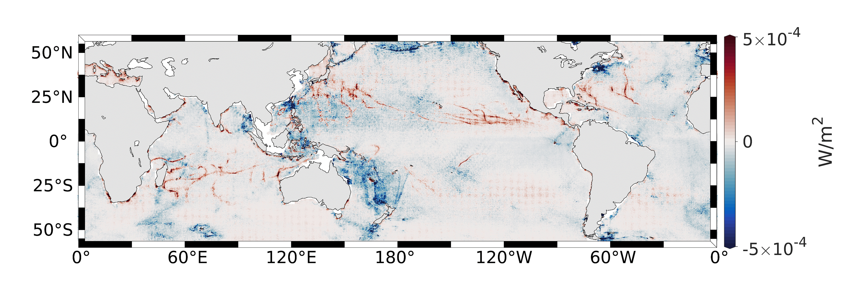
Fig. S3 | Annual wind work on ITs in the fully coupled ocean-atmosphere simulation. Spatial distribution of ITs wind work diagnosed from the fully coupled ocean-atmosphere simulation. Positive and negative values indicate energy transfer to and from ITs, respectively. The globally integrated wind work is -7.7 GW, comprising 4.4 GW of positive wind work and -12.1 GW of negative wind work.
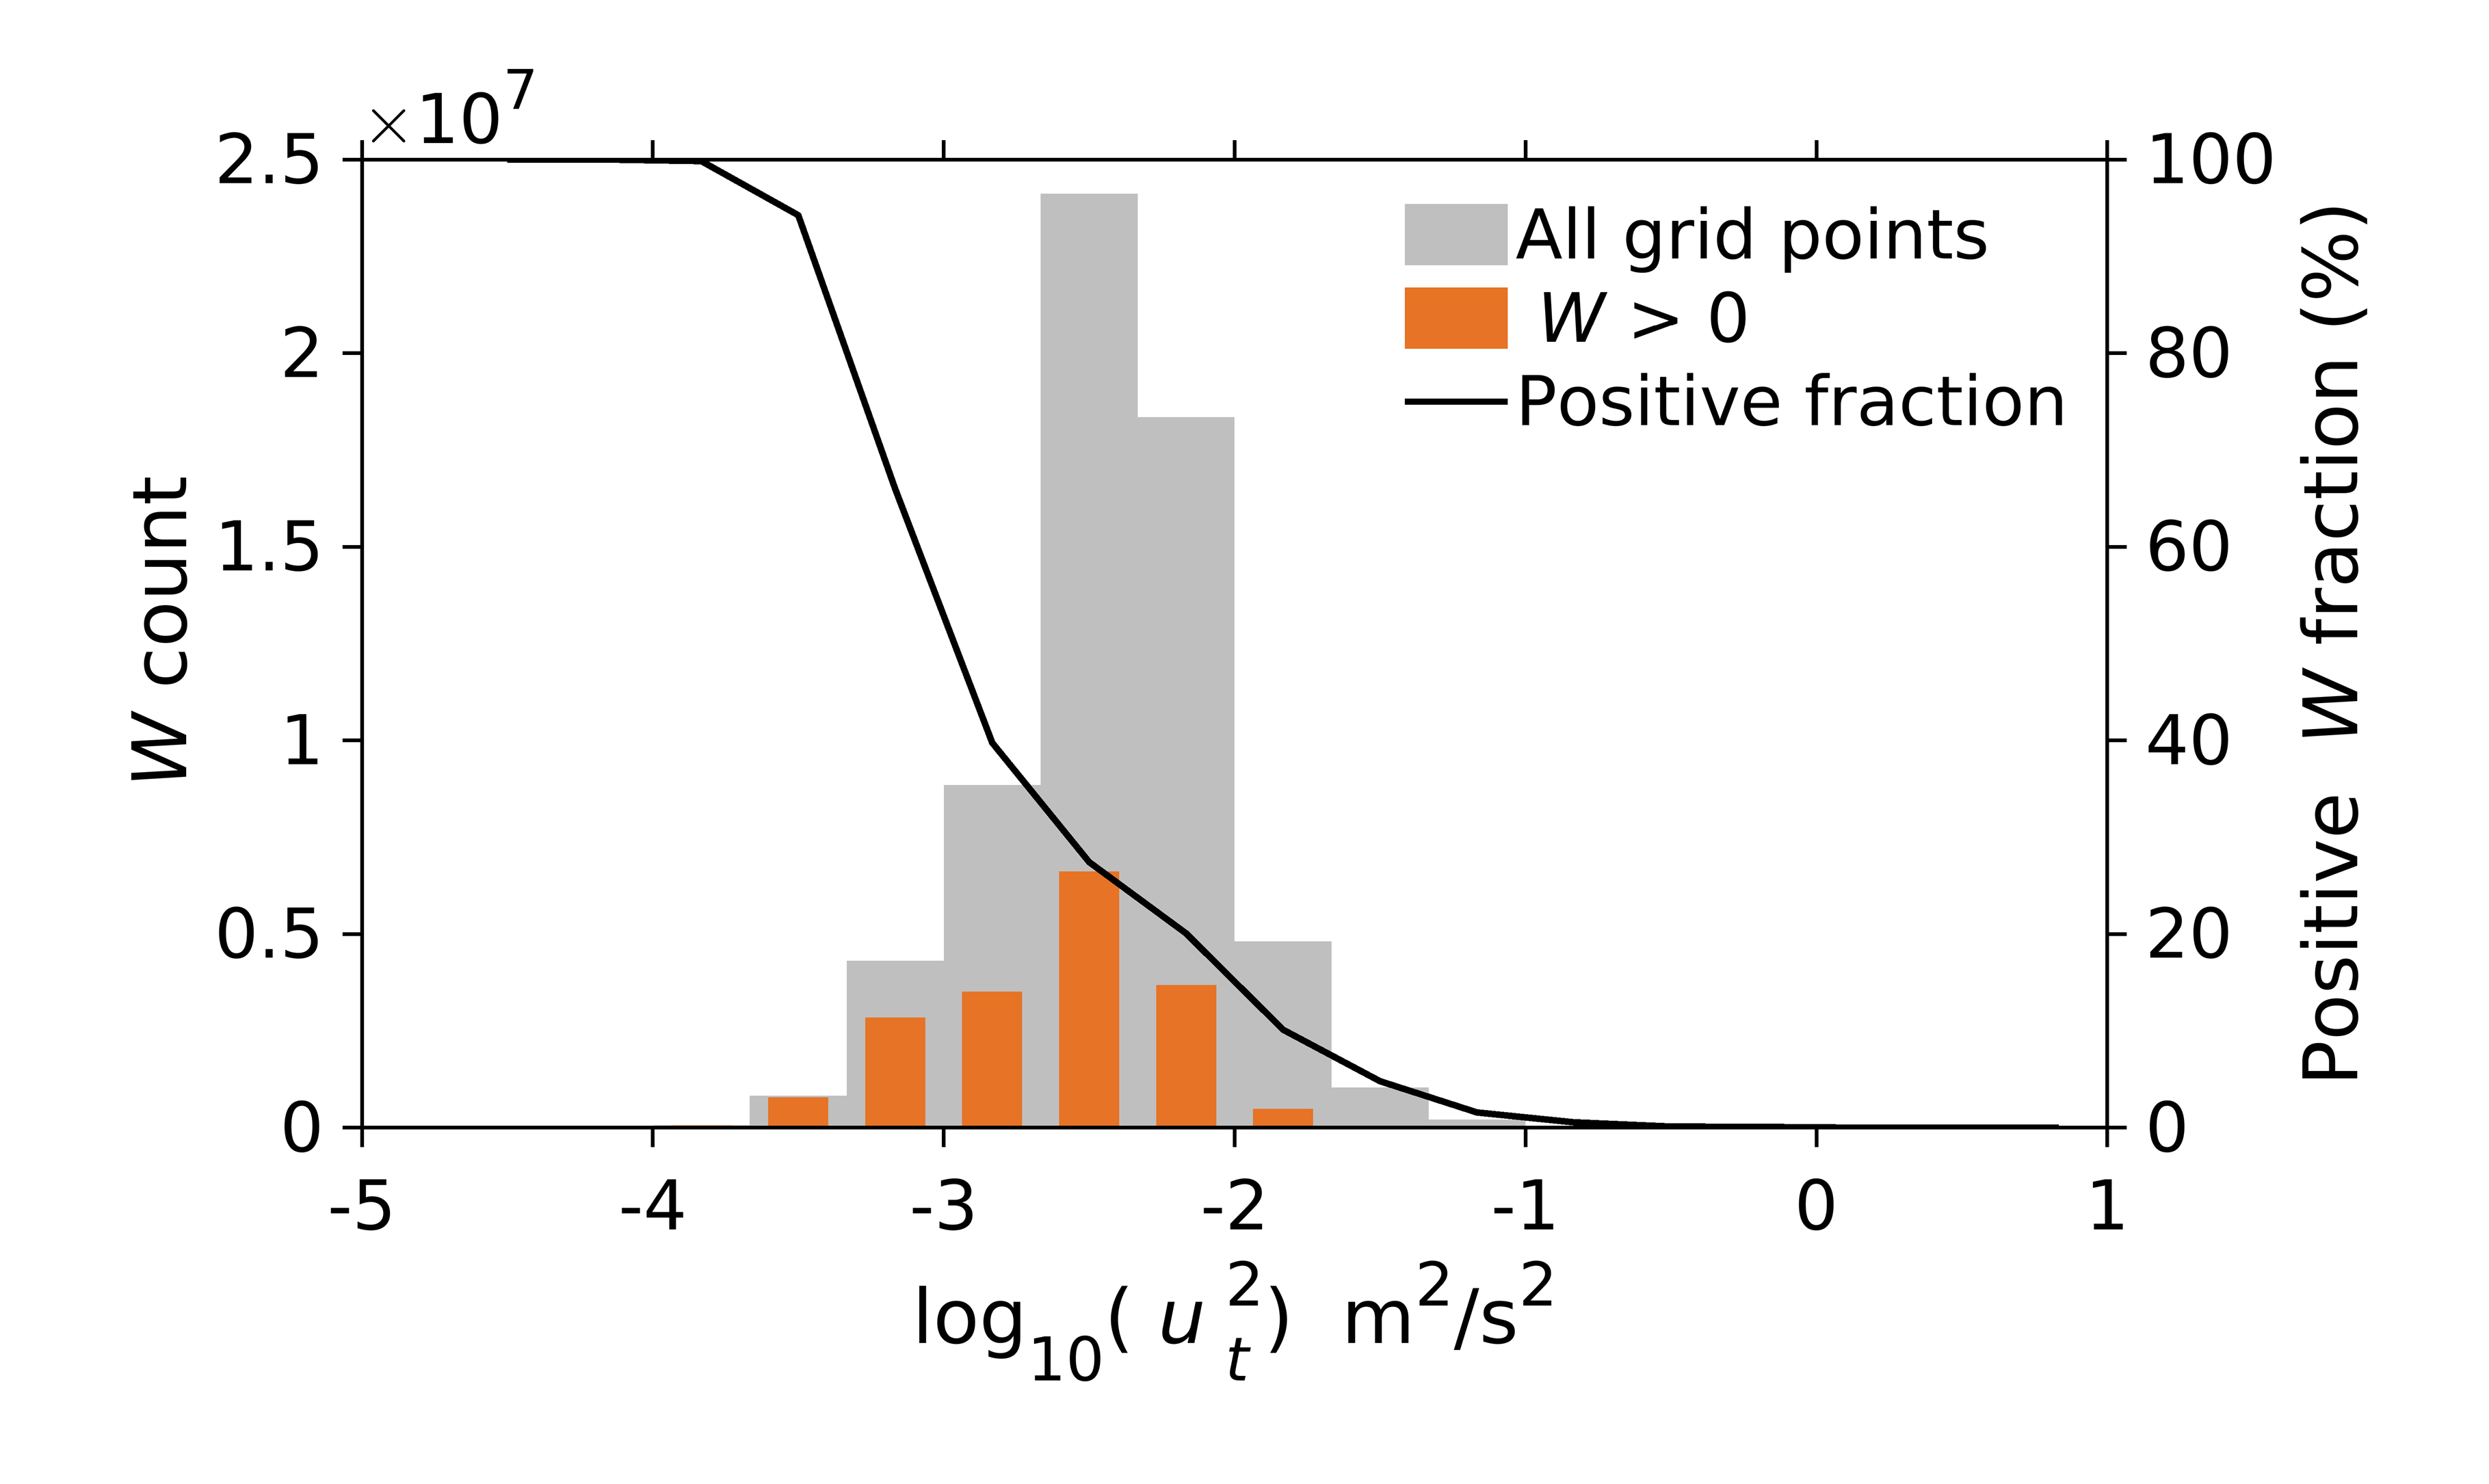
Fig. S4 | Distribution of positive ITs wind work across ITs kinetic energy bins in the fully coupled simulation. Gray bars show the frequency distribution of all grid points according to ocean surface ITs kinetic energy, while orange bars show the distribution for grid points with positive ITs wind work. The black curve indicates the fraction of grid points with positive wind work within each ITs kinetic energy bin.
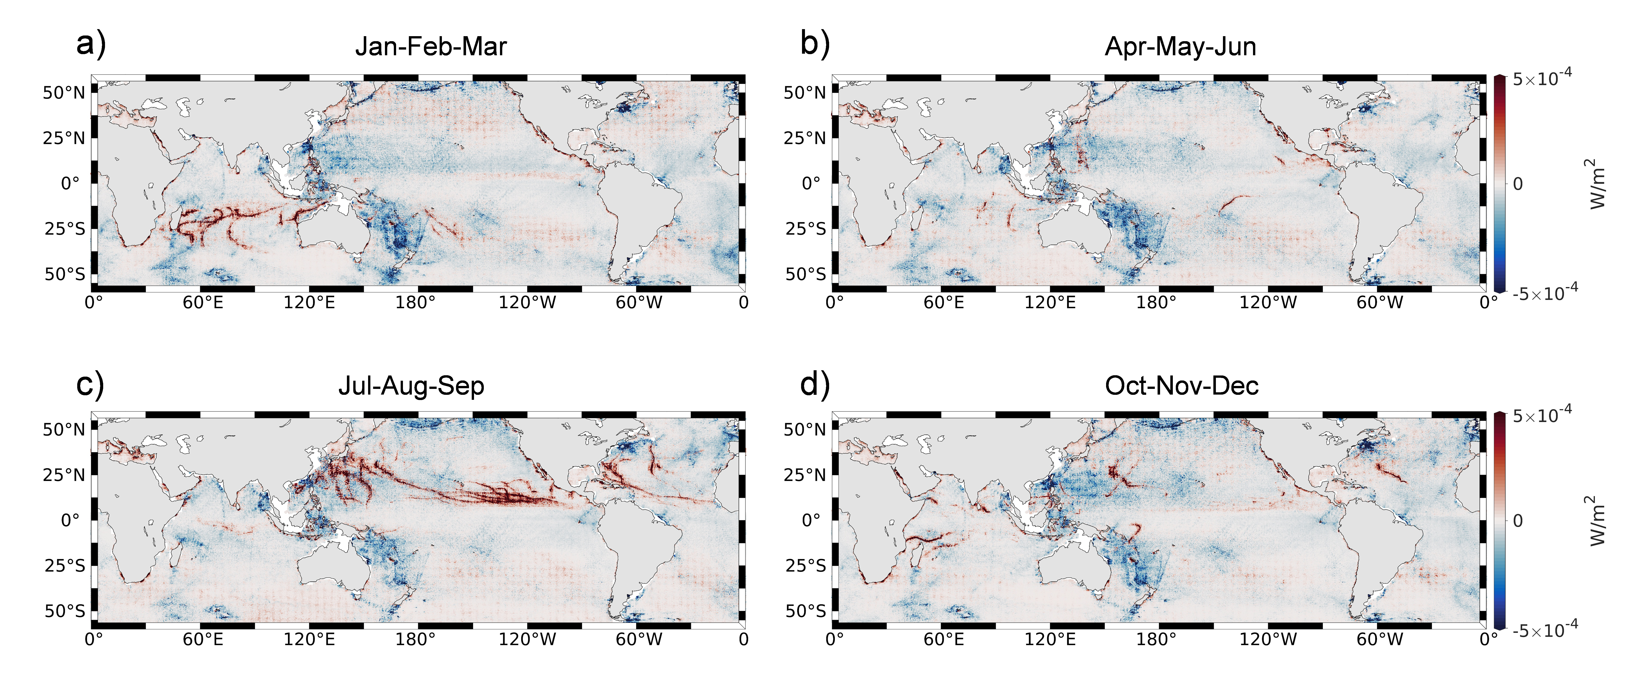Fig. S5 | Seasonal wind work on ITs in the fully coupled ocean-atmosphere simulation. Weak positive values near 30° may partly reflect overlap between the diurnal and near-inertial frequency bands, whereas much stronger positive signals at lower latitudes show pronounced hemispheric seasonality, with enhanced values in the Southern Hemisphere during austral summer and in the Northern Hemisphere during boreal summer. 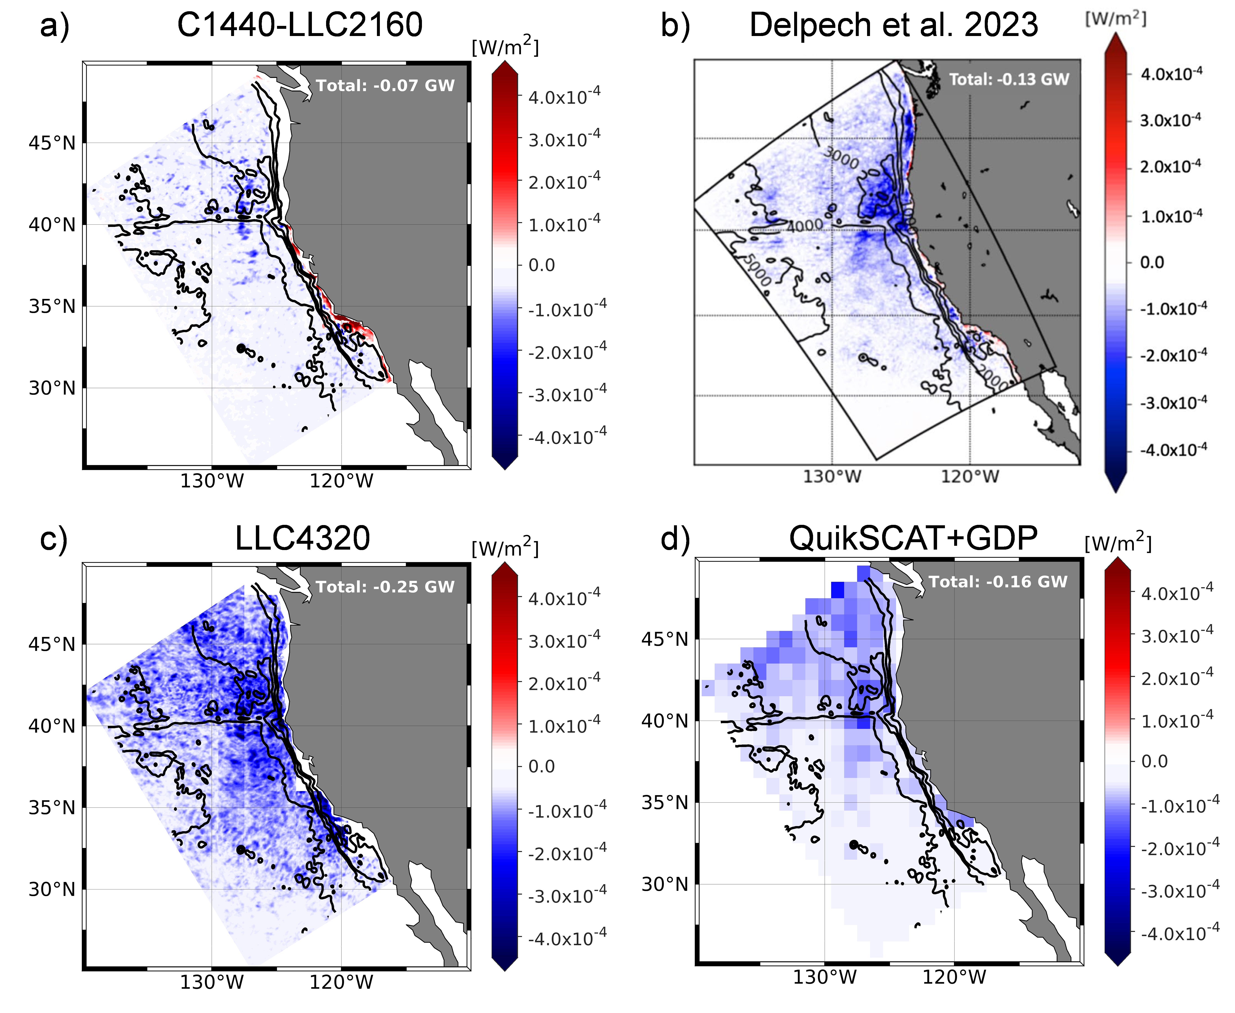
Fig. S6 | Comparison of ITs wind work across coupled simulations, LLC4320, and the observation-based estimate in the Northeastern Pacific. (a) ITs wind work diagnosed from the two-way coupled ocean-atmosphere simulation. (b) ITs wind work estimated from the coupled simulation of Delpech et al.¹⁵ (c) ITs wind work directly diagnosed from LLC4320. (d) Observation-based estimate derived from QuikSCAT winds and GDP-based surface ITs currents. Our observation-based estimate are broadly consistent with Delpech et al.¹⁵, whose coupled simulation likewise yields predominantly negative wind work with a similar magnitude.
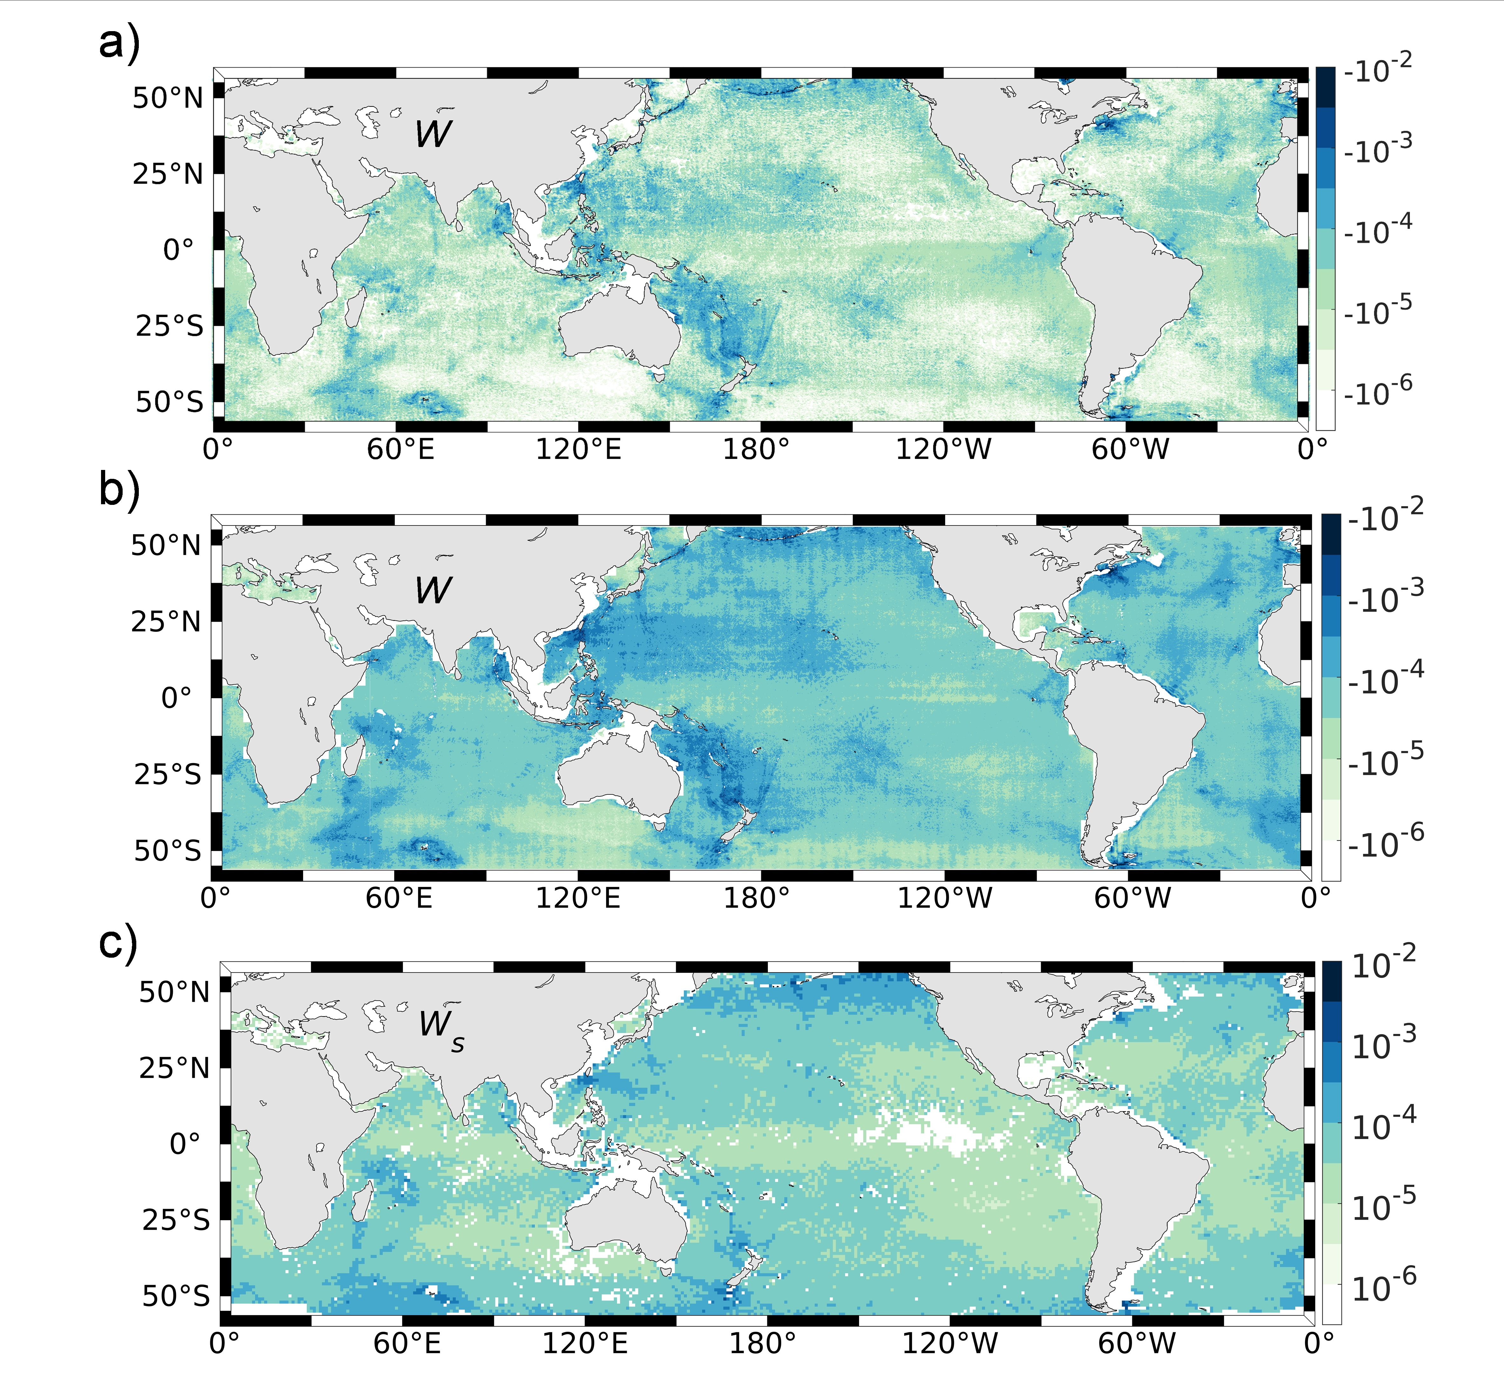
Fig. S7 | Comparison of negative ITs wind work across the fully coupled simulation, LLC4320 and the observation-based estimate. Spatial distributions of the magnitude of negative ITs wind work from (a) the coupled ocean-atmosphere simulation, (b) LLC4320, and (c) the GDP-based observation estimate, shown on a logarithmic scale. Only grid points with negative wind work are included.

