Supplementary Information
Supplementary Figures S1–S2. Individual-mouse bioluminescence total flux and body weight trajectories. S1: PBS, Vector-T, CD19 CAR-T, and M23 CAAR-T groups in the D15107-Nalm6 xenograft model. S2: M23 CAAR-T-treated mice bearing D15107-Nalm6 or Nalm6-WT cells. Each line represents one mouse. File type: Word.

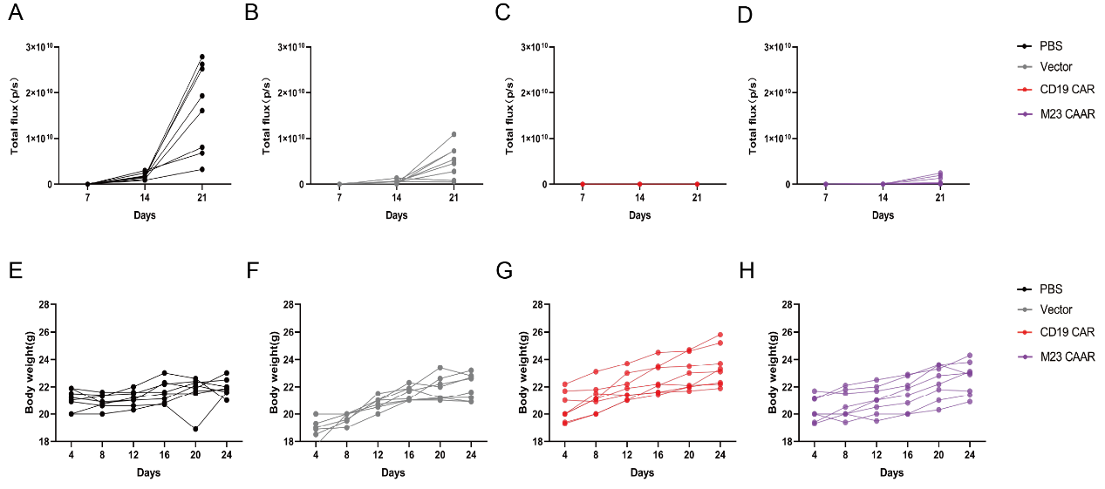
Figure S1. Individual-mouse trajectories of target-cell burden and body weight in the D15107-Nalm6 xenograft model. (A–D) Longitudinal bioluminescence total flux for individual mice in the PBS (A), Vector-T (B), CD19 CAR-T (C), and M23 CAAR-T (D) groups, corresponding to the group-level data in Fig. 5C. (E–H) Body weight of individual mice in the same groups, respectively, corresponding to Fig. 5D. Each line represents one mouse.

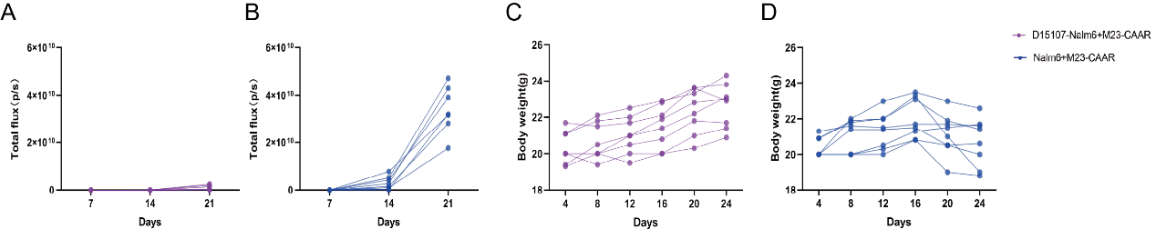
Figure S2. Individual-mouse trajectories in antigen-positive and antigen-negative challenge models. (A, B) Longitudinal bioluminescence total flux for individual M23 CAAR-T-treated mice bearing D15107-Nalm6 (A) or Nalm6-WT (B) cells, corresponding to Fig. 6B. (C, D) Body weight of individual mice bearing D15107-Nalm6 (C) or Nalm6-WT (D) cells, corresponding to Fig. 6C. Each line represents one mouse.

