Supplementary material
Supplementary Figure S1. Selection of the analytical sample
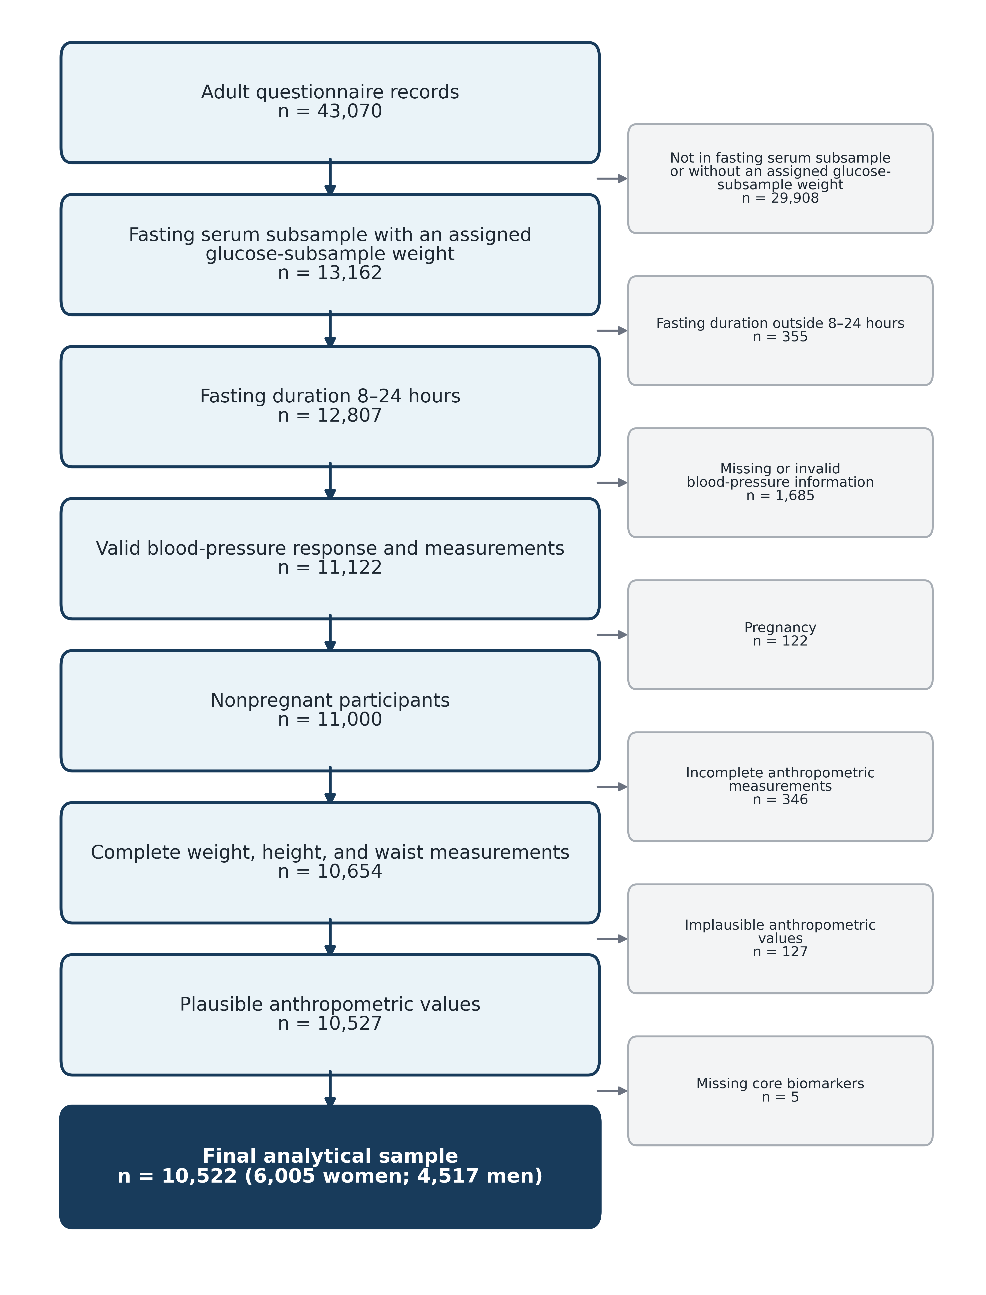
Note: The combined exclusion count reflects sequential application of fasting-duration, blood-pressure, pregnancy, anthropometric, and core-biomarker eligibility criteria.

Supplementary Table S1. Distribution of CKM syndrome stages by 10-year age group and sex
Sex | Age, years | Unweighted n | Population, millions | Stage 0 | Stage 1 | Stage 2 | Stage 3 | Stage 4
Women | 20–29 | 977 | 9.89 | 24.2 (19.8–28.7) | 37.5 (32.7–42.2) | 36.8 (32.2–41.4) | 0.1 (0.0–0.2) | 1.4 (0.4–2.5)
Women | 30–39 | 1,317 | 9.30 | 9.2 (6.8–11.6) | 30.8 (26.9–34.7) | 57.4 (53.2–61.6) | 0.0 (0.0–0.0) | 2.6 (1.2–3.9)
Women | 40–49 | 1,343 | 9.13 | 5.5 (3.1–8.0) | 20.3 (16.9–23.8) | 71.9 (67.9–75.8) | 0.0 (0.0–0.0) | 2.2 (1.3–3.2)
Women | 50–59 | 1,020 | 7.08 | 2.1 (1.1–3.2) | 16.6 (12.6–20.6) | 75.3 (70.7–79.9) | 1.0 (0.0–2.1) | 4.9 (2.8–7.0)
Women | 60–69 | 761 | 5.24 | 0.7 (0.1–1.3) | 14.4 (8.8–19.9) | 70.3 (63.8–76.8) | 7.8 (3.9–11.7) | 6.9 (4.6–9.2)
Women | 70–79 | 420 | 2.67 | 1.8 (0.5–3.1) | 8.0 (2.2–13.9) | 49.8 (41.6–58.0) | 31.3 (23.3–39.3) | 9.1 (5.2–13.0)
Women | ≥80 | 167 | 1.31 | 1.9 (0.0–4.1) | 8.9 (2.0–15.8) | 81.9 (73.5–90.4) | 1.4 (0.0–2.9) | 5.9 (1.8–10.1)
Men | 20–29 | 828 | 9.25 | 28.1 (23.0–33.2) | 20.9 (16.8–25.1) | 48.9 (43.7–54.2) | 0.0 (0.0–0.0) | 2.0 (0.6–3.3)
Men | 30–39 | 903 | 7.88 | 12.2 (8.2–16.2) | 23.4 (18.9–27.8) | 60.5 (55.3–65.7) | 0.0 (0.0–0.1) | 3.9 (1.7–6.1)
Men | 40–49 | 942 | 7.40 | 5.8 (3.6–8.1) | 19.5 (14.8–24.2) | 71.5 (66.5–76.5) | 0.4 (0.0–0.8) | 2.8 (1.1–4.6)
Men | 50–59 | 754 | 5.99 | 4.9 (2.9–6.9) | 14.6 (10.2–19.0) | 73.6 (68.6–78.7) | 2.6 (1.0–4.2) | 4.2 (1.9–6.5)
Men | 60–69 | 570 | 3.76 | 4.8 (2.4–7.2) | 13.0 (6.8–19.2) | 63.7 (56.7–70.8) | 11.1 (7.3–15.0) | 7.3 (3.9–10.7)
Men | 70–79 | 368 | 2.29 | 1.8 (0.5–3.1) | 6.0 (2.0–10.0) | 35.8 (25.7–46.0) | 47.2 (37.3–57.1) | 9.1 (3.9–14.3)
Men | ≥80 | 152 | 0.98 | 5.1 (1.2–9.0) | 8.9 (0.4–17.3) | 80.0 (70.4–89.6) | 0.2 (0.0–0.7) | 5.8 (2.0–9.6)

Note: Stage-specific values are weighted prevalence estimates, % (95% CI). Population estimates use recalibrated fasting-biochemical-subsample weights. Participants were assigned hierarchically to their highest qualifying CKM stage. Percentages may not sum to 100% because of rounding. CI=confidence interval; CKM=cardiovascular–kidney–metabolic.

Supplementary Table S2. PREVENT-CVD risk among eligible adults
Measure | Weighted estimate
Eligible unweighted sample | 7,043
Median 10-year total CVD risk, % (IQR) | 2.9 (1.2–7.9)
Risk <5%, % | 63.1
Risk 5% to <10%, % | 16.6
Risk 10% to <20%, % | 14.7
Risk ≥20%, % | 5.6

CVD=cardiovascular disease; IQR=interquartile range.
Supplementary Table S3. Sensitivity analyses of CKM stage prevalence
Panel A. Alternative operational definitions
Specification | Stage 0 | Stage 1 | Stage 2 | Stage 3 | Stage 4 | CKM stages 1–4
Primary study-specific operational definition | 10.4 (9.4–11.5) | 21.3 (20.0–22.6) | 60.8 (59.2–62.4) | 3.7 (3.0–4.3) | 3.8 (3.2–4.3) | 89.6 (88.5–90.6)
Triglycerides ≥150 mg/dL independently qualify for stage 2 | 8.2 (7.2–9.2) | 15.2 (14.1–16.4) | 69.1 (67.6–70.7) | 3.7 (3.0–4.3) | 3.8 (3.2–4.3) | 91.8 (90.8–92.8)
PREVENT-CVD predictors truncated to nearest validated boundary | 10.4 (9.4–11.5) | 21.3 (20.0–22.6) | 59.7 (58.1–61.3) | 4.8 (4.1–5.5) | 3.8 (3.2–4.3) | 89.6 (88.5–90.6)
Waist circumference ≥88 cm in women and ≥102 cm in men | 13.6 (12.4–14.8) | 22.0 (20.7–23.3) | 56.9 (55.2–58.5) | 3.7 (3.0–4.3) | 3.8 (3.2–4.3) | 86.4 (85.2–87.6)

Panel B. Alternative definitions of clinical cardiovascular disease
Definition | Stage 4 prevalence, % (95% CI)
Full definition: myocardial infarction, stroke, angina, or heart failure | 3.8 (3.2–4.3)
Restricted definition: myocardial infarction or stroke | 1.9 (1.5–2.2)
Angina or heart failure without reported myocardial infarction or stroke | 1.9 (1.5–2.3)

Panel C. Survey-weighting specifications
Weighting specification | Analytical population, millions | CKM stages 1–4 | Metabolic syndrome | Advanced CKM stages 3–4
Official fasting-glucose subsample weight | 66.63 | 89.9 (88.8–90.9) | 55.9 (54.2–57.6) | 7.6 (6.8–8.4)
Recalibrated analytical weight | 82.16 | 89.6 (88.5–90.6) | 55.2 (53.6–56.9) | 7.5 (6.6–8.3)

Note: Values are weighted prevalence estimates, % (95% CI), unless otherwise indicated. The primary operational definition used waist thresholds of ≥80 cm in women and ≥90 cm in men; triglycerides ≥150 mg/dL and low HDL-C contributed to stage 2 only as components of metabolic syndrome; PREVENT-CVD was estimated only within its validated predictor ranges; and clinical cardiovascular disease included self-reported myocardial infarction, stroke, angina, or heart failure. Advanced CKM syndrome comprises stages 3–4. All confidence intervals used Taylor series linearization with grand-mean adjustment for 40 singleton strata. CI=confidence interval; CKM=cardiovascular–kidney–metabolic; CVD=cardiovascular disease; HDL-C=high-density lipoprotein cholesterol.

