Supplementary materials
Linking projections from distribution models and management in Indigenous communities

Breeding occurrence data
The Haida Gwaii 2017 breeding survey points were selected using a stratified random sampling using QGIS (v 3.16.0, (QGIS, 2021), by randomly selecting 54 wetlands or open waterbodies within the three main biogeoclimatic (BEC) zones represented on Graham Island from a candidate list of such sites in the BC Freshwater Atlas (BC Ministry of Forests; Fig. 1). All survey sites were within 5km of a road (for ease of access), at least 1km apart, visited twice and searched for two hours.
The breeding presences and absences (n = 609 locations in total; n = 117 Haida Gwaii, n = 492 native range) were filtered down from ~800 observations to ensure they accurately reflected breeding activity. For instance, sites with non-detections (absences) were excluded if they were past peak breeding season, because (Rowe et al., 2019) found that there was a lower detection probability for NRLFs later in the season. Additionally, to reduce spatial autocorrelation, we considered lakes and wetlands to harbor independent populations (Rowe et al., 2019) as long as they were separated by 200m, as that is the distance the NRLF has been documented to explore potential breeding sites in the post-thaw/pre-breeding season ((Grand et al., 2017). For sites that were sampled more than once, only the most recent presence was included. Additionally, 95 absences in the Haida Gwaii dataset were removed that were both far from any presences and beyond large dispersal barriers (salt water and large mountains; Sup. Mat.; Fig. S1). This was to avoid training the models on geographic areas that were still limited by dispersal during a range expansion, as that can result in underpredicting habitat suitability (Václavík & Meentemeyer, 2012).

Environmental variables — sampling
The Freshwater Atlas and forest cover consisted of polygon layers for wetlands, forest, streams and open water bodies based on 2002 habitat. The habitat polygons were converted to percentages (for wetlands, forest, open water bodies) and densities per km² (for streams) using buffers with multiple radii (100m, 200m, 500m, 1km and 2km) around the survey points (conducted in R using package sp; functions st_area() and st_length(), and dplyr package — function summarise(); (Pebesma & Bivand, 2005; Bivand et al., 2008; Wickham et al., 2018). Buffer widths were chosen from Rose et al. (Rose, Halstead & Fisher, 2020) and (Green, Govindarajulu & Higgs, 2020). Within each buffer, elevation was sampled using the USGS 1 arc-second resolution (~30 meters) Digital Elevation Model (DEM) (Farr & Kobrick, 2000) and the zonal statistics tool in QGIS to calculate elevation range (the difference between the minimum and maximum elevation). To decide which buffer spatial scale to include, we followed the recommendations in (Bradter et al., 2013) and ran models (model building discussed in section 4.2) with all variables, but varied buffer width and picked the model with the buffer size that explained the highest variance (out of an average of 50 simulations). The model with the 500m buffer size performed best.

Random Forest model methods
The Random Forest model randomly selected a subset of the full dataset to create a tree (bootstrapped data), which at every branch selected the variable that best split the data into presences and absences of the NRLF from a random subset of variables (the number of variables determined by the ‘mtry’ parameter) ((Breiman, 2001). After a predetermined number of iterations, the outputs were averaged to get a measure of the model fit on the testing data. The Random Forest was run as a regression with the default settings — number of trees (i.e., iterations) set to 500, and the ‘mtry’ parameter set to the number of predictors divided by three, as recommended by (Breiman, 2001). A variable importance ranking of the covariates (% increase in mean squared errors) was generated using the varImp() function in the caret R package (Kuhn, 2008). The variable importance ranking is based on the number of times a variable was chosen to best separate presences and absences across all trees (Breiman, 2001). We generated response curves for the variables using the plotmo() function in the plotmo R package (Milborrow, 2018).

Map projection methods
The Haida Gwaii grid points were run through this model using the predict() function from the randomForest R package (Liaw & Wiener, 2002). We then converted the georeferenced Haida Gwaii grid points with habitat suitability to a raster with a resolution of 250 x 250 m by: 1) creating a square buffer around the points with a radius of 125 m in R; and 2) using the rasterize tool in QGIS (projection EPSG: 3005 for all mapping and subsequent analyses), to convert the polygon layer to a raster. To generate prediction error estimates, we set predict.all=TRUE within the predict() function in the randomForest R package, and then calculated the standard error for every grid habitat suitability prediction for Haida Gwaii across all 500 trees using a custom function (Liaw & Wiener, 2002). The average standard error was 0.04 for predictions for all time periods.

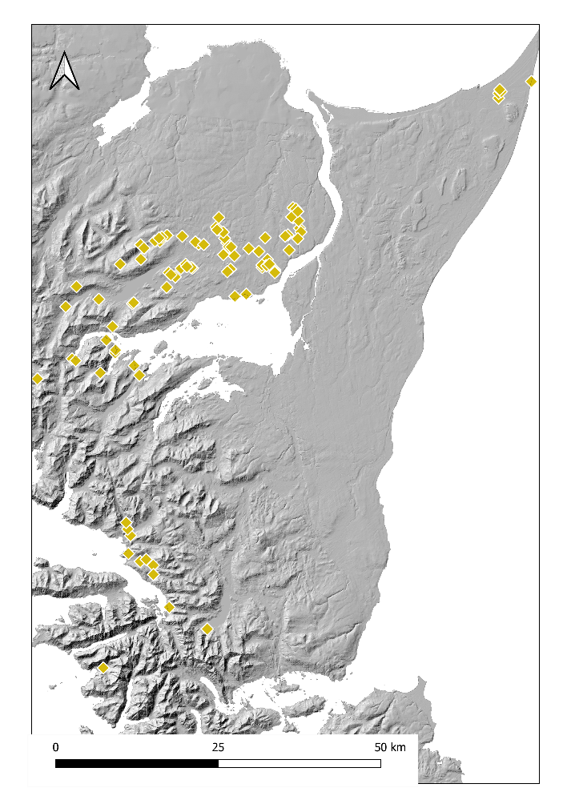
Fig. S1. Map of central Graham Island, Haida Gwaii, showing the absences that were removed (n=95) from the Random Forest model.
These were removed because they were outside the dispersal range from 2002 observations (based on dispersal rate) or beyond a large dispersal barrier (e.g., high mountains in southwest Graham Island). Points overlayed on a 1-arc digital elevation model (Farr & Kobrick, 2000).

Table S1. Environmental variables used in this study.
These were chosen a priori because they all have been shown previously to influence the suitability of habitat for Northern Red-legged Frog breeding. Rationales taken from (COSEWIC, 2015).

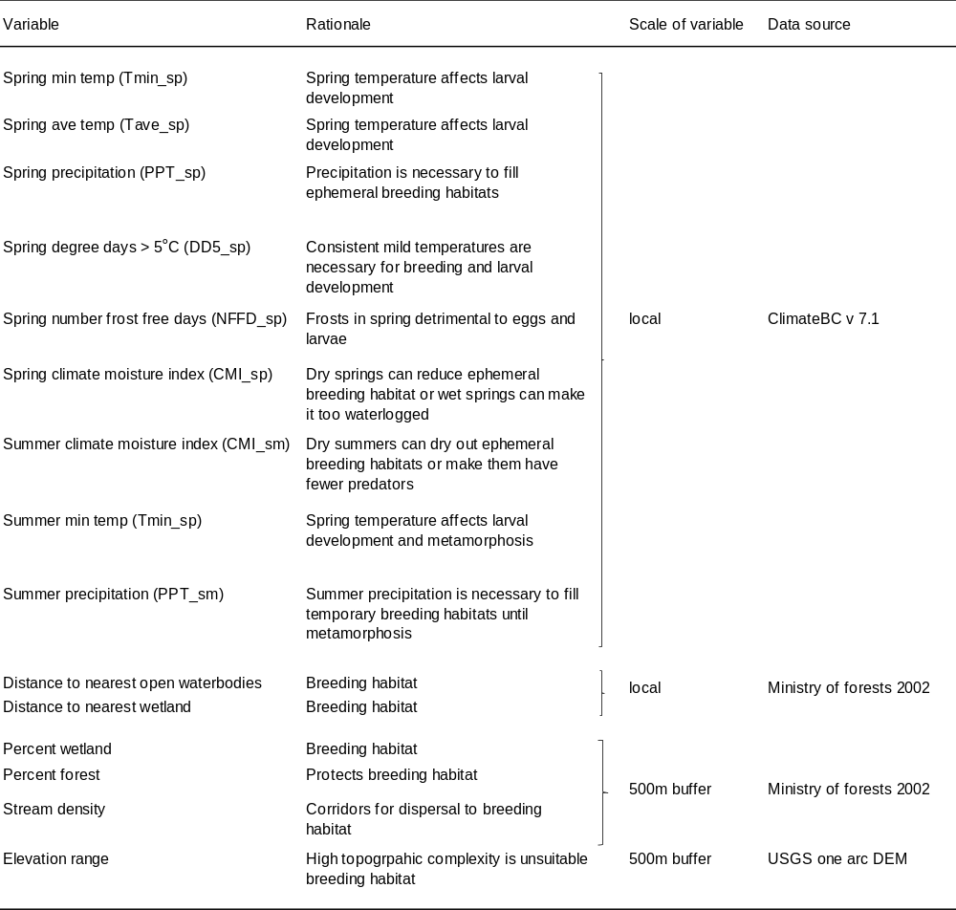

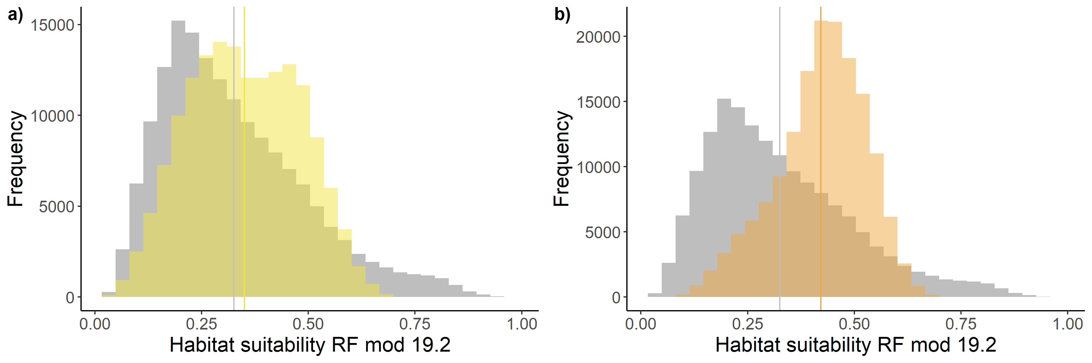
Fig. S2. Histogram and mean (vertical lines) of habitat suitability across Haida Gwaii.
Generated from the Random Forest model output comparing current conditions (grey) to future a) 2021-2040 ensemble SSP2-4.5 (yellow) yellow and b) 2081-2100 ensemble SPP2-4.5 (orange).

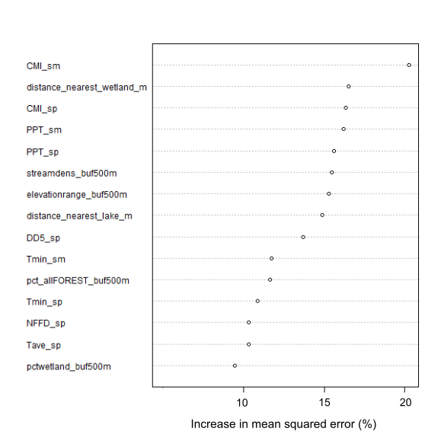
Fig. S3. Increase in mean squared error for the variables in the Random Forest model with both Haida Gwaii and native range data (n=609).
Higher increase in mean squared error = higher importance. Full variable names are in Table S1 and descriptions of the climate variables can be found in Climate BC (Wang et al., 2012).

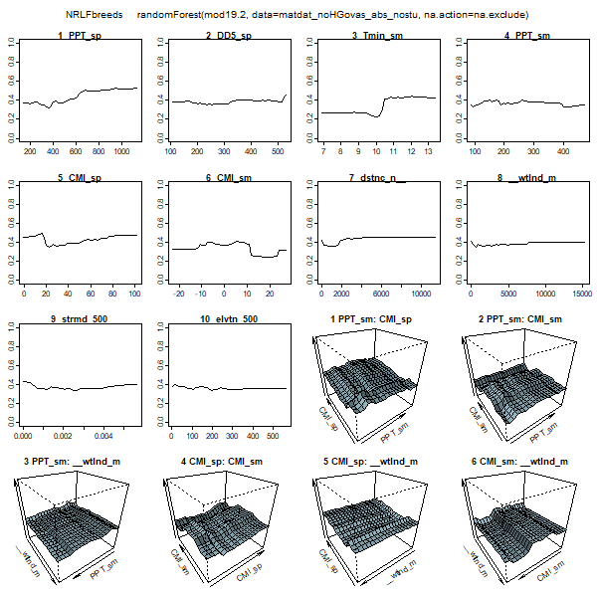
Fig. S4. Response curves for the Random Forest model, using both native range and Haida Gwaii data (n=609).
Full names can be found in Table S1 and descriptions of the climate variables can be found in Climate BC (Wang et al., 2012). “distnc_n” = distance nearest water body, “wtland_m” = distance nearest wetland, “strmd_500” = stream density (km2) in 500m buffer, “elvtn 500” = elevation range (m) in 500m buffer.

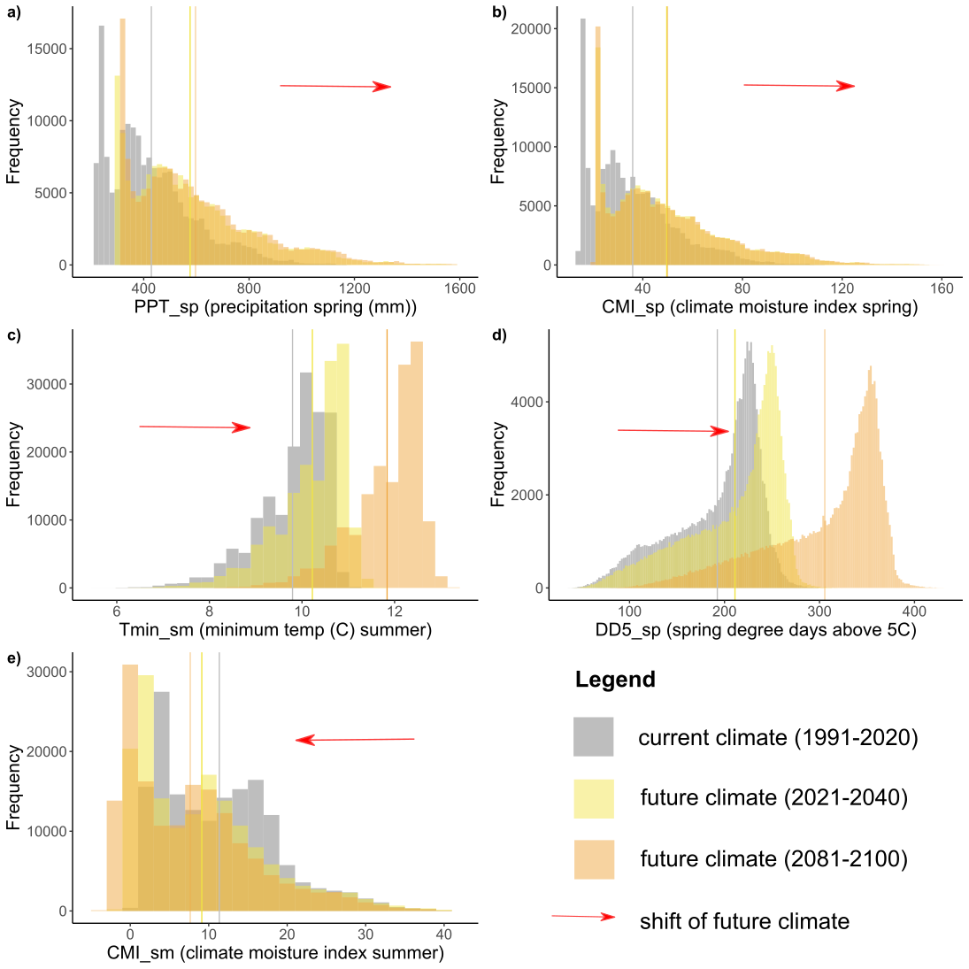
Fig. S6. Current and future climate for Haida Gwaii for a range of variables with the means indicated as vertical lines (in the same colour as the data).
a) spring precipitation; b) spring Hogg’s climate moisture index; c) minimum spring temperature; d) spring degree days above 5ºC; e) summer Hogg’s climate moisture index. Data from Climate BC v 7.1 (Wang et al., 2012, 2016; Mahony et al., 2021). Descriptions of the climate variables can be found in Climate BC (Wang et al., 2012).

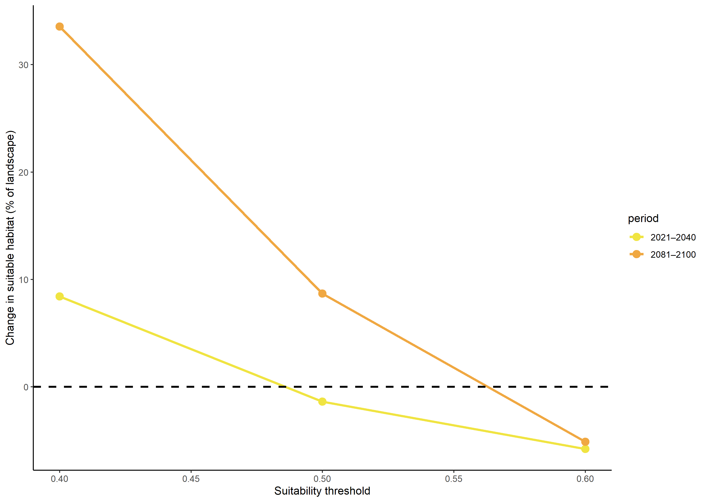
Fig. S7. Threshold sensitivity of suitable habitat change for the NRLF on Haida Gwaii.

