Supplemental information

Article title: Immunohistochemical and immunogold localization of 7B2 (secretogranin V) to large dense-core vesicles in both neurons and astrocytes of the rat brain: implications for extrasynaptic peptide release

Journal name: Histochemistry and Cell Biology

Author names: Hiroshi Gomi, Seiji Torii, Masahiro Hosaka, and Tadashi Yasui

e-mail address of the corresponding author: gomi.hiroshi@nihon-u.ac.jp

Supplementary Fig. 1 Specificity of the anti-7B2 antibody #77–90 and supporting images. Sections were incubated with non-absorbed (a, c, k, and m) or immunogen peptide-preabsorbed (b, d–j, l, and n) antibodies. In each case, preabsorption abolished the immunoreactivity. (a and b) Low-magnification views of the forebrain. (c) Strongly labeled fiber structures in the suprachiasmatic nucleus (SCh). (d–j) Negative controls for the regions shown in Fig. 2a–g: d parietal cerebral cortex (Par); e caudate-putamen (CP); f habenular nucleus (Hb); g hippocampal CA1 region; h CA3 region; i DG; j pontine nucleus (PN). (k and l) Low-magnification views of the cerebellum; the lobules are designated by Roman numerals (III, V, VI, IX, and X) and DN indicates deep cerebellar nucleus (medial nucleus). (m) In cerebellar lobule V, black arrowheads indicate strongly labeled Purkinje cell perikarya and the small white arrowhead indicates the pinceau formation. (n) Negative control for m. 3v, third ventricle; al, alveus hippocampi; gcl, granule cell layer; gr, granular layer; lhb, lateral habenular nucleus; lm, stratum lacunosum-moleculare; lu, stratum lucidum; mhb, medial habenular nucleus; mo, molecular layer; or, stratum oriens; ox, optic chiasm; pc, Purkinje cell layer; po, polymorphic layer; py, pyramidal cell layer; ra, stratum radiatum. Scale bars: 50 µm (c–f, m, and n), 100 µm (g–j), and 500 µm (a, b, k, and l)
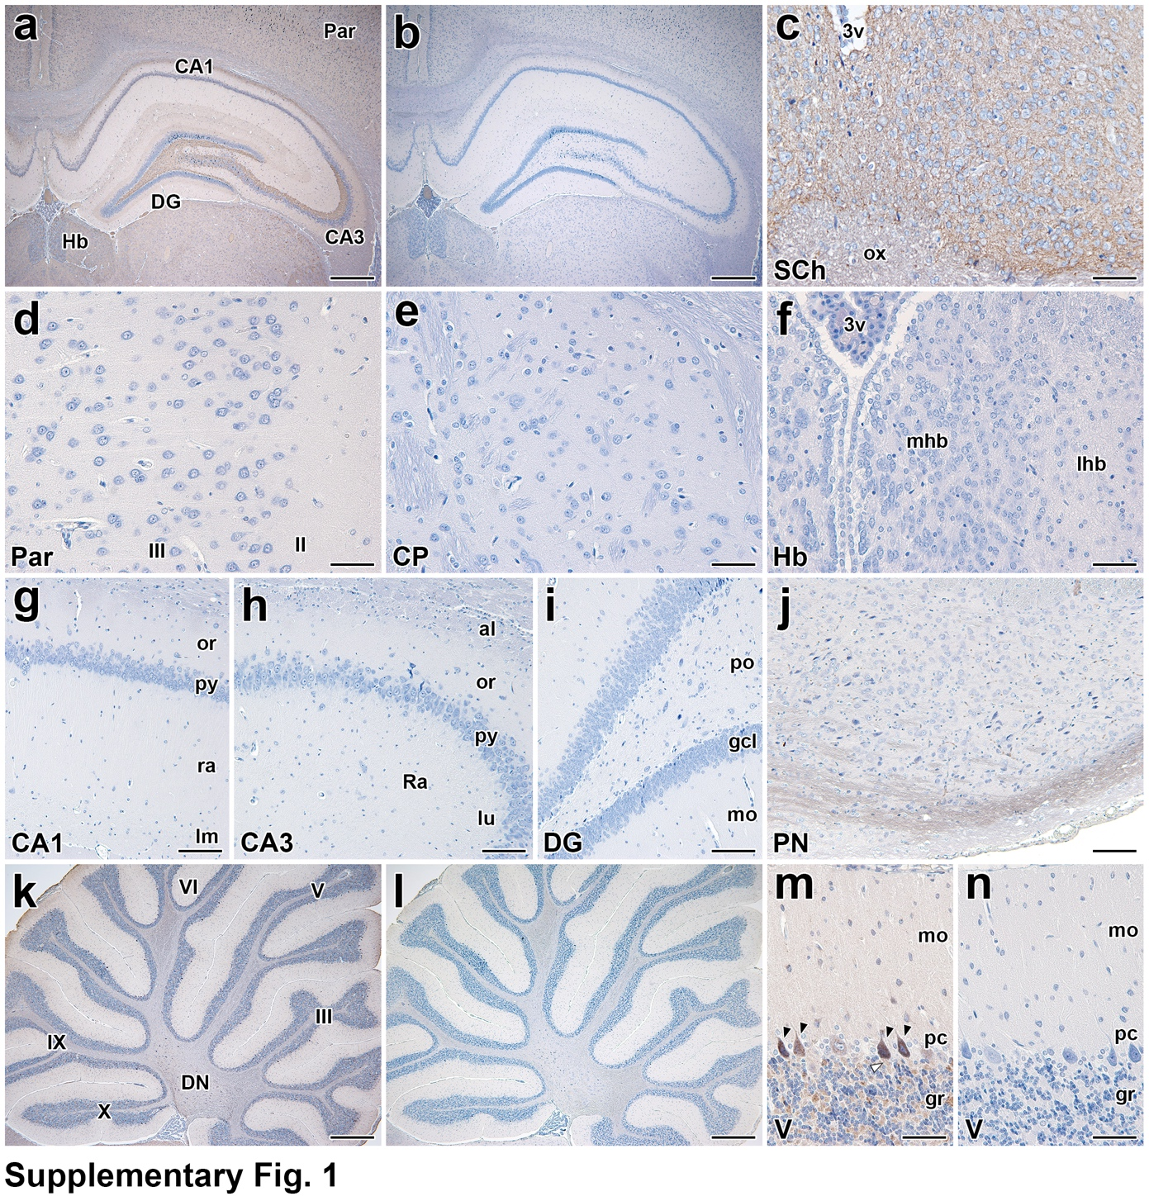

Supplementary Fig. 2 7B2 immunohistochemistry in the olfactory system and related forebrain regions: supporting images and negative controls. Sections were incubated with non-absorbed (a–c and g–i) or immunogen peptide-preabsorbed antibodies (d–f and j–o). Preabsorption treatment abolished immunoreactivity. (a and d) Anterior olfactory nucleus (AON). (b and e) Anterior piriform cortex, ventral part (APCv). (c and f) Cortical amygdaloid nucleus (CoA). (g and j) Accessory olfactory bulb (AOB). (h and k) Bed nucleus of the stria terminalis (BNST). (i and l) Medial amygdaloid nucleus (MAN). (m–o) Negative controls for the regions shown in Fig. 2n–p: m olfactory bulb/accessory olfactory bulb (OB/AOB); n OB at higher magnification; o anterior piriform cortex, dorsal part (APCd). In each case, preabsorption abolished the immunoreactivity. Single asterisks in b and e indicate the islands of Calleja; the single asterisk in m indicates the vomeronasal nerve layer; double asterisks in g and j indicate the glomerulus of the accessory olfactory bulb. ac, anterior commissure; aco, anterior cortical amygdaloid nucleus; ad, medial amygdaloid nucleus, anterodorsal part; av, medial amygdaloid nucleus, anteroventral part; bl, bed nucleus of the stria terminalis, lateral division; bm, bed nucleus of the stria terminalis, medial division; bma, basomedial amygdaloid nucleus; bv, bed nucleus of the stria terminalis, ventral division; epl, external plexiform layer; f, fornix; gcl, granule cell layer; gcla, granule cell layer of the accessory olfactory bulb; gl, olfactory glomerulus; ic, internal capsule; ipl, internal plexiform layer; lot, lateral olfactory tract; lv, lateral ventricle; mcl, mitral cell layer; mtcl, mitral/tufted cell layer of the accessory olfactory bulb; ot, optic tract; plco, posterolateral cortical amygdaloid nucleus; tu, olfactory tubercle; vp, ventral pallidum. Scale bars: 50 µm (n), 100 µm (a–g, j, and o), 200 µm (h, i, and k–m)
