Article title: Statistical Modeling and Multi-Objective Optimization of Thermally Assisted End Milling of 254 SMO Super Austenitic Stainless Steel
Journal name: International Journal of Advanced Manufacturing Technology
Author names: Émerson S. Passari, André J. Souza, Carlos A. G. Aita, Guilherme V. Schirmer, Liu Y. Barros, Rodrigo Blödorn
Corresponding author: Émerson S. Passari — Federal Institute of Rio Grande do Sul (IFRS) / Federal University of Rio Grande do Sul (UFRGS)
Corresponding author e-mail: emerson.passari@gmail.com

Online Resource 1
Bibliometric analysis supporting the research gap
The bibliometric analysis was performed using the Web of Science Core Collection (WoS). Two independent searches were carried out using the topics Super Austenitic Stainless Steel (SASS) and Thermally Assisted Machining (TAM). Bibliometric networks were generated using VOSviewer (v.1.6.21), including keyword co-occurrence and overlay visualization maps to identify the main research trends and existing knowledge gaps.
S1. Super Austenitic Stainless Steel
The bibliometric survey indicates that research on Super Austenitic Stainless Steels is well established and has experienced continuous growth over the last decades. Although the literature is extensive, most publications are concentrated on corrosion resistance, microstructure, alloy design and phase precipitation, whereas machining-related studies represent only a small fraction of the scientific production (Fig. S1).
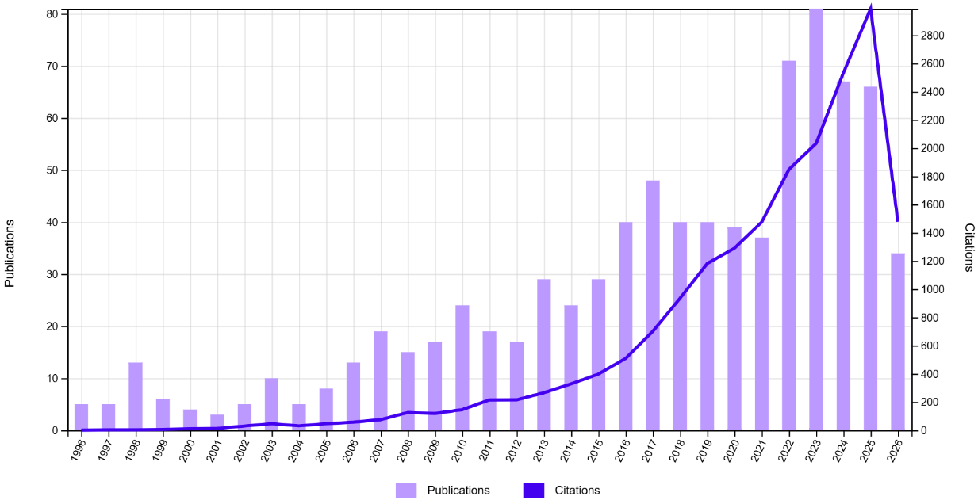
Fig. S1 Publications and citations accumulated related to the term Super Austenitic Stainless Steel in the last 30 years.
The keyword co-occurrence network confirms that behavior, microstructure, precipitation, pitting corrosion and mechanical properties dominate the research landscape. Terms directly related to machining, cutting processes and surface generation exhibit low occurrence, suggesting limited attention to manufacturing aspects (Fig. S2).
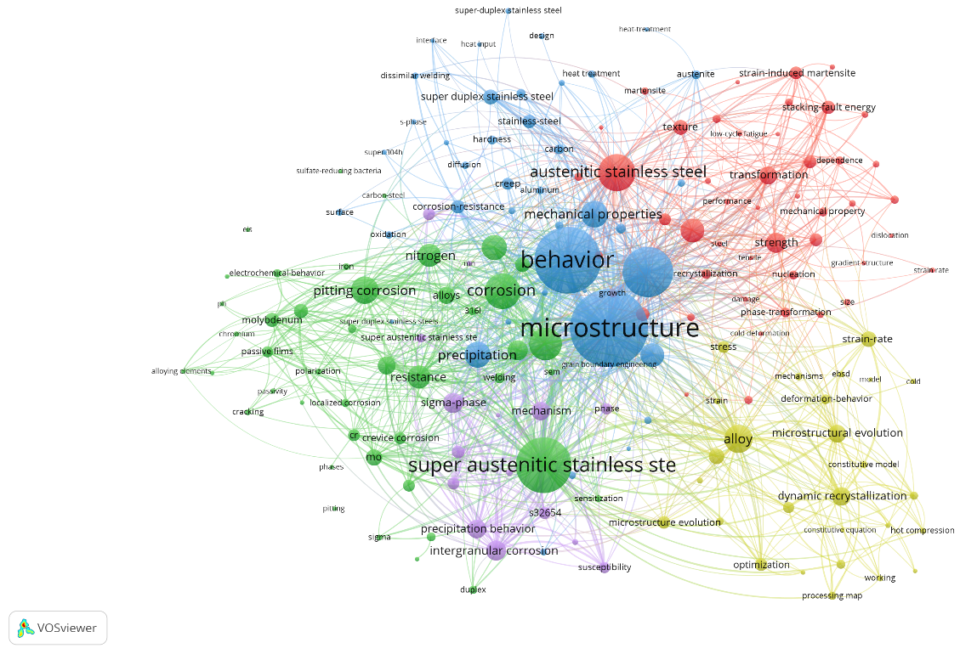
Fig. S2 General network of connections for the term Super Austenitic Stainless Steel generated by the VOSviewer software.
The temporal overlay indicates that recent studies continue to prioritize corrosion behavior and alloy development, while machining-related topics remain underrepresented (Fig. S3).
S2. Thermally Assisted Machining
The bibliometric analysis identified a strong increase in Thermally Assisted Machining publications during recent years, demonstrating growing scientific interest. Despite this expansion, most studies have focused on titanium alloys and nickel-based superalloys (Fig. S4).
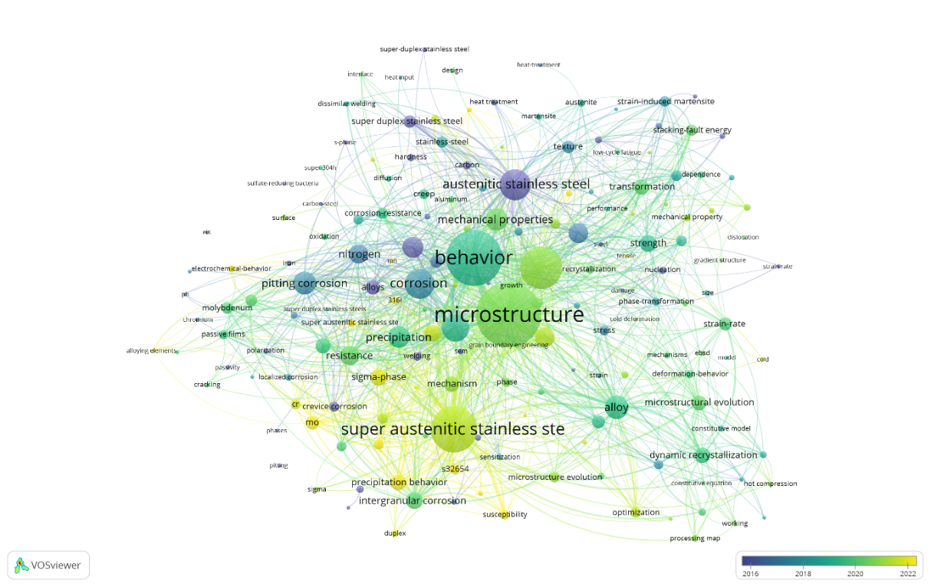
Fig. S3 Network of connections for the term Super Austenitic Stainless Steel by average number of years of publications.
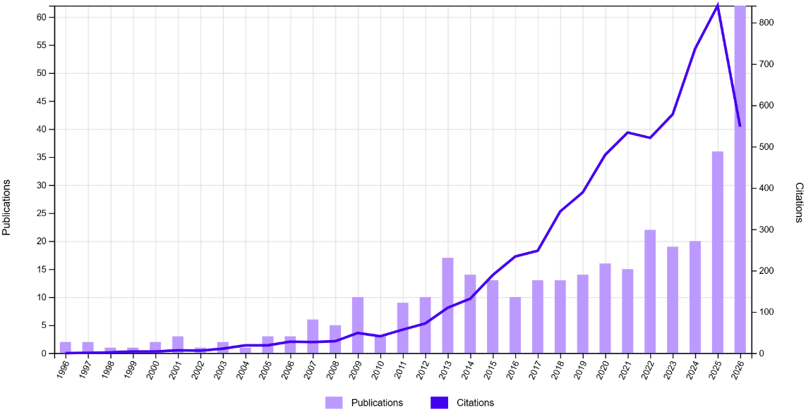
Fig. S4 Publications and citations related to the term Thermally Assisted Machining throughout the WoS database period.
The main research topics include temperature, machinability, cutting force, surface integrity, prediction, machine learning and simulation. These keywords reveal that current research is mainly directed toward process modeling, optimization and predictive analysis (Fig. S5).
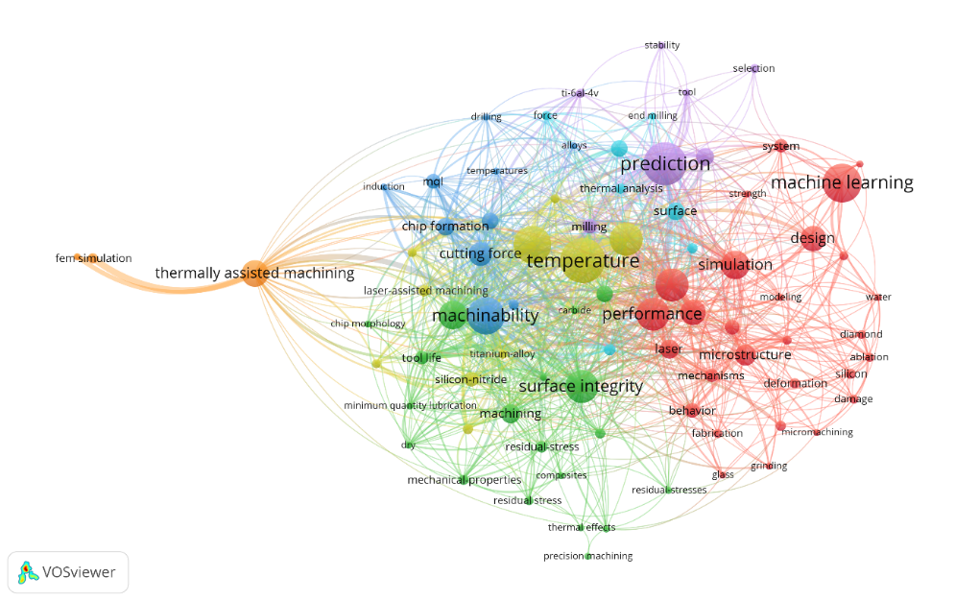
Fig. S5 General network of connections for the term Thermally Assisted Machining generated by the bibliometric tool VOSviewer.
Recent publications increasingly incorporate artificial intelligence, machine learning and predictive modeling. However, Super Austenitic Stainless Steels appear only marginally within the network, indicating limited application of Thermally Assisted Machining to this material (Fig. S6).
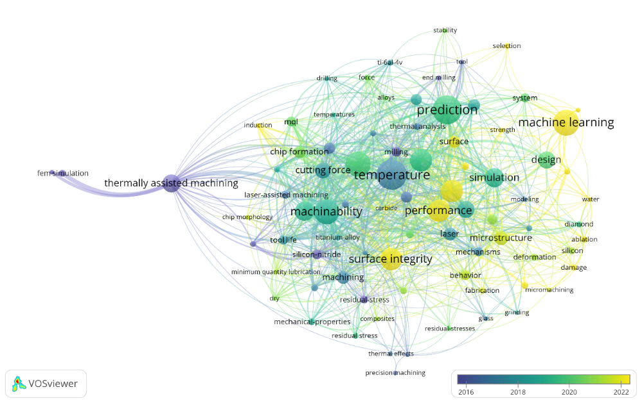
Fig. S6 Connections of the term Thermally Assisted Machining presented by average years of publications.
The combined bibliometric analyses demonstrate that, although Super Austenitic Stainless Steels have been extensively investigated regarding corrosion and metallurgy, studies addressing their machinability remain scarce. Likewise, the rapidly growing Thermally Assisted Machining literature has primarily focused on titanium and nickel-based alloys. The absence of a strong connection between Super Austenitic Stainless Steels and Thermally Assisted Machining keywords highlights an important research gap, supporting the investigation of “thermally assisted end milling of 254 SMO super austenitic stainless steel” presented in this work.

