Extended Data
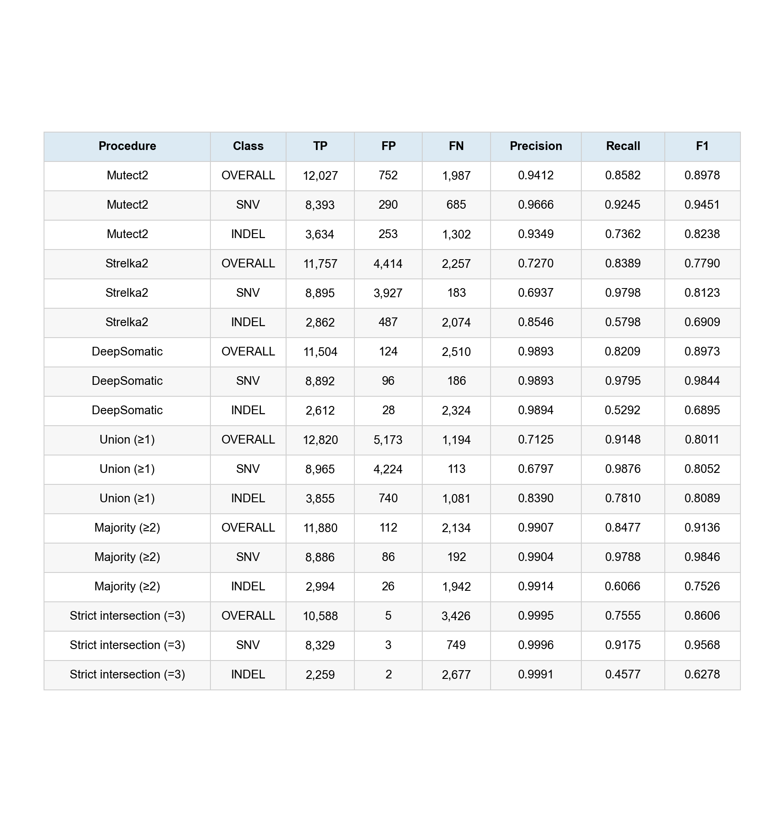
Extended Data Table 1 | Complete primary caller and consensus metrics. Overall, SNV and INDEL TP, FP, FN, precision, recall and F1 for all six frozen procedures in the HG008 v0.3 nogermlineinterference primary region. Metrics are displayed to four decimal places.
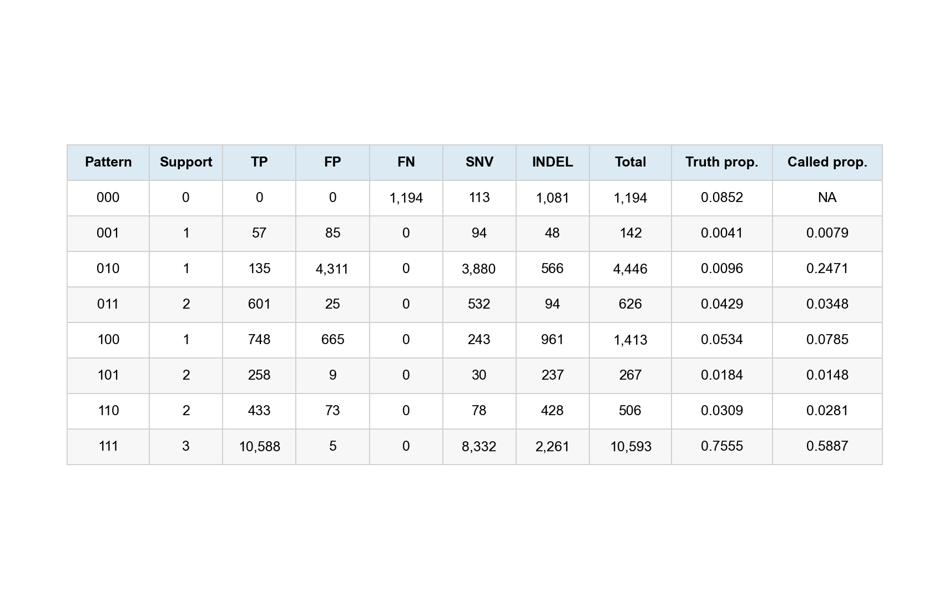
Extended Data Table 2 | Complete caller-support pattern results. Fixed 000–111 Mutect2/Strelka2/DeepSomatic states with support count, TP, FP, FN, SNV, INDEL, total-event and proportion fields. NA denotes a scientifically undefined proportion. Prespecified before HG008 access and executed after completion of the primary external evaluation.
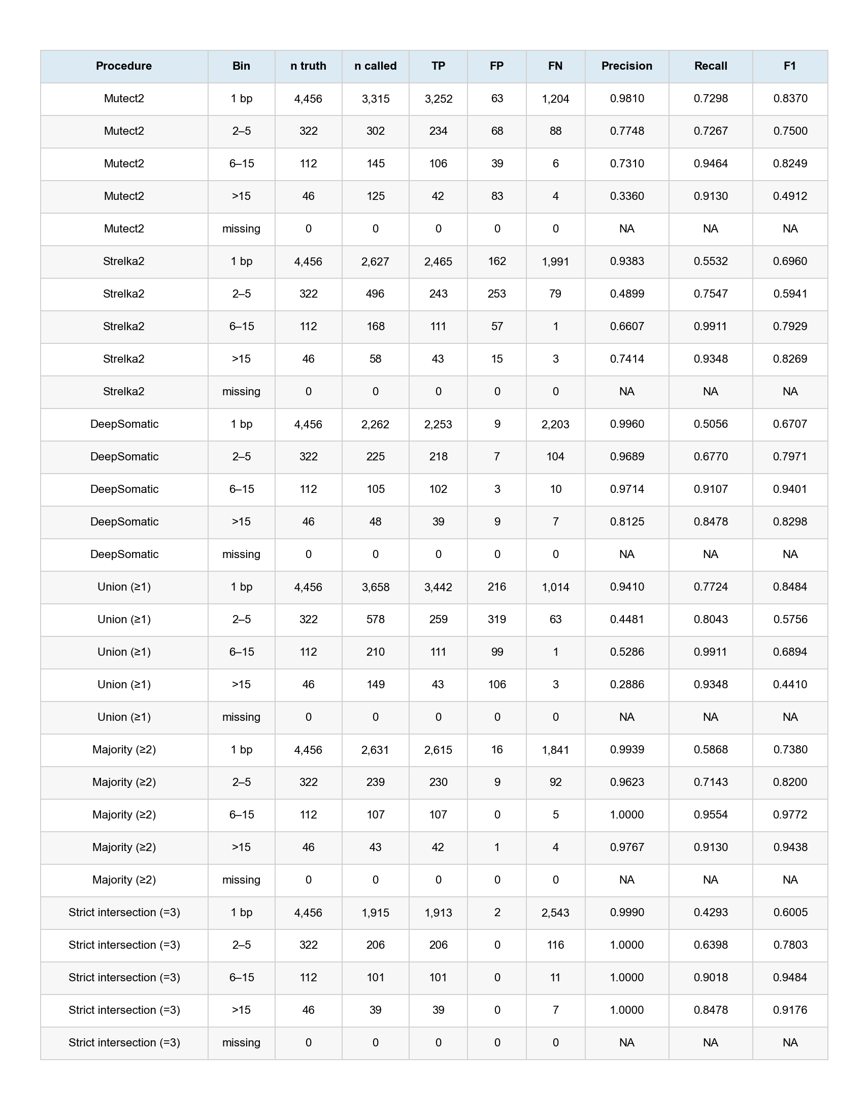
Extended Data Table 3 | Complete INDEL-length stratification. All six procedures across the frozen 1-bp, 2–5-bp, 6–15-bp, >15-bp and missing bins, retaining truth and called denominators, TP, FP, FN, precision, recall and F1. NA denotes undefined metrics in the explicit missing bin. Prespecified before HG008 access and executed after completion of the primary external evaluation.
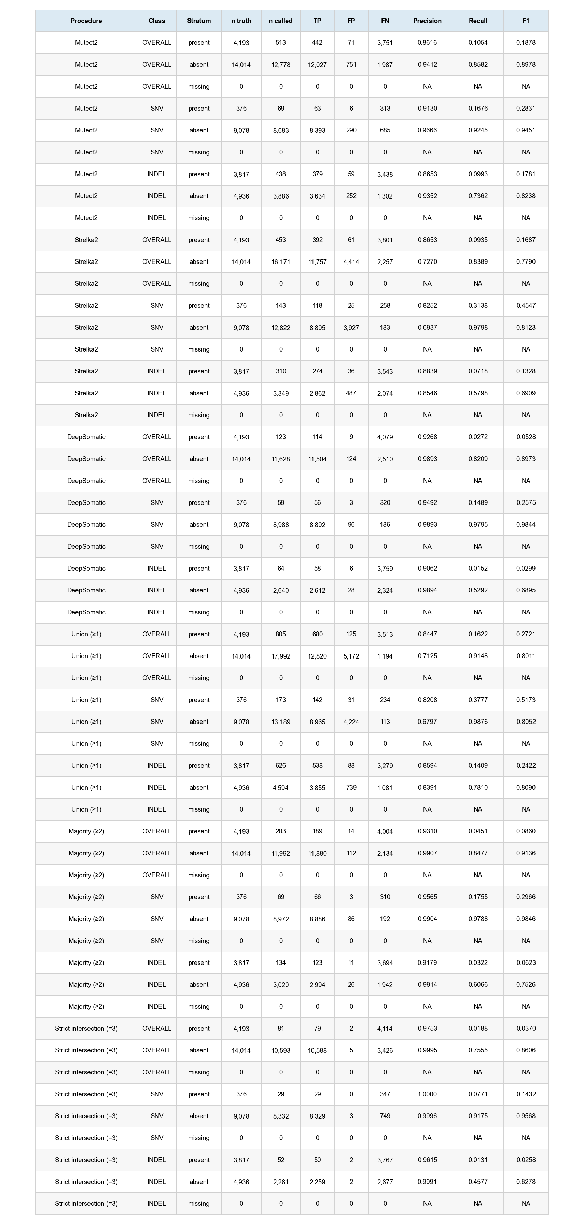
Extended Data Table 4 | Complete predefined germline-context stratification. All six procedures and overall, SNV and INDEL partitions in interference-present, interference-absent and missing strata. Counts and denominators are retained; NA denotes undefined metrics. The analysis used checksum-locked benchmark-region resources, was prespecified before HG008 access and executed after completion of the primary external evaluation and is descriptive rather than causal.

