Title: Responses of CO₂ emissions and soil microbial community structures to organic amendment in two contrasting soils in Zambia

Names of the authors:
Toru Hamamoto^{1, 2}, Nhamo Nhamo³, David Chikoye⁴, Ikabongo Mukumbuta⁵, Yoshitaka Uchida⁵

Address:
¹Faculty of Agriculture, Tohoku University, 468-1 Aramaki Aoba Aoba-Ku Sendai Miyagi 980-8572, Japan; hamamotoru@gmail.com
²Graduate School of Agriculture, Hokkaido University, Kita 9 Nishi 9 Kita-Ku Sapporo Hokkaido 060-8589, Japan
³International Center for Biosaline Agriculture, P. O. Box 14660, Dubai, United Arab Emirates
⁴International Institute of Tropical Agriculture (IITA), Southern Africa Research and Administration Hub, P.O. Box 310142, Chelstone, Lusaka, Zambia
⁵Research Faculty of Agriculture, Hokkaido University, Kita 9 Nishi 9 Kita-Ku Sapporo Hokkaido 060-8589, Japan

Correspondence:
T Hamamoto, Arid Land Research Center, Tottori University, 1390 Hamasaka Tottori 680-0001, Japan
Email: hamamotoru@gmail.com
Tel: +81857306356

Keywords: drylands, organic amendments, soil microbes, CO₂ emissions

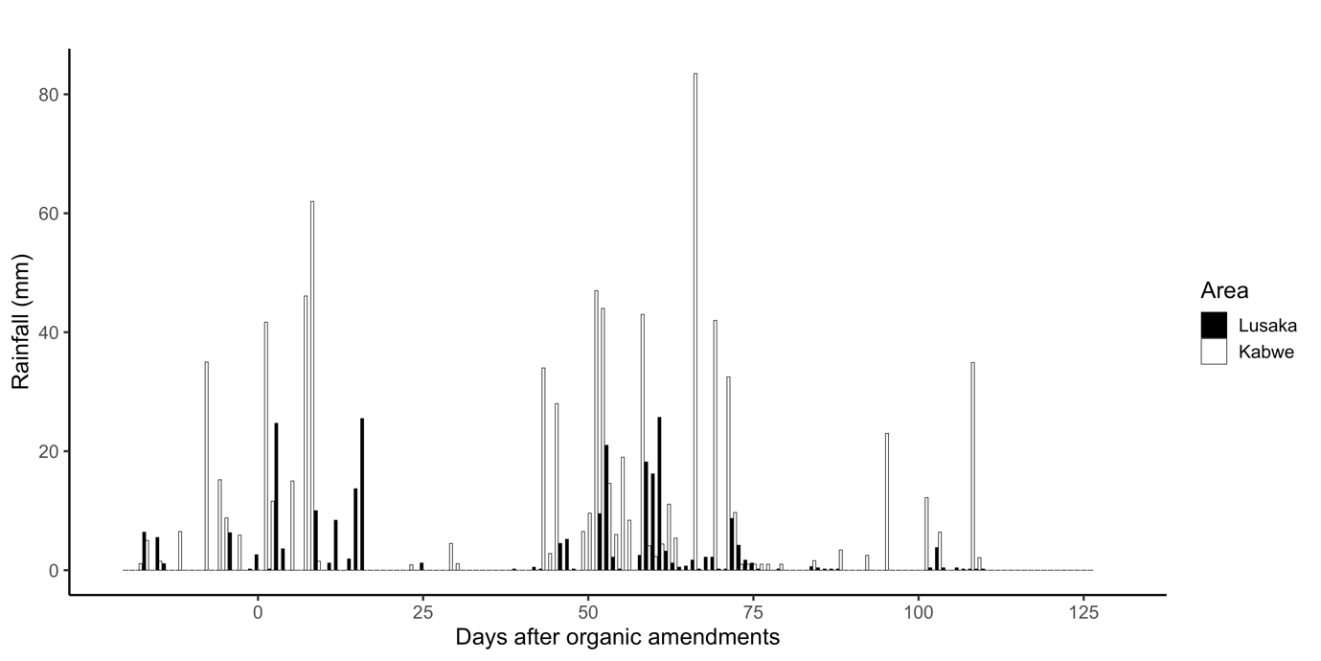
Figure S1. Fluctuations in rainfall at the Lusaka and Kabwe sites during the experimental period. Black bars show the Lusaka site while White bars show the Kabwe site.

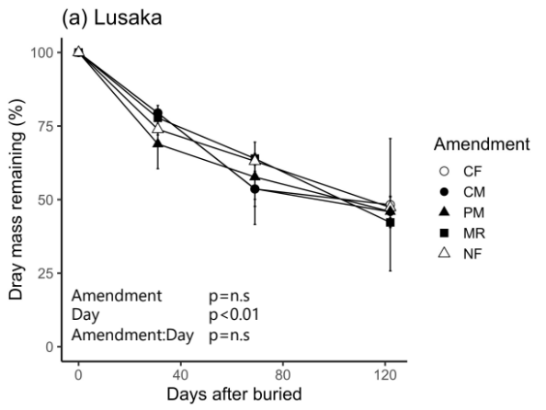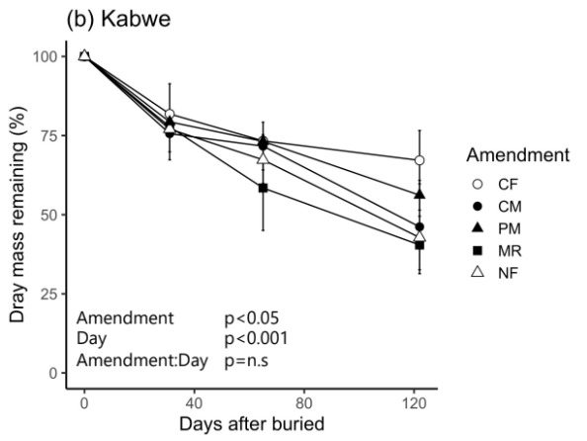

Figure S2. Temporal changes of litter bag decomposition rate at (a) Lusaka site and (b) Kabwe site. Levels of significance were based on mixed model results for repeated measurements. Error bars represent standard deviation (n = 3 or 2). CF: chemical fertilizer treatment, CM: cattle manure treatment, PM: poultry manure treatment, MR: maize residue treatment, and NF: no fertilizer treatment.

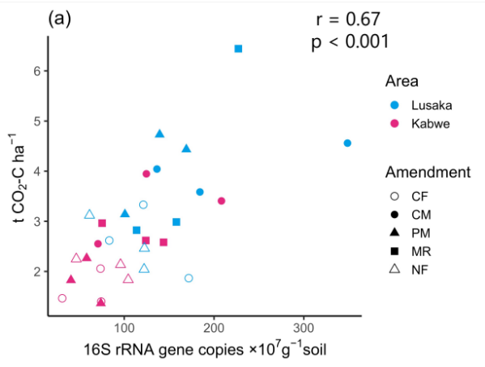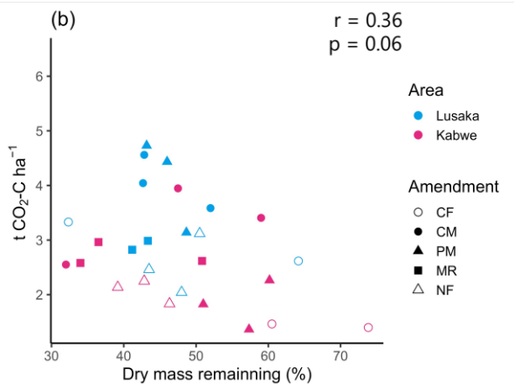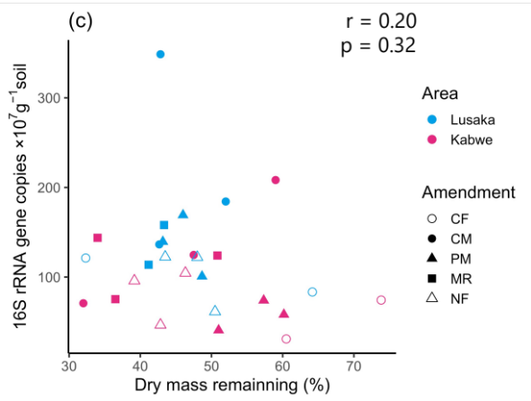

Figure S3. Relationships between (a) cumulative CO₂ emissions and soil bacterial and archaeal abundance when averaged across sampling dates, (b) cumulative CO₂ emissions and litter bag decomposition rates 120 days after buried, and (c) soil bacterial and archaeal abundance and litter bag decomposition rates. CF: chemical fertilizer amendment, CM: cattle manure amendment, PM: poultry manure amendment, MR: maize residue amendment, and NF: no fertilizer amendment.

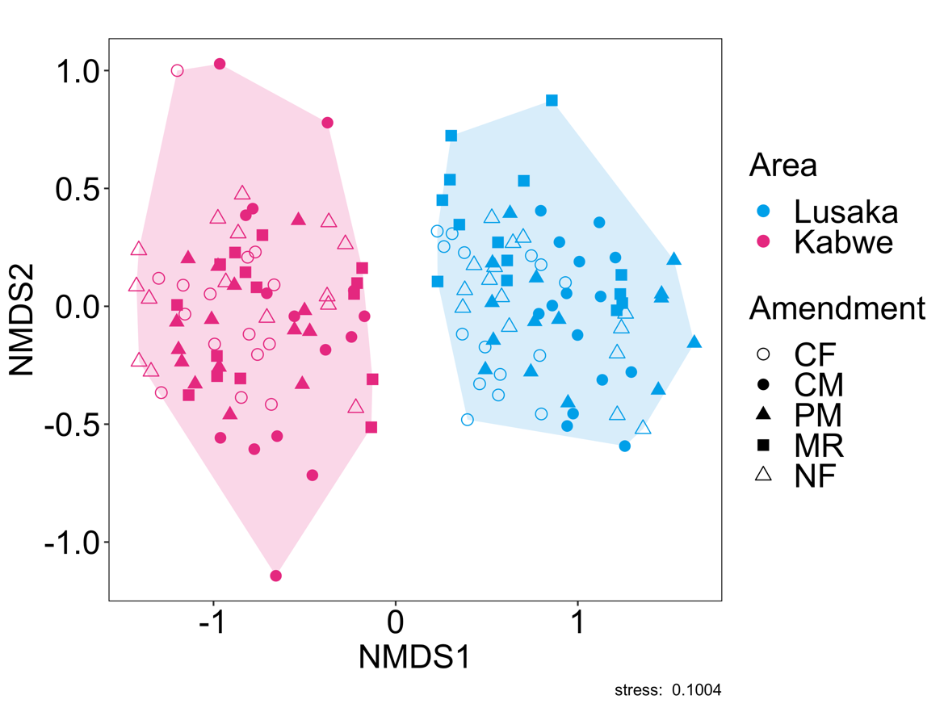

Figure S4. Nonmetric multidimensional scaling (NMDS) plots of difference in the bacterial and archaeal community structures at OTU level. CF: chemical fertilizer amendment, CM: cattle manure amendment, PM: poultry manure amendment, MR: maize residue amendment, and NF: no fertilizer amendment.

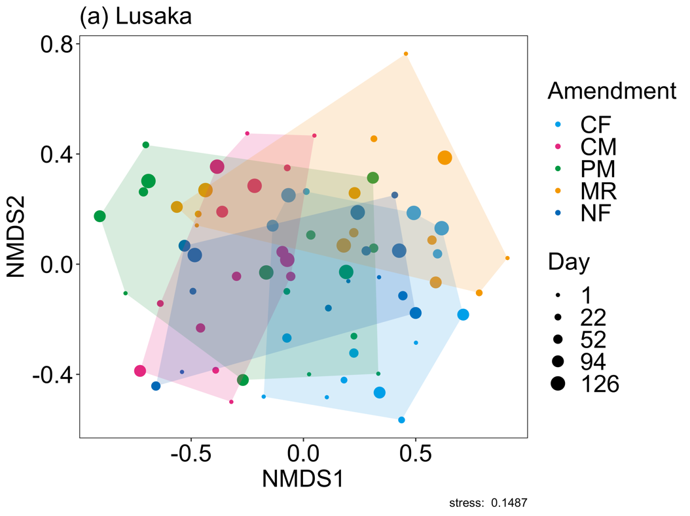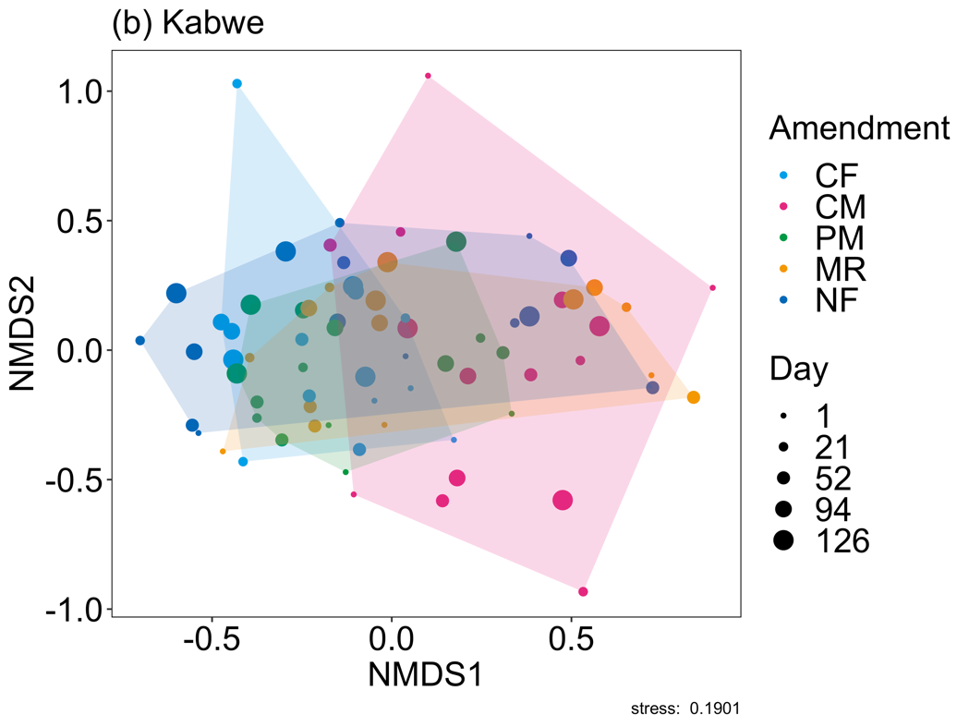
Figure S5. Nonmetric multidimensional scaling (NMDS) plots of difference in the bacterial and archaeal community structures at OTU level in (a) Lusaka site and (b) Kabwe site. CF: chemical fertilizer amendment, CM: cattle manure amendment, PM: poultry manure amendment, MR: maize residue amendment, and NF: no fertilizer amendment.

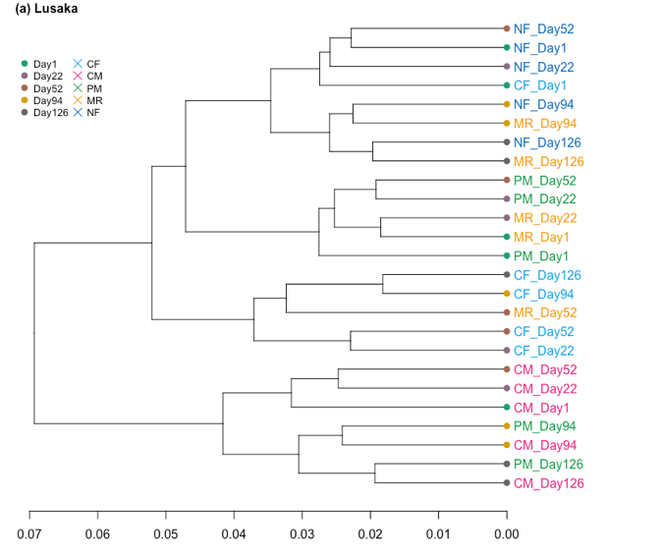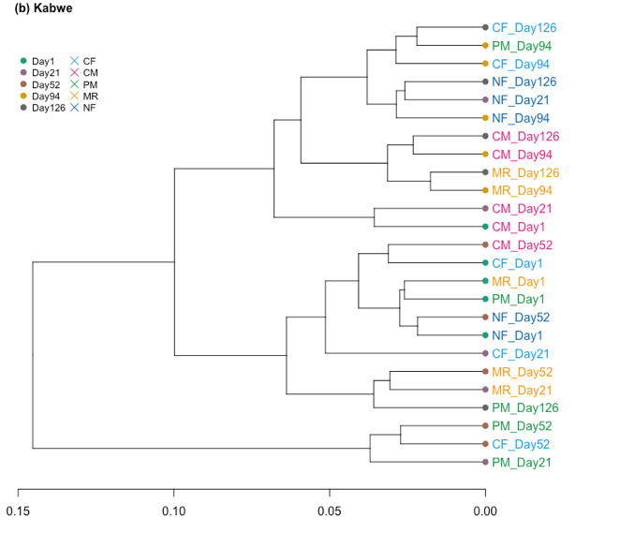

Figure S6. Cluster analysis of distribution of the abundances of bacteria and archaea at OTU level under different fertilizer treatments and sampling dates. CF: chemical fertilizer amendment, CM: cattle manure amendment, PM: poultry manure amendment, MR: maize residue amendment, and NF: no fertilizer amendment. The different colored letters indicate each fertilizer treatment and different colored points indicate each sampling date.

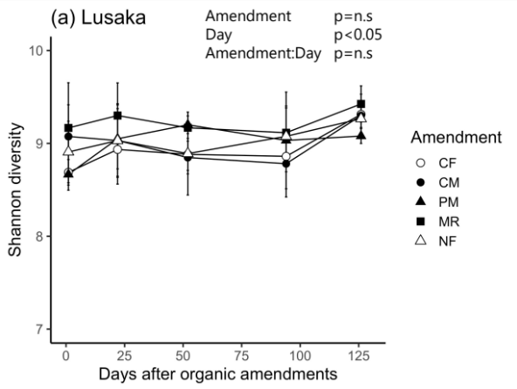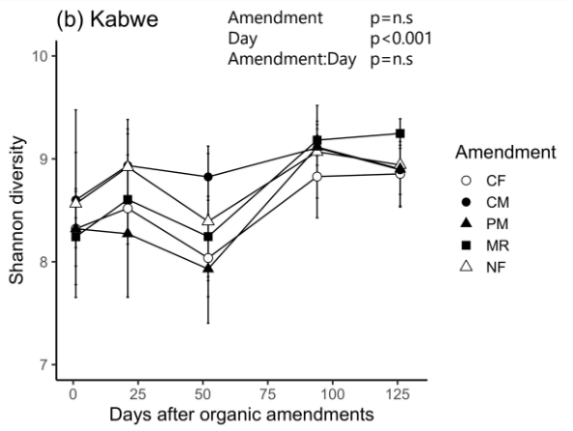
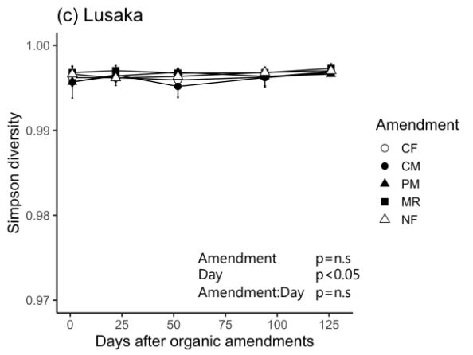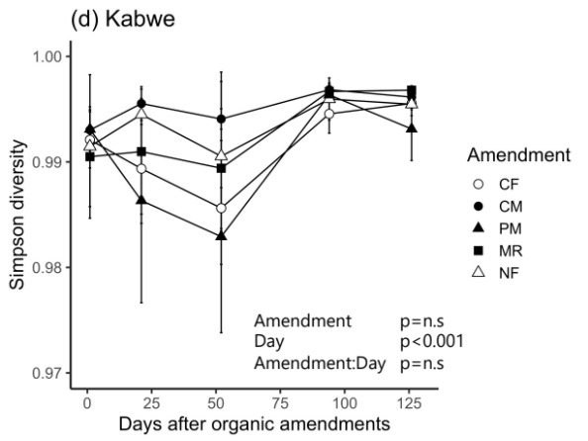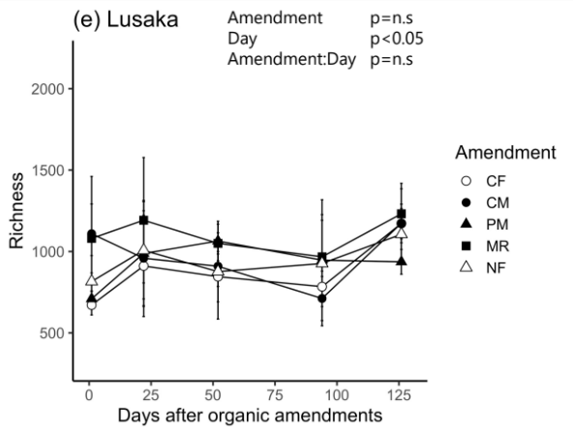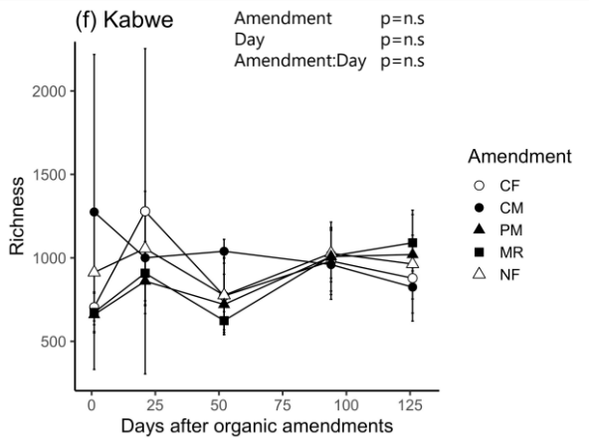
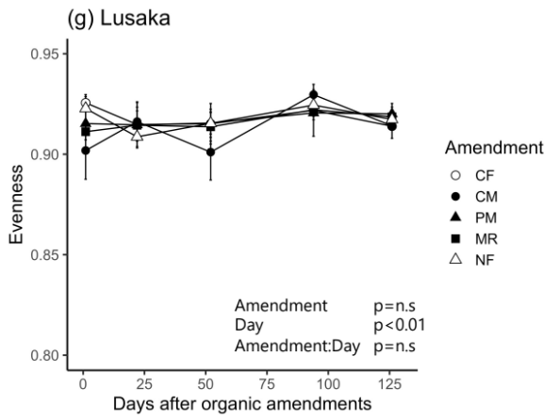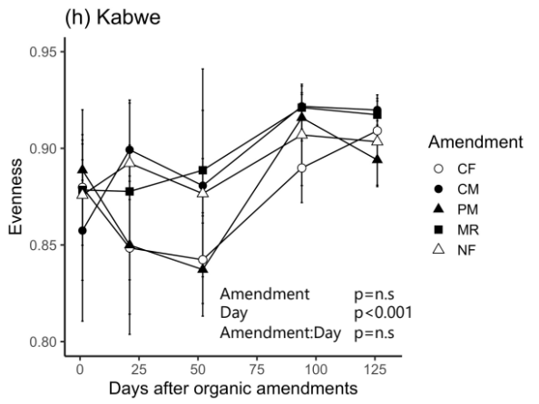

Figure S7. Temporal changes of bacterial and archaeal diversity at OTU level. Left panels show (a) Shannon diversity, (c) Simpson diversity, (e) richness, and (g) evenness in the Lusaka site, respectively. Right panels show (b) Shannon diversity, (d) Simpson diversity, (f) richness, and (h) evenness in the Kabwe site, respectively. Levels of significance were based on mixed model results for repeated measurements. Error bars represent standard deviation (n = 3). CF: chemical fertilizer amendment, CM: cattle manure amendment, PM: poultry manure amendment, MR: maize residue amendment, and NF: no fertilizer amendment.

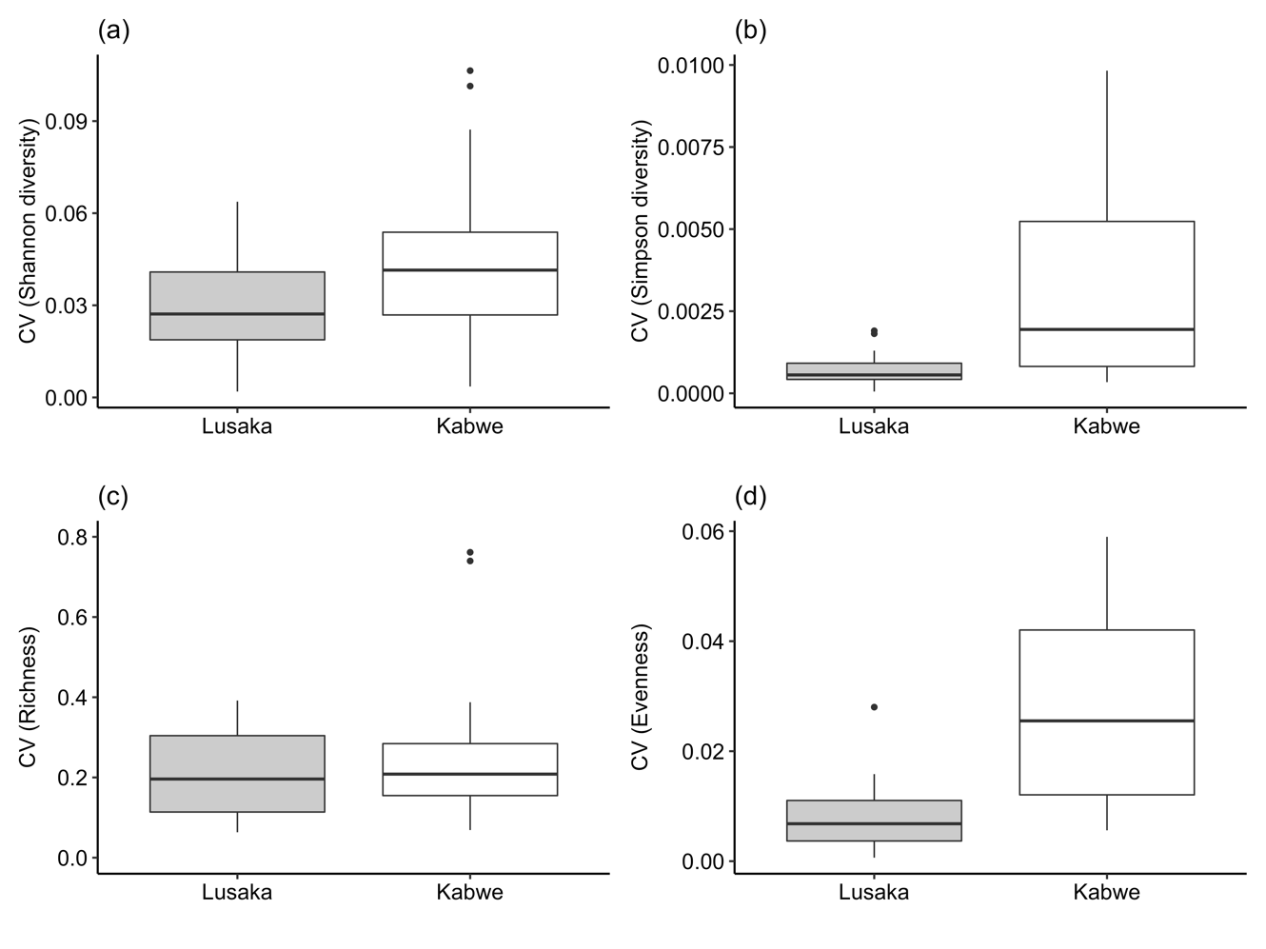
Figure S8. The coefficient of variation (CV) of shannon diversity (a), simpson diversity (b), richness (c), and evenness (d) in Lusaka and Kabwe sites, when averaged across the treatments and sampling dates, respectively.

