Extended Data Fig. 1: Phylogeny and structural alignment of SPARMA Mrr domains.
a. Phylogenetic tree of Mrr-like domains associated with pAgos. The tree was inferred from 80 Mrr-APAZ and Mrr-TIRAPAZ sequences (461 sites) in IQ-TREE 2, using the Q.pfam+R5 model for the Mrr partition and the Q.pfam+R4 model for the APAZ partition, with 1,000 ultrafast bootstrap (UFBoot2) and 1,000 SH-aLRT replicates. Branch support is shown for nodes with UFBoot2 ≥ 95 and SH-aLRT ≥ 80. As no outgroup was available, the tree is rooted on the branch separating the two main Mrr-like clades (SH-aLRT = 100, UFBoot2 = 100). For clarity, all clades are collapsed, with the exception of the local clades of PspSPARMA indicated in bold. The clade in which KjAgo Mrr-APAZ is included (Kordia jejudonensis, WP_046756489.1) is indicated. b. Structural alignment of the PspSPARMA Mrr domain with the E. coli K-12 Mrr protein. Mrr domains were modeled using AlphaFold3 and PspSPARMA Mrr was aligned to the E. coli Mrr model. Putative catalytic residues for mutagenesis are indicated: D67 and Q78.
Extended data Fig. 2: Extended antiplasmid and antiphage activity of PspSPARMA.
a. SPARMA is toxic only in the presence of a trigger plasmid. Growth curves of E. coli containing an empty BAC or a BAC expressing PspSPARMA or PspSPARMA^{Mrr-D67A-Q78A} in the absence (left panel) or presence (right panel) of a pUC trigger plasmid. b. High transcription of plasmid DNA increases SPARMA-mediated cell death. Left: schematic representation of the experiment with trigger plasmids with different transcription levels. Experiments were performed in E. coli BW25113 (DE3), which expresses the T7 RNA polymerase. Right: cell viability of E. coli expressing PspSPARMA (or catalytic mutant) either in the absence or presence of a pUC-derivative from which the mRFP gene is transcribed but not translated (pUC-mRFP^{ΔRBS}), or encoded but not transcribed (pUC-mRFP^{ΔPT7-ΔRBS}). c. Heatmap showing the reduction in plaque-forming units (PFU) relative to an empty-vector control across a panel of E. coli lytic phages: BASEL collection phages (Bas01–Bas69), classical phages T2, T4, T5, T6, T7, N4, λ_{vir}, P1_{vir}, P2_{vir}, and two ssDNA phages (φX174 and M13). Phage drop assays were performed in biological triplicate on double-layer LB agar supplemented with 0.2% arabinose to induce PspSPARMA system expression. Unless indicated otherwise, PFU assays were performed in E. coli BW25113 expressing PspSPARMA from a BAC under control of the P_{BAD} promoter. For φX174, the PspSPARMA system was chromosomally integrated at the attTn7 site in E. coli C3000. For filamentous phage M13, the systems were chromosomally integrated at the attTn7 site in E. coli BW25113 F⁺. d. SPARMA provides protection against infection by bacteriophages. Bacteriophage drop test assay on double-layered LB agar plates. E. coli expressing PspSPARMA or PspSPARMA^{Mrr-APAZ-D67A-Q78A} were challenged with 10-fold serial dilutions of λ_{vir}, P1_{vir}, and P2_{vir} bacteriophages. Experiments were performed in biological triplicate; representative results of one experiment are shown.

Extended data Fig. 3: RNA-guided DNA detection by PspSPARMA results in collateral ssDNA and dsDNA degradation.
a. Activated SPARMA complexes cleaves efficiently dsDNA and ssDNA in trans but not ssRNA. PspSPARMA or catalytic mutants PspSPARMA^{Mrr-APAZ-D67A-Q78A} proteins were first incubated with 5′P-RNA guides and complementary ssDNA targets, after which different nucleic acid substrates (60 bp dsDNA, 60 nt ssDNA, 60 nt ssRNA) were added to assess in trans cleavage activity. b. SPARMA in trans cleavage shows no sequence bias. SPARMA-degraded genomic E. coli DNA was subjected to next-generation sequencing. WebLogo representation of the nucleotide context surrounding cleavage sites from sequencing reads.

Extended data Fig. 4: SPARMA guide preferences and target mismatch tolerances.
a-b. Guide RNA 5′-end nucleotide (a) and length (b) preferences. PspSPARMA were incubated with guide RNAs containing different nucleotides (A, U, G, or C) at the first or second position (a) of guide RNAs of different lengths (b), complementary ssDNA targets, and DNaseAlertTM. Graphs show the maximum relative change in DNaseAlertTM fluorescence. Experiments were performed in technical triplicate; dots indicate single experiments; error bars indicate standard deviation. c-d. Effect of mismatches on SPARMA activation. PspSPARMA was incubated with guide RNA and ssDNA targets containing single or double mismatches, then DNaseAlertTM substrate was added to follow in trans cleavage activity over time. The bar graphs show the maximum change in fluorescence.
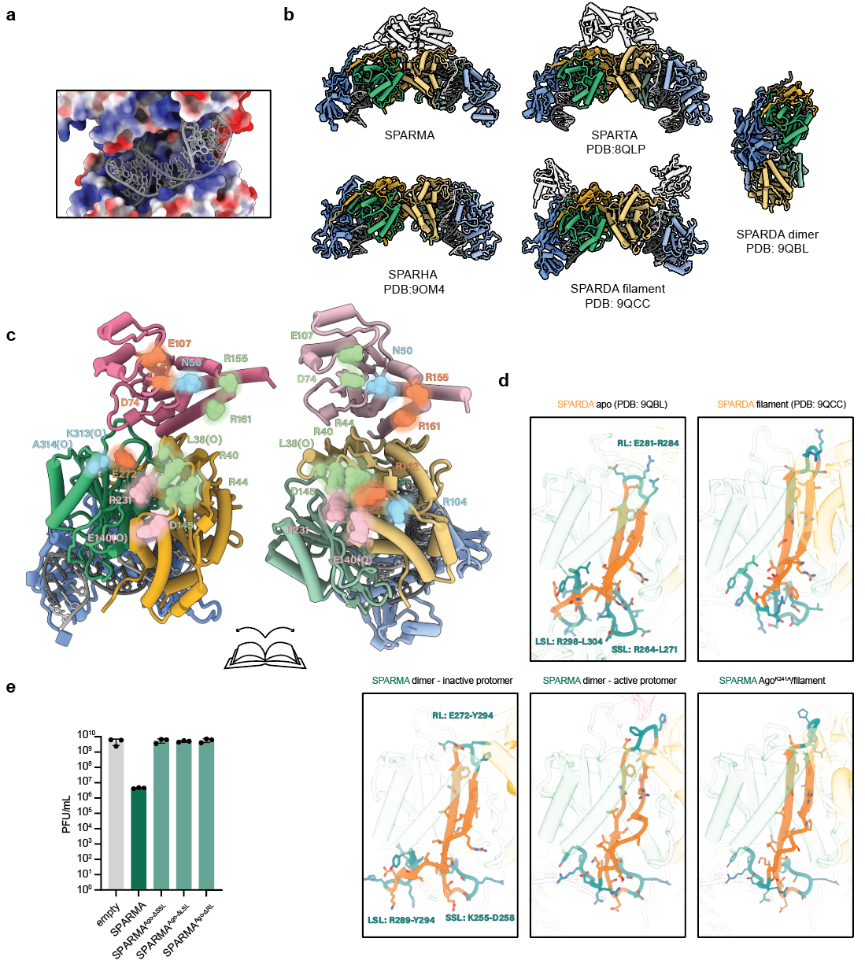Extended data Fig. 5: SPARMA dimerization and importance of the beta-relay.
a. RNA/DNA duplex binds in SPARMA positively charged pocket. Zoomed-in view of the positively charged region of SPARMA located between the APAZ and MID-PIWI* domains colored according to its electrostatic potential using the corresponding tool in ChimeraX (blue indicates a positive potential). The guide-target duplex is depicted in grey. b. Comparison between SPARMA dimer and other short pAgos dimers. Cartoon representations of known short pAgo systems, in which the dimers are highlighted in color according to the same color scheme as used for SPARMA in Figure 5. Accessory domains are colored in grey. c. Overview of the residues that mediate SPARMA dimerization. Cartoon representation of dimeric SPARMA “folded open” to reveal atom representations of interacting residues between the two SPARMA protomers, matched by color. d. Comparison of Beta-relay regions in SPARMA and other short pAgos. Zoomed-in view of the Beta-relay (BR) region of apo-SPARDA, filamentous SPARDA, both SPARMA protomers within the dimer, and the SPARDA AgoK241A mutant. The signature regions of the BR are indicated in teal: the Large Sensor Loop (LSL), the Small Sensor Loop (SSL), and the Response Loop (RL). e. Beta relay loops are essential for anti-phage activity. Barplot representing the result of λ_{vir} phage drop-test assay of E. coli BW25113 strain expressing SPARMA or beta-relay loops mutants (SPARMA^{AgoΔSSL (K255-L258->GG)}; SPARMA^{AgoΔLSL (R289-Y294)}; SPARMA^{AgoΔRL (E272-H275->GGG)}) from a BAC. Experiments were performed in biological triplicate. Dots indicate single experiments, and error bars indicate standard deviation.
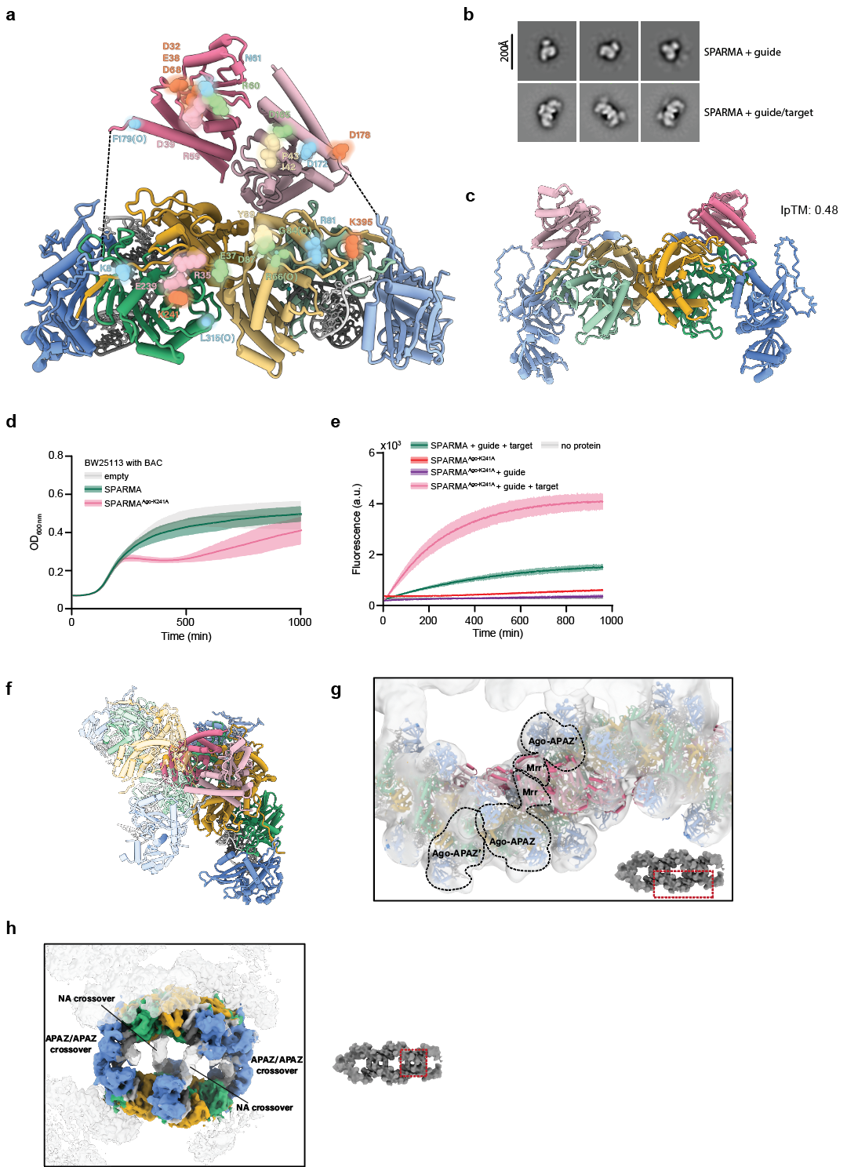
Extended data Fig. 6: The Mrr domain is docked in the SPARMA dimer but released in the SPARMA filament.
a. Overview of the residues that mediate Mrr-docking in SPARMA. Cartoon representation of dimeric SPARMA “folded open” to reveal atom representations of interacting residues between the dimerized Mrr domains and the MID-PIWI domains, matched by color. SPARMA dimerization interfaces. b. Representative 2D class averages images of SPARMA incubated of with a guide, or with both guide and target. The averages were obtained by analysis of negative-stain electron micrographs. c. Alpha-Fold prediction of SPARMA^{Mrr-∆181:189}. By making this truncation, the Mrr domains are no longer predicted to dimerize. d. SPARMA^{Ago-K241A} is toxic upon expression. Bacterial growth curve of E. coli BW25113 expressing SPARMA or SPARMA^{Ago-K241A} from a BAC. e. SPARMA^{Ago-K241A} is hyperactive. SPARMA or SPARMA^{Ago-K241A} were incubated with or without guide RNA and with or without complementary target ssDNA, after which a DNaseAlertTM substrate was added to follow trans-cleavage activity over time. Data points represent the average of three technical replicates; shaded areas indicate standard deviations. f. Docked Mrr-domains are incompatible with SPARMA filamentation. Cartoon representations of SPARMA dimers fitted in the density of the SPARMA filament. The Mrr domains of one of the dimers are shown, which clash with the MID-PIWI domains of the neighboring protomer. g. Location of the Mrr domains in the SPARMA filament. Separate Mrr-dimers are fitted in a low-pass cryo-EM density map of the SPARMA filament, revealing their approximate location. h. SPARMA filaments dimerize to form higher-order filaments through interactions of their APAZ domains, and associated nucleic acids. Locally refined cryo-EM density map of the crossover point between two SPARMA filaments. The map is colored according to the same color scheme used for SPARMA in Figure 5.

