Supplementary data – Uncropped gels
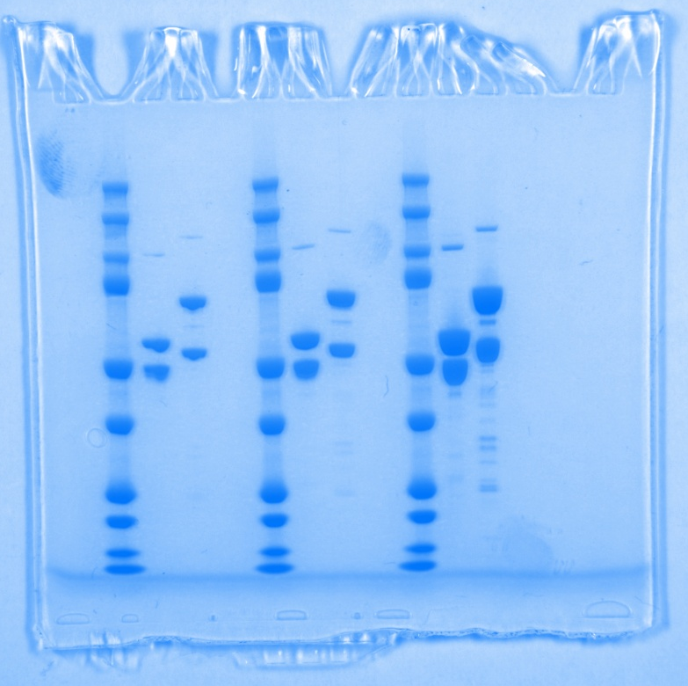
Figure 2A

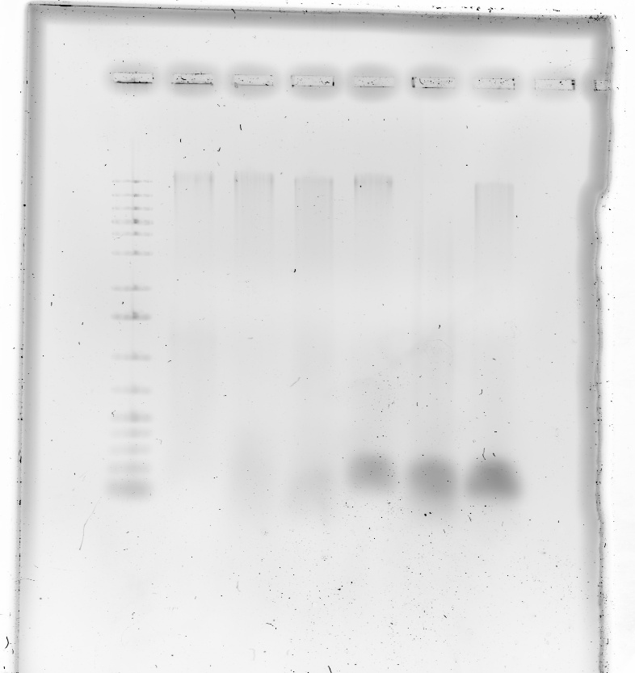
Figure 2F

Figure 3D

Extended Data Figure 3A (left: ssDNA, middle: dsDNA, right: ssRNA)

