Supplementary information

Table S1: Cryo-EM data collection, refinement, and validation statistics.
 | SPARMA  (EMD-59177)  (PDB 32UH) | SPARMA-K241  dimer  (EMD-59154)  (PDB 32TP) | SPARMA-K241  tetramer  (EMD-59178)  (PDB 32UI) | SPARMA-K241  hexamer  (MD-59195)  (PDB 32VD)
Data collection and processing
Magnification | 120,000 | 120,000 | 120,000 | 120,000
Voltage (kV) | 200 | 200 | 200 | 200
Electron exposure (e–/Å²) | 40 | 40 | 40 | 40
Defocus range (μm) | -1.2 to -2.2 | -1.2 to -2.2 | -1.2 to -2.2 | -1.2 to -2.2
Pixel size (Å) | 1.182 | 1.182 | 1.182 | 1.182
Symmetry imposed | C1 | C2 | C1 | C2
Initial particle images (no.) | 27,945,706 | 5,538339 | 5,538339 | 5,538339
Final particle images (no.) | 507,634 | 279,688 | 49,724 | 49,724
Map resolution (Å)  FSC threshold | 2.9  0.143 | 2.8  0.143 | 3.2  0.143 | 3.0  0.143
Map resolution range (Å)
Refinement
Initial model used (PDB code) | ModelAngelo model | SPARMA, docked protomer (32UH) | K241 dimer (32TP) | K241 tetramer (32UI)
Model resolution (Å)  FSC threshold | 3.0  0.143 | 2.9  0.143 | 3.3  0.143 | 3.3  0.143
Model resolution range (Å) | N/A | N/A | N/A | N/A
Map sharpening B factor (Å²) | 82.1 | 95.2 | 63.3 | 70.2
Model composition  Non-hydrogen atoms  Protein residues  Ligands | 15508  1759  Nucleotide: 60  Mn ion: 4 | 12928  1406  Nucleotide: 72  Mn ion: 2 | 25856  2812  Nucleotide: 144  Mn ion: 4 | 38784  4218  Nucleotide: 216  Mn ion: 6
B factors (Å²)  Protein  Nucleotide | 68.16  64.18 | 39.28  30.35 | 77.34  86.63 | 105.67  119.66
R.m.s. deviations  Bond lengths (Å)  Bond angles (°) | 0.004  0.689 | 0.003  0.589 | 0.003  0.640 | 0.003  0.688
Validation  MolProbity score  Clashscore  Poor rotamers (%) | 0.97  1.52  0.95 | 1.44  3.53  1.97 | 1.51  4.57  2.01 | 1.45  4.18  2.03
Ramachandran plot  Favored (%)  Allowed (%)  Disallowed (%) | 97.63  2.37  0.00 | 97.68  2.32  0.00 | 97.68  2.32  0.00 | 97.95  2.05  0.00

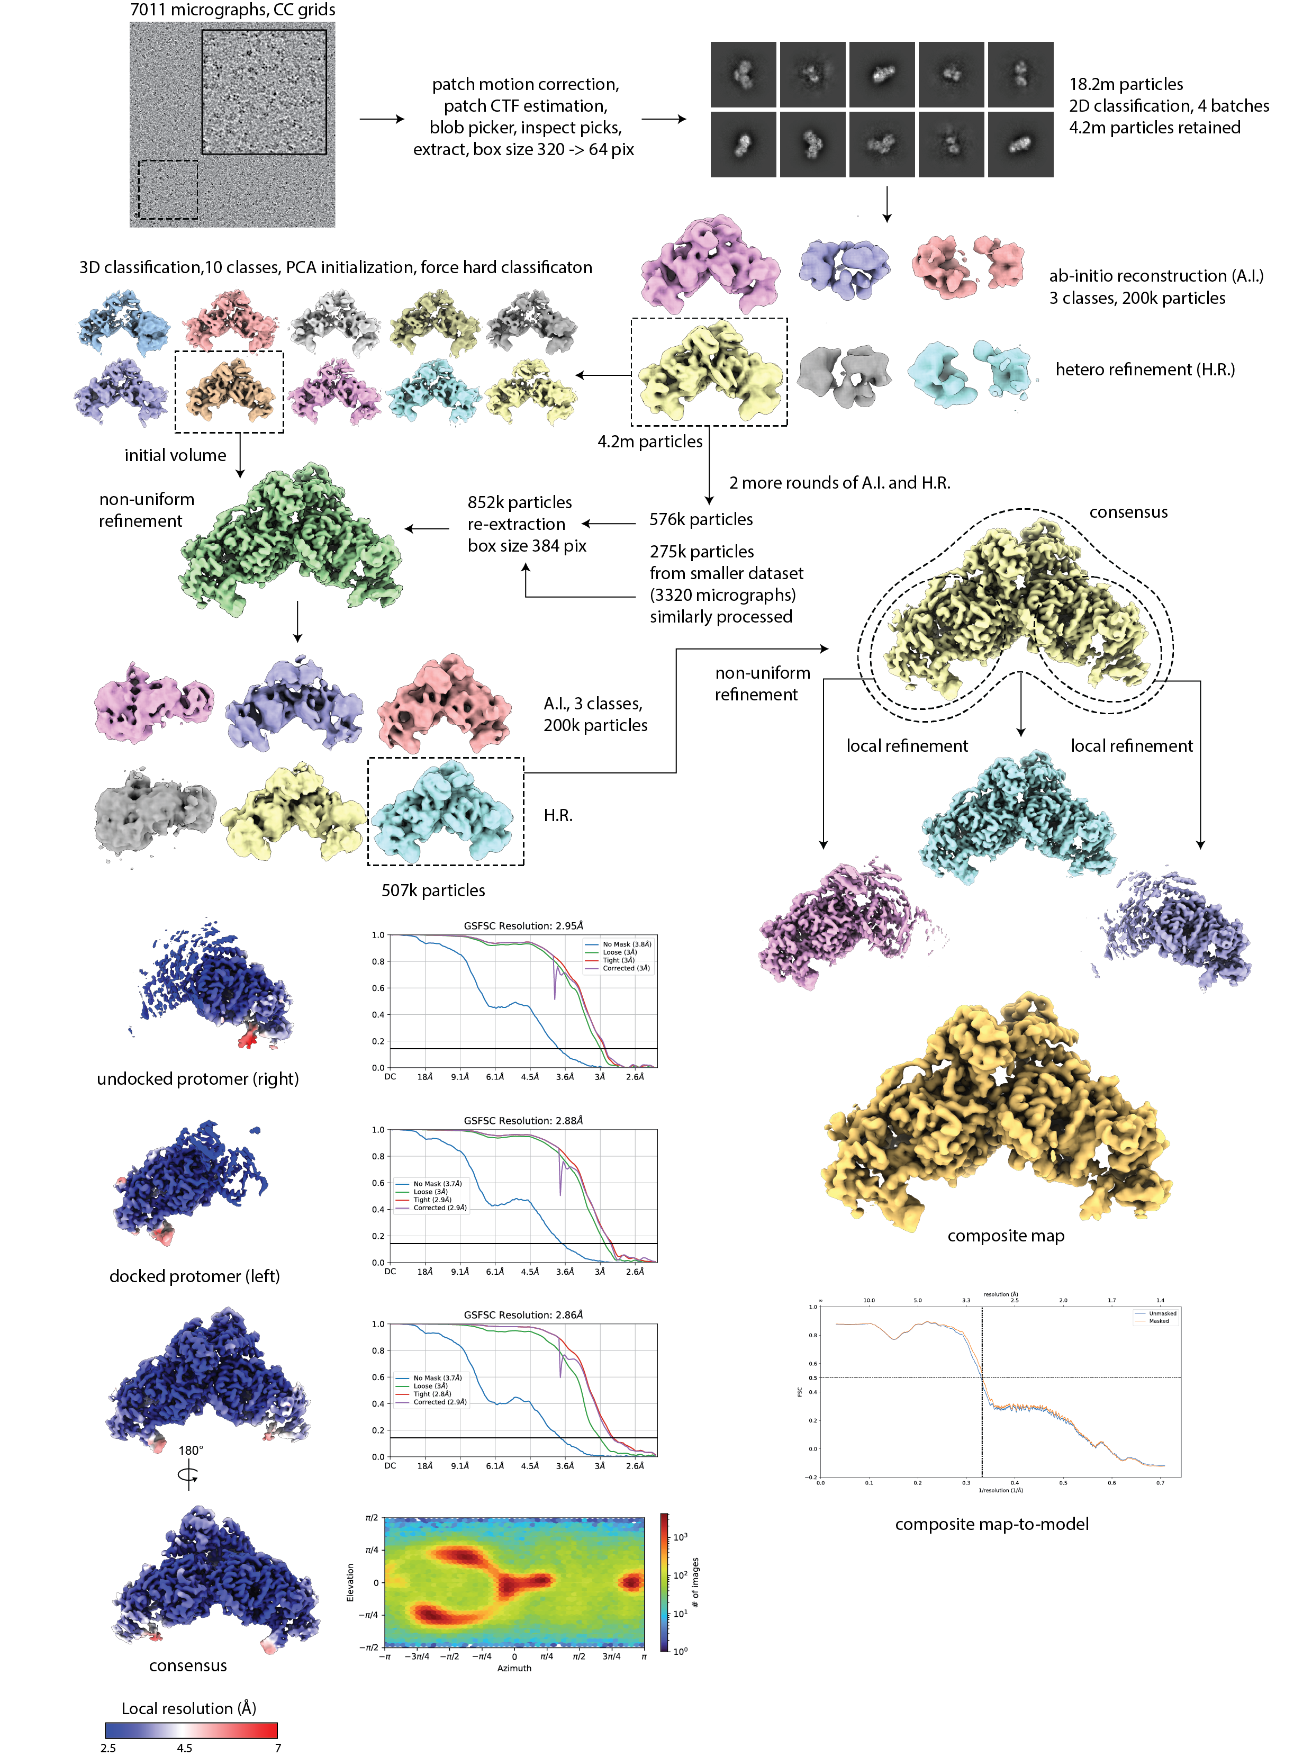
Figure S1. Cryo-EM data processing of dimeric SPARMA.
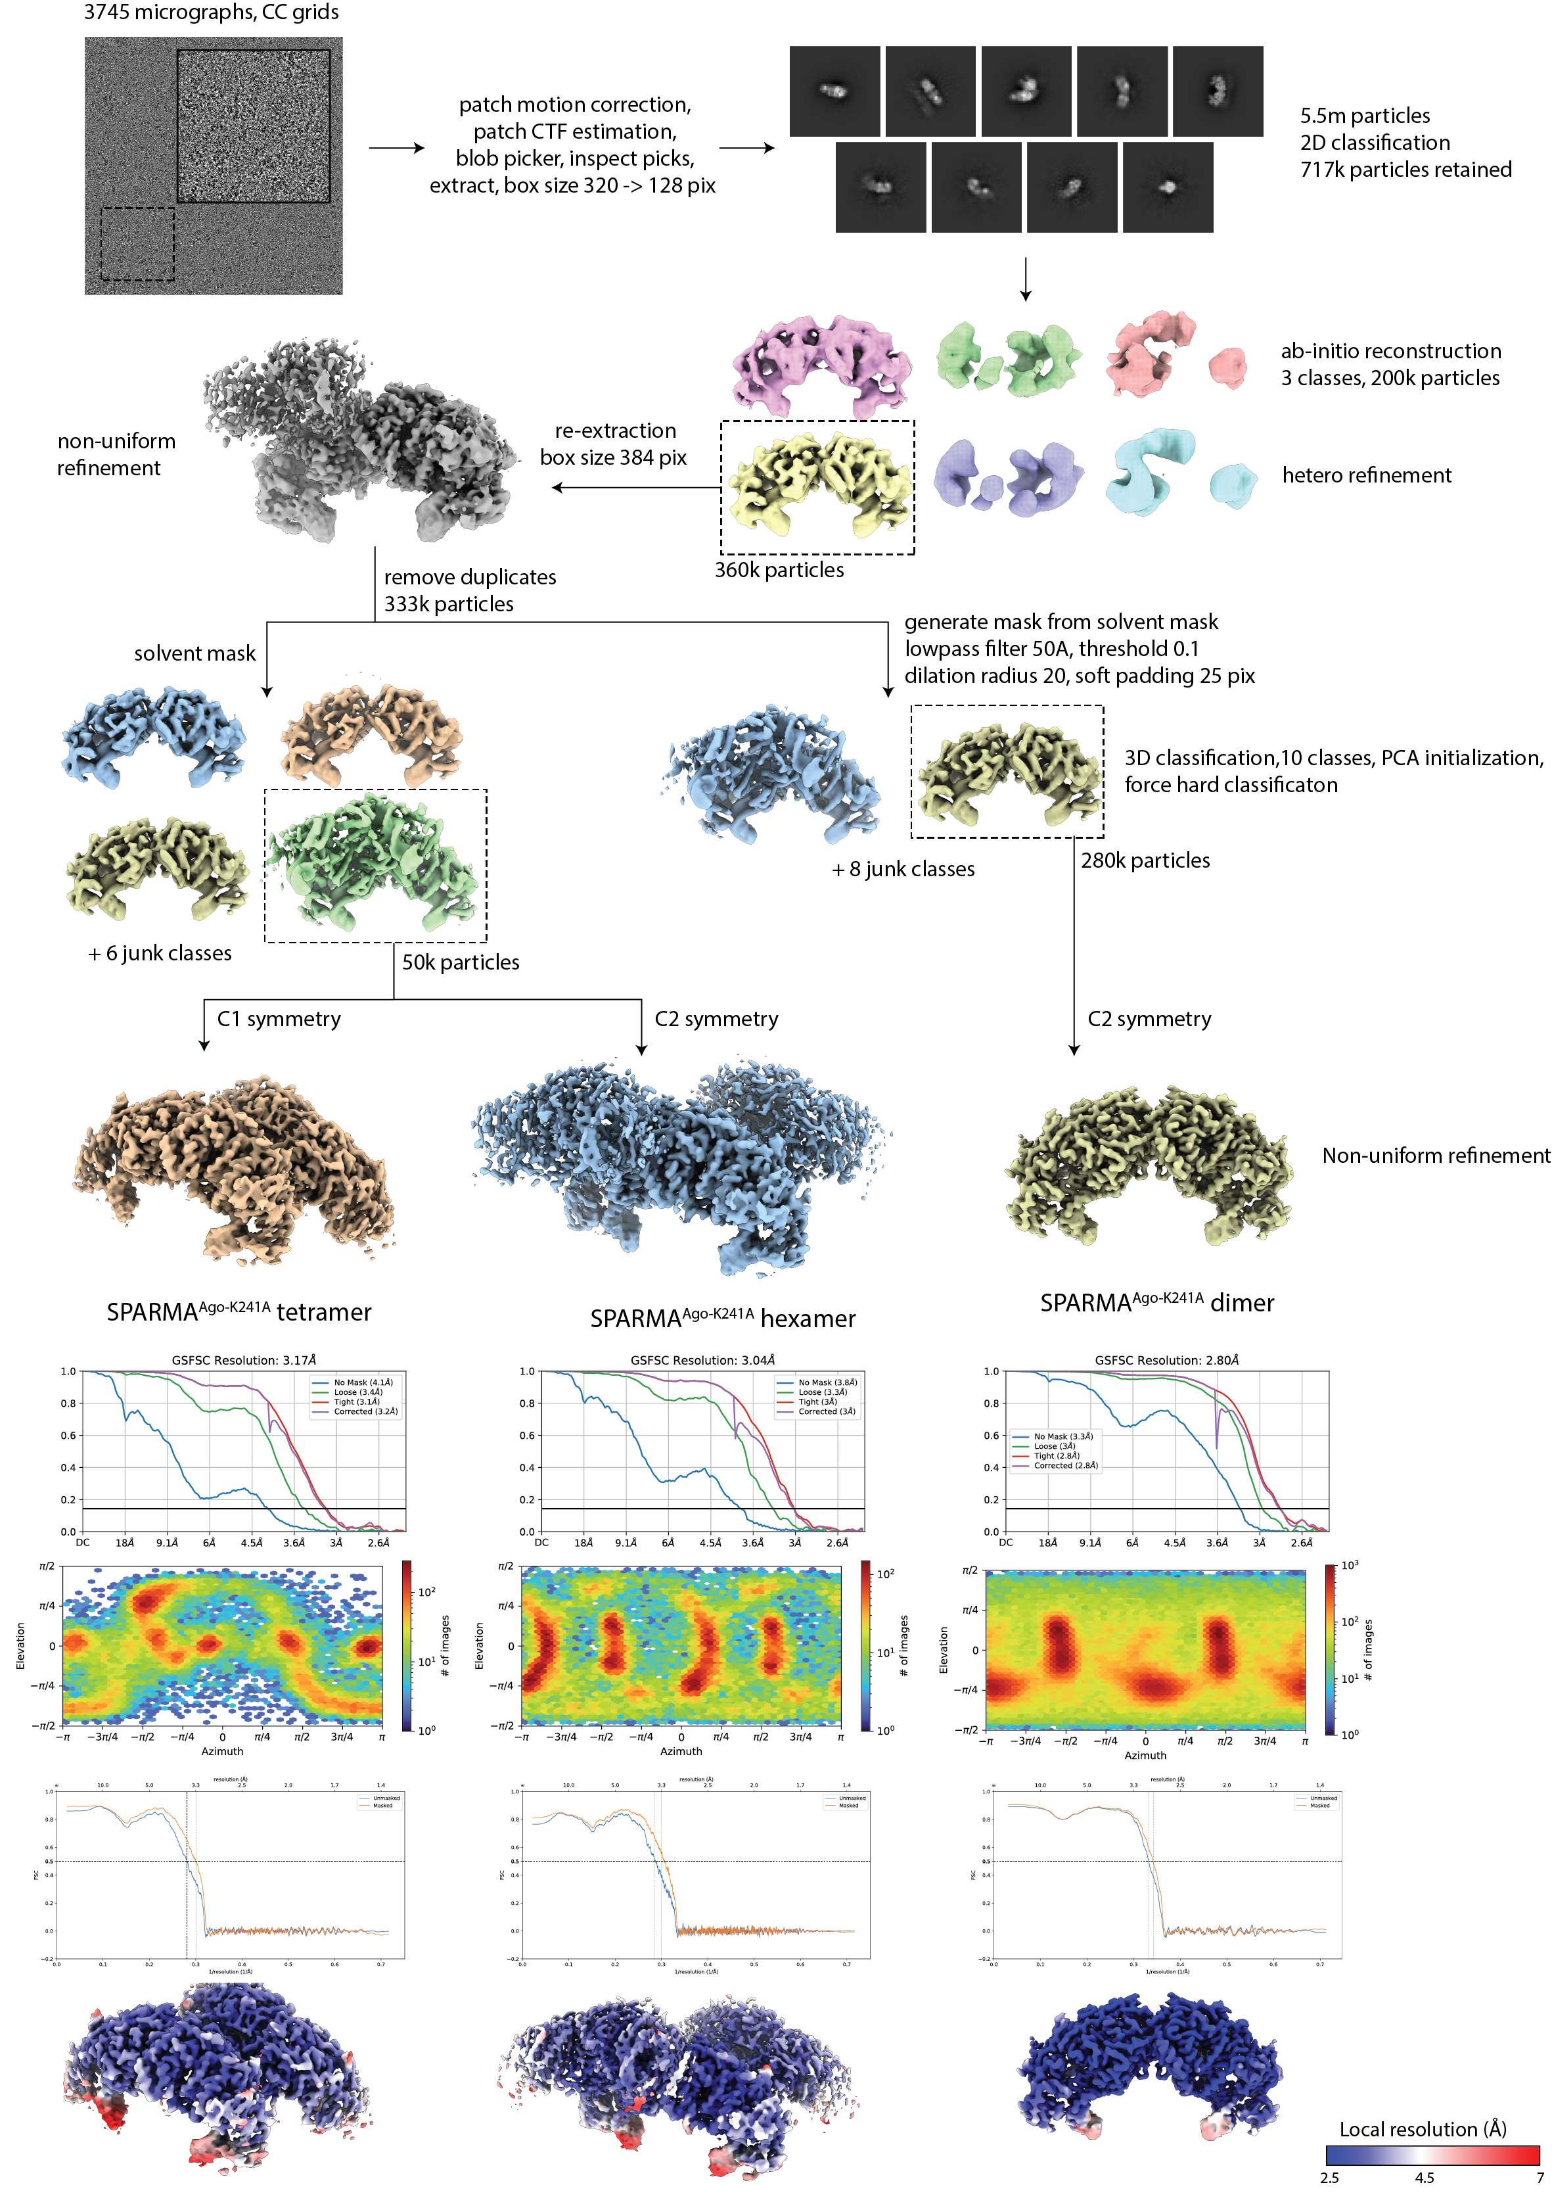
Figure S2. Cryo-EM data processing of SPARMA^{Ago-K241A}.

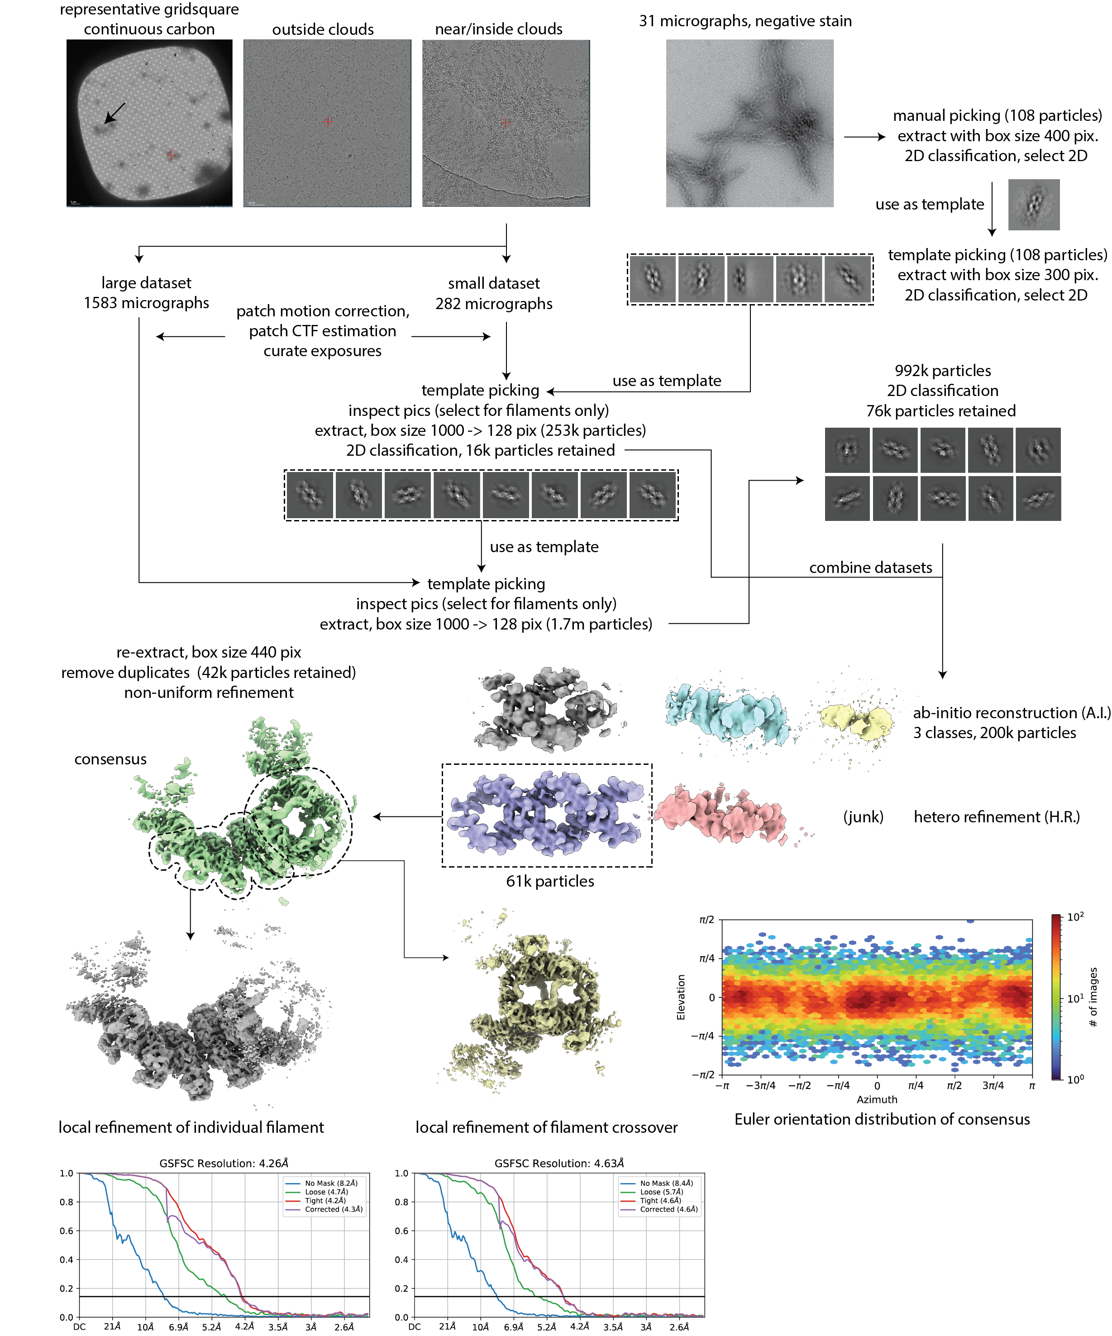
Figure S3. Cryo-EM data processing of SPARMA filaments.

