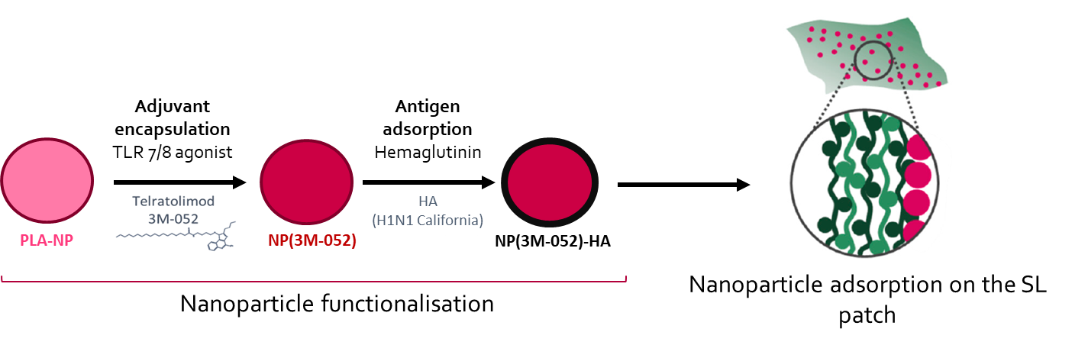
Scheme 1: Preparation of the sublingual vaccine. The TLR 7/8 agonist telratolimod (3M-052) was encapsulated inside polymeric PLA nanoparticles (NP). Then, the viral protein hemagglutinin (HA) from the influenza virus was adsorbed on the suface of the NP (NP-HA). The functionnalised NP-HA were finally adsorbed on the surface of a mucoadhesive sublingual (SL) patch.

