Supplementary data

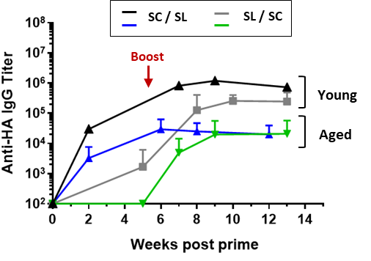
Figure S1: Systemic immune response in young (3 months) and aged (16 months) mice according to the administration route. Kinetics of anti-HA IgG titers determined after either SC prime (black and blue lines) or SL prime (grey and green lines). N= 8-10. Data are presented as mean ± SD.

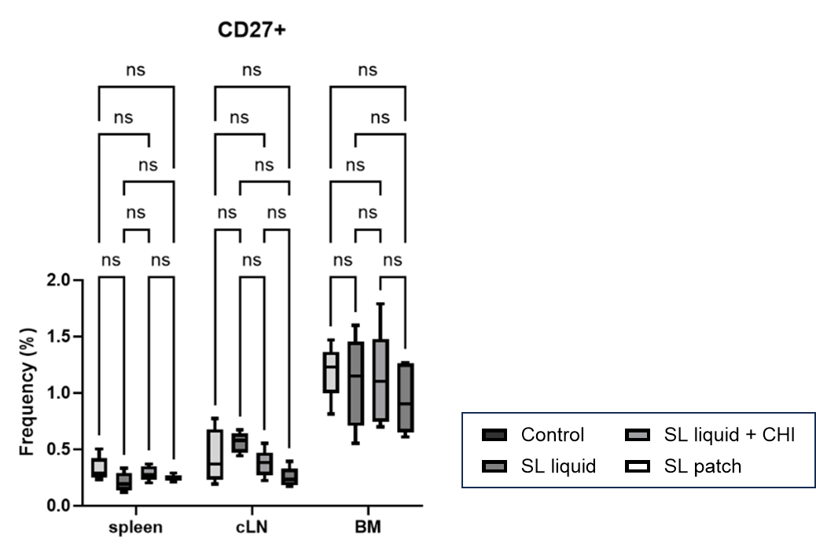
Figure S2: Frequency of B cells expressing CD27 receptor in the spleen, cervical lymph hnode (cLN) and the bone marrow (BM), 4 weeks after SL boost in absence or presence of CHI (formulated as liquid or patch) in young mice. N=5. Data are presented as mean ± SD and statistically analysed using one-way ANOVA followed by Tukey’s multiple comparison test (ns: p > 0.05).

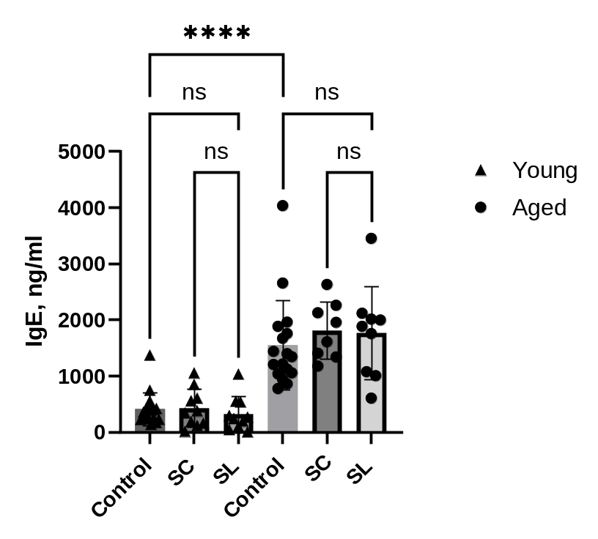
Fig S3: Systemic (non specific) IgE concentration in the blood of young (3 months) and aged (18 months) animals. Comparison of IgE concentration determined by ELISA at 4 weeks after SC or SL boost. N=8-10. Data are presented as mean ± SD and statistically analysed using one-way ANOVA followed by Tukey’s multiple comparison test (ns: p > 0.05, ****: p < 0.00001).

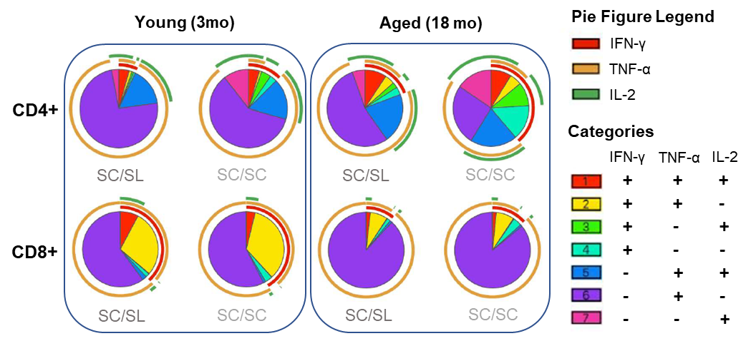

Figure S4: T cell response to the sublingual vaccine in young and aged mice. Multifunctionnal non specific Th1 CD4/CD8 cytokine-secreting response (stimulation of cells by PMA/ionomycin), represented by pie charts indicating the expression of cytokine combinations from CD4⁺ and CD8⁺ T cells.

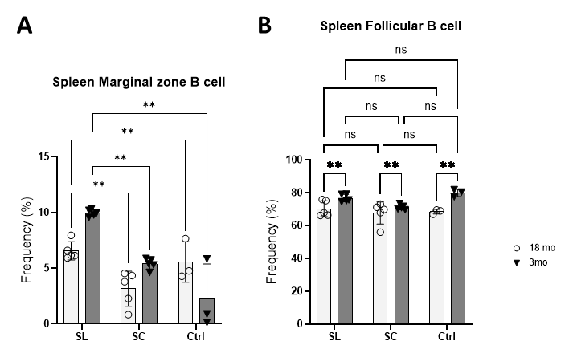

Fig S5: Spleen immunophenotyping after SC or SL boost in young and aged mice. Frequency of marginal zone Bcells (A) and (B) follicular B cells. N=5. Data are presented as mean ± SD and statistically analysed using one-way ANOVA followed by Tukey’s multiple comparison test (ns: p > 0.05, **: p < 0.001).

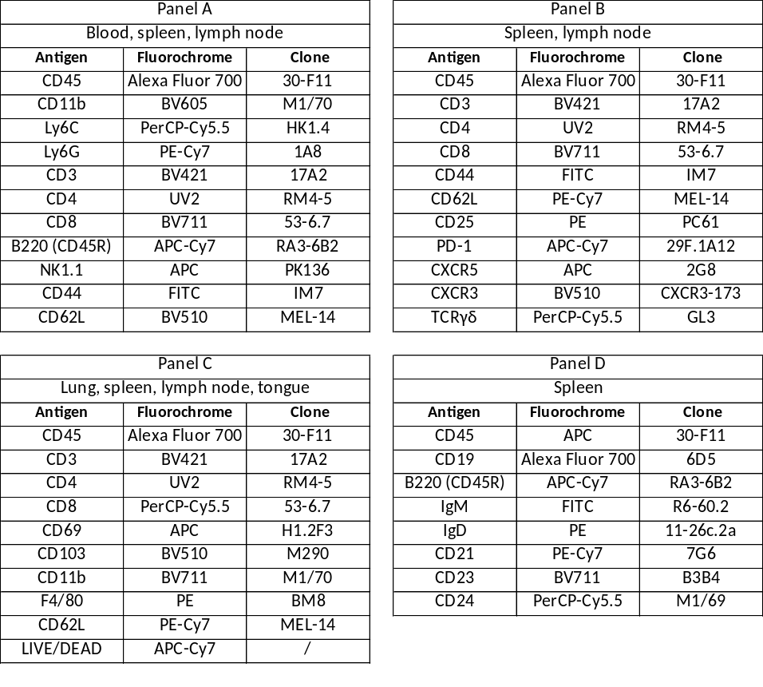
Supp Table 1: Flow cytometry antibodies used for immunophenotyping (clone, fluorochrome).

