Supplementary files

Article
EchoMed Agent: A Foundation Model–Based Agentic Framework for Echocardiographic Left Ventricular Segmentation and Functional Assessment
Leshan Sun¹, Juan Farina², Songlin Zhao³, Shuoyang Wei¹, Yuzhen Ding ¹, Reza Arsanjani², Win-Kuang Shen², Wei Liu ¹
¹The Department of Radiation Oncology, Mayo Clinic Arizona, Phoenix, AZ 85054 USA.
²the Department of Cardiovascular Medicine, Mayo Clinic Arizona, Phoenix, AZ 85054 USA.
³Department of Computer Science, Lehigh University, Bethlehem, PA 18015 USA.
.
Corresponding author: Wei Liu, PhD, E-mail: Liu.Wei@mayo.edu

Supplementary Index

Supplementary Figure 1 3
Supplementary Figure 2 4
Supplementary Figure 3 5
Supplementary Figure 4 6
Supplementary Table 1. 7

Supplementary Figure 1

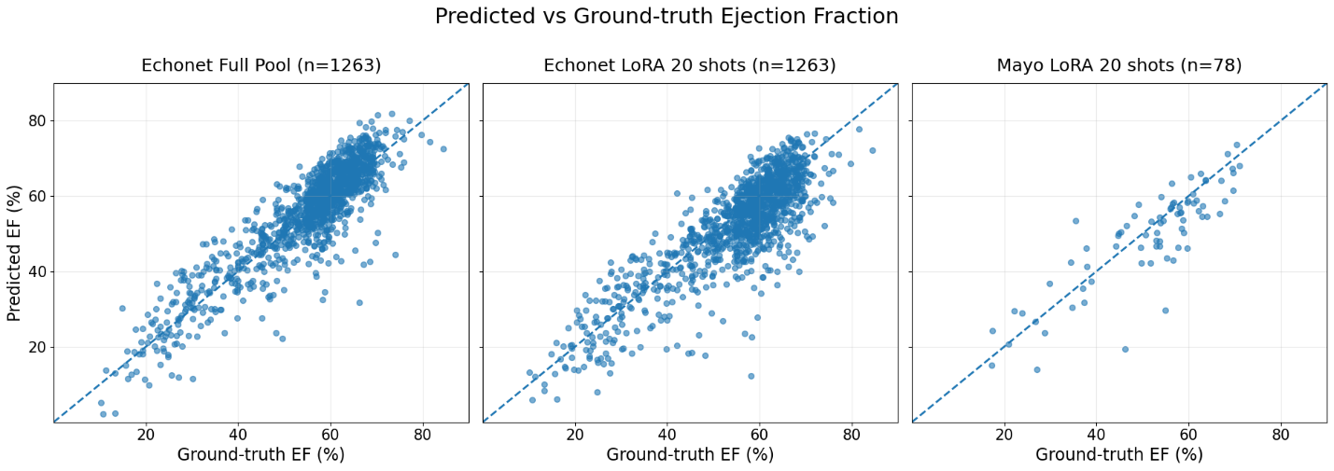
Supplementary Figure 1. Ejection fraction scatter plots. Scatter plots comparing predicted and ground-truth ejection fraction (EF) across three training settings. Left: EchoNet data using full-pool training. Middle: EchoNet data using LoRA fine-tuning with 20 shots. Right: Mayo Clinic cohort using LoRA fine-tuning with 20 shots. The dashed diagonal line represents perfect agreement between predicted and ground-truth EF.

Supplementary Figure 2

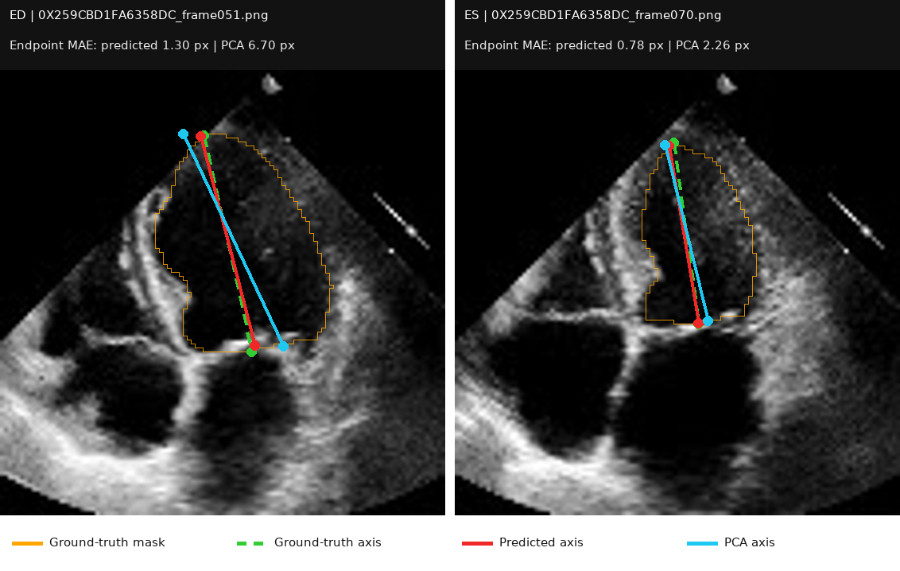
Supplementary Figure 2. Predicted cardiac long-axis endpoints outperform PCA-based axis estimation. Representative echocardiographic examples comparing the ground-truth long axis (green dashed line) with the model-predicted axis (red) and the PCA-derived axis (cyan). In both examples, the predicted axis endpoints more closely align with the ground-truth endpoints than those obtained using PCA, resulting in lower endpoint mean absolute error (MAE; left: 1.30 vs. 6.70 px; right: 0.78 vs. 2.26 px). The ground-truth segmentation mask is outlined in orange

Supplementary Figure 3
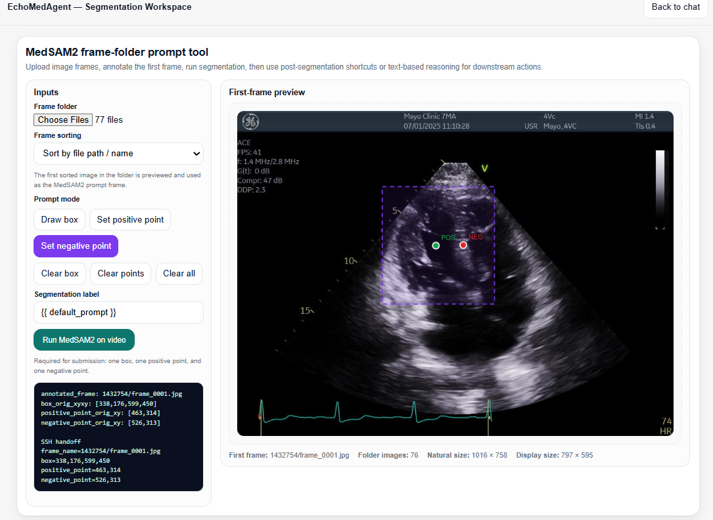
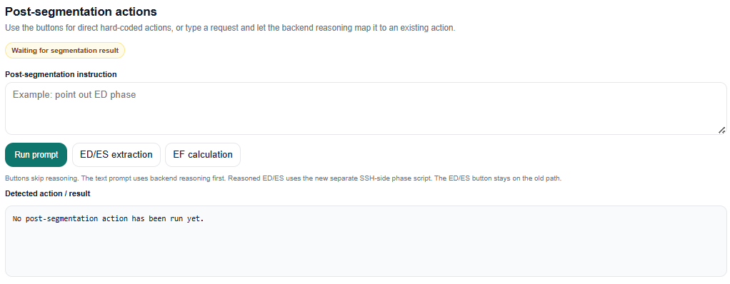
Supplementary Figure 3. Demonstration of the EchoMedAgent real API interface. The interface integrates MedSAM2-based echocardiographic video segmentation with interactive first-frame prompting and downstream post-segmentation analysis. Users can define bounding-box and positive/negative point prompts for segmentation, run MedSAM2 across the uploaded frame sequence, and subsequently invoke API-driven actions including end-diastolic/end-systolic (ED/ES) phase extraction and ejection fraction (EF) calculation.

Supplementary Figure 4

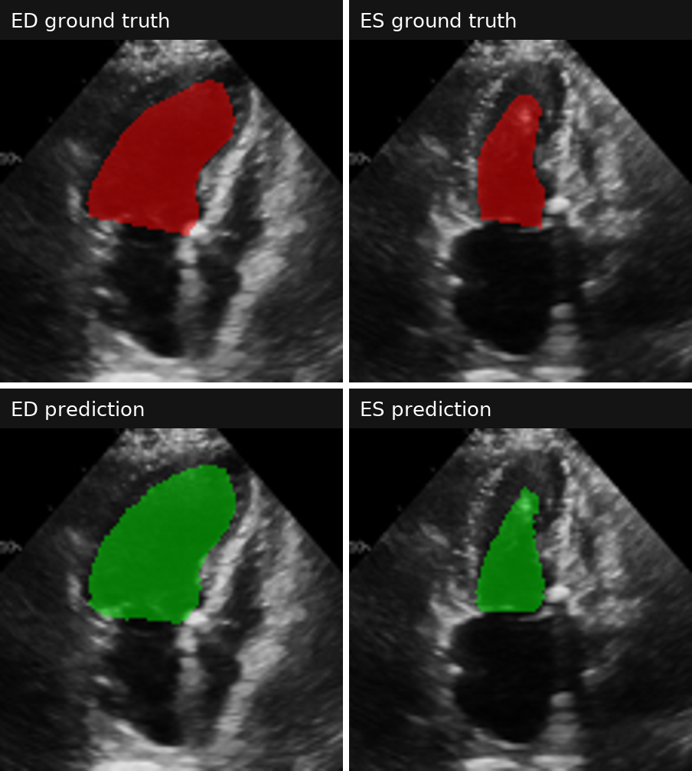
Supplementary Figure 4. Representative failure mode at end-systole. Ground-truth (top) and predicted (bottom) LV segmentations are shown at end-diastole (ED; left) and end-systole (ES; right). At ES, the imaging angle and reduced endocardial boundary conspicuity lead to inaccurate LV cavity delineation, resulting in downstream error in end-systolic volume and ejection fraction estimation.

Supplementary Table 1.

Metric | Axis prediction | PCA | Improvement
Endpoint MAE | 1.897 ± 0.956 px | 2.499 ± 1.300 px | 24.1%
Length error | 1.522 ± 1.235 px | 1.556 ± 1.046 px | 2.2%
Angle error | 2.223 ± 1.873° | 2.876 ± 2.412° | 22.7%

Supplementary Table 1. Quantitative Comparison of Axis Prediction and PCA-Based Long-Axis Estimation
Performance was evaluated across 2,526 images using endpoint mean absolute error, length error, and angular error relative to the ground truth. Values are reported as mean ± standard deviation; lower values indicate better performance.

