Supplementary information
Influence of iron and cobalt on oxalic acid degradation during underwater non-thermal plasma treatment of simulated chemical decontamination effluents
Ki-baek Shin¹,*, Kilyoung Ko¹, Sunjin Kim¹, Jong-bum Kim¹, Jin Kim¹, Jin-joo Kim¹, Jintae Hong¹, Yong Cheol Hong², Kangil Kim²,*
¹ Korea Atomic Energy Research Institute, 111 Daedeok-daero 989beon-gil, Yuseong-gu, Daejeon 34057, Republic of Korea
² Institute of Plasma Technology, Korea Institute of Fusion Energy, 37 Dongjangsan-ro, Gunsan-si, Jeonrabuk-do 54004, Republic of Korea
* Corresponding authors.
E-mail: kbshin@kaeri.re.kr (K.-b. Shin); kikim@kfe.re.kr (K. Kim)
This supplement provides measured concentration series, descriptive kinetic fits, stoichiometric calculations based on reagent additions and spectral data supporting the main text. All treatment comparisons use one batch per composition.

S1 Sample identification and analytical basis
The OA, OA+Co, OA+Fe and OA+Fe+Co series each represent one treatment batch. IC and UV-Vis results are matched by solution composition and treatment sampling time. Samples were collected at 10-min intervals from 0 to 60 min; OA has six samples through 50 min. Ferrozine-treated aliquots form an additional analytical series from the same OA+Fe batch. The original IC/UV-Vis labels are O100-b/UOX (OA), OC2-c/UOC (OA+Co), OF3-a/UOF (OA+Fe) and OFC/UFC (OA+Fe+Co). OFC and UFC refer to the same mixed-metal batch. IC sample suffixes 0-6 denote 0-60 min at 10-min intervals (0-5 and 0-50 min for OA).
The external laboratory reported oxalate concentrations in mg L⁻¹. The reports with ND results specify a 0.1 mg L⁻¹ instrumental limit and tenfold dilution, giving a 1 mg L⁻¹ sample-basis limit. The Fe-only report provides quantified concentrations at every sampling time. “IC-detectable oxalate” denotes the concentration reported under this analytical procedure, without assigning free, complexed or particulate fractions. Each report provides one concentration result per sample. Matrix-specific recovery was not independently evaluated.
Table S1 Oxalate concentrations reported by the external laboratory
Time  (min) | OA  (mg L⁻¹) | OA+Co  (mg L⁻¹) | OA+Fe+Co  (mg L⁻¹) | OA+Fe  (mg L⁻¹)
0 | 87.0 | 65.7 | 94.3 | 53.1
10 | 30.8 | 33.4 | 38.9 | 49.8
20 | ND | 5.6 | 7.2 | 46.7
30 | ND | ND | ND | 48.5
40 | ND | ND | ND | 47.5
50 | ND | ND | ND | 45.2
60 | Not sampled | ND | ND | 42.2

ND: reported below 1 mg L⁻¹. The OA sampling series ends at 50 min.
For OA+Fe, the decrease relative to the measured initial value is 100 × (53.1 - 42.2)/53.1 = 20.53%. For the other batches, a final value below 1 mg L⁻¹ corresponds to decreases greater than 98.85% (OA), 98.48% (OA+Co) and 98.94% (OA+Fe+Co), relative to their respective measured initial values. These bounds describe the decline in reported IC-detectable oxalate. Mineralisation is a separate carbon-balance endpoint.

S2 Descriptive log-linear fits and detection bounds
Ordinary least squares was applied to ln(C) = b - kt using quantified values of C in mg L⁻¹ and a freely fitted intercept b. ND observations were retained as upper-bound information outside the regression. The fits describe concentration changes within the stated quantified intervals. Their statistical scope is within-series fit behaviour for the single batch tested per composition. For OA, two points determine the line exactly, leaving zero residual degrees of freedom for assessing goodness of fit.
Table S2 Parameters of the quantified-point fits and extrapolation to the first ND result
Solution | n / interval (min) | k (min⁻¹) | b | R² | Predicted C at first ND (mg L⁻¹)
OA | 2 / 0-10 | 0.10384 | 4.4659 | - | 10.90 at 20 min
OA+Co | 3 / 0-20 | 0.12312 | 4.3700 | 0.937 | 1.97 at 30 min
OA+Fe+Co | 3 / 0-20 | 0.12862 | 4.6801 | 0.969 | 2.27 at 30 min
OA+Fe | 7 / 0-60 | 0.00309 | 3.9528 | 0.842 | -

The fitted initial concentration divided by the measured C₀ is 1.000 for OA, 1.203 for OA+Co, 1.143 for OA+Fe+Co and 0.981 for OA+Fe. A normalised curve corresponding to this fit is exp(b - kt)/C₀, retaining the fitted intercept. Figure S1 displays curves over the quantified fitting intervals and separately marks predictions at the first ND time. These predictions exceed the reported detection bound in all three series with ND results. Measured concentrations and ND bounds therefore provide the primary description of the treatment profiles; the fits summarise the stated intervals.
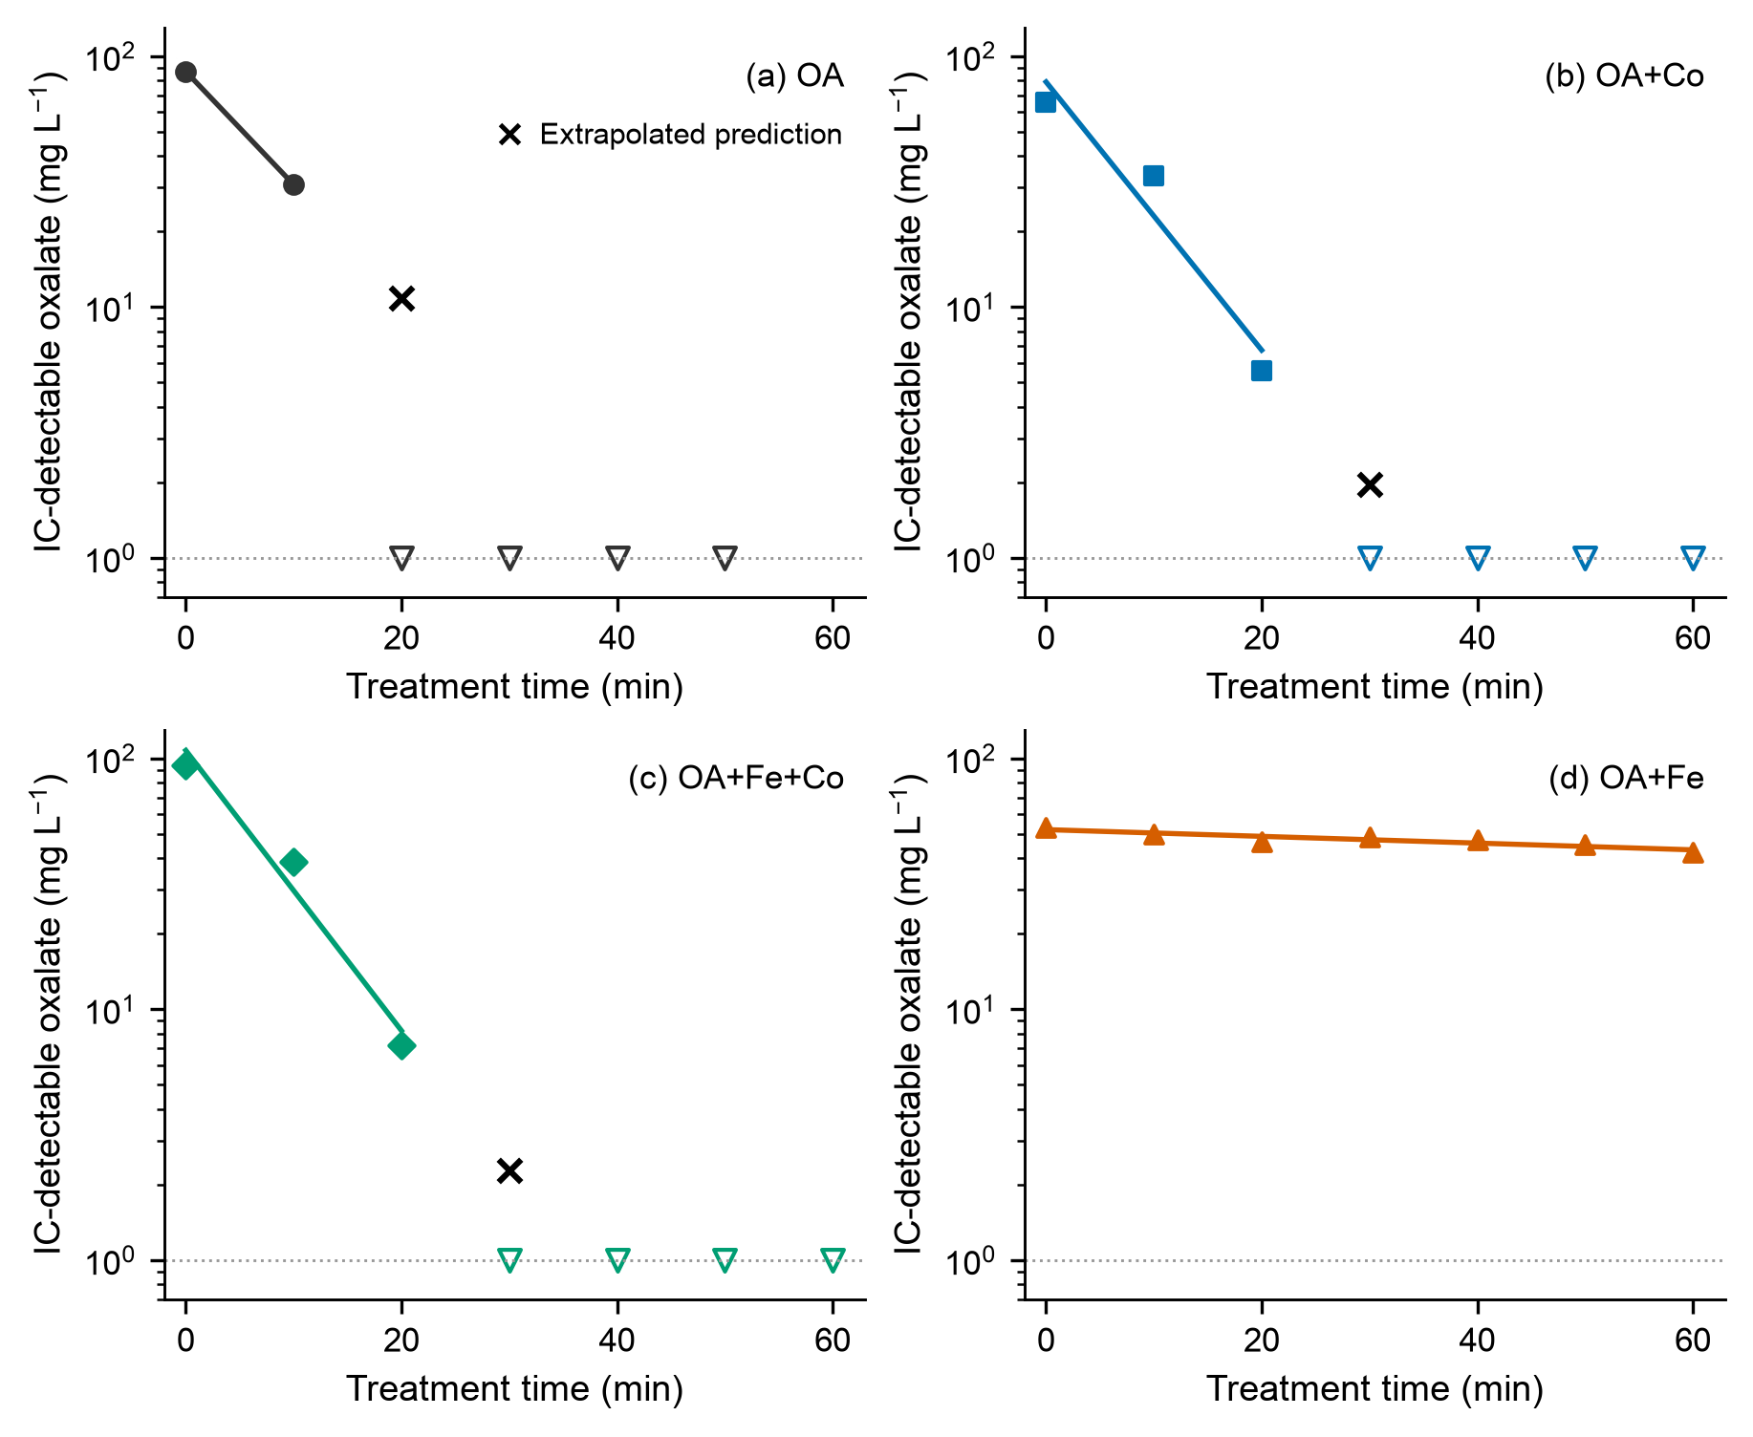
Fig. S1 Descriptive log-linear fits to quantified concentrations. Filled symbols are measured values, open downward triangles are ND upper bounds and black crosses are extrapolated predictions at the first ND time. Solid curves span the quantified fitting intervals and use a free intercept. The horizontal dotted line marks 1 mg L⁻¹.

S3 Reagent and chloride calculations
Formula masses used for the calculations are 90.03 g mol⁻¹ for anhydrous oxalic acid, 162.20 g mol⁻¹ for FeCl₃, 129.84 g mol⁻¹ for CoCl₂ and 492.46 g mol⁻¹ for ferrozine. The calculations use weighed reagent masses without purity correction. Calculations used unrounded intermediate values; results are rounded for display.
Table S3 Solution composition and ferrozine stoichiometry calculated from reagent additions
Quantity | Calculation | Result
Oxalic acid in each batch | 0.100 g / 90.03 g mol⁻¹ / 1 L | 1.1107 mmol L⁻¹
Fe in OA+Fe | 0.060 g / 162.20 g mol⁻¹ / 1 L | 0.3699 mmol L⁻¹
Co in OA+Co | 0.260 g / 129.84 g mol⁻¹ / 1 L | 2.0025 mmol L⁻¹
Fe:Ox in OA+Fe | 0.3699:1.1107 | 1:3.00
Co:Ox in OA+Co | 2.0025:1.1107 | 1.80:1
Cl⁻ in OA+Fe | 3 × 0.3699 | 1.1097 mmol L⁻¹
Cl⁻ in OA+Co | 2 × 2.0025 | 4.0049 mmol L⁻¹
Cl⁻ in OA+Fe+Co | 3 × 0.18496 + 2 × 1.00123 | 2.5573 mmol L⁻¹
Ferrozine stock | 0.050 g / 492.46 g mol⁻¹ / 0.050 L | 2.0306 mmol L⁻¹
Ferrozine per assay | 2.0306 mmol L⁻¹ × 0.004 L | 8.1225 µmol
Calculated total Fe per assay | 0.3699 mmol L⁻¹ × 0.006 L | 2.2195 µmol
Ferrozine:total Fe molar ratio | 8.1225 / 2.2195 | 3.66:1

The mixed-metal solution has half the Fe and half the Co dose of the respective single-metal batches, giving Fe:Ox = 1:6.01 and Co:Ox = 0.90:1. The Co:Ox molar ratio in the Co-only solution is 1.80:1. The ferrozine-to-total-iron molar ratio was calculated from the reagent amounts. The high-absorbance spectra are retained as qualitative assay responses.

S4 Spectral data and qualitative observations
Original UV-Vis exports were used for the OA, OA+Co, OA+Fe, OA+Fe+Co and ferrozine-treated OA+Fe series. Pure water was used as the UV-Vis blank. Each sample spectrum was corrected once by subtracting the recorded blank at the same wavelength. Negative corrected values and the original high-absorbance behaviour were retained. Tables and figures use these same corrected data.
Table S4 Selected blank-corrected absorbances from the iron-containing sample series
Time  (min) | OA+Fe A₂₇₅ | OA+Fe A₃₀₀ | OA+Fe A₃₆₅ | OA+Fe+Co A₃₀₀ | OA+Fe+Co A₃₆₅ | Ferrozine A₅₆₂
0 | 1.342 | 0.867 | 0.218 | 0.247 | 0.078 | 2.440
10 | 1.380 | 0.905 | 0.230 | 0.203 | 0.044 | 2.328
20 | 1.362 | 0.889 | 0.224 | 0.133 | 0.027 | 2.361
30 | 1.297 | 0.850 | 0.215 | 0.102 | 0.012 | 2.456
40 | 1.278 | 0.845 | 0.214 | 0.119 | 0.012 | 2.409
50 | 1.219 | 0.809 | 0.203 | 0.118 | 0.009 | 2.492
60 | 1.221 | 0.816 | 0.207 | 0.119 | 0.009 | 2.554

The Fe-only spectrum retains a near-UV shoulder and tail through 60 min. In the mixed-metal series, A₃₀₀ remains 0.102 at 30 min and 0.119 at 60 min, when IC reports ND. Together, these measurements distinguish the decline in IC-detectable oxalate from the persistence of residual optical response. The residual absorption is interpreted as the combined optical response of the sample mixture.
Figure 5c enlarges the 554-568 nm region of the ferrozine spectra. A decrease of 0.263-0.472 absorbance units between 560 and 561 nm is present at every sampling time. Individual absorbances at both wavelengths are retained with the processed spectral data and are available from the corresponding authors upon reasonable request. The original spectral shape is retained for the qualitative assay comparison, with the step treated as a recorded spectral feature.
Retained photographs of the four solution sample series are shown in main-text Fig. 2; the ferrozine-treated aliquots are shown in Fig. 5d. The photographs document qualitative sample appearance and assay colour.
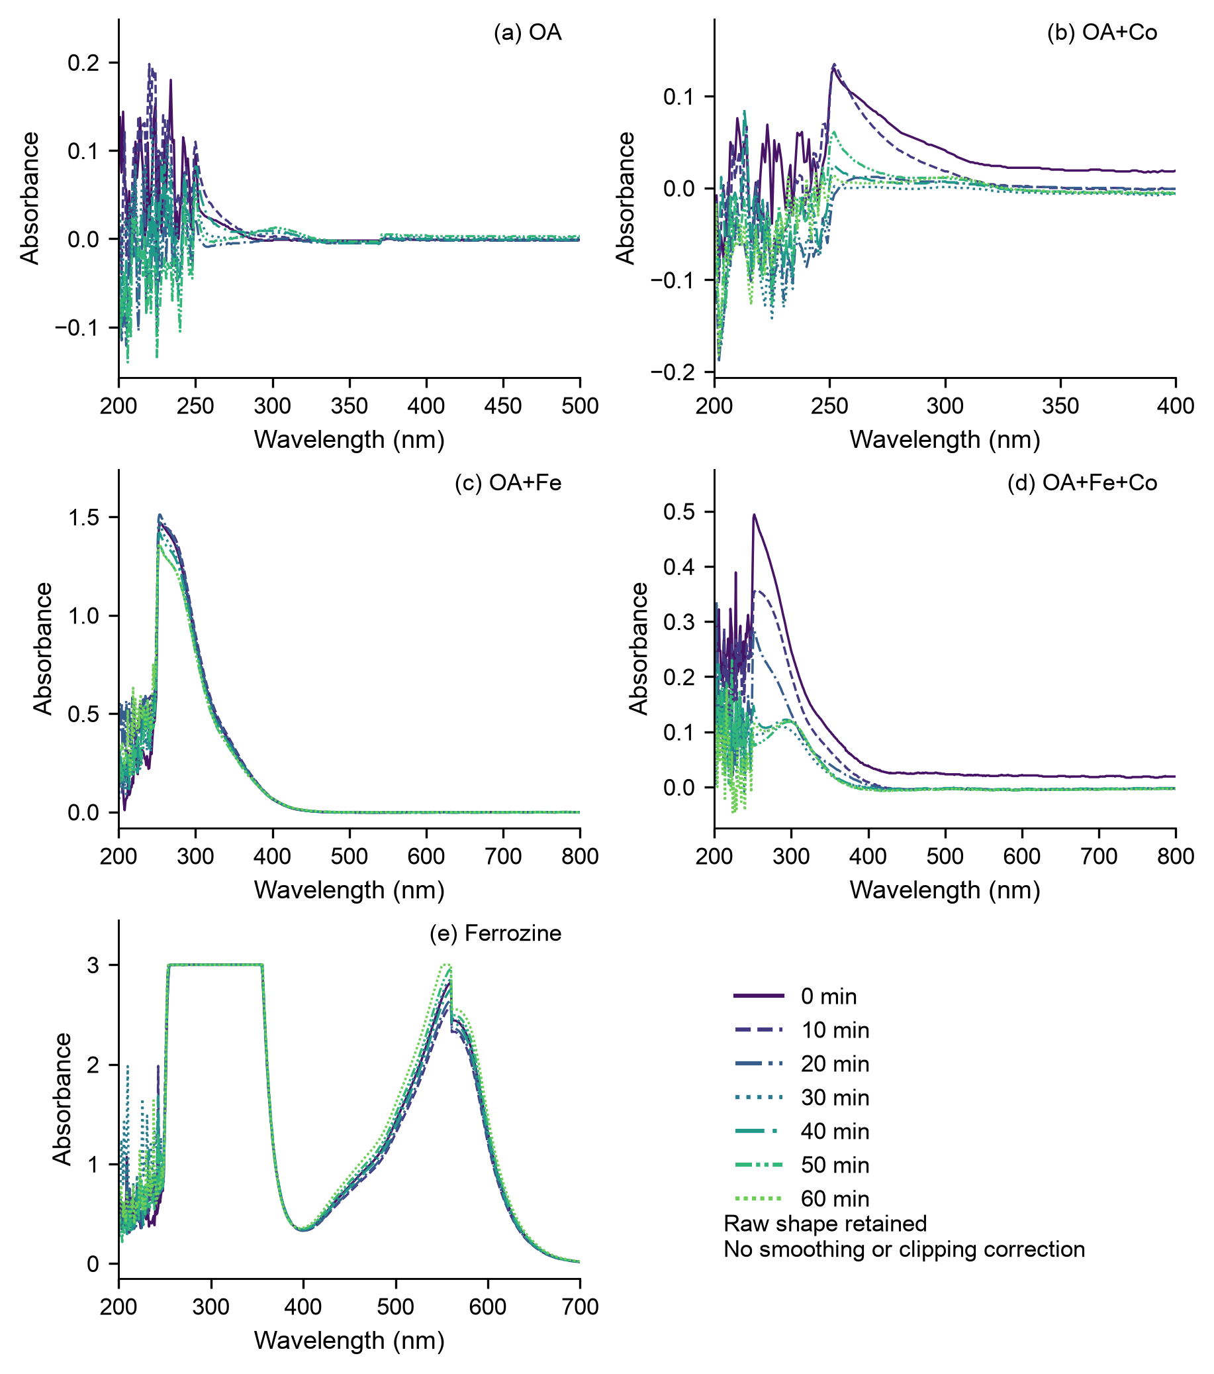
Fig. S2 Full exported wavelength ranges after subtraction of the recorded blank. The OA series contains six sampling points through 50 min; other series contain seven through 60 min. Colours and line patterns indicate treatment sampling time within each batch. Absorbance limits are chosen separately for each panel to retain its full data range. Spectral steps, clipped values and negative corrected values are retained.
The reactor photographs in Fig. 1b-d were acquired during the OA+Fe+Co experiment and are presented in acquisition order. Within these panels, the greenish tint is more apparent in c and weaker in d. Greenish tints recur in later photographs in the full acquisition record outside these panels. Automatic white balance and exposure varied during recording. Figure assembly preserved the recorded colour, contrast and white balance. The sequence provides qualitative process context, without assigning individual photographs to analytical sampling times.

S5 Data processing and reproducibility
One complete CSV export was used for each solution series, retaining its wavelength grid, blank and ordered sample columns as a single dataset. The OA export contains six aliquots collected from 0 to 50 min; each other export contains seven aliquots collected from 0 to 60 min. In each export, column (1-B) contains the pure-water blank. Sample columns (1-1) to (1-6) for OA and (1-1) to (1-7) for the other series correspond, in order, to the treatment sampling times stated above. Each sample absorbance was corrected using the blank at the same wavelength. No smoothing, baseline fitting, clipping or substitution was applied during data processing. The spectra, time-course plots and Table S4 use this common numerical basis.
Each 6-mL OA+Fe aliquot was mixed with 4 mL of ferrozine stock solution (0.05 g per 50 mL) immediately after sampling, as described in the Experimental section. This series was included to explore possible iron redox changes associated with plasma treatment. The interval from mixing to measurement and the illumination history were incompletely documented. The resulting spectra describe the post-sampling assay mixtures and provide a qualitative comparison relevant to iron redox chemistry across the aliquot series.
Tables S1-S4 provide the reported IC concentrations, descriptive fit results, stoichiometric calculations and selected blank-corrected absorbances. Fit diagnostics and full-range spectral plots are shown in Figs. S1 and S2, respectively. For each selected wavelength, the retained analysis records identify the source file, sample column, exported sample absorbance, blank and corrected absorbance. The processing script uses Python and NumPy to reproduce the corrected spectra, selected absorbances and descriptive fits. In the retained computational records, ND values retain an explicit ND status and upper bound, with the numeric concentration field left empty. Numerical precision in the computational files supports reproducibility; reported significant figures follow the precision of the source measurements. The underlying UV-Vis instrument exports, processed spectral data, calculation files and analysis code are available from the corresponding authors upon reasonable request.

