Supplementary materials - Personalised Cognitive Screening in Stroke Care: Development and Pilot Evaluation of a Modular, Adaptive, and Co-Produced Cognitive Screening Platform for Stroke
Phase 1: Development
Further details regarding OCX skeleton. The Oxford Cognitive Screening Platform (OCX) was designed for administration within 3-30 minutes. An average of 30 minutes was chosen to ensure that it would be feasible across different stroke settings – where sometimes a very brief test is more suitable than a longer assessment. The domain administration order is designed to be pre-set but can be flexibly adjusted by the assessor. Not all domains must be administered and there is no mandatory ordering.
Each domain begins with a tier 0 task, selected using two criteria: clinical relevance to all participants (not just those with suspected deficits) and moderate difficulty informed by common stroke-related impairments. Difficulty was determined through clinical and research expertise.
Performance on the initial tier 0 task in each domain is classified using normative cut-offs (typically ≤5th or ≥95th percentile, or ±1.65 SD). Depending on impairment classification and the likely source of the deficit (e.g., expressive vs. receptive language), the next tiered test (tier 1) probes either a different facet of the domain or deepens assessment of the identified issue. For example, a failed picture naming task might lead to a non-verbal semantic task (e.g., matching items by meaning), whereas a pass would prompt a more complex expressive task (e.g., reading single words).
The only materials required for administration are the tablet that is running the OCX. Ideally, the tests are run using a tablet stylus, though this is not mandatory. Healthcare professionals must administer the tool, which is not designed for self-administration.

Table S1. The topic guide for the semi-structured co-production workshops with (allied) healthcare professionals.
Area of app | Prompts
Automated structure of the OCX | What were your first impressions of the app outline?  What do you think about the cognitive domains chosen to be included, and their order?
Per cognitive domain assessed | What is your overall impression of X domain?  Is anything missing?  Is there anything that shouldn’t be there?  Is the flow of tests appropriate or not?
Note. The Oxford Cognitive Screening Platform (OCX). ‘X’ represents a given cognitive domain.
Data analysis. Healthcare professional workshops were audio-recorded, transcribed, and then analysed using a critical realistic philosophy and template analysis where text was coded at the semantic level with the goal to identify improvements, barriers, and acceptability of OCX features. We used Framework analyses to write up the results. Transcripts were written using the Intelligent Verbatim Transcription ¹, such that we captured the exact wording of participants but removed unnecessary fillers, and retained self-corrections, repetitions, and pauses. We did not edit grammar or rephrase any sentences to keep it as close to verbatim as possible ¹. We first processed audio files through Microsoft Word’s transcription (automated speech recognition) feature, which securely saved the data within the business OneDrive and was kept strictly private. The audio data was deleted immediately following transcription. A hybrid approach of first drafts using ASR, and manual editing was used to increase validity of the transcripts ². Two researchers edited the transcriptions independently (to correct for misunderstandings of the digital transcription service, missing words and pauses, etc). Differences in transcripts were reconciled into a final transcript for analyses.
Template analysis was used as we used prompts in the interview discussion which would enable pre-defined themes to emerge as well as allowing for new inductive themes to be recorded across the two workshops ³. We applied the template at each new workshop transcription. That is, we coded workshop 1 transcripts into new themes and themes based on prompts and then used codes emerging themes for workshop 2, but flexibly adapted to the new data, then applied the resultant template to the whole dataset. Qualitative analyses were facilitated by Microsoft Word and Nvivo (version 15). Deidentified transcripts are openly available (Webb et al., 2026).
On the basis of workshop feedback, we reduced the number of items within a test if it was perceived as being too long or items were not liked (i.e., they were outdated). Per subtest that was critiqued, a 2-parameter logistic IRT model (discrimination and difficulty) was fit. We used items with the highest discrimination (the discrimination parameter indicates the overall information one can obtain from each subtest, and difficulty values that correlated well with the full test score of the original subtest. The modelling for this is presented below.

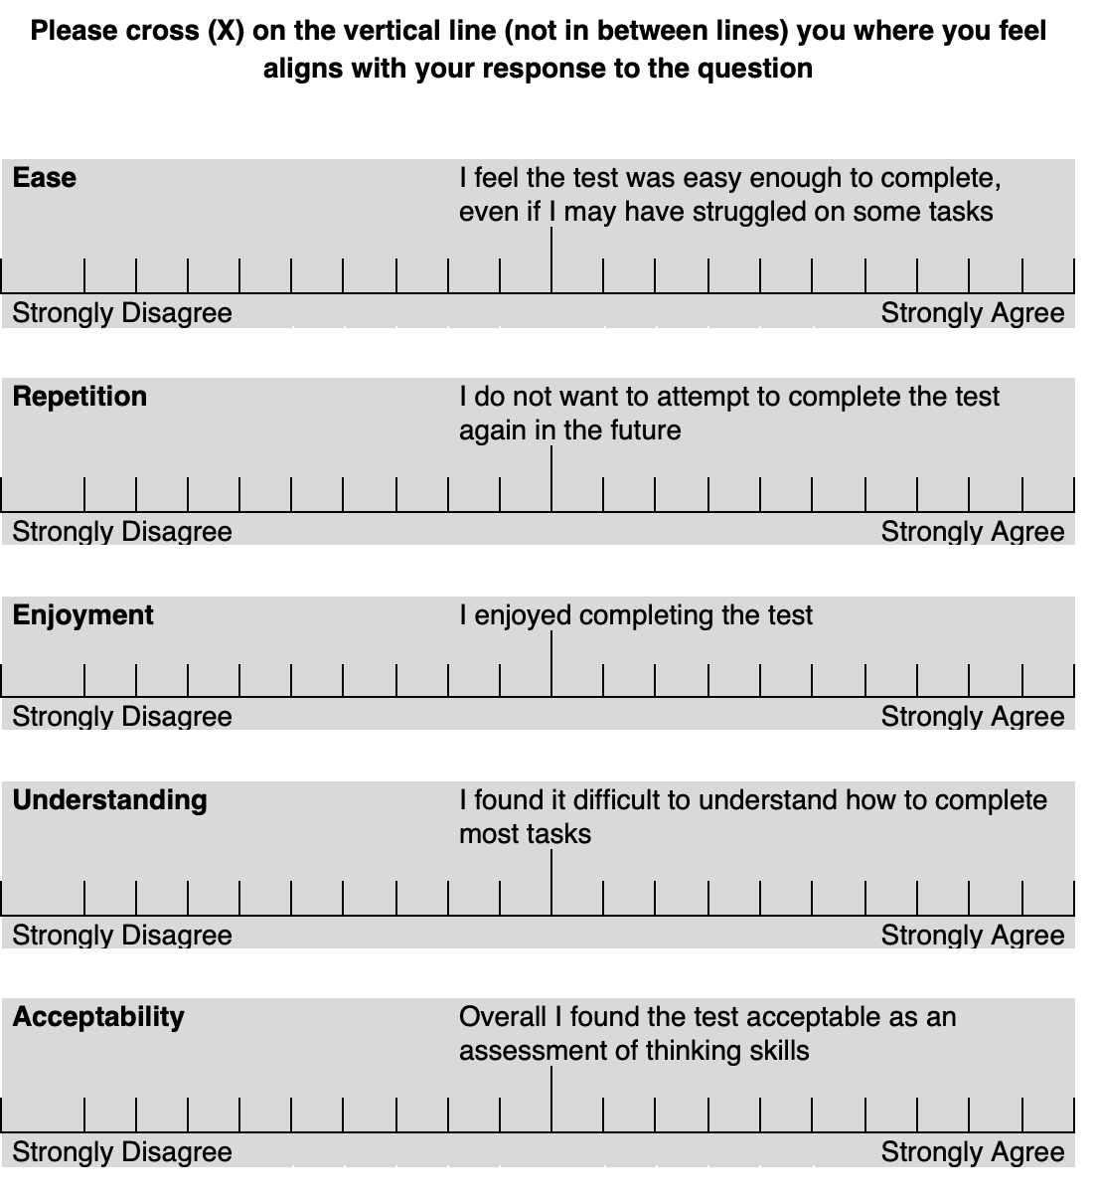
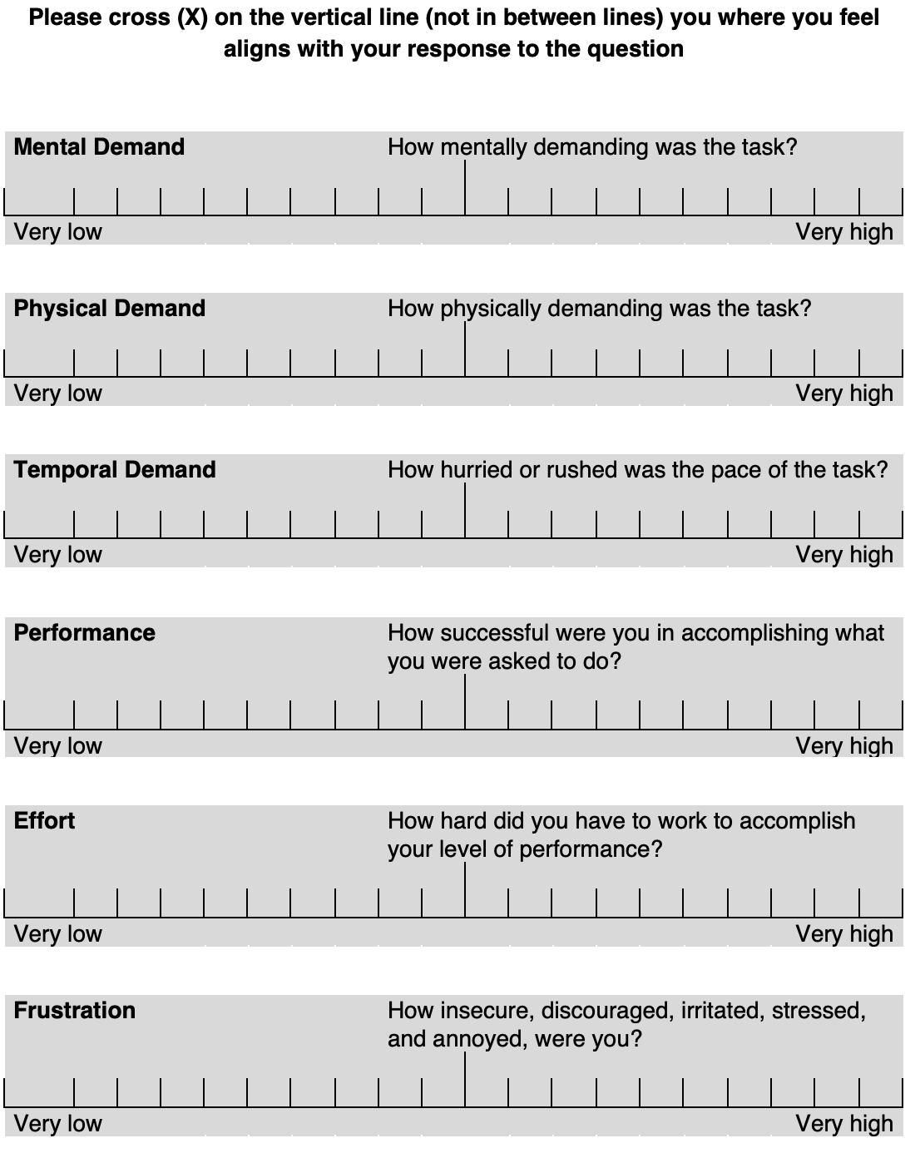
Figure S1. Feedback questionnaire developed by joining the Task Load Index with specific acceptability questions for the MCS-Stroke

IRT modelling BCoS test to reduce them
A 2-parameter logistic IRT model (discrimination and difficulty) was fit to the original normative data, separately, for several Birmingham Cognitive Screen (BCoS; ⁵) subtests due to their length or critique in workshops. Two theta values were estimated for each participant: one based on the full form with all subtest items, and one based on the proposed short-form with the selected subtest items. The subtasks to shorten were: 1) single word reading, 2) picture/picture matching, 3) word/word matching, 4) object decision, 5) written lexical decision, and 5) written number decision. Our parameters for model acceptance were as follows: difficulty between -4 and 4, discrimination of greater than 1 but less than 10 (some models showed items which were averaging around 2 but outliers were greater than 10).
Our models showed that two subtests, the picture/picture matching and written number decision, failed to provide a short form with our parameters (See analysis code – ‘IRT_model_testitemreduction.R’). We examined the two parameters for each subtest and then manually removed problematic items (difficulty and or discrimination too low <.5 or too high >4). Further, items selected in object decision and written number decision and lexical decision were too biased to response type (e.g., using mostly items which would require a ‘no’ response). To balance the subtests better we selected the items which were next highest in our parameters which had alternative response options.
We then re-ran the IRT model and provide statistical comparisons to the full IRT model per subtask. For each of our short forms, the average correlation between the short-form and the full-form was r = .85 (range .78 to .922). In Table S2 we present the IRT based short form and manually selected models, their items, and their correlation with the full form subtest for each test respectively.
Table S2. Selected subtests of the OCX, whether the model was auto generated by the IRT analysis or manually created, respective items per subtest, as well as correlation with the full form of the subtest (theta value comparison). Models retained in the final OCX are stated.
Model | Retained | Subtest | N items | Items from test | Cor
Auto | Yes | Single word reading | 3 | 3, 2, 4 | 0.92
Auto | No | Picture/picture matching | 13 | 6, 1, 2, 3, 4, 13, 10, 11, 9, 7, 14, 8, 5 | 0.97
Auto | Yes | Word/word matching | 5 | 14, 2, 9, 7, 5 | 0.78
Auto | No | Object decision | 9 | 25, 26, 13, 21, 15, 14, 24, 4, 23 | 0.84
Auto | No | Written lexical decision | 11 | 1, 4, 14, 8, 20, 17, 18, 15, 19, 16, 9 | 0.86
Auto | No | Written number decision | 4 | 3, 8, 12, 17 | ~
Manual | Yes | Picture/picture matching | 8 | 1, 2, 5, 7, 8, 9, 10, 11 | 0.99
Manual | Yes | Written number decision | 6 | 1, 2, 3, 8, 12, 14 | ~
Manual | Yes | Written lexical decision | 11 | 1, 4, 8, 9, 14, 15, 16, 17, 18, 19, 20 | 0.86
Manual | Yes | Object decision | 8 | 4, 13, 14, 15, 23, 24, 25, 27 | 0.84

Table S3. Feedback from healthcare professional workshops (part 1) on changes to make to the presented MCS-Stroke app. Author actions are included. Qualitative feedback is written up using a framework approach.
App section | Specifics | Feedback and exemplar quotes | Action points and justification
Outline | Automated structure and domains chosen | 1. Possible to keep order of domains as is- it is familiar  - “…I like the order I think it's what we're used to and I feel like it, in terms of like, cognitive hierarchy or like working your way...like starting quite basic and then working through like, an -to the higher levels of cognition, so I think it makes sense to be that way.” – HCPS005 | There is argument to keep the automated order of administration as it is mirroring the Oxford Cognitive Screen (OCS).
 |  | 2. Move number domain further down in order  - “If we're talking about the order, of, of kind of presentation on on the domains, I don't love that numbers are so close to the top. I think numbers in particular can be quite off putting and people may, people kind of feel like, oh, it's kind of like when I was in school and I never did well in school” – HCPS004 | Potential to move number domain later on in administration, but no clear guidance for where to place it.
 |  | 3. Move attention further up order  - “See I suppose I was thinking more of [Attention] coming up...further up the ladder, was because if they do have any attention deficits, it's kind of ruled out earlier on, rather than halfway down the the assessment if they were to do the full thing.”-HCPS002 | Potential to move attention domain further up list, possibly second.
 |  | 4. Fatigue will affect complex tasks later in order  - “to some degree, you’re having the most complex things last, so potentially getting a fatigue effect.” – HCPS004 | We will consider order of domains in light of fatigue and cognitive load both in the app and app manual
 |  | 5. Add instruction comprehension task first to establish comprehension  - “It might be helpful to look at...single step instructions…“Follow this instruction, close your eyes”….and that then would indicate, whether, you could go further, within the assessment. Because if someone's unable to follow an, an instruction, a single stage, or single step instruction, that that would be a useful indicator I think of, of whether you could go on or not.” -HCPS003 | Will add stepped commands task at beginning
Domain | Language | 1. Cultural inappropriateness of items in tests  - “think my concern, similarly to one of my concerns earlier, was just the cultural appropriateness of some of them, in particular the story recall. Like I noticed that the story involves like a casserole, which I just don't think is very culturally appropriate to our population.” -HCPS004 | We will consider stimuli test by test for appropriateness to wider UK population and potentially get trial level data to re-norm without problem items.
Domain | Language | 2. Semantics should be represented on both sides of the decision tree  - "I'm trying to think about cases right now where it might be important to get the semantics as well… I know that they may be able to do tasks like reading but still have problems with semantics”- HCPS006 | We will consider ways to enable assessments of semantics on both sides of the decision tree
Domain | Number | 1. Reorder number domain to put functionally relevant tasks first  - “I think that comparison is a quite nice challenge as well. It also looks at their understanding of, you know, time and money, which I don't think we really assess that much sometimes, especially in an acute setting.”-HCPS002 | We will reorder the number decision tree to ensure functionally relevant tasks are higher in order (available for more participants).
Domain |  | 2. Consider inclusion or exclusion of number writing task  - “if they pass to do the calculations, it would be interesting to see their number writing, if they're able to do it. Because that for me, a lot of my patients that I see, if they have got language issues, it's that writing down the number that they find quite difficult sometimes” – HCPS002 | We have considered the removal of the number writing task, or to make it more functionally relevant as there was sentiment to keep it and sentiment to remove it due to lack of relevance.
Domain | Attention | 1. Avoid repeating too similar tasks consecutively  - “I would only be concerned about doing the Mini-OCS broken hearts and then the, the full OCS broken hearts, that might, a lot of people that I work with when we do the full OCS broken hearts, they feel quite tired after doing that and I think then doing the same task again might be quite challenging for them due to fatigue” – HCPS002 | We will remove duplicated or too similar tasks consecutively / completely
Domain |  | 2. What task to include if failing first level but no neglect  - “But I didn't know what your thoughts were about having, after that first fail, whether it be a simpler sort of scanning exercise”-HCP002  - “would something like, the line cancellation from the [Behavioral inattention test; BIT] be an appropriate thing to do here.”- HCPS004 | We will consider removal of existing second level visual acuity test in favour of another neglect based assessment.  We cannot include tasks with intellectual property copyright.
Domain |  | 3. Necessary to include practice for hearts task to rule out comprehension of task  - “I completely agree with you that there's a cohort of patients who just don't get how to do the broken hearts. You know, they don't understand that there's some with a left gap and some with a right gap.” – HCPS004 | We will ensure we include a practice hearts as in the full OCS.
Domain | Memory | 1. Missing elements of episodic memory  - “…it all looks at, like your verbal recall of memory, rather than...so you couldn't do the speech side of things you would do the pictures, looking at more of like the, maybe some episodic memory”- HCPS002  - “I suppose one of the benefits of how the paper-based OCS is run at the moment, is that there are a variety of different... things that are experienced in the OCS that the patient has to recall. So some are, you know, that it's the, it's the, you know, ‘did I make gestures with my hand’ or ‘did you write numbers down’. So it's, it's looking at memory in a very much more holistic, in a more holistic way.”-HCPS004 | We will find a way to incorporate episodic memory or delayed memory recall
Domain |  | 2. Do not just rely on language, include everyone from first task onwards  - “So I didn’t know, if going straight to the picture one, because they can't express their speech - I understand why you've done it that way… when I have done the, the sentence, before, the story, before with someone that has got a speech impairment, they're still able to participate...when they're recalling it with the cues. So I don't know if that's something that we could think about as well.”- HCPS002  - “…It being quite language heavy again...is there...have there been any thoughts about it...being encoding of visual...something visual alongside language?”- HCPS003  - “Sorry. I don't know if HCP003 just already said that, but could you use the pictures instead, first, so that you're not relying on the language.”-HCPS001 | We will not segregate those with speech difficulties from those without, everyone will be given the same tasks depending on their performance, where each task is adapted for aphasia by default.
Domain |  | 3. Cultural appropriateness of some items  - “think my concern, similarly to one of my concerns earlier, was just the cultural appropriateness of some of them, in particular the story recall. Like I noticed that the story involves like a casserole, which I just don't think is very culturally appropriate to our population.”-HCPS004 | We will look at individual items and assess their exclusion. We will also note that normative data were not at ceiling, suggesting that if the less culturally relevant words are forgotten then there is still a chance at being classed as normal performance.
Domain | Praxis | 1. Missing tool use  - “I could be wrong, but there's not a lot of... like tool use within this….-….you could show a picture, and you know, a picture of a spoon or something, you know, and “how would you use the spoon?””-HCPS004  - “I made a note about that as well…-…about, you know, tool or object use” – HCPS002 | We will ensure we include tool use for all participants.
Domain |  | 2. Cultural appropriateness of some items  - “I don't love the hitchhike gesture. Definitely don't like the lighter gesture...But I think the others are probably all OK”-HCPS004 | We will consider stimuli test by test for appropriateness to wider UK population and potentially get trial level data to re-norm without problem items.
Domain |  | 3. Must consider aphasia in complex instruction-based praxis assessments  - “My only issue with asking them to do the gesture first is that's quite a lot...to understand if somebody's receptively aphasic, So I think with the OCS, when you're copying it, it takes away the language element of it…-...‘cause we often, speech and language therapists will use gesture, as another mode of communication” -HCPS001 | We will restructure the praxis domain to ensure that participants are not unfairly penalised due to aphasia or complex instruction comprehension.
Domain |  | 4. Difficulty to get all aspects of praxis covered  - “I think praxis is a really difficult one....To kind of get all the components…-…I think, the flow is difficult to get because, I, I think there's they’re distinct components, rather than kind of like, a flow, in the same way that some of the others are”-HCPS004 | We will consider other praxis screening assessments to best structure ours to ensure we cover relevant and important aspects of praxis.
Domain |  | 5. Remove figure copy task as it is not praxis  - “I don't. It's complex, isn't it? And I think it's...I think there's so many other things it can be in addition to praxis”-HCPS004  - “I was just interested in that it being a praxis assessment, as opposed to visual perceptual...As that's in Kathleen Vancleef's visual perceptual screen...-… I would be a little bit concerned about having something as complex as the figure copy...Because of all of the other variables that it could be, that mean that, that's not praxis that we're looking at”-HCPS003 | We will remove the figure copy test, and in light of other suggestions of tool use and restructuring praxis, we will find an alternative.
Domain | Executive function | - Rule finding task from OCS-Plus, it is too difficult and complex  - “They feel like, like, those logic ones where you're kind of like, trying to be a spy, or something [laughs]. You know, it's like aptitude tests. I find those quite difficult...So yeah, I don't, love those, subtests...And I don't know...I, I, suppose I don't know how relevant they are to our patients. You know, if they struggled with them...What's the relevance to that?...Whereas I think the...I think, I guess I find it easier to interpret the OxMET, and the, the trails...The trail aspects, and maybe that's a familiarity thing for me.”- HCPS004  - “And, I, really really, I haven't yet found a single client that has found the rule finding and switching of the OCS-Plus, rule finding and switching task, not very complex…-…Thinking about clients as well. I –it is definitely the OCS-Plus rule finding and switching task is very complex. But I found that, many clients will just be guessing, and will guess the entire time, and therefore if they fail that I -there's nothing else to go on to...-… I mean, I have had..buy-in from a client when you're assessing them is really, really, really important [laughs]. And....I would just worry, I think about having that rule finding and switching one.”-HCPS003 | We will consider either removal of the rule finding task or redesign of it to be shorter so it is less demoralising and less complex – while keeping complexity as it should have for an executive function test.
Domain |  | 2. Functional relevance of exec function assessments  - “I haven’t used the OxMET before, so it's hard for me to know the, the pros and cons to it, but I like the idea of having it higher up first, because it is more of a functional element that a lot more people will be able to... hopefully engage with rather than the, mixed trails first of all.”-HCPS002  - “Big fan of the OxMET...I have found that been -to be very helpful actually, in identifying...difficulties with planning and organising…-… I, I wondered whether the OxMET, in actual fact, may be quite a useful task to put in, in terms of, it being slightly different. So more language focussed as well, in planning and prioritising. And, I suppose as an OT, it has more functional relatability, to it, as well.”-HCPS003  - “I find that I do shopping list type planning organising, tasks a lot outside, as extra bits of cognitive rehab. So having it in an assessment...could be quite nice and being able to generate, like a pass, fail on something more, kind of standardised, than me just doing it on my own.”-HCPS005 | We will consider prioritising OxMET for all participants, not just those who fail the mixed trails, so that all can have a functionally relevant assessment.
Domain |  | 3. Consider language element of executive function  - “For executive functioning, you would expect kind of, a higher level of language there as well. So I don’t think there is anything much that I can add.”-HCPS001 | We will ensure we use the full SLT designed instructions to accompany the OxMET, as well as ensure all tasks have written instructions as well as practice and demonstrations.

Table S4. Feedback from healthcare professional workshops (part 2) on changes to make to the presented MCS-Stroke app. Author actions are included. Qualitative feedback is written up using a framework approach.
App section | Specifics | Feedback and exemplar quotes | Action points and justification
Outline | Automated structure and domains chosen | 1. Move attention to earlier in order  - “See I suppose I was thinking more of [Attention] coming up...further up the ladder, was because if they do have any attention deficits, it's kind of ruled out earlier on, rather than halfway down the the assessment if they were to do the full thing. Just so then, I suppose, if they were to get fatigued, or if they did have poor attention, then they wouldn't have to sit through the first two” – HCPS002  - “I don't know. Hm. I don’t know whether attention should come a bit higher up? More towards, the start just because that's more like a core...core skill.” – HCPS002  - “I'm generally happy with it, except that I would rather switch attention and number.”- HCPS006 | We will move attention to second place as it is short and rules out attention deficits earlier, which are cardinal symptoms following a stroke.
 |  | 2. Switching praxis and memory domains  - “I was just thinking then the order about praxis and memory. Hmm. Whether they.. Hm, should be switched I’m not too sure… if we, did have, like a functional sequencing task [in the Praxis domain] then it could then flow quite nicely into the, like executive function”- HCPS002 | We will consider the addition of a sequencing task in praxis (see later comments in praxis section) which would lead to executive function. At the moment there isn’t overlap between the two, so we will pre-emptively reorder so praxis is before executive function.
 |  | 3. Order of administration for introductory tasks (before main assessment)  - “I think it's nice to have like started with those. Because I sometimes find like, especially with visual field, you get to the point of doing that and they can't follow your instruction on how to do that and...it then just gets a bit impossible. So to know if they can follow step commands and do their visual field first and it not be part of an assessment, ‘cause their visual field might be fine but they can't understand your instructions, like ‘look at your nose and do this and do that’, I think it makes sense to just not have it included, but to have looked at it before.” – HCPS005 | We will move stepped commands to be the first task, followed by orientation, visual acuity, and visual field
Domain | Language | 1. Switch sentence reading with single word reading  - “My only thoughts was, ‘cause I know the the aim is trying to start off at a medium sort of level. And then go down as the person needs it. So, I didn't know whether the the sentence reading should come first before that, and then the single word reading come...come after…Yeah, my only thought is, ‘cause then it could rule them out first. But I suppose it can work both ways, so [laughs]...It's, yeah “ – HCPS002  - “Yeah, it's probably just my, my, an enca- slightly compulsive desire to know something about the semantics. I'm not sure how this would fit in the flow chart on the left, to be honest. That's correct. It makes it difficult. It doesn't flow from either sentence reading or written lexical decision, that if, if you fail at one of those that you would then... So, if I'm interested in something like picture picture matching,” – HCPS006 | We chose not to swap sentence reading and single word reading (which would results in sentence reading coming first then single word reading). This is because we wanted everyone to be assessed on single word reading as a core skill for those who can express themselves. We also wanted to include semantics (see next), and struggled to see how it would naturally flow. We chose instead to move from picture naming, to single word reading and a semantics task for everyone who passes picture naming, before separating those who cannot read from those who can.
Domain | Language | 2. Semantics should be included for everyone  - “I know that they may be able to do tasks like reading but still have problems with semantics…I think it would be worthwhile including semantics for everyone… So what I would do if I were to use this system is I would, on the left-hand side, assuming that people passed or failed, and it really doesn't make any difference, I would want to do a semantic task automatically.” – HCPS006  - “I was just going to say, I've had the same thoughts where I'm like “Oh, I'd quite like to know that”- HCPS004 | Based on the above feedback and this feedback, we will combine word reading and semantics for all who pas picture naming before separating further on as these are both score skills
Domain | Number | 1. Consider inclusion or exclusion of number writing task  - “Because, actually from a job perspective, you know, if you do have someone who needs to write numbers for a job, actually are they writing it, are they handwriting it are they typing it. You know, there's probably so much more that you're looking into than just that. Yeah. I mean, it's a fairly quick task isn't it. So I don't think it's a problem having it on there.” – HCPS004  - “I think I would want to keep the number writing in, simply because it is kind of like an instrumental task of daily living. Basically, to write numbers, we write telephone numbers down. Yeah, we write our names. But this is about numbers. [laughs] So, I I think it has... I think functionally it tells you, assuming they don’t have problems with their motor abilities, it tells you a lot about their functional status, I think, in the real world.” – HCPS006 | We will continue to include number writing, but since workshop one have made it more relevant by the writing of numbers as well as writing prices for more life relevance.
Domain |  | 2. General acceptance of the number domain  - “Yeah. Yeah, no I think, I don't think there's anything I can think of that should be added onto this one” – HCPS002  - “If they can't do the number comparison like, do they actually know what a number is? Like what is the problem there? And then like, going back to looking at like a number price time reading. So I think that it's in a good order and I like that- the way that it's been change” – HCPS005 | The number tasks caused most controversy but the remaining tasks seemed acceptable and appropriate so no changes were made.
Domain | Attention | 1. Potential to include auditory attention on both sides of the decision tree  - “So you do the broken hearts, then you pass that, and then you've got your sensory extinction task. But actually you're kind of missing an auditory attention. I don't know.” – HCPS004  - “But, I'm also wondering since tactile, visual and auditory are just three separate domains if all three shouldn't just be tested with, with everybody.”- HCPS006  - “They’re receiving auditory information as well as visual information to do the sensory tasks, so in a sense auditory is part of the flow of those tasks. So if they fail...some sensory neglect, could also be they have problems with hearing or... Yeah, in general, hearing or processing auditory information.” – HCPS006 | We will not include the more complex auditory attention task on the left side of the decision tree, as this task increases memory load as well as attention and would confound results compared to the simplified attention task. Auditory attention is also inadvertently assessed throughout so may be acceptable to infer from general performance. There is always scope to run the test separately outside of the multistage assessment.
Domain |  | 2. Choose between tactile and sensory (visual) extinction  - “So the, yeah the tactile extinction test, I think that would be useful to include. Because I don't think I've come across many, or any assessments that I've used that that include that as normally assessments we do outside of a screening.” – HCPS002  - “I guess the only thing with that is that it’s quite similar to the visual fields test that you would have already done. So you're kind of doing that twice. And, like I said that the -when I said at the start, it's not always necessarily the visual field problem. It could be the comprehension of instruction. So if you've already done that at the start and you feel...or like you, you feel that there's no visual problem it's just a...the way they follow commands that’s impaired that that is then...maybe...not giving them enough to assess their attention. I don't think that the tactile extinction test needs to be in there. I don't think that that's necessarily what I would...want to see on a screen.” – HCPS005 | We will include tactile extinction as a form of attention that is not often examined, but in the test manual indicate to assessors that they can combine the visual fields test with the sensory extinction test easily to give an indication of both, or include separate to the multistaged assessment.
Domain |  | 3. Inclusion of selective attention tasks  - “And if there could be anything where we could look at more their...their selective attention. So they've got different distractions going on…. ’cause I think that's something that we see quite a lot. Someone might might be able to do that task, in a quiet room and then when...when you have the more, more distractions, whether it's auditory distractions or visual distractions, whether that then makes it a bit more challenging for them.”- HCPS002 | We have not got any appropriate selective attention tasks in our tests which can be adapted or used in tablet form with normative data. We will look into literature for intellectual property free tasks which may be suitable with normative data.
Domain | Memory | 1. Add memory task to beginning of assessment for them to recall at the end  - “Thinking about where it could go, but if there's something that we could put at the start for them to, remember to, to do at a certain point in the assessment… know we said last time about...it being difficult to have...like that episodic memory like remembering things they might have seen or done. So I like the fact that the, the COMPASS delayed picture recall is on both sides and towards the end. I think that's quite a nice touch”- HPCS002 | We chose not to include a piece of information to recall at the start of the memory domain as the recall of this will be influenced by the duration of the in-between tasks which may be different depending on the side of the decision tree. Further, we would need new normative data for a single item or few items which would be to be recalled and validation of these items separately.
Domain |  | 2. Move orientation to be for everyone  - “But orientation is quite a basic thing that I would normally do quite soon on in an assessment. So I don't know, or can’t remember, what the reasoning was for doing like the OCS plus encoding 1 or 2 first and then orientation. But I would, usually like like to see orientation quite, soon, so I think that that's something like quite basic that I would normally want to see first and do first.. I tend to find that people are better at knowing like their date of birth and who they are than they are at knowing the year. So, if we haven't asked those questions...that they may not get asked those questions in this. And I would want to know...if they're orientated to like, definitely the year and where we are, that we might not be asking them that in the screen and I know we might do outside of that, but, I would still want to know that in the screen probably..” – HCPS005 | We have removed orientation from the memory domain and combined two different orientation tests into one which is part of the introductory tasks before the main domain based assessments are completed – this way all participants are assessed for their orientation to personal information as well as space and time to see where their difficulties may lie.
Domain |  | 3. General acceptance of memory domain  - “No I don't know if I have any other...points to raise for that one. ‘Cause I feel like it's got everything in there. Obviously with that addition [task to recall at beginning of assessment], it would be really useful. But I feel like it's got everything in there that I would kind of look for. So I don't think there's much else I can think of for this one.” – HCPS002  - “I think it flows really nicely, and I think it makes sense, the kind of, complexity flow as well, so...I don't think I've got any kind of suggestions, or comments for change on this one.” – HCPS004  - “OK...OK, I think this makes sense. Yeah.” -HCPS006 | Generally no changes to be made to memory except orientation.
Domain | Praxis | 1. Missing sequencing of actions  - “I was just thinking about...other bits that might be useful, ‘cause I know, in some, like apraxia assessments, they might look at someone’s sequencing. Obviously that that can be done in a functional task and could be shown in the executive function task. But if there could be, something added about, you know “What steps would you do to to complete this task?”, and if they would kind of sequence it in the correct order…I was just thinking how it, especially in...that the acute wards, where they might not pick up on that need to necessarily do that, like the functional element, like a kitchen assessment or a washing and dressing assessment, but that might just be a trigger for someone to maybe look into that a bit more”.- HCPS002 | We looked into possible sequencing tasks for praxis that we had IP, normative data, or where freely available on a tablet device and we did not find appropriate tasks. We chose to exclude sequencing here as it is appropriately covered as a concept in the executive function section.
Domain |  | 2. General acceptance of the domain  - “I think, this flows nicely, and I don't think I would change it. I can’t think of anything I’d change.” – HCPS004  - “I I absolutely agree…Yeah, this makes sense. I agree with you”” – HCPS006  - “And yeah I think it's good that you have looked into the different forms of praxis and kind of assessed –given everyone a chance to kind of assess both no matter if you pass or fail the first one.” – HCPS005 | There are no general changes to make to the new version of praxis, except the consideration of a sequencing task if not too overlapping with exec functioning.
Domain | Executive function | 1. Remove OCS baseline trails as it is not executive function, consider leaving simplified rule following instad  - “Once you’ve failed the OxMET...Then you go to the OCS circles. Is that really assessing executive function? The circles, by themselves?... My only comment would be...if that...OCS baseline circles is adding anything...I kinda see why it's there, but I'm not sure...In reality, whether it's going to tell me anything.” – HCPS004  - “Set 2 simplified rule finding would be sufficient for me for the right-hand side after a failure of OxMET. I'm not sure if...baseline circles trails add more than I would get from doing that task by itself.” – HCPS006  - “I like that we’ve still got single trails on the right, on the –if you fail the OxMET. But I don't know if it's quite a big jump between doing single trails and then doing rule finding. If we know that they can't do the OxMET but they can do trails –like single trails, whether the rule finding is then quite a jump between those two things” – HCPS005
Domain | Executive function | 2. Ensure trails are on both sides of the decision tree to aid in OT interpretation and assessing both sides similarly  - “Because we just mostly use the OCS, I like having the trails because that's normally our best way of establishing...because it's normally if there's going to be executive function problems, they've normally done everything else quite well. And then often I finally get to a mixed trial and then can’t do that. So it might just be because that's what my experience is that of not having used anything different. So that's why I would like it included. I don't know about replacing it first, like replacing single trails with the mixed straight away.” – HCPS005 | We will add OCS mixed trails appropriately on both sides.
 | Executive function | 3. Assessment of risk  - "But in, like executive function, when we’re, when I'm trying to look at someone and assessing that, it's also quite useful to like assess their understanding of risk. And what they would do in a certain situation….I was just going to say sometimes that can get missed, quite a lot. Is how someone will react to certain, situations, or weighing up the the risks.” - HCPS002 | We do not have any risk assessments with IP, no IP, or normative data that are short and appropriate, we will mention in the test manual to consider separate assessment of this.

Phase 2: Pilot feasibility
Pilot performance data. Table S5 shows some tier levels had higher pass rates than others, but that the lower the pathway progresses, the fewer pass rates there are (increasing difficulty or further investigation).
Table S5. Proportions of participants who passed at each tier level across all domains (stroke only, N=22)
Tier | Present in which domains | Mean | SD | Min | Max
T0 | 6 | 64.53 | 6.866341 | 55.56 | 72.22
T1a | 6 | 92.355 | 11.780774 | 77.78 | 110
T1a1 | 1 | 69.23 | - | 69.23 | 69.23
T1b | 6 | 68.29167 | 21.971832 | 28.57 | 85.71
T2a | 5 | 70.216 | 24.523874 | 29.41 | 91.67
T2b | 5 | 7.842 | 14.473929 | 0 | 33.33
T2c | 2 | 71.43 | 40.404081 | 42.86 | 100
T2d | 1 | - | - | - | -
Note. Not all domains have the same number of tests/tiers and as such we have reported for how many domains each tier number appeared in. Min and max values represent the minimum and maximum observed passed rates at a given tier level across all domains (e.g., Language domain may have the min value and Attention may have the max pass rate at a given tier). The minimum value of 0 was for the Praxis domain Tier 2b– gesture recognition, which no one in the pilot passed following failing of the previous tier (Tier 1) in Praxis.
Comparison of new pilot control sample to the original normative data. We found no statistical differences (Welch Two Sample t-test) between the current control sample and the original normative samples across age and education (age: mean difference = 2.18, t(60.51)=0.99, p =.33, 95% CI -2.50 to 7.39; education: mean difference = -.56, t(99.07)=-1.49, p =.14, 95% CI -1.59 to 0.22). We examined differences in performance across groups on shared variables from the OCX and the original paper-based tests. Differences in control performance (denoted by r effect size for Wilcoxon comparisons) were found for free story recall (r= -.25) and number/price/time comparison (r= -.30). For each task, the new control sample showed a better performance than the original normative cut offs, see Table S6.

Table S6. Performance and cut off comparisons between new control participant and the original normative control groups per OCX subtest
 |  |  |  |  |  | New |  | Original
Domain | Subtest |  | Original | New | Stat. Comp. | 5th | 95th | 5th | 95th
Intro. | Stepped commands |  | 120 | 37 | W = 2586, p = .052, r = .12 | 4 | - | 3 | -
Intro. | Orientation |  | 963 | 85 | W = 40446, p = .002, r = -0.01 | 7 | - | 7 | -
Intro. | Visual field |  | 160 | 37 | W = 2978, p = .689, r = .00 | 4 | - | 4 | -
Intro. | Visual acuity |  | - | - | - | - | 50 | - | -
Language | Picture naming |  | 963 | 79 | W = 36594, p < .001, r = -0.02 | 4 | - | 4 | -
Language | Word/word matching |  | 133 | 3 | W = 47, p = .032, r = -0.19 | 4ª | - | 11.6 | -
Language | Picture/picture matching |  | 133 | 76 | W = 2288, p < .001, r = -0.45 | 6ª | - | 11 | -
Language | Semantics |  | 160 | 3 | W = 354, p = .173, r = .11 | 3 | - | 2 | -
Language | Single word reading |  | 133 | 76 | W = 3773, p < .001, r = -0.21 | 18 ª | - | 21.6 | -
Language | Sentence reading |  | 160 | 76 | W = 6313, p = .499, r = .03 | 14 | - | 14 | -
Language | Written lexical decision |  | - | - | - | - | - | 21 | -
Language | Object decision |  | - | - | - | - | - | 24 | -
Praxis | Gesture production |  | 100 | 79 | W = 4340, p = .244, r = .08 | 10 | - | 10 | -
Praxis | Meaningless gesture imitation |  | 159 | 79 | W = 6622, p = .549, r = .04 | 8 | - | 8 | -
Praxis | Meaningless gesture imitation: fingers |  | 122 | 2 | W = 86, p = .515, r = -0.06 | 9 | - | 10 | -
Praxis | Meaningless gesture imitation: hand |  | - | - | - | - | - | 6 | -
Praxis | Gesture recognition |  | - | - | - | - | - | 5 | -
Attention | Auditory attention accuracy |  | 124 | 3 | W = 129, p = .066, r = -0.08 | 50 | - | 54 | -
 | Auditory attention sustained attention index |  | - | - | - | -11.7 | - | - | -
 | Broken hearts | accuracy | 173 | 79 | W = 6014, p = .143, r = -0.10 | 27 |  | 25
 |  | egocentric neglect | 173 | 79 | W = 6014, p = .143, r = -0.10 | -1 | 2 | -1 | 2
 |  | allocentric neglect | 173 | 79 | W = 6598, p = .397, r = -0.03 | 0 | 0 | 0 | 0
 | Tactile extinction: | accuracy | 100 | 76 | W = 0, p < .001, r = -0.86 | 15^{b} |  | 23 | 24
 |  | left unilateral | 100 | 30 | W = 1450, p = .125, r = -0.02 | - | 4 | - | 4
 |  | right unilateral | 100 | 30 | W = 1350, p = .004, r = -0.07 | - | 4 | - | 4
 |  | left bilateral | 100 | 30 | W = 1498, p = .985, r = -0.00 | - | 8 | - | 8
 |  | right bilateral | 100 | 30 | W = 1456, p = .570, r = -0.02 | - | 8 | - | 8
Memory | Picture recognition |  | - | 85 | - | 5 | - | - | -
 | Delayed picture recognition |  | - | 85 | - | 4 | - | - | -
 | Story recall |  | 100 | 49 | W = 1472, p < .001, r = -0.32 | 10.5 | - | 11.95 | -
 | Immediate word recall |  | 320 | 36 | W = 5969, p = .549, r = .02 | 4.75 | - | 4 | -
Number | Number/price/time comparison |  | 132 | 79 | W = 3826, p < .001, r = -0.22 | 7 | - | 8 | -
 | Number writing |  | 98 | 70 | W = 5424, p < .001, r = .50 | 4.45 | - | 4 | -
 | Written number decision |  | 132 | 9 | W = 308, p < .001, r = -0.20 | 9 | - | 17 | -
 | Calculation |  | 159 | 70 | W = 5580, p = .978, r = .00 | 3 | 4 | 3 | 4
 | Number/price/time reading |  | - | - | - | 9 | - | - | -
Exec. Func. | OxMET |  | 119 | 28 | W = 892, p < .001, r = -0.31 | -2 | - | 4 | -
 | Trail making test: simplified |  | 156 | 11 | W = 884, p = .893, r = .01 | 9.5 | - | 4.75 | -
 | Trail making test: harder |  | 320 | 25 | W = 3154, p = .125, r = -0.09 | 4.2 | - | 3 | -
 | Simplified rule detection |  | 125 | 2 | W = 50, p = .227, r = -0.13 | 22 | - | 20.2 | -
 | Rule finding |  | 320 | 72 | W = 10336, p = .244, r = -0.07 | 11.55 | - | 12 | -
Note. Rows marked with ‘-’ could not be completed due to no data or no variance. In the case of no data, this is because no new controls completed the test within the pathway. In the case of no variance, all controls scored the same (either new or original or both control groups). For picture recognition and delayed picture recognition, this was a new test and only the new controls contributed data. ª represents tests we shortened with IRT, which is reflected in smaller cut off values. ^{b} represents tests we only took specific values from to simplify scoring. OxMET refers to Oxford Digital Multiple Errands Test.
References

1. Poland, B. D. Transcription Quality as an Aspect of Rigor in Qualitative Research. Qual. Inq. 1, 290–310 (1995).
2. Bokhove, C. & Downey, C. Automated generation of ‘good enough’ transcripts as a first step to transcription of audio-recorded data. Methodol. Innov. 11, 2059799118790743 (2018).
3. Brooks, J., McCluskey, S., Turley, E. & King, N. The Utility of Template Analysis in Qualitative Psychology Research. Qual. Res. Psychol. 12, 202–222 (2015).
4. Webb, S. S., Grammatikos, P. & Demeyere, N. OCX pilot study. Github (2026).
5. Bickerton, W.-L. et al. The BCoS cognitive profile screen: Utility and predictive value for stroke. Neuropsychology 29, 638–648 (2015).

