Childhood adversity contributes more strongly than cognition to transdiagnostic mental health symptoms in young adults
Mica Komarnyckyj^{1,2}^, Marta Litwinczuk³^, Ryan Shepherd², IMAGEN Consortium, Rebecca Elliott^{1,2}
¹Manchester Biomedical Research Centre, University of Manchester, M13 9PL
²Division of Psychology & Mental Health, School of Health Sciences, University of Manchester, Manchester, M13 9PL
³School of Health Sciences, University of Manchester, Manchester, M13 9PL
^Author contributed equally to this work.
Corresponding author email: mica.komarnyckyj@manchester.ac.uk
Corresponding author address: University of Manchester, Jean McFarlane Building, 176 Oxford Rd, Manchester, M13 9PY

Evaluating model generalisability
Supplementary Table 1. Comparisons of model generalisability for childhood trauma questionnaire subscales vs adversity dimensions
Model | R²  M (SD) | R  M (SD) | Spearman’s rho  M (SD)
CTQ-only¹ | .048 ± .005 | .233 ± .006 | .199 ± .004
Cognition-only | .029 ± .004 | .184 ± .006 | .177 ± .005
CTQ-and-Cognition | .051 ± .005 | .237 ± .007 | .201 ± .006
Adversity-only² | .054 ± .004 | .241 ± .004 | .203 ± .003
Adversity-and-Cognition | .056 ± .004 | .247 ± .006 | .211 ± .005
- CTQ-only: childhood trauma questionnaire subscales ((emotional abuse, physical abuse, sexual abuse, emotional neglect and physical neglect) used in the model.
- Adversity-only: threat and deprivation variables were used in the model

Distribution of mental health symptoms
Supplementary Table 2. Distribution of scores across Development and Well-Being Assessment (DAWBA) internalising outcomes
 | DAWBA score counts across whole sample
DAWBA Outcomes | Band 0 | Band 1 | Band 2 | Band 3 | Band 4 | Band 5
Specific phobia | 540 | 370 | 11 | 6 | 0 | 0
Social phobia | 625 | 137 | 28 | 21 | 16 | 0
Agoraphobia | 750 | 76 | 0 | 1 | 0 | 0
OCD | 697 | 109 | 10 | 10 | 1 | 0
Anxiety | 0 | 615 | 139 | 60 | 13 | 0
Depression | 485 | 252 | 0 | 61 | 18 | 11
PTSD | 747 | 65 | 9 | 0 | 5 | 1

Supplementary Table 3. Distribution of scores across Strengths and Difficulties Questionnaire (SDQ) externalising outcomes
 | SDQ score counts across the whole sample
SDQ Outcomes | 0 | 1 | 2 | 3 | 4 | 5 | 6 | 7 | 8 | 9 | 10
Conduct disorder | 113 | 306 | 229 | 107 | 49 | 19 | 4 | 0 | 0 | 0 | 0
Hyperactivity/Inattention | 82 | 92 | 137 | 129 | 133 | 129 | 59 | 35 | 26 | 4 | 1

Sensitivity Analyses
Most participants in the IMAGEN dataset scored within Band 0 for Agoraphobia (M = 0.10 ± 0.31), PTSD (M = 0.12 ± 0.43), and OCD (M = 0.20 ± 0.52) (Supplementary Table 2). To assess whether the skew in these outcomes influenced the key findings of this report, we conducted a sensitivity analysis excluding these outcomes and refitting the models to the remaining outcomes. Consistently with analysis presented in the main text (see “Out-of-sample predictive performance: transdiagnostic models”), sensitivity analysis showed an increase in prediction accuracy due to inclusion of cognition in the Adversity-and-Cognition model, relative to Adversity-only (ΔR² = .005 ± 0.003; 95% percentile interval = −0.003 to 0.010). The permutation-based analysis (1,000 repetitions) confirmed significance of the positive effect of including cognition in the Adversity-and-Cognition model (p = .002).

Cognitive performance
Supplementary Table 4. Cognitive performance within the Cambridge Neuropsychological Test Automated Battery (CANTAB) (whole sample and split by sex)
 | All  M (SD) | Male  M (SD) | Female  M (SD) | Male vs Female  p-value
Affective Go/No-Go (AGN)
AGN Positive Latency | 504.14 (92.44) | 520.01 (103.04) | 490.78 (80.19) | < .001
AGN Negative Latency | 519.28 (92.98) | 535.02 (101.29) | 506.03 (83.19) | < .001
Cambridge Gambling Task (CGT)
CGT Delay Aversion | 0.20 (0.16) | 0.18 (0.14) | 0.22 (0.17) | < .001
CGT Deliberation Time | 1697.14 (754.97) | 1745.63 (784.85) | 1656.32 (727.23) | 0.09
CGT Proportion Bet | 0.49 (0.12) | 0.52 (0.12) | 0.47 (0.12) | < .001
CGT Quality Score | 0.96 (0.07) | 0.95 (0.07) | 0.96 (0.07) | 0.49
CGT Risk Adjustment | 1.96 (1.00) | 2.11 (1.03) | 1.83 (0.97) | < .001
CGT Risk Taking | 0.54 (0.13) | 0.57 (0.13) | 0.52 (0.12) | < .001
Rapid Visual Information Processing (RVP)
RVP A’ | 0.93 (0.05) | 0.93 (0.05) | 0.92 (0.05) | < .001
Spatial Working Memory (SWM)
SWM Between Errors | 10.75 (11.53) | 9.23 (10.16) | 11.99 (12.44) | < .001
SWM Strategy | 27.41 (6.18) | 26.59 (5.93) | 28.09 (6.31) | < .001

Whole sample predictive performance
Supplementary Table 5: Whole sample predictive performance for the Adversity-only, Cognition-only and Adversity-and-Cognition models
Model | Explained variance (%)* | R | Number of components
Adversity-only | 18.06 | 0.401 | 3
Cognition-only | 15.61 | 0.363 | 3
Adversity-and-Cognition | 18.90 | 0.414 | 4
*R² was multiplied by 100 to obtain the percentage of explained variance (%) in each outcome.
Supplementary Table 6: Beta values for Adversity-only whole sample model predictions
Row | Specific Phobia | Social Phobia | Agoraphobia | OCD | Anxiety | Depression | PTSD | Conduct Disorder | Hyperactivity/Inattention
Intercept | 0.000 | 0.000 | 0.000 | 0.000 | 0.000 | 0.000 | 0.000 | 0.000 | 0.000
Age | 0.284 | -0.088 | -0.081 | -0.109 | 0.373 | -0.015 | -0.097 | 0.323 | 0.333
Sex | -0.302 | -0.183 | -0.137 | -0.163 | -0.204 | -0.191 | -0.091 | 0.024 | -0.025
Threat | 0.095 | 0.200 | 0.142 | 0.172 | 0.227 | 0.184 | 0.173 | 0.153 | 0.157
Deprivation | -0.001 | 0.237 | 0.173 | 0.212 | 0.142 | 0.197 | 0.219 | 0.096 | 0.091

Supplementary Table 7: Beta values for Adversity-and-Cognition whole sample model predictions
Row | Specific Phobia | Social Phobia | Agoraphobia | OCD | Anxiety | Depression | PTSD | Conduct Disorder | Hyperactivity/Inattention
Intercept | 0.000 | 0.000 | 0.000 | 0.000 | 0.000 | 0.000 | 0.000 | 0.000 | 0.000
Age | 0.033 | 0.036 | 0.023 | 0.029 | 0.075 | 0.038 | 0.031 | 0.057 | 0.056
Sex | -0.280 | -0.164 | -0.134 | -0.147 | -0.209 | -0.159 | -0.052 | 0.035 | 0.002
Threat | 0.042 | 0.231 | 0.147 | 0.197 | 0.197 | 0.242 | 0.244 | 0.153 | 0.151
Deprivation | 0.039 | 0.215 | 0.133 | 0.185 | 0.192 | 0.224 | 0.222 | 0.135 | 0.130
AGN Positive Latency | 0.040 | -0.032 | -0.023 | -0.028 | 0.040 | -0.035 | -0.054 | 0.005 | 0.004
AGN Negative Latency | 0.032 | -0.039 | -0.028 | -0.034 | 0.032 | -0.042 | -0.058 | 0.005 | 0.003
CGT Delay Aversion | 0.038 | 0.004 | 0.031 | -0.004 | -0.002 | 0.011 | 0.020 | 0.065 | 0.081
CGT Deliberation | 0.031 | 0.069 | 0.044 | 0.059 | 0.084 | 0.072 | 0.066 | 0.059 | 0.059
CGT Proportion Bet | -0.010 | -0.070 | -0.041 | -0.064 | -0.024 | -0.070 | -0.061 | 0.024 | 0.024
CGT Quality | 0.045 | 0.005 | 0.001 | 0.004 | 0.067 | 0.004 | -0.014 | 0.027 | 0.026
CGT Risk Adjustment | 0.015 | -0.039 | -0.043 | -0.029 | 0.036 | -0.045 | -0.068 | -0.032 | -0.042
CGT Risk Taking | -0.010 | -0.063 | -0.036 | -0.058 | -0.020 | -0.062 | -0.052 | 0.029 | 0.028
RVP A′ | 0.034 | -0.002 | -0.003 | -0.003 | 0.055 | -0.003 | -0.015 | 0.031 | 0.030
SWM Errors | 0.095 | 0.024 | 0.046 | 0.016 | 0.033 | 0.028 | 0.010 | 0.035 | 0.057
SWM Strategy | 0.061 | 0.004 | 0.018 | -0.001 | 0.044 | 0.006 | -0.005 | 0.047 | 0.057
Supplementary Table 8: Beta values for Cognition-only whole sample model predictions
Row | Specific Phobia | Social Phobia | Agoraphobia | OCD | Anxiety | Depression | PTSD | Conduct Disorder | Hyperactivity/Inattention
Intercept | 0.000 | 0.000 | 0.000 | 0.000 | 0.000 | 0.000 | 0.000 | 0.000 | 0.000
Age | 0.073 | 0.054 | 0.034 | 0.046 | 0.116 | 0.058 | 0.032 | 0.058 | 0.059
Sex | -0.278 | -0.182 | -0.140 | -0.166 | -0.222 | -0.193 | -0.078 | 0.021 | -0.012
AGN Positive Latency | 0.035 | 0.029 | 0.014 | 0.025 | 0.082 | 0.031 | 0.019 | 0.050 | 0.047
AGN Negative Latency | 0.024 | 0.021 | 0.009 | 0.018 | 0.071 | 0.023 | 0.016 | 0.051 | 0.047
CGT Delay Aversion | 0.044 | 0.018 | 0.042 | 0.008 | 0.013 | 0.020 | 0.029 | 0.069 | 0.083
CGT Deliberation | 0.075 | 0.053 | 0.036 | 0.046 | 0.101 | 0.057 | 0.030 | 0.042 | 0.046
CGT Proportion Bet | -0.023 | -0.015 | -0.006 | -0.019 | 0.007 | -0.015 | 0.006 | 0.064 | 0.061
CGT Quality | 0.063 | 0.049 | 0.027 | 0.043 | 0.112 | 0.052 | 0.027 | 0.051 | 0.050
CGT Risk Adjustment | 0.006 | 0.016 | -0.012 | 0.018 | 0.072 | 0.018 | 0.001 | 0.011 | -0.001
CGT Risk Taking | -0.019 | -0.012 | -0.004 | -0.016 | 0.011 | -0.012 | 0.007 | 0.064 | 0.061
RVP A′ | 0.051 | 0.040 | 0.022 | 0.034 | 0.098 | 0.043 | 0.025 | 0.055 | 0.053
SWM Errors | 0.080 | 0.042 | 0.059 | 0.030 | 0.036 | 0.045 | 0.037 | 0.053 | 0.072
SWM Strategy | 0.065 | 0.040 | 0.042 | 0.030 | 0.074 | 0.044 | 0.034 | 0.072 | 0.081
Supplementary Table 9: Whole sample predictive performance for individual mental outcomes
Mental Health Outcome | Cognition-only |  | Adversity-only |  | Adversity-and-Cognition
 | Explained variance (%)* | R | Explained variance (%)* | R | Explained variance (%)* | R
Specific Phobia | 14.61 | .38 | 14.15 | .38 | 14.80 | .38
Social Phobia | 7.11 | .27 | 11.42 | .34 | 12.20 | .35
Agoraphobia | 4.42 | .21 | 5.52 | .23 | 6.48 | .25
OCD | 4.82 | .22 | 7.81 | .28 | 8.42 | .29
Anxiety | 39.59 | .63 | 43.14 | .66 | 43.17 | .66
Depression | 8.33 | .29 | 11.60 | .34 | 13.34 | .37
PTSD | 3.88 | .20 | 8.06 | .28 | 9.59 | .31
Conduct Disorder | 29.15 | 0.54 | 30.96 | .56 | 31.37 | .56
Hyperactivity/Inattention | 28.57 | .53 | 29.89 | .55 | 30.71 | .55
*R² was multiplied by 100 to obtain the percentage of explained variance (%) in each outcome.

Generalisability
Supplementary Table 10: Comparison of empirical and null R² distributions for the Adversity-only, Cognition-only and Adversity-and-Cognition models
Model | Empirical R²  (M ± SD) | Null R²  (M ± SD) | p | q
Adversity-and-Cognition | .056 ± 0.004 | -.008 ± .004 | .010 | < .05
Adversity-only | .054 ± 0.004 | -.006 ± .003 | .010 | < .05
Cognition-only | .029 ± 0.004 | -.007 ± .003 | .010 | < .05
q values are Benjamini–Hochberg FDR-adjusted p values for three tests.
Supplementary Table 11: Comparison of empirical and null R² distributions for the individual mental health outcomes
Adversity-only Model
Mental Health Outcome | Empirical R² (M±SD) | Null R² (M±SD) | p | q
Specific phobia | 0.079 ± 0.005 | -0.003 ± 0.004 | .010 | < .05
Social phobia | 0.067 ± 0.005 | -0.003 ± 0.004 | .010 | < .05
Agoraphobia | 0.032 ± 0.004 | -0.003 ± 0.004 | .010 | < .05
OCD | 0.046 ± 0.003 | -0.003 ± 0.004 | .010 | < .05
Anxiety | 0.095 ± 0.004 | -0.003 ± 0.004 | .010 | < .05
Depression | 0.067 ± 0.004 | -0.004 ± 0.004 | .010 | < .05
PTSD | 0.085 ± 0.008 | -0.003 ± 0.005 | .010 | < .05
Conduct disorder | 0.025 ± 0.005 | -0.004 ± 0.00 | .010 | < .05
Hyperactivity/Inattention disorder | 0.012 ± 0.004 | -0.004 ± 0.004 | .010 | < .05
Cognition-only Model
Mental Health Outcome | Empirical R² (M±SD) | Null R² (M±SD) | p | q
Specific phobia | 0.060 ± 0.008 | -0.004 ± 0.004 | .010 | < .05
Social phobia | 0.025 ± 0.004 | -0.007 ± 0.006 | .010 | < .05
Agoraphobia | 0.019 ± 0.005 | -0.005 ± 0.004 | .010 | < .05
OCD | 0.021 ± 0.004 | -0.006 ± 0.005 | .010 | < .05
Anxiety | 0.062 ± 0.005 | -0.007 ± 0.004 | .010 | < .05
Depression | 0.042 ± 0.005 | -0.006 ± 0.004 | .010 | < .05
PTSD | 0.022 ± 0.011 | -0.004 ± 0.004 | .010 | < .05
Conduct disorder | 0.021 ± 0.005 | -0.004 ± 0.004 | .010 | < .05
Hyperactivity/Inattention disorder | 0.018 ± 0.005 | -0.005 ± 0.005 | .010 | < .05
Adversity-and-Cognition Model
Outcome | Empirical R² (M±SD) | Null R² (M±SD) | p | q
Specific phobia | 0.058 ± 0.010 | -0.005 ± 0.005 | .010 | < .05
Social phobia | 0.066 ± 0.006 | -0.006 ± 0.005 | .010 | < .05
Agoraphobia | 0.034 ± 0.006 | -0.005 ± 0.005 | .010 | < .05
OCD | 0.047 ± 0.004 | -0.006 ± 0.005 | .010 | < .05
Anxiety | 0.100 ± 0.005 | -0.007 ± 0.006 | .010 | < .05
Depression | 0.078 ± 0.005 | -0.006 ± 0.006 | .010 | < .05
PTSD | 0.078 ± 0.008 | -0.005 ± 0.005 | .010 | < .05
Conduct disorder | 0.041 ± 0.005 | -0.005 ± 0.005 | .010 | < .05
Hyperactivity/Inattention disorder | 0.031 ± 0.005 | -0.006 ± 0.005 | .010 | < .05
q values are Benjamini–Hochberg FDR-adjusted p values for twenty-seven tests.

Cognitive variable correlations
Supplementary Figure 1: Correlation matrix for CANTAB variables
Note. Pearson correlation matrix showing pairwise associations between study variables. Correlation coefficients (r) are displayed within each cell; colour intensity indicates the strength and direction of the association.
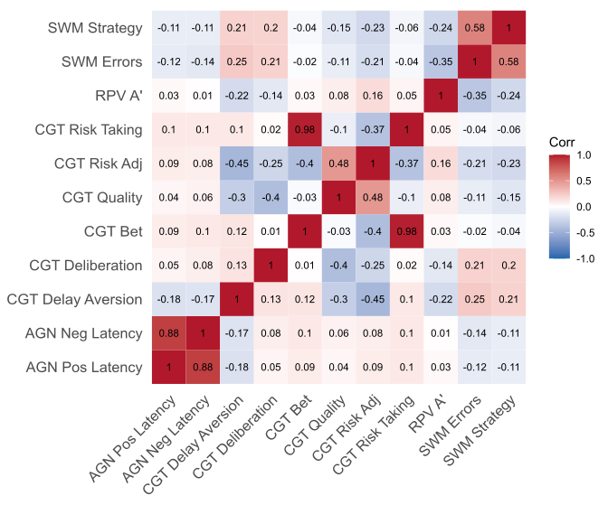

Model loadings
Supplementary Figure 2: Adversity-only model X-loadings and variable importance projections
Note. Components are ordered by the proportion of variance explained in mental health outcomes. Top matrix: X-loadings for demographic and adversity and predictors. Bottom matrix: Y-loadings for mental health outcomes. Colours indicate the direction and magnitude of loadings, with warmer colours representing positive values and cooler colours representing negative values. Numerical values correspond to X- and Y-loading coefficients.
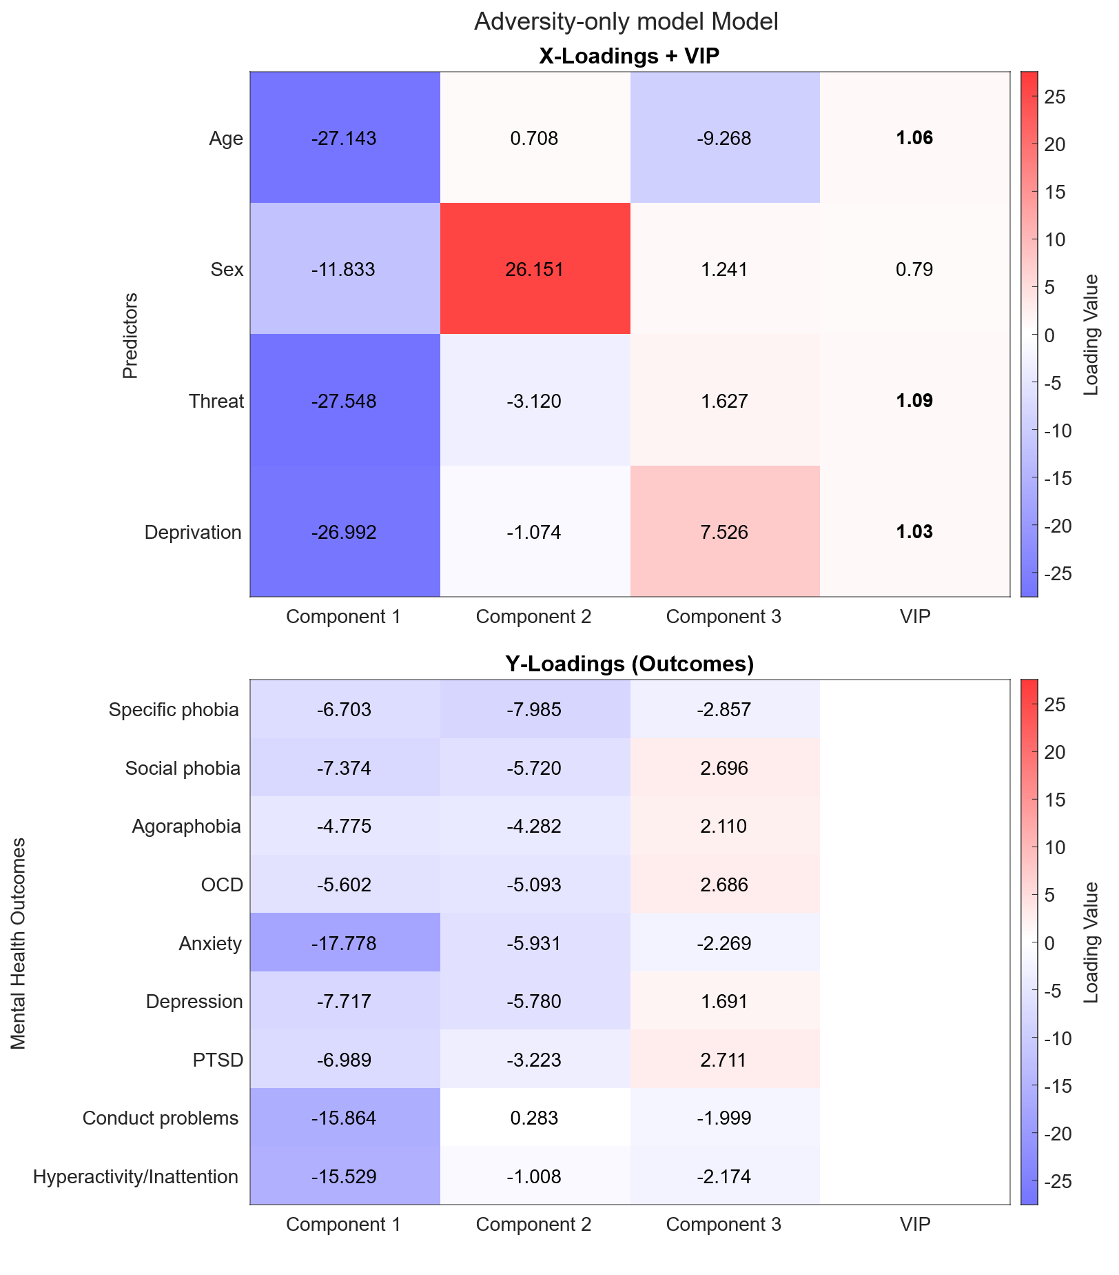

Supplementary Figure 3: Cognition-only model X-loadings and variable importance projections
Note. Components are ordered by the proportion of variance explained in mental health outcomes. Top matrix: X-loadings for demographic and cognitive predictors. Bottom matrix: Y-loadings for mental health outcomes. Colours indicate the direction and magnitude of loadings, with warmer colours representing positive values and cooler colours representing negative values. Numerical values correspond to X- and Y-loading coefficients.

