Table S1. Voxel-wise spatial correlation between PD-related QSM alterations and the six mitochondrial brain atlas maps across the HybraPD and HMAT-derived ROIs.

 | Feature | rho | CI_{lower} | CI_{upper} | ESS | df | p_{spatial} | p_{FDR}
DN | CI | 0.107 | 0.009 | 0.203 | 399.7 | 397.7 | 0.0320 | 0.1251
GPi | CI | -0.287 | -0.417 | -0.146 | 176.8 | 174.8 | 0.0001 | 0.0011
RN | CI | 0.401 | 0.253 | 0.531 | 141.5 | 139.5 | <0.0001 | <0.0001
STN | CI | 0.164 | 0.058 | 0.267 | 333.1 | 331.1 | 0.0027 | 0.0133
PMv | CI | 0.306 | 0.091 | 0.494 | 78.7 | 76.7 | 0.0062 | 0.1452
preSMA | CI | 0.222 | 0.025 | 0.403 | 98.3 | 96.3 | 0.0276 | 0.1655
CN | CII | -0.148 | -0.222 | -0.073 | 664.8 | 662.8 | 0.0001 | 0.0011
RN | CII | 0.421 | 0.279 | 0.544 | 150.1 | 148.1 | <0.0001 | <0.0001
STN | CII | 0.280 | 0.107 | 0.437 | 120.9 | 118.9 | 0.0019 | 0.0105
Thalamus | CII | 0.108 | 0.029 | 0.186 | 602.8 | 600.8 | 0.0079 | 0.0354
PMv | CII | 0.277 | 0.053 | 0.474 | 75.1 | 73.1 | 0.0161 | 0.1452
DN | CIV | 0.177 | 0.063 | 0.286 | 289.6 | 287.6 | 0.0026 | 0.0133
GPi | CIV | -0.377 | -0.534 | -0.195 | 100.2 | 98.2 | 0.0001 | 0.0011
RN | CIV | 0.475 | 0.335 | 0.595 | 138.5 | 136.5 | <0.0001 | <0.0001
PMv | CIV | 0.301 | 0.068 | 0.502 | 68.4 | 66.4 | 0.0125 | 0.1452
GPi | MitoD | -0.299 | -0.473 | -0.102 | 93.9 | 91.9 | 0.0034 | 0.0163
RN | MitoD | 0.279 | 0.147 | 0.401 | 202.9 | 200.9 | <0.0001 | 0.0009
SN | MitoD | -0.423 | -0.608 | -0.193 | 61.9 | 59.9 | 0.0006 | 0.0043
SNc | MitoD | -0.570 | -0.780 | -0.246 | 27.4 | 25.4 | 0.0017 | 0.0104
SNr | MitoD | -0.319 | -0.557 | -0.033 | 46.3 | 44.3 | 0.0302 | 0.1234
PMv | MitoD | 0.306 | 0.074 | 0.507 | 68.7 | 66.7 | 0.0107 | 0.1452
SMA | MitoD | -0.268 | -0.486 | -0.018 | 61.4 | 59.4 | 0.0364 | 0.1770
DN | MRC | 0.135 | 0.011 | 0.256 | 246.9 | 244.9 | 0.0335 | 0.1256
GPi | MRC | -0.348 | -0.505 | -0.167 | 105.5 | 103.5 | 0.0003 | 0.0022
RN | MRC | 0.470 | 0.323 | 0.595 | 128.3 | 126.3 | <0.0001 | <0.0001
SN | MRC | 0.266 | 0.044 | 0.463 | 76.3 | 74.3 | 0.0199 | 0.0851
SNc | MRC | 0.318 | 0.167 | 0.454 | 151.9 | 149.9 | <0.0001 | 0.0009
PMv | MRC | 0.268 | 0.014 | 0.490 | 59.4 | 57.4 | 0.0393 | 0.1770
DN | TRC | 0.129 | 0.004 | 0.251 | 242.9 | 240.9 | 0.0441 | 0.1586
GPi | TRC | -0.320 | -0.480 | -0.140 | 108.6 | 106.6 | 0.0007 | 0.0045
RN | TRC | 0.504 | 0.377 | 0.613 | 155.1 | 153.1 | <0.0001 | <0.0001
PMv | TRC | 0.296 | 0.048 | 0.511 | 60.7 | 58.7 | 0.0206 | 0.1486

Spatial correlations between PD-related QSM alterations and six mitochondrial feature maps: CI, CII, CIV, MitoD, MRC, and TRC were assessed. For each type of analysis, we report Spearman’s correlation coefficient (rho), 95% confidence intervals (CI_{lower} & CI_{upper}), effective sample size (ESS), degrees of freedom (df) derived from ESS, p-value from Dutilleul’s modified t-test, correcting for spatial autocorrelation (p_{spatial}), and false-discovery rate (FDR)-corrected p-values (p_{FDR}). Grey-shaded cells represent associations that did not pass the false discovery rate-corrected threshold (p_{FDR}). CI, CII, and CIV: electron transport chain protein complexes I, II, and IV. CN: caudate nucleus. DN: dentate nucleus. GPi: globus pallidus internal segment. HMAT: human motor area template. MitoD: mitochondrial density. MRC: mitochondrial respiratory capacity. PD: Parkinson’s disease. PMv: ventral premotor cortex. preSMA: presupplementary motor area. QSM: quantitative susceptibility mapping. RN: red nucleus. ROIs: regions of interest. SMA: supplementary motor area. SNc/SNr: substantia nigra pars compacta/reticulata. TRC: tissue respiratory capacity.

Table S2. Voxel-wise spatial correlation between PD-related QSM alterations and the six mitochondrial brain atlas maps across the Jülich atlas-derived ROIs.

 | Feature | rho | CI_{lower} | CI_{upper} | ESS | df | p_{spatial} | p_{FDR}
Amy-LB | CI | 0.176 | 0.044 | 0.303 | 215.7 | 213.7 | 0.0095 | 0.0588
hIP1 | CI | 0.237 | 0.000 | 0.449 | 68.8 | 66.8 | 0.0498 | 0.1888
hIP2 | CI | 0.447 | 0.081 | 0.706 | 27.0 | 25.0 | 0.0194 | 0.1015
BA44 | CI | 0.231 | 0.195 | 0.266 | 2709.8 | 2707.8 | <0.0001 | <0.0001
BA45 | CI | 0.200 | 0.128 | 0.269 | 714.4 | 712.4 | <0.0001 | <0.0001
IPL-PGa | CI | -0.070 | -0.124 | -0.016 | 1295.4 | 1293.4 | 0.0117 | 0.0698
MB | CI | 0.291 | 0.137 | 0.431 | 150.0 | 148.0 | 0.0003 | 0.0029
MGB | CI | -0.220 | -0.407 | -0.016 | 91.9 | 89.9 | 0.0354 | 0.1468
BA6 | CI | -0.107 | -0.180 | -0.032 | 685.0 | 683.0 | 0.0051 | 0.0354
TE1.0 | CI | -0.298 | -0.402 | -0.187 | 278.3 | 276.3 | <0.0001 | <0.0001
SPL-5L | CI | 0.168 | 0.123 | 0.213 | 1791.9 | 1789.9 | <0.0001 | <0.0001
SPL-7P | CI | 0.114 | 0.014 | 0.212 | 383.2 | 381.2 | 0.0252 | 0.1213
V5 | CI | -0.344 | -0.588 | -0.042 | 41.5 | 39.5 | 0.0268 | 0.1251
Amy-CM | CII | 0.406 | 0.044 | 0.673 | 28.8 | 26.8 | 0.0297 | 0.1323
BA44 | CII | 0.242 | 0.195 | 0.288 | 1584.6 | 1582.6 | <0.0001 | <0.0001
BA45 | CII | 0.214 | 0.108 | 0.314 | 330.7 | 328.7 | <0.0001 | 0.0009
Hipp-CA | CII | -0.157 | -0.264 | -0.046 | 309.8 | 307.8 | 0.0056 | 0.0371
Ins-Id1 | CII | -0.332 | -0.563 | -0.052 | 47.9 | 45.9 | 0.0215 | 0.1086
Ins-Ig2 | CII | -0.144 | -0.228 | -0.057 | 507.3 | 505.3 | 0.0012 | 0.0095
MB | CII | 0.287 | 0.033 | 0.506 | 59.1 | 57.1 | 0.0275 | 0.1261
MGB | CII | -0.255 | -0.424 | -0.068 | 107.4 | 105.4 | 0.0080 | 0.0507
TE1.0 | CII | -0.317 | -0.411 | -0.216 | 328.9 | 326.9 | <0.0001 | <0.0001
OP2 | CII | 0.105 | 0.031 | 0.178 | 691.8 | 689.8 | 0.0056 | 0.0371
SPL-5L | CII | 0.250 | 0.197 | 0.302 | 1216.4 | 1214.4 | <0.0001 | <0.0001
SPL-7A | CII | 0.167 | 0.090 | 0.242 | 625.2 | 623.2 | <0.0001 | 0.0003
SPL-7P | CII | 0.159 | 0.027 | 0.284 | 221.7 | 219.7 | 0.0181 | 0.0962
V2 | CII | 0.122 | 0.022 | 0.220 | 381.4 | 379.4 | 0.0171 | 0.0939
V4 | CII | 0.140 | 0.057 | 0.220 | 560.0 | 558.0 | 0.0009 | 0.0080
BA44 | CIV | 0.210 | 0.155 | 0.263 | 1200.6 | 1198.6 | <0.0001 | <0.0001
BA45 | CIV | 0.194 | 0.125 | 0.261 | 778.5 | 776.5 | <0.0001 | <0.0001
IPL-PGa | CIV | -0.096 | -0.128 | -0.064 | 3650.7 | 3648.7 | <0.0001 | <0.0001
Ins-Id1 | CIV | -0.331 | -0.576 | -0.031 | 42.2 | 40.2 | 0.0319 | 0.1344
MGB | CIV | -0.261 | -0.447 | -0.053 | 86.7 | 84.7 | 0.0148 | 0.0845
BA6 | CIV | -0.090 | -0.171 | -0.008 | 572.9 | 570.9 | 0.0307 | 0.1329
TE1.0 | CIV | -0.311 | -0.408 | -0.207 | 313.7 | 311.7 | <0.0001 | <0.0001
SPL-5L | CIV | 0.119 | 0.057 | 0.181 | 975.5 | 973.5 | 0.0002 | 0.0019
SPL-7A | CIV | 0.131 | 0.057 | 0.203 | 697.5 | 695.5 | 0.0005 | 0.0049
V4 | CIV | 0.124 | 0.085 | 0.162 | 2473.2 | 2471.2 | <0.0001 | <0.0001
V5 | CIV | -0.316 | -0.562 | -0.019 | 43.4 | 41.4 | 0.0380 | 0.1556
BA44 | MitoD | 0.321 | 0.272 | 0.368 | 1326.6 | 1324.6 | <0.0001 | <0.0001
BA45 | MitoD | 0.206 | 0.145 | 0.265 | 981.1 | 979.1 | <0.0001 | <0.0001
Ins-Id1 | MitoD | -0.302 | -0.522 | -0.043 | 56.5 | 54.5 | 0.0232 | 0.1139
MGB | MitoD | -0.290 | -0.432 | -0.134 | 145.8 | 143.8 | 0.0004 | 0.0037
BA6 | MitoD | -0.118 | -0.211 | -0.022 | 418.6 | 416.6 | 0.0160 | 0.0896
TE1.0 | MitoD | -0.276 | -0.365 | -0.183 | 398.4 | 396.4 | <0.0001 | <0.0001
OP4 | MitoD | -0.079 | -0.125 | -0.033 | 1811.4 | 1809.4 | 0.0008 | 0.0069
SPL-5L | MitoD | 0.071 | 0.010 | 0.132 | 1022.7 | 1020.7 | 0.0233 | 0.1139
SPL-7A | MitoD | 0.137 | 0.052 | 0.219 | 529.9 | 527.9 | 0.0016 | 0.0125
V4 | MitoD | 0.130 | 0.047 | 0.212 | 548.6 | 546.6 | 0.0022 | 0.0165
Amy-SF | MRC | -0.132 | -0.248 | -0.013 | 268.7 | 266.7 | 0.0301 | 0.1323
hIP2 | MRC | 0.462 | 0.089 | 0.721 | 25.8 | 23.8 | 0.0180 | 0.0962
BA45 | MRC | 0.220 | 0.118 | 0.317 | 352.4 | 350.4 | <0.0001 | 0.0003
Hipp-CA | MRC | -0.145 | -0.257 | -0.029 | 283.5 | 281.5 | 0.0148 | 0.0845
IPL-PFm | MRC | 0.049 | 0.018 | 0.080 | 3985.6 | 3983.6 | 0.0018 | 0.0139
Ins-Id1 | MRC | -0.325 | -0.579 | -0.014 | 39.8 | 37.8 | 0.0412 | 0.1644
MB | MRC | 0.372 | 0.223 | 0.504 | 146.3 | 144.3 | <0.0001 | <0.0001
MGB | MRC | -0.281 | -0.458 | -0.082 | 93.2 | 91.2 | 0.0064 | 0.0410
TE1.0 | MRC | -0.312 | -0.395 | -0.224 | 428.5 | 426.5 | <0.0001 | <0.0001
BA4a | MRC | 0.160 | 0.057 | 0.259 | 357.4 | 355.4 | 0.0025 | 0.0179
OP2 | MRC | 0.119 | 0.046 | 0.191 | 711.5 | 709.5 | 0.0015 | 0.0116
SPL-5L | MRC | 0.216 | 0.164 | 0.266 | 1342.7 | 1340.7 | <0.0001 | <0.0001
SPL-7A | MRC | 0.173 | 0.102 | 0.242 | 738.2 | 736.2 | <0.0001 | <0.0001
SPL-7P | MRC | 0.196 | 0.080 | 0.307 | 275.8 | 273.8 | 0.0010 | 0.0088
V2 | MRC | 0.114 | 0.010 | 0.216 | 355.8 | 353.8 | 0.0314 | 0.1338
V4 | MRC | 0.142 | 0.080 | 0.204 | 957.4 | 955.4 | <0.0001 | 0.0001
hIP2 | TRC | 0.362 | 0.007 | 0.636 | 30.7 | 28.7 | 0.0467 | 0.1813
BA44 | TRC | 0.204 | 0.126 | 0.279 | 603.4 | 601.4 | <0.0001 | <0.0001
BA45 | TRC | 0.211 | 0.132 | 0.287 | 588.9 | 586.9 | <0.0001 | <0.0001
Ins-Id1 | TRC | -0.336 | -0.581 | -0.035 | 41.8 | 39.8 | 0.0299 | 0.1323
MB | TRC | 0.205 | 0.024 | 0.373 | 116.8 | 114.8 | 0.0267 | 0.1251
MGB | TRC | -0.199 | -0.382 | -0.001 | 98.3 | 96.3 | 0.0491 | 0.1883
BA6 | TRC | -0.099 | -0.182 | -0.015 | 544.1 | 542.1 | 0.0205 | 0.1052
TE1.0 | TRC | -0.321 | -0.406 | -0.232 | 409.5 | 407.5 | <0.0001 | <0.0001
BA4a | TRC | 0.109 | 0.002 | 0.214 | 333.7 | 331.7 | 0.0458 | 0.1801
OP2 | TRC | 0.105 | 0.025 | 0.184 | 591.0 | 589.0 | 0.0106 | 0.0640
OP4 | TRC | -0.019 | -0.038 | -0.001 | 11380.4 | 11378.4 | 0.0390 | 0.1574
SPL-5L | TRC | 0.181 | 0.121 | 0.240 | 1012.2 | 1010.2 | <0.0001 | <0.0001
SPL-7A | TRC | 0.156 | 0.094 | 0.217 | 979.4 | 977.4 | <0.0001 | <0.0001
SPL-7P | TRC | 0.133 | 0.042 | 0.222 | 462.2 | 460.2 | 0.0042 | 0.0295
V4 | TRC | 0.133 | 0.088 | 0.177 | 1867.0 | 1865.0 | <0.0001 | <0.0001

Spatial correlations between PD-related QSM alterations and six mitochondrial feature maps: CI, CII, CIV, MitoD, MRC, and TRC were assessed. For each type of analysis, we report Spearman’s correlation coefficient (rho), 95% confidence intervals (CI_{lower} & CI_{upper}), effective sample size (ESS), degrees of freedom (df) derived from ESS, p-value from Dutilleul’s modified t-test, correcting for spatial autocorrelation (p_{spatial}), and false-discovery rate (FDR)-corrected p-values (p_{FDR}). Grey-shaded cells represent associations that did not pass the false discovery rate-corrected threshold (p_{FDR}). Amy-CM: amygdala centromedial group. Amy-LB: amygdala laterobasal group. Amy-SF: amygdala superficial group. BA44: Broca’s area 44. BA4a: primary motor area BA4a. BA45: Broca’s area 45. BA6: premotor cortex BA6. CI, CII, and CIV: electron transport chain protein complexes I, II, and IV. hIP1/hIP2: anterior intra-parietal sulcus 1/2. Hipp-CA: hippocampus cornu ammonis. Ins-Id1: dysgranular insular area 1. Ins-Ig2: granular insular area 2. IPL-PFm: inferior parietal lobule PFm. IPL-PGa: inferior parietal lobule PGa. MB: mammillary body. MGB: medial geniculate body. MitoD: mitochondrial density. MRC: mitochondrial respiratory capacity. OP2/OP4: secondary somatosensory cortex 2/4. PD: Parkinson’s disease. QSM: quantitative susceptibility mapping. ROIs: regions of interest. SPL-5L: superior parietal lobule 5L. SPL-7A/SPL-7P: superior parietal lobule 7A/7P. TE1.0: primary auditory cortex TE1.0. TRC: tissue respiratory capacity. V2: visual cortex V2, Brodmann’s area 18. V4/V5: visual cortex V4/V5.

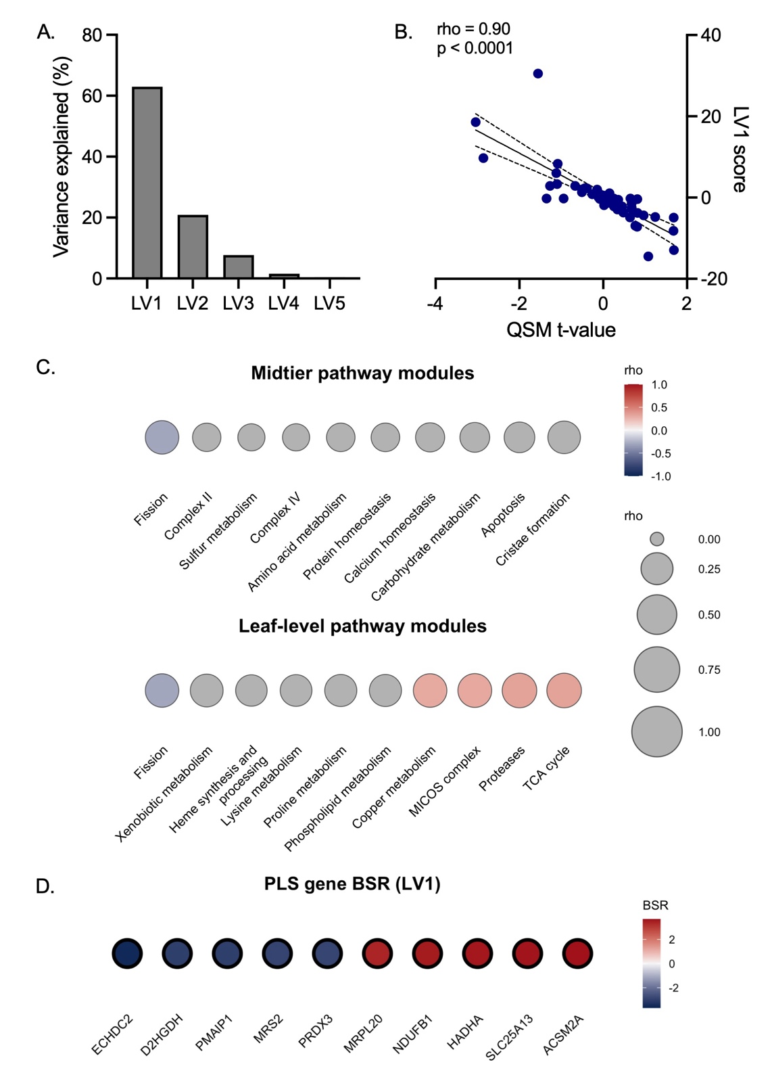

Figure S1. Regional spatial associations between PD-related QSM alterations and mitochondrial gene-expression across cortical Jülich-derived ROIs. A. Percentage of variance explained by each latent variable (LV1-5) from partial least squares regression analysis. B. Correlation between LV1 scores and QSM-derived t-values across Jülich atlas-derived ROIs. Linear fit is indicated by the blue line, and the 95% confidence interval is indicated by dashed lines. C. Top 10 correlations between mitochondrial pathway module expression and LV1, presented at the midtier and leaf-level of the MitoCarta3.0 functional hierarchy. Correlations are presented from most negative (blue) to most positive (red). Colored dots represent modules at nominal significance (p < 0.05), and bold-border dots represent modules at FDR-corrected significance (p_{FDR} < 0.05). Grey-colored dots represent modules with no statistical significance. Dot size represents the magnitude of rho. D. Bootstrap ratio scores (BSR) for the top 5 genes negatively (blue) and positively (red) contributing to LV1, ranked by magnitude. Numerical values represent each gene’s BSR. MICOS: mitochondrial contact site and cristae organizing system. PD: Parkinson’s disease. QSM: quantitative susceptibility mapping. rho: Spearman’s correlation coefficient. ROIs: regions of interest. TCA: tricarboxylic acid.

