SUPPLEMENTARY MATERIAL
Observability of Fifth Universal Definition of Myocardial Infarction components in linked electronic health records: a retrospective MIMIC-IV study
Hongwei Tan1,3,† PhD 0000-0003-4513-4435; Zheng Liu1,2,† PhD 0009-0008-0544-0204; Zhixin Li1,3 MSc 0009-0002-1532-7949; Yucheng Xie1,3 MSc 0009-0007-1104-1739; Zhuo Chen1,3 MSc 0009-0004-4864-5649;
Yongmei Nie1,3,4,5* PhD 0000-0003-0369-1890; Fengxu Yu1,3,4,5* PhD 0000-0001-5303-4640
All phenotypes are electronic evidence-availability strata. They are not clinical diagnoses, and no diagnostic-accuracy measure is estimable without an independent reference standard.

Supplementary Methods

Cohort construction and linkage
Among adults with at least one qualifying selected-troponin series, the earliest encounter by index time was retained before ED-source, pragmatic dynamic-pattern, and common-module-era restrictions. Of 15,409 person-index encounters meeting the dynamic rule, 6,189 remained after the combined ED-source and estimated 2008–2019 common-module-era restrictions; available aggregate outputs do not separate those two restriction reasons. The 5,412-encounter subset additionally required an early-note availability flag, a reference-note flag, and at least one ECG record in the broader −6 to <+12-h window; it did not require a linked machine report in the strict window.

Strict information time
ECG evidence was recomputed from candidate reports from −1 to <+2 h around ED arrival. This was a prespecified analytic visibility window, not a validated quality target. ‘Unavailable’ meant no linked machine-report ECG was present in this extract during the window; it did not mean that no ECG was acquired, interpreted, or documented elsewhere. Reports from +2 to <+12 h were retained as a late-window sensitivity.

Main cohort and contextual estimand
All 6,189 eligible encounters formed the primary retrospective observability cohort. M1 used a centred natural cubic age spline with 4 degrees of freedom (boundary knots 18 and 100 years; internal knots 38.25, 58.50, and 78.75), recorded sex, and four calendar-period categories. Empirical-distribution standardisation, HC3 covariance, and delta-method intervals supplied secondary descriptive mortality associations. The 5,412 multimodal-selected cohort was used only for sensitivities.

ECG and selection analyses
A three-level M1 model compared positive and unavailable strict-window machine-report status with negative status in all 6,189 encounters. A separate M1 directly compared positive with negative among 4,911 encounters with a linked report. Source combination was cross-tabulated by ECG status. The selection model used age, recorded sex, year group, log peak troponin/URL, log measurement count, and serial duration. Five hundred patient bootstraps repeated selection-model fitting, truncation, weighted outcome fitting, and standardisation.

Exploratory prediction
The MIMIC early-window subset required at least six observable domains. Four hierarchical models separated the burden summary from its raw components. In five repeated five-fold validations, all preprocessing and model fitting occurred within training folds. Each encounter’s five repeat-specific out-of-fold predictions were averaged before calculation of AUC, Brier score, calibration, and risk quintiles. Two hundred patient bootstraps refitted the complete workflow; duplicate observations carried the stable original analysis-row identifier and were constrained to the same fold.

eICU role
eICU lacked equivalent ECG text, ED chief complaints, approved URL maps, time-locked imaging, and procedure adjudication. It was used only for structured-data portability and assay-specific absolute-delta audits, not external validation.

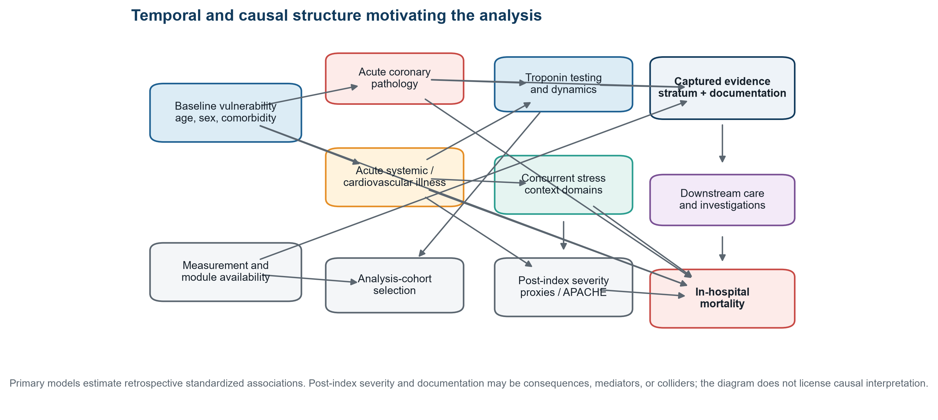
Supplementary Figure S1. Temporal and causal structure. The directed graph distinguishes baseline vulnerability, acute coronary and systemic illness, evidence capture, post-index clinical context, selection, and mortality. M2 and M3 variables may be consequences, mediators, or colliders; estimates are non-causal.
Alt text: Directed graph showing time ordering, selection, and why later clinical variables cannot form a causal adjustment set.

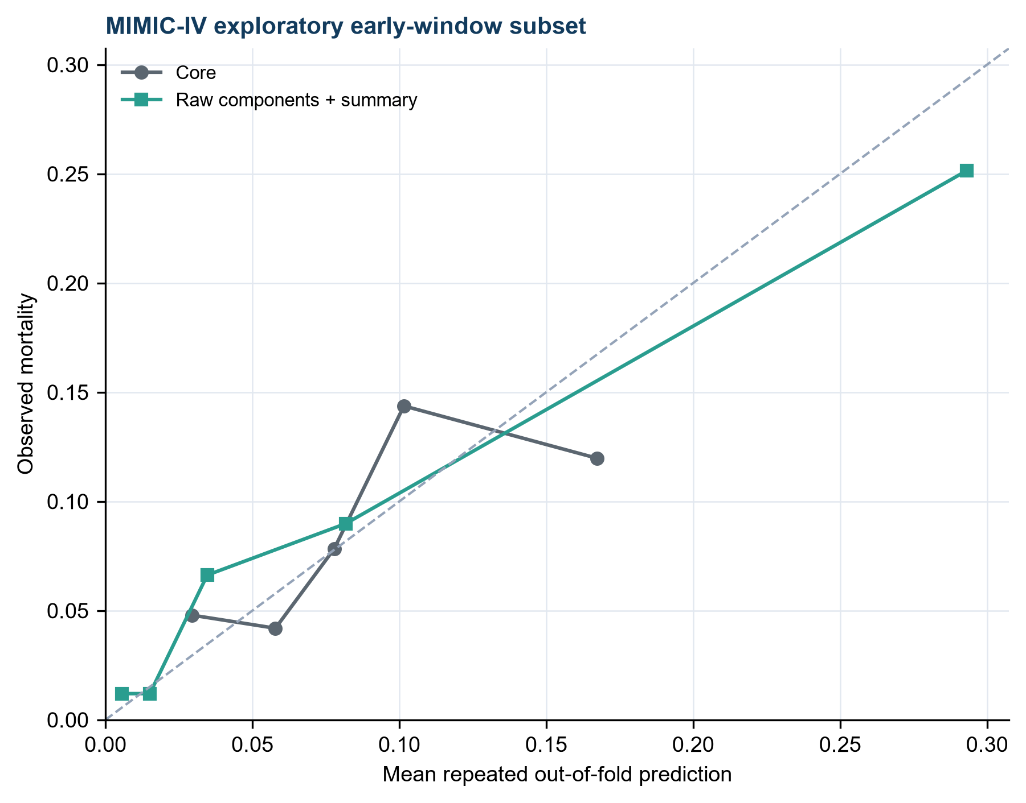
Supplementary Figure S2. Exploratory out-of-fold calibration by risk quintile. Observed versus mean predicted mortality for the core-plus-raw-components model and the same model plus the burden summary. Predictions came from five repeated five-fold validations with preprocessing refitted in every training fold. Slopes below one indicate overfitting.
Alt text: Two quintile calibration curves lie around the identity line and show calibration slopes below one.
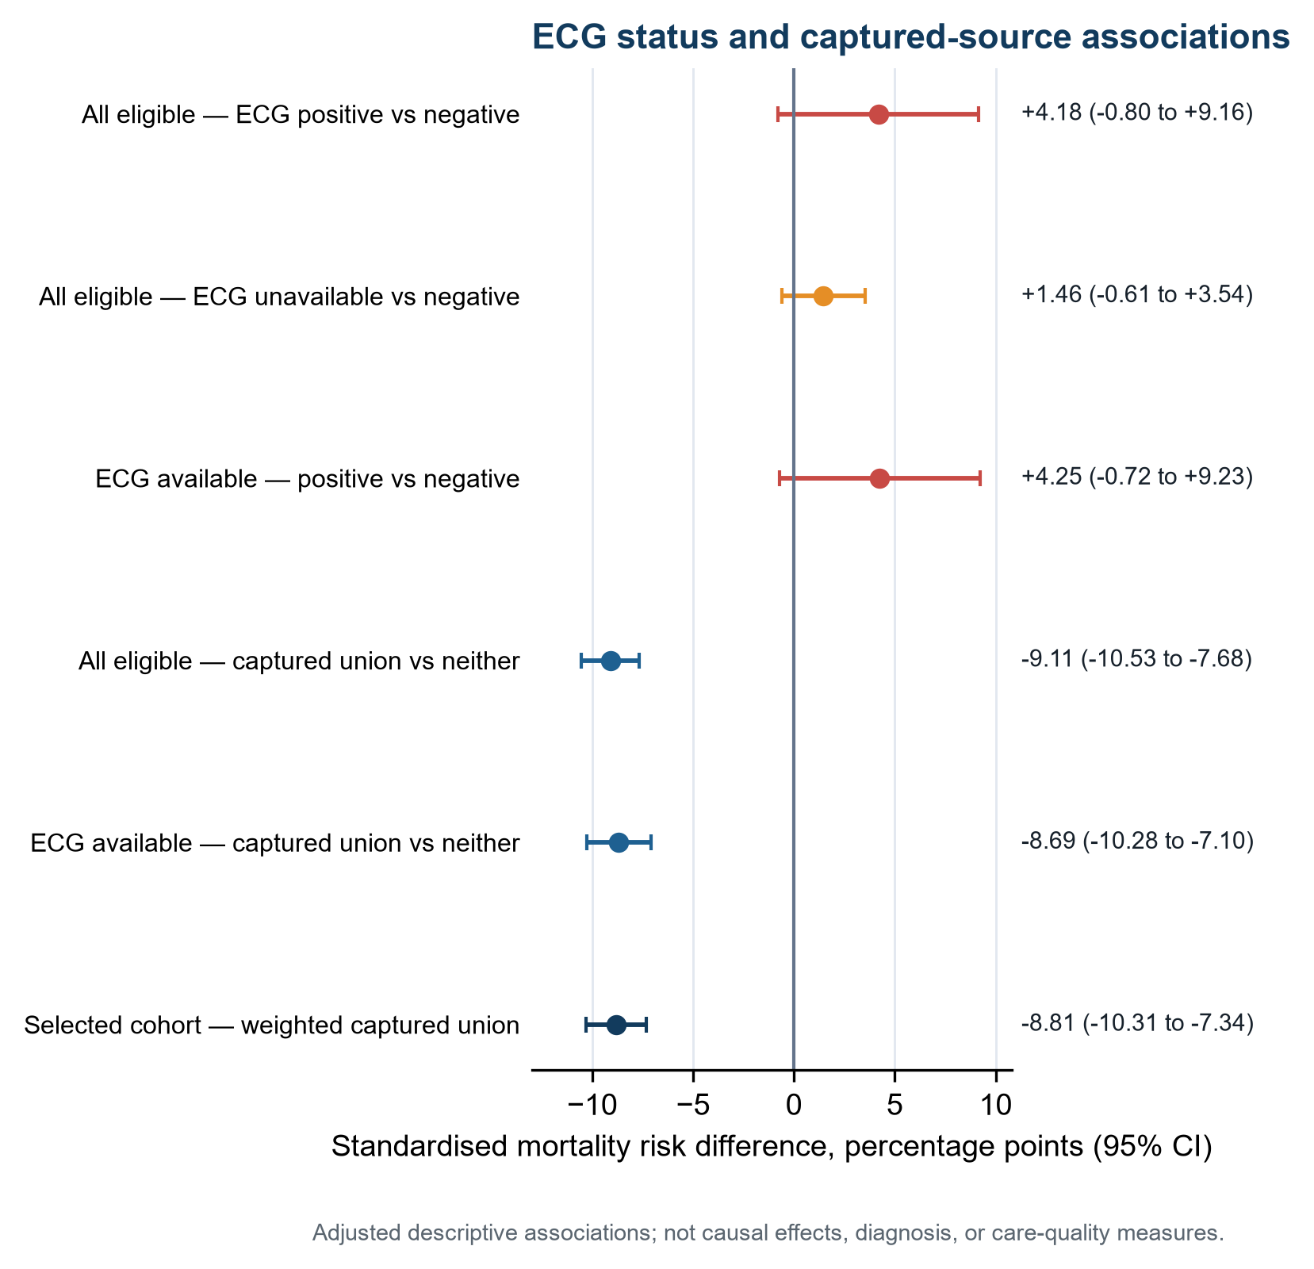
Supplementary Figure S3. Secondary mortality differences by ECG status and captured source. Forest plot of marginal standardised mortality risk differences. Rows compare positive and unavailable strict-window ECG status with negative status and positive with negative status among ECG-available encounters. Captured-union and selection-weighted rows illustrate source heterogeneity. Estimates are descriptive, not causal or diagnostic effects or measures of care quality. The selection-weighted interval used 500 full-process bootstrap replicates; other intervals used robust model-based standard errors. CI, confidence interval; ECG, electrocardiogram; pp, percentage points.
Alt text: Forest plot separating imprecise ECG-status contrasts from negative symptom-dominated captured-union contrasts.

Supplementary Tables
Supplementary Table S1a. All-eligible strict-window source combinations
Combination | n | Deaths | Mortality | Window
Neither captured source | 4710 | 621 | 13.18% | -1 to <+2 hours for ECG; ED chief complaint for symptoms
Symptom only | 1271 | 30 | 2.36% | -1 to <+2 hours for ECG; ED chief complaint for symptoms
Early ECG only | 138 | 25 | 18.12% | -1 to <+2 hours for ECG; ED chief complaint for symptoms
Symptom + early ECG | 70 | 4 | 5.71% | -1 to <+2 hours for ECG; ED chief complaint for symptoms
All 6,189 eligible encounters are included. The captured-evidence union combined symptom-only, early-ECG-only, and both-source strata and was symptom dominated. Neither captured source was the reference; it denotes absence of both captured signals, not a clinically negative ECG.
Supplementary Table S1b. Source combination by strict-window ECG status
Source combination | ECG status | n | Deaths | Mortality | Interpretation
Neither captured source | Negative | 3595 | 467 | 12.99% | Machine-report ECG available in the strict window
Neither captured source | Unavailable | 1115 | 154 | 13.81% | No machine-report ECG from -1 to <+2 hours; not a negative ECG
Symptom only | Negative | 1108 | 26 | 2.35% | Machine-report ECG available in the strict window
Symptom only | Unavailable | 163 | 4 | 2.45% | No machine-report ECG from -1 to <+2 hours; not a negative ECG
Early ECG only | Positive | 138 | 25 | 18.12% | Machine-report ECG available in the strict window
Symptom + early ECG | Positive | 70 | 4 | 5.71% | Machine-report ECG available in the strict window
Within the 4,710-patient reference group, 3,595 had an available strict-window machine report without a prespecified positive phrase and 1,115 had no machine-report ECG in the strict window. Unavailable is not a negative ECG interpretation.
Supplementary Table S2. Candidate and positive ECG timing
Window | Candidate ECGs | Candidate cases | Positive ECGs | Positive cases | Positive timing median (Q1–Q3), min
-6 to <-1 h | 90 | 84 | 2 | 2 | -122.0 (-124.5–-119.5)
-1 to <+2 h | 6254 | 4911 | 272 | 208 | 16.0 (8.0–44.2)
+2 to <+12 h | 4605 | 3280 | 151 | 130 | 312.0 (173.0–500.0)
The primary strict ECG window was −1 to <+2 h. Later reports were not treated as information available at presentation.
Supplementary Table S2b. Prespecified machine-ECG phrase frequencies in the strict window
Phrase rule | Patients | Reports
Broad match excluding reports containing consider acute infarct | 4 | 4
Broad union | 208 | 272
Contains acute [myocardial] infarct | 205 | 268
Contains acute ST elevation MI | 197 | 259
Contains consider acute infarct | 205 | 268
Phrase rows overlap. The broad union identified 208 patients and 272 reports. Reports containing ‘consider acute infarct’ accounted for 205 patients and 268 reports; excluding any report containing that phrase left four reports in four patients. One patient contributed both report types.
Supplementary Table S3. Multimodal-selected sequential and source-specific associations
Analysis | Role | Exposed n | Deaths | Risk exposed | Risk reference | Risk difference, pp (95% CI) | Risk ratio (95% CI)
Strict early-encounter symptom or explicit ECG evidence: M0_UNADJUSTED | MULTIMODAL_SELECTED_SENSITIVITY | 1341 | 55 | 4.10% | 12.85% | -8.75 (-10.22 to -7.27) | 0.319 (0.243–0.419)
Strict early-encounter symptom or explicit ECG evidence: M1_AGE_SEX_CALENDAR_PRIMARY | MULTIMODAL_SELECTED_SENSITIVITY | 1341 | 55 | 4.15% | 12.80% | -8.65 (-10.18 to -7.13) | 0.324 (0.246–0.428)
Strict early-encounter symptom or explicit ECG evidence: M2_PLUS_TROPONIN | MULTIMODAL_SELECTED_SENSITIVITY | 1341 | 55 | 3.48% | 13.52% | -10.04 (-11.46 to -8.63) | 0.257 (0.196–0.337)
Strict early-encounter symptom or explicit ECG evidence: M3_PLUS_POST_INDEX_PHYSIOLOGY | MULTIMODAL_SELECTED_SENSITIVITY | 1341 | 55 | 8.34% | 11.06% | -2.72 (-4.65 to -0.79) | 0.754 (0.604–0.942)
Legacy -6/+12-hour symptom or ECG evidence: M0_UNADJUSTED | WINDOW_SENSITIVITY | 1405 | 62 | 4.41% | 12.88% | -8.46 (-9.96 to -6.97) | 0.343 (0.265–0.443)
Legacy -6/+12-hour symptom or ECG evidence: M1_AGE_SEX_CALENDAR_PRIMARY | WINDOW_SENSITIVITY | 1405 | 62 | 4.47% | 12.83% | -8.36 (-9.90 to -6.82) | 0.348 (0.268–0.453)
Legacy -6/+12-hour symptom or ECG evidence: M2_PLUS_TROPONIN | WINDOW_SENSITIVITY | 1405 | 62 | 3.65% | 13.69% | -10.04 (-11.48 to -8.59) | 0.267 (0.205–0.347)
Legacy -6/+12-hour symptom or ECG evidence: M3_PLUS_POST_INDEX_PHYSIOLOGY | WINDOW_SENSITIVITY | 1405 | 62 | 7.99% | 11.19% | -3.20 (-5.05 to -1.35) | 0.714 (0.573–0.889)
Broad retrospective evidence: M0_UNADJUSTED | RETROSPECTIVE_SENSITIVITY | 2255 | 200 | 8.87% | 11.97% | -3.10 (-4.73 to -1.47) | 0.741 (0.630–0.872)
Broad retrospective evidence: M1_AGE_SEX_CALENDAR_PRIMARY | RETROSPECTIVE_SENSITIVITY | 2255 | 200 | 8.85% | 11.99% | -3.14 (-4.81 to -1.47) | 0.738 (0.625–0.872)
Broad retrospective evidence: M2_PLUS_TROPONIN | RETROSPECTIVE_SENSITIVITY | 2255 | 200 | 6.08% | 16.76% | -10.69 (-12.78 to -8.59) | 0.362 (0.298–0.442)
Broad retrospective evidence: M3_PLUS_POST_INDEX_PHYSIOLOGY | RETROSPECTIVE_SENSITIVITY | 2255 | 200 | 8.30% | 12.59% | -4.29 (-6.06 to -2.52) | 0.659 (0.551–0.788)
Ischaemic chief-complaint evidence: M0_UNADJUSTED | SOURCE_SENSITIVITY | 1203 | 30 | 2.49% | 13.02% | -10.53 (-11.87 to -9.18) | 0.192 (0.133–0.275)
Ischaemic chief-complaint evidence: M1_AGE_SEX_CALENDAR_PRIMARY | SOURCE_SENSITIVITY | 1203 | 30 | 2.51% | 13.00% | -10.48 (-11.86 to -9.11) | 0.193 (0.134–0.279)
Ischaemic chief-complaint evidence: M2_PLUS_TROPONIN | SOURCE_SENSITIVITY | 1203 | 30 | 2.21% | 13.45% | -11.24 (-12.54 to -9.95) | 0.164 (0.115–0.235)
Ischaemic chief-complaint evidence: M3_PLUS_POST_INDEX_PHYSIOLOGY | SOURCE_SENSITIVITY | 1203 | 30 | 6.98% | 11.11% | -4.13 (-6.24 to -2.02) | 0.628 (0.471–0.839)
Explicit ECG evidence within -1 to <+2 hours: M0_UNADJUSTED | SOURCE_SENSITIVITY | 208 | 29 | 13.94% | 10.55% | 3.39 (-1.39 to 8.17) | 1.322 (0.934–1.869)
Explicit ECG evidence within -1 to <+2 hours: M1_AGE_SEX_CALENDAR_PRIMARY | SOURCE_SENSITIVITY | 208 | 29 | 14.73% | 10.53% | 4.20 (-0.77 to 9.17) | 1.399 (0.994–1.970)
Explicit ECG evidence within -1 to <+2 hours: M2_PLUS_TROPONIN | SOURCE_SENSITIVITY | 208 | 29 | 11.61% | 10.64% | 0.97 (-3.25 to 5.19) | 1.091 (0.757–1.572)
Explicit ECG evidence within -1 to <+2 hours: M3_PLUS_POST_INDEX_PHYSIOLOGY | SOURCE_SENSITIVITY | 208 | 29 | 11.87% | 10.63% | 1.24 (-2.49 to 4.97) | 1.117 (0.814–1.532)
Explicit ECG evidence from +2 to <+12 hours: M0_UNADJUSTED | LATE_WINDOW_SENSITIVITY | 130 | 10 | 7.69% | 10.75% | -3.06 (-7.72 to 1.59) | 0.715 (0.392–1.304)
Explicit ECG evidence from +2 to <+12 hours: M1_AGE_SEX_CALENDAR_PRIMARY | LATE_WINDOW_SENSITIVITY | 130 | 10 | 7.93% | 10.75% | -2.82 (-7.58 to 1.94) | 0.738 (0.406–1.339)
Explicit ECG evidence from +2 to <+12 hours: M2_PLUS_TROPONIN | LATE_WINDOW_SENSITIVITY | 130 | 10 | 5.73% | 10.84% | -5.11 (-8.79 to -1.43) | 0.528 (0.282–0.992)
Explicit ECG evidence from +2 to <+12 hours: M3_PLUS_POST_INDEX_PHYSIOLOGY | LATE_WINDOW_SENSITIVITY | 130 | 10 | 5.51% | 10.84% | -5.33 (-8.62 to -2.05) | 0.508 (0.283–0.913)
All rows use the 5,412 multimodal-selected sensitivity cohort. The all-eligible M1 row is reported in Table 2 and Supplementary Table S5. M2 and M3 are sequential non-causal sensitivities. Negative values do not imply a protective effect.
Supplementary Table S4. Prespecified sparse analyses
Analysis | Exposed n | Exposed deaths | Reference n | Reference deaths | Exposed mortality | Reference mortality | Status
Symptom plus explicit ECG evidence within -1 to <+2 hours | 70 | 4 | 5342 | 574 | 5.71% | 10.75% | DESCRIPTIVE_ONLY_SPARSE
Early explicit ECG evidence excluding 'consider acute infarct' | 4 | 2 | 5408 | 576 | 50.00% | 10.65% | DESCRIPTIVE_ONLY_SPARSE
Early explicit ECG evidence meeting strict clock criteria | 10 | 1 | 5402 | 577 | 10.00% | 10.68% | DESCRIPTIVE_ONLY_SPARSE
Fewer than 100 exposed patients or no more than five exposed deaths precluded multivariable modelling.
Supplementary Table S5. Full-cohort primary and selection sensitivity analyses
Analysis | n | Deaths | Exposed n | Risk exposed | Risk reference | Risk difference, pp (95% CI) | CI method
Chief-complaint evidence in all eligible ED encounters | 6189 | 680 | 1341 | 2.56% | 13.30% | -10.74 (-12.04 to -9.45) | HC3 model-based
Chief-complaint evidence in multimodal analytic encounters | 5412 | 578 | 1203 | 2.51% | 13.00% | -10.48 (-11.86 to -9.11) | HC3 model-based
Captured symptom-or-machine-ECG evidence in all eligible ED encounters | 6189 | 680 | 1479 | 4.04% | 13.14% | -9.11 (-10.53 to -7.68) | HC3 model-based
Captured symptom-or-machine-ECG evidence when strict-window ECG was available | 4911 | 522 | 1316 | 4.24% | 12.93% | -8.69 (-10.28 to -7.10) | HC3 model-based
Positive versus negative machine-ECG status when a strict-window report was available | 4911 | 522 | 208 | 14.71% | 10.46% | 4.25 (-0.72 to 9.23) | HC3 model-based
Selection-weighted strict early-encounter evidence | 5412 | 578 | 1341 | 4.05% | 12.86% | -8.81 (-10.31 to -7.34) | 500-replicate full-process patient bootstrap
The captured symptom-or-machine-ECG row in all 6,189 eligible encounters is the main contextual estimate. The ECG-available sensitivity excludes 1,278 patients without a machine-report ECG in the strict window. The weighted 5,412-encounter sensitivity interval repeats the full selection-weighting procedure in 500 patient bootstraps. Other rows use robust model-based intervals.
Supplementary Table S6. Balance for every selection-model covariate
Variable | Level | Full cohort | Included | Weighted included | |SMD| before | |SMD| after
age_years | continuous | 70.817 | 70.975 | 70.806 | 0.010 | 0.001
log1p_peak_url_ratio | continuous | 2.931 | 2.949 | 2.932 | 0.012 | 0.001
log1p_measurements | continuous | 1.320 | 1.322 | 1.320 | 0.010 | 0.001
serial_span_hours | continuous | 13.503 | 13.719 | 13.507 | 0.040 | 0.001
sex | F | 0.439 | 0.441 | 0.439 | 0.003 | 0.000
sex | M | 0.561 | 0.559 | 0.561 | 0.003 | 0.000
anchor_year_group | 2008 - 2010 | 0.196 | 0.212 | 0.196 | 0.039 | 0.000
anchor_year_group | 2011 - 2013 | 0.276 | 0.300 | 0.276 | 0.053 | 0.000
anchor_year_group | 2014 - 2016 | 0.286 | 0.310 | 0.287 | 0.051 | 0.000
anchor_year_group | 2017 - 2019 | 0.242 | 0.178 | 0.241 | 0.155 | 0.000
Categorical entries are proportions. Continuous entries are means on the model scale.
Supplementary Table S7a. Strict-window ECG positive, negative, and unavailable strata
Cohort | ECG status | n | Deaths | Mortality
ALL_ELIGIBLE | POSITIVE | 208 | 29 | 13.94%
ALL_ELIGIBLE | NEGATIVE | 4703 | 493 | 10.48%
ALL_ELIGIBLE | UNAVAILABLE | 1278 | 158 | 12.36%
ANALYTIC_INCLUDED | POSITIVE | 208 | 29 | 13.94%
ANALYTIC_INCLUDED | NEGATIVE | 4703 | 493 | 10.48%
ANALYTIC_INCLUDED | UNAVAILABLE | 501 | 56 | 11.18%
Unavailable means no linked machine-report ECG in the −1 to <+2-h analytic window; it is not a negative ECG interpretation and does not establish that no ECG was acquired or read.
Supplementary Table S7b. M1-standardised mortality by strict-window ECG status
Status | n/deaths | Crude risk | Standardised risk (95% CI) | RD vs negative, pp (95% CI) | RR vs negative (95% CI) | Conditional OR (95% CI)
Negative | 4703/493 | 10.48% | 10.54% (9.69–11.46) | Reference | Reference | Reference
Positive | 208/29 | 13.94% | 14.72% (10.46–20.34) | +4.18 (-0.80 to +9.16) | 1.397 (0.991–1.968) | 1.470 (0.980–2.204)
Unavailable | 1278/158 | 12.36% | 12.01% (10.29–13.97) | +1.46 (-0.61 to +3.54) | 1.139 (0.954–1.360) | 1.159 (0.947–1.419)
M1 used a natural cubic age spline with 4 degrees of freedom, recorded sex, and calendar period; negative was reference. HC3 covariance and delta-method intervals were used. Omnibus two-degree-of-freedom Wald P=0.079. These are adjusted descriptive associations, not causal effects.
Supplementary Table S8. Multimodal-selected interaction analyses
Modifier | Level | n | Deaths | Risk difference, pp (95% CI) | Joint P
sex | F | 2386 | 271 | -8.70 (-11.10 to -6.29) | 0.846
sex | M | 3026 | 307 | -8.59 (-10.53 to -6.66) | 0.846
calendar_period | 2008 - 2010 | 1147 | 77 | -6.92 (-9.24 to -4.60) | 0.033
calendar_period | 2011 - 2013 | 1622 | 190 | -6.07 (-9.29 to -2.84) | 0.033
calendar_period | 2014 - 2016 | 1677 | 193 | -10.61 (-13.28 to -7.93) | 0.033
calendar_period | 2017 - 2019 | 966 | 118 | -11.39 (-14.90 to -7.89) | 0.033
Each modifier was tested in one M1 interaction model in the 5,412 multimodal-selected sensitivity cohort. Calendar findings are exploratory.

Supplementary Table S9. Fifth-UDMI component-by-data-source operational observability matrix
Component | Required information | EHR support | Denominator | Operationally observable n (%) | Interpretation
Acute myocardial injury | Rise and/or fall in cTn with ≥1 value above the assay- and sex-specific 99th-percentile URL | Partially supported (operational approximation) | 6189 | 6189 (100.0%) | All encounters met a pragmatic database rule using a locally recorded non-sex-specific URL and relative-change thresholds (>20% when the first value exceeded the URL and >50% otherwise); this did not establish Fifth-UDMI acute myocardial injury
Assay threshold | Sex-specific 99th-percentile URL | Unavailable | 6189 | 0 (0.0%) | Only locally recorded non-sex-specific URLs were available
Ischaemia—symptoms | Ischaemic symptoms at presentation | Partially supported | 6189 | 6189 (100.0%) | ED chief complaint is available but not a full clinician history
Ischaemia—ECG | New ischaemic ECG changes in the strict early window | Partially supported | 6189 | 4911 (79.4%) | Machine reports are a proxy; no expert over-read or prior-ECG comparison
Ischaemia—imaging | New regional wall-motion abnormality or loss of viable myocardium | Unavailable | 6189 | 0 (0.0%) | No systematic time-locked imaging result was extractable
Ischaemia—coronary thrombus | Angiographic or autopsy evidence | Not operationalised | 6189 | 0 (0.0%) | No validated time-locked structured variable
MI mechanism | Primary versus secondary MI classification | Not adjudicable | 6189 | 0 (0.0%) | Stress-domain proxies cannot establish causal mechanism
Procedure-related MI | Considered: suspected coronary complication within 30 days after a cardiac procedure, acute myocardial injury, and at least one clinical or ECG feature. Confirmed: angiographic/anatomic coronary-complication evidence and/or new regional wall-motion abnormality or loss of viable myocardium. If the complication occurs during the procedure, or the procedure is performed for acute MI, both coronary and cardiac imaging evidence are required | Not adjudicable | 6189 | 0 (0.0%) | Procedure timing, coronary-complication data, clinical/ECG features, and the required coronary and cardiac imaging were not jointly available. No single universal troponin threshold defines this category
Operationally observable means that a source field or proxy required for the audit was present. It does not mean that the corresponding Fifth-UDMI clinical component was fully evaluable or fulfilled; 100% denotes proxy-field presence only. Historical field availability does not establish contemporaneous implementation or care delivery.
Supplementary Table S10. Hierarchical leakage-free exploratory prediction models
Model | n/deaths | AUC | Brier | Calibration intercept/slope | ΔAUC vs raw | ΔBrier vs raw | Refitted-bootstrap interval
Core | 834/72 | 0.634 | 0.07879 | -0.768/0.661 | -0.163 | +0.00869 | —
Core + burden summary | 834/72 | 0.745 | 0.07476 | -0.117/0.947 | -0.053 | +0.00465 | —
Core + raw early physiology | 834/72 | 0.797 | 0.07011 | -0.464/0.748 | +0.000 | +0.00000 | —
Core + raw early physiology + burden summary | 834/72 | 0.802 | 0.07066 | -0.476/0.739 | +0.005 | +0.00055 | ΔAUC -0.009 to +0.031; ΔBrier -0.00133 to +0.00253
Five repeated five-fold validations used fixed C=1 and fitted all preprocessing inside training folds. The 200-replicate patient bootstrap refitted the full workflow; duplicate resampled encounters were grouped by original encounter identifier and could not cross training and validation folds.
Supplementary Table S11. Calibration quintiles
Model | Quintile | n | Deaths | Observed risk | Mean prediction
Core | 1 | 167.0 | 8.0 | 4.79% | 2.95%
Core | 2 | 167.0 | 7.0 | 4.19% | 5.78%
Core | 3 | 166.0 | 13.0 | 7.83% | 7.78%
Core | 4 | 167.0 | 24.0 | 14.37% | 10.16%
Core | 5 | 167.0 | 20.0 | 11.98% | 16.73%
Core + raw early physiology + burden summary | 1 | 167.0 | 2.0 | 1.20% | 0.56%
Core + raw early physiology + burden summary | 2 | 167.0 | 2.0 | 1.20% | 1.51%
Core + raw early physiology + burden summary | 3 | 166.0 | 11.0 | 6.63% | 3.46%
Core + raw early physiology + burden summary | 4 | 167.0 | 15.0 | 8.98% | 8.17%
Core + raw early physiology + burden summary | 5 | 167.0 | 42.0 | 25.15% | 29.31%
Quintiles replace unstable deciles in the 834-patient exploratory subset.
Supplementary Table S12. Early-window prediction-subset selection
Group | n | Deaths | Mortality | Mean age | Female | Early evidence
EARLY6_ELIGIBLE | 834 | 72 | 8.63% | 71.1 | 48.2% | 21.9%
EARLY6_NOT_ELIGIBLE | 4578 | 506 | 11.05% | 70.9 | 43.3% | 25.3%
Eligibility required at least six observable early burden domains and therefore selected a minority of the main cohort.
Supplementary Table S13. eICU assay-specific absolute-delta portability audit
Assay | Unit | Group | Threshold | n | Deaths | Mortality | Structured evidence n (%)
troponin - i | ng/ml | ALL | NA | 16639 | 2481 | 14.91% | 3407 (20.5%)
troponin - i | ng/ml | ASSAY_SPECIFIC_TOP_QUARTILE_ABSOLUTE_DELTA | 3.121 | 4160 | 606 | 14.57% | 2283 (54.9%)
troponin - t | ng/ml | ALL | NA | 2942 | 455 | 15.47% | 575 (19.5%)
troponin - t | ng/ml | ASSAY_SPECIFIC_TOP_QUARTILE_ABSOLUTE_DELTA | 0.55 | 741 | 116 | 15.65% | 362 (48.9%)
Assay-specific upper-quartile absolute deltas are descriptive and are not diagnostic thresholds or external validation.

